

*Water Resources Research*

Supporting Information for

**Temperature loggers capture intraregional variation of inundation timing for intermittent ponds**

K.L. Gendreau1, V.L. Buxton1, C.E. Moore1, and M.C. Mims1

1Department of Biological Sciences, Virginia Tech, Blacksburg, Virginia, USA

**Contents of this file**

Text S1

Figures S1 to S3

Tables S1, S4, S5, S6

**Additional Supporting Information (Files uploaded separately)**

Captions for Tables S2 and S3

**Introduction**

This file contains additional details on how temperature loggers were deployed in ponds, issues in the HOBO logger design identified early in the project timeline, and equipment costs and information for building a sensor. It also contains parameter estimates and summary statistics from the hidden Markov models applied in this study. Each section and figure of this file is referred to in the main text.

**Text S1. Protocol for long-term field deployment of temperature loggers**

The following details the step-by-step protocol for deploying HOBO temperature loggers in the field long-term to measure inundation timing of ephemeral ponds. Equipment details and total cost of deployment can be found in Table S1. Photos showing how the rugged housing unit is built can be found in Figure 1.

1. **Field installation of loggers (N=2 per pond) in rugged housing units:**
   1. Record logger numbers in dedicated field notebook.
   2. Deploy logger according to study design (e.g., record every 15 minutes in degrees C; turn off Bluetooth)
   3. Place logger in rugged housing unit, with flat side near bottom. Do not secure logger in place; in case rugged housing unit is flipped or dislodged, the logger should be allowed to move within the unit.
   4. Secure lid of rugged housing unit with screws, placing two nuts each between the unit and the lid to allow airflow at top of unit.
   5. Secure label to housing unit using Ziptie.
2. **Site selection:**
   1. Select an in-pond and out-of-pond location for two loggers housed in the rugged housing unit at each pond during the dry season.
   2. The in-pond logger should be placed in the lowest point of the pond.
   3. The out-of-pond logger should be placed above the high-water mark (e.g., higher than the pond’s berm), preferably in a vegetation-free area.
3. **In-pond logger:**
   1. Secure rugged housing unit with logger inside (*already launched!*) to fencepost (if available) or rebar using cable and swaging clamps. This step is to secure housing unit in place and avoid theft/tampering.
   2. Drive rebar/concrete tie with into the ground at the lowest point in the pond, ensuring that rebar is below ground level (e.g., cannot injure livestock). If rebar cannot be driven completely into ground, rocks must be arranged in such a way that exposed rebar cannot injure livestock.
   3. Place small flat rock underneath housing unit to attempt to minimize chance of housing unit becoming submerged in mud at bottom of pond.
   4. *Optional:* Arrange rocks/small logs around housing unit to hide sensor/housing unit. This step is to minimize risk of tampering.
4. **Out-of-pond logger:**
   1. Secure rugged housing unit with logger inside (*already launched!*) to fencepost (if available) or the rebar using cable and swaging clamps. This step is to secure housing unit in place and avoid theft/tampering.
   2. Drive rebar/concrete tie with into the ground at the lowest point in the pond, ensuring that rebar is below ground level (e.g., cannot injure livestock). If rebar cannot be driven completely into ground, rocks must be arranged in such a way that exposed rebar cannot injure livestock.
   3. Place small flat rock underneath housing unit to attempt to minimize chance of housing unit becoming submerged in water during heavy rains.
   4. *Optional:* Arrange rocks/small logs around housing unit to hide sensor/housing unit. This step is to minimize risk of tampering.

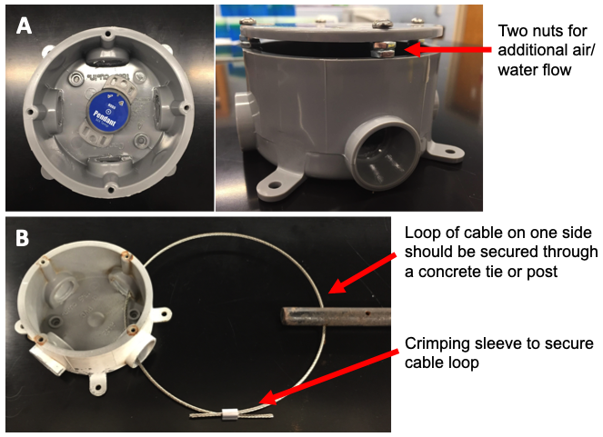

**Figure S1.** Rugged housing unit for temperature logger protection in the field. (A) Top and side view of the junction box used for containing the logger. Nuts between the box and lid provided additional air flow or water inundation. (B) Top view of housing unit without temperature logger. Cable can be configured as necessary to ensure a secure fit to a concrete tie, fence post, or other anchor.

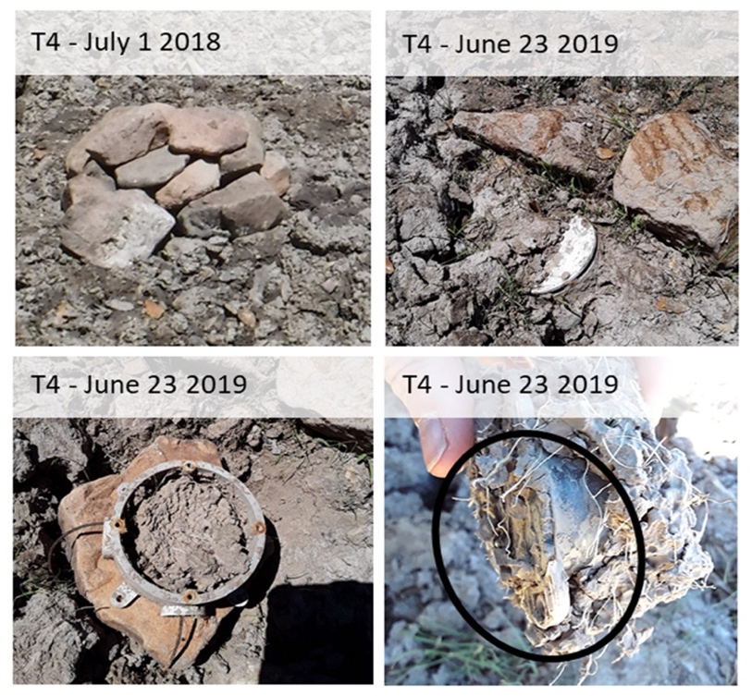

**Figure S2.** T4 pond logger at time of deployment (1 July 2018, top left) and summer return visit (23 June 2019, top right and bottom panels). Mud partially filled the rugged housing unit and adhered to the logger (circled).

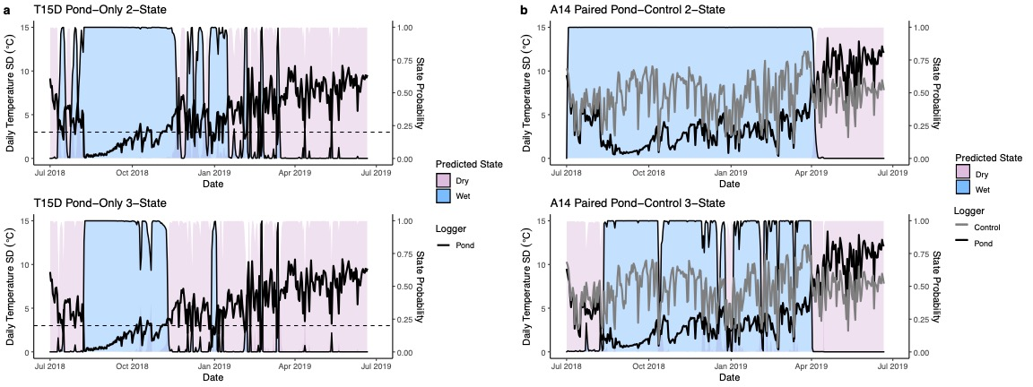

**Figure S3.** Increased accuracy of state prediction by 3- versus 2-state hidden Markov models for (a) pond T15D pond-only dataset and (b) pond A14 paired pond-control dataset. “Wet” state thresholds are based on an average daily temperature standard deviation of 3.0°C for the pond-only dataset (dotted line) and an average delta daily temperature standard deviation of -2.0°C for the paired pond-control dataset.

|  |  |  |
| --- | --- | --- |
| **Equipment** | **Description** | **Approx. Cost (USD)** |
| HOBO Pendant Temperature Data Logger | Model MX2201 from Onset; waterproof temperature logger; connects to iOS or Android mobile device through bluetooth to deliver data | 54.00 /1 unit |
| PVC Type-X Round Junction Box with Cover | 3/4 in; Junction box with lid and holes for securing and protecting the temperature logger | 8.11 /1 box |
| Galvanized Cable; 3/32" | Uncoated stainless steel; for securing junction box to a post or rebar; we used approximately 30" per unit | 0.35 /1 ft |
| Hex Screw Nut;  #10-32 | Screw nuts for creating additional airflow through the lid of the junction box; nut size must match screws used on junction box; 8 per unit, 2 on each screw | 8.19 /100 screw nuts |
| Aluminum Crimping Loop Sleeve Ferrule; 3/32" | For securing the cable around a post or rebar; ferrule size must match the wire size used; 1 per unit | 11.99 /100 ferrules |
| Steel rebar pins with holes | For securing unit in the ground if necessary; must have a hole for looping cable through to attach to unit; 1 per unit minimum if nothing else to secure to | 4.15 /1 pin |
|  | *Approx. cost to build one unit* | ~70.00 |
| **Misc. Construction Equipment** | | |
| Phillips head screw driver | For open or closing the junction box | ~ 7.00 |
| Swaging tool | Tool used for securing the ferrule on the cable | ~ 30.00 |
| Cable cutters | Tool for cutting cable and removing excess cable on unit | ~ 25.00 |

**Table S1.** Detailed descriptions of equipment used for each step of the logger deployment with associated costs as of 25 October 2020.

|  |  |  |  |  |  |  |
| --- | --- | --- | --- | --- | --- | --- |
| **Site** | **Paired pond-control** | |  | | **Pond-only Control** | |
| **T1** | *State 1 (Wet)*:  *State 2 (Dry)*: | Average delta tSD (°C)  -4.551 +/- 1.780  -0.705 +/- 0.734 | *State 1 (Wet)*:  *State 2 (Dry)*: | Average tSD (°C)  0.994 +/- 0.445  3.501 +/- 1.935 | | Average tSD (°C)  5.578 +/- 2.029  5.633 +/- 1.844 |
| **T2** | *State 1 (Wet)*:  *State 2 (Dry)*: | Average delta tSD (°C)  -3.264 +/- 1.203  -0.299 +/- 0.812 | *State 1 (Wet)*:  *State 2 (Dry)*: | Average tSD (°C)  2.247 +/- 1.211  5.485 +/- 2.035 | | Average tSD (°C)  4.638 +/- 1.029  5.595 +/- 1.820 |
| **T4** | *State 1 (Wet)*:  *State 2 (Dry)*: | Average delta tSD (°C)  -5.917 +/- 1.893  -2.078 +/- 1.553 | *State 1 (Wet)*:  *State 2 (Dry)*: | Average tSD (°C)  0.409 +/- 0.297  3.636 +/- 1.843 | | Average tSD (°C)  5.595 +/- 2.305  7.621 +/- 2.851 |
| **T8** | *State 1 (Wet)*:  *State 2 (Dry)*: | Average delta tSD (°C)  -6.461 +/- 0.954  -2.654 +/- 1.896 | *State 1 (Wet)*:  *State 2 (Dry)*: | Average tSD (°C)  0.207 +/- 0.130  2.763 +/- 2.437 | | Average tSD (°C)  5.527 +/- 1.973  4.937 +/- 1.556 |
| **T9** | *State 1 (Wet)*:  *State 2 (Dry)*: | Average delta tSD (°C)  -6.719 +/- 1.381  -2.861 +/- 1.622 | *State 1 (Wet)*:  *State 2 (Dry)*: | Average tSD (°C)  0.311 +/- 0.175  2.561 +/- 2.140 | | Average tSD (°C)  3.906 +/- 2.015  7.360 +/- 2.596 |
| **T11** | *State 1 (Dry)*:  *State 2 (Dry)*: | Average delta tSD (°C)  -1.937 +/- 0.791  0.382 +/- 0.734 | *State 1 (Dry)*:  *State 2 (Dry)*: | Average tSD (°C)  4.365 +/- 1.717  8.311 +/- 1.333 | | Average tSD (°C)  5.108 +/- 1.981  7.995 +/- 1.305 |
| **T12** | *State 1 (Wet)*:  *State 2 (Dry)*: | Average delta tSD (°C)  -3.589 +/- 1.621  1.300 +/- 1.532 | *State 1 (Wet)*:  *State 2 (Dry)*: | Average tSD (°C)  0.500 +/- 0.327  6.463 +/- 3.430 | | Average tSD (°C)  4.008 +/- 1.639  6.586 +/- 1.970 |
| **T13** | *State 1 (Wet)*:  *State 2 (Dry)*: | Average delta tSD (°C)  -3.663 +/- 1.395  -0.334 +/- 1.235 | *State 1 (Wet)*:  *State 2 (Dry)*: | Average tSD (°C)  2.260 +/- 1.157  6.337 +/- 2.413 | | Average tSD (°C)  5.369 +/- 2.008  6.948 +/- 2.513 |
| **T15D** | *State 1 (Wet)*:  *State 2 (Dry)*: | Average delta tSD (°C)  -3.387 +/- 1.394  0.227 +/- 0.876 | *State 1 (Wet)*:  *State 2 (Dry)*: | Average tSD (°C)  2.563 +/- 1.577  7.195 +/- 1.754 | | Average tSD (°C)  4.622 +/- 1.750  6.894 +/- 1.671 |
| **T15U** | *State 1 (Damp)*:  *State 2 (Dry)*: | Average delta tSD (°C)  -0.841 +/- 0.880  2.952 +/- 0.691 | *State 1 (Damp)*:  *State 2 (Dry)*: | Average tSD (°C)  4.801 +/- 1.875  10.445 +/- 1.114 | | Average tSD (°C)  5.685 +/- 1.793  8.202 +/- 1.396 |
| **T17** | *State 1 (Wet)*:  *State 2 (Dry)*: | Average delta tSD (°C)  -2.826 +/- 1.401  -0.580 +/- 0.784 | *State 1 (Wet)*:  *State 2 (Dry)*: | Average tSD (°C)  3.687 +/- 1.589  7.190 +/- 1.299 | | Average tSD (°C)  5.811 +/- 2.212  8.435 +/- 1.620 |
| **T19** | *State 1 (Damp)*:  *State 2 (Dry)*: | Average delta tSD (°C)  -0.605 +/- 0.606  1.248 +/- 0.922 | *State 1 (Dry)*:  *State 2 (Dry)*: | Average tSD (°C)  5.581 +/- 1.974  9.580 +/- 1.656 | | Average tSD (°C)  5.521 +/- 1.976  8.940 +/- 1.958 |
| **A14** | *State 1 (Wet)*:  *State 2 (Dry)*: | Average delta SD (°C)  -4.181 +/- 2.373  2.932 +/- 1.112 | *State 1 (Wet)*:  *State 2 (Dry)*: | Average SD (°C)  2.884 +/- 1.535  9.934 +/- 2.250 | | Average SD (°C)  7.174 +/- 2.395  7.385 +/- 1.579 |
| **T20** | *State 1 (Damp)*:  *State 2 (Dry)*: | Average delta tSD (°C)  -0.924 +/- 0.747  0.463 +/- 0.460 | *State 1 (Wet)*:  *State 2 (Dry)*: | Average tSD (°C)  3.326 +/- 1.255  6.342 +/- 1.214 | | Average tSD (°C)  4.285 +/- 1.445  6.121 +/- 1.134 |

**Table S4.** 2-statehidden Markov model parameter estimates.

|  |  |  |  |  |  |  |
| --- | --- | --- | --- | --- | --- | --- |
| **Site** | **Paired pond-control** | |  | | **Pond-only Control** | |
| **T1** | *State 1 (Wet)*:  *State 2 (Wet)*:  *State 3 (Dry)*: | Average delta tSD (°C)  -6.387 +/- 0.745  -3.544 +/- 1.513  -0.525 +/- 0.570 | *State 1 (Wet)*:  *State 2 (Wet)*:  *State 3 (Dry)*: | Average tSD (°C)  0.527 +/- 0.162  1.223 +/- 0.427  3.805 +/- 1.925 | | Average tSD (°C)  5.981 +/- 1.863  5.432 +/- 2.059  5.636 +/- 1.853 |
| **T2** | *State 1 (Wet)*:  *State 2 (Wet)*:  *State 3 (Dry)*: | Average delta tSD (°C)  -4.389 +/- 0.669  -2.507 +/- 0.667  -0.306 +/- 0.804 | *State 1 (Wet)*:  *State 2 (Wet)*:  *State 3 (Dry)*: | Average tSD (°C)  0.740 +/- 0.444  2.724 +/- 0.857  5.378 +/- 2.062 | | Average tSD (°C)  4.945 +/- 1.029  4.560 +/- 1.633  5.462 +/- 1.863 |
| **T4** | *State 1 (Wet)*:  *State 2 (Wet)*:  *State 3 (Dry)*: | Average delta tSD (°C)  -7.163 +/- 1.829  -4.700 +/- 1.297  -1.176 +/- 0.916 | *State 1 (Wet)*:  *State 2 (Wet)*:  *State 3 (Dry)*: | Average tSD (°C)  0.274 +/- 0.177  1.131 +/- 0.526  4.728 +/- 1.363 | | Average tSD (°C)  5.367 +/- 2.188  6.565 +/- 2.598  7.926 +/- 2.917 |
| **T8** | *State 1 (Wet)*:  *State 2 (Wet)*:  *State 3 (Dry)*: | Average delta tSD (°C)  -6.703 +/- 0.782  -3.498 +/- 1.446  0.604 +/- 0.509 | *State 1 (Wet)*:  *State 2 (Wet)*:  *State 3 (Dry)*: | Average tSD (°C)  0.123 +/- 0.053  0.313 +/- 0.121  2.763 +/- 2.437 | | Average tSD (°C)  5.571 +/- 1.863  5.471 +/- 2.116  4.937 +/- 1.556 |
| **T9** | *State 1 (Wet)*:  *State 2 (Wet)*:  *State 3 (Dry)*: | Average delta tSD (°C)  -6.802 +/- 1.363  -3.961 +/- 0.914  -1.436 +/- 1.233 | *State 1 (Wet)*:  *State 2 (Wet)*:  *State 3 (Dry)*: | Average tSD (°C)  0.278 +/- 0.149  0.867 +/- 0.279  4.175 +/- 2.001 | | Average tSD (°C)  3.786 +/- 1.891  6.132 +/- 2.614  8.123 +/- 2.553 |
| **T11** | *State 1 (Damp)*:  *State 2 (Dry)*:  *State 3 (Dry)*: | Average delta tSD (°C)  -1.937 +/- 0.791  0.037 +/- 0.534  1.181 +/- 0.459 | *State 1 (Damp)*:  *State 2 (Dry)*:  *State 3 (Dry)*: | Average tSD (°C)  3.430 +/- 1.273  6.458 +/- 1.097  9.092 +/- 0.799 | | Average tSD (°C)  4.466 +/- 1.952  6.623 +/- 1.478  8.544 +/- 0.893 |
| **T12** | *State 1 (Wet)*:  *State 2 (Wet)*:  *State 3 (Dry)*: | Average delta tSD (°C)  -4.472 +/- 1.240  -2.118 +/- 1.219  1.835 +/- 1.210 | *State 1 (Wet)*:  *State 2 (Wet)*:  *State 3 (Dry)*: | Average tSD (°C)  0.397 +/- 0.212  1.220 +/- 0.449  7.432 +/- 2.956 | | Average tSD (°C)  3.893 +/- 1.564  5.012 +/- 2.106  6.634 +/- 1.921 |
| **T13** | *State 1 (Wet)*:  *State 2 (Wet)*:  *State 3 (Dry)*: | Average delta tSD (°C)  -5.097 +/- 1.351  -3.183 +/- 0.907  -0.345 +/- 1.226 | *State 1 (Wet)*:  *State 2 (Wet)*:  *State 3 (Dry)*: | Average tSD (°C)  0.912 +/- 0.297  2.788 +/- 1.023  6.514 +/- 2.424 | | Average tSD (°C)  5.027 +/- 1.726  5.475 +/- 2.033  7.077 +/- 2.562 |
| **T15D** | *State 1 (Wet)*:  *State 2 (Dry)*:  *State 3 (Dry)*: | Average delta tSD (°C)  -3.387 +/- 1.394  0.274 +/- 1.150  0.172 +/- 0.350 | *State 1 (Wet)*:  *State 2 (Damp)*:  *State 3 (Dry)*: | Average tSD (°C)  1.547 +/- 1.006  4.612 +/- 1.281  7.678 +/- 1.682 | | Average tSD (°C)  4.648 +/- 1.853  5.158 +/- 1.599  7.144 +/- 1.751 |
| **T15U** | *State 1 (Damp)*:  *State 2 (Dry)*:  *State 3 (Dry)*: | Average delta tSD (°C)  -1.702 +/- 0.627  -0.231 +/- 0.384  2.952 +/- 0.691 | *State 1 (Damp)*:  *State 2 (Dry)*:  *State 3 (Dry)*: | Average tSD (°C)  3.887 +/- 1.575  6.503 +/- 1.114  10.592 +/- 1.935 | | Average tSD (°C)  5.033 +/- 1.769  6.936 +/- 1.178  8.151 +/- 1.416 |
| **T17** | *State 1 (Wet)*:  *State 2 (Wet)*:  *State 3 (Dry)*: | Average delta tSD (°C)  -4.307 +/- 1.463  -2.222 +/- 0.819  -0.491 +/- 0.734 | *State 1 (Wet)*:  *State 2 (Dry)*:  *State 3 (Dry)*: | Average tSD (°C)  2.229 +/- 0.993  4.627 +/- 1.277  7.587 +/- 1.019 | | Average tSD (°C)  4.943 +/- 2.439  6.293 +/- 1.837  8.899 +/- 1.317 |
| **T19** | *State 1 (Damp)*:  *State 2 (Dry)*:  *State 3 (Dry)*: | Average delta tSD (°C)  -1.489+/- 0.450  -0.465 +/- 0.336  1.188 +/- 0.925 | *State 1 (Dry)*:  *State 2 (Dry)*:  *State 3 (Dry)*: | Average tSD (°C)  5.200 +/- 1.795  8.378 +/- 1.176  11.023 +/- 0.946 | | Average tSD (°C)  5.288 +/- 1.970  7.616 +/- 1.348  10.460 +/- 1.573 |
| **A14** | *State 1 (Wet)*:  *State 2 (Dry)*:  *State 3 (Dry)*: | Average delta SD (°C)  -4.918 +/- 2.041  -0.819 +/- 1.157  3.404 +/- 0.454 | *State 1 (Wet)*:  *State 2 (Dry)*:  *State 3 (Dry)*: | Average SD (°C)  2.235 +/- 1.108  4.961+/- 0.802  7.624 +/- 1.093 | | Average SD (°C)  6.828 +/- 2.367  8.117 +/- 2.140  8.890 +/- 1.315 |
| **T20** | *State 1 (Damp)*:  *State 2 (Dry)*:  *State 3 (Dry)*: | Average delta tSD (°C)  -1.801+/- 0.653  -0.533 +/- 0.349  0.463 +/- 0.460 | *State 1 (Wet)*:  *State 2 (Dry)*:  *State 3 (Dry)*: | Average tSD (°C)  2.633 +/- 0.952  4.565 +/- 0.951  6.869 +/- 0.882 | | Average tSD (°C)  3.724 +/- 1.387  5.151 +/- 1.084  6.482 +/- 0.944 |

**Table S5.** 3-statehidden Markov model parameter estimates.

|  |  |  |
| --- | --- | --- |
| **Site** | **Paired pond-control** | **Pond-only** |
| **T1** | 30 July 2018 – 03 Feb 2019 (189 days)  *Pond logger failure 4 Feb 2019* | 30 July 2018 – 03 Aug 2018 (5 days)  23 Aug 2018 – 25 Sept 2018 (34 days)  30 Sept 2018 – 03 Feb 2019 (127 days)  *Pond logger failure 4 Feb 2019* |
| **Total wet days** | 189 / 218 | 166 / 218 |
| **T2** | 25 Aug 2018 – 18 Sept 2018 (25 days)  21 Sept 2018 – 11 Oct 2018 (21 days)  18 Oct 2018 – 29 Nov 2018 (43 days)  *Pond logger failure 21 Dec 2018* | 10 July 2018 – 22 July 2018 (13 days)  21 Aug 2018– 16 Dec 2018 (118 days)  *Pond logger failure 21 Dec 2018* |
| **Total wet days** | 89 / 174 | 131 / 174 |
| **T4** | 31 July 2018 – 11 Oct 2018 (73 days)  17 Oc­t 2018 – 29 Nov 2018 (44 days)  9 Dec 2018 – 15 Dec 2018 (7 days)  19 Dec 2018 – 25 Dec 2018 (7 days)  4 Jan 2019 – 2 Feb 2019 (30 days)  7 Feb 2019 – 21 Feb 2019 (15 days)  25 Feb 2019 – 11 Mar 2019 (15 days)  14 Mar 2019 – 21 June 2019 (100 days) | 4 Aug 2018 – 20 May 2019 (290 days) |
| **Total wet days** | 291 / 356 | 290 / 356 |
| **T8** | 17 July 2018 – 14 Jan 2019 (182 days)  *Pond logger failure 14 Jan 2019* | 14 July 2018 – 22 Aug 2018 (40 days)  24 Aug 2018 – 14 Jan 2019 (144 days)  *Pond logger failure 14 Jan 2019* |
| **Total wet days** | 182 / 198 | 184 / 198 |
| **T9** | 17 July 2018 – 7 Aug 2018 (22 days)  11 Aug 2018 – 14 Aug 2018 (4 days)*  16 Aug 2018 – 22 Aug 2018 (7 days)  25 Aug 2018 – 11 Oct 2018 (48 days)  18 Oct 2018 – 29 Nov 2018 (43 days)  24 Jan 2019 – 31 Jan 2019 (8 days)  12 Feb 2019 – 14 Feb 2019 (3 days)*  27 Feb 2019 – 11 Mar 2019 (13 days)  14 Mar 2019 – 21 June 2019 (100 days) | 17 July 2018 – 5 Aug 2018 (20 days)  8 Aug 2018 – 14 May 2019 (280 days) |
| **Total wet days** | 241 / 356 | 300 / 356 |
| **T11** | *None* | *None* |
| **Total wet days** | 0 / 356 | 0 / 356 |
| **T12** | 17 July 2018 – 19 May 2019 (307 days) | 17 July 2018 – 29 Apr 2019 (289 days) |
| **Total wet days** | 307 / 356 | 289 / 356 |
| **T13** | 17 July 2018– 11 Oct 2018 (87 days)  15 Oct 2018– 24 Nov 2018 (41 days)  25 Feb 2019 – 7 Mar 2019 (11 days)  14 Mar 2019 – 9 Apr 2019 (27 days)  *Pond logger failure 5 May 2019* | 10 July 2018 – 23 Nov 2018 (137 days)  26 Dec 2018 – 22 Jan 2019 (28 days)  1 Feb 2019 – 6 Feb 2019 (6 days)  21 Feb 2019– 21 Mar 2019 (29 days)  *Pond logger failure 5 May 2019* |
| **Total wet days** | 166 / 308 | 200 / 308 |
| **T15D** | 7 Aug 2018 – 19 Nov 2018 (105 days) | 8 Aug 2018 – 3 Nov 2018 (88 days)  29 Dec 2018 – 2 Jan 2019 (5 days)  4 Feb 2019 – 6 Feb 2019 (3 days)*  22 Feb 2019 – 23 Feb 2019 (2 days)*  12 Mar 2019 – 13 Mar 2019 (2 days)* |
| **Total wet days** | 105 / 356 | 93 / 356 |
| **T15U** | *None* | *None* |
| **Total wet days** | 0 / 356 | 0 / 356 |
| **T17** | 22 July 2018 – 10 Oct 2018 (81 days)  14 Oct 2018 – 14 Nov 2018 (32 days)  30 Dec 2018 – 31 Dec 2018 (2 days)*  24 Feb 2019 – 28 Feb 2019 (5 days)  15 Mar 2019 – 19 Mar 2019 (5 days)  1 April 2019 – 11 June 2019 | 10 July 2018 – 16 July 2018 (7 days)  9 Aug 2018 – 20 Sept 2018 (43 days)  11 Oct 2018 – 15 Oct 2018 (5 days)  26 Dec 2018 – 2 Jan 2019 (8 days)  2 Feb 2019 – 6 Feb 2019 (5 days)  21 Feb 2019 – 23 Feb 2019 (3 days)* |
| **Total wet days** | 195 / 356 | 68 / 356 |
| **T19** | *None* | *None* |
| **Total wet days** | 0 / 356 | 0 / 356 |
| **A14** | 12 Aug 2018 – 24 Dec 2018 (135 days)  3 Jan 2019 – 1 Feb 2019 (30 days)  7 Feb 2019 – 31 Mar 2019 (53 days) | 13 July 2018 – 16 July 2018 (4 days)*  8 Aug 2018 – 24 Nov 2018 (109 days)  29 Nov 2018 – 16 Dec 2018 (18 days)  25 Dec 2018 – 23 Feb 2019 (61 days)  7 Mar 2019 – 13 Mar 2019 (7 days) |
| **Total wet days** | 218 / 356 | 195 / 356 |
| **T20** | *None* | 13 July 2018 – 16 July 2018 (4 days)*  25 July 2018 – 29 July 2018 (5 days)  8 Aug 2018 – 3 Sept 2018 (27 days)  11 Sept 2018 – 24 Sept 2018 (14 days)  1 Oct 2018 – 2 Oct 2018 (2 days)*  11 Oct 2018 – 23 Oct 2018 (13 days)  29 Oct 2018 – 31 Oct 2018 (3 days)*  30 Nov 2018 – 2 Dec 2018 (3 days)*  6 Dec 2018 – 18 Dec 2018 (13 days)  25 Dec 2018 – 15 Jan 2019 (22 days)  2 Feb 2019 – 6 Feb 2019 (5 days)  9 Feb 2019 – 11 Feb 2019 (3 days)*  14 Feb 2019 – 23 Feb 2019 (10 days)  12 Mar 2019 – 19 Mar 2019 (8 days) |
| **Total wet days** | 0 / 356 | 117 / 356 |

**Table S6.** Pond wet dates predicted by 3-state hidden Markov models. Asterisks indicate predicted wet dates that fell below the inundation criteria of duration of 5 or more consecutive days.

**Table S2.** Wet state cutoff determination for 2-state hidden Markov models. We compared the observed inundation status of ponds at the time of our site visits to the mean temperature standard deviations of the states predicted by hidden Markov models (Table S4). Here we also report the temperature standard deviation on the day of the site visit, which was not used to determine wet state cutoffs. Yellow highlighting indicates an incorrectly predicted state.

**Table S3.** Wet state cutoff determination for 3-state hidden Markov models. We compared the observed inundation status of ponds at the time of our site visits to the mean temperature standard deviations of the states predicted by hidden Markov models (Table S5). Here we also report the temperature standard deviation on the day of the site visit, which was not used to determine wet state cutoffs. Yellow highlighting indicates an incorrectly predicted state.