How to Submit: Answer each problem on a separate page(s). Write your name on every page and mark each page with the homework number and problem number. Please do not staple answers to different questions together. Submit a hard copy of your completed homework by forming a separate stack of each problem.

Problem 1. Exploring Instruction Flow and and Instruction level parallelism:

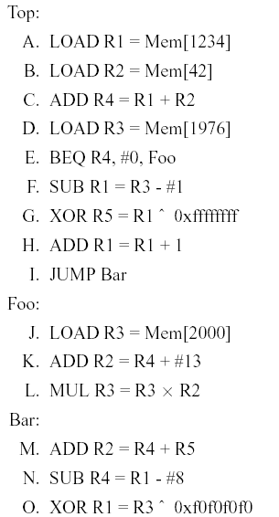
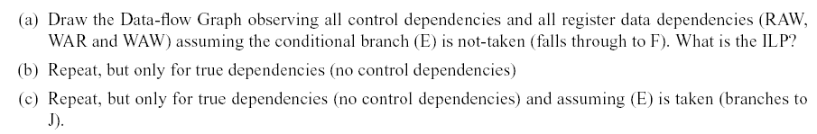
HINT: The intention of the problem is not to use a specific pipeline. It is however, to identify different kinds of data dependences and the degree of ILP (Instruction Level Parallelism) achievable.

Normally you want do this graphically using a data flow graph. Where a node of the graph is one instruction (A, B, C, ...) and you have a directed edge from one node to the other if there is a dependence. You may want to use a different color for different dependence types.

Once you have the graph, you can find out what would be the maximum parallelism you would obtain for that graph (computation) if you had all the hardware you needed. So then the depth of the data flow graph gives us the minimum execution time possible for the graph. The total number of instructions in the graph will give up the execution time with out any extra hardware. This means every thing must be executed sequentially and one at a time.

Then ILP is defined as = (Number of instructions in dataflow graph)/(depth of dataflow graph).

Solution:
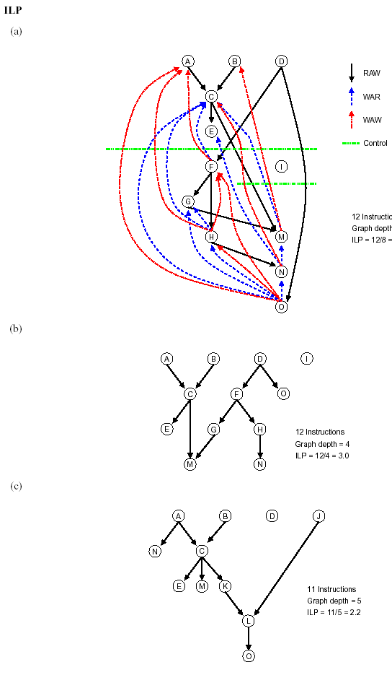

Problem 2. Instruction Flow and Branch Prediction [30 points]
Write down all assumptions. If you need more space, attach additional pages to the back, and label accordingly. Please save your work for this problem after you submit your answers. We will build on this assignment asIntroduction
Introduction
This problem investigates the effects of branches and control flow changes on program performance for a scalar pipeline (to keep the focus on branch prediction). Branch penalties increase as the number of pipeline stages increases between instruction fetch and branch resolution (or condition and target resolution). This effect of pipelined execution drives the need for branch prediction. This problem explores both static branch prediction in Part C (we will see dynamic branch prediction based on this design in a future assignment). For this problem the base machine is a 5-Stage pipeline.

The 5-Stage Pipeline without Dynamic Branch Prediction
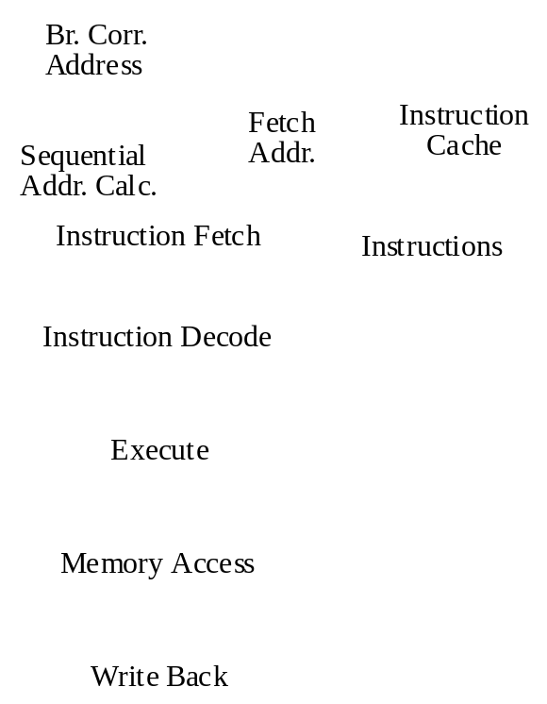
Execution Assumptions:
- unconditional branches execute in the decode stage
- conditional branches execute in the execute stage
- Effective address calculation is performed in the execute stage
- All memory access is performed in the memory access stage
- All necessary forwarding paths exist
- The register file is read after write
The fetch address is a choice between the sequential address generation logic and the branch correction logic. If a mispredicted branch is being corrected the correction address is chosen over the sequential address for the next fetch address.
Part A: Branch Penalties. [4 points]

What are the branch penalties for unconditional and conditional branches?

Unconditional _______1______ Conditional _______2______
(if the unconditional branch does not need to access the register file)

Part B: No Branch Prediction. [12 points]

This problem will use the bubble sort program. An execution trace, or a sequence of executed basic blocks, is provided for this problem. A basic block is a group of consecutive instructions that are always executed together in sequence.
Example Code: Bubble Sort
BB Line# Label Assembly_Instruction Comment

1 1 main: addi r2, r0, ListArray r2 <- ListArray
2 addi r3, r0, ListLength r3 <- ListLength
3 add r4, r0, r0 i = 0;
2 4 loop1: bge r4, r3, end while (i < Length)
{
3 5 addi r5, r4, 1 j = i + 1;
4 6 loop2: bge r5, r3, cont while (j < Length)
{
5 7 lw r6, r4(r2) temp = ListArray[i];
8 lw r7, r5(r2) temp2 = ListArray[j];
9 ble r6, r7, skip if (temp > temp2)
{
6 10 sw r7, r4(r2) ListArray[i] <- temp;
11 sw r6, r5(r2) ListArray[j] <- temp2;
}
7 12 skip: addi r5, r5, 1 j++;
13 ba loop2 }
8 14 cont: addi r4, r4, 1 i++;
15 ba loop1 }
9 16 end: lw r1, (sp) r1 <- Return Pointer
17 ba r1

Execution Trace: Sequence of Basic Blocks Executed:
1 2 3 4 5 6 7 4 5 7 4 5 7 4 8 2 3 4 5 6 7 4 5 7 4 8 2 3 4 5 6 7 4 8 2 3 4 8 2 9

[Hint: An alternate way to represent the same execution trace above is to use the sequence of branch instructions, both conditional and unconditional (i.e. ba), executed.]
1. (6 points) Fill in the branch execution table with an N for not taken and a T for taken. This table is recording the execution pattern for each (static) branch instruction. Use the execution trace on Page 2.

Branch Execution - Assume No Branch Prediction:

Branch Instruction No. (i.e. Line#) | Branch Instruction Execution (dynamic executions of each branch)
Branch Instruction No. (i.e. Line#) | 1 | 2 | 3 | 4 | 5 | 6 | 7 | 8 | 9 | 10
4 | N | N | N | N | T
6 | N | N | N | T | N | N | T | N | T | T
9 | N | T | T | N | T | N
13 | T | T | T | T | T | T
15 | T | T | T | T
17 | T

Using the branch execution table above to calculate the statistics requested in the following table.

Branch Execution Statistics:

Branch Instr. No. | Times Executed | Times Taken | Times Not Taken | % Taken | %Not Taken
4 | 5 | 1 | 4 | 20 | 80
6 | 10 | 4 | 6 | 40 | 60
9 | 6 | 3 | 3 | 50 | 50
13 | 6 | 6 | 0 | 100 | 0
15 | 4 | 4 | 0 | 100 | 0
17 | 1 | 1 | 0 | 100 | 0

2. (3 points) How many cycles does the trace take to execute (include all pipeline fill and drain cycles)? [Hint: you don’t need to physically simulate the execution trace, just compute the cycle count.]

68 instructions + 4 pipeline fill cycles + 7 data penalty cycles + 42 conditional branch penalty cycles + 11 unconditional branch penalty cycles = 132 cycles

3. (3 points) How many cycles are lost to control dependency stalls?

42 conditional + 11 unconditional branch penalty cycles = 53 cycles
Part C: Static Branch Prediction. [14 points]

Static branch prediction is a compile-time technique of influencing branch execution in order to reduce control dependency stalls. Branch opcodes are supplemented with a static prediction bit that indicates a likely direction during execution of the branch. This is done based on profiling information, ala that in Part B. For this part of Problem 1, new branch opcodes are introduced:

bget - branch greater than or equal with static predict taken
bgen - branch greater than or equal with static predict not-taken
blet - branch less than or equal with static predict taken
blen - branch less than or equal with static predict not-taken

Static branch prediction information is processed in the decode stage of the 5-stage pipeline. When a branch instruction with static predict taken (i.e. bget) is decoded the machine predicts taken. Conversely, when a branch instruction with static predict not-taken (i.e. bgen) is decoded the machine predicts not-taken.

1. [10 points] Pretend you are the compiler, rewrite each conditional branch instruction in the original code sequence using the new conditional branch instructions with static branch prediction encoded.

Line# Instruction
- bgen
6 bgen
9 blen or blet

2. [4 points] Assuming the same execution trace, what is the new total cycle count of the modified code sequence incorporating static branch prediction instructions. Indicate the resultant IPC.

The static branch prediction will help us predict 13 of the dynamic conditional branches correctly. However, even with the static prediction, we still lose 1 cycle in decoding the branch instruction. Therefore, for conditional branches with the correct prediction, we only lose 1 cycle. Thus, with the new static branch prediction, we save 13 cycles in conditional branch penalty.

Total cycle = old cycle count – 13 = 132 – 13 = 119 cycles
IPC = 68 instructions / 119 cycles = 0.571 inst/cycle

