**AltTab**

AltTab is a small application created in C++ and Win32, is an alternative for windows native task switcher (Alt+Tab / Alt+Shift+Tab).

Use Alt+Tab / Alt+Shift+Tab to bring the main AltTab window.



# Features

* Find the right window faster (filter windows using search string), uses [fuzzy string matching algorithm](https://en.wikipedia.org/wiki/Approximate_string_matching) (no need to type the exact search string).
* Switch between windows of the same application using **Alt + `** (Grave Accent / Backtick, the key right above the Tab on a US English keyboard layout).
* Terminate a process or all processes either normally or forcefully using keyboard shortcuts.
* Provided configuration/setting INI file & UI to change font style, background color, window transparency, width and height.
* Exclude processes.

# Switch between windows of the same application using Alt+(Accent/Backtick)

Define similar processes as one group to switch between these processes using **Alt + Backtick.**

**Ex: Processes notepad.exe and notepad++.exe are displayed in Alt + Backtick window if notepad.exe and notepad++.exe are defined as similar processes.**

# Keyboard Shortcuts

The below keyboard shortcuts work in both **Alt + Tab, Alt + Backtick**

|  |  |
| --- | --- |
| Key | Description |
| Home / PageUp | Move selection to first row |
| End / PageDown | Move selection to last row |
| Up / Down | Move selection to previous / next row |
| Del | Close currently selected window |
| Accent / Backtick (`) | Move selection to the next window of the currently selected application |
| Shift + Accent / Backtick (`) | Move selection to the previous window of the currently selected application |
| Shift + Del | Terminate currently selected process |
| AlphaNumeric | Filter windows while typing, can delete last type character using backspace.  Search string is displayed on static control. |
| F1 (FunctionKey) | Display help file |
| F2 (FunctionKey) | Display settings dialog |

# Keyboard shortcuts work in window list of Alt + Tab only

|  |  |
| --- | --- |
| Key | Description |
| Accent / Backtick (`) | Move selection to the next window of the currently selected application |
| Shift + Accent / Backtick (`) | Move selection to the previous window of the currently selected application |

# Context Menu

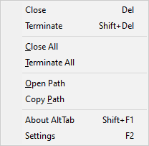

|  |  |
| --- | --- |
| Menu | Description |
| Open Path | Open the file explorer of the selected process file path |
| Copy Path | Copy the selected process path to clipboard |

# Tray Menu

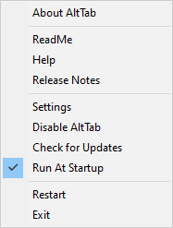

# Configuration INI File

Used to read/write the settings of application.

# Settings Dialog

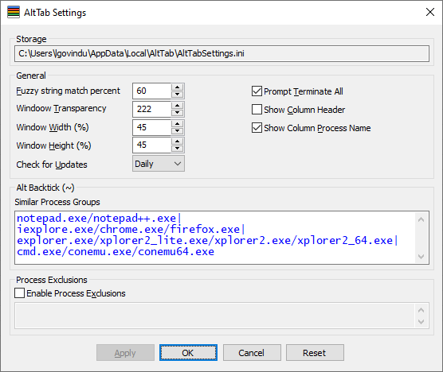

|  |  |
| --- | --- |
| Setting | Description |
| Storage | AltTab settings file path. |
| Fuzzy string match percent | Fuzzy name match percent between search string and process name/title.  100 % means exact match (uses native string search algorithm)  80 % would cause "files" to match "filas" and so on ...  **Reference:** [Approximate string matching](https://en.wikipedia.org/wiki/Approximate_string_matching), [Levenshtein distance](https://en.wikipedia.org/wiki/Levenshtein_distance)  **Note:**  If string match percent is NOT 100%, search uses approximate string-matching algorithm, this is significantly slow compare to native string search. |
| Window Transparency | Indicate the degree of transparency.  0 – makes the window invisible  255 – makes it opaque |
| Window Width (%) | Main window width w.r.t percentage of screen width. |
| Window Height (%) | Main window maximum height w.r.t percentage of screen height.  If there are more number of processes which exceeds the WindowHeight to accommodate all the tasks, then resize the window to WindowHeight according scroll bar presence. |
| Check for Updates | How frequently check for updates.  **Available Options:** Startup / Daily / Weekly / Never. **Default:** Weekly   |  |  | | --- | --- | | **Startup** | At startup | | **Daily** | For every 24 hours since the last run | | **Weekly** | For every 7 days since the last run | | **Never** | Never check for updates | |
| Prompt Terminate All | Prompt for confirmation before terminating. |
| Show Column Header | Show column header for listview in AltTab window. |
| Show Column Process Name | Add the process name column to listview in AltTab window. |
| Similar Process Groups | Define similar processes as one group to switch between these processes using **Alt + Backtick / Alt + Shift + Backtick.**   1. Processes in a process group are separated by forward slash (/) and process groups are separated by Pipe/Vertical Bar (|). 2. A file/process name can't contain any of the following characters: **\ / : * ? " < > |**   **Defaults**: notepad.exe/notepad++.exe|iexplore.exe/  chrome.exe/firefox.exe|explorer.exe/xplorer2_lite.exe/  xplorer2.exe/xplorer2_64.exe |
| Process Exclusions | Given process names are excluded in AltTab window |
| Reset | Reset settings to default settings. |