INCLUDEPICTURE "Z:\\SHARE\\NEWLOGO.BMP" \* MERGEFORMATINET 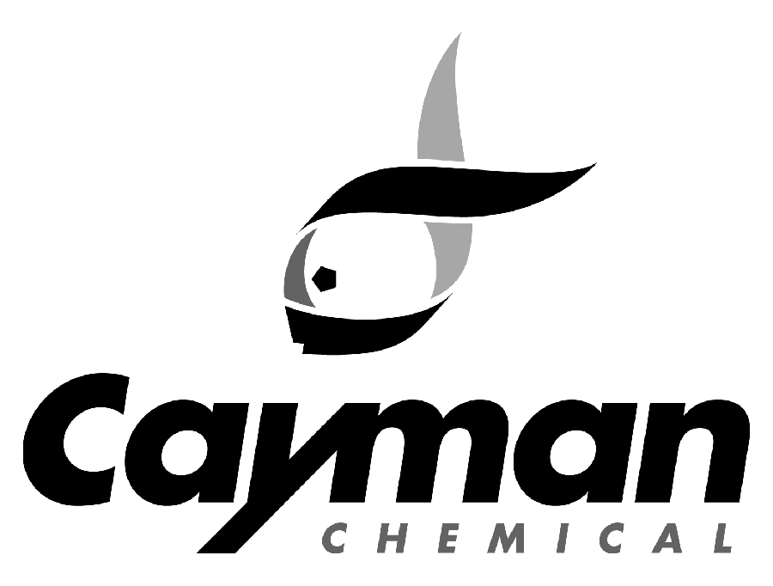
1180 E. Ellsworth Road
Phone: 800-364-9897, 734-971-3335 • Fax: 734-971-3640

FROM: Cayman Chemical Customer Service

RE: Account Application

To Whom It May Concern:

Thank you for your interest in Cayman Chemical products and services. In order to place an order with Cayman Chemical, we require some additional information regarding your institution.

Please complete the attached account application and return it to the attention of the Credit Department. Upon completion you will be notified of your account number, account status and payment terms with Cayman Chemical. Please note that the information provided to us is considered confidential between Cayman Chemical and the applicant and will not be made available to a third party unless otherwise requested. If you should have any questions during this process please let us know.

Cayman Chemical’s Federal ID number is 84-084-5784.

Please email the completed application to custserv@caymanchem.com or to fax number 734-971-3640.

Best Regards,

Customer Service
Cayman Chemical Company
800-364-9897 - Toll Free
734-971-3640 - Fax
custserv@caymanchem.com
www.caymanchem.com

INCLUDEPICTURE "Z:\\SHARE\\NEWLOGO.BMP" \* MERGEFORMATINET
1180 E. Ellsworth, Ann Arbor, MI 48108
Phone: 800-364-9897, 734-971-3335 • Fax: 734-971-3640

Confidential Account Application
Complete and return this form. All information supplied will be held in strict confidence.
The form must be typed, signed, and dated.

COMPANY INFORMATION
Company Name:
Company Phone Number:
Company Fax Number:
Company Website:
Type of Business (select one): Corporation
Partnership
Sole-Proprietorship
Other:
Date Established:
E.I.N. Number OR SSN#
(Corporation, Partnership, Sole Proprietorship) | (All Other)

NAMES OF PRINCIPAL OFFICERS, PARTNERS, OR PROPIETORS
Name | Title

BILLING INFORMATION
Company Name:
Attn:
Address:

City/State/Zip:
Accounts Payable Contact:
Accounts Payable Phone Number:
Accounts Payable Fax Number:
Accounts Payable Email Address:

SHIPPING INFORMATION
Company Name:
Attn:
Address:

City/State/Zip:

Type of Account Requested (choose one of the following)
Credit Card/Prepay (American Express, Visa, MasterCard, check, wire transfer)
Credit Card for first order, then Purchase Order (please complete the credit information section)
Purchase Order (Terms Net 30 days and please complete the credit information section)

CREDIT INFORMATION
Note: trade references must be provided for all Purchase Order accounts. Do not complete this section if establishing an account for credit card/prepay.
TRADE REFERENCES
Company Name #1:
Address:
City/State/Zip:
Account No.:
Phone No.;
Fax No.:

Company Name #2:
Address:
City/State/Zip:
Account No.:
Phone No.;
Fax No.:
Company Name #3:
Address:
City/State/Zip:
Account No.:
Phone No.;
Fax No.:

BANK REFERENCE
Name:
Address:
City/State/Zip:
Account No.:
Contact Person:
Phone No.:

SALES AND USE TAX EXEMPTION
The purchaser hereby claims exemption from state sales or use tax on the purchase of goods and services from Cayman Chemical Company, Inc. and certifies that this claim is based upon the purchaser’s proposed use of the items or services, or the status of the purchaser.

ITEMS COVERED BY THIS CERTIFICATE:
All items purchased are exempt from state sales or use tax.
Limited to the following items:

BASIS FOR EXEMPTION CLAIM:
For Resale at Retail – Sales Tax Registration Number:
For Resale at Wholesale
Agricultural Production
Industrial Processing
Government Entity Nonprofit School Nonprofit Hospital Church
Nonprofit Internal Revenue Code Section 501(c) (3) and 501 (c) (4) Exempt
Nonprofit Organization with an Exempt letter from state (please attach copy)
Other (explain):
Company is NOT exempt from state sales tax

CUSTOMER CLASSIFICATION GROUP
Government
NON-Pharmaceutical
Other
Pharmaceutical
Reseller
University

USE OF RESEARCH PRODUCTS
Unless otherwise indicated on the Product Information and Certificate of Analysis, the products sold by Cayman Chemical are not for human or veterinary disease diagnosis or therapeutic drug use. They should be used only by technically qualified individuals or those under their direct supervision. Any individual working with these products should have free access to the applicable material Safety Data Sheet (MSDS) and should read and understand it completely prior to use.

CERTIFICATION
I declare, under penalty of perjury, that the information on this certificate is true, that I have consulted the statutes, administrative rules and other sources of law applicable to my exemption, and that I have exercised reasonable care in assuring that my claim of exemption is valid. In the event this claim is disallowed, I accept full responsibility for the payment of tax, penalty and any accrued interest, including, if necessary, reimbursement to the vendor for tax and accrued interest.

Name (Print or Type)

Signature & Title Date

