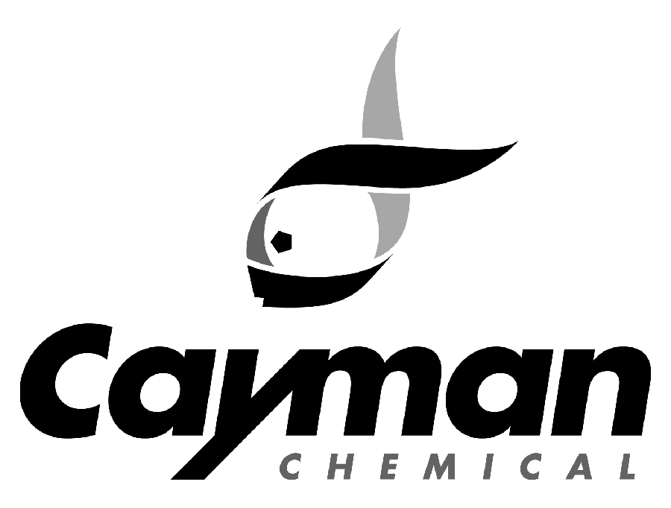
1180 E. Ellsworth Road
Ann Arbor, MI 48108
Phone: 800-364-9897, 734-971-3335 • Fax: 734-971-3640
custserv@caymanchem.com

Orders for Schedule I DEA Regulated items

Thank you for your order. In order to process your order for shipment, we require the following documents:

- A copy of the institution’s DEA license (Form 223) (can be faxed, emailed or mailed)

- An ORIGINAL DEA Form 222
Please mail the form to the address above, to the attention of
Customer Service/DEA Order processing. Phone: 800-364-9897.

NOTE: The DEA Form 222 can only have the DEA regulated items on it - item(s) cannot be crossed off.

The following sections need to be completed (by purchaser) on the form:
- Supplier: Cayman Chemical (address above)
- Date
- No. of Packages: quantity of item being ordered
- Size of Package: size of item being ordered (i.e, 5 mg, 25µg)
- Name of item: Complete catalog description of item being ordered (see our website for item descriptions); catalog numbers are not needed
- Last Line Completed: fill in the total number of lines
- Signature of Purchaser or Attorney or Agent: form needs to be signed
- The Name and Address of Registrant must match the shipping address on your order. Note: we cannot ship to PO boxes.

*The 222 from will be returned to the purchaser due to any omission or errors of the above sections and a new one will have to be sent to Cayman Chemical

- There is a DEA processing fee of $25.00 per order.

Customer Instructions for Completing DEA 222 Forms
Required for Schedules I and II

- To: Cayman Chemical Company
- Street Address: 1180 E. Ellsworth
- City and State: Ann Arbor MI, 48108
- Date: Date you are filling out the form.
- Order Details: MUST be filled in. If any part is left blank, the form will be returned to you for completion.
  - No. of Packages: The quantity of the drug being ordered (e.g., 1).
  - Size of Package: The size of the drug being ordered (e.g., 5 mg).
  - Name of Item: The name of the drug being ordered. (Please use the name listed on the Cayman website,www.caymanchem.com
  - ONLY Schedules I & II may be on the form: Any other schedules will result in the form being returned for correction.
- Last Line Completed: the line number that contains the LAST drug you are ordering. Do NOT skip any lines when completing the form and use only one line per item. This field MUST be filled in. If this is left blank or incorrect, the form will be returned to you for completion (if blank) or replacement (if incorrect).
- Signature of Purchaser or Attorney or Agent: You MUST sign this form. If the form is not signed, it will be returned for your signature. If it is signed by anyone other than the registrant, we must have a copy of the Power of Attorney form.
- Name and Address of Registrant: Your preprinted address must match your currently registered address on your DEA Registration Certificate. Shipments of controlled substances must be sent to your current registered address only.
- Sending Form: You must submit Supplier’s Copy 1 (brown) and DEA Copy 2 (green) and the carbon between them to Cayman Chemical Company at the above-noted address. If either of these copies is missing, the form will be returned for replacement. Please retain Copy 3 (blue) for your records.
- Please leave the National Drug Code blank: until you receive your shipment. Once the order is received, you should fill in the NDC (found on the vial); number of packages received and date, Copy 3 (blue).

