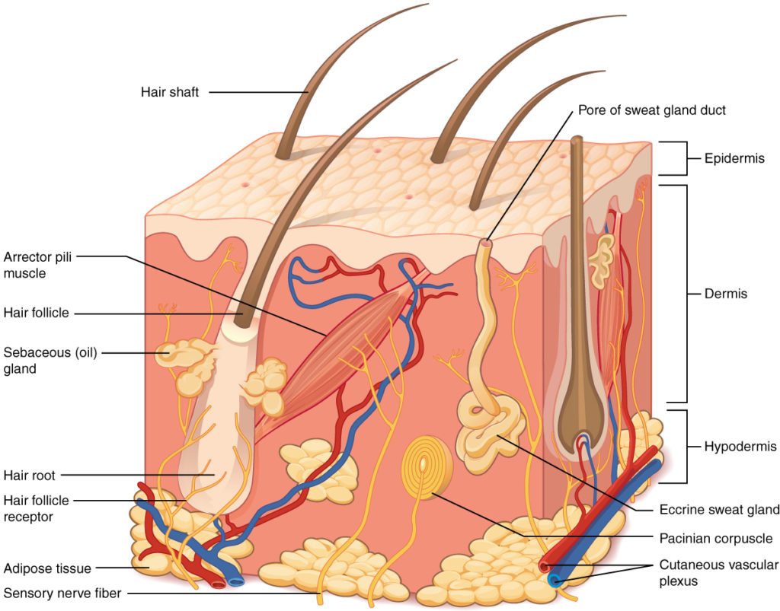
Layer of the Skin

Image Source: Biology for Majors II
URL Link: https://courses.lumenlearning.com/suny-wmopen-biology2/chapter/structure-and-function-of-skin/

Skin Science

Lee Caren

031225-08-0438

4427 Words

Title Page

Skin Science

TQUK Higher Diploma in
Aesthetics Practice and
Beauty Salon Management (Level 4)

Lee Caren

031225-08-0438

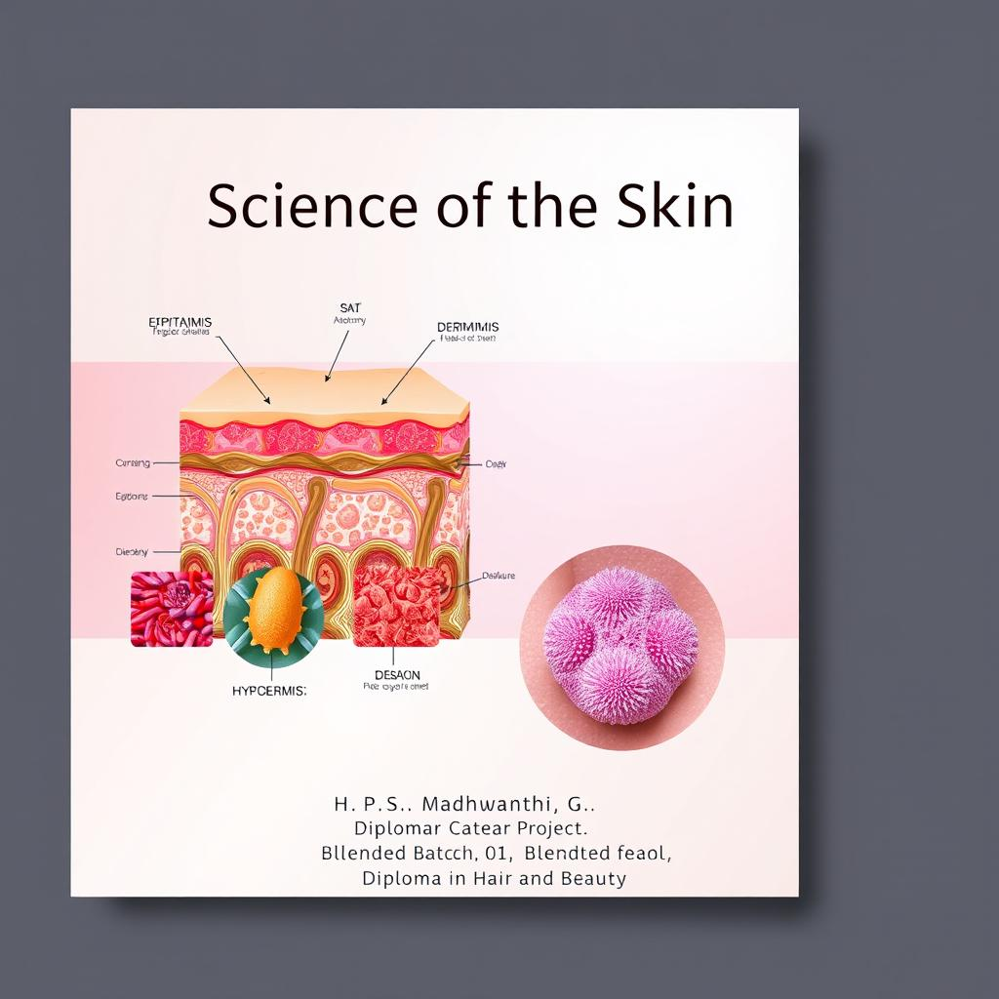
Science of the Skin

Image Source: Idyllic
URL Link: https://us.idyllic.app/idea/tvKPvy0wTGCj7ol1Q_niKA

Introduction

The objective of this project is to understand the structure, functions, and importance of the human skin which is the largest organ of the human body. Our skin covers and protects the whole body. It acts as a skin barrier to keep harmful germs and chemicals out and prevents too much water from leaving the body. In this project, I will learn about the different layers of the skin, the types of tissues, the process of the keratinization, the skin glands, and the factors that influence skin color, thickness, and aging.

1. Skin Science

A) Describe the structure of the layers of the skin - epidermis and dermis.

The epidermis is the thin, outer layer of the skin made of flat cells called keratinocytes. It has no blood vessels, so it gets nutrients from the layer below. The epidermis protects the body from injury, germs, and water loss. The epidermis provides the body’s first line of defense against mechanical injury, pathogens, and dehydration.
Underneath it is the dermis, which is much thicker and made of connective tissue. The dermis gives the skin its strength and stretch because it contains collagen and elastic fibers. It also has blood vessels, nerves, and glands like sweat and oil glands, as well as hair follicles that help keep the skin healthy and working properly.

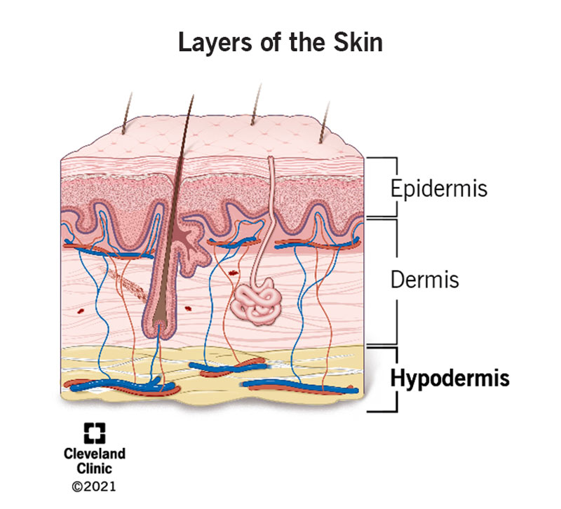
Layer of the Skin

Image Source: Cleveland Clinic
URL Link: https://my.clevelandclinic.org/health/body/21902-hypodermis-subcutaneous-tissue

B) Identify that the epidermis is an epithelial tissue, and the dermis is a connective tissue.
The skin is made up of different types of tissue that give it structure, strength, and protective functions. The epidermis, the outermost layer densely packed cells with little matrices. It has no blood vessels; nutrients diffuse from dermis. This Epithelial tissue has polarity and a basement membrane.

Main Function: Protection and Water Retention
Main Cells: Keratinocytes, Melanocytes, Langerhans cells

Beneath the epidermis lies the dermis, which is composed of connective tissue, mainly dense irregular connective tissue. This connective tissue has sparse cells, abundant matrices, non-polar structure and it contains blood vessels and nerves.

Function: Support, Elasticity, Nutrition, and Sensation
Components: Collagen, Elastic Fibers, and Ground Substance

C) Describe the hypodermis (subcutaneous layer).
The hypodermis lies beneath the dermis and is composed mainly of loose connective tissue and adipose tissue.

Functions:
- Cushion underlying structures and protect against mechanical stress.
- Store energy as fat.
- Support and connect skin to muscles or organs.
- Contain immune and endocrine cells for defense and regulation.
- Help regulate body temperature.
- It provides insulation and allows the passage of larger blood vessels and nerves.

D) Describe the structure of the epidermal layers in detail including the names of the layers and cells present.
The epidermis is a stratified squamous epithelium. Its layers include:
Layer Name | Position | Main Cells | Key Features / Functions
Stratum Basale | The deepest, close to the base | Basal keratinocytes, melanocytes, Merkel cells | Cell division, melanin production, touch sensation
Stratum Spinosum | Above the base | Keratinocytes, Langerhans cells | Desmosomes give “spiny” look, strength, flexibility, immune defense
Stratum Granulosum | Above the spiny layer | Keratinocytes | Keratin and lipid granules, forms waterproof barrier to prevent moisture loss
Stratum Lucidum (only in thick skin) | Above the particle layer, mainly in the thick skin (palms and soles of the feet) | Dead keratinocytes (eleidin) | Transparent layer, reduces friction, provide additional protection and wear resistance
Stratum Corneum | The most surface | Corneocytes  (dead keratinized cells) | Thick, protective, waterproof outer layer that sheds regularly

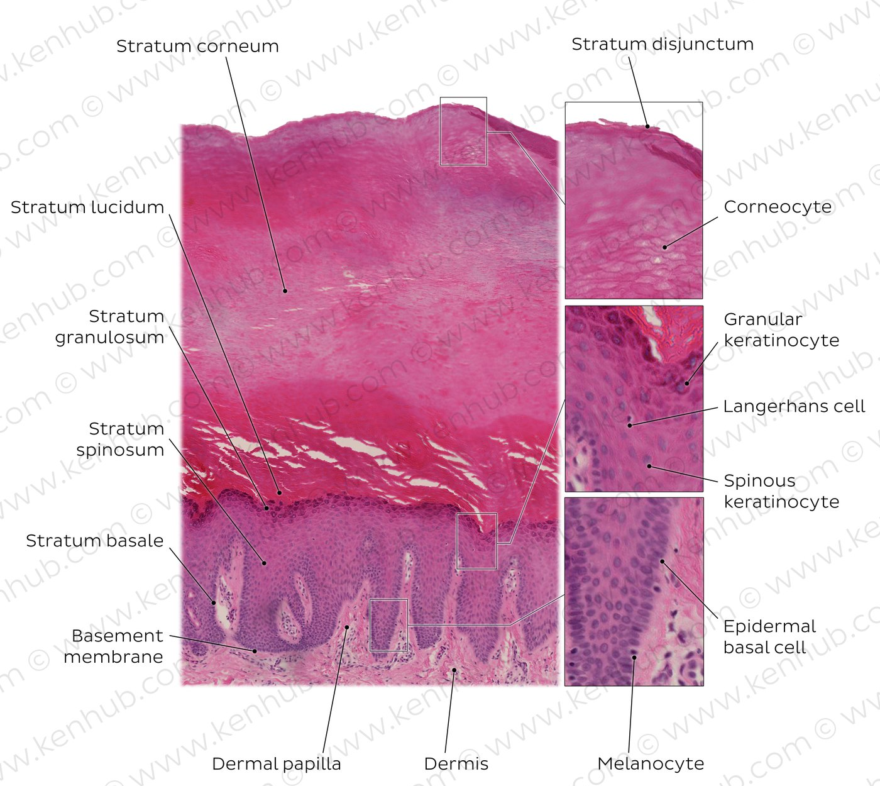
Structure of the Epidermis Layers

Image Source: KenHub
URL Link: https://www.kenhub.com/en/library/anatomy/histology-of-the-skin

E) Explain that the appearance of the epidermal layers is a result of the movement of epithelial cells from deep to superficial layers, from living to dead layers.
Cells move from deep to surface:

- Basal Layer (cell division)
- The basal layer, the deepest layer of the epidermis, contains a large number of actively dividing basal cells. These cells continuously produce new cells through mitosis.

- Spinosum Layer (keratin formation)
- Newly generated cells are gradually pushed to the surface. At the same time, they begin to differentiate with their morphology and function gradually changing. They transform from round living cells into flattened cells filled with keratin.

- Granulosum Layer (keratinization)
- In the granular layer and stratum lucidum, cells gradually lose their nuclei and other organelles, cease metabolism, and enter a state of death.

- Corneum Layer (dead cells)
- These completely keratinized, dead cells form the hard stratum corneum which protects the body, prevents moisture loss and resists external aggression.

- Shedding
- The dead cells of the stratum corneum eventually shed and new cells continue to migrate from the basal layer, completing the entire renewal cycle, which usually takes about 28 days.

F) Describe the epidermal lipids (ceramides, squalene, cholesterol, fatty acids), their origin, and how they work in function with the skin barrier.

Lipid Type | Origin | Main function in skin barriers | Features
Ceramides | Produced by keratinocytes in the stratum granulosum (from sphingolipids in lamellar bodies) | - Prevent water loss (hydration)  - Provide structural integrity  - Aid in barrier repair and protection | - Make up ~50% of stratum corneum lipids  - Contain sphingosine + fatty acid  - Form layered (lamellar) structures between corneocytes
Cholesterol | Synthesized by keratinocytes and released from lamellar bodies | - Ensures stability and flexibility of lipid layers  - Helps reorganize and repair barrier after damage | - Steroid lipid  - Interacts with ceramides and fatty acids  - Maintains lipid fluidity
Squalene | Produced by sebaceous glands (component of sebum) | -Acts as surface lubricant  - Provides antioxidant protection  - Enhances softness, smoothness, and flexibility | - Unsaturated hydrocarbon (triterpene)  - Highly emollient and antioxidant  - Nonpolar surface lipid
Free Fatty Acids | Derived from hydrolysis of phospholipids and triglycerides (keratinocytes & sebaceous glands) | - Maintain acid mantle (low pH)  - Support lipid matrix structure  - Provide antimicrobial defense | - Long-chain fatty acids  - Amphiphilic (hydrophobic and acidic properties)  - Contribute to skin’s acidic pH

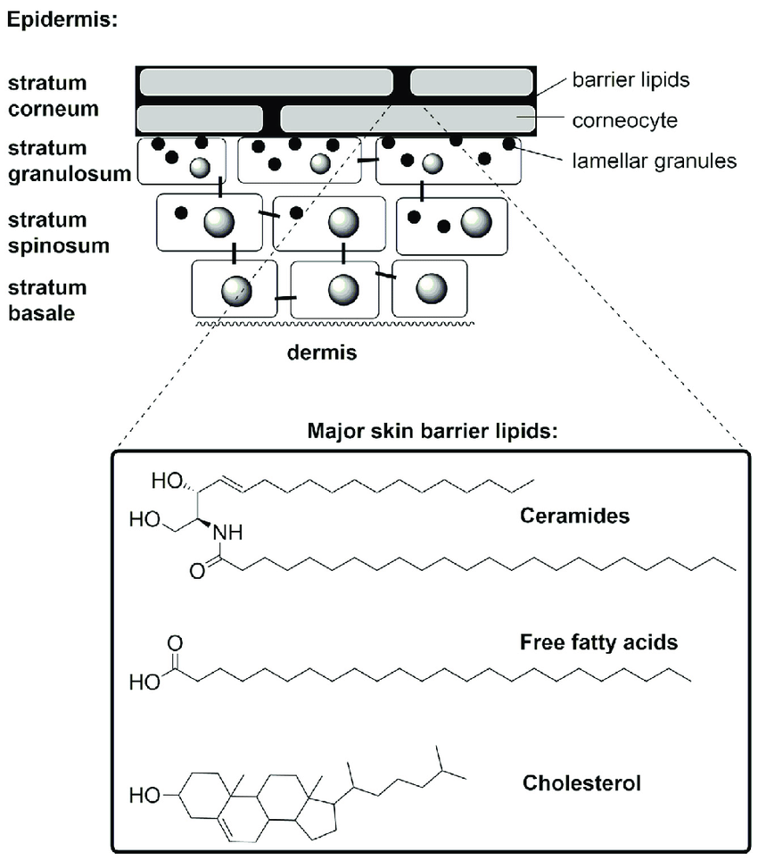
Structure of the Stratum Corneum

Image Source: Research Gate
URL Link: https://www.researchgate.net/figure/Schematic-representation-of-epidermal-layers-structure-of-the-stratum-corneum-and-the_fig1_318401653
G) Describe the process of keratinization and know the function of keratin.

Definition:
The process by which keratinocytes (skin cells) mature, fill with keratin protein, die, and form the tough outer layer (stratum corneum) of the skin.

Purpose:
To create a strong, waterproof, and protective barrier on the skin surface.

Steps of Keratinization:

- Stratum Basale:
- New keratinocytes are formed by cell division.
- Cells start producing keratin filaments.

- Stratum Spinosum:
- Cells become spiny and connected by desmosomes.
- More keratin is produced for strength.

- Stratum Granulosum:
- Cells flatten and begin to die.
- Keratohyalin granules and lipids form to waterproof the skin.

- Stratum Lucidum (only in thick skin):
- Cells lose nuclei and become clear and dense with eleidin (a keratin form).

- Stratum Corneum:
- Cells become dead, flat corneocytes filled with keratin.
- They form a protective outer barrier and are eventually shed.

Timeframe:
It takes about 28–30 days for a cell to move from the basal layer to the skin surface.

Functions of Keratin
- Provides strength and structure to the skin, hair, and nails.
- Acts as a protective barrier against friction, pathogens, chemicals, and UV rays.
- Helps prevent water loss (maintains hydration).
- Aids in skin renewal and wound healing.
- Contributes to the flexibility and durability of the skin surface.

H) Describe the structure of the dermis in detail - names of layers (strata), cells and fibers present; structures present including appendages, muscles, nerve endings, blood and lymphatic vessels.
The dermis has two layers:
- Papillary layer
- Reticular Layer
Layer | Tissue Type | Cells | Fibers | Main Structures Present | Functions
Papillary Layer | Loose areolar connective tissue | Fibroblasts, mast cells, macrophages, leukocytes | Fine collagen & elastic fibers | Dermal papillae, capillaries, Meissner’s corpuscles, free nerve endings | Nourishes epidermis, sensory reception
Reticular Layer | Dense irregular connective tissue | Fibroblasts, macrophages, mast cells, adipocytes | Thick collagen bundles, elastic fibers | Hair follicles, sebaceous & sweat glands, Pacinian & Ruffini corpuscles, blood & lymphatic vessels, arrector pili muscles | Provides strength, elasticity, and houses skin appendages

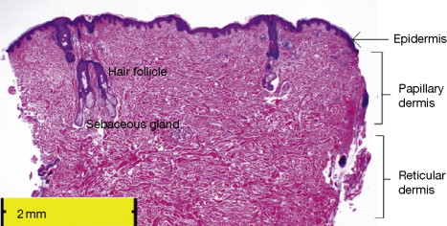
Name of Layers

Image Source: Science Direct
URL Link: https://www.sciencedirect.com/topics/immunology-and-microbiology/papillary-dermis

I) Identify factors influencing skin thickness.

Factors Influencing Skin Thickness

1. Age
- Infants and children: thinner skin, more delicate.
- Adults: thicker dermis and epidermis.
- Elderly: skin thins again due to collagen and elastin loss, reduced cell turnover.

2. Sex / Gender
- Males: generally thicker skin, especially on the back, chest, and abdomen.
- Females: thinner skin, more subcutaneous fat layer.

3. Body Site / Location
- Thick skin: palms, soles (stratum corneum very thick, no hair).
- Thin skin: eyelids, genitalia, lips (minimal stratum corneum).

4. Genetics / Ethnicity
- Genetic factors determine baseline skin thickness and collagen density.
- Some ethnic groups may have naturally thicker dermis or higher collagen content.

5. Hormones
- Androgens (testosterone): increase skin thickness and collagen density.
- Estrogens: can make skin thinner but more hydrated.
- Hormonal changes (puberty, menopause) influence skin structure.

6. Nutrition
- Adequate protein, vitamin C, zinc → support collagen synthesis → thicker, stronger skin.
- Malnutrition → thinner, fragile skin.

7. Environmental Factors
- Sun exposure (UV radiation): chronic exposure → thickened epidermis (callus-like) but damages dermal collagen → overall weaker skin.
- Mechanical stress: repeated friction → thicker stratum corneum (e.g., palms, soles).

8. Health / Medical Conditions
- Obesity: may increase dermal thickness.
- Chronic diseases (like corticosteroid overuse, diabetes) → thinner skin and fragile dermis.

J) List factors influencing skin color.

Factors Influencing Skin Color

1. Melanin
- Primary determinant of skin color.
- Produced by melanocytes in the basal layer of epidermis.
- The amount, type, and distribution of melanin determine skin tone.
Types of melanin:
- Eumelanin – brown to black pigment
- Pheomelanin – red to yellow pigment

2. Genetics
- Determines baseline skin color, melanin production, and distribution.
- Accounts for racial and ethnic differences in pigmentation.

3. Sunlight / UV Exposure
- UV radiation stimulates melanin production → tanning.
- Protects skin against UV-induced DNA damage.

4. Hemoglobin
- Red pigment in blood contributes to skin color.
- Visible in lighter skin tones → gives pink/reddish hue.

5. Carotene
- Yellow-orange pigment from dietary sources (carrots, sweet potatoes).
- Accumulates in the stratum corneum and subcutaneous fat → yellowish tint.

6. Hormonal Factors
- Certain hormones influence melanin production:
- Melanocyte-stimulating hormone (MSH) → increases pigmentation
- Pregnancy hormones → can cause hyperpigmentation (melasma)

7. Age
- Melanin production may decrease with age → paler or patchy skin.
- Some areas may show age spots (lentigines) due to localized melanin accumulation.

8. Pathological Conditions
- Hyperpigmentation: Addison’s disease, post-inflammatory hyperpigmentation
- Hypopigmentation: Vitiligo, albinism, anemia
- Cyanosis: Bluish skin from low oxygen
- Jaundice: Yellowish skin from bilirubin accumulation

K) Describe sweat glands - including structure and function of eccrine and apocrine sweat glands and the differences between them.

Sweat Glands (Sudoriferous Glands)

Definition: Exocrine glands that produce sweat, aiding in thermoregulation, excretion, and skin protection.
Location: Found throughout the skin; density varies by body region.
Types:
- Eccrine sweat glands
- Apocrine sweat glands

1. Eccrine Sweat Glands

Structure:
- Small, coiled tubular glands
- Secretory portion in dermis/hypodermis
- Duct opens directly onto skin surface

Distribution:
- Widespread (palms, soles, forehead)

Secretion:
- Clear, watery sweat (water, salts, urea)
- Merocrine secretion (via exocytosis)

Function:
- Thermoregulation (cooling by evaporation)
- Minor excretion of metabolic waste
- Maintains skin hydration and pH

Innervation:
- Sympathetic (cholinergic) – responds to heat/emotion

2. Apocrine Sweat Glands

Structure:
- Larger, coiled tubular glands
- Secretory portion in dermis/hypodermis near hair follicles
- Duct opens into hair follicle

Distribution:
- Axillae, areola, genital region, eyelids

Secretion:
- Milky/viscous, rich in proteins and lipids
- Initially odorless; bacteria metabolize → body odor
- Mostly merocrine secretion in humans

Function:
- Emotional sweating
- Produces pheromones
- Minor role in thermoregulation

Innervation:
- Sympathetic (adrenergic) – activated by stress/emotion

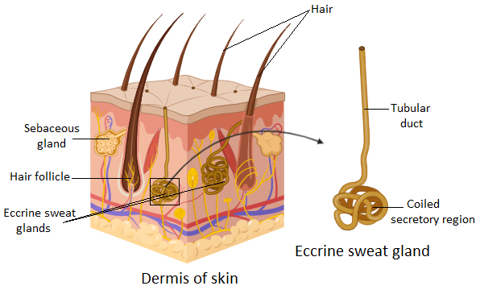
Structure and Function of Eccrine and Apocrine Sweat Glands

Image Source: Vedantu
URL Link: https://www.vedantu.com/question-answer/simple-coiled-tubular-glands-are-found-in-a-class-11-biology-cbse-5fd81f13609c0e2b766e56c9

Feature | Eccrine | Apocrine
Size | Smaller | Larger
Location | Throughout skin (palms, soles, forehead) | Axillae, areola, genital region
Duct opening | Directly onto skin surface | Into hair follicle
Secretion | Watery, salty | Milky, viscous, rich in proteins/lipids
Secretion type | Merocrine | Apocrine (but mostly merocrine in humans)
Function | Thermoregulation, excretion | Emotional sweating, pheromone release
Innervation | Sympathetic (cholinergic) | Sympathetic (adrenergic)
Odor | Odorless | Initially odorless, develops odor by bacterial action
L) Describe sebaceous glands - including structure and function and relevance to the condition of skin and hair.

Type & Location:
- Holocrine glands, mostly associated with hair follicles; absent on palms & soles

Structure:
- Alveolar glands; secretory cells = sebocytes that release sebum by disintegration

Secretion & Function:
- Sebum lubricates skin & hair, maintains barrier, has antimicrobial properties

Clinical Relevance:
- Overactive → oily skin, acne
- Underactive → dry skin & brittle hair
- Stimulated by androgens, decreases with age

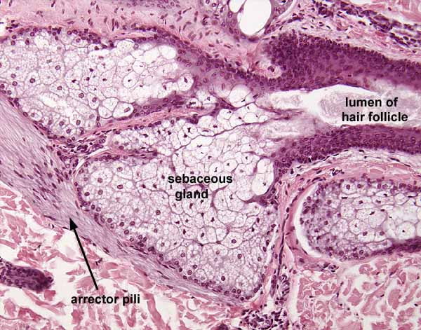
Sebaceous Gland

Image Source: SIU Southern Illnois University Carbondale
URL Link: https://histology.siu.edu/intro/IN042b.htm

M) Describe the functions of the skin - including protection, (physical, chemical and biological barrier), temperature regulation, secretions and excretions, absorption, sensory function, and vitamin D synthesis.

Function | Mechanism
Protection | Physical barrier (mechanical, friction)  Chemical barrier (pH, sebum, melanin)  Biological barrier (Langerhans cells, macrophages)
Temperature regulation | Sweating, vasodilation/vasoconstriction, insulation via subcutaneous fat
Secretions & excretions | Sweat (water, salts, urea)  Sebum (lubrication, antimicrobial)
Absorption | Limited absorption of lipid-soluble substances; potential toxin entry
Sensory function | Touch, pressure, vibration, pain, temperature, stretch
Vitamin D synthesis | UVB → 7-dehydrocholesterol → vitamin D3; regulates calcium & bone metabolism

N) Identify factors influencing the appearance of aging skin.

- Intrinsic aging:
- natural thinning, loss of collagen/elastin, dryness, wrinkles

- Sun exposure (UV):
- photoaging, wrinkles, pigmentation

- Smoking:
- reduced blood flow, premature wrinkles

- Pollution:
- oxidative stress, collagen damage

- Lifestyle:
- poor nutrition, stress, alcohol → weak repair, dull skin

- Hormonal changes:
- menopause/androgen decline → thinner, less elastic skin

- Genetics:
- baseline skin thickness, collagen, aging rate

- Health/medications:
- chronic disease or corticosteroids → fragile, thin skin

2. Skin Disease

A) Recognize abnormalities of the skin and describe and classify skin disorders and diseases.
To recognise abnormalities, the skin is assessed for changes from normal appearance, including:
1. Colour
- Redness (erythema): inflammation, allergy, infection
- Pallor: poor circulation, anemia
- Cyanosis (blue tint): lack of oxygen
- Jaundice (yellow): liver problems
- Hyperpigmentation: melasma, post-inflammatory pigmentation
- Hypopigmentation: vitiligo, albinism

2. Texture
- Rough, scaly: eczema, psoriasis, fungal diseases
- Thickened: callus, chronic irritation
- Thin/fragile: steroid damage, aging

3. Moisture & Oil Levels
- Dry / dehydrated
- Excess oil (acne, seborrhea)

4. Temperature
- Hot: inflammation, infection
- Cool: poor circulation

5. Lesions (spots, bumps, crusts, blisters)
Recognition of primary and secondary lesions helps identify the disorder.

6. Distribution & Pattern
- Localised or generalized
- Symmetrical or asymmetrical
- Clustered or linear
📋Classification of Skin Disorders & Diseases
Category | Description | Common Examples
Inflammatory Disorders | Conditions involving redness, swelling, itching, and irritation | Eczema/dermatitis, psoriasis, urticaria (hives)
Infectious Diseases | Caused by bacteria, viruses, fungi, or parasites | Bacterial: impetigo, cellulitis, folliculitis  Viral: herpes simplex, shingles, warts  Fungal: tinea (ringworm), candidiasis  Parasitic: scabies, head lice
Pigmentation Disorders | Problems with melanin  (too much or too little) | Hyperpigmentation: melasma, age spots, PIH  Hypopigmentation: vitiligo, albinism
Sebaceous Gland Disorders | Disorders of oil (sebum) production | Acne vulgaris, seborrhea (oily skin)
Sweat Gland Disorders | Disorders involving sweating | Hyperhidrosis (excessive sweating), anhidrosis (reduced sweating)
Autoimmune Skin Diseases | Immune system attacks skin cells or tissues | Lupus, psoriasis, scleroderma
Vascular Disorders | Conditions affecting blood vessels in the skin | Rosacea, telangiectasia, port-wine stain
Tumours (Benign & Malignant) | Abnormal growths: non-cancerous or cancerous | Benign: moles, skin tags  Malignant: BCC, SCC, melanoma
Allergic & Irritant Reactions | Skin reacts to substances, allergens, or irritants | Contact dermatitis, atopic dermatitis, hives

B) Describe, using correct terminology, abnormal appearances of the skin, and primary and secondary lesions.
✅ Abnormal Appearances of the Skin (General Skin Changes)
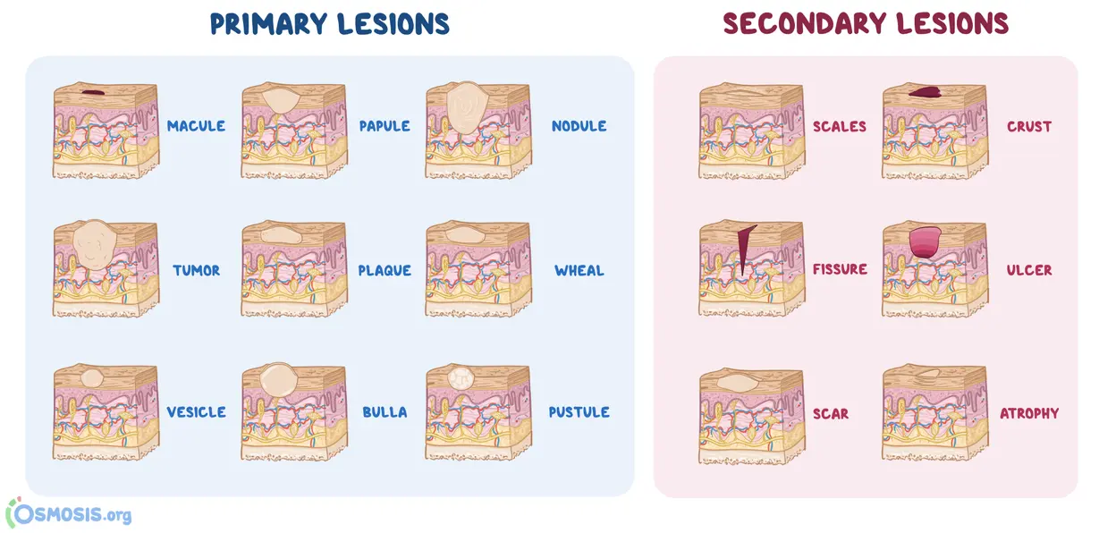
Skin Lesions

Image Source: OSMOSIS from ELSEVIER
URL Link: https://www.osmosis.org/answers/skin-lesions

✅ Abnormal Appearances of the Skin (General Skin Changes)
1. Erythema
- A redness of the skin caused by increased blood flow in superficial capillaries.
- Often indicates inflammation, irritation, or infection.
2. Edema
- Swelling caused by excess fluid accumulation in the tissues.
- Skin may appear puffy, stretched, or shiny.
3. Erythroderma
- Widespread redness covering most or all of the body.
- Usually linked to severe inflammation, drug reactions, or systemic disease.
✅ Primary Skin Lesions (First to Appear on Normal Skin)
1. Macule
- A flat, clearly defined area of discoloration.
- Not raised, less than 1 cm.
- Example: freckles, flat acne marks.
2. Papule
- A solid, raised lesion.
- Less than 1 cm in diameter.
- Example: small acne bumps, insect bites.
3. Pustule
- A raised lesion filled with pus (neutrophils + fluid).
- Common in acne, folliculitis.
✅ Secondary Skin Lesions (Result From Primary Lesions or Damage)
1. Scale
- Flakes or sheets of dead epidermal cells.
- Occurs when the stratum corneum is over-produced or sheds excessively.
- Seen in dryness, eczema, psoriasis.
2. Crust
- Dried serum, pus, or blood on the skin’s surface.
- Forms scabs after pustules or wounds burst.

C) Identify the basic features and causes of specific skin diseases.

Skin Diseases | Basic Features | Causes
1. Acne Vulgaris | - Comedones (blackheads + whiteheads)  - Papules, pustules, nodules (in severe cases)  - Oily skin (seborrhea)  - Often leaves pigmentation or pitted scars | - Excess sebum (oil) production  - Blocked pores  - Overgrowth of Cutibacterium acnes  - Hormonal stimulation (androgens)  - Inflammation  - Genetics
2. Eczema (Dermatitis) | - Red, itchy, inflamed skin  - Dryness, scale, or crust  - In severe cases: oozing and fissures | - Impaired skin barrier (loss of moisture)  - Allergens or irritants (soap, fragrance, dust)  - Immune overreaction  - Genetics (e.g., filaggrin mutation)  - Stress triggers
3. Psoriasis | - Thick, red plaques with silvery-white scale  - Common on elbows, knees, scalp  - May cause nail pitting | - Autoimmune condition causing rapid skin cell turnover  - Genetic predisposition  - Triggered by stress, infection (strep), cold weather, trauma
4. Fungal Infections (Tinea) | - Ring-shaped lesions  - Red, scaly borders with central clearing  - Itching | - Dermatophyte fungi (e.g., Trichophyton)  - Spread by contact, moisture, contaminated surfaces
5. Bacterial Infections | a) Impetigo: Honey-colored crust, usually on face  b) Cellulitis: Warm, red, swollen skin; painful | a) Herpes Simplex: Staphylococcus aureus or Streptococcus pyogenes  b) Varicella/Zoster: Deep bacterial infection (usually Staph or Strep)
6. Viral Skin Diseases | a) Herpes Simplex: Painful grouped vesicles  b) Varicella/Zoster: Vesicles on an erythematous base (“dew drops on a rose petal”) | a) Herpes Simplex: HSV-1 / HSV-2 infection  b) Varicella/Zoster: Varicella-zoster virus (chickenpox → shingles)
7. Rosacea | - Persistent facial redness  - Papules and pustules (but no comedones)  - Flushing triggered by heat, alcohol, spicy foods | - Vascular dysregulation  - Inflammation  - Sensitivity to Demodex mites  - Environmental triggers
8. Urticaria (Hives) | - Raised, itchy wheals  - Come and go within 24 hours  - Often accompanied by swelling (angioedema) | - Allergic reactions (food, drugs, insect bites)  - Stress  - Physical triggers (heat, cold, pressure)  - Autoimmune causes

D) Describe how various disease processes can present similar clinical features.
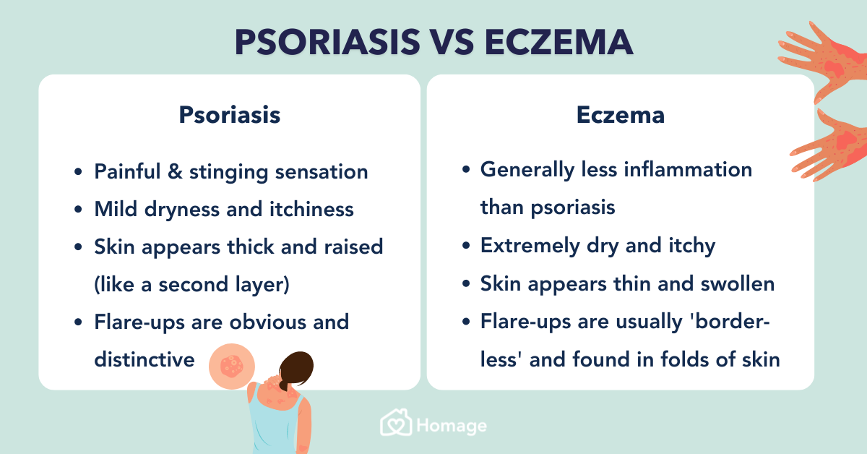
Disease Processes - Psoriasis vs Eczema

Image Source: Homage
URL Link: https://www.homage.com.my/health/psoriasis-vs-eczema/

E) Recognize the limitations of a beauty therapist about diseases of the skin.

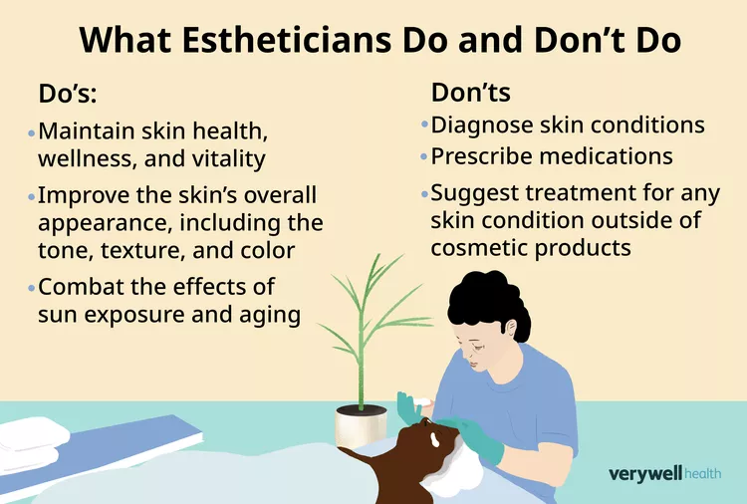
Limitations about beauty therapist about Skin Disease

Image Source: The Wellness Corner
URL Link: https://www.thewellnesscorner.com/blog/aesthetician-vs-esthetician

F) Recognize conditions of the skin which are contraindicated to beauty treatments.

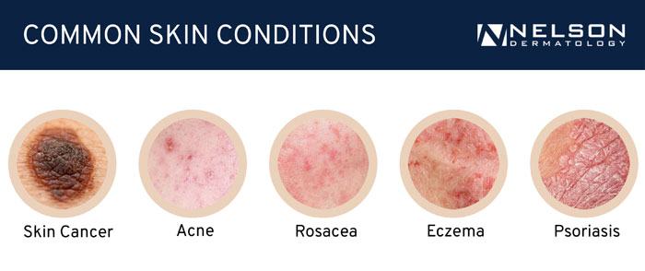
Conditions of Skin

Image Source: Nelson Dermatology
URL Link: https://nelsondermatology.com/medical-dermatology/medical-dermatology.html

G) Recognize conditions of the skin that would benefit from beauty treatments.

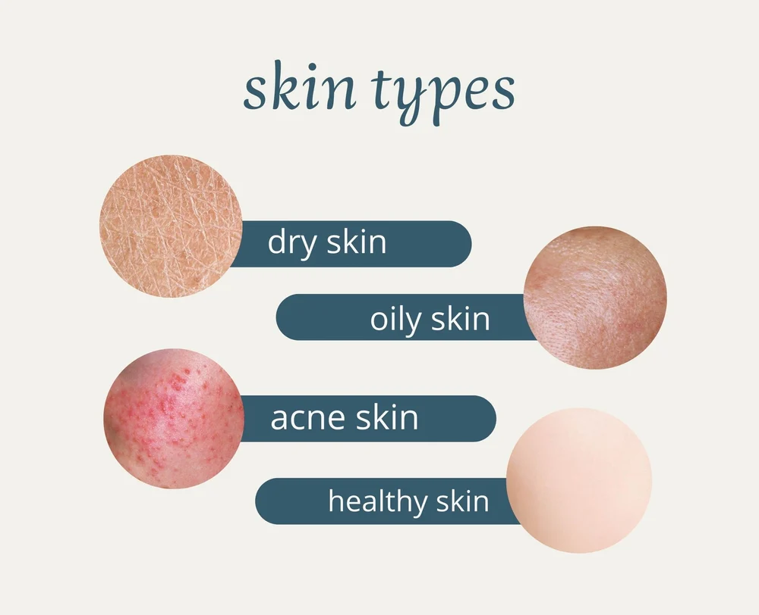
Conditions of Skin (Benefits)

Image Source: Colore Science
URL Link: https://www.colorescience.com/blogs/learn/how-to-manage-an-uneven-skin-tone?srsltid=AfmBOoqPml9lRV7J_wKZ370lNRxUrm9_u-Mf5lmw6GWNzc4Bs8u4ef8V

H) Establish guidelines for beauty therapy treatments within the limitations of skin diseases and the medical treatment of those diseases.

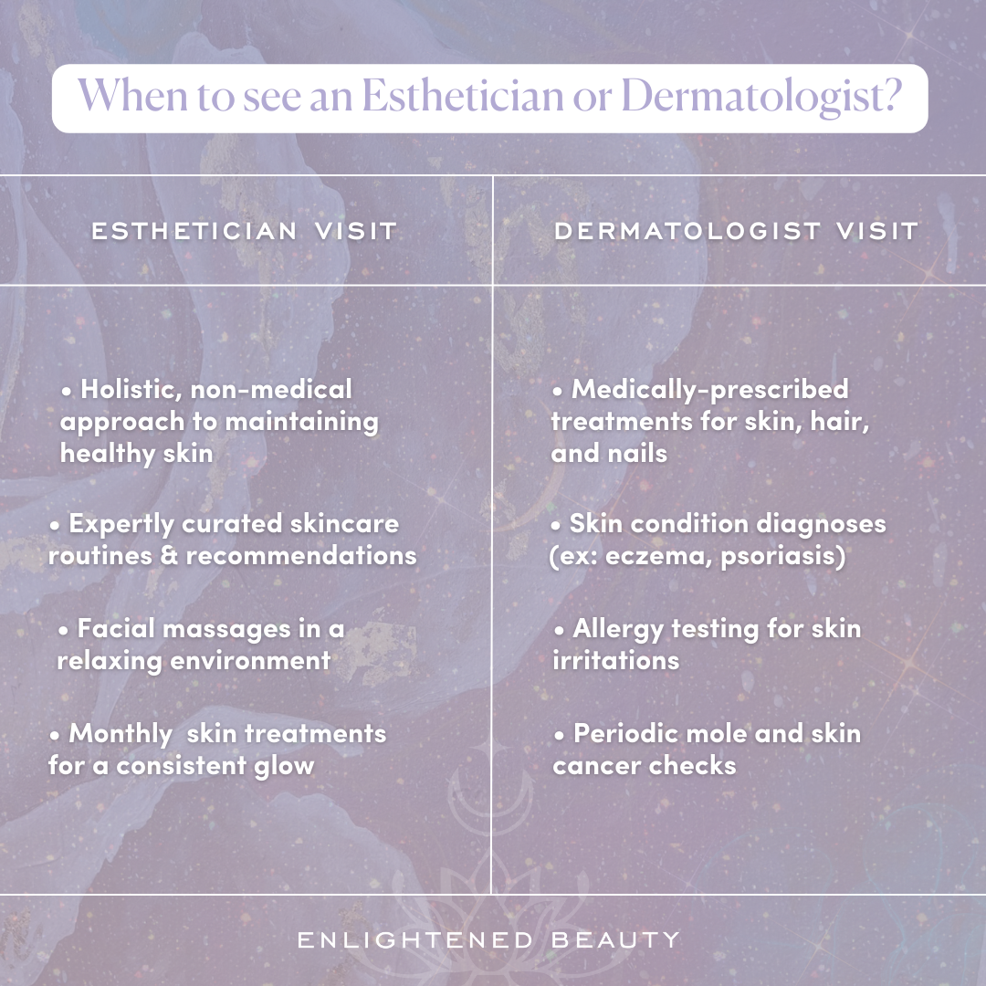
Guidelines for treatment

Image Source: Enlightened Beauty by Sacramento
URL Link: https://www.enlightenedbeautysacramento.com/blog/esthetician-vs-dermatologist
I) Recognize the clinical features of possible skin cancers, by competent skills of recognition.

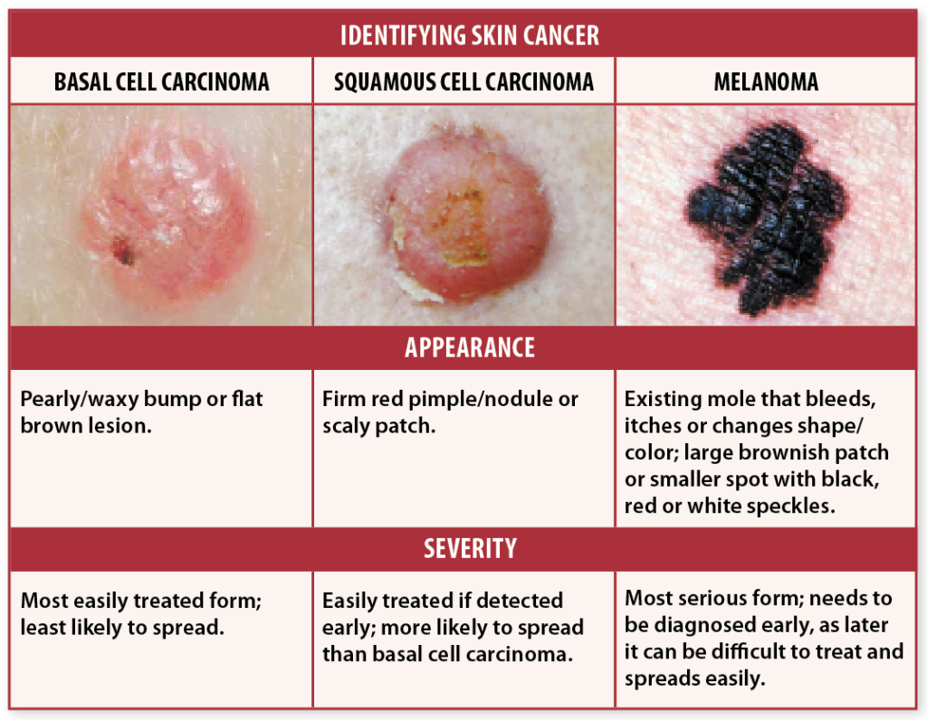
Skin Cancer

Image Source: HUTTON KLEIN DERMATOLOGY
URL Link: https://kleinmd.com/services/skin-cancer/

J) Competently list the risk factors for skin cancer.

1. UV Exposure (Most Significant Factor)
- Excessive sunlight exposure
- Frequent sunburns, especially in childhood
- Use of tanning beds or sunlamps

2. Skin Type
- Fair skin
- Light-colored eyes (blue, green)
- Skin that burns easily and tans poorly

3. Genetic & Personal History
- Family history of skin cancer
- Personal history of skin cancer
- Presence of many moles or atypical (dysplastic) moles
- Genetic conditions (e.g., xeroderma pigmentosum)

4. Age & Gender
- Older age (cumulative sun exposure)
- Male gender (higher exposure + less protection)

5. Environmental Factors
- Living in sunny or high-altitude climates
- Outdoor work or outdoor lifestyle
- Exposure to arsenic or radiation

6. Immune System Factors
- Immunosuppression (HIV, organ transplant patients)
- Long-term immunosuppressive medications

7. Lifestyle & Behavioural Factors
- Lack of sun protection
- Smoking (particularly linked to squamous cell carcinoma)
K) Describe the correct referral techniques for suspicious lesions.

1. Recognize When a Lesion Is Suspicious
- Common warning signs (ABCDE, “ugly duckling,” non-healing wounds).

2. Stop Treatment Immediately
- Do not perform any beauty therapy treatment over or near the lesion.
- Protect the area from irritation or friction.

3. Explain Your Concern Professionally
Use neutral, non-diagnostic language:
- “I’ve noticed a change in your skin that would benefit from a medical check.”
- Avoid words like “cancer,” “malignant,” or “dangerous.”

4. Provide Clear Referral Guidance
Advise the client to visit a:
- Dermatologist
- Skin cancer clinic

5. Document Your Observations
Record:
- Lesion location
- Client statements
- Your actions (e.g., stopped treatment, recommended GP visit)
- No photographs unless client consent is given and clinic policy permits.

6. Maintain Client Confidentiality
Follow:
- Local privacy laws
- Workplace confidentiality policies
- Do not discuss findings with other clients or staff unnecessarily

7. Follow Workplace Protocols
This may include:
- Incident reporting
- Filing mandatory referral documentation

8. Encourage Follow-Up
You may politely ask at a later appointment:
- “Were you able to see your GP about the area we discussed last time?”
- Avoid asking for medical details or outcomes.

L) Provide an in-depth description of the various forms of Acne which includes the clinical features, an overview of possible medical or non-medical treatments, and the role of the Beauty Therapist in managing these conditions.

✔️ Forms of Acne, Features, Treatments & Beauty Therapist Role
1. Forms of Acne & Clinical Features
- Comedonal Acne
- Features: Blackheads (open comedones), whiteheads (closed comedones)
- Characteristics: Non-inflamed, most common on forehead, nose, chin
- Severity: Mild

- Papular Acne
- Features: Small red raised bumps
- Characteristics: Early inflammation, may be tender
- Severity: Mild to moderate

- Pustular Acne
- Features: Yellow/white pus-filled spots
- Characteristics: Inflamed, risk of scarring if picked
- Severity: Moderate

- Nodular Acne
- Features: Deep, painful lumps under the skin
- Characteristics: Severe inflammation, high scarring risk
- Severity: Moderate to severe

- Cystic Acne
- Features: Deep cysts filled with fluid or pus
- Characteristics: Very painful, often widespread, scarring likely
- Severity: Severe (requires medical treatment)

2. Overview of Possible Treatments
- Medical Treatments (Prescribed by Doctors)
Topical medications:
- Benzoyl peroxide, retinoids, salicylic acid, antibiotics

Oral medications:
- Antibiotics, hormonal therapy (e.g., birth control),
- Isotretinoin for severe acne

Procedures:
- Chemical peels, corticosteroid injections, laser/light therapy

- Non-Medical / Over-the-Counter Treatments
- Gentle exfoliants (AHA/BHA)
- Non-comedogenic skincare
- Antibacterial cleansers

- Lifestyle Management
- Reduce touching/picking
- Regular cleansing
- Healthy diet and hydration
- Stress management

3. Role of the Beauty Therapist
- What Beauty Therapists Can Do
Provide mild to moderate acne support

Offer non-invasive treatments:
- Gentle facials
- Light exfoliation (if suitable)
- High-frequency (if allowed by local regulations)

Educate clients on:
- Proper skincare routines
- Avoiding squeezing/picking
- When to Refer to a Medical Professional
- Severe acne (nodules, cysts)
- Rapid worsening or painful lesions
- Signs of infection
- Suspected acne caused by medication or hormones
- Scarring or pigmentation concerns needing medical intervention

- What Beauty Therapists Should Not Do
- Attempt to diagnose acne subtypes
- Perform invasive extraction on inflamed lesions
- Treat clients on isotretinoin with aggressive exfoliation, peels, or waxing

M) Define Rosacea and list possible causes and discuss the role of the Beauty Therapist both during and after medical treatment.

Rosacea:
A chronic skin condition causing facial redness, visible blood vessels, bumps, and sometimes eye irritation, often affecting the central face (cheeks, nose, forehead, chin).

- Possible Causes:
- Genetic predisposition
- Immune system overreaction
- Demodex mites
- Sun exposure
- Hot or spicy foods, alcohol
- Stress, extreme temperatures
- Certain medications

- Role of the Beauty Therapist:
- During medical treatment: Provide gentle, non-irritating skincare, avoid harsh treatments (e.g., strong exfoliation, heat-based facials), educate clients on triggers, and support overall skin comfort.
- After medical treatment: Maintain skin health with calming products, protect against sun, continue gentle care, monitor for flare-ups, and advise on lifestyle or skincare adjustments.

N) Provide an overview of the process of skin repair and regeneration.

Skin Repair and Regeneration Overview:
- Hemostasis (Immediate response)
- Blood vessels constrict and clot forms to stop bleeding.
- Inflammation (0–3 days)
- White blood cells remove bacteria, debris, and damaged cells.
- Redness, heat, and swelling may occur.
- Proliferation (3–10 days)
- New tissue forms: fibroblasts produce collagen, new blood vessels grow (angiogenesis).
- Skin cells (keratinocytes) migrate to cover the wound.
- Maturation/Remodeling (Weeks–Months)
- Collagen reorganizes, strengthening the tissue.
- Wounds gradually gain flexibility and normal skin function.

Key Points:
- Skin repair is a structured, multi-stage process.
- Proper care, hydration, and protection from infection are crucial.

Bibliography/Reference

1. Structure and Function of Skin
Title: Structure and Function of Skin
Author: Biology for Majors II (Lumen Learning)
Source: Safari
Link: https://courses.lumenlearning.com/suny-wmopen-biology2/chapter/structure-and-function-of-skin/

2. Science of the Skin

Title: Science of the Skin
Author: Idyllic (Editorial Team)
Source: Safari
Link: https://us.idyllic.app/idea/tvKPvy0wTGCj7ol1Q_niKA

3. Hypodermis (Subcutaneous Tissue)
Title: Hypodermis (Subcutaneous Tissue)
Author: Cleveland Clinic Medical Professionals
Source: Safari
Link: https://my.clevelandclinic.org/health/body/21902-hypodermis-subcutaneous-tissue

4. Histology of the Skin – Epidermal Layers
Title: Histology of the Skin
Author: Kenhub Anatomy Team
Source: Safari
Link: https://www.kenhub.com/en/library/anatomy/histology-of-the-skin

5. Epidermal Layers & Stratum Corneum Structure
Title: Schematic Representation of Epidermal Layers and Stratum Corneum
Author: ResearchGate Contributors
Source: Safari
Link: https://www.researchgate.net/figure/Schematic-representation-of-epidermal-layers-structure-of-the-stratum-corneum-and-the_fig1_318401653

6. Papillary Dermis
Title: Papillary Dermis
Author: ScienceDirect Topics
Source: Safari
Link: https://www.sciencedirect.com/topics/immunology-and-microbiology/papillary-dermis

7. Sweat Glands – Simple Coiled Tubular Glands
Title: Simple Coiled Tubular Glands
Author: Vedantu Biology Team
Source: Safari
Link: https://www.vedantu.com/question-answer/simple-coiled-tubular-glands-are-found-in-a-class-11-biology-cbse-5fd81f13609c0e2b766e56c9

8. Sebaceous Glands – Histology
Title: Sebaceous Glands
Author: Southern Illinois University School of Medicine
Source: Safari
Link: https://histology.siu.edu/intro/IN042b.htm

9. Skin Lesions - Primary and Secondary Skin Lesions
Title: Skin Lesions
Author: OSMOSIS from ELSEVIER
Source: Safari
Link: https://www.osmosis.org/answers/skin-lesions
10. Disease Processes - Psoriasis vs Eczema
Title: Disease Processes
Author: Homage
Source: Safari
Link: https://www.homage.com.my/health/psoriasis-vs-eczema/

11. Limitations about beauty therapist about Skin Disease
Title: Skin Disease
Author: The Wellness Corner
Source: Safari
Link: https://www.thewellnesscorner.com/blog/aesthetician-vs-esthetician

12. Conditions of Skin
Title: Skin Condition
Author: Nelson Dermatology
Source: Safari
Link: https://nelsondermatology.com/medical-dermatology/medical-dermatology.html

13. Conditions of Skin - Benefits
Title: Skin Condition
Author: Colore Science
Source: Safari
Link: https://www.colorescience.com/blogs/learn/how-to-manage-an-uneven-skin-tone?srsltid=AfmBOoqPml9lRV7J_wKZ370lNRxUrm9_u-Mf5lmw6GWNzc4Bs8u4ef8V

14. Guidelines for treatments
Title: Treatments
Author: Enlightened Beauty by Sacramento
Source: Safari
Link: https://www.enlightenedbeautysacramento.com/blog/esthetician-vs-dermatologist

15. Skin Cancer
Title: Skin Cancer
Author: HUTTON KLEIN DERMATOLOGY
Source: Safari
Link: https://kleinmd.com/services/skin-cancer/

THE END
THANK YOU!

