**01_实验九**

**1.题目：**

|  |
| --- |
| 1、编写一个程序，统计Abraham Lincoln 的某段演讲中的单词数，网址为https://liveexample.pearsoncmg.com/data/Lincoln.txt |

**完整代码：**

LincolnSpeechWordCounter.java：

|  |
| --- |
| Java import java.net.URL; import java.net.URLConnection; import java.io.BufferedReader; import java.io.InputStreamReader; import java.io.IOException;  public class LincolnSpeechWordCounter {  public static void main(String[] args) {  String urlString = "https://liveexample.pearsoncmg.com/data/Lincoln.txt";  try {  URL url = new URL(urlString);  URLConnection connection = url.openConnection();  BufferedReader reader = new BufferedReader(  new InputStreamReader(connection.getInputStream())  );   StringBuilder content = new StringBuilder();  String line;  int wordCount = 0;  while ((line = reader.readLine()) != null) {  content.append(line).append("\n");  if (!line.trim().isEmpty()) {  String[] words = line.trim().split("\\s+");  wordCount += words.length;  }  }  reader.close();  System.*out*.println("演讲内容：");  System.*out*.println(content.toString());  System.*out*.println("\n单词总数：" + wordCount + " 个单词");   } catch (IOException e) {  System.*out*.println("读取文件时发生错误：");  e.printStackTrace();  }  } } |

**代码运行截图：**

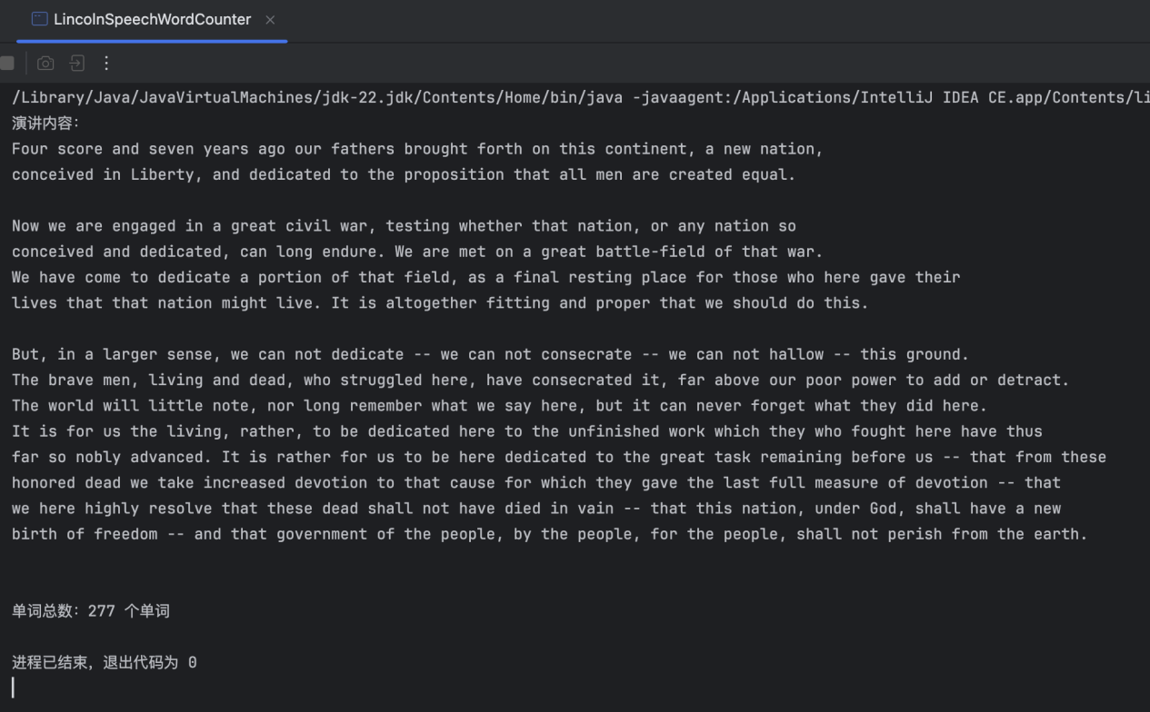

**2.题目：**

|  |
| --- |
| 2、画出交通红绿灯图案（红、黄、绿） |

**完整代码：**

TrafficLightRadio.java：

|  |
| --- |
| Java import javax.swing.*; import java.awt.*; import java.awt.event.*;  public class TrafficLightRadio extends JFrame {  private JPanel lightPanel;  private int currentLight = 0; // 0-红灯，1-黄灯，2-绿灯  private static final int *LIGHT_SIZE* = 100;  private ButtonGroup buttonGroup;   public TrafficLightRadio() {  setTitle("交通信号灯控制");  setSize(250, 500);  setDefaultCloseOperation(JFrame.*EXIT_ON_CLOSE*);  setLocationRelativeTo(null);  JPanel mainPanel = new JPanel(new BorderLayout());  JPanel controlPanel = new JPanel();  controlPanel.setBackground(Color.*WHITE*);  lightPanel = new JPanel() {  @Override  protected void paintComponent(Graphics g) {  super.paintComponent(g);  drawLights(g);  }  };  lightPanel.setBackground(Color.*WHITE*);  lightPanel.setPreferredSize(new Dimension(200, 400));  buttonGroup = new ButtonGroup();  JRadioButton redButton = new JRadioButton("红灯");  JRadioButton yellowButton = new JRadioButton("黄灯");  JRadioButton greenButton = new JRadioButton("绿灯");  redButton.setSelected(true);  buttonGroup.add(redButton);  buttonGroup.add(yellowButton);  buttonGroup.add(greenButton);  redButton.addActionListener(e -> {  currentLight = 0;  lightPanel.repaint();  });   yellowButton.addActionListener(e -> {  currentLight = 1;  lightPanel.repaint();  });   greenButton.addActionListener(e -> {  currentLight = 2;  lightPanel.repaint();  });  controlPanel.add(redButton);  controlPanel.add(yellowButton);  controlPanel.add(greenButton);  mainPanel.add(lightPanel, BorderLayout.*CENTER*);  mainPanel.add(controlPanel, BorderLayout.*SOUTH*);  add(mainPanel);  }   // 绘制信号灯  private void drawLights(Graphics g) {  Graphics2D g2d = (Graphics2D) g;  g2d.setRenderingHint(RenderingHints.*KEY_ANTIALIASING*, RenderingHints.*VALUE_ANTIALIAS_ON*);  g2d.setColor(Color.*DARK_GRAY*);  g2d.fillRoundRect(45, 20, *LIGHT_SIZE* + 10, 340, 20, 20);  g.setColor(currentLight == 0 ? Color.*RED* : Color.*DARK_GRAY*);  g.fillOval(50, 30, *LIGHT_SIZE*, *LIGHT_SIZE*);  g.setColor(Color.*BLACK*);  g.drawOval(50, 30, *LIGHT_SIZE*, *LIGHT_SIZE*);  g.setColor(currentLight == 1 ? Color.*YELLOW* : Color.*DARK_GRAY*);  g.fillOval(50, 140, *LIGHT_SIZE*, *LIGHT_SIZE*);  g.setColor(Color.*BLACK*);  g.drawOval(50, 140, *LIGHT_SIZE*, *LIGHT_SIZE*);  g.setColor(currentLight == 2 ? Color.*GREEN* : Color.*DARK_GRAY*);  g.fillOval(50, 250, *LIGHT_SIZE*, *LIGHT_SIZE*);  g.setColor(Color.*BLACK*);  g.drawOval(50, 250, *LIGHT_SIZE*, *LIGHT_SIZE*);  }   public static void main(String[] args) {  SwingUtilities.*invokeLater*(() -> {  TrafficLightRadio trafficLight = new TrafficLightRadio();  trafficLight.setVisible(true);  });  } } |

**代码运行截图：**

