Notes How to Convert HTML to Wordpress

1. Install wordpress
2. Change permalinks settings
3. Delete Default Pages and Post
4. Create new Pages and Post
5. Move all pix (make sure pictures paths are correct in style.css
6. Edit style.css, header.php, sidebar.php, footer.php, and page.php
7. Delete style.css content
   1. Style.css - Change Theme name, URI, Desription, Version, and Author
   2. Replace - screenshot.png
8. Edit - header.php
   1. delete header.php inline CSS
   2. delete specific body class
   3. delete all div
9. Link external style.css file
   1. <link rel="stylesheet" type="text/css" href="<?php bloginfo('template_url'); ?>style.css" />
10. Delete Entire Sidebar.php content except comments (edit comments as you may like)
11. Delete footer.php except <?php wp_footer(); ?>
12. copy files from index.html to header.php, sidebar.php, footer.php, and page.php apporiately
13. Use default wordpress functions to automate

<?php bloginfo ('name'); ?> --> this is wordpress default blogname

<?php wp_list_pages ('include=3,5,7&title_li='); ?> --> list all wordpress pages

(for Main Nav, footer, or sidebar, 3,5,7 are page id, &title_li= is to make page invisible)

<?php wp_list_pages ('exclude=3,5,7&title_li=&depth=1'); ?> --> list all pages excluding 3,5,7 &depth=1 list only top pages

<?php echo date('Y'); ?> grab the latest year use for copyright

example: <li> Copyright <?php bloginfo ('name'); ?> &copy; <?php echo date('Y'); ?></li> -- footer example

<?php if ($post->post_parent);{ wp_list_pages ('title_li= &depth=1 &child_of'.$post->post_parent);} ?>

Version 2 convert HTML to Wordpress

1. Create a theme folder
2. Drag the style.css from mockup
3. Inside the style.css

/* Theme Name: Wordpress Forest

Theme URI: <http://blog.themeforest.net>

Description: A test theme fore the video screencast series on ThemeForest.net Version:4.0

Author: Drew Douglass Author

URI: <http://dev-tips.com>

Tags: boring, dull, void of life*/

1. create an index.php
   1. copy and paste the index.html to index.php
2. insert screanshot.jpg or png
3. Activate the theme
4. Slowly divide the content from index.php to other files ie.. header.php and sidebar.php
5. To call Header: <?php get_header(); ?>
   1. 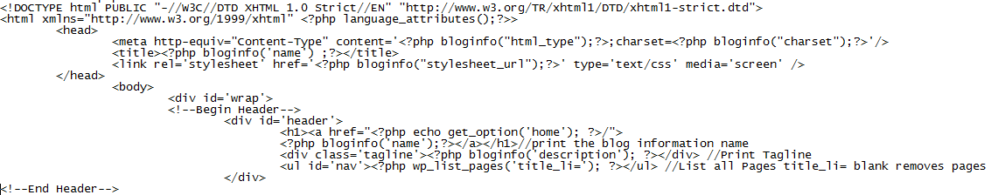
6. To Call Sidebar: <div id='sidebar'>
   1. 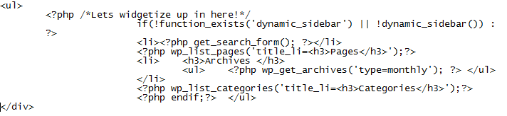

TAGS

