TOP LEVEL DIAGRAM

LOW LEVEL DIAGRAMS

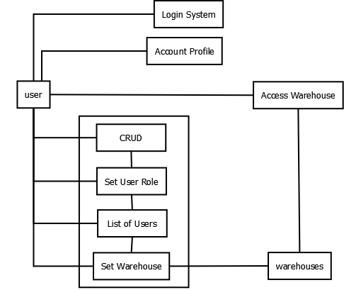

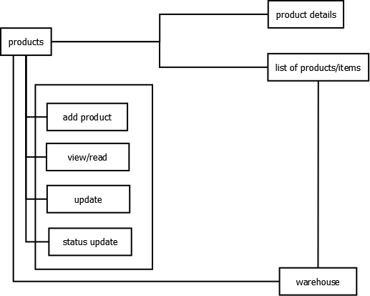

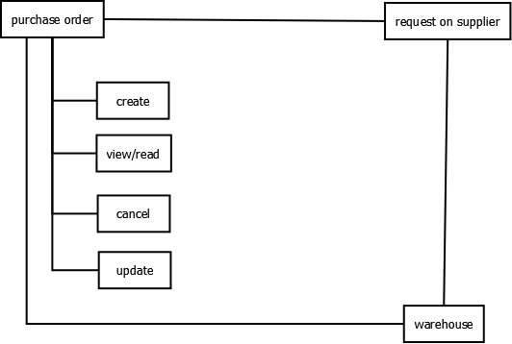

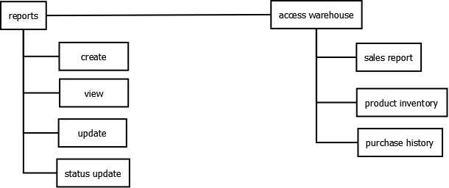

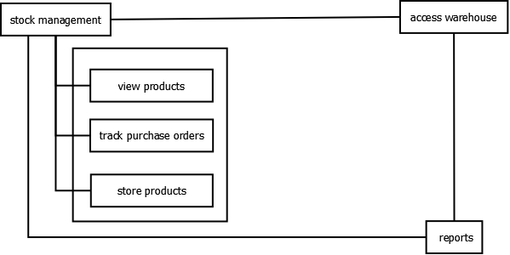

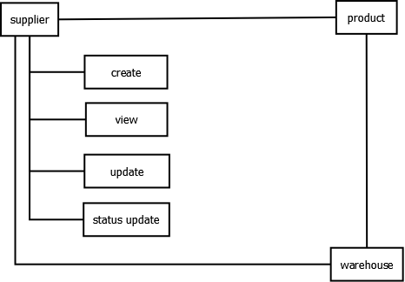

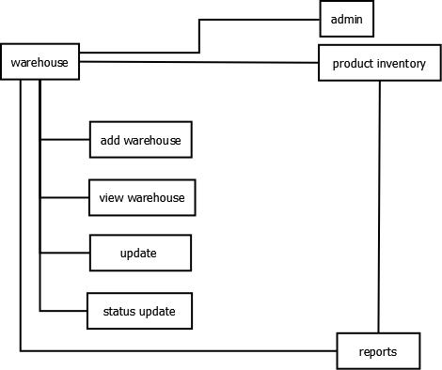

ER DIAGRAM

SEQUENCE DIAGRAM

DATAFLOW DIAGRAM

