MedFlow Doctor Appointment Booking Platform

Developed by: Kesaram Aashritha

1. Introduction
When our team first gathered to brainstorm ideas for our software engineering project, we wanted to build something that people use every single day to address real-world health and lifestyle needs. We decided that a healthcare connection and appointment booking platform would be the perfect challenge. We named our project MedFlow. The primary objective was to create an intuitive, secure, and robust digital ecosystem that bridges the gap between patient users seeking medical advice and certified healthcare professionals through seamless digital interactions.

Project Title: MedFlow Doctor Appointment Booking Platform.
Developer: Kesaram Aashritha acts as the Lead Developer and Systems Architect. The developer handled database modeling, frontend user interface design, and cloud backend deployment.

2. Project Overview
Purpose: MedFlow was built to address the complexities of modern patient-doctor scheduling. Traditional healthcare platforms often suffer from slow monolithic architectures that are difficult to update. Our purpose was to adopt a decoupled, component-driven frontend combined with a stateless backend architecture, allowing the application to support large volumes of concurrent appointment requests and doctor profiles while maintaining incredibly fast response times.

Features: The application highlights several key functionalities. It includes secure JWT-based authentication protecting patient, doctor, and admin accounts. It features a massive, search-friendly doctor directory populated with experience details, clinical fees, ratings, and specializations. It includes role-based access control, ensuring that patients can book appointments, doctors can manage active bookings, and administrators can approve/reject doctor applications or manage users. Furthermore, it implements automated appointment cancellation workflows that notify patients immediately if a doctor profile is rejected or deactivated by the administrator.

3. Architecture
We selected the MERN stack for our architecture, meaning we wrote the entire application using JavaScript from top to bottom.

Frontend
We built the frontend architecture using React. Instead of relying on traditional DOM manipulation, which is slow, React utilizes a Virtual DOM to ensure highly optimized render cycles. We managed our global application state using React's native Context API (Auth and UI context).

Backend
The backend architecture is powered by Node.js and Express.js. Node.js provides a non-blocking, asynchronous runtime environment, which is perfect for an API that needs to handle thousands of concurrent database requests. Express.js acts as the framework that structures these requests.

Here is the core server initialization code we wrote for the backend to start the Express application, connect to the database, and handle request middleware:
const express = require('express');
const dotenv = require('dotenv');
const cors = require('cors');
const morgan = require('morgan');
const path = require('path');
const connectDB = require('./config/db');

dotenv.config();
connectDB();

const app = express();

app.use(cors());
app.use(express.json());
app.use(express.urlencoded({ extended: true }));
app.use(morgan('dev'));

app.use('/uploads', express.static(path.join(__dirname, 'uploads')));

app.use('/api/auth', require('./routes/authRoutes'));
app.use('/api/doctors', require('./routes/doctorRoutes'));
app.use('/api/appointments', require('./routes/appointmentRoutes'));
app.use('/api/admin', require('./routes/adminRoutes'));

const PORT = process.env.PORT || 5000;
if (process.env.NODE_ENV !== 'production') {
app.listen(PORT, () => {
console.log(`Server running on http://localhost:${PORT}`);
});
}

module.exports = app;

Database
For our database schema and interactions, we utilized MongoDB. Because doctor details and medical schedules have variable attributes, a NoSQL document database was far superior to a rigid SQL table. We interacted with MongoDB using the Mongoose ORM. Here is the connection initialization script:
const mongoose = require('mongoose');

const connectDB = async () => {
try {
const conn = await mongoose.connect(process.env.MONGO_URI);
console.log(`MongoDB Connected: ${conn.connection.host}`);
} catch (error) {
console.error(`MongoDB Connection Error: ${error.message}`);
process.exit(1);
}
};

module.exports = connectDB;

4. Setup Instructions
To ensure any new developer could easily contribute to MedFlow, we standardized the local setup process.

Prerequisites: Before starting, a developer must have Node.js installed on their machine to run the JavaScript environment. They also need a Git client to clone the repository and a MongoDB Atlas account to host their database cluster.

Installation: First, the developer opens their terminal and uses the Git clone command pointing to the MedFlow repository. Once downloaded, they navigate into the backend directory and run npm install. They then create a local .env file. The code inside the .env file should look exactly like this:
PORT=5000
MONGO_URI=mongodb+srv://<username>:<password>@cluster0.mongodb.net/medflow?retryWrites=true&w=majority
JWT_SECRET=medflow_super_secret_jwt_key_2024
NODE_ENV=development

Finally, they open a separate terminal, navigate into the frontend directory, and run npm install again to fetch the React dependencies.

5. Folder Structure
A clean folder structure is the hallmark of a maintainable software project.

Client: The React frontend is organized inside the client (frontend) directory. The src folder contains the core application. Inside src, we created a components folder that holds isolated, reusable UI elements like the Doctor Card and Navigation Bar. We created a pages folder to hold the main visual views.

Server: The Node.js backend is organized logically inside the backend directory. We created a models folder to hold the Mongoose schema definitions that dictate how our data looks in the database. For example, here is the exact code we wrote to structure the Doctor schema:
const mongoose = require('mongoose');

const doctorSchema = new mongoose.Schema(
{
userId: {
type: mongoose.Schema.Types.ObjectId,
ref: 'User',
required: true,
},
firstName: { type: String, required: true },
lastName: { type: String, required: true },
email: { type: String, required: true },
phone: { type: String, required: true },
website: { type: String, default: '' },
address: { type: String, required: true },
specialization: { type: String, required: true },
experience: { type: String, required: true },
feesPerConsultation: { type: Number, required: true },
timings: {
type: [String],
default: ['09:00', '17:00'],
},
workingDays: {
type: [String],
default: ['Monday', 'Tuesday', 'Wednesday', 'Thursday', 'Friday'],
},
bio: { type: String, default: '' },
qualifications: { type: String, default: '' },
profilePic: { type: String, default: '' },
certificate: { type: String, default: '' },
status: {
type: String,
enum: ['pending', 'approved', 'rejected'],
default: 'pending',
},
rating: { type: Number, default: 0 },
totalRatings: { type: Number, default: 0 },
},
{ timestamps: true }
);

module.exports = mongoose.model('Doctor', doctorSchema);

We also created a controllers folder to hold the complex business logic functions, and a routes folder that simply maps URL paths to those specific controller functions.

6. Running the Application
To start the application locally, the developer needs to initialize both the client and the server simultaneously. The following commands are used in the terminal.

Frontend: To start the React application, the developer must open a terminal, navigate into the frontend directory, and execute the development server script. The code entered in the terminal is:
cd frontend
npm start

Backend: To start the Express server, the developer opens a second terminal, navigates into the backend directory, and executes the Node runtime. The code entered in the terminal is:
cd backend
npm run dev

This executes the Node environment, which reads the variables, connects to the MongoDB database, and begins listening for incoming HTTP requests on port 5000.

7. API Documentation
The backend exposes a highly structured RESTful API. Every endpoint expects and returns data in JSON format.

Our authentication endpoints include a POST request to /api/auth/register, which requires name, email, password, and phone, and a POST request to /api/auth/login, which requires an email and password and returns the user payload. Here is the controller code we wrote to handle searching and fetching approved doctors via a GET request to /api/doctors:
const getDoctors = async (req, res) => {
try {
const { specialization, search } = req.query;
let filter = { status: 'approved' };

if (specialization) filter.specialization = { $regex: specialization, $options: 'i' };
if (search) {
filter.$or = [
{ firstName: { $regex: search, $options: 'i' } },
{ lastName: { $regex: search, $options: 'i' } },
{ specialization: { $regex: search, $options: 'i' } },
];
}

const doctors = await Doctor.find(filter).sort({ createdAt: -1 });
res.json({ success: true, data: doctors });
} catch (error) {
res.status(500).json({ success: false, message: error.message });
}
};

8. Authentication
We designed our authentication system to be entirely stateless and secure using JSON Web Tokens (JWT) exchanged via JSON headers and validated on every private route.

When a user successfully logs in, the backend uses the bcrypt library to compare password hashes, and then generates a secure token. Here is the exact authentication code we implemented to handle a secure user login:
const loginUser = async (req, res) => {
try {
const { email, password } = req.body;

const user = await User.findOne({ email });
if (!user) {
return res.status(401).json({ success: false, message: 'Invalid email or password' });
}

const isMatch = await user.matchPassword(password);
if (!isMatch) {
return res.status(401).json({ success: false, message: 'Invalid email or password' });
}

if (!user.isActive) {
return res.status(403).json({ success: false, message: 'Account has been deactivated' });
}

res.json({
success: true,
message: 'Login successful',
data: {
_id: user._id,
name: user.name,
email: user.email,
role: user.role,
token: generateToken(user._id),
},
});
} catch (error) {
res.status(500).json({ success: false, message: error.message });
}
};

9. User Interface
The user interface was crafted to provide a premium, modern aesthetic using React components. We utilized a clean, responsive layout with strict attention to typography and spacing. The interface relies on clean, dynamic card grids.

Here is an example of the React JSX code structure we wrote for the DoctorCard component to render the doctor details dynamically on the screen:
import React from 'react';
import { Link } from 'react-router-dom';
import { FaClock, FaCalendarAlt, FaMapMarkerAlt, FaStar } from 'react-icons/fa';

const DoctorCard = ({ doc, getInitials }) => {
return (
<Link to={`/doctors/${doc._id}`} style={{ textDecoration: 'none' }}>
<div className="doctor-card">
<div className="doctor-card-header">
<div className="doctor-avatar">{getInitials(doc.firstName, doc.lastName)}</div>
<div>
<div className="doctor-name">Dr. {doc.firstName} {doc.lastName}</div>
<div className="doctor-spec">{doc.specialization}</div>
</div>
</div>
<div className="doctor-card-body">
<div className="info-row"><FaClock /> {doc.experience} yrs experience</div>
<div className="info-row"><FaCalendarAlt style={{ color: 'var(--teal)' }} /> {doc.workingDays?.join(', ')}</div>
<div className="info-row"><FaMapMarkerAlt /> {doc.address}</div>
<div className="info-row"><FaStar style={{ color: 'var(--warning)' }} /> {doc.rating?.toFixed(1) || '4.5'}</div>
</div>
<div className="doctor-card-footer" style={{ display: 'flex', alignItems: 'center', justifyContent: 'space-between' }}>
<span style={{ color: 'var(--success)', fontWeight: 700, fontSize: '0.95rem' }}>Rs.{doc.feesPerConsultation}</span>
<span className="btn-primary-custom" style={{ padding: '0.35rem 0.9rem', fontSize: '0.78rem' }}>Book Now</span>
</div>
</div>
</Link>
);
};

10. Testing
Our testing strategy was divided into two distinct phases to ensure maximum application stability.

First: We conducted extensive manual API testing using a tool called Postman. Before integrating the frontend, we sent dozens of simulated HTTP requests directly to our backend server. We intentionally sent malformed data, such as missing email fields or invalid passwords, to ensure that our Express error-handling middleware caught the mistakes and returned graceful 400-level error messages rather than crashing the Node.js process.

Second: We performed rigorous end-to-end user flow testing directly in the browser. We simulated the exact path a human user would take: registering a new patient account, navigating the doctor directory, filtering by specialization, selecting an appointment time slot, and finalizing the booking. We repeated this process across multiple modern browsers, including Google Chrome and Mozilla Firefox, to verify that our React context state remained synchronized.

11. Screenshots or Demo

LANDING PAGE
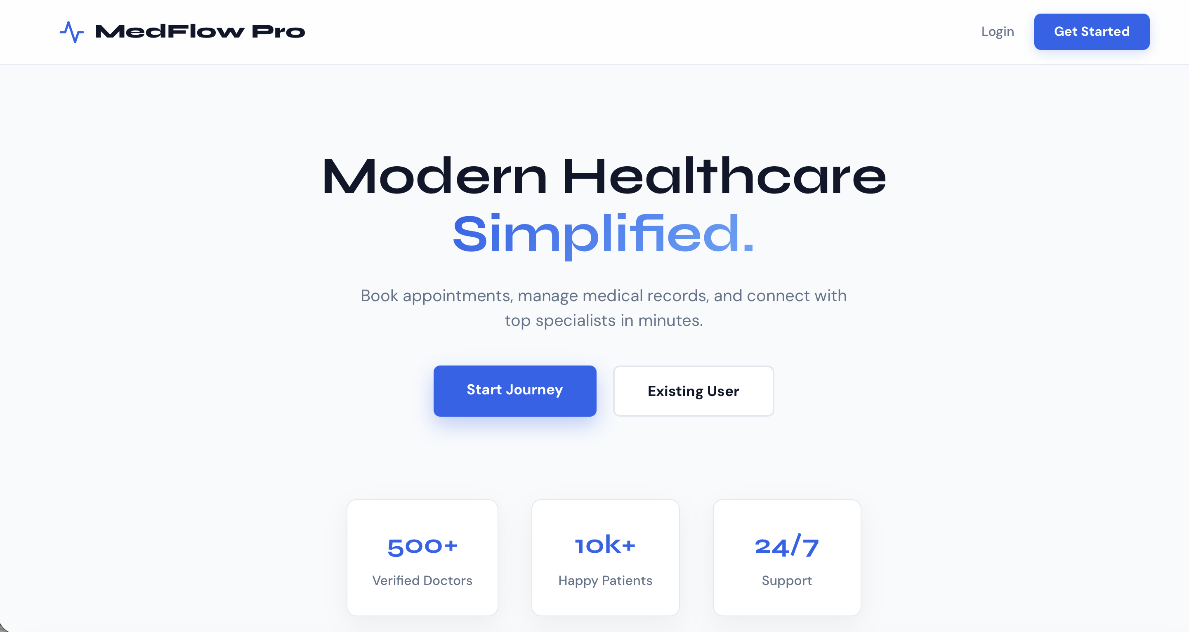

LOGIN PAGE
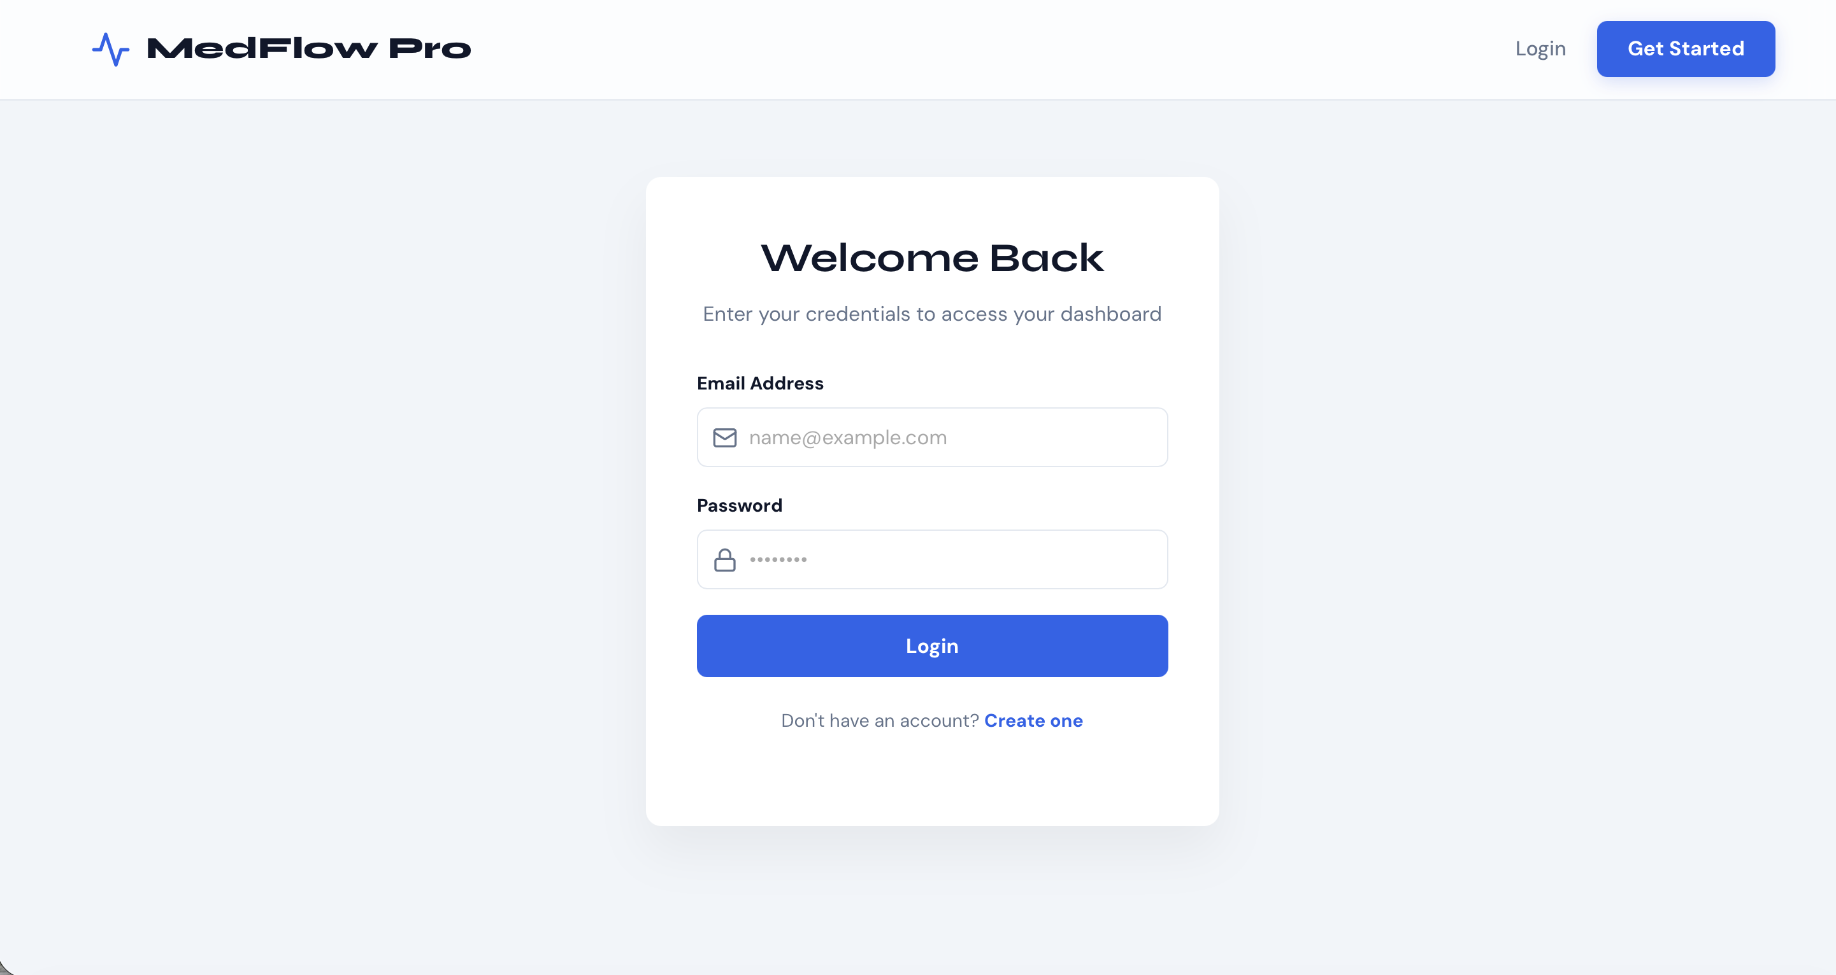

ADMIN DASHBOARD

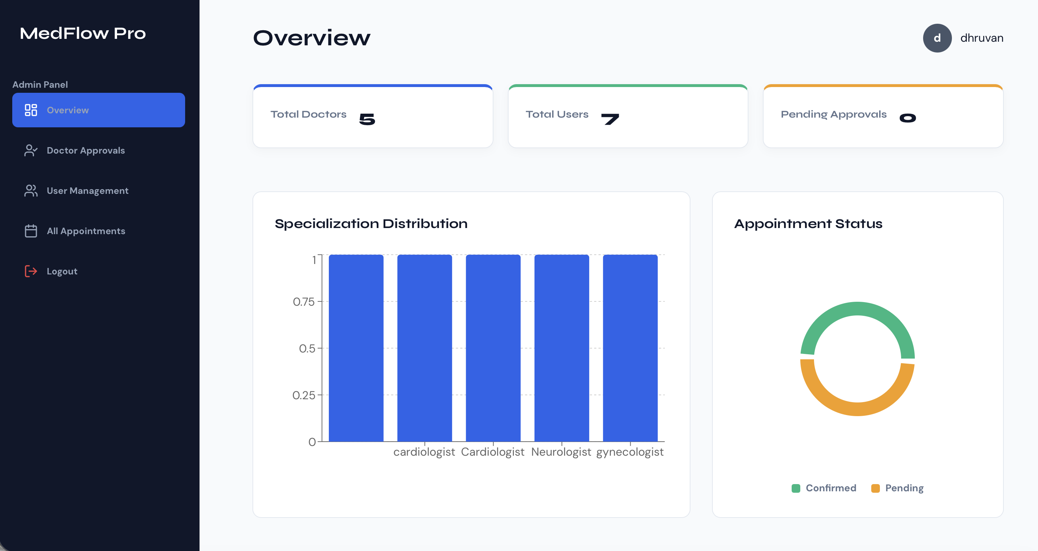

DOCTOR DASHBOARD

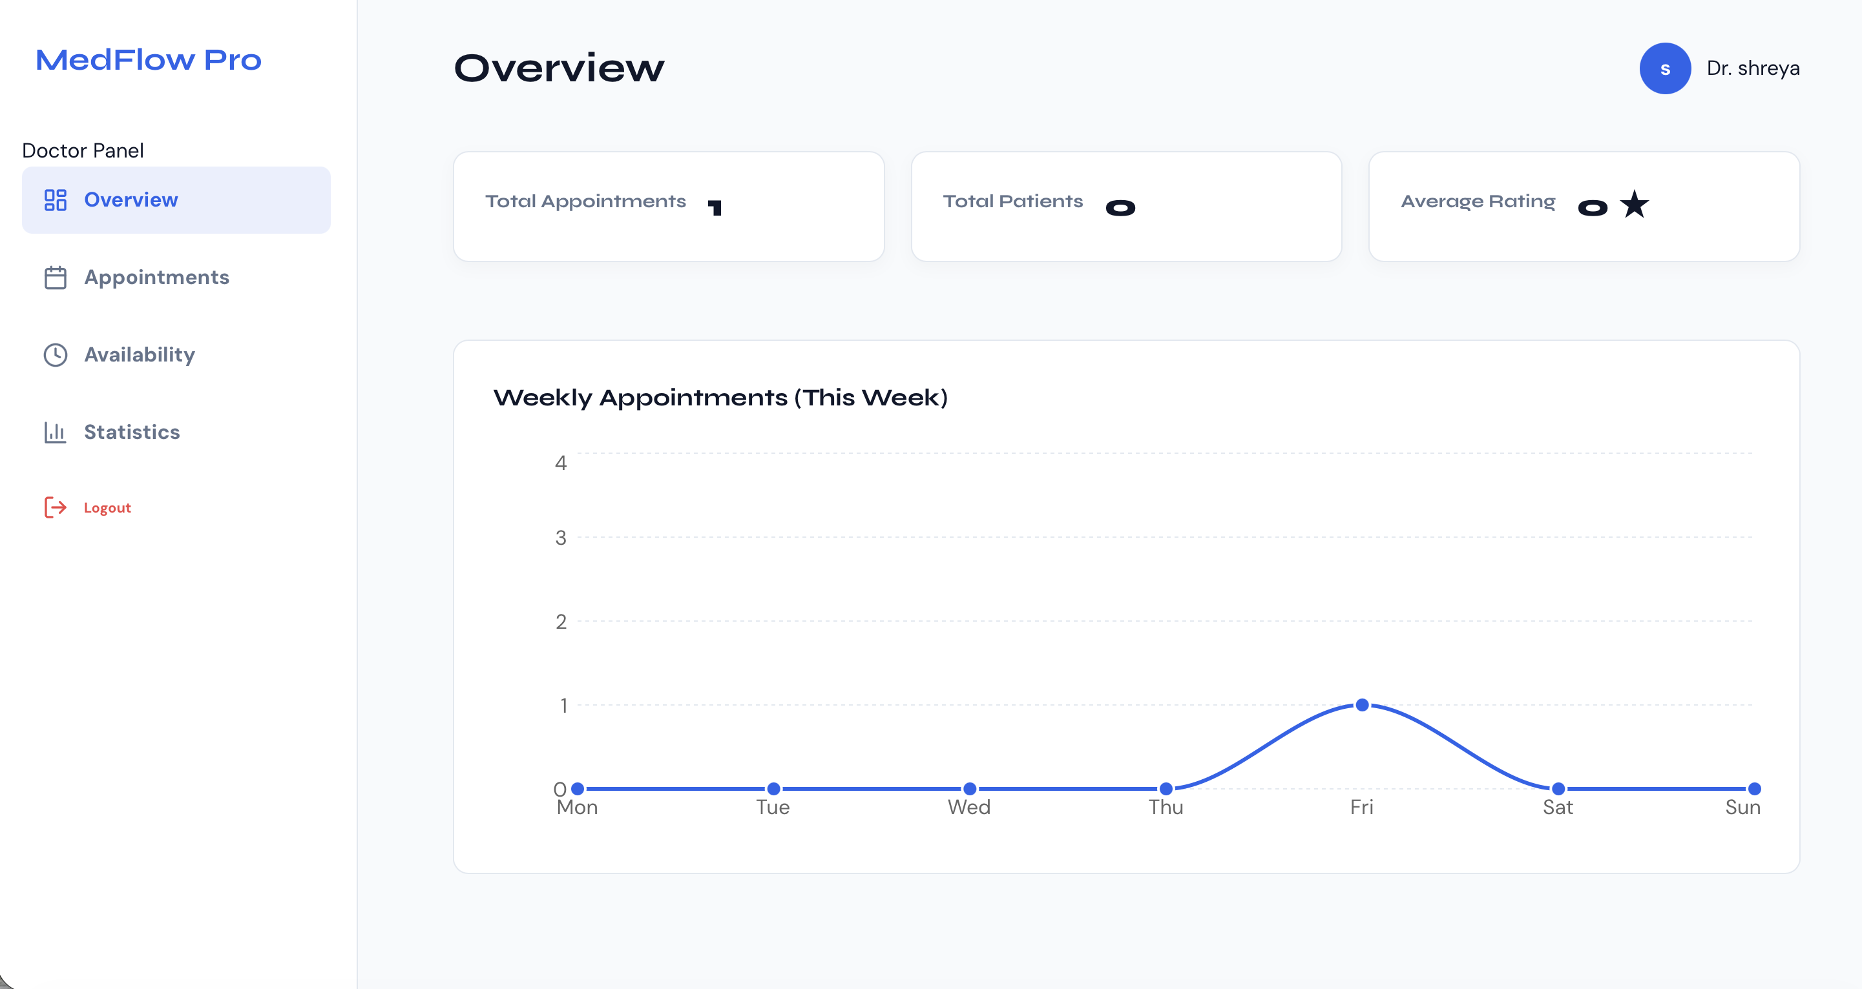

PATIENT DASHBOARD

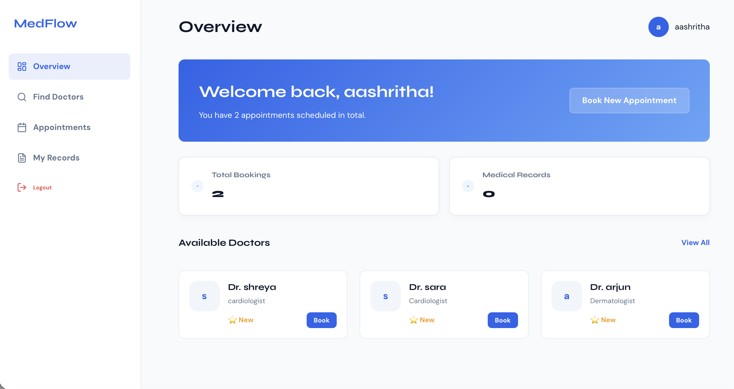

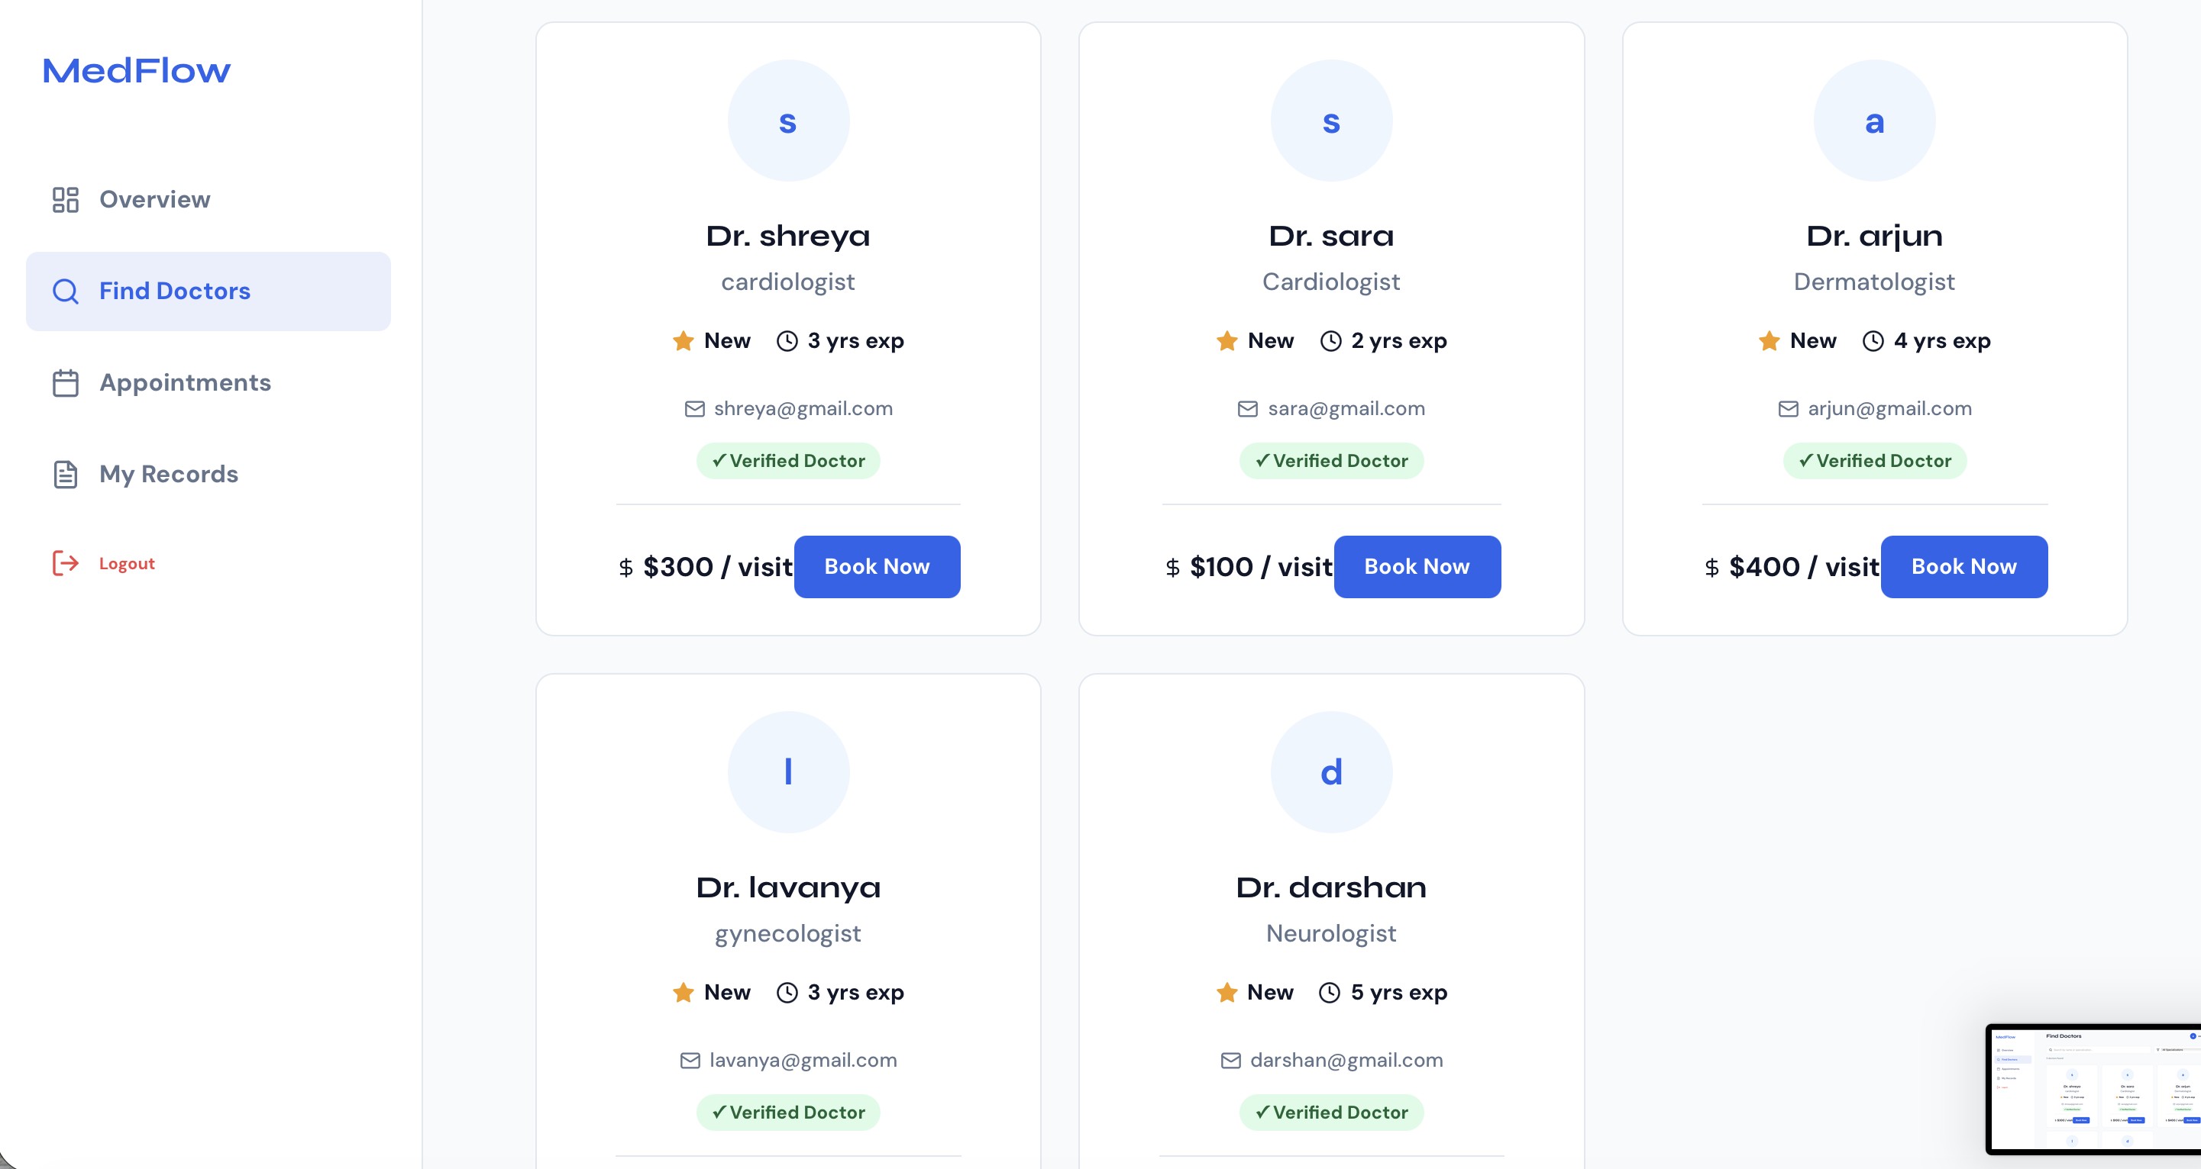

12. Known Issues
There are a few known issues inherent to our deployment architecture that developers should be aware of.

Serverless Cold Starts: Because Vercel puts our backend functions to sleep when no users are active, the very first API request made after a period of inactivity may take an additional one to two seconds to resolve. This delay occurs because the serverless function has to wake up, execute the Node runtime, and establish a fresh connection to the MongoDB Atlas cluster before it can answer the frontend.

Serverless Local Storage: Multer file uploads store files locally. In Vercel's read-only serverless environment, local files are deleted after the container terminates. Thus, doctor certificates are stored temporarily.

13. Future Enhancements
While the current platform is incredibly robust, we have outlined several potential future features that would elevate the project even further.

Payment Gateway Integration: We plan to integrate Stripe or Razorpay to process real credit card payments securely for booking consultation fees.

Email & SMS Notifications: Integrate Twilio or SendGrid/Nodemailer to send immediate appointment status updates and reminders directly to patient and doctor inbox/email.

Video Consultations: Build WebRTC-based video rooms to facilitate live virtual medical sessions directly inside the patient-doctor dashboards.

