M.Sc.(I.C.T) 1st Semester
Practical Assignment – 2 (Servlet)
(Java Web Development)
-----------------------------------------------------------------------------------------------------------------------------
1. Develop a servlet to get the client information who made the request.
Solution:
cilentInfoServlet.java
package servlets;
import java.io.IOException;
import java.io.PrintWriter;
import javax.servlet.ServletException;
import javax.servlet.http.HttpServlet;
import javax.servlet.http.HttpServletRequest;
import javax.servlet.http.HttpServletResponse;
import java.io.*;
import javax.servlet.*;
import javax.servlet.http.*;
import java.util.*;

public class CilentInfoServlet extends HttpServlet {

// Method to handle GET method request.
public void doGet(HttpServletRequest request, HttpServletResponse response)
throws ServletException, IOException {

// Set response content type
response.setContentType("text/html");

PrintWriter out = response.getWriter();
String title = "Cilent Header Inormation";

out.println(
"<html>\n" +
"<head><title>" + title + "</title></head>\n"+
"<body bgcolor = \"#f0f0f0\">\n" +
"<h1 align = \"center\">" + title + "</h1>\n" +
"<table width = \"100%\" border = \"1\" align = \"center\">\n" +
"<tr bgcolor = \"#949494\">\n" +
"<th>Header Name</th><th>Header Value(s)</th>\n"+
"</tr>\n"
);
Enumeration headerNames = request.getHeaderNames();
while(headerNames.hasMoreElements()) {
String paramName = (String)headerNames.nextElement();
out.print("<tr><td>" + paramName + "</td>\n");
String paramValue = request.getHeader(paramName);
out.println("<td> " + paramValue + "</td></tr>\n");
}
out.println("</table>\n</body></html>");
}
// Method to handle POST method request.
public void doPost(HttpServletRequest request, HttpServletResponse response)
throws ServletException, IOException {
doGet(request, response);
}
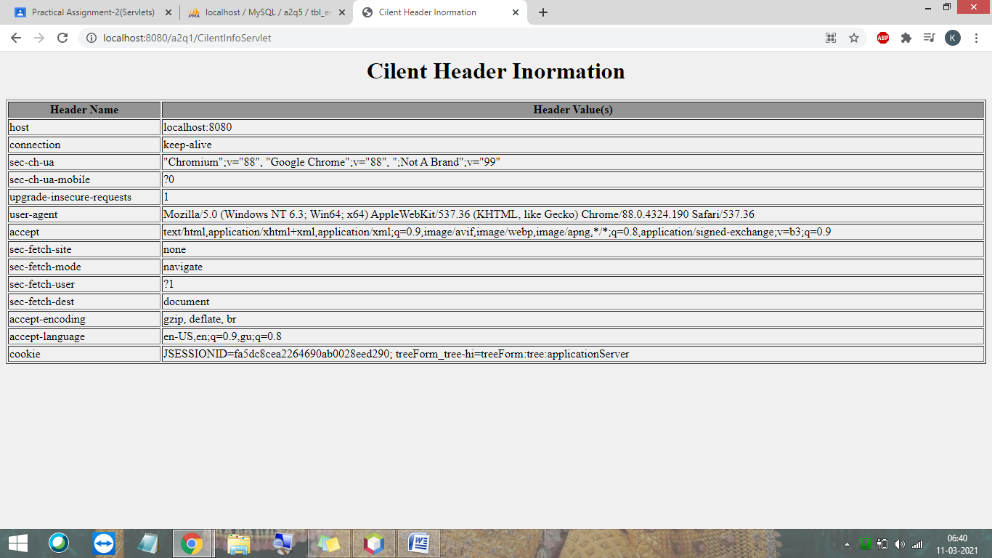
}

2. Make a Student Registration Form and retrieve the value in the servlet.
Note: Take all possible fields and do the validation in Filter.
Solution :
index.html

<html>
<head>
<title>Student Registration form</title>
<meta charset="UTF-8">
<meta name="viewport" content="width=device-width, initial-scale=1.0">
</head>
<body>
<h1 align="Center"><U>STUDENT REGISTRATION FORM</U></h1><br><br>
<div align="center">
<form method="post" action="DisplayServlet">
<table cellspacing="10" cellpadding="10">
<tr>
<td>Enter Name:</td>
<td><input type="text" name="txtName" /></td>
</tr>
<tr>
<td>Select your gender: </td>
<td>
<input type="radio" name="rdGender" value="Female" />Female<br>
<input type="radio" name="rdGender" value="Male" />Male<br>
</td>
</tr>
<tr>
<td>Select Course :</td>
<td>
<select name="ddlCourse">
<option value="--select--">--select--</option>
<option value="Msc.IT">Msc.IT</option>
<option value="Msc.ICT">Msc.ICT</option>
<option value="MCA">MCA</option>
</select>
</td>
</tr>
<tr>
<td>Languages Known :</td>
<td>
<input type="checkbox" name="chkLanguage" value="Hindi"/>Hindi<br>
<input type="checkbox" name="chkLanguage" value="English"/>English<br>
<input type="checkbox" name="chkLanguage" value="Gujarati"/>Gujarati<br>
</td>
</tr>
<tr>
<td><input type="submit" value="submit" /></td>
</tr>
</table>
</form>
</div>
</body>
</html>

web.xml
<?xml version="1.0" encoding="UTF-8"?>
<web-app version="4.0" xmlns="http://xmlns.jcp.org/xml/ns/javaee" xmlns:xsi="http://www.w3.org/2001/XMLSchema-instance" xsi:schemaLocation="http://xmlns.jcp.org/xml/ns/javaee http://xmlns.jcp.org/xml/ns/javaee/web-app_4_0.xsd">
<filter>
<filter-name>authFilter</filter-name>
<filter-class>filters.authFilter</filter-class>
</filter>
<filter-mapping>
<filter-name>authFilter</filter-name>
<url-pattern>/DisplayServlet</url-pattern>
</filter-mapping>
<servlet>
<servlet-name>DisplayServlet</servlet-name>
<servlet-class>servlets.DisplayServlet</servlet-class>
</servlet>
<servlet-mapping>
<servlet-name>DisplayServlet</servlet-name>
<url-pattern>/DisplayServlet</url-pattern>
</servlet-mapping>
<session-config>
<session-timeout>
30
</session-timeout>
</session-config>
</web-app>

authFilter.java

package filters;

import java.io.IOException;
import java.io.PrintWriter;
import javax.servlet.*;
import java.io.IOException;
import java.io.PrintStream;
import java.io.PrintWriter;
import java.io.StringWriter;
import javax.servlet.Filter;
import javax.servlet.FilterChain;
import javax.servlet.FilterConfig;
import javax.servlet.ServletException;
import javax.servlet.ServletRequest;
import javax.servlet.ServletResponse;
import javax.servlet.http.HttpServletRequest;
import javax.servlet.http.HttpServletResponse;

/**
*
* @author Parth Computer
*/
public class authFilter implements Filter {

@Override
public void doFilter(ServletRequest request, ServletResponse response, FilterChain chain) throws IOException, ServletException {
//throw new UnsupportedOperationException("Not supported yet."); //To change body of generated methods, choose Tools | Templates.

HttpServletRequest req = (HttpServletRequest)request;
HttpServletResponse resp = (HttpServletResponse)response;
PrintWriter out=resp.getWriter();
String name = request.getParameter("txtName");
String gender = request.getParameter("rdGender");
String course = request.getParameter("ddlCourse");
String languages[] = request.getParameterValues("chkLanguage");
resp.setContentType("text/html");

if((name.equals("") || name.equals(null)) || course.equals("--select--") || (languages== null) || gender == null ){
out.println("<h3 style='color:red'>Please fill all the fields !!</h3>");
RequestDispatcher rd = req.getRequestDispatcher("index.html");
rd.include(request, response);
}
else{
chain.doFilter(request, response);
}

}

}

DisplayServlet.java

package servlets;

import java.io.IOException;
import java.io.PrintWriter;
import javax.servlet.ServletException;
import javax.servlet.http.HttpServlet;
import javax.servlet.http.HttpServletRequest;
import javax.servlet.http.HttpServletResponse;

public class DisplayServlet extends HttpServlet {

protected void processRequest(HttpServletRequest request, HttpServletResponse response)
throws ServletException, IOException {
response.setContentType("text/html;charset=UTF-8");
try (PrintWriter out = response.getWriter()) {
/* TODO output your page here. You may use following sample code. */
out.println("<!DOCTYPE html>");
out.println("<html>");
out.println("<head>");
out.println("<title>Servlet DisplayServlet</title>");
out.println("</head>");
out.println("<body >");
String name = request.getParameter("txtName");
String gender = request.getParameter("rdGender");
String course = request.getParameter("ddlCourse");
String languages[] = request.getParameterValues("chkLanguage");
out.println("<div align='center'>");
out.println("<h1 style='color:MediumSeaGreen'>Welcome, " +name+"</h1>");
out.println("<br>");

out.print("<tabel cellspacing='10' cellpadding='10'>");
out.print("<tr>");
out.print("<td>");
out.print("<b>Your is Gender : </b>");
out.print("</td>");
out.print("<td>");
out.print("<b>"+gender+"</b><br/>");
out.print("</td>");
out.print("</tr><br/>");
out.print("<tr>");
out.print("<td>");
out.print("<b>Your course is : " +course+"</b><br/>");
out.print("</td>");
out.print("</tr><br/>");
out.print("<tr>");
out.print("<td>");
out.print("<b>Languages Known: </b>");
for (String lang : languages) {
out.print("<b>\t" + lang +"</b>");
}
out.println("</div>");
out.println("</body>");
out.println("</html>");
}
}

// <editor-fold defaultstate="collapsed" desc="HttpServlet methods. Click on the + sign on the left to edit the code.">
/**
* Handles the HTTP <code>GET</code> method.
*
* @param request servlet request
* @param response servlet response
* @throws ServletException if a servlet-specific error occurs
* @throws IOException if an I/O error occurs
*/
@Override
protected void doGet(HttpServletRequest request, HttpServletResponse response)
throws ServletException, IOException {
processRequest(request, response);
}

/**
* Handles the HTTP <code>POST</code> method.
*
* @param request servlet request
* @param response servlet response
* @throws ServletException if a servlet-specific error occurs
* @throws IOException if an I/O error occurs
*/
@Override
protected void doPost(HttpServletRequest request, HttpServletResponse response)
throws ServletException, IOException {
processRequest(request, response);
}

/**
* Returns a short description of the servlet.
*
* @return a String containing servlet description
*/
@Override
public String getServletInfo() {
return "Short description";
}// </editor-fold>

}

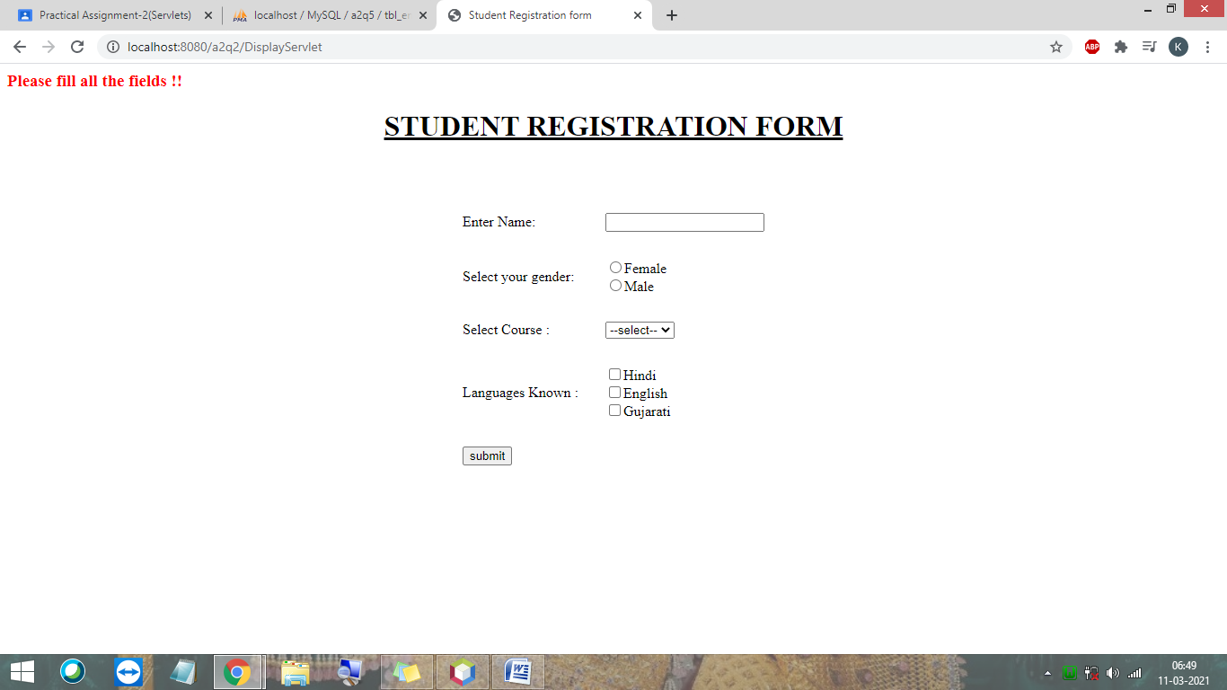
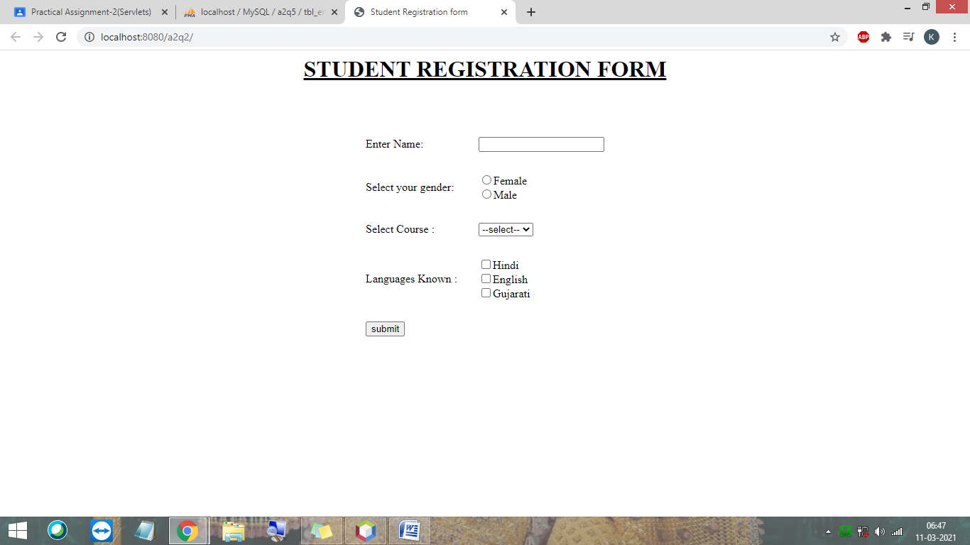

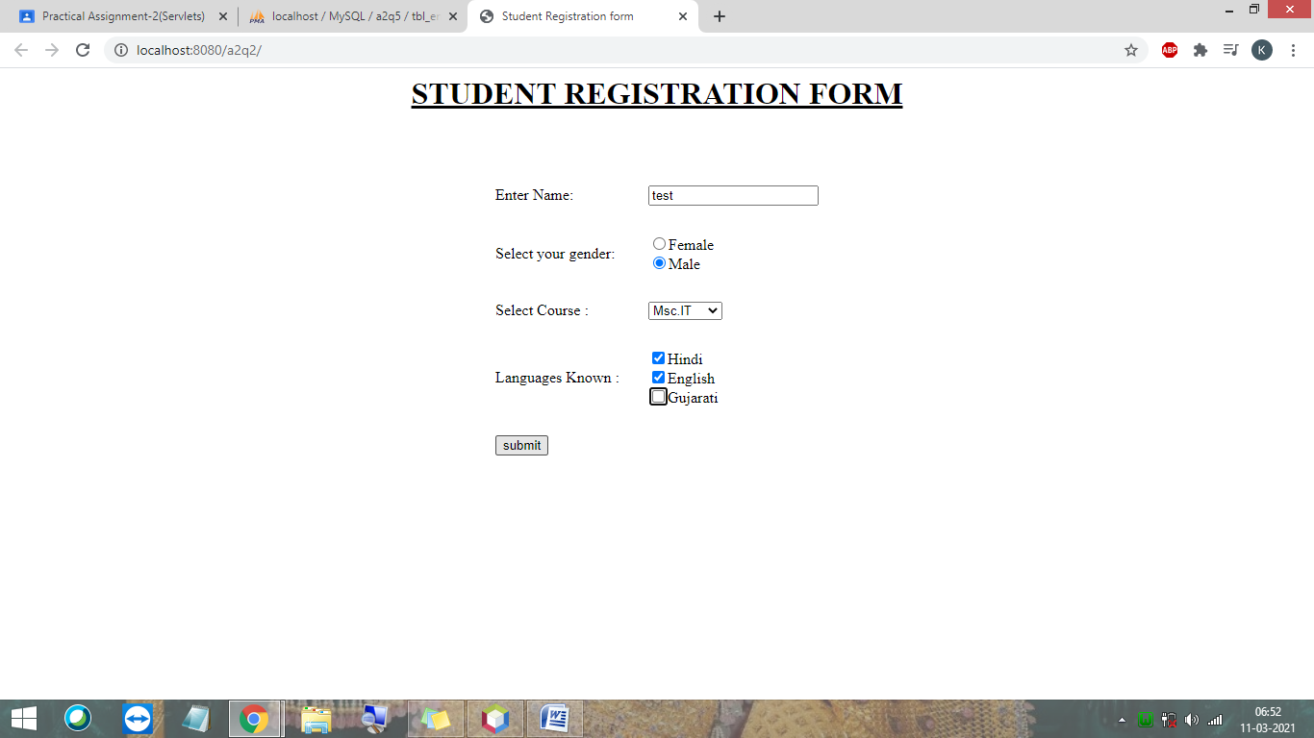

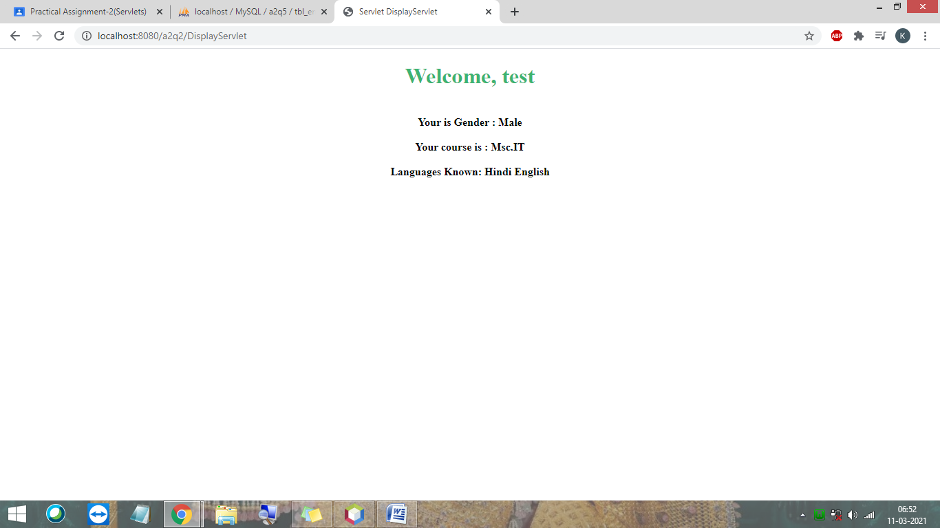

3. Develop a servlet to illustrate the use of Session Tracking.
Solution:
web.xml
<?xml version="1.0" encoding="UTF-8"?>
<web-app version="4.0" xmlns="http://xmlns.jcp.org/xml/ns/javaee" xmlns:xsi="http://www.w3.org/2001/XMLSchema-instance" xsi:schemaLocation="http://xmlns.jcp.org/xml/ns/javaee http://xmlns.jcp.org/xml/ns/javaee/web-app_4_0.xsd">
<servlet>
<servlet-name>sessionTrackingServlet</servlet-name>
<servlet-class>servlets.sessionTrackingServlet</servlet-class>
</servlet>
<servlet-mapping>
<servlet-name>sessionTrackingServlet</servlet-name>
<url-pattern>/sessionTrackingServlet</url-pattern>
</servlet-mapping>
<session-config>
<session-timeout>
30
</session-timeout>
</session-config>
</web-app>

sessionTrackingServlet.java

package servlets;

import java.io.*;
import javax.servlet.*;
import javax.servlet.http.*;
import java.util.*;
import java.io.IOException;
import java.io.PrintWriter;
import javax.servlet.ServletException;
import javax.servlet.http.HttpServlet;
import javax.servlet.http.HttpServletRequest;
import javax.servlet.http.HttpServletResponse;

public class sessionTrackingServlet extends HttpServlet {

public void doGet(HttpServletRequest request, HttpServletResponse response)
throws ServletException, IOException {

// Create a session object if it is already not created.
HttpSession session = request.getSession(true);

// Get session creation time.
Date createTime = new Date(session.getCreationTime());

// Get last access time of this web page.
Date lastAccessTime = new Date(session.getLastAccessedTime());

String title = "Welcome Back to my website";
Integer visitCount = new Integer(0);
String visitCountKey = new String("visitCount");
String userIDKey = new String("userID");
String userID = new String("Kesar");

// Check if this is new comer on your web page.
if (session.isNew()) {
title = "Welcome to my website";
session.setAttribute(userIDKey, userID);
} else {
visitCount = (Integer)session.getAttribute(visitCountKey);
visitCount = visitCount + 1;
userID = (String)session.getAttribute(userIDKey);
}
session.setAttribute(visitCountKey, visitCount);

// Set response content type
response.setContentType("text/html");
PrintWriter out = response.getWriter();

out.println(
"<html>\n" +
"<head><title> Sesion Tracking </title></head>\n" +

"<body bgcolor = \"#f0f0f0\">\n" +
"<h1 align = \"center\">Sesion Tracking</h1>\n" +
"<h2 align = \"center\">Session Infomation</h2>\n" +
"<table border = \"1\" align = \"center\">\n" +

"<tr bgcolor = \"#949494\">\n" +
" <th>Session info</th><th>value</th></tr>\n" +

"<tr>\n" +
" <td>id</td>\n" +
" <td>" + session.getId() + "</td></tr>\n" +

"<tr>\n" +
" <td>Creation Time</td>\n" +
" <td>" + createTime + " </td></tr>\n" +

"<tr>\n" +
" <td>Time of Last Access</td>\n" +
" <td>" + lastAccessTime + " </td></tr>\n" +

"<tr>\n" +
" <td>User ID</td>\n" +
" <td>" + userID + " </td></tr>\n" +

"<tr>\n" +
" <td>Number of visits</td>\n" +
" <td>" + visitCount + "</td></tr>\n" +
"</table>\n" +
"</body></html>"
);
}

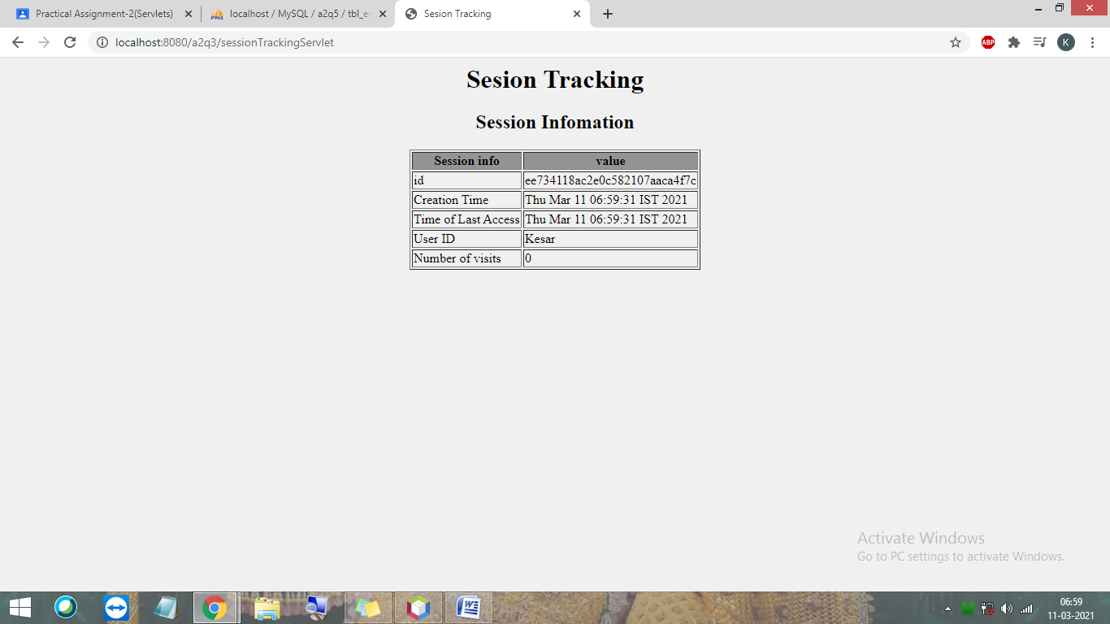
}

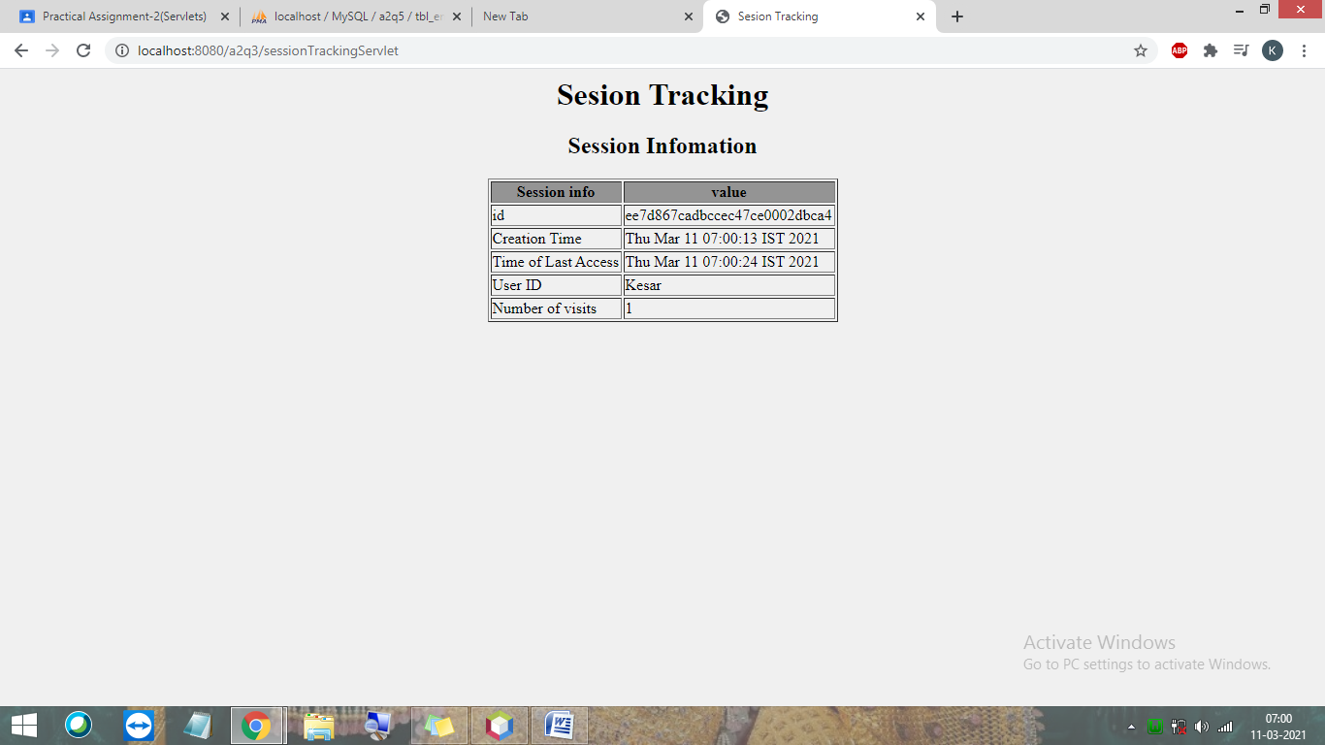

4. Develop a servlet to illustrate the use of Servlet Config and Servlet Context.
Solution:
web.xml
<?xml version="1.0" encoding="UTF-8"?>
<web-app version="4.0" xmlns="http://xmlns.jcp.org/xml/ns/javaee" xmlns:xsi="http://www.w3.org/2001/XMLSchema-instance" xsi:schemaLocation="http://xmlns.jcp.org/xml/ns/javaee http://xmlns.jcp.org/xml/ns/javaee/web-app_4_0.xsd">
<servlet>
<servlet-name>sellerServlet</servlet-name>
<servlet-class>servlets.sellerServlet</servlet-class>
<init-param>
<param-name>Email</param-name>
<param-value>forSellers@gmail.com</param-value>
</init-param>
</servlet>
<servlet>
<servlet-name>customerServlet</servlet-name>
<servlet-class>servlets.customerServlet</servlet-class>
<init-param>
<param-name>Email</param-name>
<param-value>forCustomer@gmail.com</param-value>
</init-param>
</servlet>
<servlet-mapping>
<servlet-name>sellerServlet</servlet-name>
<url-pattern>/sellerServlet</url-pattern>
</servlet-mapping>
<servlet-mapping>
<servlet-name>customerServlet</servlet-name>
<url-pattern>/customerServlet</url-pattern>
</servlet-mapping>
<session-config>
<session-timeout>
30
</session-timeout>
</session-config>
<context-param>
<param-name>Website-name</param-name>
<param-value>MyWebsite.org</param-value>
</context-param>
</web-app>

sellerServlet.java
package servlets;

import java.io.*;
import javax.servlet.*;
import javax.servlet.http.*;
import java.io.IOException;
import java.io.PrintWriter;
import javax.servlet.ServletException;
import javax.servlet.http.HttpServlet;
import javax.servlet.http.HttpServletRequest;
import javax.servlet.http.HttpServletResponse;

public class sellerServlet extends HttpServlet {

protected void doGet(HttpServletRequest request,
HttpServletResponse response)
throws ServletException, IOException
{
String email
= getServletConfig()
.getInitParameter("Email");
String website
= getServletContext()
.getInitParameter("Website-name");
PrintWriter out = response.getWriter();
out.println("<html>");
out.println("<body>");
out.println("<center><h1 style='Color:MediumSeaGreen'>" + website + "</h1></center><br><h3><b style='Color:dodgerblue'>Contact us:"+ email +"</b></h3>");
out.println("</body>");
out.println("</html>");
}

}

customerServlet.java
package servlets;

import java.io.*;
import javax.servlet.ServletException;
import javax.servlet.http.*;
import java.io.IOException;
import java.io.PrintWriter;
import javax.servlet.ServletException;
import javax.servlet.http.HttpServlet;
import javax.servlet.http.HttpServletRequest;
import javax.servlet.http.HttpServletResponse;

/**
*
* @author Parth Computer
*/
public class customerServlet extends HttpServlet {

protected void doGet(HttpServletRequest request,
HttpServletResponse response)
throws ServletException, IOException
{

String email
= getServletConfig()
.getInitParameter("Email");
String website
= getServletContext()
.getInitParameter("Website-name");
PrintWriter out = response.getWriter();
// out.println("<center><h1>" + website + "</h1></center><br><p>Contact us:"+ email +"</p>");
out.println("<html>");
out.println("<body>");
out.println("<center><h1 style='Color:MediumSeaGreen'>" + website + "</h1></center><br><h3><b style='Color:dodgerblue'>Contact us:"+ email +"</b></h3>");
out.println("</body>");
out.println("</html>");
}
}

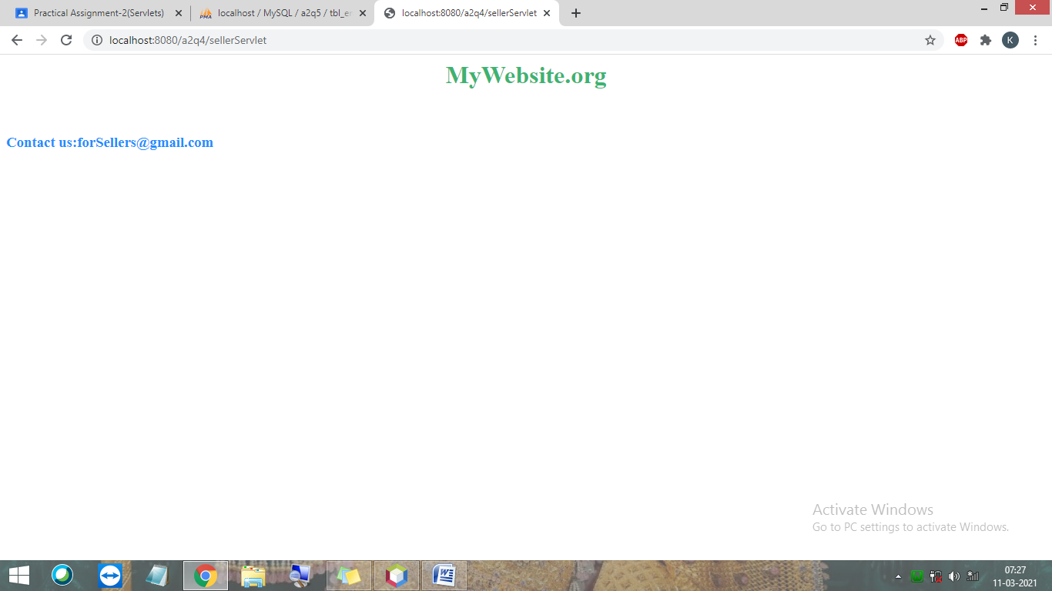

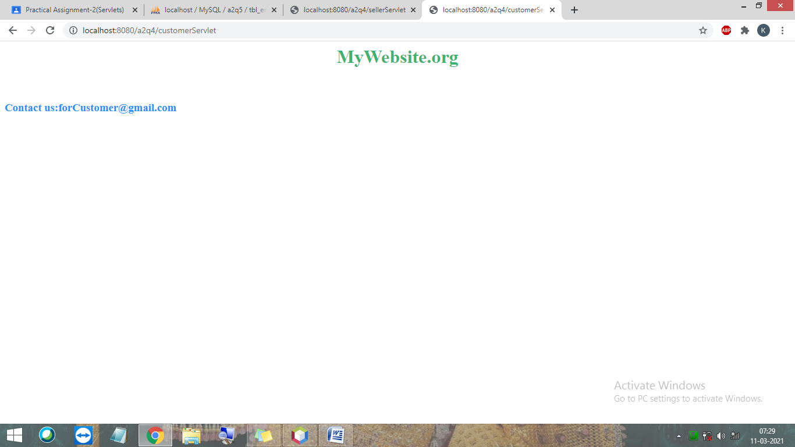

5. Do the following:
- Create department and employee table with appropriate fields and
integrity constraints.
- Write Servlet to insert , update , delete and display the records in
department and employee. (Do validate the fields in filter)
- Display the following reports:
- department wise employees.
- Print department-wise total salary of employees.
Solution:
Database:
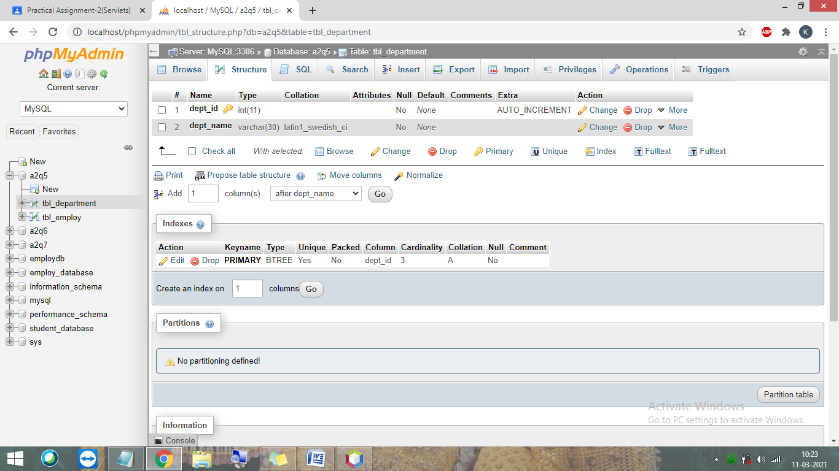

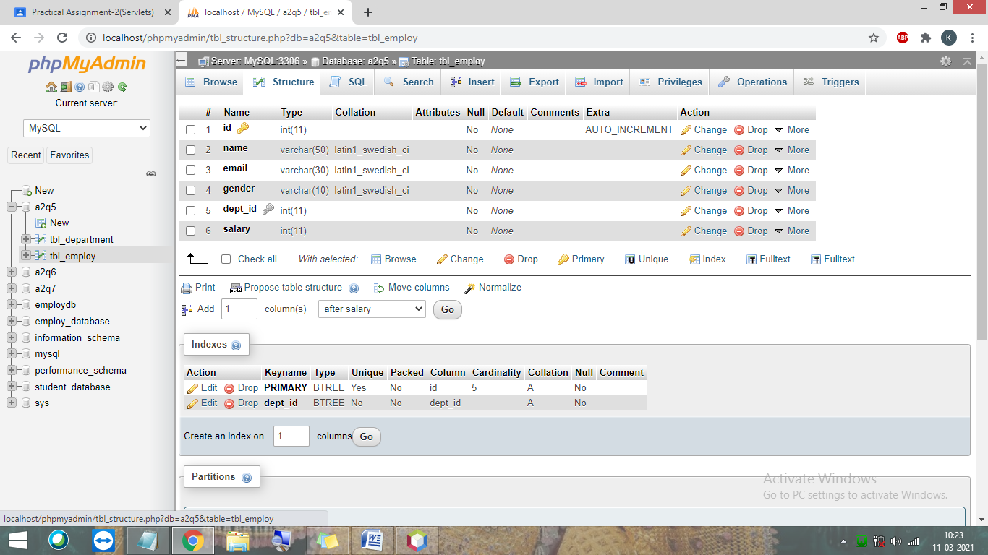

index.html
<html>
<head>
<title>Registration form</title>
<meta charset="UTF-8">
<meta name="viewport" content="width=device-width, initial-scale=1.0">
</head>
<body bgcolor='#D5F5E3'>
<div style='background:#34495E' >
<h1 align='center' style='color:white'>Employ Registration form</h1>
</div>
<div align="center">
<form METHOD="POST" action="addServlet">
<table cellspacing="10" cellpadding="10">
<tr>
<td>Enter employ name : </td>
<td><input type="text" name="txtName" /></td>
</tr>
<tr>
<td>Enter email:</td>
<td><input type="text" name="txtEmail" /></td>
</tr>
<tr>
<td>Select gender:</td>
<td>
<input type="radio" name="rdGender" value="male" />Male<br>
<input type="radio" name="rdGender" value="female"/>Female
</td>
</tr>
<tr>
<td>Select department: </td>
<td>
<select name="ddlDept" style="width:150px">
<option value="1">Sales</option>
<option value="2">Finance</option>
<option value="3">Manufacturing</option>
</select>
</td>
</tr>
<tr>
<td>Enter Salary: </td>
<td><input type="text" name=txtSalary /></td>
</tr>
<tr>
<td colspan="2" align="center"><input type="submit" value="insert" /></td>
</tr>
</table>
</form>
</div>
</body>
</html>

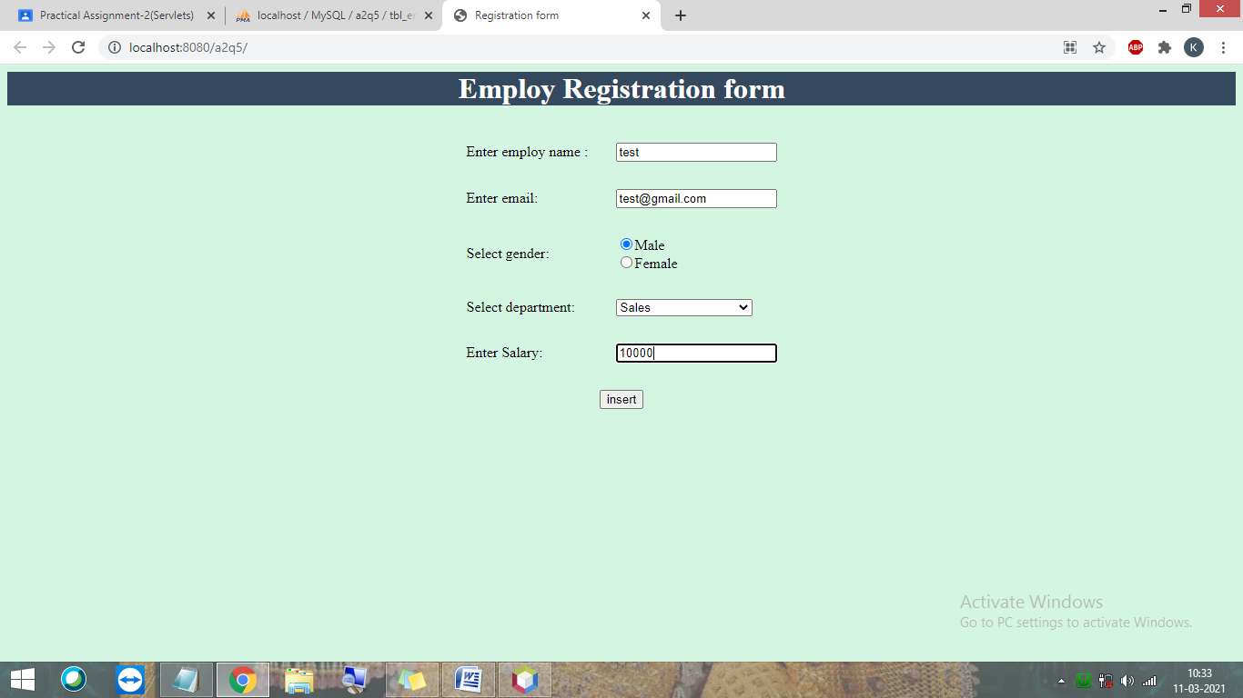
web.xml
<?xml version="1.0" encoding="UTF-8"?>
<web-app version="4.0" xmlns="http://xmlns.jcp.org/xml/ns/javaee" xmlns:xsi="http://www.w3.org/2001/XMLSchema-instance" xsi:schemaLocation="http://xmlns.jcp.org/xml/ns/javaee http://xmlns.jcp.org/xml/ns/javaee/web-app_4_0.xsd">
<filter>
<filter-name>authFilter</filter-name>
<filter-class>filters.authFilter</filter-class>
</filter>
<filter-mapping>
<filter-name>authFilter</filter-name>
<url-pattern>/addServlet</url-pattern>
</filter-mapping>
<servlet>
<servlet-name>addServlet</servlet-name>
<servlet-class>servlets.addServlet</servlet-class>
</servlet>
<servlet>
<servlet-name>displayServlet</servlet-name>
<servlet-class>servlets.displayServlet</servlet-class>
</servlet>
<servlet>
<servlet-name>deleteServlet</servlet-name>
<servlet-class>servlets.deleteServlet</servlet-class>
</servlet>
<servlet>
<servlet-name>editServlet</servlet-name>
<servlet-class>servlets.editServlet</servlet-class>
</servlet>
<servlet>
<servlet-name>editServlet2</servlet-name>
<servlet-class>servlets.editServlet2</servlet-class>
</servlet>
<servlet>
<servlet-name>displayDeptWiseServlet</servlet-name>
<servlet-class>servlets.displayDeptWiseServlet</servlet-class>
</servlet>
<servlet-mapping>
<servlet-name>addServlet</servlet-name>
<url-pattern>/addServlet</url-pattern>
</servlet-mapping>
<servlet-mapping>
<servlet-name>displayServlet</servlet-name>
<url-pattern>/displayServlet</url-pattern>
</servlet-mapping>
<servlet-mapping>
<servlet-name>deleteServlet</servlet-name>
<url-pattern>/deleteServlet</url-pattern>
</servlet-mapping>
<servlet-mapping>
<servlet-name>editServlet</servlet-name>
<url-pattern>/editServlet</url-pattern>
</servlet-mapping>
<servlet-mapping>
<servlet-name>editServlet2</servlet-name>
<url-pattern>/editServlet2</url-pattern>
</servlet-mapping>
<servlet-mapping>
<servlet-name>displayDeptWiseServlet</servlet-name>
<url-pattern>/displayDeptWiseServlet</url-pattern>
</servlet-mapping>
<session-config>
<session-timeout>
30
</session-timeout>
</session-config>
</web-app>

addServlet.java
package servlets;

import java.sql.*;
import java.io.IOException;
import java.io.PrintWriter;
import javax.servlet.ServletException;
import javax.servlet.http.HttpServlet;
import javax.servlet.http.HttpServletRequest;
import javax.servlet.http.HttpServletResponse;

public class addServlet extends HttpServlet {

protected void processRequest(HttpServletRequest request, HttpServletResponse response)
throws ServletException, IOException {
response.setContentType("text/html;charset=UTF-8");
try (PrintWriter out = response.getWriter()) {
/* TODO output your page here. You may use following sample code. */
out.println("<!DOCTYPE html>");
out.println("<html>");
out.println("<head>");
out.println("<title>Servlet addServlet</title>");
out.println("</head>");
out.println("<body>");
try{
String url = "jdbc:mysql://localhost/a2q5";
String username = "root";
String password = "";
Connection con = DriverManager.getConnection(url, username, password);

String query = "insert into tbl_employ(name, email, gender, dept_id, salary) values(?, ?, ?, ?, ?)";;
PreparedStatement pstmt = con.prepareStatement(query);
String name = request.getParameter("txtName");
String email = request.getParameter("txtEmail");
String gender = request.getParameter("rdGender");
String dept = request.getParameter("ddlDept");
int salary = Integer.parseInt((request.getParameter("txtSalary")));

pstmt.setString(1, name);
pstmt.setString(2, email);
pstmt.setString(3, gender);
pstmt.setString(4, dept);
pstmt.setInt(5, salary);

int rowsAffected = pstmt.executeUpdate();
if(rowsAffected > 0){
//out.println("1 row inserted..");
response.sendRedirect("displayServlet");
}
else{
out.println("recoed not inserted!!");
}

}catch(Exception ex){
out.println("Error : " +ex.getMessage());
}
out.println("</body>");
out.println("</html>");
}
}

// <editor-fold defaultstate="collapsed" desc="HttpServlet methods. Click on the + sign on the left to edit the code.">
/**
* Handles the HTTP <code>GET</code> method.
*
* @param request servlet request
* @param response servlet response
* @throws ServletException if a servlet-specific error occurs
* @throws IOException if an I/O error occurs
*/
@Override
protected void doGet(HttpServletRequest request, HttpServletResponse response)
throws ServletException, IOException {
processRequest(request, response);
}

/**
* Handles the HTTP <code>POST</code> method.
*
* @param request servlet request
* @param response servlet response
* @throws ServletException if a servlet-specific error occurs
* @throws IOException if an I/O error occurs
*/
@Override
protected void doPost(HttpServletRequest request, HttpServletResponse response)
throws ServletException, IOException {
processRequest(request, response);
}

/**
* Returns a short description of the servlet.
*
* @return a String containing servlet description
*/
@Override
public String getServletInfo() {
return "Short description";
}// </editor-fold>

}

deleteServlet.java
package servlets;

import java.io.IOException;
import java.io.PrintWriter;
import java.sql.*;
import java.sql.DriverManager;
import javax.servlet.ServletException;
import javax.servlet.http.HttpServlet;
import javax.servlet.http.HttpServletRequest;
import javax.servlet.http.HttpServletResponse;

public class deleteServlet extends HttpServlet {

protected void processRequest(HttpServletRequest request, HttpServletResponse response)
throws ServletException, IOException {
response.setContentType("text/html;charset=UTF-8");
try (PrintWriter out = response.getWriter()) {
/* TODO output your page here. You may use following sample code. */
out.println("<!DOCTYPE html>");
out.println("<html>");
out.println("<head>");
out.println("<title>Servlet deleteServlet</title>");
out.println("</head>");
out.println("<body>");
try{
String url = "jdbc:mysql://localhost/a2q5";
String username = "root";
String password = "";
Connection con = DriverManager.getConnection(url, username, password);
String eid=request.getParameter("id");
int id=Integer.parseInt(eid);
PreparedStatement ps=con.prepareStatement("delete from tbl_employ where id=?");
ps.setInt(1,id);
int rowsAffected = ps.executeUpdate();
if(rowsAffected > 0){
response.sendRedirect("displayServlet");
}
else{
out.println("record not deleted!!");
}

}catch(Exception ex){
out.println("Error : "+ex.getMessage());
}
out.println("</body>");
out.println("</html>");
}
}

// <editor-fold defaultstate="collapsed" desc="HttpServlet methods. Click on the + sign on the left to edit the code.">
/**
* Handles the HTTP <code>GET</code> method.
*
* @param request servlet request
* @param response servlet response
* @throws ServletException if a servlet-specific error occurs
* @throws IOException if an I/O error occurs
*/
@Override
protected void doGet(HttpServletRequest request, HttpServletResponse response)
throws ServletException, IOException {
processRequest(request, response);
}

/**
* Handles the HTTP <code>POST</code> method.
*
* @param request servlet request
* @param response servlet response
* @throws ServletException if a servlet-specific error occurs
* @throws IOException if an I/O error occurs
*/
@Override
protected void doPost(HttpServletRequest request, HttpServletResponse response)
throws ServletException, IOException {
processRequest(request, response);
}

/**
* Returns a short description of the servlet.
*
* @return a String containing servlet description
*/
@Override
public String getServletInfo() {
return "Short description";
}// </editor-fold>

}

editServlet.java
package servlets;

import java.sql.*;
import java.io.IOException;
import java.io.PrintWriter;
import javax.servlet.ServletException;
import javax.servlet.http.HttpServlet;
import javax.servlet.http.HttpServletRequest;
import javax.servlet.http.HttpServletResponse;

public class editServlet extends HttpServlet {
protected void processRequest(HttpServletRequest request, HttpServletResponse response)
throws ServletException, IOException {
response.setContentType("text/html;charset=UTF-8");
try (PrintWriter out = response.getWriter()) {
/* TODO output your page here. You may use following sample code. */
out.println("<!DOCTYPE html>");
out.println("<html>");
out.println("<head>");
out.println("<title>Servlet editServlet</title>");
out.println("</head>");
out.println("<body>");
out.println("<div style='background:lavender'>");
out.println("<h1 align='center' style='color:white'>Edit Employee Details</h1>");
out.println("</div>");
try{
String url = "jdbc:mysql://localhost/a2q5";
String username = "root";
String password = "";
Connection con = DriverManager.getConnection(url, username, password);
int eid = Integer.parseInt(request.getParameter("id"));
Statement stmt = con.createStatement();

String test = "select * from tbl_employ where id = " + eid;
ResultSet rs2 = stmt.executeQuery(test);

String name = "";
String email = "";
String gender = "";
int did = 0;
int sal = 0;

while(rs2.next()) {
name = rs2.getString(2);
email = rs2.getString(3);
gender = rs2.getString(4);
did = rs2.getInt(5);
sal = rs2.getInt(6);
}

out.print("<form action ='editServlet2' method = 'post'>");
out.print("<table cellspacing=\"10\" cellpadding=\"10\">\n" +
"<input type = 'hidden' name = 'id' value='" + eid + "'/>" +
" <tr>\n" +
" <td>Enter employ name : </td>\n" +
" <td><input type=\"text\" name=\"txtName\" value ='"+ name +"' /></td>\n" +
" </tr> \n" +
" <tr>\n" +
" <td>Enter email:</td>\n" +
" <td><input type=\"text\" name=\"txtEmail\" value ='"+ email +"' /></td>\n" +
" </tr>\n" +
" <tr>\n" +
" <td>Select gender:</td>\n" +
" <td>\n" +
" <input type=\"radio\" name=\"rdGender\" value=\"male\" />Male<br>\n" +
" <input type=\"radio\" name=\"rdGender\" value=\"female\"/>Female\n" +
" </td>\n" +
" </tr>\n" +
" <tr>\n" +
" <td>Select department: </td>\n" +
" <td>\n" +
" <select name=\"ddlDept\" style=\"width:150px\">\n" +
" <option value=\"1\">Sales</option>\n" +
" <option value=\"2\">Finance</option>\n" +
" <option value=\"3\">Manufacturing</option>\n" +
" </select>\n" +
" </td>\n" +
" </tr>\n" +
" <tr>\n" +
" <td>Enter Salary: </td>\n" +
" <td><input type=\"text\" name=txtSalary value ='"+ sal +"' /></td>\n" +
" </tr>\n" +
" <tr>\n" +
" <td colspan=\"2\" align=\"center\"><input type=\"submit\" value=\"Update\" /></td>\n" +
" </tr>\n" +
" </table>"
+ "</form>");
}catch(Exception ex){
out.println("Error : "+ ex.getMessage());
}
out.println("</body>");
out.println("</html>");
}
}

// <editor-fold defaultstate="collapsed" desc="HttpServlet methods. Click on the + sign on the left to edit the code.">
/**
* Handles the HTTP <code>GET</code> method.
*
* @param request servlet request
* @param response servlet response
* @throws ServletException if a servlet-specific error occurs
* @throws IOException if an I/O error occurs
*/
@Override
protected void doGet(HttpServletRequest request, HttpServletResponse response)
throws ServletException, IOException {
processRequest(request, response);
}

/**
* Handles the HTTP <code>POST</code> method.
*
* @param request servlet request
* @param response servlet response
* @throws ServletException if a servlet-specific error occurs
* @throws IOException if an I/O error occurs
*/
@Override
protected void doPost(HttpServletRequest request, HttpServletResponse response)
throws ServletException, IOException {
processRequest(request, response);
}

/**
* Returns a short description of the servlet.
*
* @return a String containing servlet description
*/
@Override
public String getServletInfo() {
return "Short description";
}// </editor-fold>

}
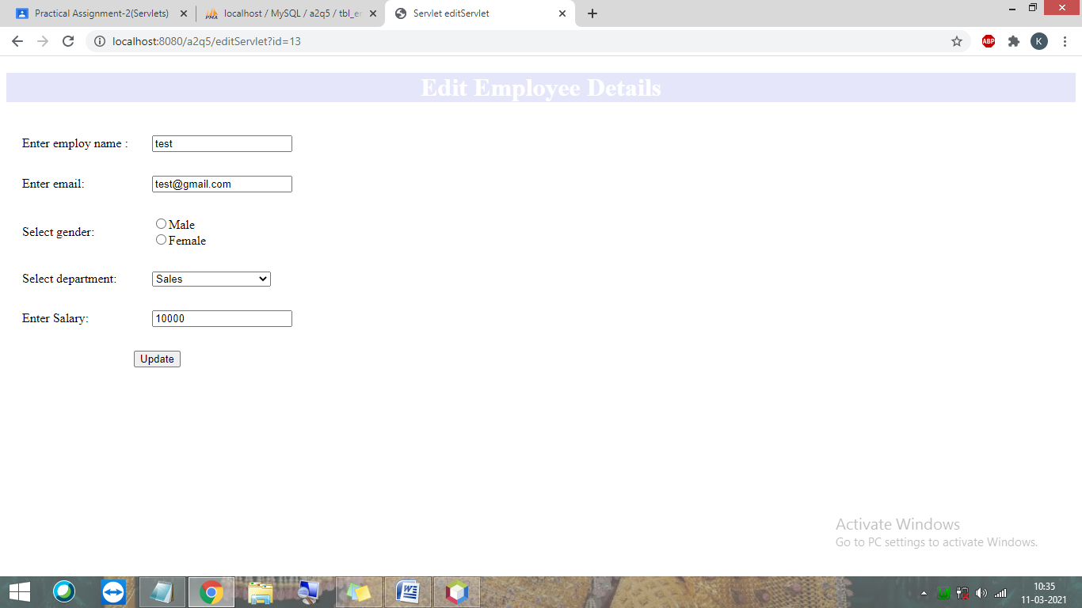
editServlet2.java

package servlets;

import java.io.IOException;
import java.io.PrintWriter;
import java.sql.Connection;
import java.sql.DriverManager;
import java.sql.ResultSet;
import java.sql.SQLException;
import java.sql.Statement;
import java.util.logging.Level;
import java.util.logging.Logger;
import javax.servlet.ServletException;
import javax.servlet.http.HttpServlet;
import javax.servlet.http.HttpServletRequest;
import javax.servlet.http.HttpServletResponse;

public class editServlet2 extends HttpServlet {
protected void processRequest(HttpServletRequest request, HttpServletResponse response)
throws ServletException, IOException {
response.setContentType("text/html;charset=UTF-8");
PrintWriter out = response.getWriter();

int id = Integer.parseInt(request.getParameter("id"));
String name = request.getParameter("txtName");
String email = request.getParameter("txtEmail");
String gender = request.getParameter("rdGender");
int did = Integer.parseInt(request.getParameter("ddlDept"));
int sal = Integer.parseInt(request.getParameter("txtSalary"));
try {
String url = "jdbc:mysql://localhost/a2q5";
String username = "root";
String password = "";
Connection con = null;
con = DriverManager.getConnection(url, username, password);
String query = "update tbl_employ set name='"+ name +"', email = '"+ email +"', gender = '"+ gender +"', dept_id = " + did + ", salary = " + sal + " where id = " + id + ";";
Statement stmt = con.createStatement();
stmt.executeUpdate(query);

response.sendRedirect("displayServlet");
}catch (Exception ex) {
out.println("Error : "+ex.getMessage());
}
}

// <editor-fold defaultstate="collapsed" desc="HttpServlet methods. Click on the + sign on the left to edit the code.">
/**
* Handles the HTTP <code>GET</code> method.
*
* @param request servlet request
* @param response servlet response
* @throws ServletException if a servlet-specific error occurs
* @throws IOException if an I/O error occurs
*/
@Override
protected void doGet(HttpServletRequest request, HttpServletResponse response)
throws ServletException, IOException {
processRequest(request, response);
}

/**
* Handles the HTTP <code>POST</code> method.
*
* @param request servlet request
* @param response servlet response
* @throws ServletException if a servlet-specific error occurs
* @throws IOException if an I/O error occurs
*/
@Override
protected void doPost(HttpServletRequest request, HttpServletResponse response)
throws ServletException, IOException {
processRequest(request, response);
}

/**
* Returns a short description of the servlet.
*
* @return a String containing servlet description
*/
@Override
public String getServletInfo() {
return "Short description";
}// </editor-fold>

}

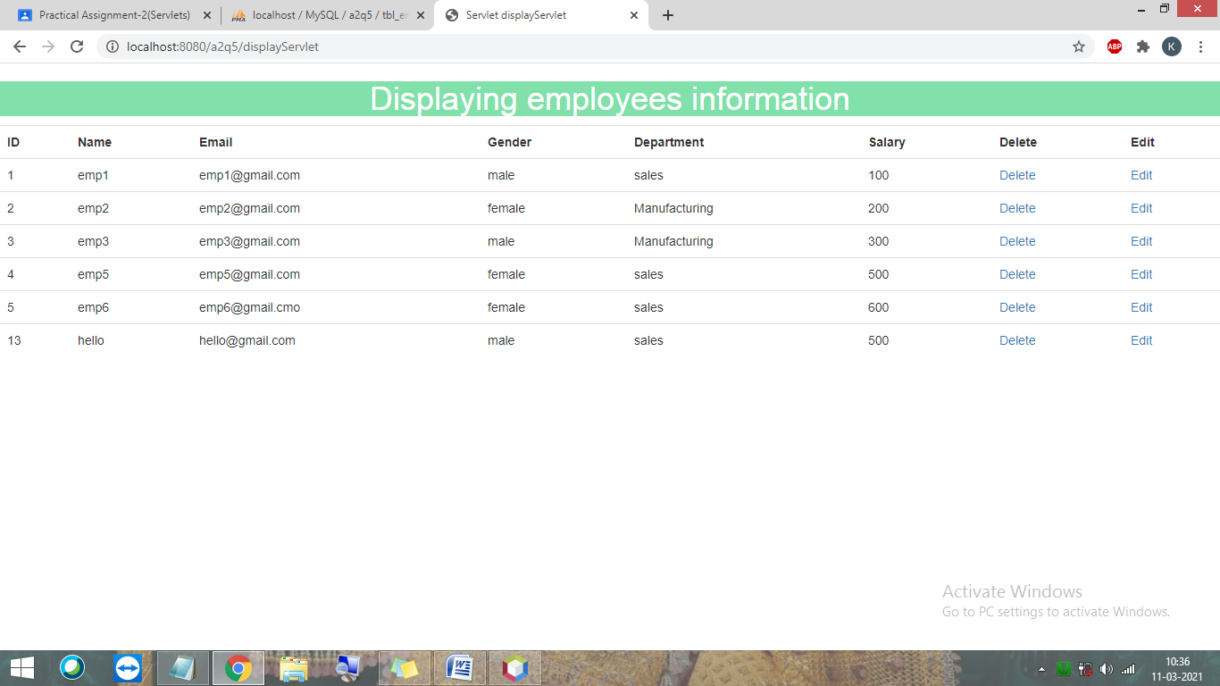
displayServlet.java
package servlets;

import java.io.IOException;
import java.io.PrintWriter;
import javax.servlet.ServletException;
import javax.servlet.http.HttpServlet;
import javax.servlet.http.HttpServletRequest;
import javax.servlet.http.HttpServletResponse;
import java.sql.*;
public class displayServlet extends HttpServlet {

protected void processRequest(HttpServletRequest request, HttpServletResponse response)
throws ServletException, IOException {
response.setContentType("text/html;charset=UTF-8");
try (PrintWriter out = response.getWriter()) {
/* TODO output your page here. You may use following sample code. */
out.println("<!DOCTYPE html>");
out.println("<html>");
out.println("<head>");
out.println("<title>Servlet displayServlet</title>");
out.println("<meta charset=\"utf-8\">\n" +
" <meta name=\"viewport\" content=\"width=device-width, initial-scale=1\">\n" +
" <link rel=\"stylesheet\" href=\"https://maxcdn.bootstrapcdn.com/bootstrap/3.4.1/css/bootstrap.min.css\">\n" +
" <script src=\"https://ajax.googleapis.com/ajax/libs/jquery/3.5.1/jquery.min.js\"></script>\n" +
" <script src=\"https://maxcdn.bootstrapcdn.com/bootstrap/3.4.1/js/bootstrap.min.js\"></script>");
out.println("</head>");
out.println("<body>");
out.println("<div style='background:#82E0AA'>");
out.println("<h1 align='center' style='color:white'>Displaying employees information</h1>");
out.println("</div>");
try{
String url = "jdbc:mysql://localhost/a2q5";
String username = "root";
String password = "";
Connection con = DriverManager.getConnection(url, username, password);
String query = "select * from tbl_employ";
Statement stmt = con.createStatement();
Statement stmt2 = con.createStatement();
out.print("<table class='table' align='center'>");
out.print("<tr>");
out.print("<th>ID</th>");
out.print("<th>Name</th>");
out.print("<th>Email</th>");
out.print("<th>Gender</th>");
out.print("<th>Department</th>");
out.print("<th>Salary</th>");
out.print("<th>Delete</th>");
out.print("<th>Edit</th>");
out.println("</tr>");

ResultSet rs = stmt.executeQuery(query);
while (rs.next()){
String test = "select dept_name from tbl_department where dept_id="+rs.getInt(5);
ResultSet rs2 = stmt2.executeQuery(test);
out.print("<tr>");
out.print("<td>"+rs.getInt(1)+"</td>");
out.print("<td>"+rs.getString(2)+"</td>");
out.print("<td>"+rs.getString(3)+"</td>");
out.print("<td>"+rs.getString(4)+"</td>");
int e = rs.getInt(1);
while(rs2.next()) {
out.print("<td>"+rs2.getString(1)+"</td>");
}
rs2.close();
out.print("<td>"+rs.getInt(6)+"</td>");
out.println("<td><a href='deleteServlet?id="+e+"'>Delete</a></td>");
out.println("<td><a href='editServlet?id="+e+"'>Edit</a></td>");
out.println("</tr>");
}
rs.close();
out.println("</table>");
stmt.close();
con.close();
}catch(Exception ex){
out.println("Error: "+ex.getMessage());
}
out.println("</body>");

out.println("</html>");
}
}

// <editor-fold defaultstate="collapsed" desc="HttpServlet methods. Click on the + sign on the left to edit the code.">
/**
* Handles the HTTP <code>GET</code> method.
*
* @param request servlet request
* @param response servlet response
* @throws ServletException if a servlet-specific error occurs
* @throws IOException if an I/O error occurs
*/
@Override
protected void doGet(HttpServletRequest request, HttpServletResponse response)
throws ServletException, IOException {
processRequest(request, response);
}

/**
* Handles the HTTP <code>POST</code> method.
*
* @param request servlet request
* @param response servlet response
* @throws ServletException if a servlet-specific error occurs
* @throws IOException if an I/O error occurs
*/
@Override
protected void doPost(HttpServletRequest request, HttpServletResponse response)
throws ServletException, IOException {
processRequest(request, response);
}

/**
* Returns a short description of the servlet.
*
* @return a String containing servlet description
*/
@Override
public String getServletInfo() {
return "Short description";
}// </editor-fold>

}

displayDeptWiseServlet.java
package servlets;

import java.io.IOException;
import java.io.PrintWriter;
import javax.servlet.ServletException;
import javax.servlet.http.HttpServlet;
import javax.servlet.http.HttpServletRequest;
import javax.servlet.http.HttpServletResponse;
import java.sql.*;

public class displayDeptWiseServlet extends HttpServlet {

protected void processRequest(HttpServletRequest request, HttpServletResponse response)
throws ServletException, IOException {
response.setContentType("text/html;charset=UTF-8");
try (PrintWriter out = response.getWriter()) {
/* TODO output your page here. You may use following sample code. */
out.println("<!DOCTYPE html>");
out.println("<html>");
out.println("<head>");
out.println("<title>Servlet displayDeptWiseServlet</title>");
out.println("<meta charset=\"utf-8\">\n" +
" <meta name=\"viewport\" content=\"width=device-width, initial-scale=1\">\n" +
" <link rel=\"stylesheet\" href=\"https://maxcdn.bootstrapcdn.com/bootstrap/3.4.1/css/bootstrap.min.css\">\n" +
" <script src=\"https://ajax.googleapis.com/ajax/libs/jquery/3.5.1/jquery.min.js\"></script>\n" +
" <script src=\"https://maxcdn.bootstrapcdn.com/bootstrap/3.4.1/js/bootstrap.min.js\"></script>");
out.println("</head>");
out.println("<body>");
try{

String url = "jdbc:mysql://localhost/a2q5";
String username = "root";
String password = "";
Connection con = DriverManager.getConnection(url, username, password);

out.println("<div style='background:#F1C40F'>");
out.println("<h1 align='center' style='color:white'>Displaying employees department wise</h1>");
out.println("</div>");

//String query = "select * from tbl_employ where dept_id = (select dept_id from tbl_department where dept_name='sales')";
String query = "select * from tbl_employ group by dept_id";
Statement stmt = con.createStatement();
out.print("<table class='table' align='center' >");
out.println("<thead>");
out.print("<tr>");
out.print("<th>ID</th>");
out.print("<th>Name</th>");
out.print("<th>Email</th>");
out.print("<th>Gender</th>");
out.print("<th>Salary</th>");
out.println("</tr>");
out.println("</thead>");

ResultSet rs = stmt.executeQuery(query);
while (rs.next()){
out.println("<tbody>");
out.print("<tr>");
out.print("<td>"+rs.getInt(1)+"</td>");
out.print("<td>"+rs.getString(2)+"</td>");
out.print("<td>"+rs.getString(3)+"</td>");
out.print("<td>"+rs.getString(4)+"</td>");
out.print("<td>"+rs.getInt(6)+"</td>");
out.println("<tbody>");
}
out.println();
rs.close();
}catch(Exception ex){
out.println("Error : " + ex.getMessage() );
}
out.println("</body>");
out.println("</html>");
}
}

// <editor-fold defaultstate="collapsed" desc="HttpServlet methods. Click on the + sign on the left to edit the code.">
/**
* Handles the HTTP <code>GET</code> method.
*
* @param request servlet request
* @param response servlet response
* @throws ServletException if a servlet-specific error occurs
* @throws IOException if an I/O error occurs
*/
@Override
protected void doGet(HttpServletRequest request, HttpServletResponse response)
throws ServletException, IOException {
processRequest(request, response);
}

/**
* Handles the HTTP <code>POST</code> method.
*
* @param request servlet request
* @param response servlet response
* @throws ServletException if a servlet-specific error occurs
* @throws IOException if an I/O error occurs
*/
@Override
protected void doPost(HttpServletRequest request, HttpServletResponse response)
throws ServletException, IOException {
processRequest(request, response);
}

/**
* Returns a short description of the servlet.
*
* @return a String containing servlet description
*/
@Override
public String getServletInfo() {
return "Short description";
}// </editor-fold>

}

7. A Computer Shop wishes to have its presence on web, It sells branded, assembeled computers and separate parts like RAM, CD-ROM, Monitor etc. to its client. All the clients need to register them with the site providing some crucial information regarding them selves. After providing their registration information they are allowed to login. After successful login they can view the computer shop.Perform shopping, prepare their bill and make payments. The User with Administrative rights can enter records required to maintain the computer shop.
Solution:
Database
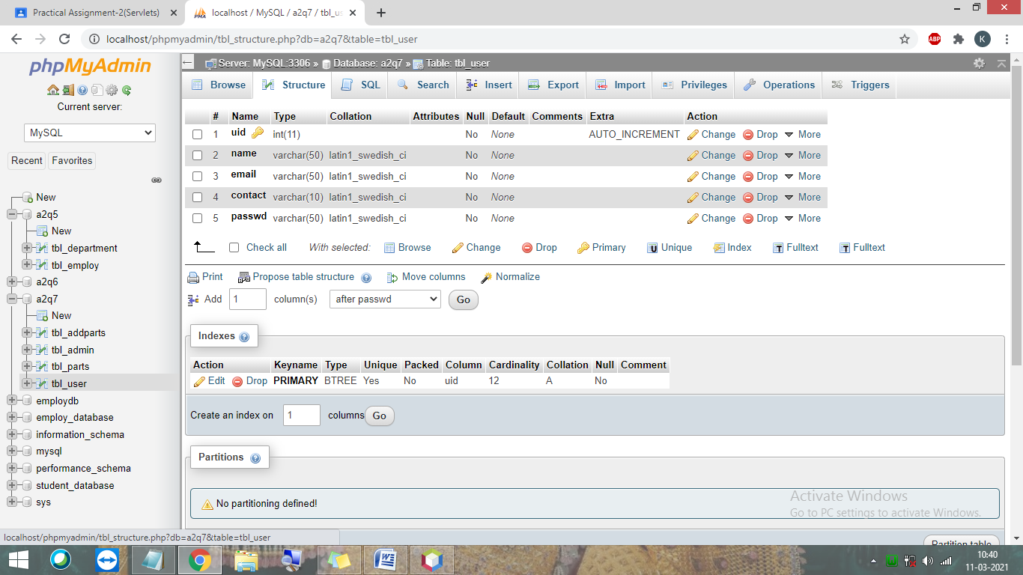

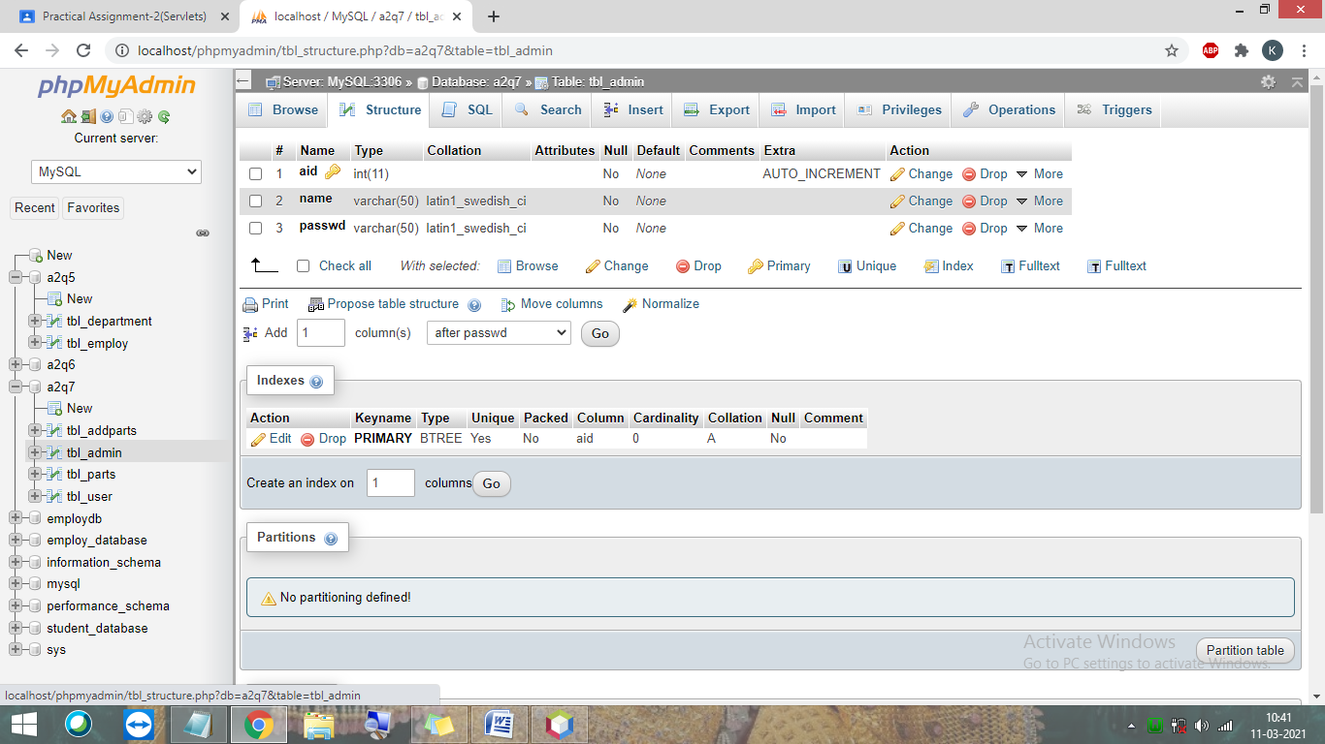
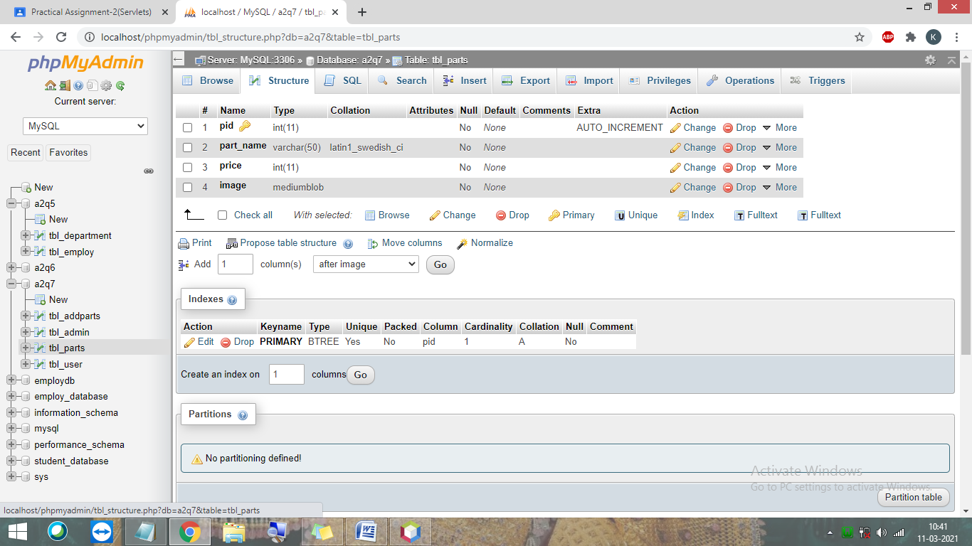

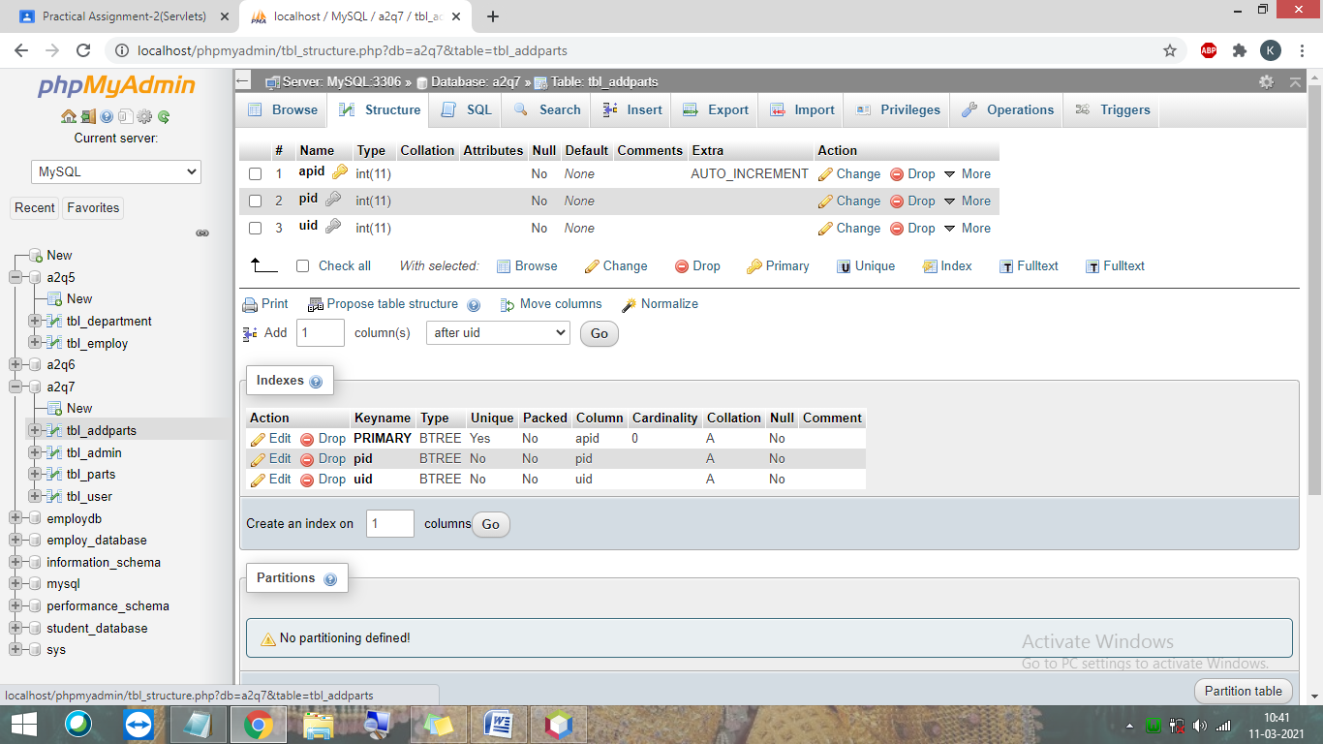
index.html

<html>
<head>
<title>TODO supply a title</title>
<meta charset="UTF-8">
<meta name="viewport" content="width=device-width, initial-scale=1.0">
</head>
<body>
<div style="display: flex; justify-content: center; align-items: center; width: 100%; height: 100vh">
<a href="login.html" style="text-decoration: none; color: black; margin: 0 1.5rem "><div style="width:10rem; height:2rem; border: 1px solid black; border-radius: 8px; display: flex; justify-content: center; align-items: center">
<span>Log In</span>
</div></a>
<a href="signUpServlet" style="text-decoration: none; color: white; margin: 0 1.5rem"><div style="width:10rem; height:2rem; background-color: #1f1f1f; border-radius: 8px; display: flex; justify-content: center; align-items: center">
<span>Sign Up</span>
</div></a>
</div>
</body>
</html>
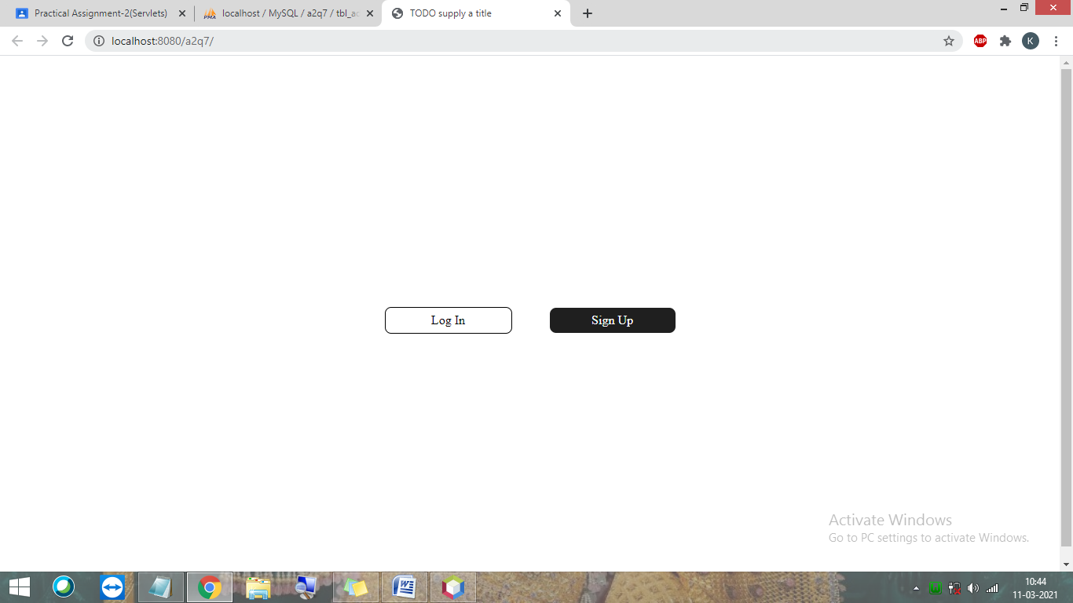

web.xml
<?xml version="1.0" encoding="UTF-8"?>
<web-app version="4.0" xmlns="http://xmlns.jcp.org/xml/ns/javaee" xmlns:xsi="http://www.w3.org/2001/XMLSchema-instance" xsi:schemaLocation="http://xmlns.jcp.org/xml/ns/javaee http://xmlns.jcp.org/xml/ns/javaee/web-app_4_0.xsd">
<servlet>
<servlet-name>signUpServlet</servlet-name>
<servlet-class>servlets.signUpServlet</servlet-class>
</servlet>
<servlet>
<servlet-name>addSignUpServlet</servlet-name>
<servlet-class>servlets.addSignUpServlet</servlet-class>
</servlet>
<servlet>
<servlet-name>loginServlet</servlet-name>
<servlet-class>servlets.loginServlet</servlet-class>
</servlet>
<servlet>
<servlet-name>validateLoginServlet</servlet-name>
<servlet-class>servlets.validateLoginServlet</servlet-class>
</servlet>
<servlet>
<servlet-name>displayProductServlet</servlet-name>
<servlet-class>servlets.displayProductServlet</servlet-class>
</servlet>
<servlet>
<servlet-name>servlet1</servlet-name>
<servlet-class>servlets.servlet1</servlet-class>
</servlet>
<servlet>
<servlet-name>addProductPageServlet</servlet-name>
<servlet-class>servlets.addProductPageServlet</servlet-class>
</servlet>
<servlet>
<servlet-name>addProductServlet</servlet-name>
<servlet-class>servlets.addProductServlet</servlet-class>
</servlet>
<servlet-mapping>
<servlet-name>signUpServlet</servlet-name>
<url-pattern>/signUpServlet</url-pattern>
</servlet-mapping>
<servlet-mapping>
<servlet-name>addSignUpServlet</servlet-name>
<url-pattern>/addSignUpServlet</url-pattern>
</servlet-mapping>
<servlet-mapping>
<servlet-name>loginServlet</servlet-name>
<url-pattern>/loginServlet</url-pattern>
</servlet-mapping>
<servlet-mapping>
<servlet-name>validateLoginServlet</servlet-name>
<url-pattern>/validateLoginServlet</url-pattern>
</servlet-mapping>
<servlet-mapping>
<servlet-name>displayProductServlet</servlet-name>
<url-pattern>/displayProductServlet</url-pattern>
</servlet-mapping>
<servlet-mapping>
<servlet-name>servlet1</servlet-name>
<url-pattern>/servlet1</url-pattern>
</servlet-mapping>
<servlet-mapping>
<servlet-name>addProductPageServlet</servlet-name>
<url-pattern>/addProductPageServlet</url-pattern>
</servlet-mapping>
<servlet-mapping>
<servlet-name>addProductServlet</servlet-name>
<url-pattern>/addProductServlet</url-pattern>
</servlet-mapping>
<session-config>
<session-timeout>
30
</session-timeout>
</session-config>
</web-app>

signupServlet.java
package servlets;

import java.sql.*;
import java.io.IOException;
import java.io.PrintWriter;
import java.util.ArrayList;
import javax.servlet.ServletException;
import javax.servlet.http.HttpServlet;
import javax.servlet.http.HttpServletRequest;
import javax.servlet.http.HttpServletResponse;

public class signUpServlet extends HttpServlet {
protected void processRequest(HttpServletRequest request, HttpServletResponse response)
throws ServletException, IOException {
response.setContentType("text/html;charset=UTF-8");
try (PrintWriter out = response.getWriter()) {
/* TODO output your page here. You may use following sample code. */
out.println("<!DOCTYPE html>");
out.println("<html>");
out.println("<head>");
out.println("<title>Servlet signUpServlet</title>");
out.println("</head>");
out.println("<body>");
out.println("<div style='background:#82E0AA'>");
out.println("<h1 align='center' style='color:white'>Registration yourself!</h1>");
out.println("</div>");
out.println("<form action='addSignUpServlet' method = 'post'"
+ "<table>"
+ "<tr>"
+ "<th>Name : </th>"
+ "<td><input type='text' name='txtName' /></td>"
+ "</tr><br/><br/>"
+ "<tr>"
+ "<th>Email : </th>"
+ "<td><input type='text' name='txtEmail' /></td>"
+ "</tr><br/><br/>"
+ "<tr>"
+ "<th>Contact No. : </th>"
+ "<td><input type = 'text' name='txtContact'</td>"
+ "</tr><br/><br/>"
+ "<tr>"
+ "<th>Password : </th>"
+ "<td><input type = 'password' name = 'txtPassword' /></td>"
+ "</tr><br/></br>"
+ "<tr colspan='2'>"
+ "<td><input type='submit' value='Register'/></td>"
+ "</tr>");

out.println("</table></form>");
out.println("</body>");
out.println("</html>");

}
}

// <editor-fold defaultstate="collapsed" desc="HttpServlet methods. Click on the + sign on the left to edit the code.">
/**
* Handles the HTTP <code>GET</code> method.
*
* @param request servlet request
* @param response servlet response
* @throws ServletException if a servlet-specific error occurs
* @throws IOException if an I/O error occurs
*/
@Override
protected void doGet(HttpServletRequest request, HttpServletResponse response)
throws ServletException, IOException {
processRequest(request, response);
}

/**
* Handles the HTTP <code>POST</code> method.
*
* @param request servlet request
* @param response servlet response
* @throws ServletException if a servlet-specific error occurs
* @throws IOException if an I/O error occurs
*/
@Override
protected void doPost(HttpServletRequest request, HttpServletResponse response)
throws ServletException, IOException {
processRequest(request, response);
}

/**
* Returns a short description of the servlet.
*
* @return a String containing servlet description
*/
@Override
public String getServletInfo() {
return "Short description";
}// </editor-fold>
}
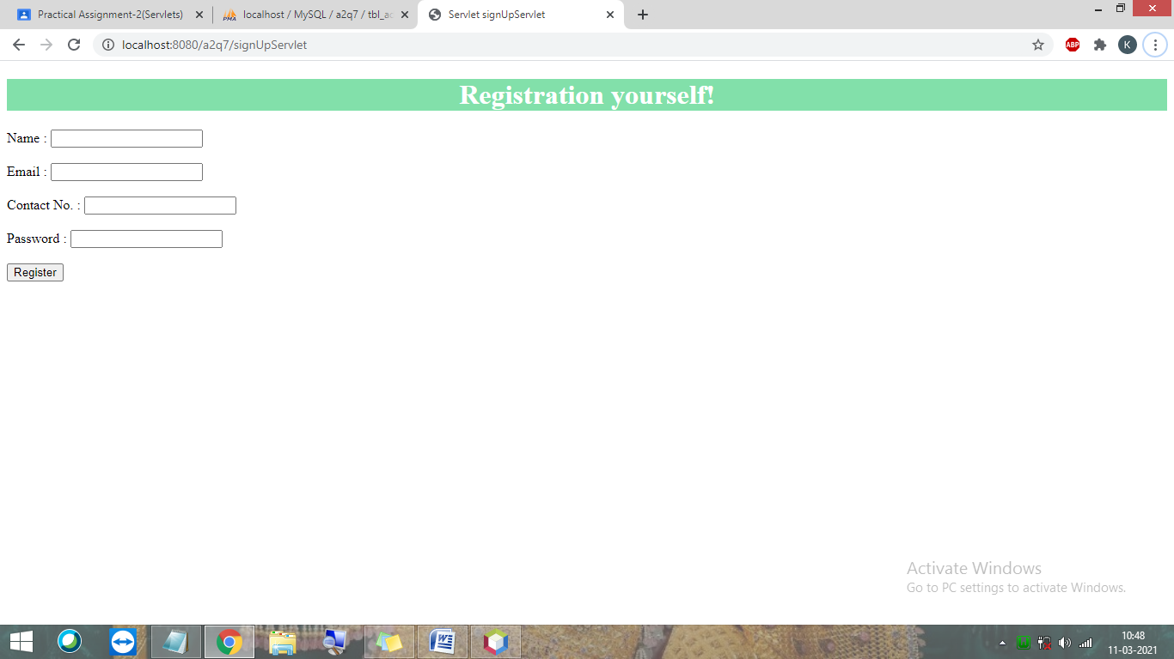
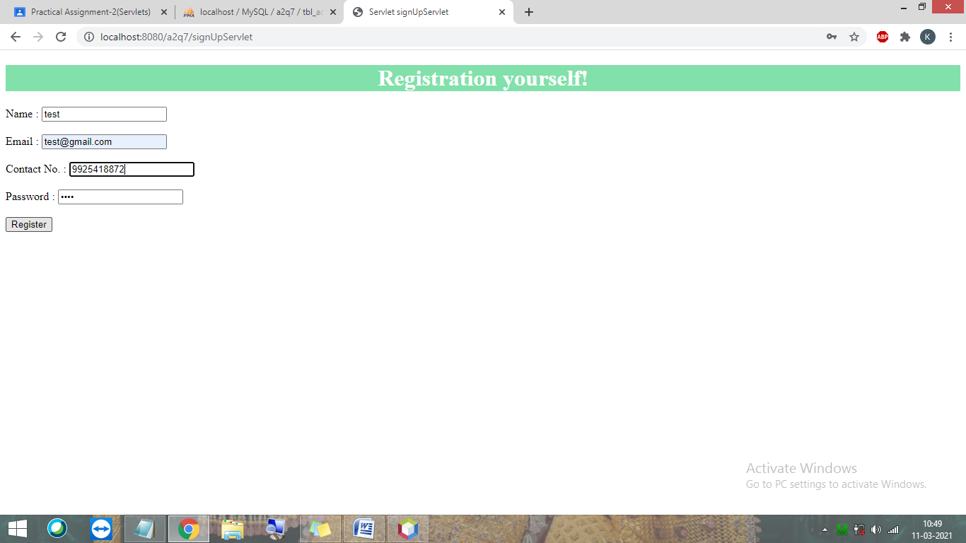

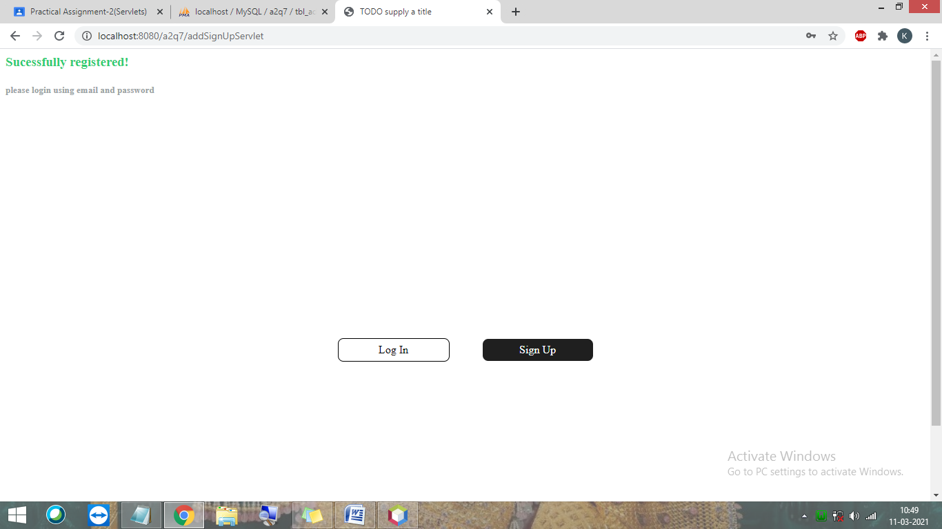

loginServlet.java
/*
* To change this license header, choose License Headers in Project Properties.
* To change this template file, choose Tools | Templates
* and open the template in the editor.
*/
package servlets;

import java.sql.*;
import java.io.IOException;
import java.io.PrintWriter;
import javax.servlet.ServletException;
import javax.servlet.http.HttpServlet;
import javax.servlet.http.HttpServletRequest;
import javax.servlet.http.HttpServletResponse;

public class loginServlet extends HttpServlet {

protected void processRequest(HttpServletRequest request, HttpServletResponse response)
throws ServletException, IOException {
response.setContentType("text/html;charset=UTF-8");
try (PrintWriter out = response.getWriter()) {
/* TODO output your page here. You may use following sample code. */
out.println("<!DOCTYPE html>");
out.println("<html>");
out.println("<head>");
out.println("<title>Servlet loginServlet</title>");
out.println("</head>");
out.println("<body>");
out.println("<form action=\"login1Servlet\" method=\"post\">\n" +
" <h1 align=\"center\">Login</h1>\n" +
" <table>\n" +
" <tr>\n" +
" <th>Enter email : </th>\n" +
" <td><input type=\"text\" name=\"txtEmail\"/></td>\n" +
" </tr>\n" +
" <tr>\n" +
" <th>Enter password : </th>\n" +
" <td><input type=\"text\" name=\"txtPassword\"/></td>\n" +
" </tr>");
out.println("<tr>");
out.println("<td colspan='2' align='center'>");
out.println("<input type='submit' value='Login'/>");
out.println("</td>");
out.println("</tr>");
out.println("</table>");
out.println("</form>");
out.println("</body>");
out.println("</html>");

}
}

// <editor-fold defaultstate="collapsed" desc="HttpServlet methods. Click on the + sign on the left to edit the code.">
/**
* Handles the HTTP <code>GET</code> method.
*
* @param request servlet request
* @param response servlet response
* @throws ServletException if a servlet-specific error occurs
* @throws IOException if an I/O error occurs
*/
@Override
protected void doGet(HttpServletRequest request, HttpServletResponse response)
throws ServletException, IOException {
processRequest(request, response);
}

/**
* Handles the HTTP <code>POST</code> method.
*
* @param request servlet request
* @param response servlet response
* @throws ServletException if a servlet-specific error occurs
* @throws IOException if an I/O error occurs
*/
@Override
protected void doPost(HttpServletRequest request, HttpServletResponse response)
throws ServletException, IOException {
processRequest(request, response);
}

/**
* Returns a short description of the servlet.
*
* @return a String containing servlet description
*/
@Override
public String getServletInfo() {
return "Short description";
}// </editor-fold>

}

servlet1.java
/*
* To change this license header, choose License Headers in Project Properties.
* To change this template file, choose Tools | Templates
* and open the template in the editor.
*/
package servlets;

import java.LoginDao;
import java.io.IOException;
import java.io.PrintWriter;
import javax.servlet.RequestDispatcher;
import javax.servlet.ServletException;
import javax.servlet.http.HttpServlet;
import javax.servlet.http.HttpServletRequest;
import javax.servlet.http.HttpServletResponse;

/**
*
* @author Parth Computer
*/
public class servlet1 extends HttpServlet {

protected void processRequest(HttpServletRequest request, HttpServletResponse response)
throws ServletException, IOException {

response.setContentType("text/html");
PrintWriter out = response.getWriter();

String n=request.getParameter("txtEmail");
String p=request.getParameter("txtPasswd");

if(LoginDao.validate(n, p)){
RequestDispatcher rd=request.getRequestDispatcher("servlet2");
rd.forward(request,response);
}
else{
out.print("Sorry username or password error");
RequestDispatcher rd=request.getRequestDispatcher("index.html");
rd.include(request,response);
}

out.close();
}

}

validateLoginServlet.java
/*
* To change this license header, choose License Headers in Project Properties.
* To change this template file, choose Tools | Templates
* and open the template in the editor.
*/
package servlets;

import java.io.IOException;
import java.io.PrintWriter;
import javax.servlet.ServletException;
import javax.servlet.http.HttpServlet;
import javax.servlet.http.HttpServletRequest;
import javax.servlet.http.HttpServletResponse;
import java.sql.*;
import javax.servlet.RequestDispatcher;
/**
*
* @author Parth Computer
*/
public class validateLoginServlet extends HttpServlet {

/**
* Processes requests for both HTTP <code>GET</code> and <code>POST</code>
* methods.
*
* @param request servlet request
* @param response servlet response
* @throws ServletException if a servlet-specific error occurs
* @throws IOException if an I/O error occurs
*/
protected void processRequest(HttpServletRequest request, HttpServletResponse response)
throws ServletException, IOException {
// response.setContentType("text/html;charset=UTF-8");
// PrintWriter out = response.getWriter();
// /* TODO output your page here. You may use following sample code. */
// out.println("<!DOCTYPE html>");
// out.println("<html>");
// out.println("<head>");
// out.println("<title>Servlet validateLoginServlet</title>");
// out.println("</head>");
// out.println("<body>");
// out.println("<h1>Servlet validateLoginServlet at " + request.getContextPath() + "</h1>");
// out.println("</body>");
// out.println("</html>");
//
HttpServletResponse resp = (HttpServletResponse)response;
HttpServletRequest req = (HttpServletRequest)request;
PrintWriter out=resp.getWriter();
resp.setContentType("text/html");

try{

String url = "jdbc:mysql://localhost/a2q7";
String username = "root";
String password = "";
Connection con = DriverManager.getConnection(url, username, password);
String email = request.getParameter("txtName");
String passwd = request.getParameter("txtEmail");
String query = "select * from tbl_user where email="+email;
Statement stmt = con.createStatement();
ResultSet rs = stmt.executeQuery(query);
while(rs.next()){
if(rs.getString(passwd).equals(passwd)){
response.sendRedirect("displayProductServlet");
// out.println("validated");
}
else{
out.println("invalid");
}
break;
}
// out.println("invalidate");
// RequestDispatcher rd = req.getRequestDispatcher("loginServlet");
// rd.include(request, response);

}catch(Exception ex){
out.println("Error : "+ex.getMessage());
}
}

// <editor-fold defaultstate="collapsed" desc="HttpServlet methods. Click on the + sign on the left to edit the code.">
/**
* Handles the HTTP <code>GET</code> method.
*
* @param request servlet request
* @param response servlet response
* @throws ServletException if a servlet-specific error occurs
* @throws IOException if an I/O error occurs
*/
@Override
protected void doGet(HttpServletRequest request, HttpServletResponse response)
throws ServletException, IOException {
processRequest(request, response);
}

/**
* Handles the HTTP <code>POST</code> method.
*
* @param request servlet request
* @param response servlet response
* @throws ServletException if a servlet-specific error occurs
* @throws IOException if an I/O error occurs
*/
@Override
protected void doPost(HttpServletRequest request, HttpServletResponse response)
throws ServletException, IOException {
processRequest(request, response);
}

/**
* Returns a short description of the servlet.
*
* @return a String containing servlet description
*/
@Override
public String getServletInfo() {
return "Short description";
}// </editor-fold>

}

