Sri Lanka Institute of Information
Technology


PULSEOS
Web-Based Hospital Management System
Proposal Report

Year 2 Semester 1
BATCH 02 | Group 60 | 2026-Y2-S1-KU-60
Submission Date: 7ᵗʰ August 2026

STUDENT ID | STUDENT NAME
IT25103819 | Somarathna P.C.D.S
IT25103999 | Rathnayaka R.M.K.L.B
IT25101620 | Malwatta M.W.C.S
IT25100826 | Udumullage S.H.U
IT25103992 | Dhanasinghe K.A.K.H
IT25103363 | Thilakarathne H.S.K.P.N

Software Engineering | SE2030
B.Sc. (Hons) in Information Technology

TABLE OF CONTENTS

1. Introduction .............................................................................................. 3
1.1 Project Background .............................................................................. 3
1.2 Project Objectives ................................................................................ 3
1.3 Target Users ......................................................................................... 3
1.4 Scope and Limitations .......................................................................... 4
2. System Overview Diagram ........................................................................ 5
3. Functional Requirements .......................................................................... 6
4. Non-Functional Requirements .................................................................. 6
5. Major Stakeholders / Users ...................................................................... 6
6. Six Major Functions ................................................................................... 7
6.1 Patient Management ........................................................................... 7
6.2 Doctor Management ............................................................................ 7
6.3 Appointment Management ................................................................. 7
6.4 Inventory & Pharmacy Management ................................................... 8
6.5 Billing & Payment Management .......................................................... 8
6.6 Laboratory & Test Management .......................................................... 8
7. Minor Functions ........................................................................................ 9
7.1 User Authentication ............................................................................. 9
7.2 Password Recovery .............................................................................. 9
7.3 Role-Based Access Control ................................................................... 9
7.4 Audit Logs ............................................................................................. 9
7.5 Reporting .............................................................................................. 9
8. System Limitations and Constraints ....................................................... 10
9. Simple Project Timeline .......................................................................... 11
10. Conclusion ............................................................................................. 11
10.1 Importance ....................................................................................... 11
10.2 Feasibility .......................................................................................... 11
10.3 Value ................................................................................................ 11
10.4 Closing Remarks ............................................................................... 11

Introduction

Project Background
Hospitals manage large volumes of patient information, appointments, prescriptions, laboratory tests, medicine inventories, and financial transactions every day. Many healthcare institutions still rely on manual record-keeping systems or disconnected software applications, which often result in delays, errors, duplicate data entry, and communication difficulties between departments.
These challenges can negatively affect patient care, staff productivity, and overall hospital efficiency. Long waiting times, misplaced records, inventory shortages, and billing inaccuracies are common issues that can arise from inefficient hospital management practices.
PulseOS is proposed as a web-based Hospital Management System that centralizes key hospital operations into a single platform. The system aims to streamline processes, improve communication, reduce paperwork, and provide secure access to healthcare information.

Project Objectives
The main objectives of PulseOS are:
    - To digitize hospital administrative and operational activities.
    - To maintain accurate and centralized patient records.
    - To improve doctor and staff management.
    - To streamline appointment scheduling processes.
    - To manage pharmacy inventory efficiently.
    - To automate billing and payment operations.
    - To simplify laboratory test management.
    - To improve communication among hospital departments.
    - To enhance data security and confidentiality.

Target Users
PulseOS is designed for several stakeholders who interact with the system based on their responsibilities within the hospital. Each user is provided with role-based access permissions to ensure secure and efficient use of the system.
System Administrator
Manages user accounts, system settings, security controls, and overall system maintenance.
Doctor
Reviews patient records, provides diagnoses, prescribes medications, and requests laboratory tests.
Nurse
Monitors patient conditions, updates nursing records, and assists doctors in providing patient care.
Receptionist
Registers patients, schedules appointments, manages admissions, and supports administrative activities.
Pharmacist
Dispenses medicines, manages pharmacy inventory, and maintains medicine stock records.
Laboratory Technician
Processes laboratory test requests, records test results, and generates laboratory reports.
Patient
Books appointments, accesses medical information, views laboratory reports, and reviews billing details.

Scope and Limitations

Scope

PulseOS covers major hospital operations including patient management, doctor management, appointment scheduling, pharmacy and inventory management, billing and payment processing, laboratory test management, and secure user authentication. The system provides a centralized platform that allows different hospital departments to access and share information efficiently.

Limitations

The system requires internet connectivity and operates through web browsers. The first version of the system will focus only on core hospital functions and will not include integrations with insurance providers, government healthcare systems, or third-party medical platforms. The effectiveness of the system depends on accurate data entered by users and may require basic training for hospital staff.

- System Overview Diagram
PulseOS follows a three-layer architecture consisting of the User Layer, Application Layer, and Database Layer with six integrated modules connected through a centralized database.
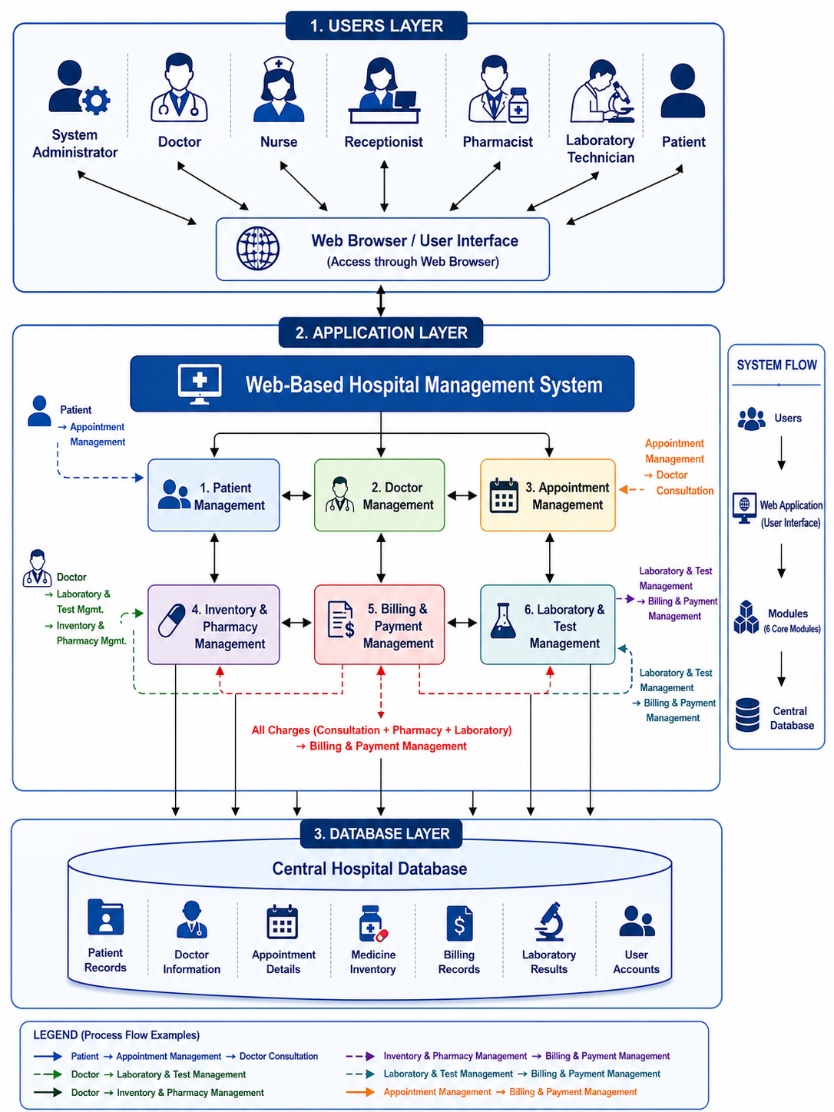

Functional Requirements
Patient Management
Manages patient registration, personal information, medical history, and treatment records.
Doctor Management
Manages doctor profiles, qualifications, specializations, and schedules.
Appointment Management
Handles appointment booking, scheduling, rescheduling, and cancellation.
Inventory & Pharmacy Management
Maintains medicine inventory, prescriptions, and dispensing activities.
Billing & Payment Management
Handles invoices, payments, receipts, and financial records.
Laboratory & Test Management
Manages laboratory test requests, test results, and laboratory reports.

Non-Functional Requirements
Security
The system must ensure secure access to data through authentication, authorization, and data protection mechanisms.
Performance
The system should provide fast response times and support multiple users simultaneously without performance degradation.
Reliability
The system should maintain continuous availability and protect data through backup and recovery procedures.
Usability
The system should be easy to learn, user-friendly, and accessible to users with basic computer knowledge.
Scalability
The system should support future expansion in terms of users, departments, and functionalities.
Maintainability
The system should be designed in a way that makes future updates, bug fixes, and enhancements easier to implement.

Major Stakeholders / Users


System Administrator
Manages user accounts, access permissions, security settings, and the overall operation of the PulseOS system.

Doctor

Provides patient diagnosis and treatment by reviewing medical records, prescribing medication, and requesting laboratory tests.

Nurse

Supports patient care by monitoring patient conditions, updating medical records, and following doctors' treatment instructions.


Receptionist
Handles patient registration, appointment scheduling, admissions, and basic billing-related activities.

Pharmacist

Manages medicine inventory, dispenses prescribed medications, and maintains accurate pharmacy records.

Laboratory Technician

Performs laboratory tests, records test results, and ensures reports are available to doctors promptly.


Patient
Uses the system to manage appointments, view medical reports, track payments, and access personal health information.

Six Major Functions

Patient Management ( Somarathna P.C.D.S – IT25103819 )
Description
The Patient Management module serves as the central repository for storing and managing patient information throughout the patient's interaction with the hospital.
Who Will Use It?
Receptionist Doctor Nurse Patient
System Administrator
What It Does
This module registers patients, maintains medical records, stores health-related information, and provides authorized users with access to patient data.

CRUD Operations
    - Create: Creates new patient profiles and medical records for newly registered patients.
    - Read: Retrieves patient personal information, medical histories, diagnoses, and treatment records.
    - Update: Updates patient details, contact information, medical histories, and treatment information.
    - Delete: Archives or removes inactive, duplicate, or invalid patient records when required.

Expected Outcome: Provides accurate and centralized patient information, reducing paperwork and improving the quality of patient care.

Doctor Management ( Rathnayaka R.M.K.L.B – IT25103999 )
Description
The Doctor Management module manages information related to doctors, including professional details, specializations, qualifications, and consultation schedules.
Who Will Use It?
System Administrator Doctor
Receptionist
What It Does
This module maintains doctor records and schedules to support effective staff management and appointment coordination.

CRUD Operations
    - Create: Creates doctor profiles, consultation schedules, and specialization records.
    - Read: Retrieves doctor information, schedules, qualifications, and availability details.
    - Update: Updates doctor profiles, schedules, qualifications, and availability status.
    - Delete: Archives or removes inactive, retired, or duplicate doctor records.

Expected Outcome: Improves doctor scheduling, staff administration, and efficient allocation of medical resources.

Appointment Management ( Malwatta M.W.C.S – IT25101620 )
Description
The Appointment Management module handles all activities related to scheduling and managing patient appointments.
Who Will Use It?
Patient Receptionist Doctor Nurse
What It Does
This module allows appointments to be booked, viewed, updated, rescheduled, and cancelled while maintaining an organized consultation schedule.

CRUD Operations
    - Create: Creates new appointment bookings between patients and doctors.
    - Read: Retrieves appointment details, schedules, statuses, and appointment history records.
    - Update: Updates appointment times, dates, statuses, and consultation schedules.
    - Delete: Cancels or removes appointments that are no longer required.

Expected Outcome: Reduces appointment conflicts, improves scheduling efficiency, and minimizes patient waiting times.

Inventory & Pharmacy Management ( Udumullage S.H.U – IT25100826 )

CRUD Operations
Description
The Inventory & Pharmacy Management module manages medicine inventory, stock records, prescriptions, suppliers, and medicine dispensing activities.
Who Will Use It?
Pharmacist Doctor
System Administrator
What It Does
This module monitors medicine availability, manages stock levels, processes prescriptions, and records medicine dispensing activities.
    - Create: Creates medicine records, inventory entries, supplier records, and stock transactions.
    - Read: Retrieves medicine information, inventory records, prescription details, and stock levels.
    - Update: Updates stock quantities, medicine details, supplier information, and inventory balances.
    - Delete: Archives or removes expired, damaged, discontinued, or duplicate medicine records.

Expected Outcome: Improves inventory control, reduces medicine shortages, and ensures the availability of medications when required.

Billing & Payment Management ( Dhanasinghe K.A.K.H – IT25103992 )
Description
The Billing & Payment Management module manages financial transactions, patient invoices, payments, and hospital billing records.
Who Will Use It?
Receptionist Patient
System Administrator Pharmacist
What It Does
This module generates bills, records payments, manages invoices, and maintains financial information related to hospital services.

CRUD Operations
    - Create: Creates invoices, payment records, billing transactions, and payment receipts.
    - Read: Retrieves billing details, transaction histories, payment records, and financial reports.
    - Update: Updates payment statuses, invoice information, and billing records.
    - Delete: Cancels or removes incorrect, duplicate, or invalid billing records.

Expected Outcome: Provides accurate billing, improves payment processing, and supports efficient financial management.

Laboratory & Test Management ( Thilakarathne H.S.K.P.N – IT25103363 )

CRUD Operations
Description
The Laboratory & Test Management module manages laboratory test requests, sample information, result recording, and report generation.
Who Will Use It?
Laboratory Technician Doctor
Nurse Patient
What It Does
This module supports the complete laboratory testing process by managing test requests, processing results, and providing reports to authorized users.
    - Create: Creates laboratory test requests, sample records, and laboratory testing entries.
    - Read: Retrieves test requests, result records, laboratory reports, and patient test histories.
    - Update: Updates laboratory results, test statuses, verification records, and report information.
    - Delete: Cancels or removes invalid, duplicate, or obsolete laboratory test records.

Expected Outcome: Improves laboratory efficiency, reduces delays in diagnosis, and ensures timely access to accurate test results.

- Minor Functions




7.4 Audit Logs
Records important system activities for monitoring and accountability purposes.
Features
Login Tracking Activity Monitoring
Record Modification Logs
Transaction Logs
7.3 Role-Based Access Control
Controls access permissions according to user roles and responsibilities.
Features
Role Management Permission Assignment Access Restrictions
7.2 Password Recovery
Allows users to securely recover and reset the forgotten passwords.
Features
Forgot Password Email Verification Password Reset
7.1 User Authentication
Provides secure login and logout functionality for authorized users.
Features
Login Logout
Session Management

7.5 Reporting
Generates reports that support hospital monitoring and decision-making.
Features
Patient Reports Appointment Reports Billing Reports Pharmacy Reports Laboratory Reports

- System Limitations and Constraints

Although PulseOS is designed to improve hospital operations significantly, several limitations and constraints must be considered.
Internet Dependency
Since PulseOS is a web-based application, users must have a stable internet connection to access system functionalities. Network failures may temporarily interrupt access to hospital information.
User Training Requirement
Hospital staff may require training to understand the system features, workflows, and security practices.
Improper usage may reduce the effectiveness of the system.
Data Accuracy
The accuracy of reports and records generated by the system depends on the quality of data entered by users. Incorrect or incomplete information may affect decision-making and patient care.
Infrastructure Requirement
The hospital must maintain suitable servers, computer systems, and network resources to ensure smooth operation and acceptable performance.
Integration Constraints
The initial version of PulseOS will not support integration with external healthcare systems, insurance services, or government medical databases.
Security Risks
Although security controls will be implemented, regular system updates, monitoring, and maintenance are required to protect against cybersecurity threats.
Maintenance Requirement
The system requires regular software updates, database backups, and technical support to maintain reliability and prevent data loss.
Browser-Based Operation
The system is designed primarily for web browser access and does not include dedicated mobile or desktop applications in the first version.

- Simple Project Timeline

Week | Planned Activities
Week 3 | Identify the project scope, define the six major functions, gather initial requirements, and prepare the system proposal.
Week 4 | Conduct stakeholder interviews, analyze requirements, document functional and non-functional requirements, and identify system constraints.
Week 5 | Create the system architecture, use case diagram, and define user roles, permissions, and major system workflows.
Week 6 | Design the database structure (ER Diagram), define entities and relationships, and prepare UI wireframes for all modules.
Week 7 | Set up the development environment, configure the database, implement user authentication, and begin developing the Patient Management module.
Week 8 | Develop the Doctor Management and Appointment Management modules including CRUD operations and input validations.
Week 9 | Develop the Inventory & Pharmacy Management and Laboratory & Test Management modules and establish database connectivity.
Week 10 | Develop the Billing & Payment Management module and integrate completed modules with the centralized database.
Week 11 | Implement Role-Based Access Control (RBAC), Reporting, Audit Logs, and complete the remaining system functionalities.
Week 12 | Perform module integration testing, verify data flow between modules, fix identified bugs, and improve system stability.
Week 13 | Conduct system testing, validate all CRUD operations, improve user interface consistency, and optimize performance.
Week 14 | Complete final refinements, perform user acceptance testing, finalize documentation, and prepare the system for deployment.

- Conclusion
10.4 Closing Remarks
PulseOS is expected to provide a practical and reliable solution for modernizing hospital operations. By integrating patient management, appointment scheduling, pharmacy services, billing functions, and laboratory operations into one platform, the system will support better healthcare delivery and improved hospital performance.

10.3 Value
The proposed system improves operational efficiency, enhances patient care, strengthens data management, and supports better decision-making through accurate information and reporting.

10.2 Feasibility
The project is technically feasible using modern web development technologies, database systems, and standard computing infrastructure available in healthcare institutions.

10.1 Importance
PulseOS addresses common hospital management challenges by integrating major hospital operations into a centralized digital platform, improving efficiency and reducing manual work.

