Sri Lanka Institute of Information
Technology



PULSEOS
Web-Based Hospital Management System
DESIGN DOCUMENT

Year 2 Semester 1
BATCH 02 | Group 60 | 2026-Y2-S1-KU-60
Submitted on 27th September 2026

Member | Student ID
Somarathna P.C.D.S | IT25103819
Rathnayaka R.M.K.L.B | IT25103999
Malwatta M.W.C.S | IT25101620
Udumullage S.H.U | IT25100826
Dhanasinghe K.A.K.H | IT25103992
Thilakarathne H.S.K.P.N | IT25103363

Software Engineering | SE2030
B.Sc. (Hons) in Information Technology
1. Agile Sprint & Project Management
1.1 Sprint Methodology Overview
PulseOS follows the Scrum lifecycle, with development divided into four 2-week iterations (sprints) running from Week 3 to Week 13. Each sprint draws a focused set of Product Backlog Items (PBIs) from the six project personas (Receptionist, Doctor, Patient, Pharmacist, Laboratory Technician, System Administrator). PBIs are assigned on a person-ownership basis: each of the six team members owns one functional module end-to-end — requirements, design, implementation, and testing — for every PBI within that module across all four sprints, rather than PBIs being reassigned sprint to sprint. This keeps accountability clear and avoids duplicated effort across members.
1.2 Completed Sprint Histories (Sprints 1–3)
Sprint | Sprint Goal | Key PBIs Addressed | Status | Key Deliverables
Sprint 1 | Establish system foundation: user access and core registration/booking. | PBI-21, PBI-22, PBI-01, PBI-09, PBI-03, PBI-10 | Completed | User accounts & RBAC, patient registration module, appointment booking workflow
Sprint 2 | Enable core medical operations: records, prescriptions, lab requests. | PBI-05, PBI-07, PBI-08, PBI-13, PBI-17, PBI-19 | Completed | Medical-history view, prescription creation, lab test request & result entry
Sprint 3 | Complete pharmacy, billing and laboratory reporting features. | PBI-14, PBI-15, PBI-16, PBI-04, PBI-11, PBI-20 | Completed | Inventory management, low-stock alerts, bill generation, laboratory report generation
1.3 Individual Task Allocation Matrix
The table below is the single master reference mapping each team member to their functional module ownership across the entire project. Full PBI-level traceability — including which sprint each backlog item was delivered in and its current status — is provided in the Sprint Progress & Backlog Tracking table in Section 1.5.
Member | IT Number | Scrum Role | Module Owned
Somarathna P.C.D.S | IT25103819 | Product Owner | Patient Management
Rathnayaka R.M.K.L.B | IT25103999 | Scrum Master | Doctor Management
Malwatta M.W.C.S | IT25101620 | Developer | Appointment Management
Udumullage S.H.U | IT25100826 | Developer | Inventory & Pharmacy Management
Dhanasinghe K.A.K.H | IT25103992 | Developer | Billing & Payment Management
Thilakarathne H.S.K.P.N | IT25103363 | Developer | Laboratory & Test Management
1.4 Remaining Backlog & Mitigation Plan
Of the original 24 Product Backlog Items, 22 (92%) are now complete. Only two System Administration items remain outstanding: PBI-23 (Monitor Audit Logs) and PBI-24 (Generate Operational Reports). Both are jointly owned by the team as part of the cross-cutting System Administration module, consistent with the Authentication module's shared ownership model.
Sprint | Planned Goal | Remaining PBIs / Tasks | Responsible Members | Expected Deliverable
Sprint 4 (Continuation) | Complete the two remaining System Administration functions so that all 24 planned backlog items are fully implemented. | PBI-23 – Monitor Audit Logs; PBI-24 – Generate Operational Reports | Team (System Administration – joint ownership) | Fully functional audit-logging and reporting modules; Product Backlog reaches 24/24 (100%) completion

To accelerate completion, the remaining work is split into two pair-programming assignments rather than being handled by a single member in isolation. Somarathna (Product Owner) is paired with Udumullage on PBI-23 (Monitor Audit Logs), since the Inventory & Pharmacy module already implements a similar event-triggered pattern for low-stock alerts that can be adapted for logging audit events. Rathnayaka (Scrum Master) is paired with Dhanasinghe on PBI-24 (Generate Operational Reports), since the Billing module's existing bill-aggregation logic provides a direct template for summarising operational data such as appointment volumes and billing totals. Pairing reduces the risk of a single point of failure on the two remaining items and allows each pair to review the other's work before the Final Evaluation.
1.5 Sprint Progress & Backlog Tracking
The table below provides item-level traceability for all 24 Product Backlog Items, showing the sprint each item was delivered (or is planned for) and its current status.
PBI | Backlog Item (Task) | Status (Sprint + Done/Planned)
PBI-01 | Register new patient profile | Sprint 1 – Done
PBI-02 | Update existing patient profile | Sprint 4 – Done
PBI-03 | Book new appointment | Sprint 1 – Done
PBI-04 | Generate consolidated patient bill | Sprint 3 – Done
PBI-05 | Create / manage doctor profile | Sprint 2 – Done
PBI-06 | Update patient treatment record | Sprint 4 – Done
PBI-07 | View doctor's schedule | Sprint 2 – Done
PBI-08 | Update doctor availability | Sprint 2 – Done
PBI-09 | View patient medical history | Sprint 1 – Done
PBI-10 | Cancel / update existing appointment | Sprint 1 – Done
PBI-11 | Process laboratory test | Sprint 3 – Done
PBI-12 | View patient-facing billing summary | Sprint 4 – Done
PBI-13 | Manage medicine inventory catalogue | Sprint 2 – Done
PBI-14 | Update medicine stock levels | Sprint 3 – Done
PBI-15 | Generate low-stock alert | Sprint 3 – Done
PBI-16 | Dispense medication to patient | Sprint 3 – Done
PBI-17 | Request laboratory test | Sprint 2 – Done
PBI-18 | Track / update laboratory test status | Sprint 4 – Done
PBI-19 | Record laboratory test results | Sprint 2 – Done
PBI-20 | Generate laboratory report | Sprint 3 – Done
PBI-21 | Create user account & assign role (RBAC) | Sprint 1 – Done
PBI-22 | User login, logout & password reset | Sprint 1 – Done
PBI-23 | Monitor audit logs | Sprint 4 – Planned
PBI-24 | Generate operational reports | Sprint 4 – Planned

The table below tracks cumulative Product Backlog completion sprint by sprint, giving a single reference point for overall project progress against the Week 10 milestone and showing exactly how many items remain.
Sprint | PBIs Planned | PBIs Completed | Cumulative % Complete
Sprint 1 | 6 | 6 | 25%
Sprint 2 | 6 | 6 | 50%
Sprint 3 | 6 | 6 | 75%
Sprint 4 | 6 | 4 (2 remaining) | 92% (target: 100%)

2. Final Use Case Diagram
2.1 System Boundary Scope
PulseOS's core system boundary covers everything that can be digitised as data entry, validation, storage, or retrieval: patient registration and record-keeping, appointment scheduling, prescription creation and medicine dispensing records, billing and payment processing, and laboratory test request/result tracking. It does not attempt to digitise or automate the physical, real-world actions that surround these records — for example, PulseOS records that a laboratory sample was collected and logs its status, but the physical collection of the sample, the doctor's clinical judgement in diagnosis, the physical handling of cash payments, and the manufacturing or physical dispensing of medication itself all remain manual hospital actions outside the system. The boundary is drawn so that PulseOS supports and records the administrative and informational side of these processes without replacing clinical or physical responsibility.

2.2 Diagram Notation & Relationship Rules
- System boundary: all use cases are grouped within the “PULSEOS – Web Based Hospital Management System” boundary box, with each module further grouped in its own colour-coded box, so the diagram visually separates what belongs to the system from what does not.
- <<extend>> was chosen specifically for Recover Password extending Login, because password recovery is optional and conditional behaviour — it is only invoked when a normal login attempt fails, rather than being part of every login attempt. This distinguishes it from a mandatory step.
- <<include>> was chosen for relationships such as Dispense Medication and Process Laboratory Test referencing Billing, because these represent a mandatory dependency check: dispensing medication or completing a laboratory test must always trigger a billing entry, with no valid path where that dependency is skipped.
- Actor generalisation: an abstract “System User” actor generalises all six concrete actors for shared Login, Logout, and Recover Password behaviour, avoiding repeated associations for every actor and reflecting that authentication rules apply identically regardless of role.
● Actor duplication: several actors — including Doctor, Patient, Receptionist, and System Administrator — appear more than once across the diagram. Each recurring icon represents the same actor; duplication is used purely as a layout technique to keep connector lines short and local to the module being described, avoiding long crossing lines across the diagram.

2.3 Use Case Diagram

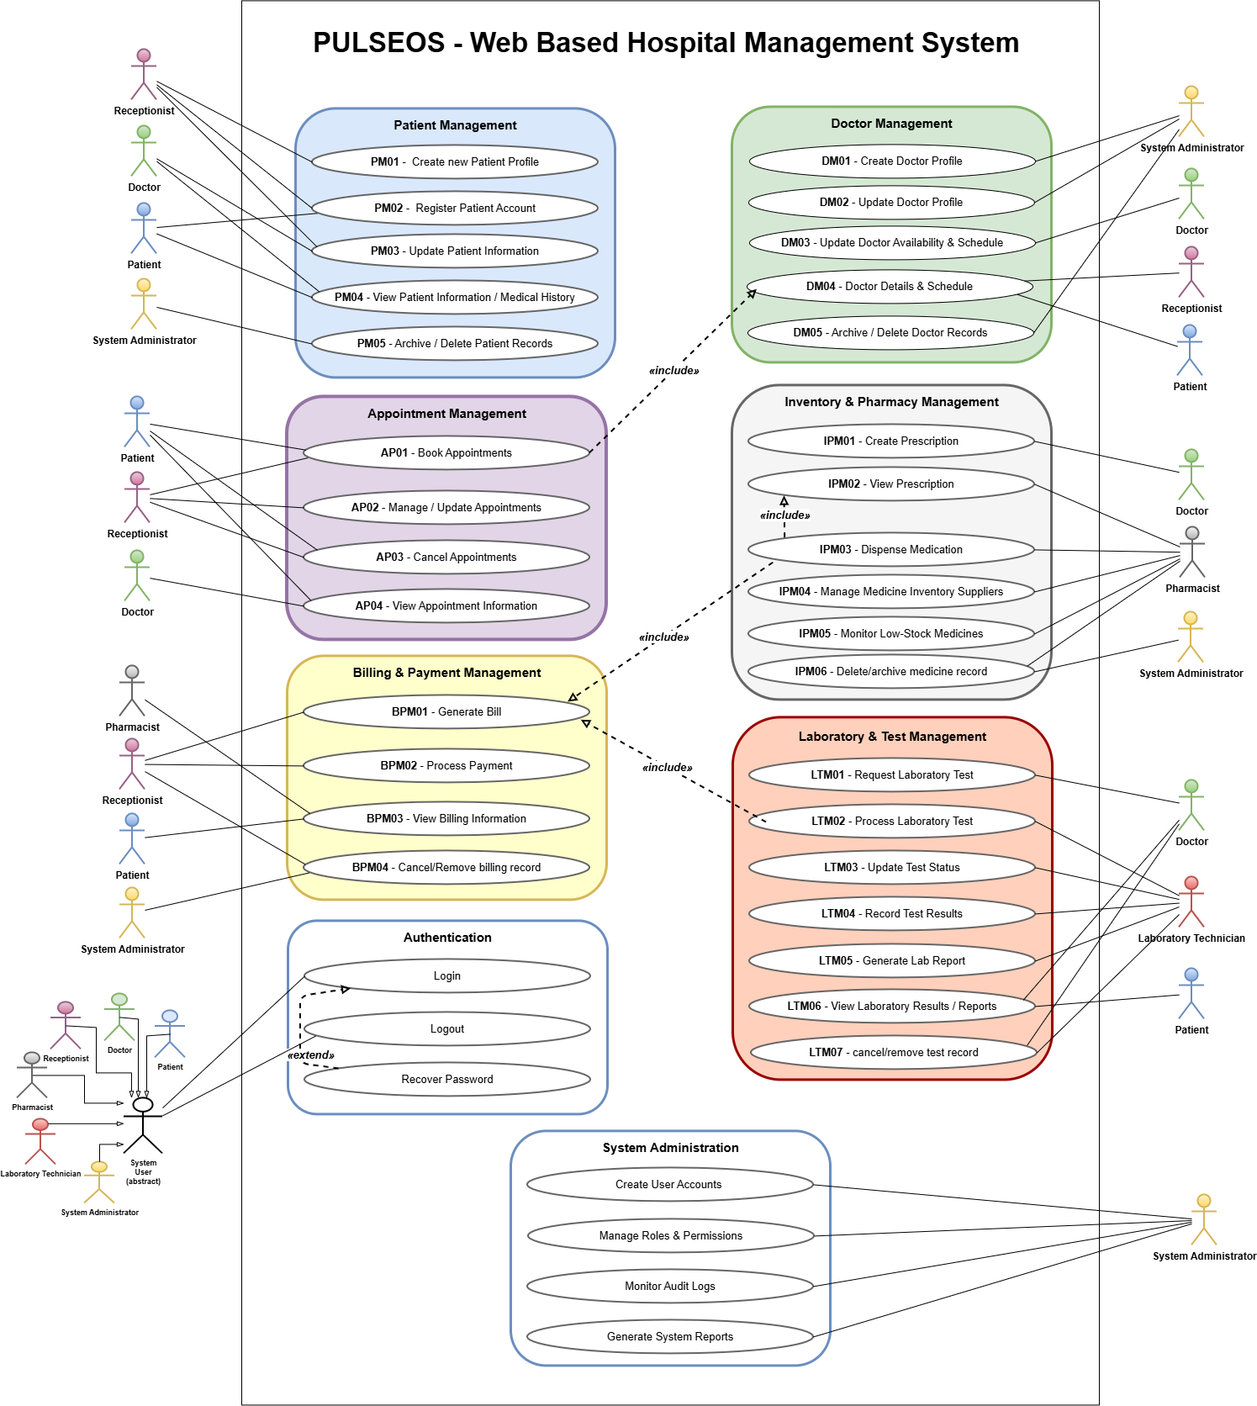
Figure 2.1: PulseOS – Final Use Case Diagram
3. Class Diagram
3.1 Application Architectural Pattern
PulseOS follows a layered (N-tier) architecture. The Presentation layer (Servlet/JSP or MVC controllers) handles user interaction across the six standard functional modules and routes requests to the appropriate service. The Business/Service layer contains the application and validation logic that operates on the data represented in the class diagram — for example, stock-threshold checks for Drugs, payment validation for Invoices and Payments, and laboratory test processing — independently of the user interface. The Data Access layer uses the DAO / repository approach to provide persistence operations for the entities documented in Section 3.4. The technical class diagram represents the entities, attributes and relationships used by the system, while application behaviour is implemented in the Business/Service layer. This separation supports modular development across Patient Management, Doctor Management, Appointment Management, Inventory & Pharmacy Management, Billing & Payment Management, and Laboratory & Test Management, with System Administration providing cross-cutting access and control functions.
3.2 Technical Class Diagram
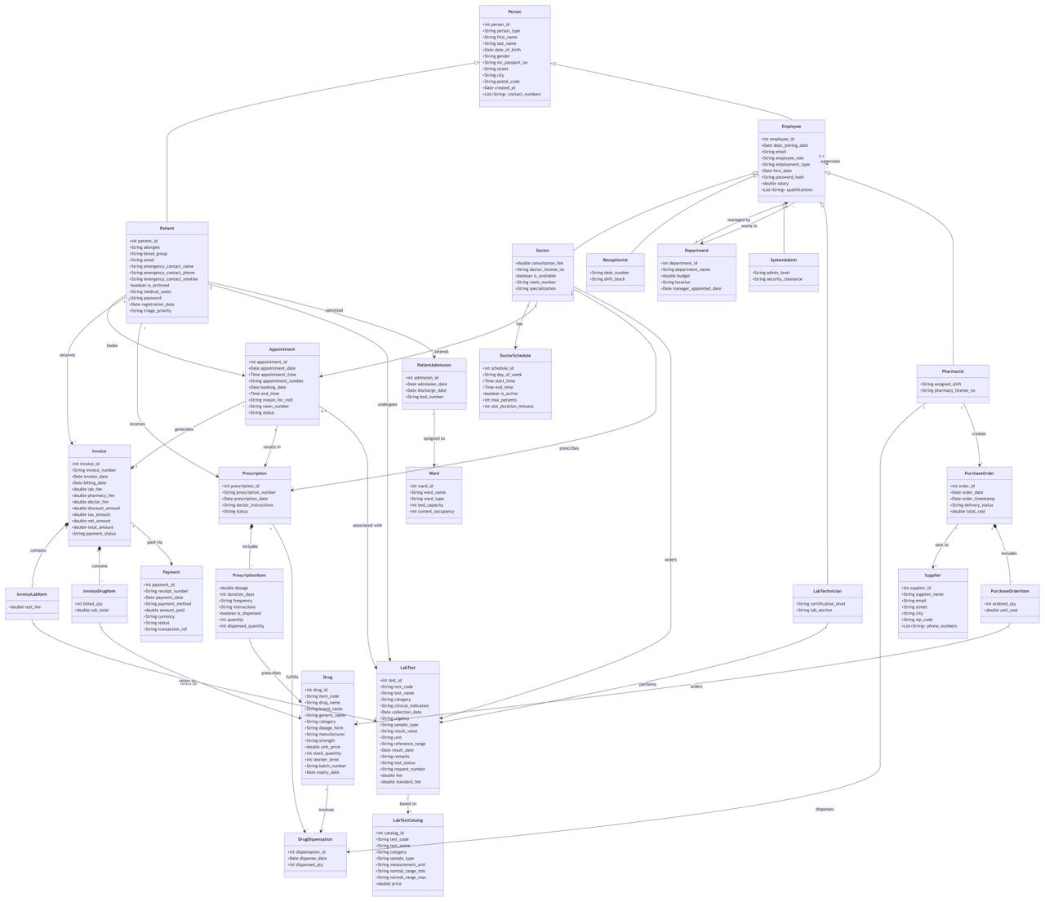
Figure 3.1: PulseOS – Technical Class Diagram (Entities, Attributes, Keys & Relationships)
3.3 Notation and Conventions
- Entity box (header + attribute compartment): each entity in the class diagram is drawn as a rectangle with a title bar naming the entity and a single compartment listing its attributes. Because this section documents the system's structural model rather than implementation-level methods, no separate method compartment is shown; application behaviour is implemented in the Service layer described in Section 3.1.
- Primary-key marking: the key attribute shown at the top of an entity identifies the record within that entity.
- Relationship references: the connecting lines and arrow directions in the class diagram show how entities are associated, such as Patients with Appointments, Doctors with Schedules and Appointments, and Invoices with Payments and billing items.
- Data-type notation: each attribute is preceded by a type indicator such as int, String, Date, Time, boolean, double or List<String>, as shown in the class diagram.
- Relationship notation: directed association lines and labelled relationships are used to show how one entity interacts with another, following the connections visible in the class diagram.
- Generalisation: Patients and Employees are specialised from Person, while Doctors, Receptionists, Pharmacists, Lab_Technicians and System_Admins are specialised from Employee. The class diagram shows these parent–specialisation relationships directly.
- Dependent entities: Invoice_Lab_Items, Invoice_Drug_Items, Prescription_Items and Purchase_Order_Items represent detail records belonging to their respective parent transactions. Their dependency is shown through the relationships in the class diagram.
3.4 Design and Architectural Patterns Used in Implementation
Pattern | How Is It Implemented | Why Is It Implemented
MVC (Model–View–Controller) | The Presentation layer separates views and controllers from the Business/Service layer, while the Data Access layer handles persistence. | Separates presentation, application logic and data access so the system is easier to maintain and update.
DAO / Repository | DAO/Repository components provide database access for modules such as Patient Management, Appointment Management, Pharmacy, Billing and Laboratory, keeping SQL/database operations outside business logic. | Separates persistence operations from business logic and provides a consistent way to access the relational data.
Strategy | Billing & Payment Management can use separate payment-processing strategies for Cash, Card and Health Insurance, selected according to the payment method. | Encapsulates payment-method-specific validation and processing and avoids scattering payment-specific branching logic through the billing service.

4. Activity Diagrams
4.1 Behavioral Overview
This section traces the step-by-step execution logic of the six core member-assigned functions, focusing on branching decisions and error routes rather than on who the actors are (already covered in Section 2) or what data fields are involved (covered in Section 3). Each workflow is presented as a Primary Success Flow — the expected successful execution sequence — followed by its Alternative & Exception Paths, which define what happens at each decision point when execution diverges from the expected outcome.
4.2 Activity Diagram Task Allocation
The table below maps each activity diagram figure in this section to its corresponding use case, functional module, and the team member who owns and presents that workflow.
Figure No | Use Case | Module | Member Name
Figure 4.1 | Create New Patient Profile (PM01) | Patient Management | Somarathna P.C.D.S
Figure 4.2 | Create Doctor Profile (DM01) | Doctor Management | Rathnayaka R.M.K.L.B
Figure 4.3 | Book Appointment (AP01) | Appointment Management | Malwatta M.W.C.S
Figure 4.4 | Dispense Medication (IPM03) | Inventory & Pharmacy Management | Udumullage S.H.U
Figure 4.5 | Process Payment (BPM02) | Billing & Payment Management | Dhanasinghe K.A.K.H
Figure 4.6 | Process Laboratory Test (LTM02) | Laboratory & Test Management | Thilakarathne H.S.K.P.N
4.3 Notation
- Start / End nodes: every one of our six diagrams begins with a single start node (filled circle) representing the actor's initial action — e.g. “Select Create New Patient Profile” — and ends at a filled circle with a ring representing a completed or terminated outcome, such as a confirmation message or a rejected booking.
- Action (rounded rectangle): each rounded rectangle in our diagrams is either a user-driven step (e.g. “Enter patient personal, contact & demographic details”) or a system-driven step (e.g. “Generate unique Patient ID & save profile”). This distinction shows exactly where responsibility shifts between the actor and the system during each workflow.
- Decision (diamond): every diamond in our six diagrams corresponds directly to a validation or business-rule check drawn from the class/entity diagram in Section 3 — for example, the duplicate-NIC check in Patient Management queries the Persons entity's nic_passport_no attribute (inherited by Patients), and the stock-sufficiency check in Inventory & Pharmacy Management maps directly to the Drugs entity's stock_quantity and reorder_level attributes. This is the logical link between Sections 3 and 4: the diamonds here are the runtime expression of validation logic that operates over the attributes defined in the class/entity diagram.
- Guard conditions: each branch out of a diamond is labelled with the exact condition it represents (e.g. [duplicate NIC found], [insufficient stock], [equipment failure]) rather than a generic Yes/No, so the diagram documents precisely which business rule is enforced at each decision point.
- Flow arrows: in every diagram, a failed validation loops back to an earlier action step (e.g. back to data entry) rather than terminating, reflecting that most exceptions in PulseOS are recoverable by the user correcting their input; only a small number of terminal conditions (e.g. appointment limit exceeded, equipment failure) route to a separate end node instead.

4.4 Patient Management (Somarathna P.C.D.S)
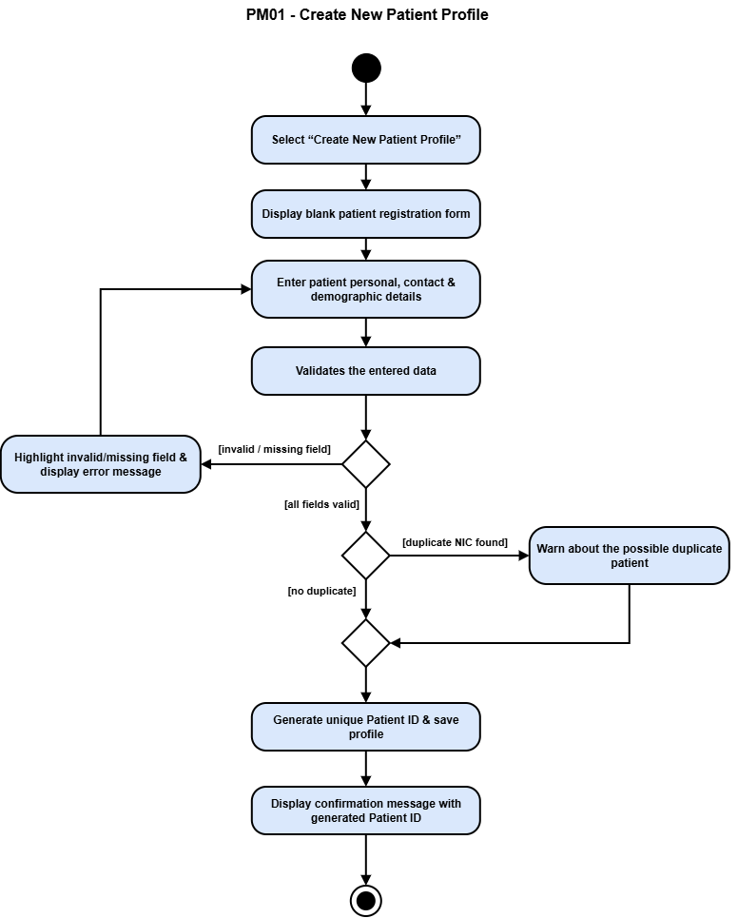
Figure 4.1: Patient Management Activity Diagram (PM01 – Create New Patient Profile)
Primary Success Flow
- Receptionist selects Create New Patient Profile and enters personal, contact, and demographic details.
- System validates all mandatory fields → all fields valid.
- System checks the entered NIC against existing records → no duplicate found.
- System generates a unique Patient ID, saves the profile, and displays a confirmation message.
Alternative & Exception Paths
- [invalid / missing field] → the form highlights the error and routes back to data entry for correction.
- [duplicate NIC found] → the system displays a warning so the receptionist can confirm this is genuinely a new patient before the flow continues.

4.5 Doctor Management (Rathnayaka R.M.K.L.B)
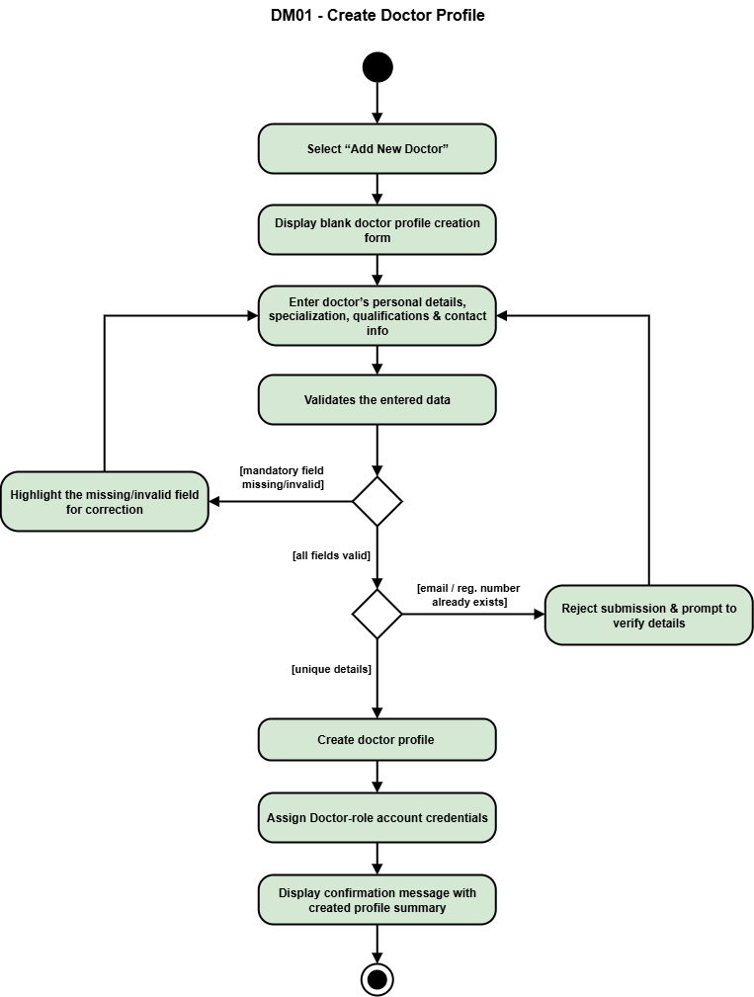
Figure 4.2: Doctor Management Activity Diagram (DM01 – Create Doctor Profile)
Primary Success Flow
- System Administrator selects Add New Doctor and completes the profile form (personal details, specialization, qualifications).
- System validates mandatory fields → all fields valid.
- System checks the submitted email and registration number against existing doctor records → unique.
- System creates the doctor profile, assigns Doctor-role credentials, and displays a confirmation summary.
Alternative & Exception Paths
- [mandatory field missing/invalid] → route back to data entry for correction.
- [email / registration number already exists] → reject the submission outright and prompt the administrator to verify and resubmit, since duplicate credentials cannot be permitted for a role with system-wide access.

4.6 Appointment Management (Malwatta M.W.C.S)
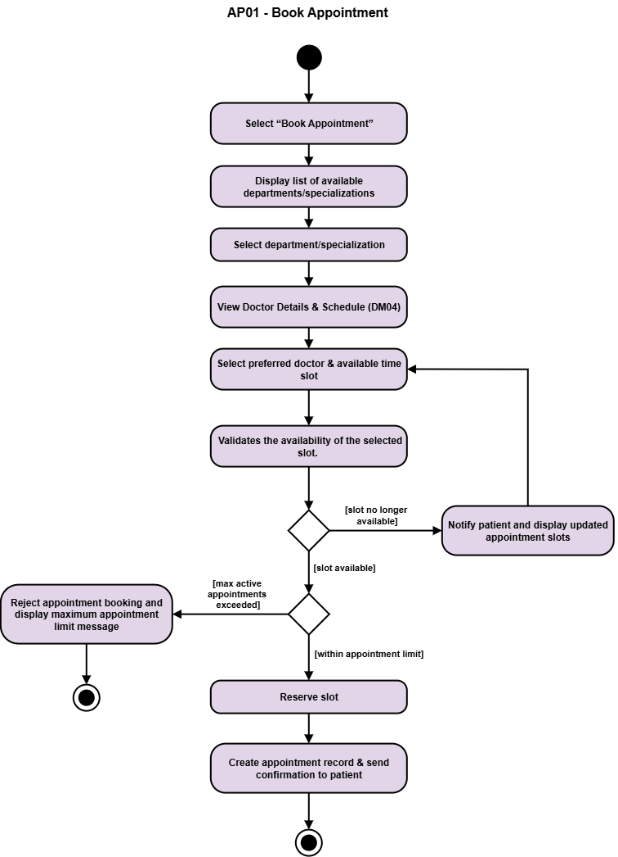
Figure 4.3: Appointment Management Activity Diagram (AP01 – Book Appointment)
Primary Success Flow
- Patient selects Book Appointment, chooses a department/specialization, and reviews the relevant doctor's details and schedule.
- Patient selects a preferred doctor and time slot.
- System validates slot availability → slot available.
- System checks the patient's active appointment count against the limit → within limit.
- Slot is reserved, the appointment record is created, and a confirmation is sent to the patient.
Alternative & Exception Paths
- [slot no longer available] → the patient is notified and shown an updated list of open slots, returning to slot selection rather than the booking simply failing.
- [maximum active appointments exceeded] → the booking is rejected with an explanatory message, ending the flow to prevent appointment hoarding.

4.7 Inventory & Pharmacy Management (Udumullage S.H.U)
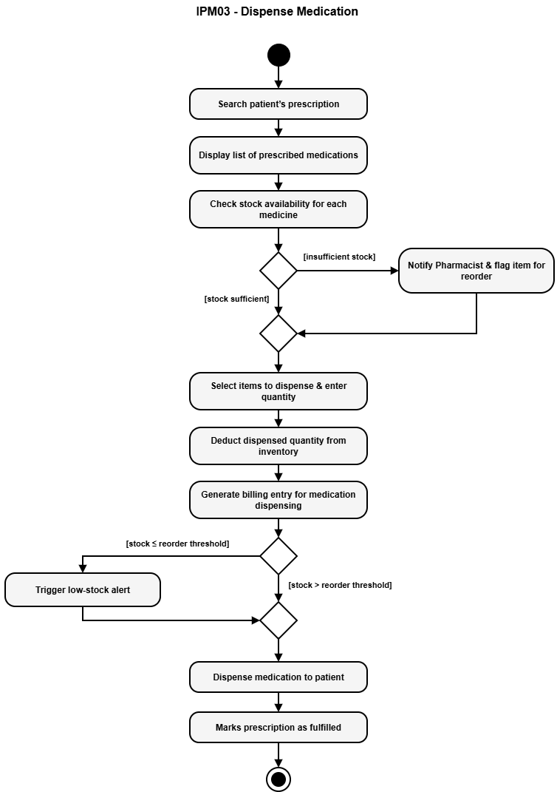
Figure 4.4: Inventory & Pharmacy Management Activity Diagram (IPM03 – Dispense Medication)
Primary Success Flow
- Pharmacist searches for a patient's prescription; system displays the prescribed medications.
- System checks stock availability for each item → stock sufficient.
- Pharmacist selects items and quantities to dispense; system deducts the dispensed amount from inventory and generates a billing entry.
- System checks the remaining stock against the reorder threshold → above threshold.
- Medication is dispensed and the prescription is marked as fulfilled.
Alternative & Exception Paths
- [insufficient stock] → the pharmacist is notified and the item is flagged for reorder, but this does not block the rest of the transaction — available items can still be dispensed.
- [stock ≤ reorder threshold after dispensing] → the system automatically triggers a low-stock alert.

4.8 Billing & Payment Management (Dhanasinghe K.A.K.H)
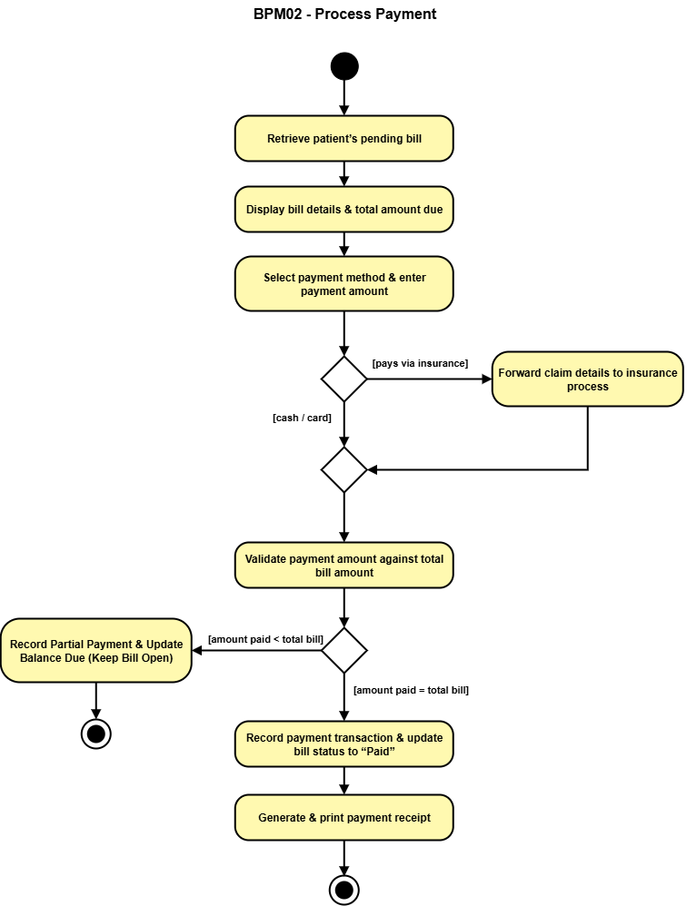
Figure 4.5: Billing & Payment Management Activity Diagram (BPM02 – Process Payment)
Primary Success Flow
- Receptionist retrieves a patient's pending bill; system displays the total amount due.
- Receptionist selects a payment method (cash/card) and enters the payment amount.
- System validates the amount against the total bill → amount matches total.
- System records the transaction, updates the bill status to “Paid,” and generates a payment receipt.
Alternative & Exception Paths
- [pays via insurance] → claim details are forwarded to a separate insurance process before rejoining the standard validation step.
- [amount paid < total bill] → a partial payment is recorded and the bill remains open with an updated balance rather than being rejected.

4.9 Laboratory & Test Management (Thilakarathne H.S.K.P.N)
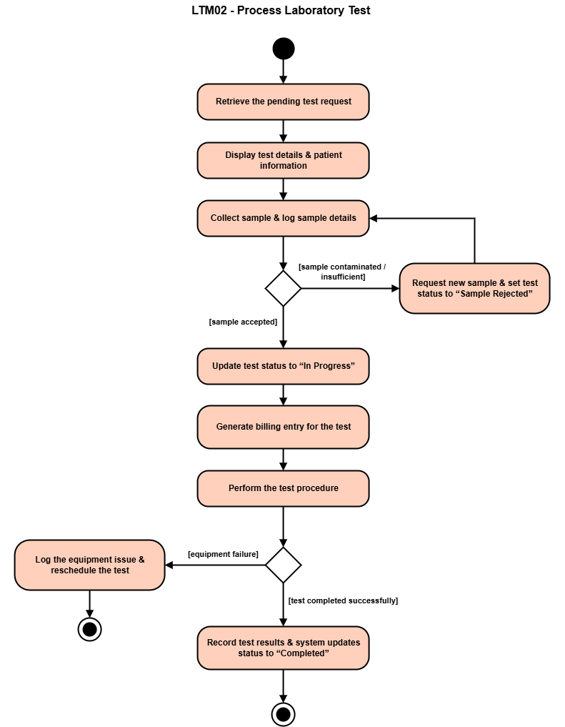
Figure 4.6: Laboratory & Test Management Activity Diagram (LTM02 – Process Laboratory Test)
Primary Success Flow
- Laboratory Technician retrieves a pending test request, reviews test and patient details, and collects and logs the sample.
- System validates the sample → sample accepted.
- System updates the test status to “In Progress” and generates a billing entry.
- Technician performs the test procedure → completed successfully.
- Technician records the results and the system updates the status to “Completed.”
Alternative & Exception Paths
- [sample contaminated / insufficient] → status is set to “Sample Rejected” and the technician requests a new sample, routing back to sample collection.
- [equipment failure] → the issue is logged and the test is rescheduled, ending this instance of the flow as a distinct outcome.

5. Ethical Considerations
5.1 Data Privacy
PulseOS enforces role-based access control at both the interface and the data-access layer, so what a staff member can see and do is determined by their assigned role rather than left to interface-level trust alone. A pharmacist's session, for example, is restricted to prescription and medication data together with only the patient details needed to dispense safely — clinical notes and allergy information outside that scope are never returned to that role. Because this restriction is enforced on the server side rather than only hidden in the interface, a technically capable user cannot bypass the screen to reach data their role does not permit.
5.2 Data Integrity
Audit records are designed to be append-only: once an action is logged, the system provides no way to edit or delete that entry, even for a System Administrator working through the application. This preserves the audit trail as reliable, tamper-resistant evidence of what actually happened, rather than a log that could be altered after the fact.
5.3 Patient Consent and Transparency
Administrative and billing-facing staff, such as Receptionists, can see the financial line items needed to generate and explain a charge, but have no visibility into clinical results or the substance of a prescription beyond what billing requires. This reflects a data-minimisation principle: each role's access is limited to what its function needs, reducing the exposure of sensitive clinical information to non-clinical staff and giving patients confidence that their medical details are seen only by those who need them.
5.4 Accessibility
Form layouts across all six modules follow consistent, accessibility-conscious design: a single-column layout that supports a predictable reading and tab order, a minimum readable text size, and inline validation feedback shown next to the relevant field rather than in a separate summary block. Status information is conveyed through a combination of icon or shape and a text label rather than colour alone, so that colour-blind users are not dependent on distinguishing a green/red hue to understand what a status means.
5.5 User and System Security
PulseOS treats login credentials, administrative privileges, and payment information as distinct security concerns. Passwords are stored as hashed values rather than in plain text, administrative accounts carry differentiated privilege levels rather than being uniformly powerful, and payment records keep only an opaque transaction reference rather than raw card or bank details. Together, these choices reduce how much sensitive information the system exposes and limit the damage a compromised account could cause.
5.6 Fairness in Patient Services
PulseOS supports equitable treatment through explicit, consistent rules rather than informal staff discretion. Clinical urgency is captured directly on the patient record, so prioritisation is driven by documented need rather than by payment method, arrival order, or staff familiarity. Consultation charges are drawn from the doctor's own record when billing is generated, so the same consultation is charged consistently rather than priced ad hoc. Appointment availability is handled through the defined doctor scheduling and booking rules, with no mechanism for preferential reservation of slots.
5.7 Accountability
PulseOS establishes traceability by linking every operational record — appointments, prescriptions, laboratory tests, dispensed medication, purchase orders — to the staff member responsible for it, and every employee sits within a management chain for escalation and oversight. This creates a clear, traceable responsibility structure for operational review, rather than relying on informal recollection of who handled what.
5.8 Ethical Risk Summary Matrix
Ethical Concern | Potential Risk | Mitigation / How System Addresses It
5.1 Data Privacy | Unauthorized access or disclosure of patient information by users outside their permitted role. | Role-based access restrictions, enforced at the data-access layer, limit each role to the data and actions required for its function.
5.2 Data Integrity | Historical audit records could be altered or removed, weakening the reliability of system evidence. | Audit records are designed as append-only, with no application-level update or delete operation exposed.
5.3 Patient Consent and Transparency | Sensitive clinical information may be exposed to non-clinical users beyond what their work requires. | Role-specific views and queries expose only the fields necessary for the relevant administrative, billing, or clinical task.
5.4 Accessibility | Users with different accessibility needs may have difficulty interpreting or completing system tasks. | Consistent form layouts, readable text sizing, inline validation, and status indicators using both text and visual symbols support accessible interaction.
5.5 User and System Security | Credential compromise, excessive administrative privilege, or unnecessary exposure of payment-related information could create security or financial risk. | Credential hashing, tiered administrative security clearance, and opaque payment transaction references reduce the exposure and impact of sensitive information.
5.6 Fairness in Patient Services | Patients could receive inconsistent prioritisation, scheduling, or pricing because of informal or preferential rules. | An explicit clinical-priority field, record-based consultation fees, and defined appointment-allocation rules provide consistent decision criteria.
5.7 Accountability | Operational actions may lack a clearly identifiable responsible staff member or escalation path. | Clinical and operational records link to responsible employees, and each employee's place in the management chain establishes a clear escalation hierarchy.

