CO1-AT2
Data Interpretation Exercise
NAME- DILEEP KUMAR DESHABOINA
REG NO- 192424281
COURSE CODE-DSA 0603
COURSE NAME- DATA HANDLING AND VISUALISATIONS
1. Write an R program to create a scatter plot with Sales on the x-axis and Profit on the
y-axis.
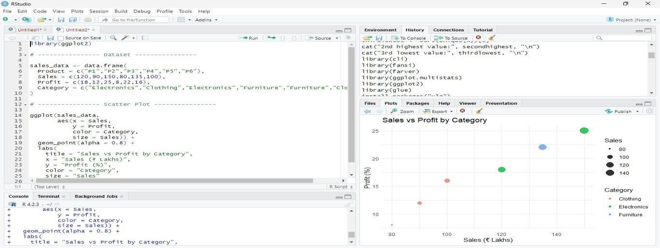

- Interpretation of the relationship between Sales and Profit
  - The scatter plot shows a positive relationship between Sales and Profit.
  - As Sales increase, Profit also tends to increase.
  - Electronics products have the highest sales and profit.
  - Furniture and Clothing products have comparatively lower values.

- Type of Scale Used

Variable | Scale Type
Sales | Continuous (Numeric)
Profit | Continuous (Numeric)
Category | Categorical (Nominal)
Color | Mapped to Category
Size | Mapped to Sales

- Alternative Visualization

  - A bubble chart (already created by mapping size = Sales) is a good alternative because it shows Sales, Profit, and Category together.
  - Another suitable alternative is a grouped bar chart to compare Sales and Profit across categories.
Q2) Coordinate Systems (Cartesian and Polar)

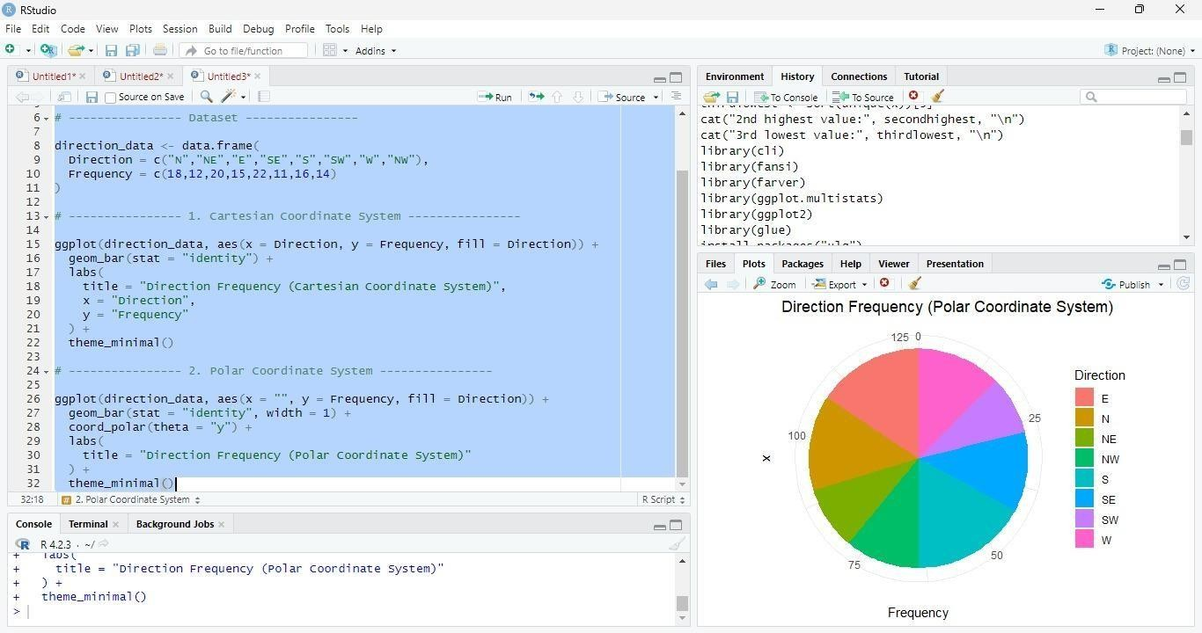

- Comparison of Both Visualizations
  - Cartesian Coordinate System (Bar Chart):
    - Easy to compare frequencies. o Differences between directions are clearly visible. o Best for accurate value comparison.
  - Polar Coordinate System (Pie Chart):
    - Displays the proportion of each direction.
    - More visually appealing for directional or circular data.
    - Less accurate for comparing similar values.

- Which Coordinate System is More Appropriate?
Polar Coordinate System is more appropriate for directional data.

- Justification
  - Directional data (North, South, East, West, etc.) naturally represents angles around a circle.
  - The polar coordinate system reflects compass directions, making it easier to understand the distribution of frequencies.
  - The Cartesian coordinate system is better for comparing exact values, while the polar coordinate system better represents the circular nature of directional data.
Q3) Color Scales for Data Representation

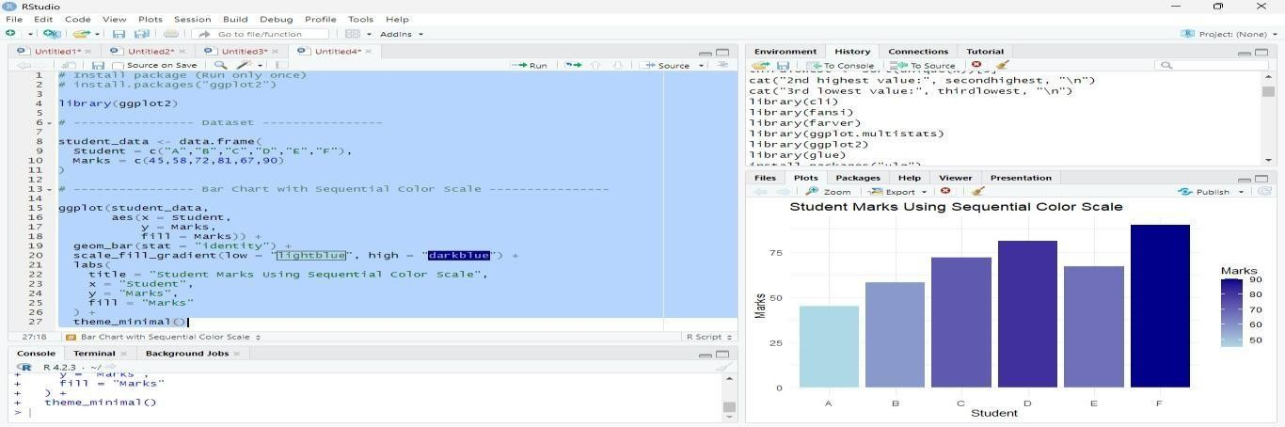

- Highest and Lowest Marks

  - Highest Marks: Student F → 90
  - Lowest Marks: Student A → 45

- Why is a Sequential Color Scale Appropriate?

  - Marks are continuous numeric values.
  - A sequential color scale uses light colors for low values and dark colors for high values.
  - It helps users quickly identify high and low marks.

- Color Palette Suitable for Color-Blind Users
A good color-blind-friendly palette is Viridis.
Replace the color scale with:
scale_fill_viridis_c()
(If needed, install the package first: install.packages("viridis").)
5. Difference Between Sequential and Categorical Color Scales

Sequential Color Scale Categorical Color Scale
Used for continuous numeric data Used for categorical data
Colors change gradually from light to dark Each category gets a distinct color
Example: Marks, Salary, Temperature Example: Gender, Department, Product Category
Shows magnitude or intensity Distinguishes between different groups
Q4: Highlighting with Color

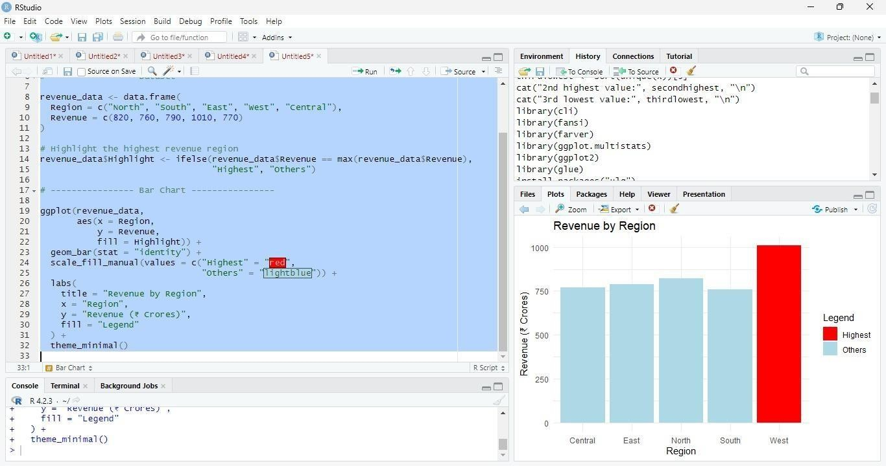

2. How Highlighting Improves Data Interpretation

- Highlighting draws attention to the most important data point.
- It helps users quickly identify key insights.
- It makes the chart easier to understand at a glance.
3. Highest-Performing Region

• West has the highest revenue with ₹1010 Crores.

4. Effect of Excessive Use of Colors

- Too many colors can make the chart confusing.
- Important information may become harder to identify.
- It reduces readability and distracts from the main message.

5. Alternative Highlighting Technique

Instead of color, you can:

- Add data labels (show the revenue value on each bar).
- Increase the size or border thickness of the highlighted bar.
- Use an arrow or annotation to point to the highest value.

These techniques emphasize important data without relying only on color.
Q5: Integrated Visualization

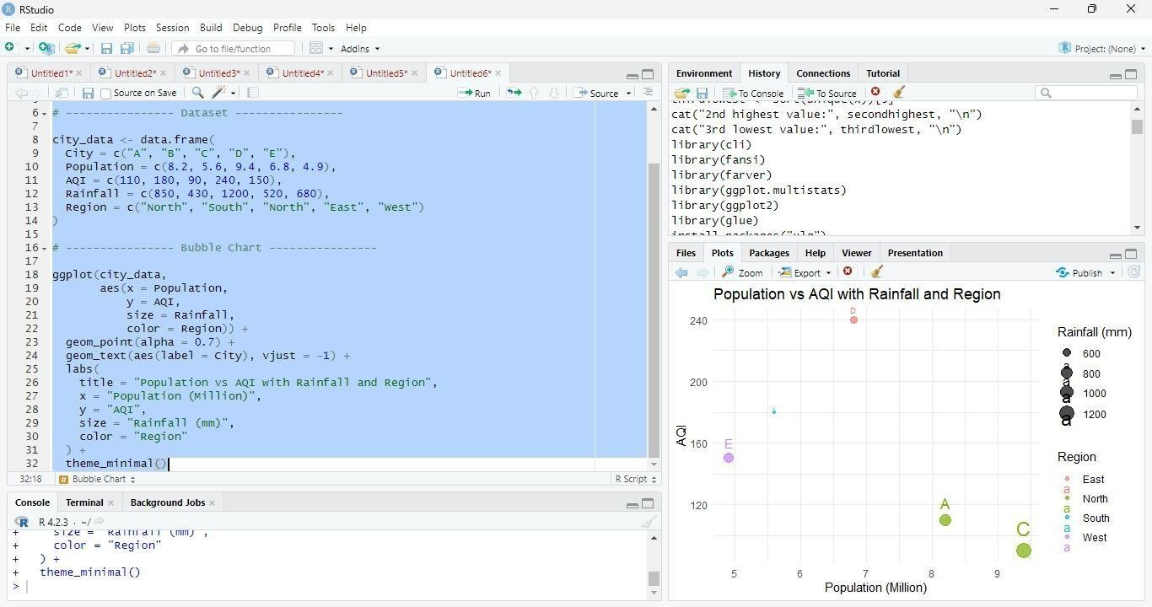

- Aesthetic Mappings

Variable | Aesthetic
Population | X-axis
AQI | Y-axis
Rainfall | Bubble Size
Region | Bubble Color

- Interpretation of Population and AQI

  - There is no strong positive relationship between Population and AQI.
  - Some cities with larger populations have lower AQI, while smaller cities may have higher AQI.
  - This suggests that factors other than population also affect air quality.

- Continuous and Categorical Variables

Variable | Type
Population | Continuous
AQI | Continuous
Rainfall | Continuous
Region | Categorical
City | Categorical
- Recommendation to Improve Readability

  - Add city labels to each bubble (already included in the code using geom_text()).
  - Increase bubble transparency (alpha) to reduce overlap.
  - Use a color-blind-friendly palette (such as scale_color_viridis_d()) for better accessibility.

