CRMITdesk Evolved
AI Demo Data Map
Which seeded record proves which AI feature — and the exact click path for each, verified live on 24 Aug 2026

Contents

What the demo data is designed to prove
Every record in the refreshed demo seed exists to make one specific AI feature land on stage. Nothing is filler: the duplicate tickets really are duplicates, the stalled deals really are stalled, and the "hot" lead really carries every buying signal the scoring model looks for. This map tells you, feature by feature, which record to open, what the AI will say, and which seeded facts it is reading to say it.

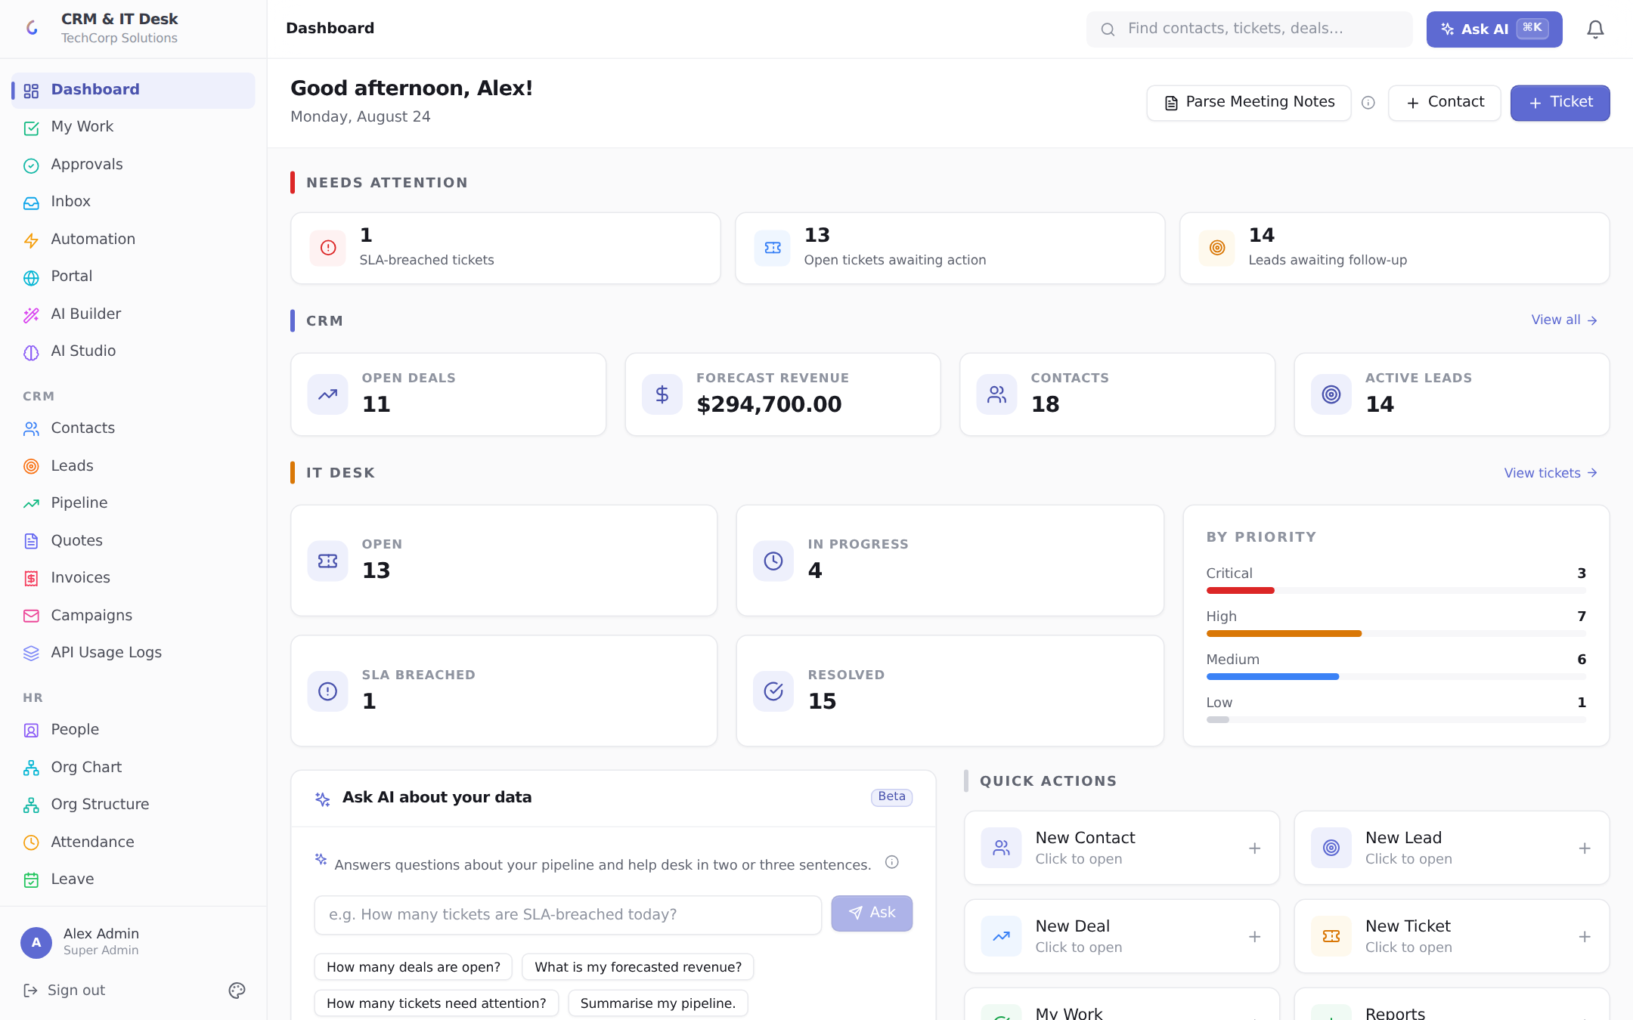
The dashboard after reseeding — real backlog, priority spread, forecast revenue, and an SLA breach to point at.

IT Desk features

1. Duplicate detection — while creating a ticket

2. KB suggestions — same screen, same typing

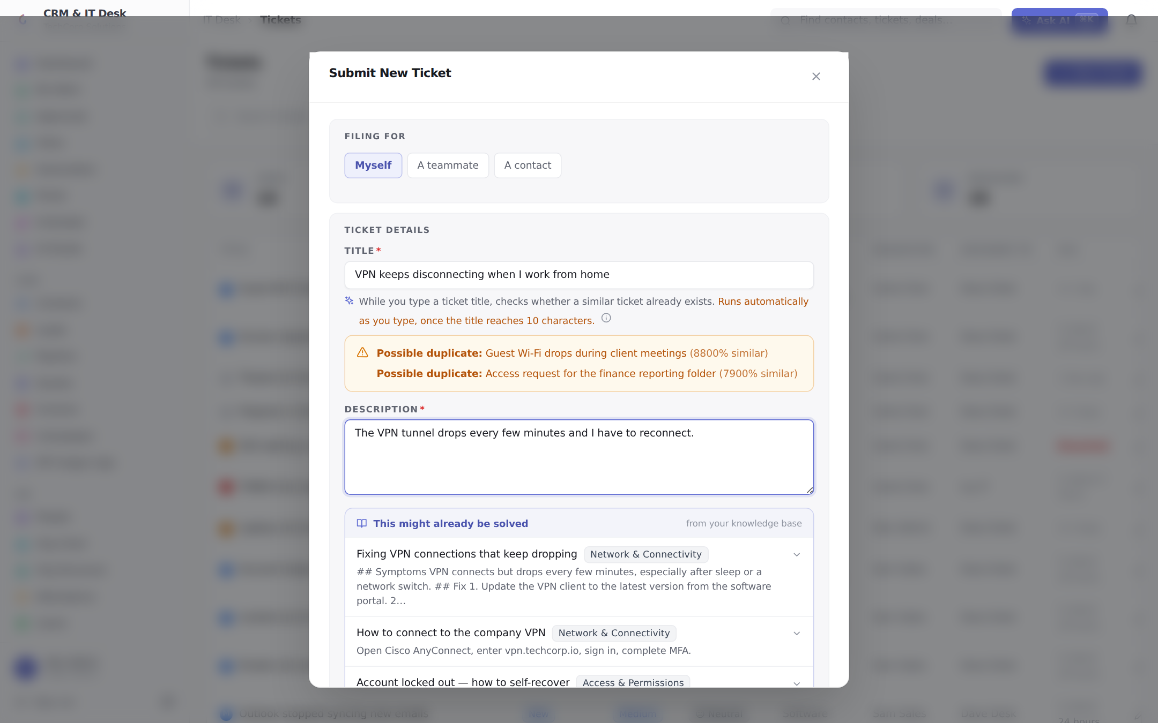
One typed sentence, two AI reactions: possible duplicates flagged above, self-service answers suggested below.

3. Thread summary + resolution estimate

4. Generate KB article → save to knowledge base

5. Sentiment + SLA risk

6. AI reply suggestion

CRM features

7. Lead scoring — the ladder

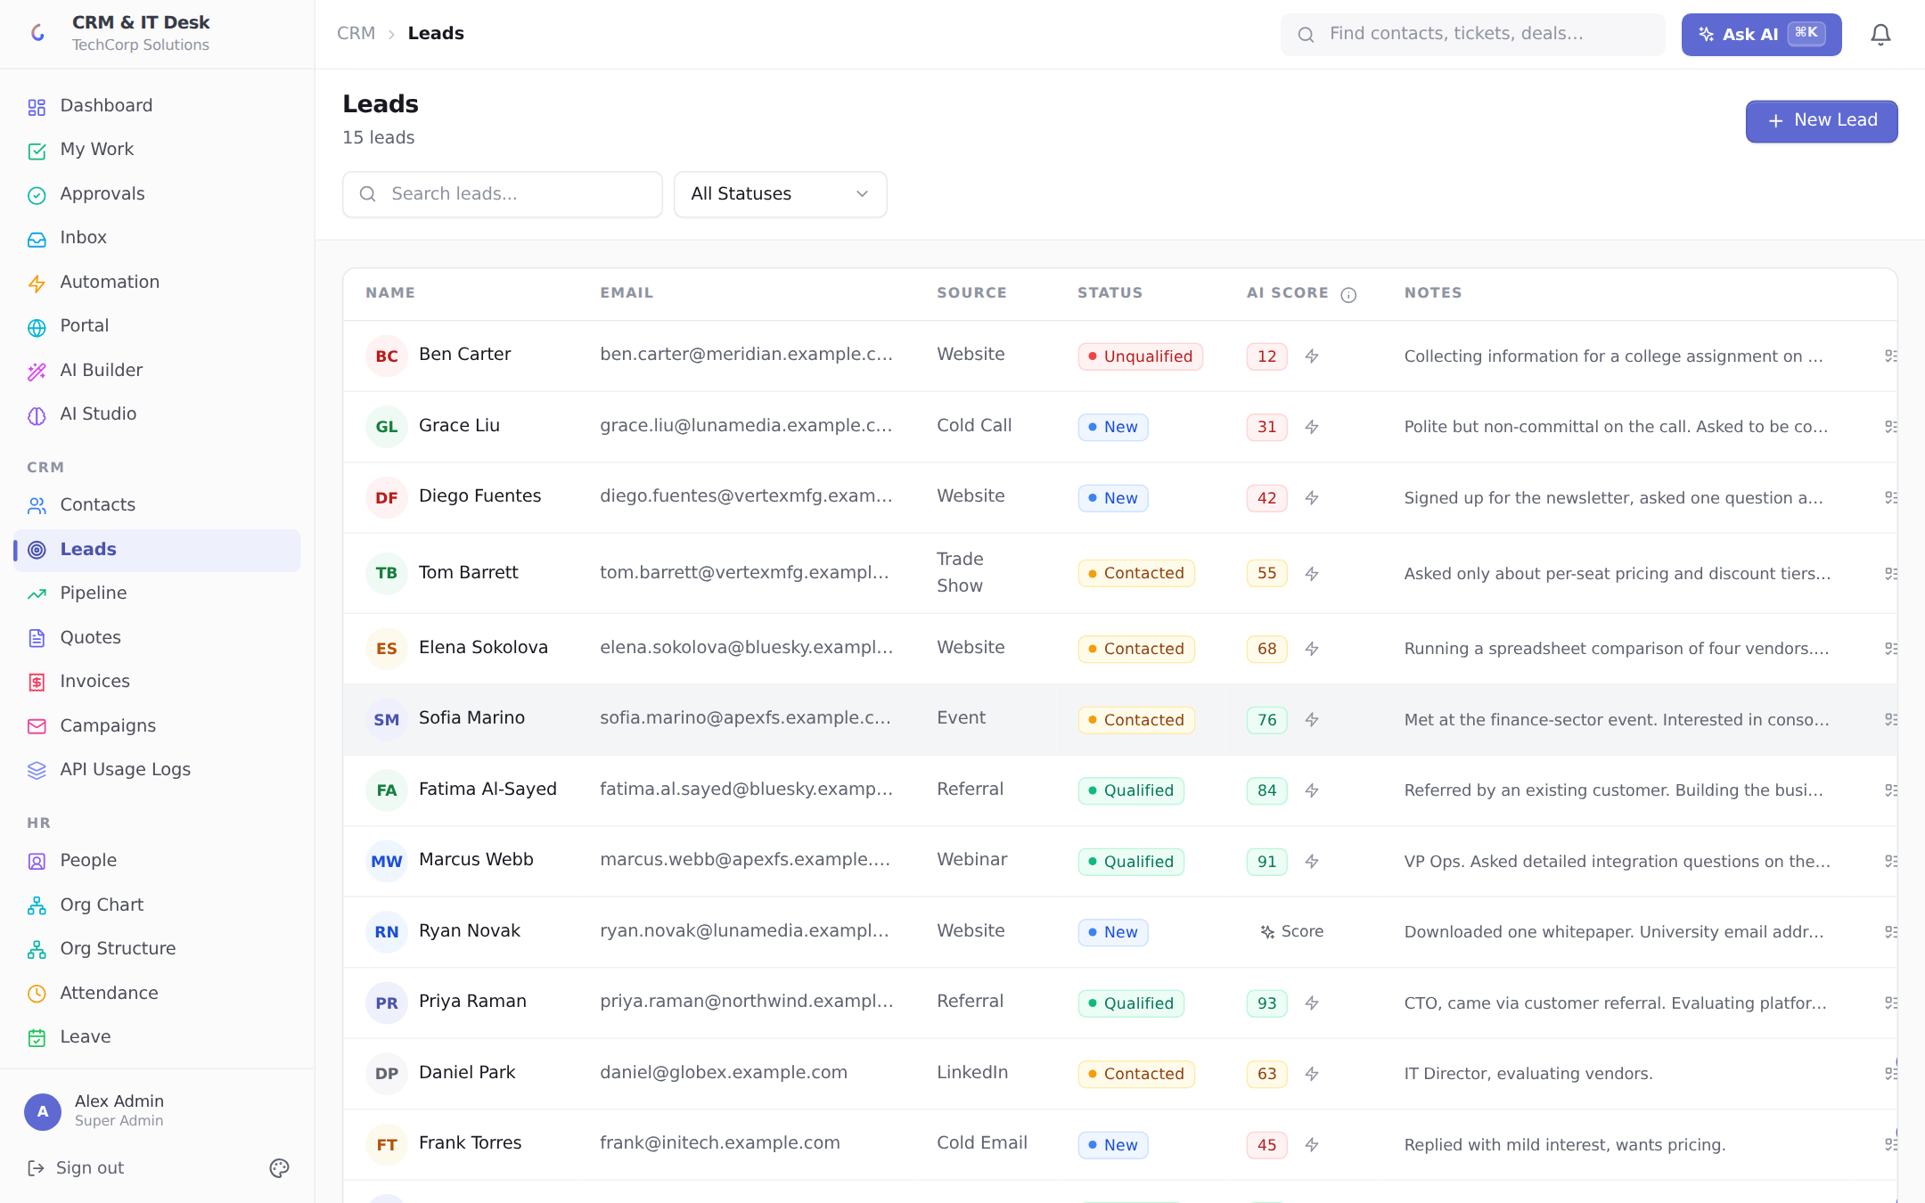
The scoring ladder: pre-scored rows show the spread; the unscored rows are the live demo.

8. Follow-up email drafts

9. Win probability + pipeline health

10. Churn risk

11. Ask AI about your data (natural-language queries)

Running the reseed

- Log in as admin@crmitdesk.com / Admin@123 and spot-check: Leads shows the score ladder, Tickets shows ~39 rows, the dashboard shows the forecast and priority spread.
Order on stage A sequence that builds: type the VPN ticket (duplicates + deflection) → open the slow-dashboard ticket (summary) → open the resolved drive ticket (generate KB → publish) → retype a drive request (your new article now deflects it) → switch to CRM: score Priya vs Ryan → pipeline health names the stalls → churn risk on Meridian. Each step feeds the next.

