CRMITdesk Evolved
Client Demo Runbook
45–60 minute live demo for an ERP-developer & marketing audience · prep, click path, talking points, fallbacks, Q&A
Presenter: Kesava · August 2026

Contents

0. Know Your Room
This runbook is tuned for a mixed audience of ERP developers and marketing people. They evaluate differently: the developers will judge architecture, extensibility and whether this threatens or complements what they build; marketing will judge whether they can position and sell it. Feed both throughout:
- The frame that wins the room: "This is not an ERP and doesn’t want to be one. ERP owns finance, inventory, procurement — the system of record. This owns the people-facing layer around it: sales pipeline, customer support, employee self-service, all AI-first. They connect over a REST API, signed webhooks and scheduled sync." Complement, not competitor — say it in the first two minutes and the developers relax.
- For the developers: sprinkle one-line technical asides throughout ("that check ran server-side against a permission engine, not in the UI") and give them a dedicated Under the Hood act (Act 7) — don’t make them wait until Q&A.
- For marketing: lead every module with the sellable phrase, not the mechanism — the phrases are marked Pitch line in each act. Act 8 hands them the full positioning kit: differentiators, verticals, white-label, pricing story.

1. Before the Demo — Preparation Checklist

1.1 The day before
- Pick the demo workspace. Eight seeded industry verticals exist (Technology, Healthcare, Retail, Financial Services, Manufacturing, Salon & Spa, Automotive, Real Estate). For this audience, Technology (TechCorp) is the safe default — but showing a second vertical for 30 seconds is itself a marketing point ("verticalized demos out of the box"). Default login: admin@crmitdesk.com / Admin@123; other verticals: admin@<slug>.demo / Admin@123.
- Reseed for a clean stage (locally: npm run db:seed --workspace=server; deployed: the nightly reset or POST /api/demo/reset). Fresh data = predictable demo.
- Confirm AI is live. Open a lead, click Score. If it says "AI not configured", set GROQ_API_KEY on the server — the AI moments carry this demo.
- Confirm the September release is deployed. Billing should show a fourth "Custom Licence" card and Attendance (as a manager) a "Live map" tab. If either is missing, the licensing/attendance work is not on this server yet — demo those parts from a local build (npm run dev after npx prisma migrate dev) or present them as "shipping this month". Never deploy in the minutes before a demo.
- Verify the keep-alive workflow is green in GitHub Actions so the server is warm at start time.
- Props: a second browser window in incognito ("the customer"), your phone for the attendance check-in, the 61-page documentation as leave-behind, and — for the developers — have the repo open in an editor tab in case they ask to see code (server/src/modules is a clean tour: one folder per feature).
- Have GET /api/docs open in a tab — the self-describing public API reference. Developers trust an endpoint more than a slide.

1.2 Thirty minutes before
- Open the app and sign in — this also wakes the server. Leave the tab open.
- Dry-run the five wow moments (2.2) silently: AI scoring, pipeline drag, quote e-sign, AI command bar, check-in.
- Browser zoom 100–110%, notifications off, extra tabs closed; incognito window ready and minimized.
- Hotspot ready as network fallback; documentation PDF open as visual fallback.

1.3 Golden rules during the demo
- Never type long text live — templates and AI generators fill content in one click. Typing is dead air.
- Alternate altitude deliberately: one sentence of business value (for marketing), one of mechanism (for developers). Never five minutes of either.
- If something misbehaves, don’t debug on screen — "I'll come back to that", move on.
- Park deep questions visibly: "Noting that for the technical section — Act 7 answers it properly."
- Let the room drive the AI moments: ask THEM what to type into the command bar. Their words, executed live with a confirmation card, is your strongest 30 seconds.

2. The Storyline (45–60 minutes)
One continuous story — a company running sales, support and HR in a single AI-first workspace that sits beside an ERP, not instead of it. Business acts run first and fast; the developers get a dedicated deep-dive before the close. Scripted time ≈ 48 minutes, leaving 10–12 for Q&A.

2.1 Act structure at a glance
Time | Act | Primarily for
0–4 | Opening: positioning vs ERP | Both — sets the frame
4–8 | Dashboard | Marketing (Ask-AI moment)
8–17 | CRM: lead to cash | Marketing (the sellable story)
17–24 | IT Desk + customer portal + inbox | Both
24–29 | HR & People (fast pass) | Marketing
29–36 | Automation & the AI platform | Both — AI governance impresses developers
36–44 | Under the hood | Developers — architecture, extensibility, ERP integration
44–48 | Positioning kit, white-label & plans | Marketing
48–60 | Q&A + close | Both

2.2 The five "wow" moments
Rehearse these above all: (1) the customer e-signing a quote on the public link while the invoice creates itself; (2) dragging a deal across the pipeline; (3) the AI command bar executing a dictated instruction behind a confirm card; (4) a ticket auto-routed, auto-drafted and turned into a KB article; (5) geo-verified check-in. For this audience add a sixth: (6) creating a custom module live and watching it appear in the sidebar — the "platform, not app" proof developers respect. With the September release add two more: (7) a face-verified check-in followed by the manager’s Live map showing the person inside the office radius; (8) building a custom licence — toggling modules and seats while the price recalculates live, then changing a module’s price in the Platform Admin Pricing panel and watching the customer’s quote update.

Act 1 — Opening: positioning vs ERP (0–4 min)
Say: "You build and sell ERP — the system of record for finance, inventory, operations. What I’m showing you is the layer your customers keep asking for around it: CRM, customer support, employee self-service — AI-first, white-labelable, and built to integrate rather than replace. By the end I’ll show you exactly how it talks to an ERP, and where the partnership opportunity is."
- Start at the /demo landing page. Point at the eight industry chips: "One seed, eight verticalized demo environments — your sales team gets an industry-native demo for every prospect." Click Technology → "Try the live demo".
- You land signed-in on the dashboard. One sentence on the shell: role-driven sidebar, four themes, org-level branding — "everything you'll see can carry a partner's brand."
Pitch line "ERP runs the back office. This runs the front office — and the two connect."

Act 2 — Dashboard (4–8 min)
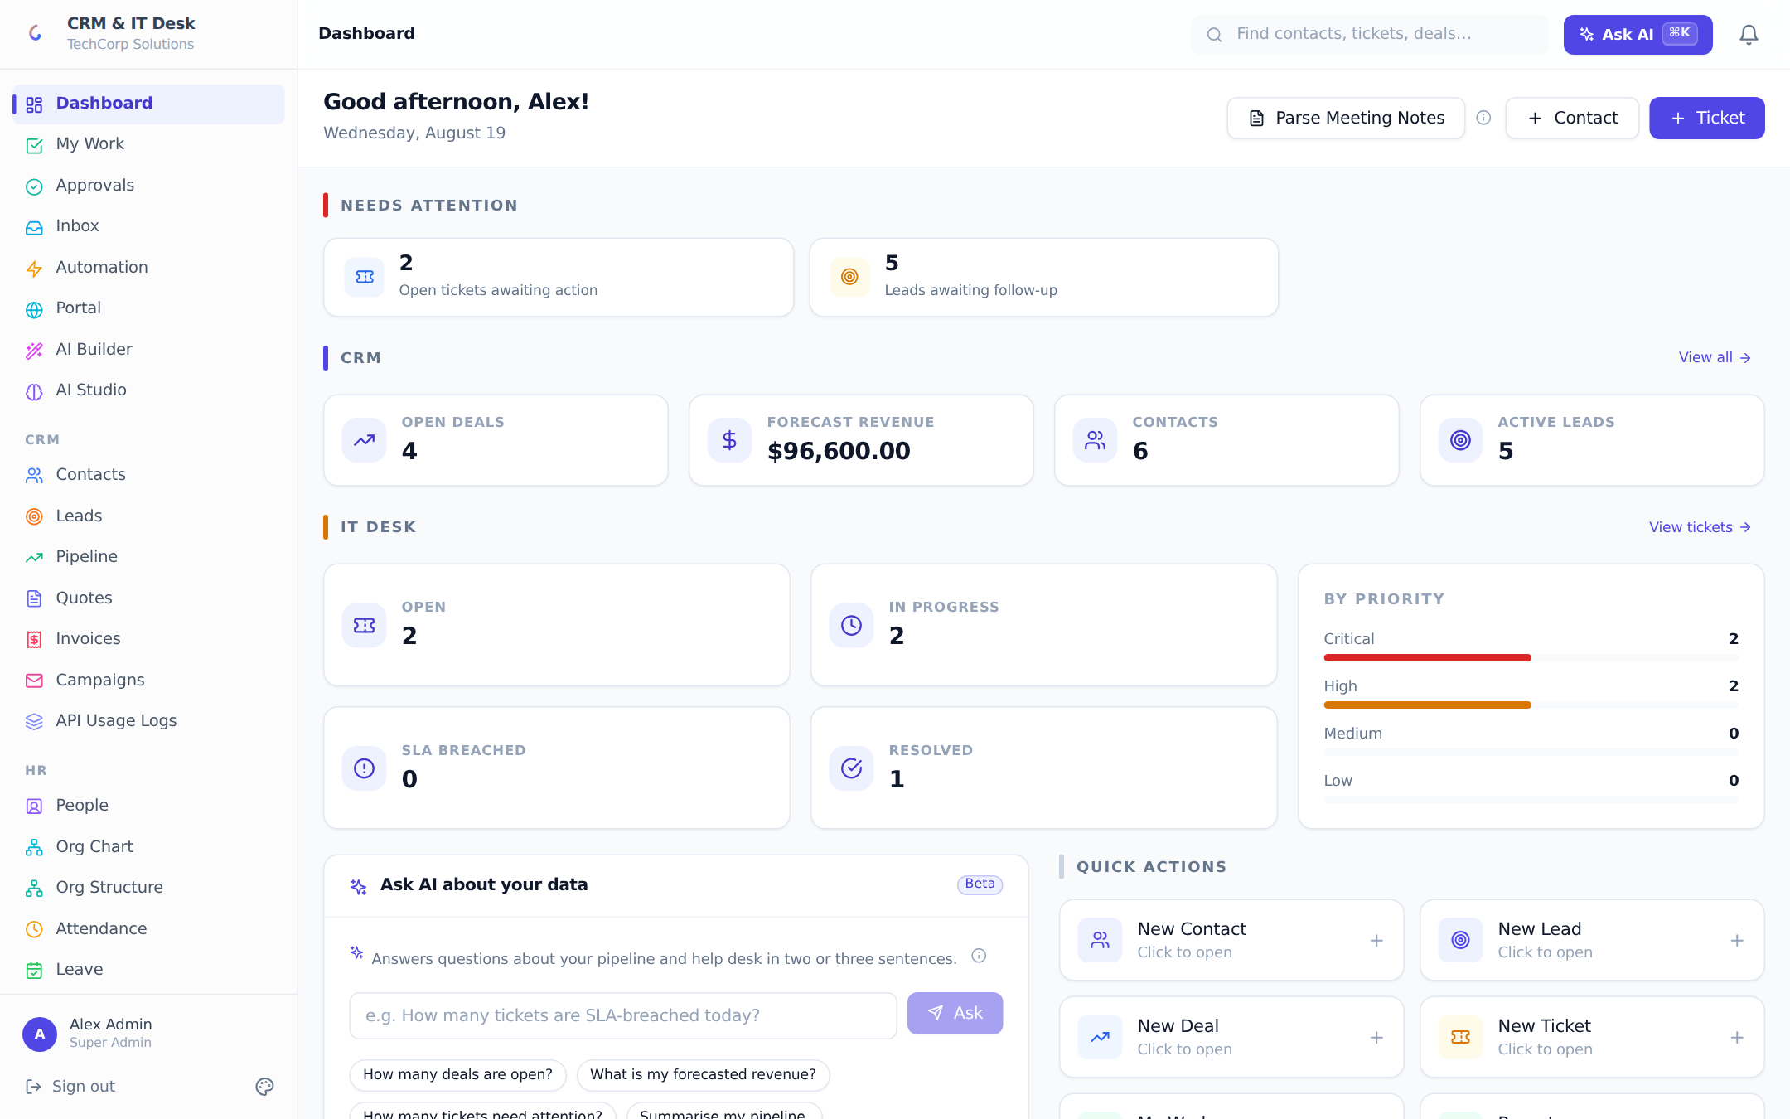
- Walk the "Needs attention" strip: "The system triages your day — SLA breaches, waiting tickets, cold leads — one click to the filtered list." Sweep the CRM and IT Desk stat rows briefly.
- Star moment: "Ask AI about your data" — invite the room to pick a question, or use "Summarise my pipeline". Read the answer aloud: "Computed from live data at ask-time, not a canned report." Developer aside: "the model gets aggregated metrics, not raw rows — row access is filtered by the permission engine first."
- Mention Parse Meeting Notes in one sentence; demo only if ahead of schedule.

Act 3 — CRM: lead to cash (8–17 min)
Say: "One deal, first contact to money in the bank, eight minutes." This act is marketing’s highlight reel — keep it moving.

Leads (2 min)
- CRM → Leads. Score an unscored lead: "AI-rated conversion likelihood, with the why." Hover the icon for reasoning. Developer aside: "scoring runs on the cheap fast-tier model; heavy generation uses a smarter tier — routed automatically."
- Row menu → AI follow-up email → Copy. Mention the 3-step nurture sequence. No live typing.
- Convert the lead → keep pre-filled title, set value, Create. "Lead becomes contact plus live deal."

Pipeline (3 min)
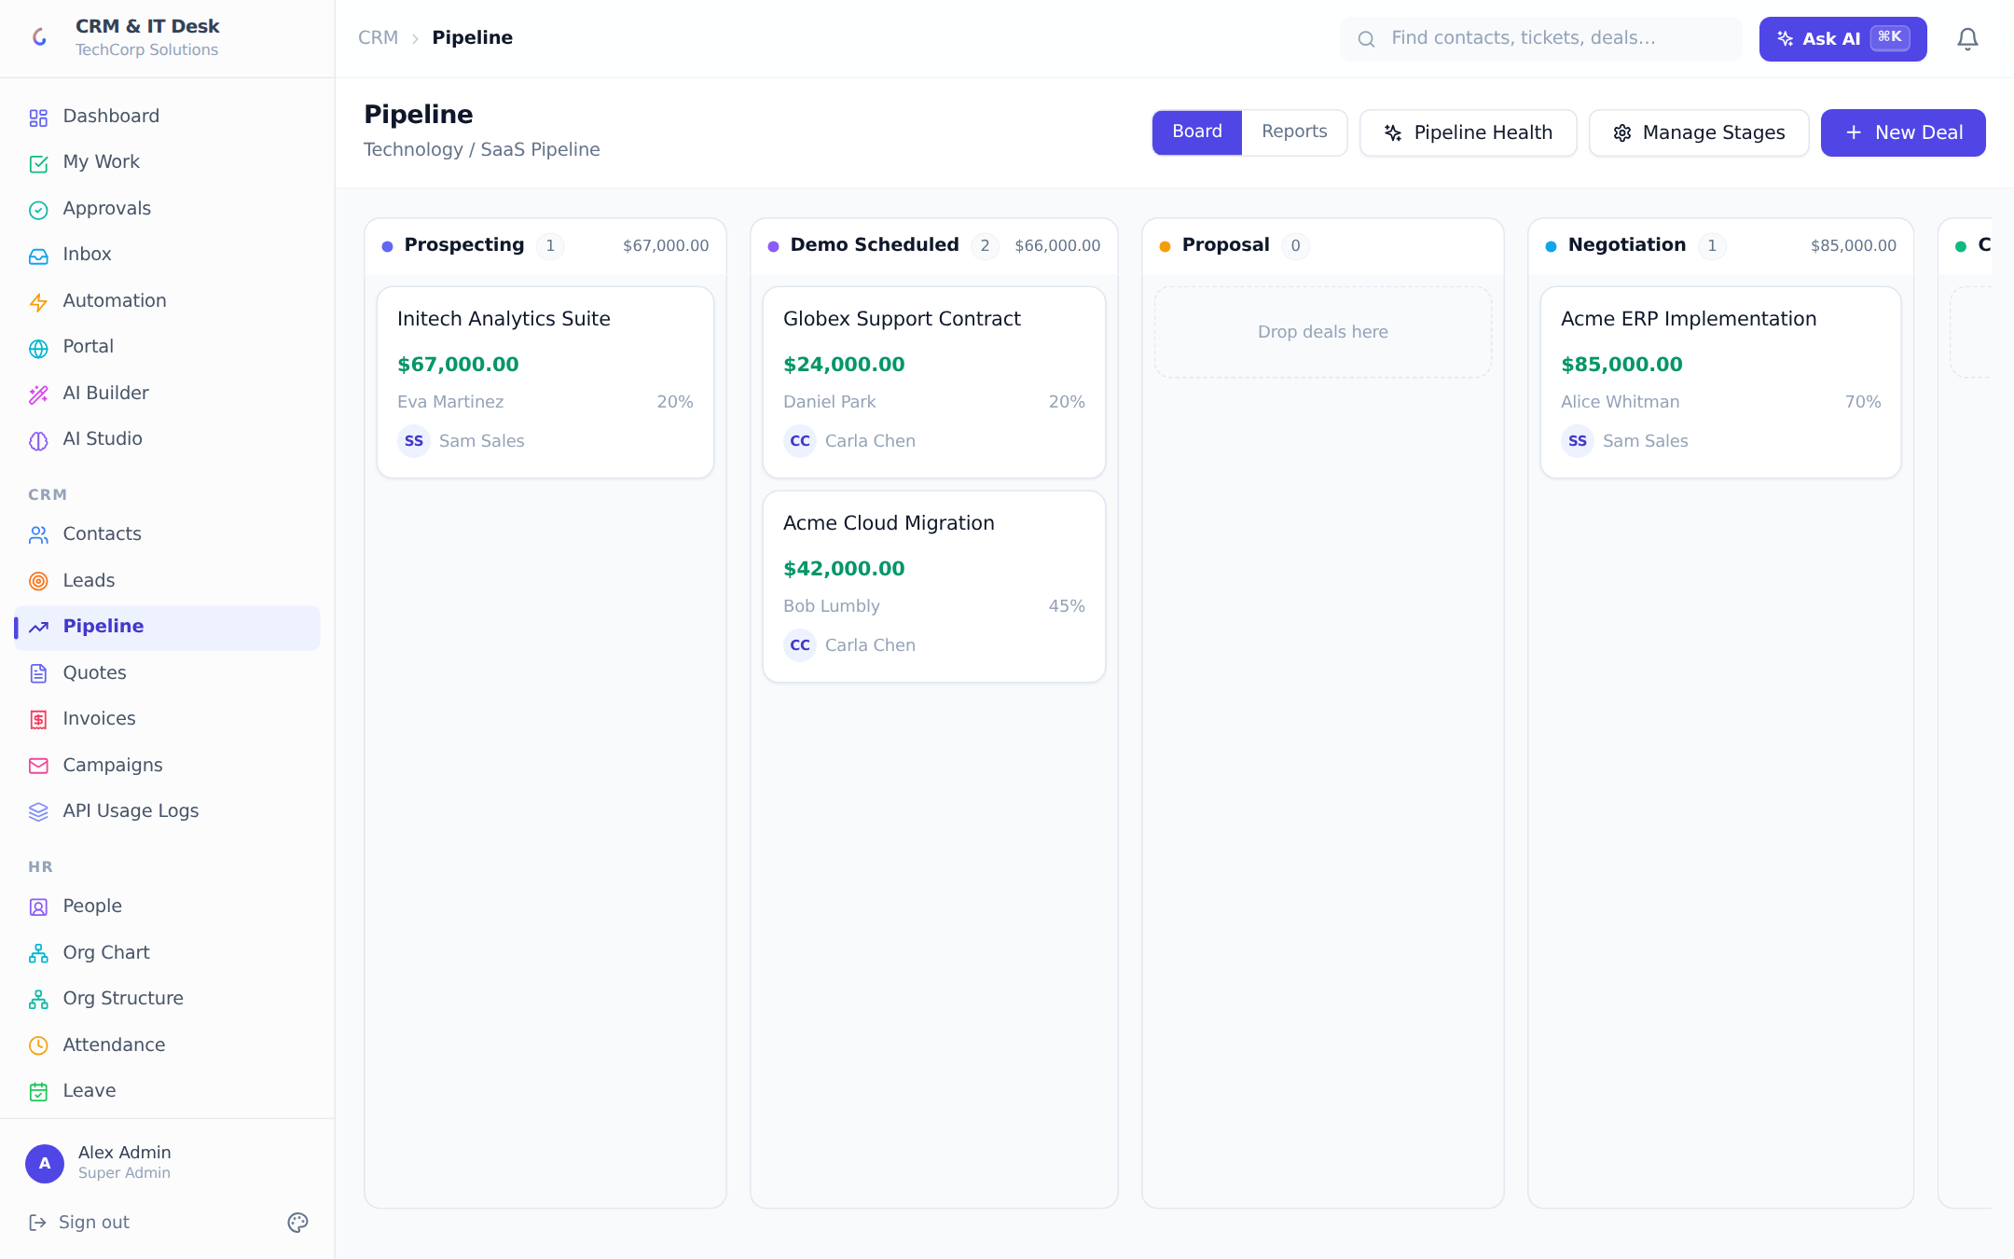
- Star moment: drag the new deal to the next stage — pause on the drop. "Stages, colors and win-percentages are org-defined" (flash Manage Stages five seconds).
- Open a big deal → Analyze win probability → read factors aloud. Generate follow-up email → Tone Check: "it reviews the email’s tone before the rep sends it."

Quote → e-signature → invoice (4 min)
- Quotes → New Quote → pick a quote template, title it, Create, Send.
- Star moment: "Copy customer link" → paste in incognito → play the customer: review, accept, draw a signature. Back in the app: quote Accepted, and in Invoices the invoice has created itself — numbered, taxed, with its own public link. Developer aside: "the link is HMAC-signed and login-free; signature, IP and timestamp are captured server-side."
- Close the act: "Lead → scored → converted → worked → quoted → signed → invoiced. No copy-paste, AI at every step." One sentence on Campaigns (bulk email from templates).
Pitch line "Your customer’s sales team lives here all day — and every number it produces can flow into the ERP’s ledgers through the API."

Act 4 — IT Desk, customer portal & unified inbox (17–24 min)
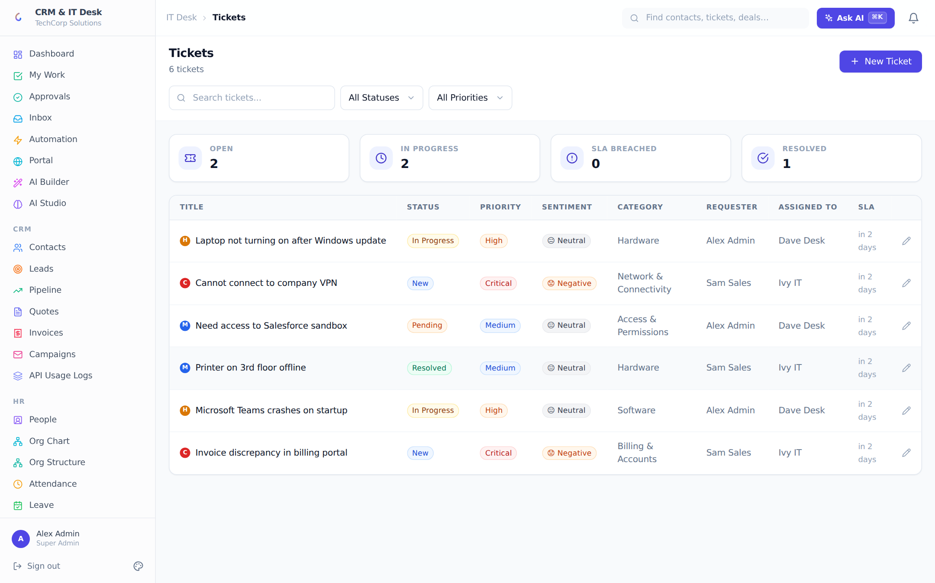
- Tickets queue: priority dots, AI sentiment emojis, SLA countdown column. "Response-time promises, enforced and escalated automatically."
- Star moment: open a ticket → AI Auto-Routing (category + agent + reasoning) → Suggest Reply, read two lines: "grounded in the org’s knowledge base, with citations". Resolve it → Generate KB Article: "every solved problem becomes searchable knowledge."
- Sidebar point, one sentence each: Assets, Changes (ITIL-style approval flow), Categories & SLA policies.
- Incognito window: open the customer portal → magic-link sign-in ("no passwords"), submit a ticket, send a chat message from the widget.
- Back in the app: Inbox — the chat message is a conversation; reply and it lands in the customer’s widget. "Email, WhatsApp and live chat, one queue, replies go back out on the customer’s own channel."
Pitch line "A branded self-service portal your customers can put their own logo on — that’s a resellable product in itself."

Act 5 — HR & People, fast pass (24–29 min)
- People: "Everyone in the company, with or without a login — directory-only people are free on every plan; access granted or revoked in one click." (Developers: note the deliberate person-vs-login split.)
- Org Chart: expand one branch — "built from reporting lines; the approval engine walks this tree to find the right manager automatically."
- Star moment: Attendance → Check In on your phone or browser. The webcam modal opens, finds your face and captures automatically — "three signals: GPS against an office geo-fence, the office network (including a dynamic-DNS hostname for offices without a static IP), and a face match against the employee’s enrolled Face ID. Multiple sessions a day." Developer aside: "the face model runs in the browser and only a 128-number signature is stored — never the photo; the server compares signatures."
- Rules, auto check-out and the Live map: HR Settings → Check-in / check-out verification. Show the rule editor: tick Location, Network, Face and flip All (AND) / Any (OR) — "on-site people pass by GPS, field staff pass by face; every customer decides." Point at the auto check-out toggle: "walk out of the geofence for five minutes and the session closes itself at the moment you left — no inflated hours." Then Attendance → Live map: office circles, green/amber/grey markers, click yourself to see today’s trail, press Locate now. Say plainly if asked: "location flows while the app is open; a closed phone gets a push asking to reopen it — always-on tracking is the native-app edition."
- Leave balances + approval queue in 30 seconds; Payroll: open a payslip → Print — the branded letterhead. "One click runs the month; employees self-serve payslips."

Act 6 — Automation & the AI platform (29–36 min)
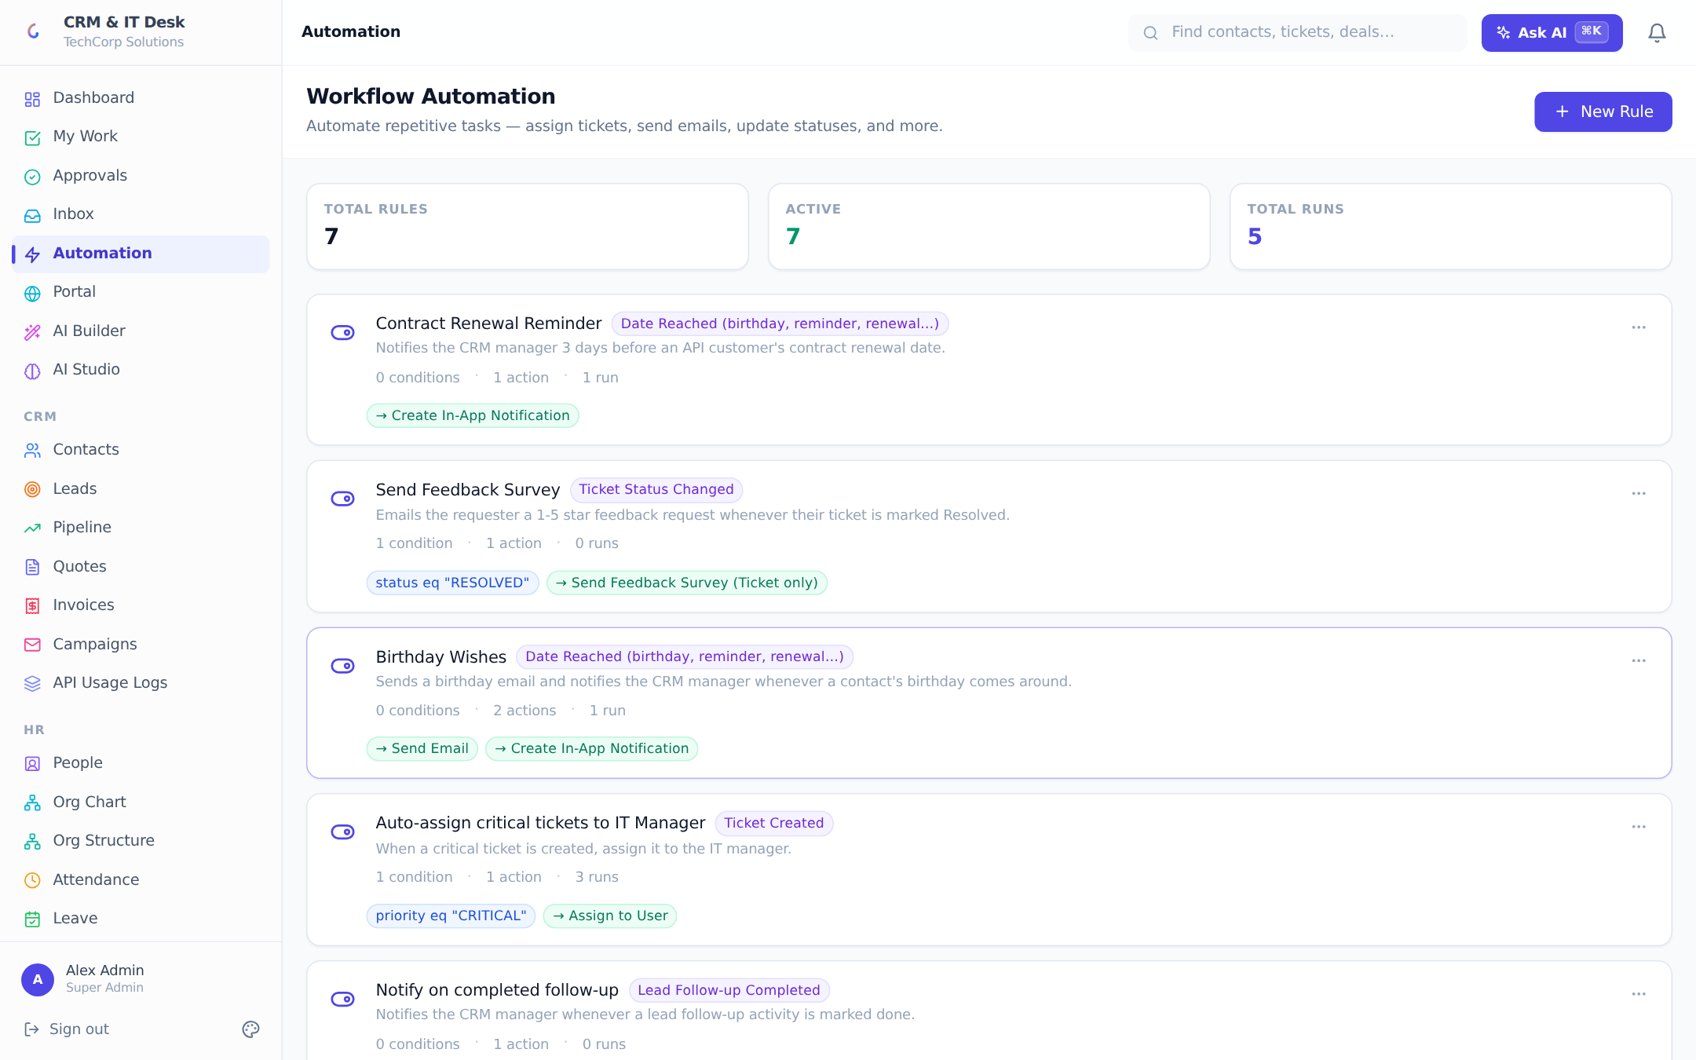
- Workflows: read one rule as a sentence ("critical ticket → assign senior engineer + phone notification"). Scroll triggers/actions once: emails, WhatsApp, webhooks, CSAT, date-driven birthdays and renewals. Show a rule’s run log.
- Star moment: Ctrl+K, let the room dictate — or use "Move the [deal] to Negotiation and add a note that the client asked for a discount." Read the confirm card before clicking Confirm & Run, then show the moved deal. To the developers: "The model can only select from a whitelist of 24 server-registered actions. Every handler re-validates role and org scope itself, nothing mutates without the confirmation click, and the execution lands in the audit log flagged as AI-performed with the original command text. The model plans; it never executes."
- AI Studio, 60 seconds: Business Context (industry, tone, glossary) and Generate Setup — "the AI proposes renamed terminology and starter automations for the customer’s industry; nothing applies without review." Mention custom AI functions and sandboxed form scripts for the developers.
- AI Governance: cost/latency dashboard, monthly budget with hard stop, and the interaction log — "every call: who, what, tokens, cost, and exactly which fields were redacted from the prompt under field-level permissions." This is the slide ERP buyers ask for; here it’s a live screen.
Pitch line "AI-first, but governed: budgets, audit, redaction. You can sell the AI story to a CFO, not just a demo audience."

Act 7 — Under the hood, for the developers (36–44 min)
Say: "Let me open the hood — five minutes of architecture, three of how it integrates with an ERP."

Architecture in five sentences (2 min)
- Stack: React 18 + TypeScript + Tailwind + React Query front; Node/Express + TypeScript + Prisma back; PostgreSQL; ~50 feature modules each a controller + routes pair under server/src/modules — show the folder tree in your editor for ten seconds.
- Multi-tenancy: every table carries orgId and every query is tenant-scoped at the call site AND through the permission engine’s scope filters — two independent walls. Roles are data, not code: ~130 catalog permissions, record scopes (own/team/department/all), and field-level hide/mask rules enforced on every egress path — REST, search, CSV export, and AI prompts.
- Demonstrate it: open an employee profile — bank account shows ••••1234. "Masked server-side by role. The client never even receives the value."
- Background machinery, one breath: email sync, SLA monitor, schedule/WhatsApp poller, date-driven automation, external-sync poller, and a Postgres-backed retry queue with exponential backoff for every outbound delivery — show the Jobs page for five seconds.
- Quality: Playwright end-to-end suite across the product, JWT+refresh auth, TOTP 2FA, rate limiting per-IP and per-API-key, encrypted secrets at rest, GDPR export/erasure.

The ERP integration story (3 min)
- Outbound: workflow webhooks — HMAC-signed JSON on any trigger ("deal won → POST to your ERP’s order intake"), SSRF-guarded, retried with backoff. Show the SEND_WEBHOOK action in the rule editor.
- Inbound: the REST API with scoped API keys (read/write/admin, 120 req/min per key) — flip to your GET /api/docs tab: "self-describing, covers CRM and desk resources plus search."
- Star moment #6: Custom Modules → create "ERP Work Orders" under IT Desk, add two fields — it appears in the sidebar as a working CRUD module. Then open its External Sync panel: "point it at an ERP endpoint, map fields, and it polls on schedule with dedupe — a read-model of your ERP inside this workspace, built in ninety seconds without code."
Pitch line "Integration isn’t a roadmap slide — you just watched me build one live."

Act 8 — Positioning kit, white-label & plans (44–48 min)
This act is for the marketing side — hand them the words to sell with.
- Differentiators, one breath each: unified front-office (CRM + desk + HR in one login); AI-first with governance (budgets, audit, redaction); verticalized demos out of the box; white-label from branding to outbound email; no-code extensibility (fields, modules, workflows, AI rules); free unlimited employee seats — "you only pay for the desk-workers".
- Branding: change the primary color live, show the portal preview; mention Tier-1 white-label sending (platform mail goes out under the org’s brand) and the platform admin console for managing many tenant orgs — "built for a partner reselling to their customer base."
- Plans: Free (5 seats, core + limited AI) → Pro $49/mo (25 seats, full AI, automation, portal, 5GB) → Enterprise $149/mo (unlimited seats, SSO, white-label, 50GB), each monthly or yearly (two months free). "Employees who never work the desk are free on every tier — the pricing story sells itself to HR-heavy businesses."
- Star moment — Custom licence: Billing → the fourth card, Build your licence. Drag seats to 60 (watch the 10% volume tier light up), tick only Workflow Automation and Advanced Analytics, switch to Yearly — the quote sidebar recalculates on every click: per-seat price, add-ons, discount, what Stripe will bill. "A customer pays for exactly the modules they use, per seat; Stripe checkout, seat changes in the portal sync back automatically, and if a payment fails they keep access through a grace period before dropping to Free — nothing is ever deleted."
- Who sets the prices: Platform Admin → Pricing. Change one module’s per-seat price or switch a module off for sale, save, and refresh the customer’s licence builder — the quote already reflects it. "The operator owns every price from one screen, live, no redeploy; a customer admin can only buy at those prices. For a reseller, that is the margin lever." Also show the licence editor on an org: plan, seats, CUSTOM with hand-picked features for negotiated deals.
- Close: "Two asks. Developers — pick one integration scenario and I’ll build it with you this week. Marketing — I’ll spin up a branded workspace in your name today so you can put it in front of one real prospect."

3. Fallback Plans
If this happens | Do this
"Waking up the server" screen appears | Own it: "free-tier hosting waking — production runs always-on." Sub-minute; use the gap for positioning talk. The developers will actually appreciate the honest cold-start UX.
An AI button errors or stalls | "AI provider hiccup — moving on." Retry once later, never three times on screen.
Public quote/portal link fails in incognito | Show a seeded accepted quote (signature fields visible) and the portal pages in the documentation.
Geolocation blocked | Use the manager manual-attendance entry via the AI command bar — itself a feature moment.
Camera blocked or face model slow to load | The model (6 MB) loads on first use — open the check-in modal once during prep so it is cached. If the camera is refused, switch the check-in rule to Any (OR) in HR Settings and check in on GPS; or show a seeded record’s "Face" badge in history.
Live map is empty | Only checked-in people with the app open appear. Check in on your phone first and keep the app in the foreground; an office location must exist in HR Settings for the geofence circle to draw.
Stripe checkout not configured | Stop at the quote sidebar — the live price is the moment; say "checkout is Stripe-hosted" and show the Platform Admin Pricing panel instead.
Internet dies | Hotspot; meanwhile walk the 61-page documentation PDF — full screenshots of every screen.
Demo data messy | Switch verticals from /demo — eight independent seeded workspaces.
A developer asks to see code | Say yes — open server/src/modules (feature-per-folder), utils/permissions.ts, utils/ai-actions.ts (the whitelist), or utils/workflow-engine.ts. Clean, commented code is a selling point here, not a risk.

4. Likely Questions — Prepared Answers

4.1 From the ERP developers
Question | Answer
What’s the stack and why? | React 18/TypeScript/Tailwind/React Query; Node/Express/Prisma; PostgreSQL. Boring on purpose — hireable skills, huge ecosystems, one language end to end. Playwright e2e suite on top.
How is multi-tenancy isolated? | Row-level: orgId on every table, enforced at every query call site AND by the permission engine’s scope filters (a deliberately unsatisfiable filter on scope=NONE, so a missed check returns nothing, not everything). No cross-tenant path has ever been in the API surface.
How would it sync with our ERP? | Three lanes: signed outbound webhooks on any workflow trigger; a scoped REST API (X-API-Key, 120/min per key, /api/docs self-describes); and scheduled inbound polling into custom modules with field mapping and dedupe — demonstrated live in Act 7.
Is the AI safe to let loose on business data? | The model never runs code or queries. Commands map to a fixed server-side whitelist of 24 actions; each handler re-validates role and org; execution requires an explicit confirm; everything is audit-logged with the original prompt. Field-level permission rules redact sensitive fields from prompts, and the redaction is itself logged.
How does face verification work, and is it safe? | The face-recognition model runs in the browser and produces a 128-number signature; the server stores only signatures (never photos) and compares by distance against a per-org strictness. Location and network checks run first, so an off-site attempt never touches biometric data. Employees enrol themselves, can remove it any time, and managers can reset it. Honest limits: the signature is computed client-side and there is no liveness check yet — a server-side provider such as AWS Rekognition can be plugged in behind the same endpoint.
Can you track staff when the app is closed? | No web app can — browsers give no GPS to a closed page and service workers have no geolocation. While the app is open (foreground or background tab) it pings every minute and answers "Locate now" instantly over SSE; when it is closed the server sends a push notification asking the person to reopen it, and the map shows "no recent fix". True always-on tracking is a native shell (Capacitor + background geolocation) posting to the same heartbeat endpoint — no server change.
How is the licence enforced? | One effective-licence evaluator reads the Stripe state (active, past-due with a grace window, cancelled) and hands every gate — seats, feature flags, hosted-storage quota — the same answer. A lapsed org drops to Free limits but keeps every user, rule and file (grandfathering). Custom licences store their module list on the subscription; the operator’s pricing is one JSON override layered over code defaults.
What about scale? | Stateless API behind a proxy (scales horizontally), Postgres as the single store, 60-second cached permission contexts, paginated list endpoints, background work in pollers/queues rather than request paths. pgvector optional for AI retrieval with an in-process fallback.
Schema migrations / upgrades? | Prisma migrations, 40 in the repo, applied automatically on deploy (migrate deploy in the start command). Additive permission seeding never overwrites an admin’s narrowed grants.
Can we self-host / white-label the platform? | Deployable anywhere Node+Postgres runs (render.yaml blueprint included, Docker-ready). White-label: org branding, branded portal, branded outbound mail, and a platform-admin console for operating many tenant orgs — the partner-hosting story.
Auth & security posture? | JWT (15-min) + rotating refresh tokens, bcrypt, TOTP 2FA with backup codes, Google Sign-In, per-org Entra ID SSO with group→role mapping and daily directory sync, rate limiting, Helmet, encrypted secrets at rest, full audit log, GDPR export/anonymization.

4.2 From marketing
Question | Answer
Who is this for? What’s the ICP? | 20–500-person companies that need CRM + support + HR without an enterprise suite — and partners (like an ERP vendor) who want a front-office product to attach to their install base. Free employee seats make HR-heavy businesses unusually cheap to land.
What’s the one-line pitch? | "Your sales, support and people — one AI-first workspace that plugs into the systems you already run."
How is it different from Zoho/Freshworks/HubSpot? | One product instead of a bundle of separately-priced apps; AI with governance (budget, audit, redaction) rather than AI sprinkles; white-label and platform console for partners; verticalized demo environments; unlimited free employee seats.
Can we sell it under our brand? | Yes — per-org branding and portal today, Tier-1 branded sending, Enterprise white-label, and the platform admin console is built exactly for a partner operating many customer orgs.
What demo assets exist? | Eight seeded industry workspaces with a public /demo picker, a 61-page illustrated documentation set, a product showcase video and deck in the repo, and this runbook.
What’s the pricing story? | Free forever tier to land; Pro $49/mo per org (not per seat) as the volume tier; Enterprise $149/mo for SSO/white-label; and a Custom licence for everyone in between — pick modules, pay per seat, volume discounts from 51 seats, two months free on yearly. The operator sets every price from Platform Admin without a release. Simple enough to put on one slide, flexible enough to close odd-shaped deals.
Can a customer buy only some modules? | Yes — Billing → Build your licence: any mix of Advanced AI, Workflow Automation, Customer Portal, Advanced Analytics, Custom Branding and Hosted Storage, for any number of seats, monthly or yearly, with the price shown live before checkout. Modules not licensed simply do not appear for that org.
How fast can a customer onboard? | Same day: self-service workspace, invite links, CSV import with dedupe, and the AI setup generator configures industry terminology and starter automations in one click.

5. After the Demo
- Same-day follow-up, split by audience: developers get the documentation PDF, /api/docs link and a proposed integration scenario; marketing gets the positioning one-liners, pricing table and a branded trial workspace link.
- Propose a concrete next step for each side: a half-day integration spike with one developer, and one joint prospect demo with one marketer.
- Answer every parked question explicitly in writing — parked-and-forgotten questions kill momentum.

