CRMITdesk Evolved
Complete Product & Technical Documentation
CRM · IT Help Desk · HR & People · Work & Approvals · AI Platform
Version: August 2026
User Guide (chapters 2–15) · Technical Reference (chapters 16–17)

Table of Contents

1. Introduction
CRMITdesk Evolved is a unified, multi-tenant business workspace that brings together four traditionally separate systems in a single web application: a CRM (contacts, leads, deals, quotes, invoices and campaigns), an IT Help Desk (tickets, SLAs, assets, knowledge base and change management), an HR & People platform (employee directory, org chart, attendance, leave and payroll), and a work & approvals layer (a personal task queue and a universal approval engine) — all wrapped with deeply integrated AI assistance, no-code automation, and enterprise-grade security.
Every organization (tenant) gets its own isolated data, users, branding, currency and timezone, its own integrations (email, WhatsApp, Slack, Teams, Google, Microsoft Entra ID), and its own configurable roles and permissions. A separate platform-operator console manages all tenants, plans and platform-level fallbacks.

Technology stack at a glance
Layer | Technology
Frontend | React 18, TypeScript, Tailwind CSS, React Query, React Router, Recharts, Vite
Backend | Node.js, Express, TypeScript, Prisma ORM
Database | PostgreSQL (optional pgvector extension for AI vector search)
Authentication | JWT + refresh tokens, bcrypt, TOTP 2FA, Google Sign-In, Microsoft Entra ID SSO
AI | OpenAI or Groq (OpenAI-compatible API) behind a central AI gateway with budgets and audit
Messaging | SMTP/IMAP email, Twilio WhatsApp, Slack & Teams webhooks, Web Push (VAPID)
Billing | Stripe subscriptions (Free / Pro / Enterprise)
File storage | Google Drive (bring-your-own), any S3-compatible bucket, or platform-hosted S3
Testing | Playwright end-to-end suite, Node unit tests

How this document is organized
Chapters 2–15 form the user and administrator guide: every screen in the application is described feature by feature, with real screenshots captured from a running instance seeded with demo data, and worked examples that walk through common workflows. Chapters 16–17 form the technical reference: architecture, the full data model, the API surface, configuration and background services. Nothing that ships in the product is intentionally left out — small conveniences (copy buttons, empty states, keyboard shortcuts) are documented alongside the headline features.

2. Getting Started

2.1 Signing in
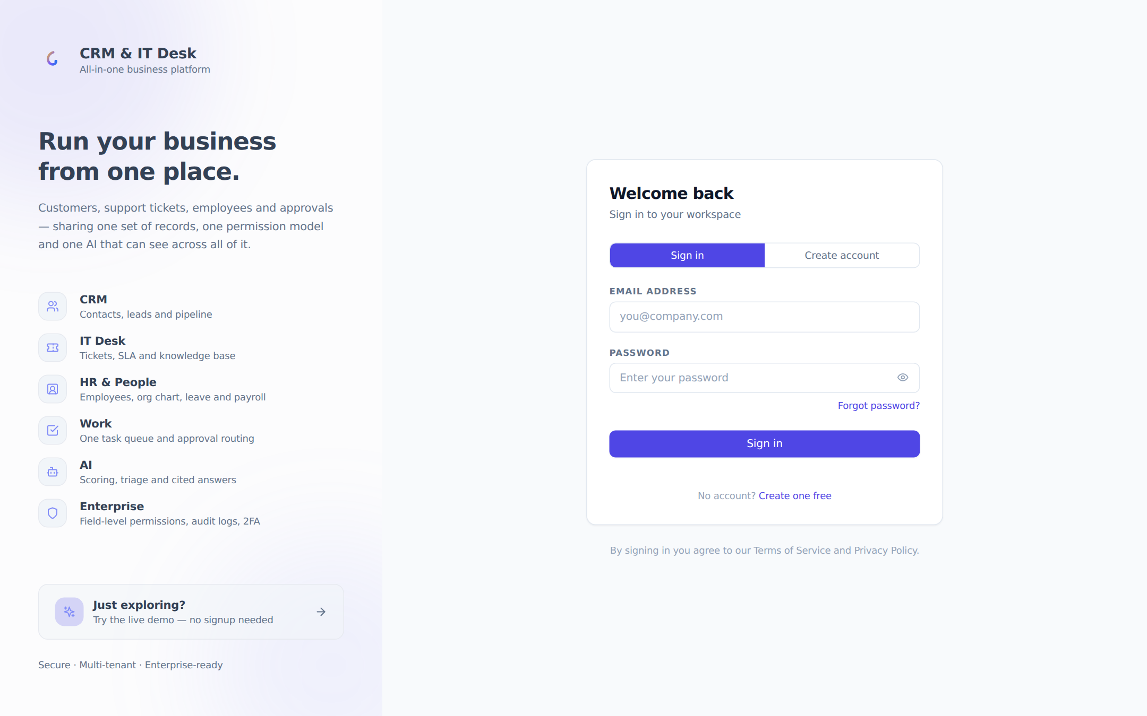
The sign-in page, with password login, Google Sign-In, self-service workspace creation and a live-demo shortcut.
The login page combines four ways into the product:
- Email + password — the standard flow. If the account has two-factor authentication enabled, a second step asks for the 6-digit authenticator code (or a backup code). A "Forgot password?" link starts an email-based reset flow.
- Google Sign-In — one-click login for users who have linked their Google account from their Profile page (shown only when the deployment has a Google client ID configured).
- Microsoft Entra ID SSO — each organization can enable single sign-on with its own tenant and a friendly sign-in link of the form /login/<company-slug>. Failed SSO attempts land back here with a clear error message.
- Create account — self-service registration (company name, your name, work email, password) creates a brand-new workspace, held for approval where configured.
Example A new customer visits the app, switches to the "Create account" tab, enters "Acme Corp", their name and email, and gets a free workspace with 5 seats. Later they invite teammates from Administration → Users, connect their Gmail inbox, and upgrade to Pro from the Billing page.

2.2 The live demo
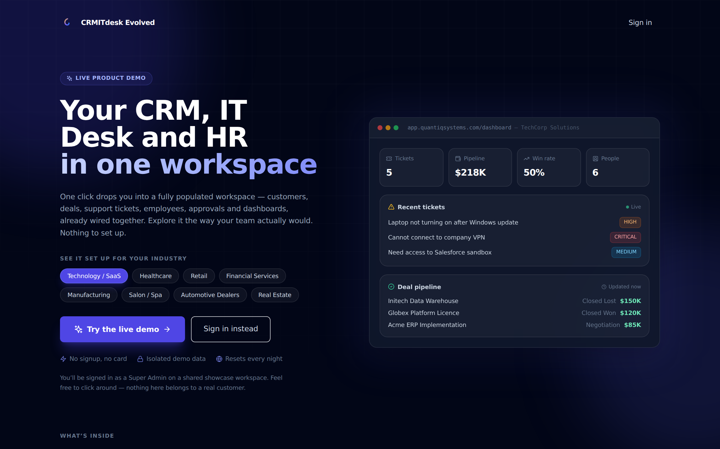
The public demo landing page: pick an industry vertical and enter a fully seeded workspace with one click.
The public /demo page lets anyone explore the product without signing up. A visitor picks an industry vertical — Technology, Healthcare, Retail, Financial Services, Manufacturing, Salon & Spa, Automotive or Real Estate — and is signed into a seeded showcase workspace for that industry as a Super Admin. The page shows a live preview of the selected workspace (real stats, recent tickets and pipeline from the seed data), and the demo data resets nightly. Platform administrators visiting the page can seed any missing vertical workspaces with one click.

2.3 Navigation
The application shell has a left sidebar and a top bar. The sidebar groups pages into sections — a top ungrouped block (Dashboard, My Work, Approvals, Inbox, Automation, Portal, AI Builder, AI Studio), then CRM, HR, IT Desk, Admin and Integrations. Sections collapse and remember their state; utility sections (Admin, Integrations) start collapsed. Each item shows a colored icon, and the active page is highlighted with an accent bar. What a user sees is role-driven: a Sales Rep never sees the IT Desk admin pages, an Employee sees only self-service items, and custom modules appear as extra links in whichever section the admin placed them.
The top bar shows the current section and page, a global AI-powered smart search ("Find contacts, tickets, deals…"), the Ask AI command button (Ctrl/Cmd+K), and the notification bell with real-time in-app notifications. On mobile, the sidebar becomes a slide-in drawer and search moves below the top bar.

2.4 Personalization: themes, fonts and labels
- Themes — a theme picker in the sidebar footer offers four visual themes (Minimal, Modern, Classic, Friendly), each with a light and dark variant.
- Fonts — four font choices: Inter (default), Plus Jakarta Sans, DM Sans and Nunito Sans.
- Terminology — organizations can rename core entities app-wide (e.g. "Tickets" → "Cases", "Deals" → "Matters") through AI Studio label overrides; every page and menu respects the override.
- Currency & timezone — set once in Org Settings and applied to every money value and date in the workspace.

3. Dashboard
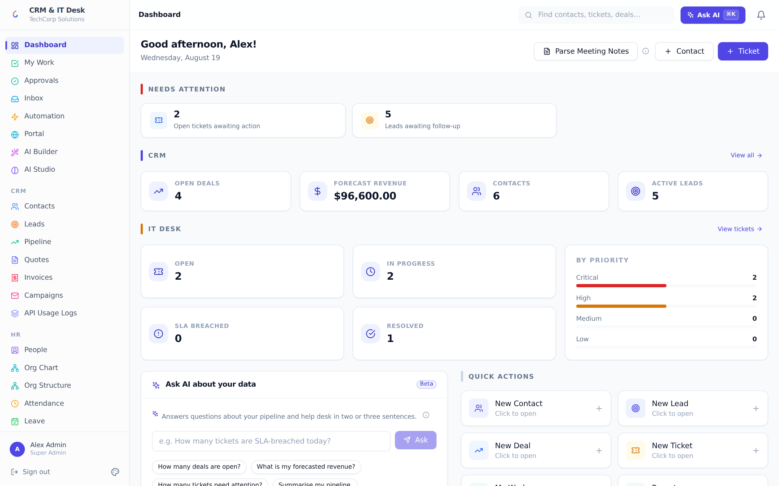
The role-aware dashboard: attention items, CRM and IT Desk stats, priority breakdown, AI Q&A and quick actions.
The dashboard is the landing page after login and adapts to the signed-in role — every widget is both rendered and fetched only if the user’s role can read the underlying data.
- Needs attention — the first block surfaces what is urgent right now: SLA-breached tickets, open tickets awaiting action, and leads awaiting follow-up. Each tile links straight to the filtered page. When everything is clear it collapses to a friendly "All caught up" line.
- CRM stats — Open Deals, Forecast Revenue (in the org currency), Contacts and Active Leads, each clickable.
- IT Desk stats — Open, In Progress, SLA Breached and Resolved ticket counts plus a "By Priority" mini-chart of Critical/High/Medium/Low volumes.
- Ask AI about your data — managers can type a natural-language question ("How many tickets are SLA-breached today?") and get a two-to-three-sentence answer computed from the org’s live metrics, with suggested starter questions.
- Quick Actions — role-filtered shortcut tiles: New Contact, New Lead, New Deal, New Ticket, My Work, Reports, Import CSV.
- AI Insights — a proactive insights widget for managers: 3–5 AI-generated observations (stale deals, aging tickets, growth trends) with optional calls to action.
- Parse Meeting Notes — paste raw meeting notes and the AI extracts contacts, leads, deals and next steps, offering to pre-fill the corresponding create forms.
Example A sales manager logs in at 9am. The attention strip shows "5 leads awaiting follow-up"; one click opens the Leads page pre-filtered. Back on the dashboard she asks the AI "What is my forecasted revenue?" and gets "$96,600 across 4 open deals, the largest being Acme ERP Implementation at $85,000."

4. CRM Suite
The CRM covers the full revenue cycle: capture a lead, qualify and convert it into a deal, work the deal across a drag-and-drop pipeline, send a quote the customer can accept and e-sign online, invoice it, and follow up at scale with email campaigns. All CRM pages are gated to CRM roles (Super Admin, Sales Manager, Sales Rep); other roles that navigate in by URL get a friendly access-denied screen instead of errors.
Shared record features. Every major record (contact, lead, deal, quote, invoice, campaign, ticket, asset, change request…) supports the same toolkit: colored tags, threaded comments, file attachments (stored in the org’s connected storage), linked tasks, org-defined custom fields (with defaults and conditional visibility), and record templates that pre-fill create forms.

4.1 Contacts
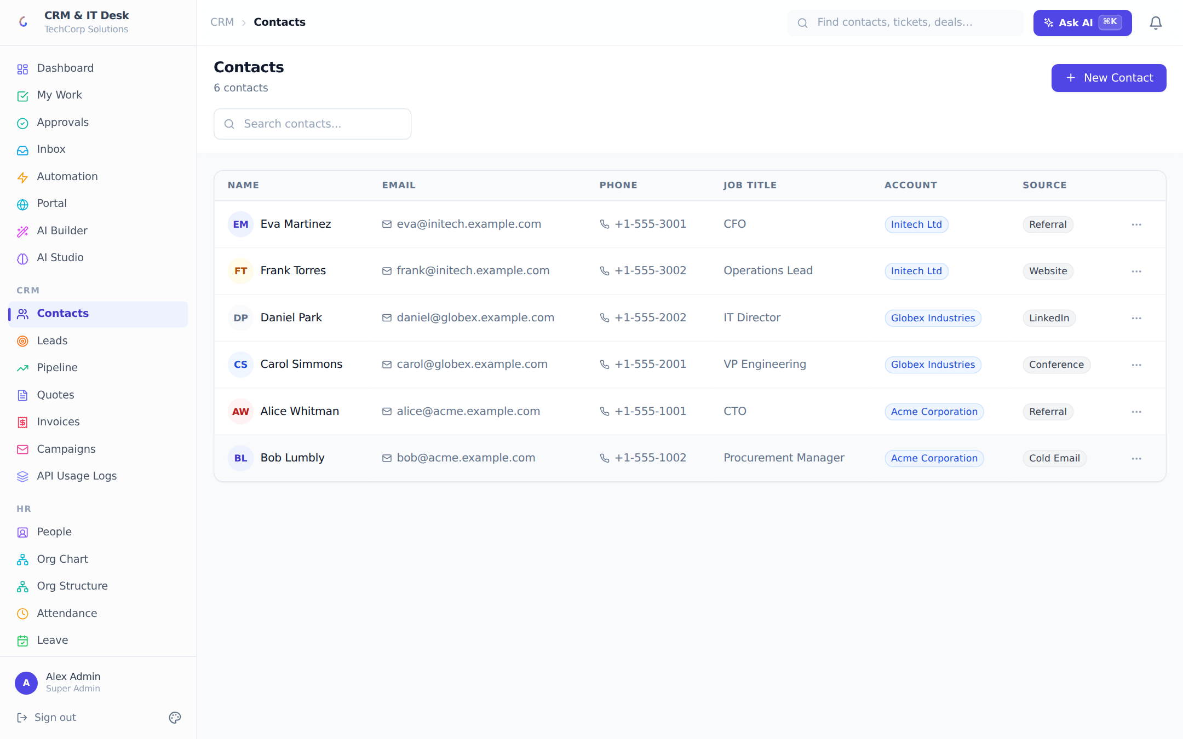
The Contacts list: searchable table with account and source badges.
The Contacts page lists every person your organization deals with — name with avatar, email, phone, job title, linked account (company) and source. Free-text search matches name, email and phone. The create/edit form captures basic information (name, email, phone, job title, date of birth) and classification (source: Web, Referral, Cold Outreach, Event, Social Media, Other; account link), plus any custom fields. The date-of-birth field deliberately powers birthday automations (see Workflows).
Contact detail page. Clicking a contact opens a full profile: contact info card, a pipeline summary (total deal value, deal counts, open deals), the list of linked deals with stage badges, and an activity timeline where you log calls, emails, meetings, tasks and notes with due dates. An AI Churn Risk card assesses the relationship (HIGH/MEDIUM/LOW with a 0–100 score and reasoning) from activity recency and support-ticket sentiment. Tags, comments, attachments and tasks complete the page.
Example After a call with Priya at Globex, a rep opens her contact page, clicks "Log Activity", picks type Call, subject "Renewal discussion", due date next Tuesday — the call appears on the timeline and (if Google Calendar is connected) on the rep’s calendar.

4.2 Leads
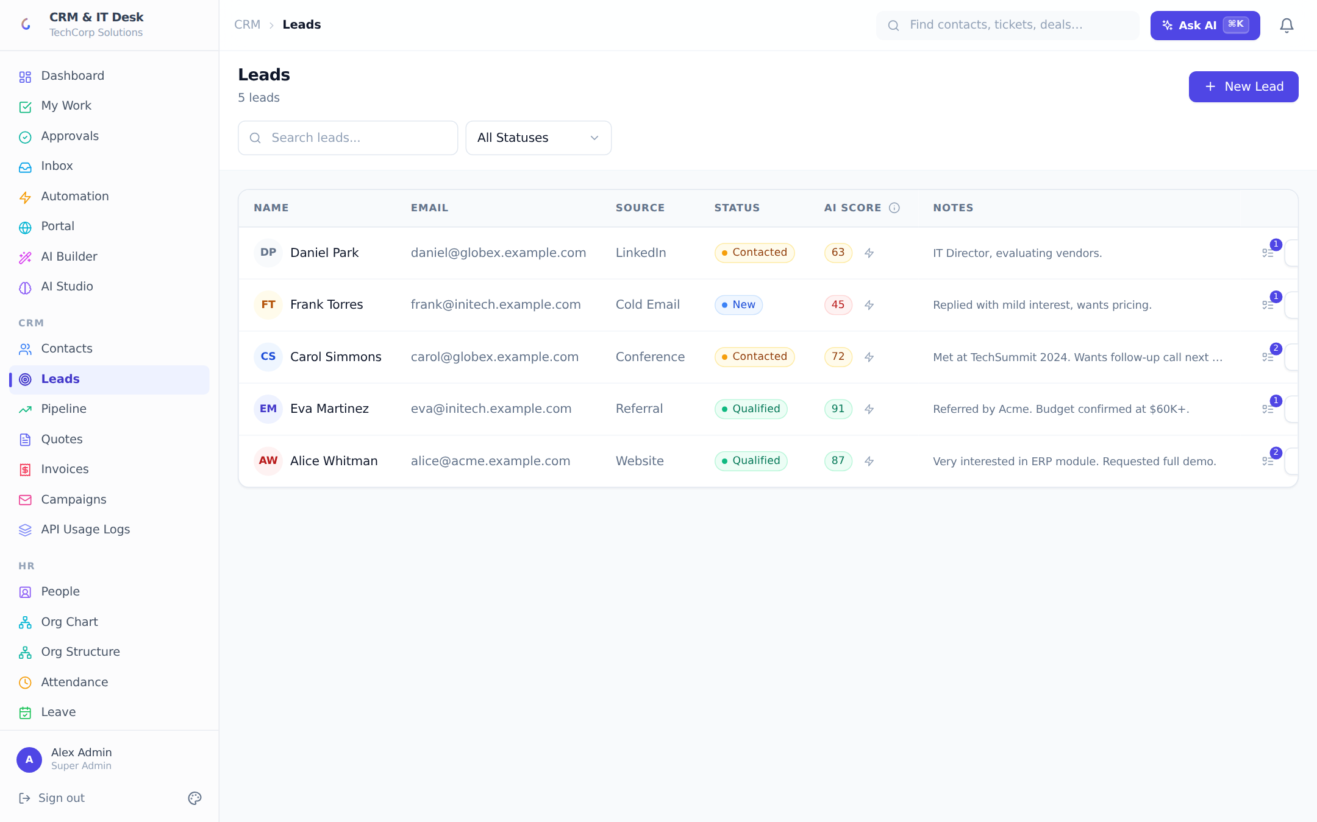
Leads with statuses, AI scores and conversion actions.
Leads move through five statuses: NEW → CONTACTED → QUALIFIED (or UNQUALIFIED) → CONVERTED. The list shows each lead’s status, source, notes and an AI Score column: click "Score" and the AI rates conversion likelihood 0–100 with a one-line reason (color-coded green ≥75, yellow ≥50, red below). Managers can bulk-score every lead at once from the AI Builder page.
Each lead row offers follow-up activities (schedule calls/emails/meetings with due dates, mark them done, and see the count at a glance), an AI follow-up email generator (subject + body with copy buttons and a regenerate option), an AI nurture sequence generator (a 3-step drip plan with day offsets), and editing with tags, attachments and tasks.
Converting a lead. The Convert button opens a modal summarizing the lead and asking for the new deal’s title (pre-filled), value, probability and pipeline stage. On confirm the lead is marked Converted, a contact is created (or linked), and the deal appears on the pipeline board.
Live example A web form captures "Eva Martinez — Initech". The rep clicks Score (AI returns 82: "engaged, enterprise domain, recent activity"), generates a follow-up email, sends it, logs a call, then hits Convert → "Deal - Eva Martinez", $67,000, stage Prospecting. The lead shows a green Converted check and the deal card is now on the board.

4.3 Pipeline (Deals)
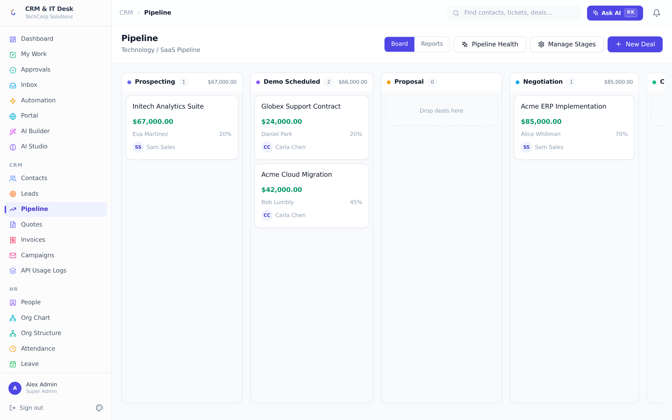
The Kanban pipeline: drag deals between customizable stages; each column totals its value.
The Pipeline page is a full-height Kanban board. Each column is a stage of the org’s pipeline — with its own color, deal count and total value — and deal cards are dragged between stages (the move is saved instantly and recorded in the deal’s history). Cards show title, value, contact, probability and assignee, with hover-delete.
- Manage Stages — rename, recolor, reorder, add and remove stages, and set a per-stage win probability. Removing a stage that still holds deals prompts you to move them to another stage first ("Move & Delete"). Renaming a stage moves every deal in it along.
- Deal detail — stat tiles (stage, value, contact, assignee) plus AI Win Probability (a percentage with contributing factors and a recommendation), an AI follow-up email generator with a one-click Tone Check (tone label, 0–100 score, issues and suggestions — and an explicit warning state if the AI could not review it), WhatsApp reminder scheduling, tags, custom fields, comments, attachments and tasks.
- Pipeline Health (AI) — managers get an org-wide analysis: a summary, a list of risks (stale deals, concentration) and opportunities.
- Reports view — managers can flip the board to Reports: a pipeline funnel (per-stage counts and value with proportional bars), a probability-weighted forecast, and Won/Lost counters.

4.4 Quotes & Proposals
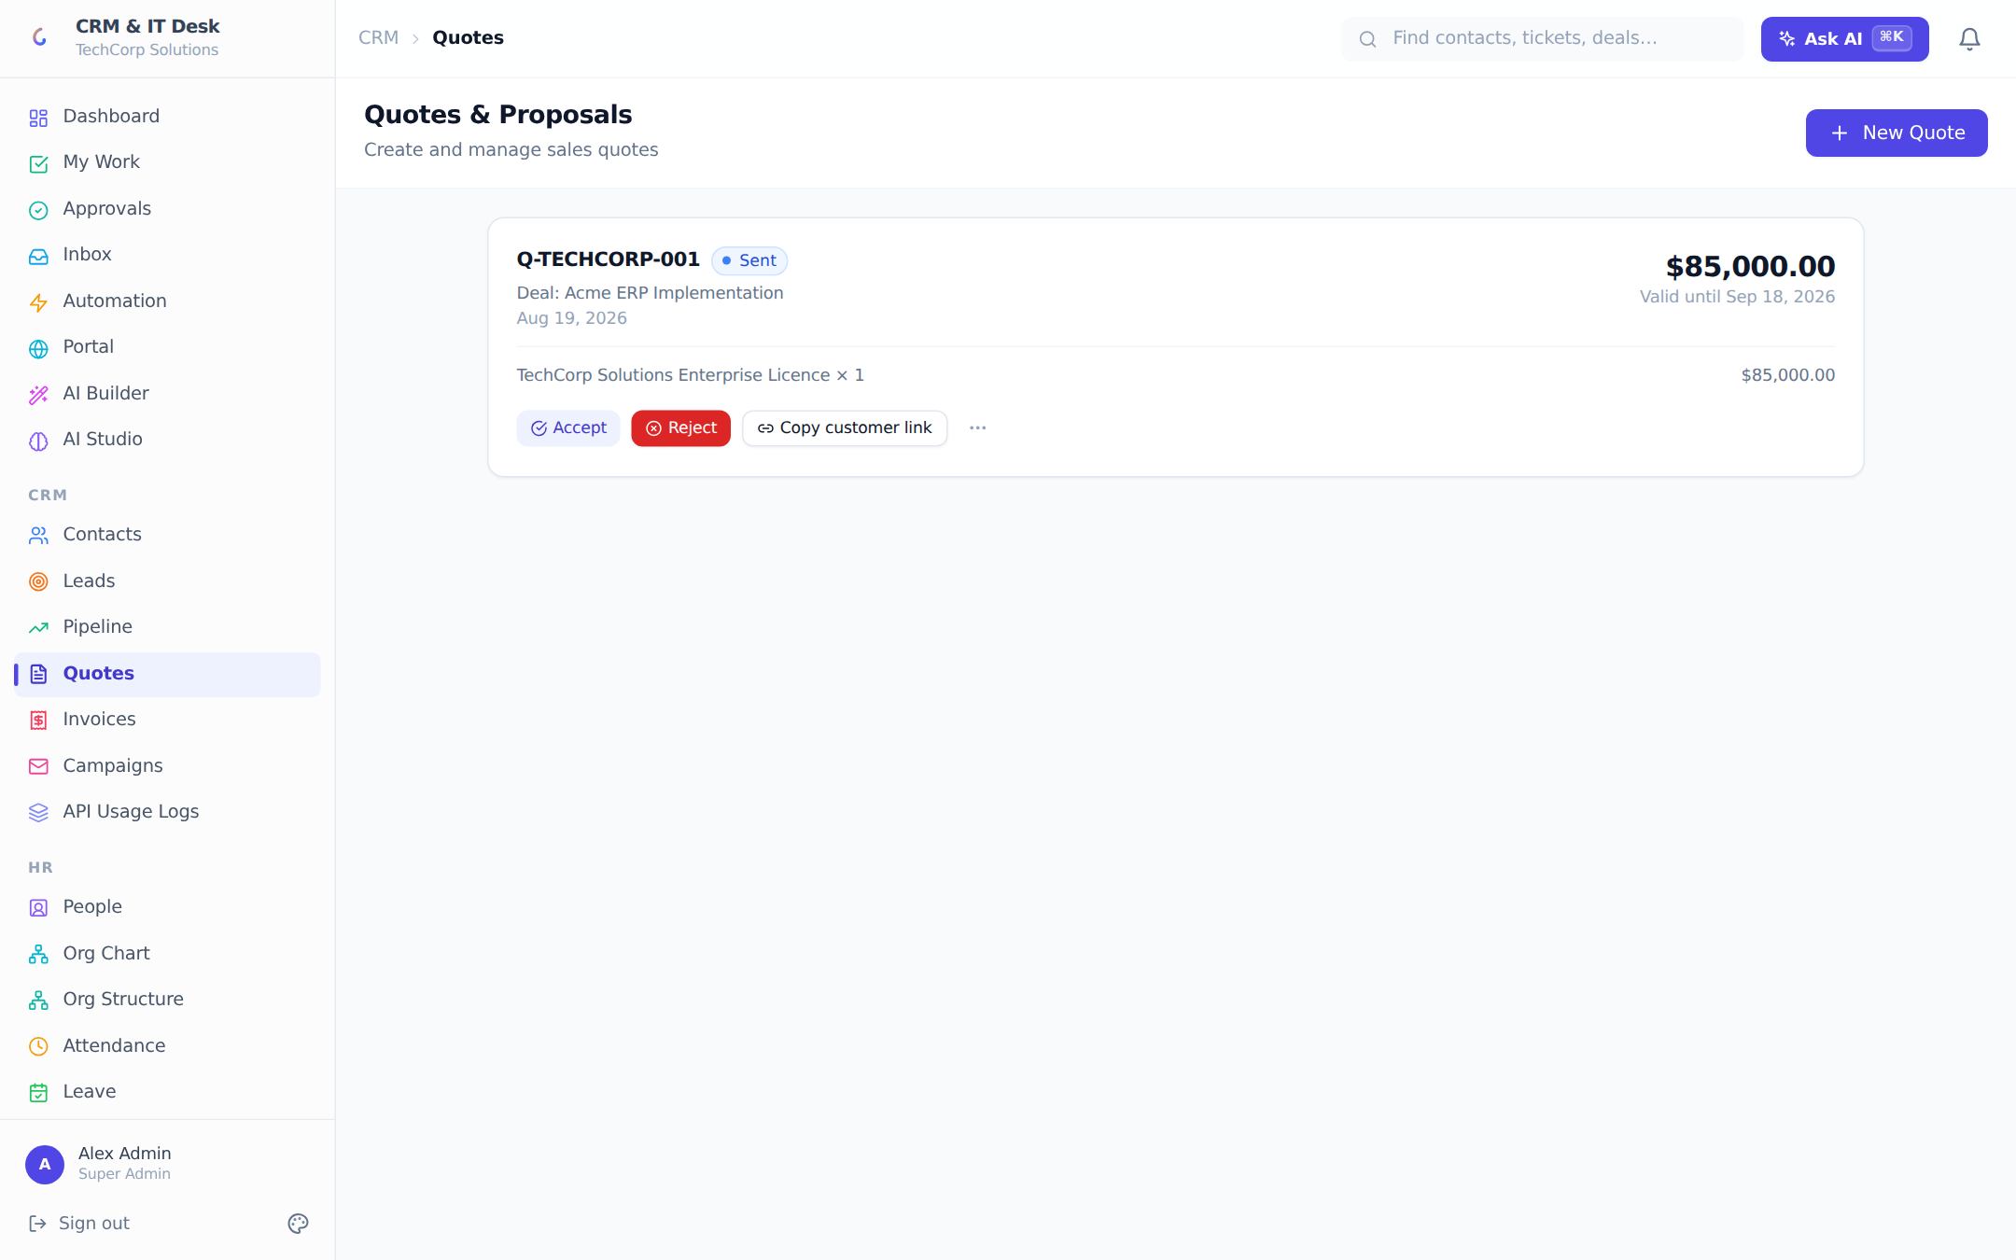
Quotes: line-item proposals customers can accept and e-sign through a secure public link.
Quotes carry a title, validity date and line items (description × quantity × unit price) with a live total. The lifecycle is DRAFT → SENT → ACCEPTED or REJECTED. A quote can start from a reusable quote template. Once sent, the "Copy customer link" action produces a cryptographically signed public URL: the customer opens it without any login, reviews the quote, and accepts with an e-signature (name, email, drawn signature, IP and timestamp are captured). Acceptance automatically generates an invoice.

4.5 Invoices
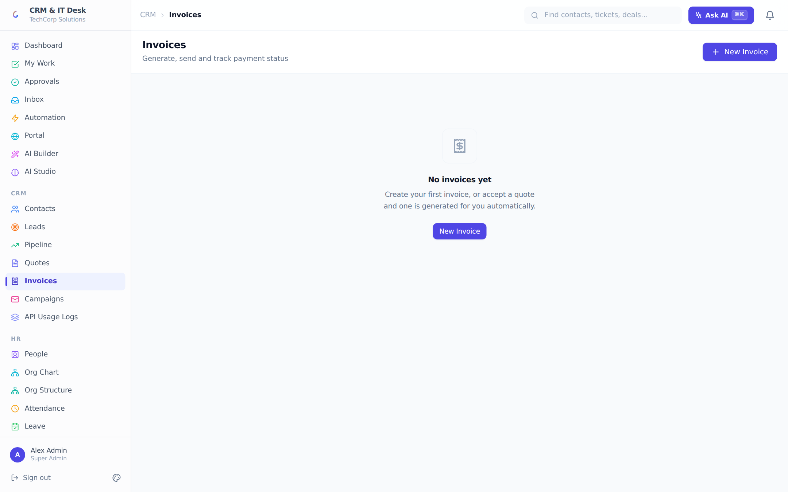
Invoices with sequential numbers, per-line discounts, tax and public payment links.
Invoices get sequential numbers (INV-0001…), line items with per-line discount %, an invoice-level tax rate, and computed subtotal/tax/grand total. Statuses: DRAFT → SENT → PAID, plus OVERDUE and VOID. Invoices are created automatically when a quote is accepted, or by hand. Each non-draft invoice has a public share link for the customer; "Mark Paid" stamps the payment date. Paid and void invoices become immutable in the UI.

4.6 Email Campaigns
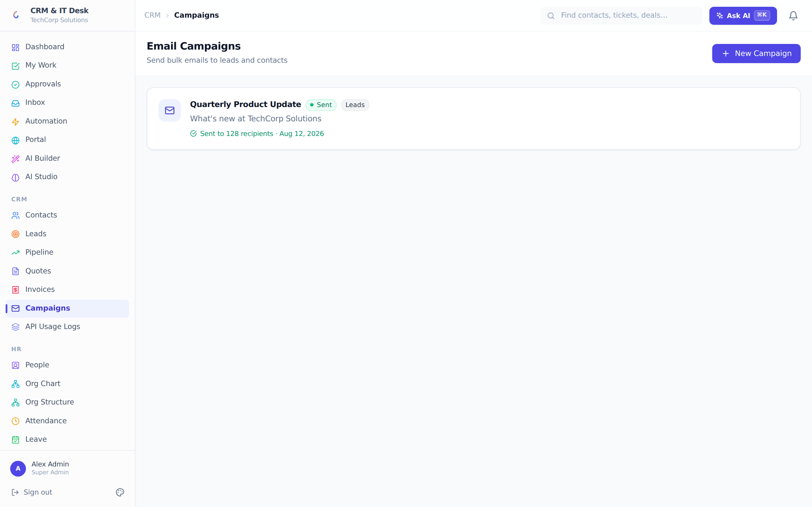
Campaigns: bulk email to all leads or all contacts, with templates and send tracking.
Campaigns send one email to a whole audience: Leads (unconverted) or All Contacts. A campaign has a name, subject and body, can start from an email template, and moves DRAFT → SENDING → SENT with a recipient count and timestamp. Sending asks for confirmation and is irreversible; sent campaigns become read-only. Mail goes out through the org’s connected email account (or the platform fallback, branded with the org’s name).
End-to-end example Lead → deal → cash: score and convert a lead (4.2), drag the deal to Negotiation (4.3), send a quote from the "Standard implementation" template (4.4) — the customer opens the public link on their phone and signs. The app auto-creates invoice INV-0007; the rep sends it and marks it paid when the transfer lands. Every step is visible on the contact’s timeline, the deal history, and the audit log.

5. IT Help Desk

5.1 Tickets
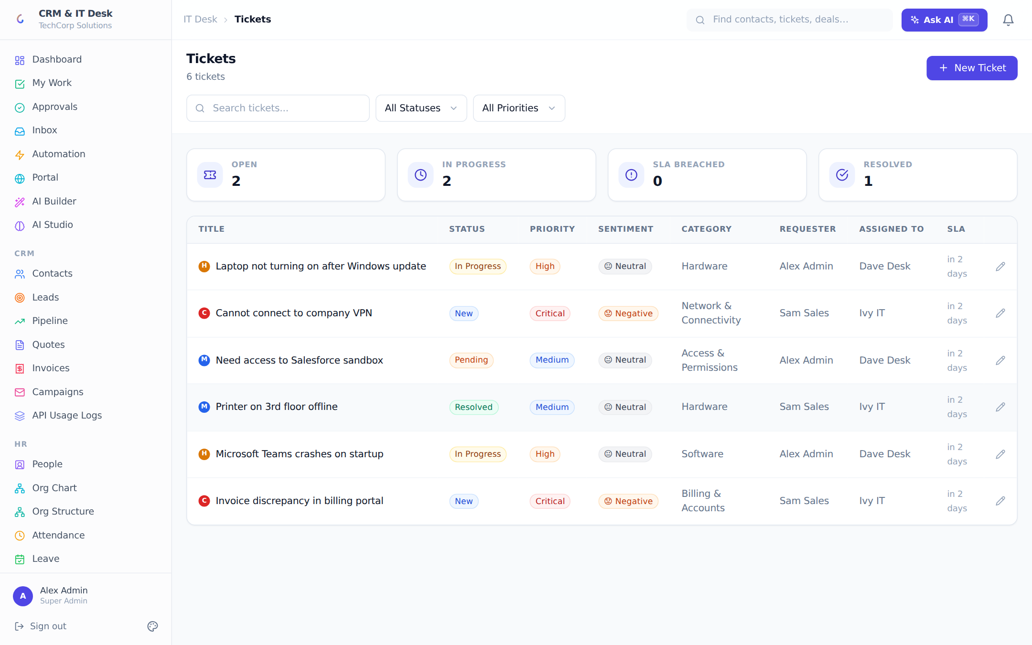
The ticket queue: priority dots, status and sentiment badges, SLA countdowns and manager stats.
Tickets are the heart of the help desk. The queue shows every ticket with a colored priority dot (LOW / MEDIUM / HIGH / CRITICAL), a status badge (New / In Progress / Pending / Resolved / Closed), an AI-detected sentiment badge (😊 Positive, 😐 Neutral, 😟 Negative, 😤 Frustrated), category, requester, assignee, and a live SLA column that counts down to the resolution deadline and turns red "Breached" when missed. Filters cover free-text search, status and priority; managers additionally see Open / In Progress / SLA Breached / Resolved stat tiles.
Creating a ticket. Staff can file for themselves, for a teammate, or on behalf of a CRM contact. The form supports record templates, custom fields, and — as soon as the title reaches ten characters — live AI duplicate detection that warns about similar existing tickets with a percentage match.
The ticket detail view has two tabs. History is a timeline of every status change. Details shows the description, a summary strip (requester, assignee, category, SLA due, created, and "on behalf of" contact when relevant), tag and custom-field panels, one-click status pills, and an assignee picker limited to IT roles. Below sit the collaboration panels: per-ticket time tracking, WhatsApp reminder scheduling, threaded comments, attachments and linked tasks.
Six AI assists are built into every ticket:
- Suggest Reply — drafts an empathetic agent response, grounded in relevant knowledge-base articles, with copy-to-clipboard.
- Auto-Routing — picks the best category and agent and applies them immediately, showing its reasoning.
- Thread Summary — condenses a long conversation into 3–4 sentences.
- Resolution Estimate — predicts how long the ticket will take, with reasoning.
- SLA Risk — rates breach risk HIGH/MEDIUM/LOW with a 0–100 score.
- Generate KB Article — turns a resolved ticket into a draft knowledge-base article in Markdown.
Ticket lifecycle example A portal customer reports "VPN drops every hour" → the ticket lands as New with the Network category’s 24-hour SLA. AI auto-route assigns Ivan (network specialist); he uses Suggest Reply, logs 45 minutes in time tracking, resolves the ticket, and clicks Generate KB Article so the fix is searchable next time. A workflow rule automatically emails the customer a satisfaction survey.

5.2 Categories & SLA policies
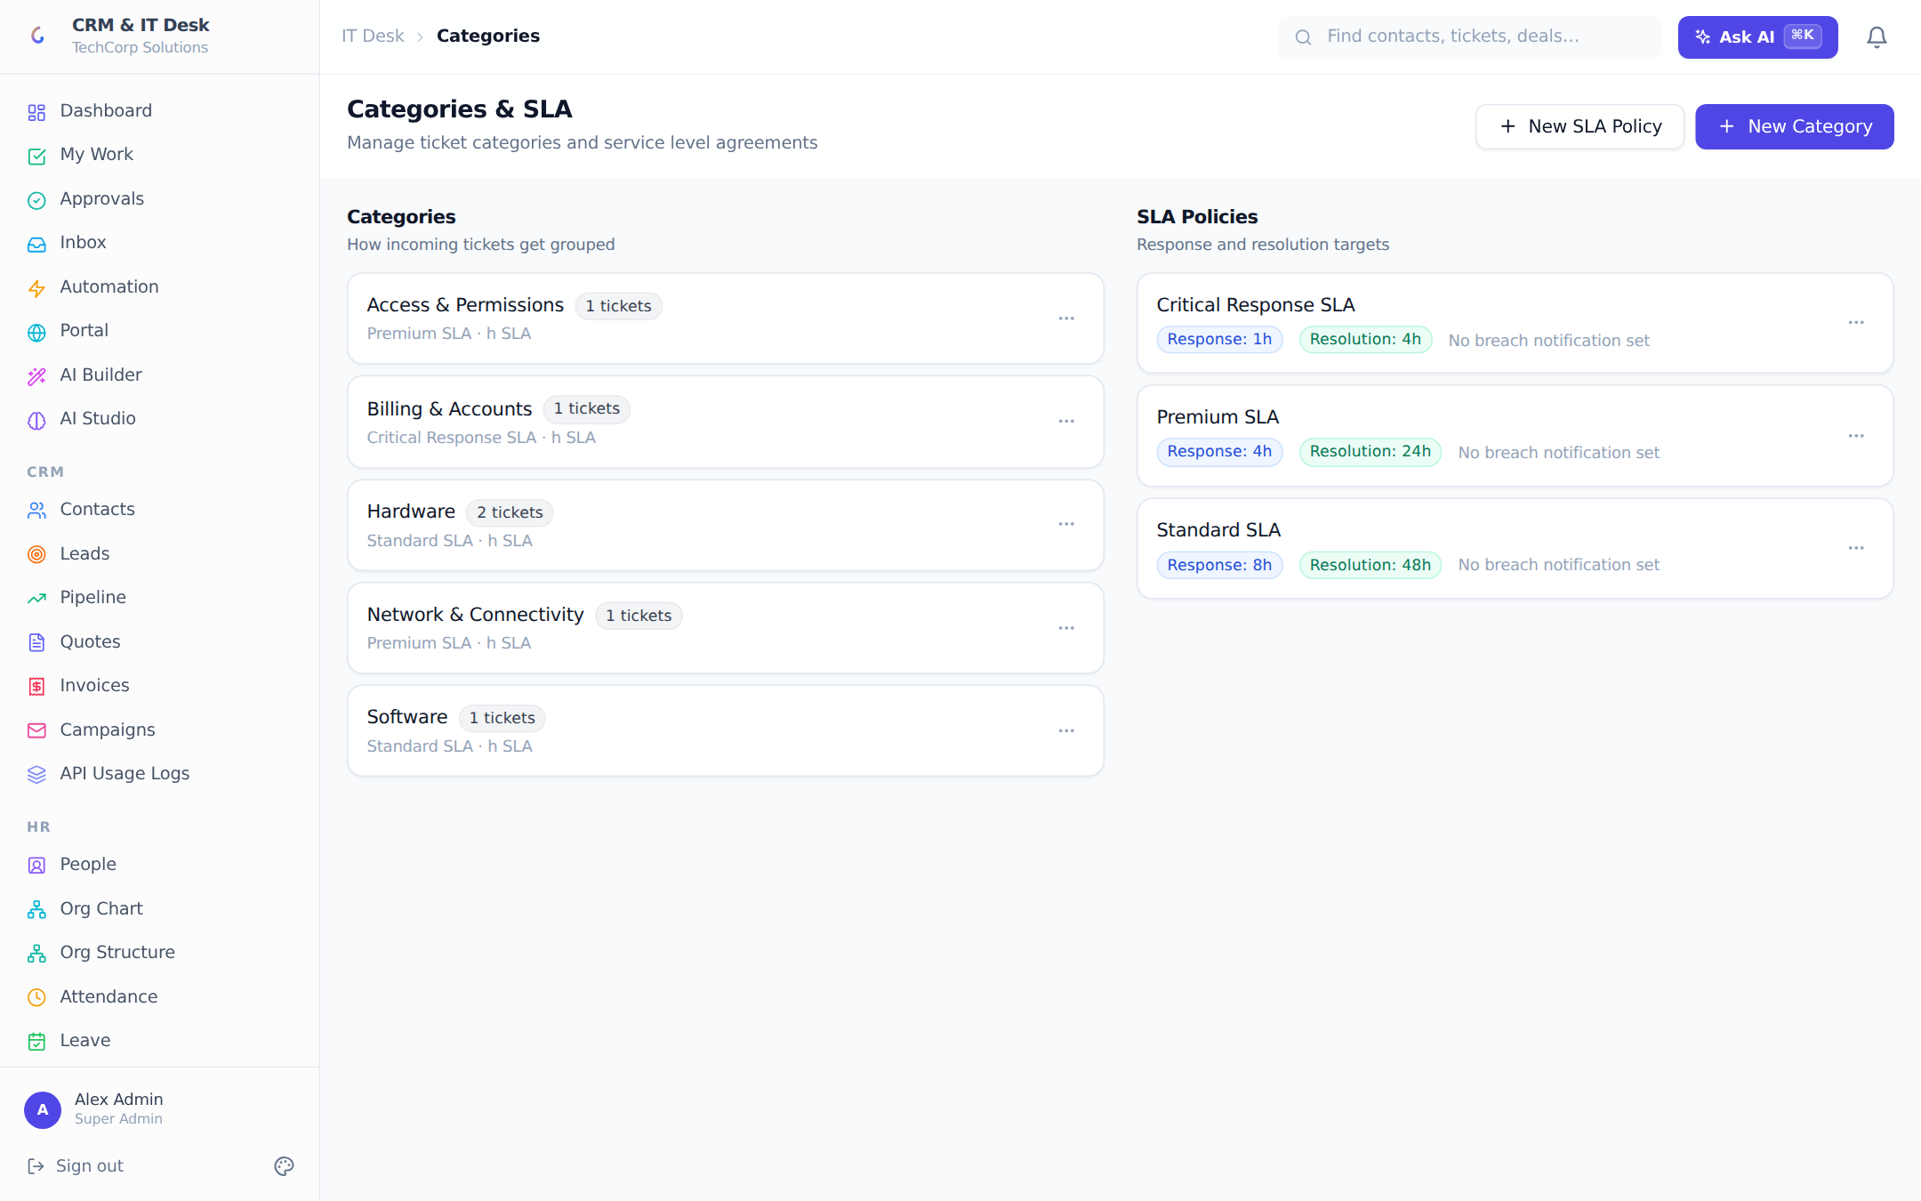
Categories on the left, SLA policies with response/resolution targets on the right.
Categories organize tickets and articles, and each category can link to an SLA policy. A policy defines a response-time and resolution-time target in hours, and optionally a user to notify the moment a ticket under the policy misses its resolution deadline (in-app + push), independent of any workflow rule. New tickets inherit their category’s SLA automatically; breaches drive the red indicators on the queue, the SLA_BREACH workflow trigger and Slack/Teams alerts.

5.3 Knowledge Base
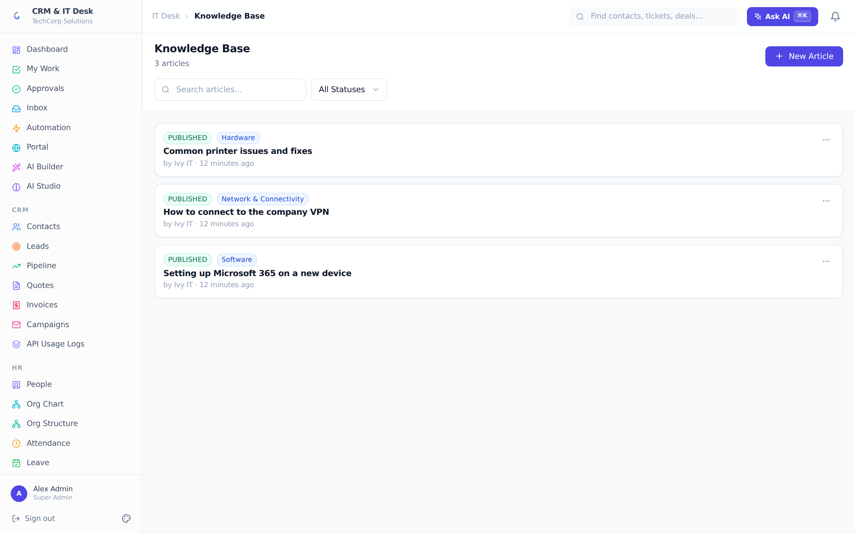
The knowledge base: Markdown articles with categories and a publish lifecycle.
Articles are Markdown documents with a category and a lifecycle of DRAFT → PUBLISHED → ARCHIVED. Published articles are also automatically indexed into the AI knowledge layer (see chapter 10) so the assistant can answer questions with citations. Articles can be born from resolved tickets via the AI generator.

5.4 Assets
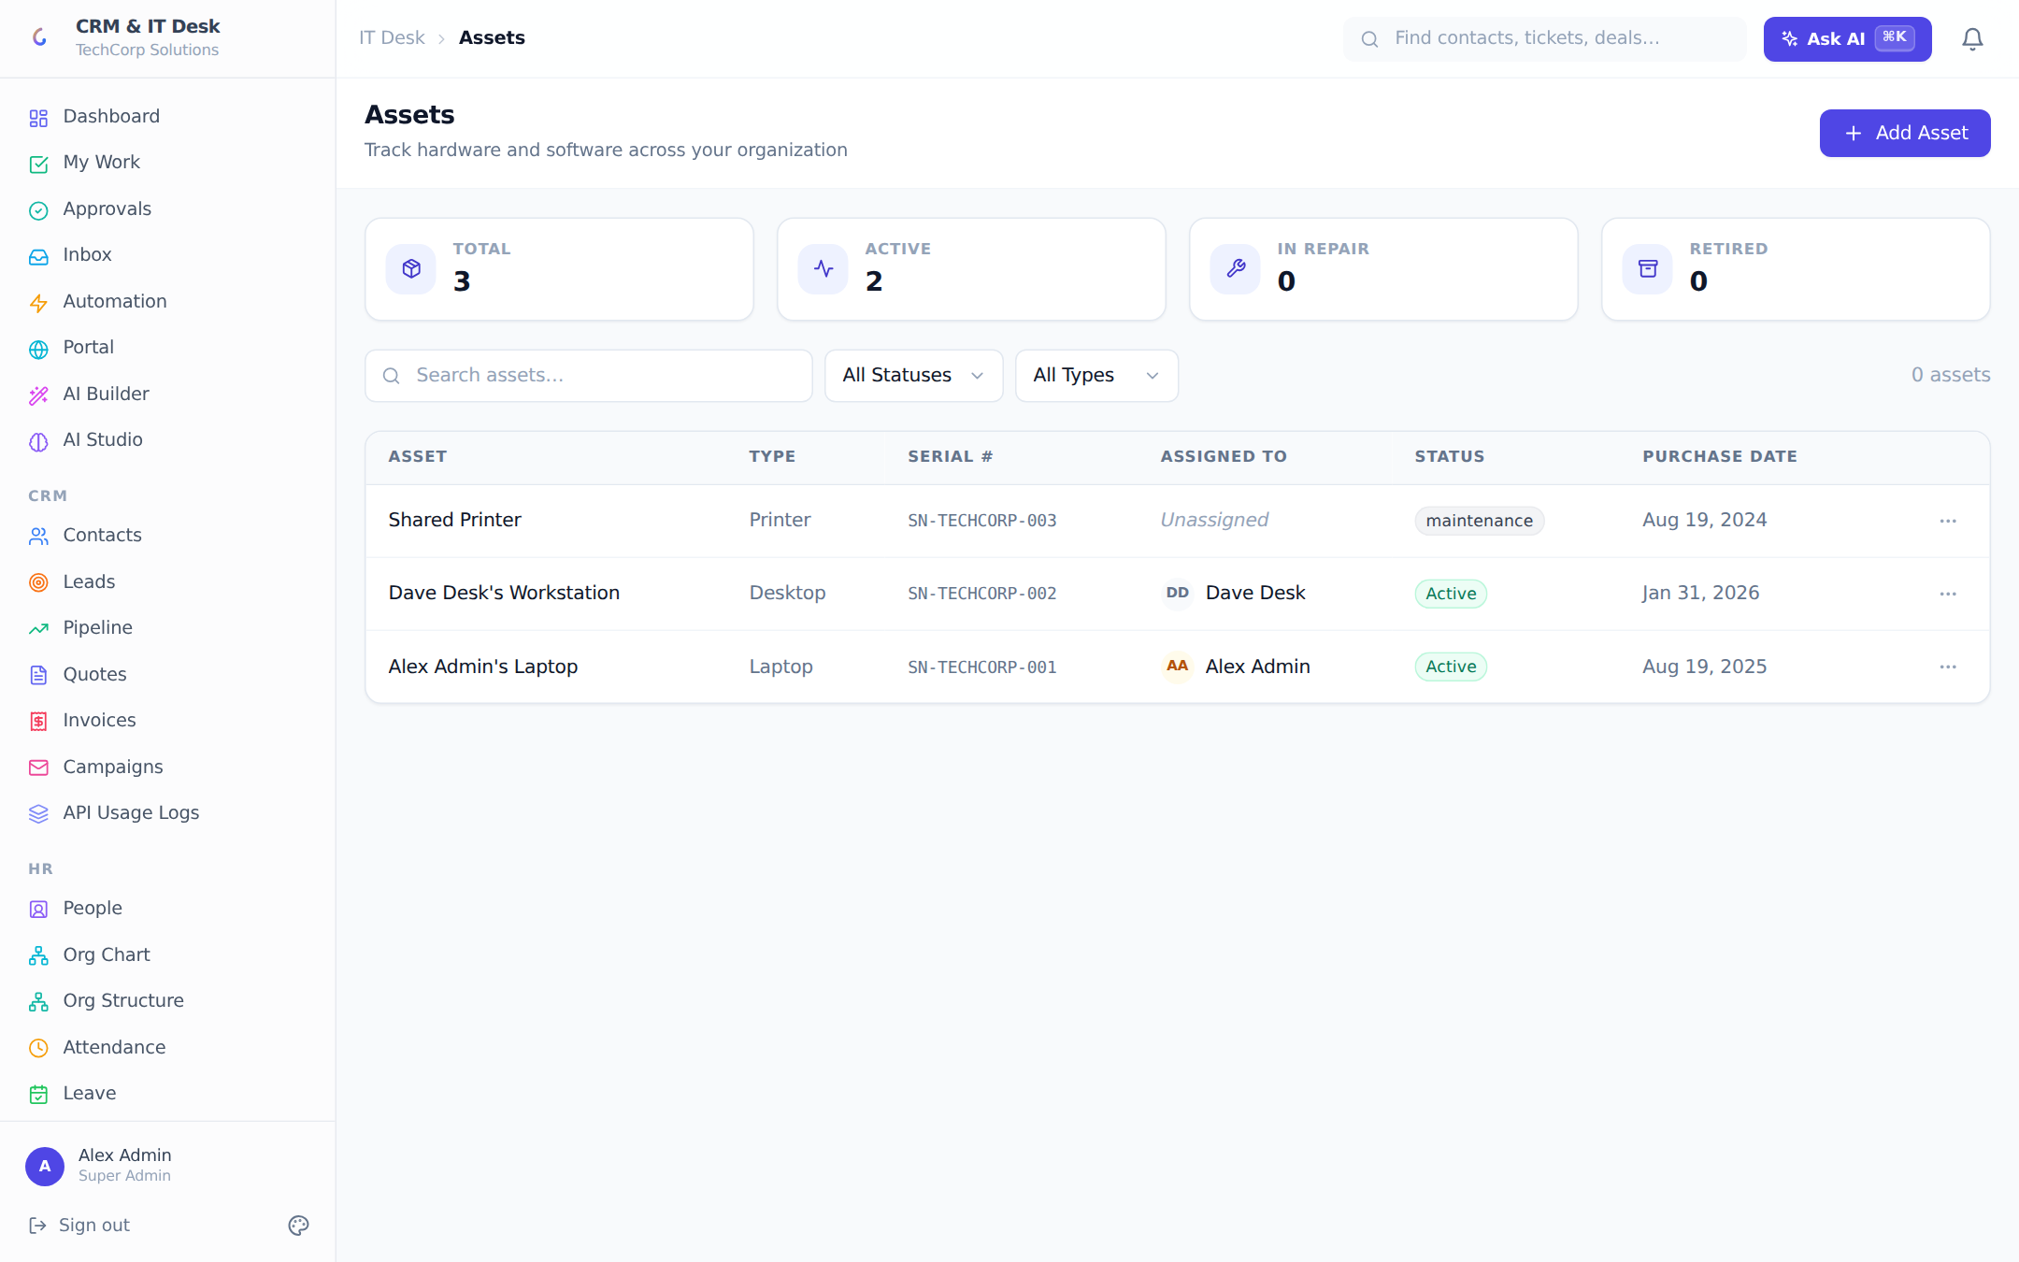
The asset inventory with stats, filters and assignment tracking.
The asset registry tracks hardware and equipment: name, type (Laptop, Desktop, Monitor, Phone, Tablet, Server, Printer, Network, Peripheral, Other), serial number, assigned user, status (Active, Inactive, In Repair, Retired) and purchase date. Stat tiles summarize totals by status; assets support tags, attachments and tasks, and can be linked to tickets.

5.5 Change Management
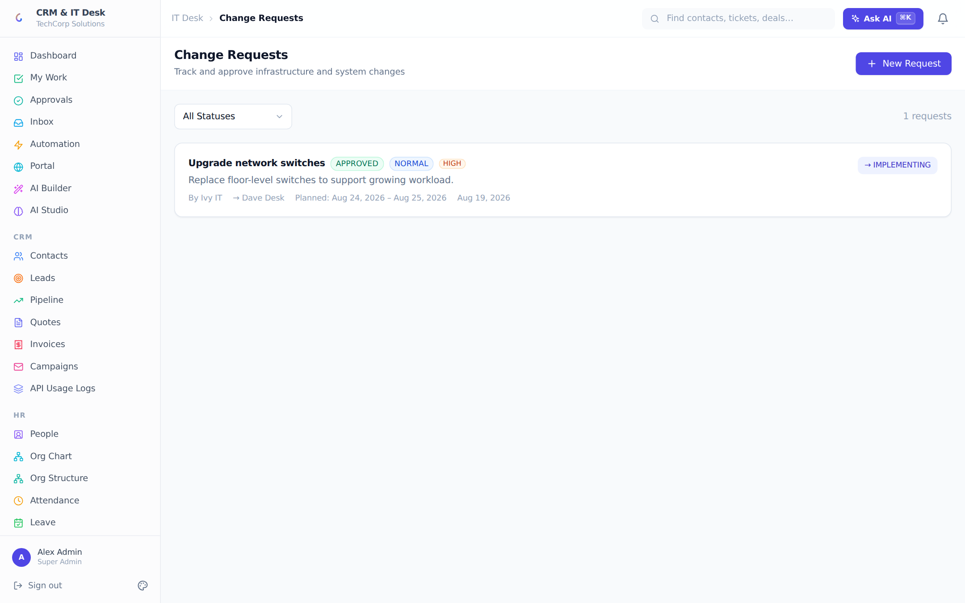
ITIL-style change requests with an approval workflow and planned windows.
Change requests follow an ITIL-style flow: DRAFT → SUBMITTED → APPROVED → IMPLEMENTING → DONE, with REJECTED (reason required, shown on the card) as a terminal branch. Each change has a type (Standard, Normal, Emergency), a risk/priority level, an assignee and a planned start/end window. Editing narrows as the change progresses (drafts and submissions only) and deletion is draft-only, so an approved change can never be quietly altered.

6. Unified Inbox
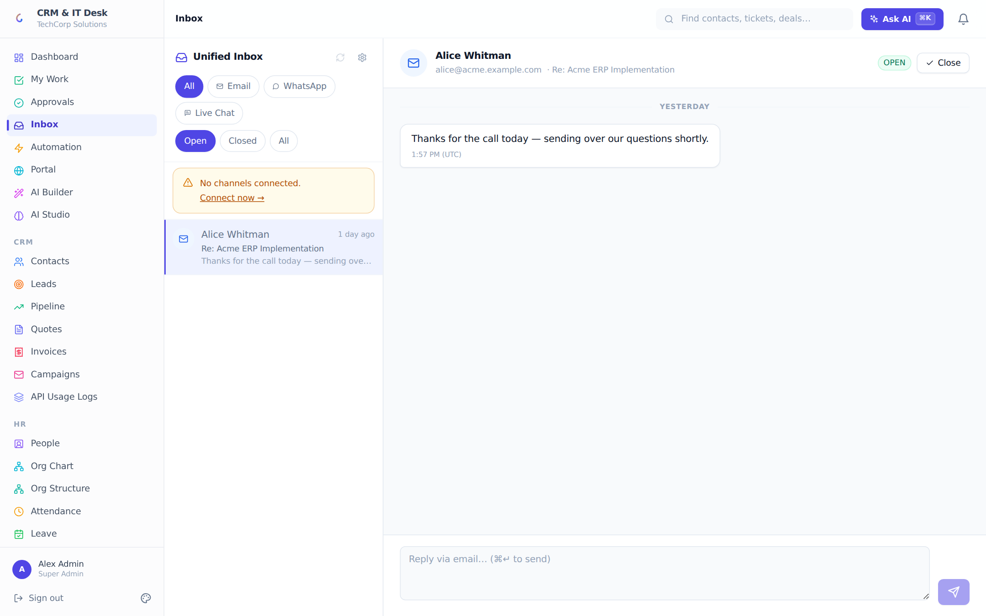
The omnichannel inbox: email, WhatsApp and live chat in one two-pane view.
The inbox merges three channels into one conversation list: Email (the org’s IMAP/SMTP mailbox, synced every five minutes with a manual Sync button), WhatsApp (the org’s Twilio number, receiving via webhook), and Live Chat (messages from the customer portal’s chat widget). Conversations carry the contact’s identity, unread badges, and an Open/Closed status; filters cover channel and status.
The thread view renders messages as chat bubbles with day separators and timestamps. The reply composer is channel-aware (replies go out through the same channel the customer used) and supports Ctrl/Cmd+Enter to send. Closed conversations must be reopened to reply.
Channel settings (IT managers only): the Email tab connects any IMAP/SMTP account (with Gmail App-Password guidance); the WhatsApp tab connects a Twilio account (SID, token, number), sets an optional org-default notification number used by reminders and workflow actions, and displays the exact webhook URL to paste into the Twilio console.

7. My Work & Approvals

7.1 My Work
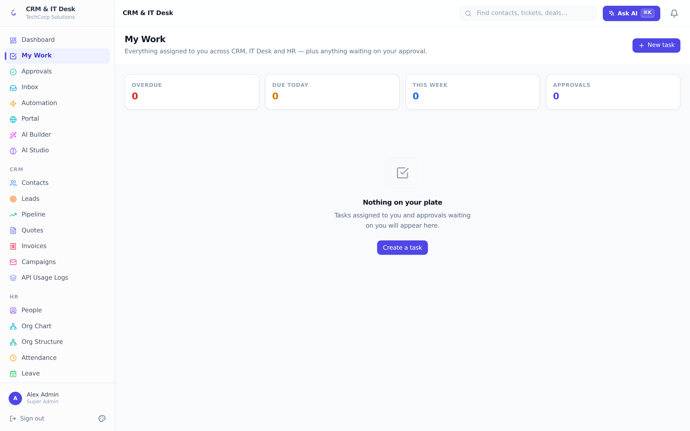
My Work: one personal queue across CRM, IT Desk and HR, bucketed by time.
My Work gathers everything assigned to you across every module into one queue organized by time, not by module: Overdue, Today, This week, Later, No date. Stat tiles count each bucket plus pending approvals. Tasks have priorities (Low/Medium/High/Urgent), statuses (Open, In Progress, Blocked, Done, Cancelled), due dates, checklists with per-item toggles, "blocked by" dependencies, and a source badge when a workflow, onboarding flow or the AI created them. A "Waiting on you" card surfaces approvals inline so deciders never need to leave the page.

7.2 Approvals
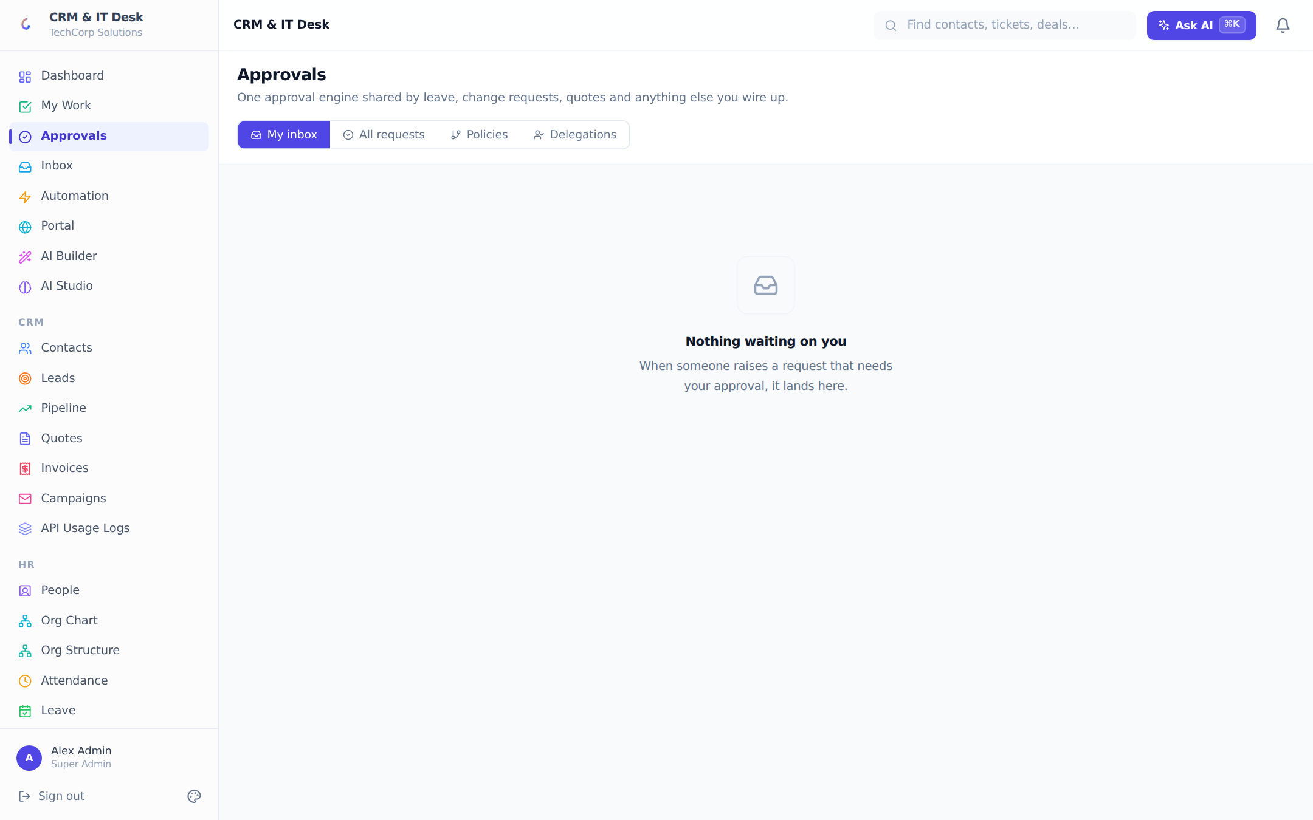
The universal approval engine: inbox, request tracking, policies and delegations.
One approval engine serves the whole product — leave requests, change requests, quotes, expenses, purchases, onboarding/offboarding and custom types. Policies (managers only) define when approval is required and who approves: a named sequence of steps, each resolved dynamically to the requester’s manager, the skip-level manager, the department head, the team lead, anyone holding a role, or a specific person — combined in one of four modes: Sequential, Parallel, Any one, Unanimous, with an expiry window (default 7 days) after which undecided requests expire automatically.
My inbox is the approver’s queue (approve/reject with an optional comment the requester sees). All requests tracks every request with a step-by-step timeline of decisions. Delegations hand your approvals to a colleague for a date range (both of you can decide while it is active), with revocation.
Example policy "Quotes above $10,000" → Step 1: requester’s manager; Step 2: Finance (role) — Sequential, expires in 72 hours. A rep sends a $12,400 quote; their manager approves on their phone from My Work; Finance approves the next morning; the quote unlocks for sending. The full decision trail stays on the request.

8. Customer Portal
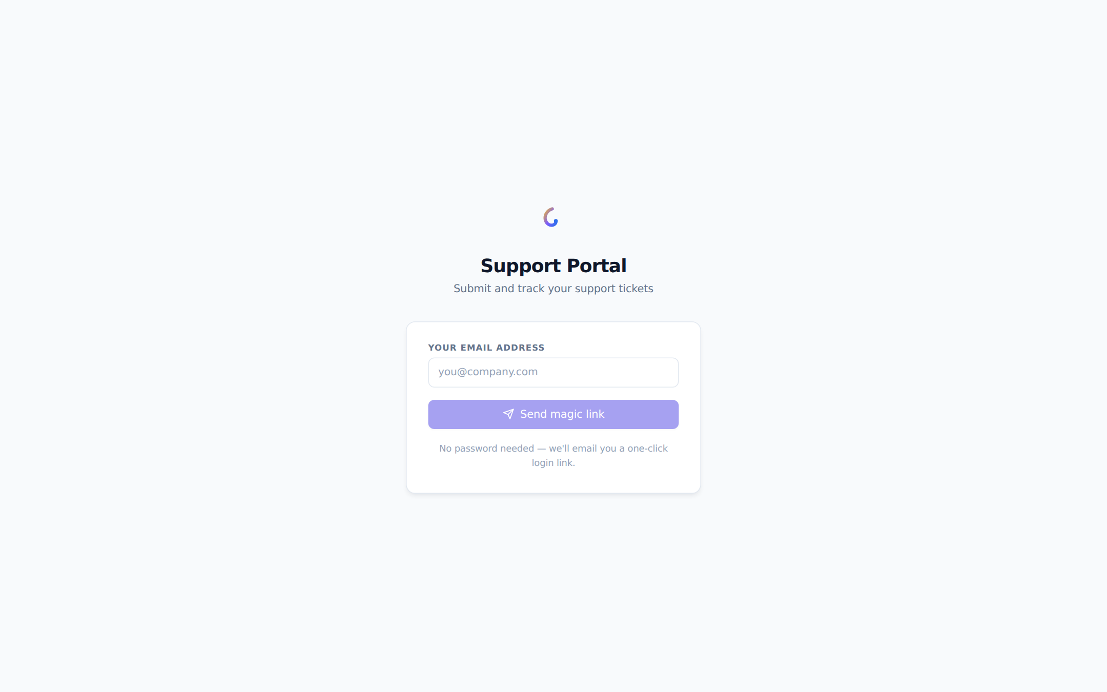
The customer-facing portal: passwordless magic-link sign-in.
Each organization gets a branded self-service portal for its customers at a shareable link. Sign-in is passwordless: the customer enters their email and receives a one-click magic link (valid 30 minutes). Inside, customers see their tickets as cards with live status badges, open new tickets with a simple subject/details form, and read ticket details — all in the org’s branding (logo, color, welcome message from the Branding page).
A floating live chat widget lets customers message the team directly; messages appear in the staff Unified Inbox as the Chat channel and replies flow back into the widget.

8.1 Managing portal customers
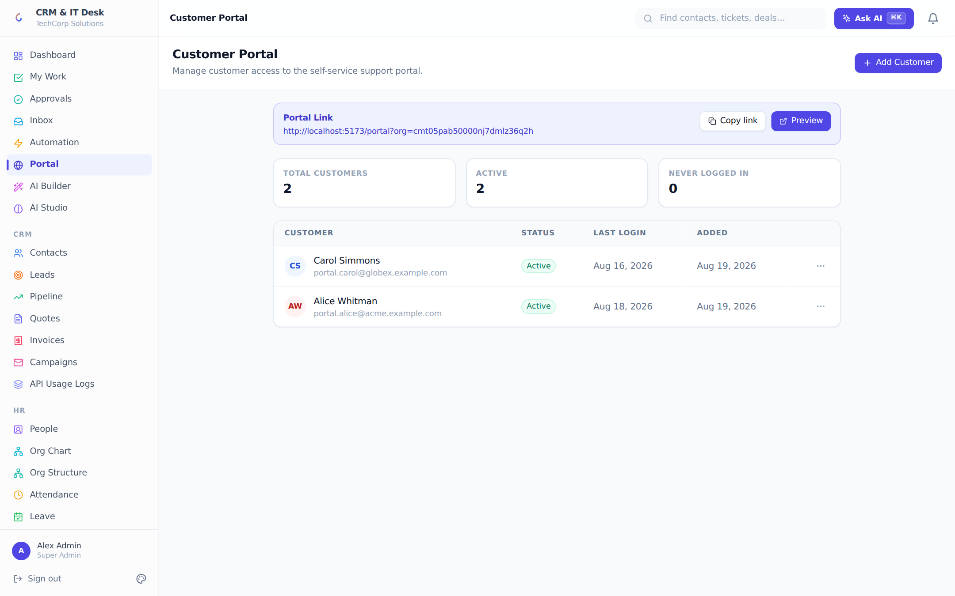
Staff-side portal user management with invite, activate/deactivate and stats.
The Portal page (IT managers) manages customer access: a copyable portal link and preview button, stat tiles (total customers, active, never logged in), and a customer table with resend-invite, activate/deactivate and remove actions. Adding a customer optionally sends an invite email with the portal link.

9. HR & People
The HR suite is built on a deliberate separation: a person (Employee record) and a login (User account) are different things. Directory-only staff appear in the org chart, hold assets and receive tasks without consuming a licensed seat; access can be granted or revoked at any time without losing the person’s history.

9.1 People
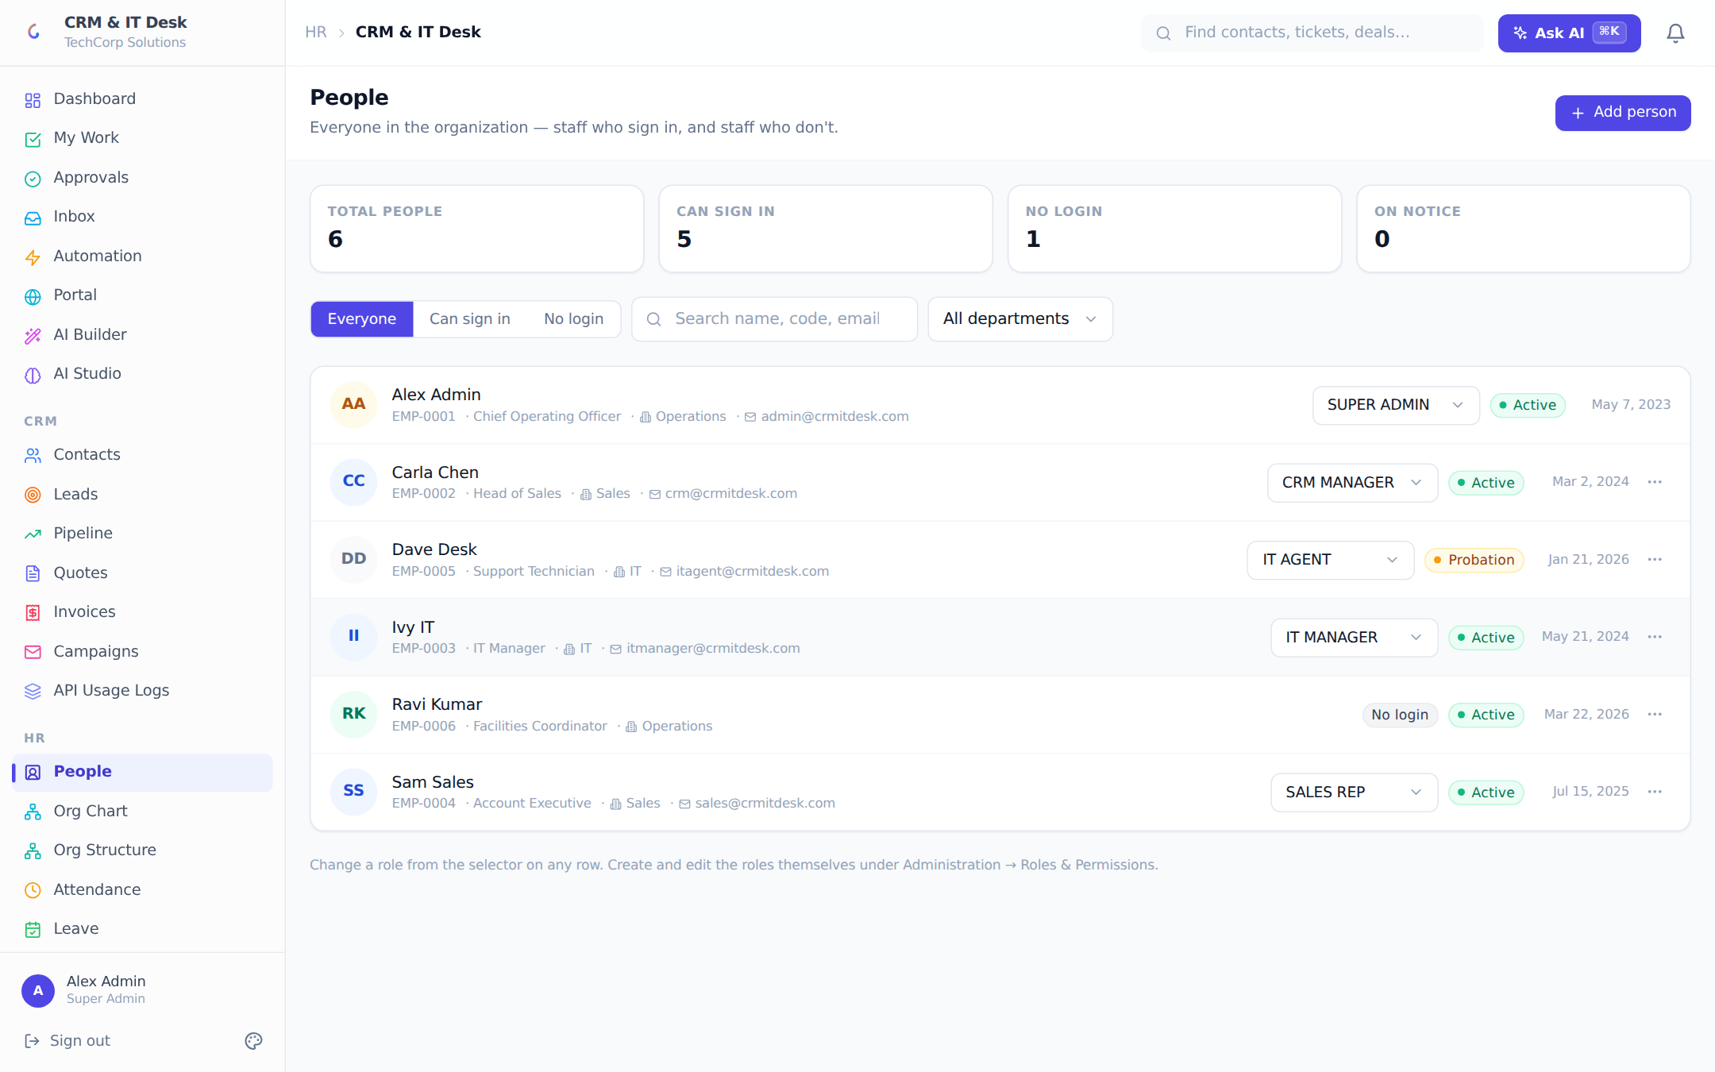
People: everyone in the organization — with or without a login — in one place.
The People page replaces the old Users-vs-Employees split with one list of everyone. Stat tiles show Total people, Can sign in, No login, and On notice. Filters cover login state, free-text search and department. Each row shows the person’s code, designation, department, email, employment-status badge and access badges; managers change a person’s role inline from the row. Row actions grant a login to a directory-only person (invite link or set a password) or revoke access (never your own). A repair banner detects logins missing a person record and fixes them in one click.
Adding a person captures name, designation, joining date, department, location, manager and employment type (Full-time, Part-time, Contract, Intern, Consultant, Temporary), plus a three-way system-access choice: send an invite (the link is also shown for manual copy), set a password now, or no login. Employees with no login are free and unlimited on every plan.

9.2 Employee directory & org chart
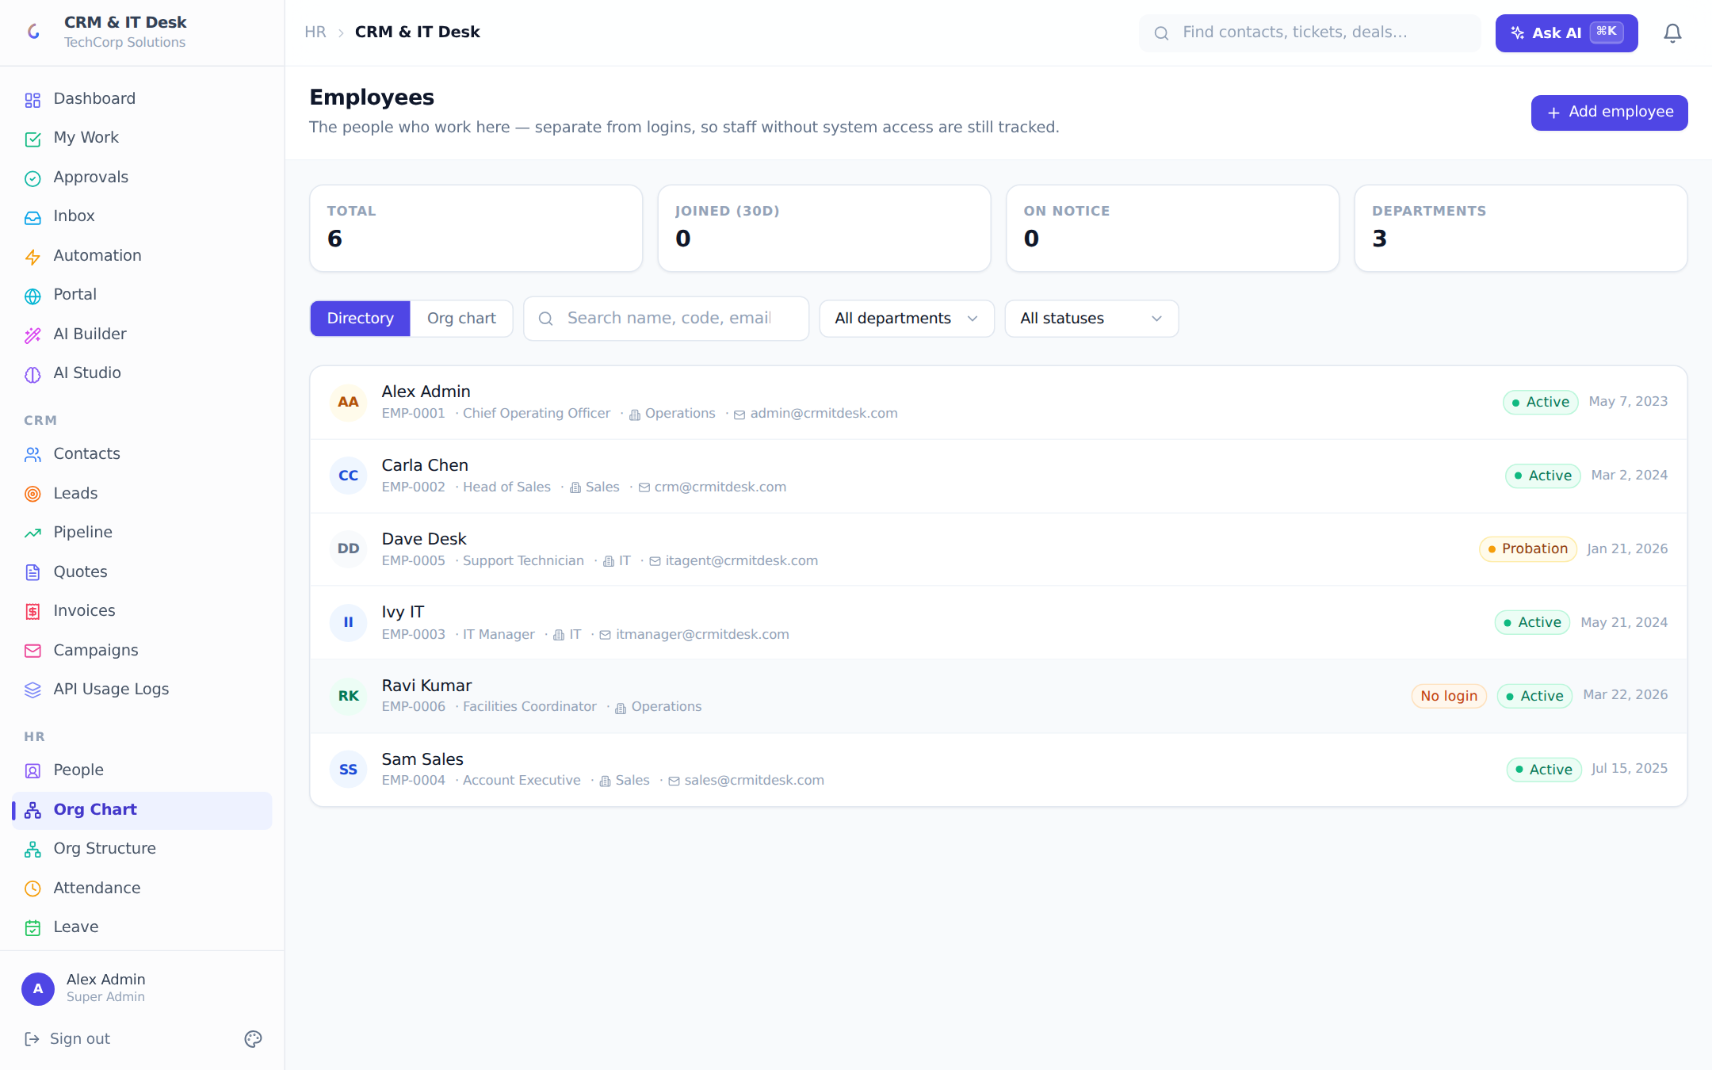
The employee directory with profile modals; an Org chart tab builds the hierarchy from reporting lines.
The directory lists employees with search, department and status filters (Active, Probation, On Leave, Notice Period, Suspended, Exited). The profile modal shows identity, contact and employment details, direct reports, skills with levels, certifications with expiry dates — and a sensitive-details card (bank account, tax ID, national ID) whose values arrive from the server already masked (••••••1234) or removed according to the viewer’s field-level permissions; the client never decides what to hide. Record exit starts offboarding: last working day, exit type (Resignation, Termination, Retirement, End of Contract, Absconded) and reason.
The Org chart tab renders a collapsible reporting tree built purely from "reports to" links — employees without a manager appear as roots.

9.3 Org structure: departments, teams, locations
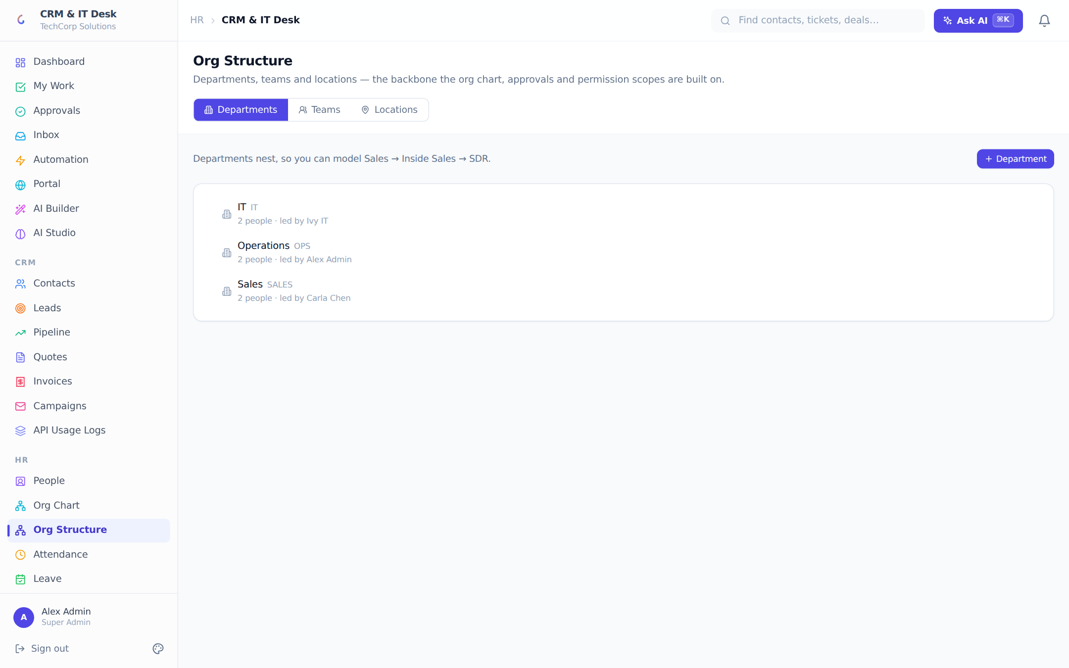
Departments (nested), Teams (with members and leads) and Locations.
Departments nest to any depth (Sales → Inside Sales → SDR), each with a code, cost centre and head — the head powers "Department head" approval steps. Teams group people across departments with a lead and members; team membership drives TEAM-scoped permissions (teammates can see each other’s records where a role allows it). Locations (Head Office, Branch, Plant, Warehouse, Client Site, Remote) place employees and assets geographically; attendance geo-fences can roll up to them.

9.4 Attendance
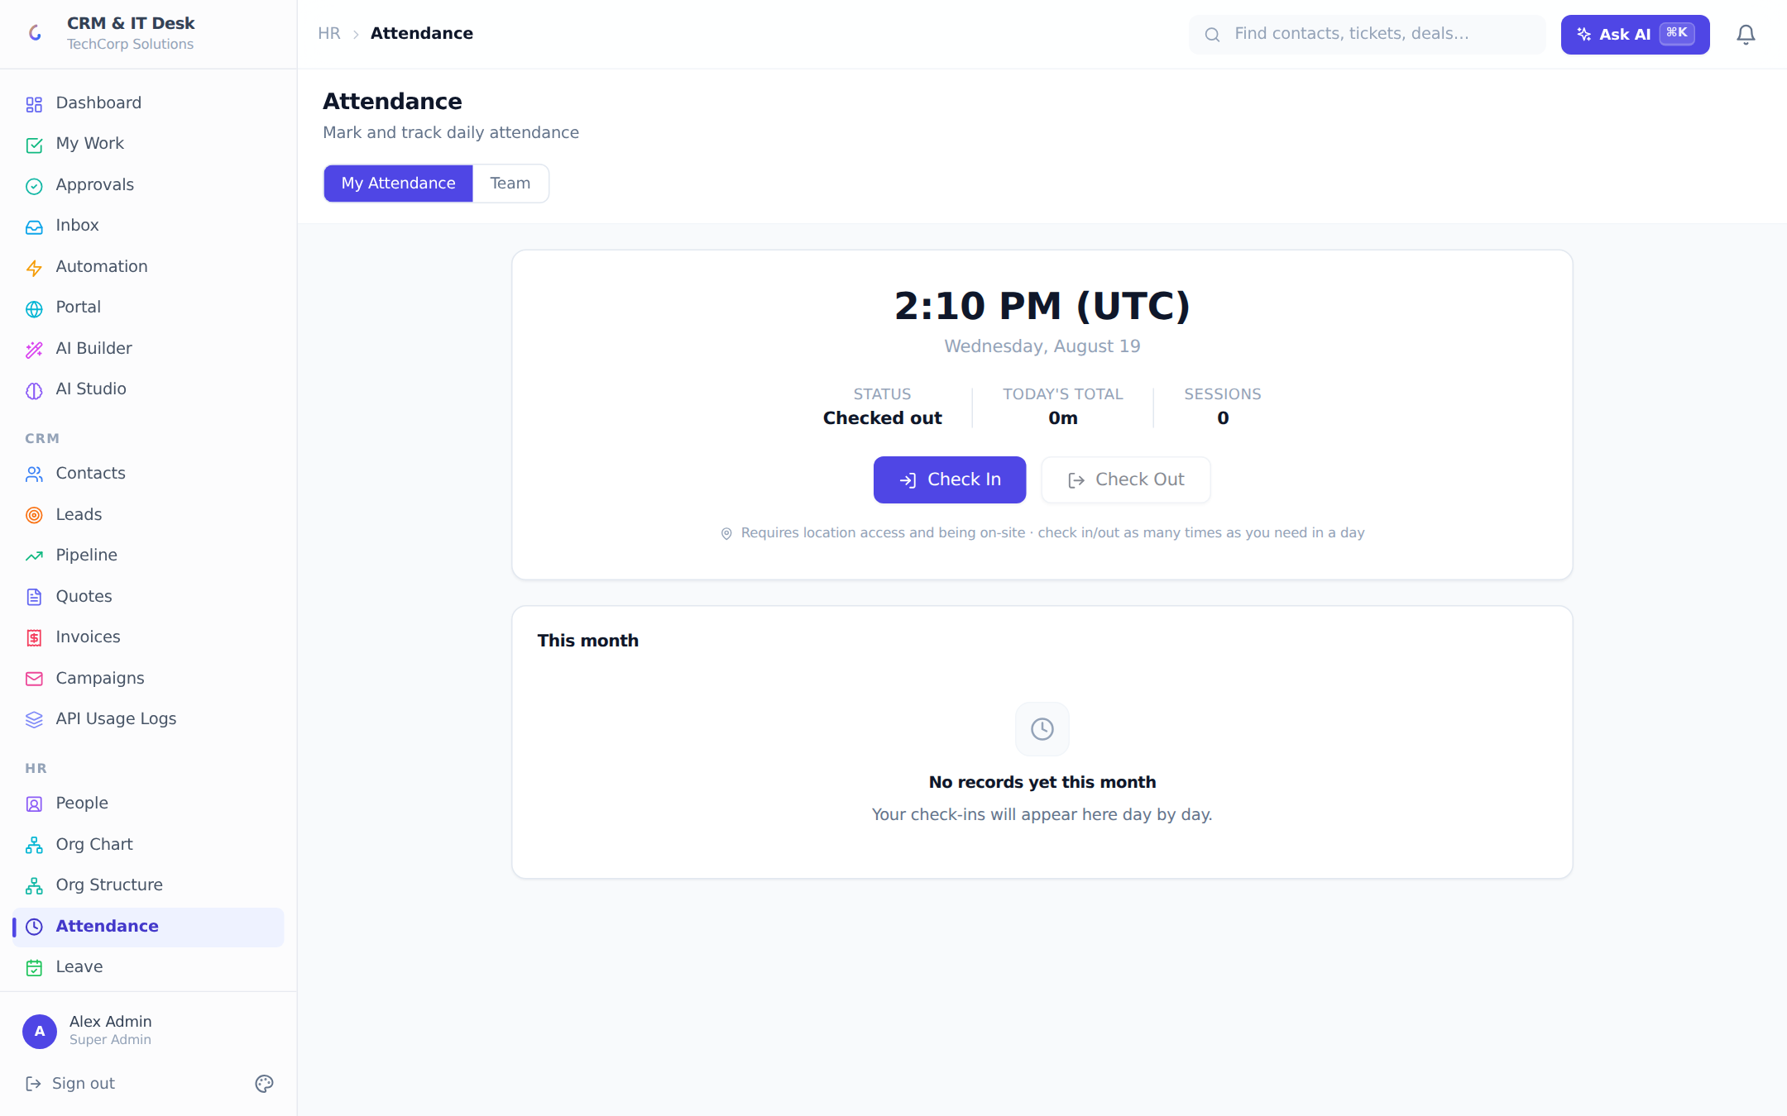
Geo-verified check-in/out with live clock, session chips and a manager team view.
Attendance is location-verified: employees must be inside the radius of an active office geo-fence or on an allowed office IP/network to check in. The My Attendance tab shows a live clock in the org timezone, today’s status, total worked time and session chips — multiple check-in/out sessions per day are supported. The month view groups sessions by day with a verification badge per day: Verified (GPS and network checks passed), Manual entry, or Partial. Managers get a Team tab: who is on-site now, checked out, or absent, with per-person session chips and totals. Managers can also add manual attendance entries through the AI command bar.

9.5 Leave
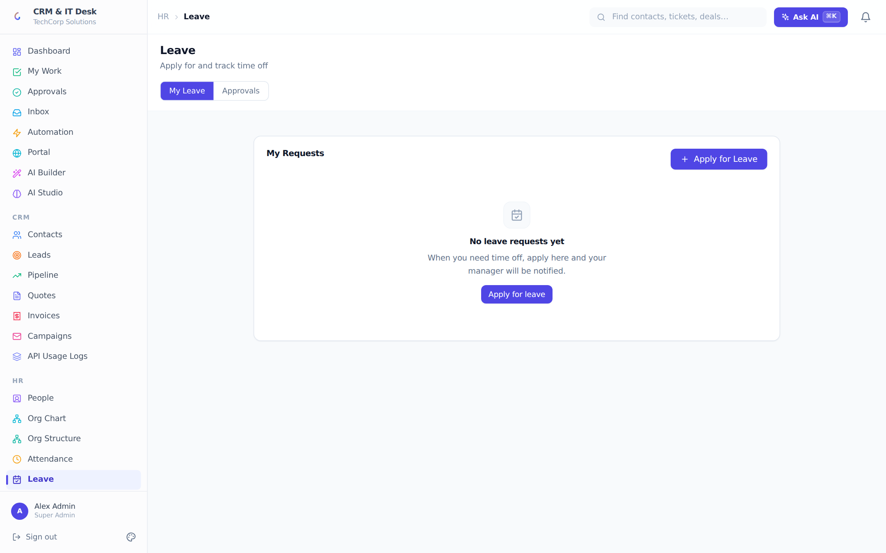
Leave balances, requests and the manager approval queue.
Employees see per-type balance cards ("8 / 12 left"), apply with a type, date range and reason, and can cancel pending requests. Managers see an org-wide Pending Approval queue with approve/reject (rejection requires a reason the employee sees) and a decided-requests history. Leave types are fully configurable in HR Settings; approvals can also route through the universal approval engine and be decided from My Work or by the AI assistant.

9.6 Payroll
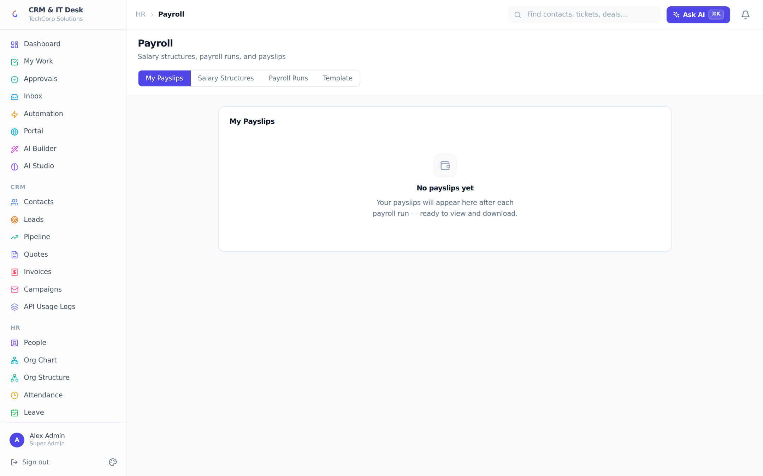
Salary structures, monthly payroll runs, payslips and a customizable letterhead.
Payroll works in three steps. 1) Salary structures: per-employee pay components — basic, HRA, allowances, PF % (default 12), professional tax, other deductions — with an effective-from date; revisions keep the old structure on record so past payslips stay accurate. 2) Payroll runs: one click generates a payslip for every employee with a structure for the chosen month; runs show status and can be marked all-paid. 3) Payslips: every employee self-serves their own payslips (numbered PAY-YYYY-MM-NNNN) with an itemized earnings/deductions breakdown and a print/save-as-PDF view. A letterhead template (company name, address, logo, accent color, footer note, optional signature line) applies to every printed payslip, with a live preview.

9.7 HR Settings
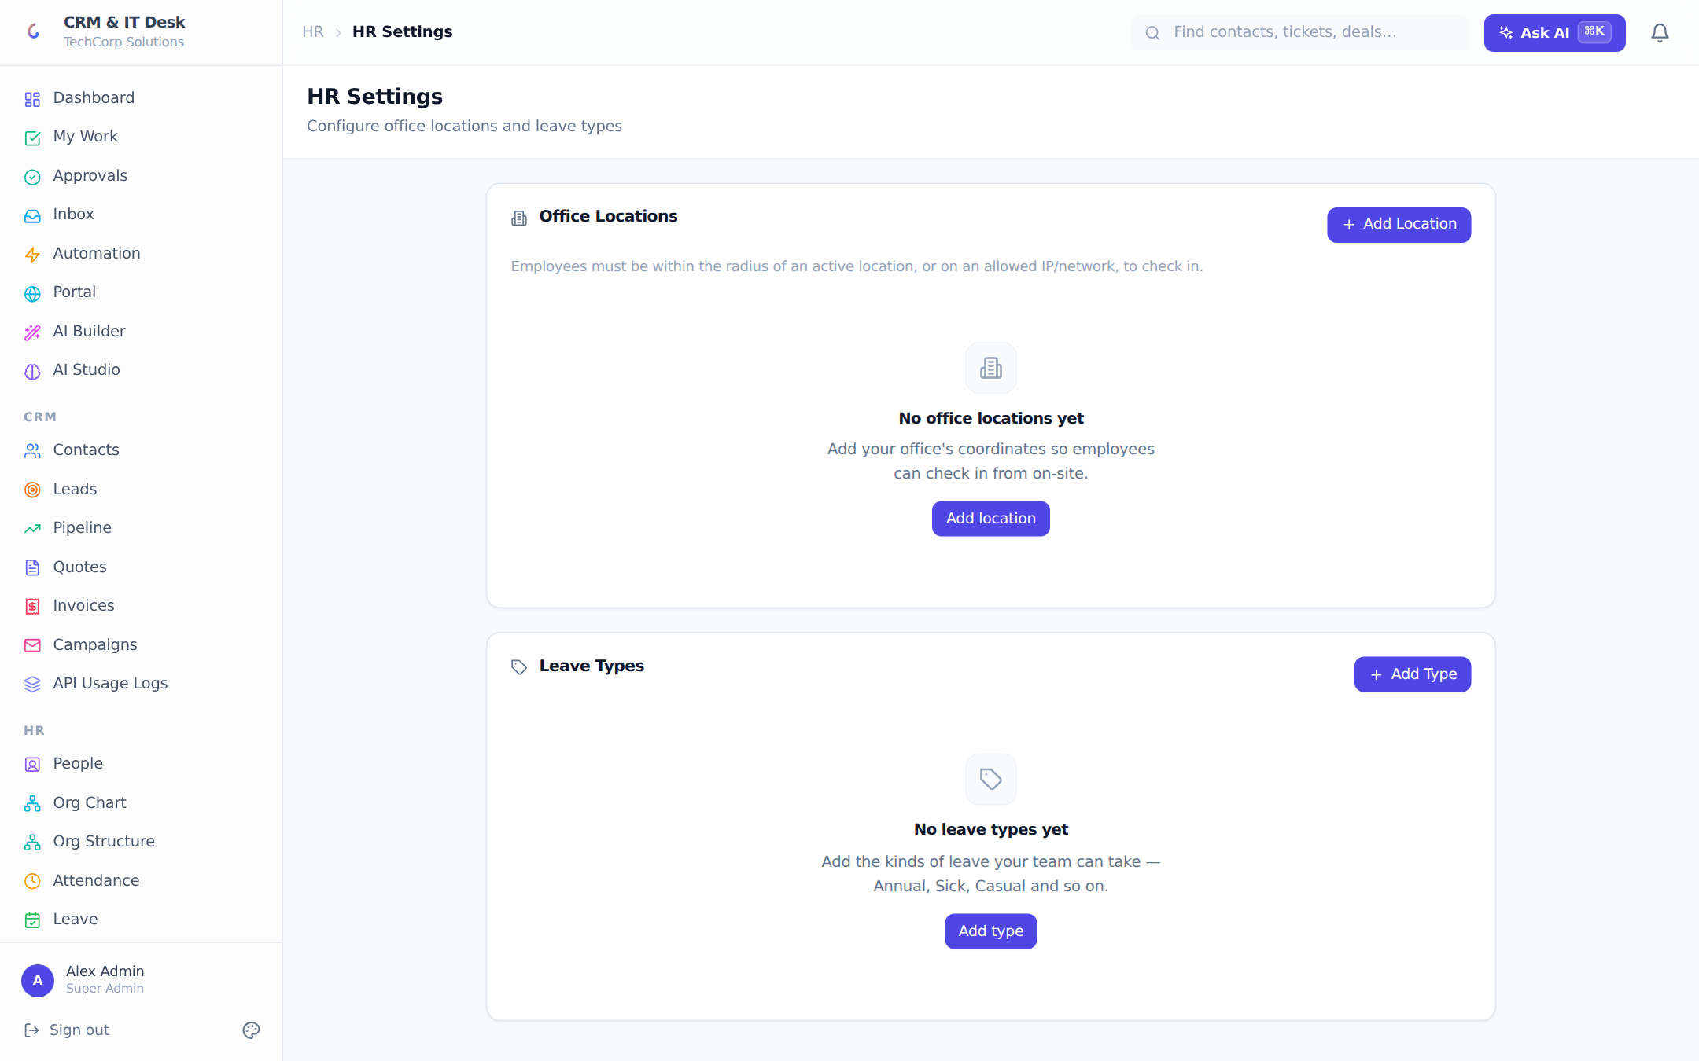
Office geo-fence locations with IP allowlists, and configurable leave types.
Two policy objects live here. Office locations: name, latitude/longitude (with a "Use my current location" helper), check-in radius in meters, and an optional comma-separated IP/CIDR allowlist (with a "Use my current IP" helper that returns exactly the IP the server will see at check-in time). Locations can be deactivated without deletion. Leave types: name, annual quota in days, paid/unpaid flag and a display color; deactivation is a soft delete so history is never lost.
Onboarding example HR adds "Rohan Mehta, Support Engineer, joins Monday" with Send an invite. He appears in the directory and org chart under his manager, the invite email carries his login link, his role is IT Technician, and payroll gets his salary structure. On day one he checks in from the office geo-fence and files his first ticket triage — no separate user-management step ever happened.

10. AI Platform
AI is woven through the entire product rather than bolted on: every AI feature is labeled, auditable, budget-controlled and permission-aware. The backend talks to OpenAI or Groq (whichever key is configured) through a central AI gateway that enforces per-org budgets, logs every call with tokens/cost/latency, redacts fields the caller may not see before building prompts, and degrades gracefully — if no AI key is configured, every feature falls back to an honest non-AI behavior instead of failing.
Two model tiers are routed automatically: a FAST tier for high-volume assists (scoring, tagging, sentiment) and a SMART tier for heavyweight generation (KB articles, pipeline analysis, command planning, grounded answers). Four capabilities stay available on the Free plan — lead scoring, ticket sentiment, auto-routing and auto-tagging; the rest are Pro/Enterprise.

10.1 The AI command bar (Ctrl/Cmd + K)
From anywhere in the app, press Ctrl/Cmd+K (or the Ask AI button) and type what you want in plain language. Two engines answer:
- Create/update parser — "new critical ticket: mail server down, printers offline in Building B" opens the ticket form pre-filled with title, description and priority; you review and submit. Works for tickets, contacts, leads, deals and articles.
- Action registry — for "do it for me" commands, the model may only choose one action from a fixed, server-defined whitelist of 24 actions; it can never run queries or invent behavior. Every action re-validates your role and org on the server, and almost all show a "Confirm & Run" card before anything happens. Executions are written to the audit log tagged as AI-performed, with your original command.
The 24 whitelisted actions:
Action | Who can use it
Move a deal to another pipeline stage | CRM staff
Change a ticket’s status | IT staff
Assign a ticket to an agent | IT staff
Update a lead’s status (conversion excluded by design) | CRM staff
Score a lead with AI | CRM staff
Add a note to a ticket, deal or contact | All staff
Log a call/email/meeting/task activity | CRM staff
Schedule a WhatsApp reminder on a ticket/deal | All staff
Send a WhatsApp message now | All staff
Change a quote’s status (accepting stays customer-only) | CRM staff
Change an invoice’s status (incl. mark paid) | CRM staff
Send an email campaign now | CRM managers
Create an account (company) | CRM staff
Create / update an IT asset | IT managers
Create a ticket category | IT managers
Toggle a workflow rule on/off | Managers
Create a custom module | CRM managers
Add a field to a custom module | CRM managers
Create a custom-module record | All staff
Request leave | Everyone
Approve a leave request | Managers
Reject a leave request (with reason) | Managers
Add a manual attendance entry | Managers
(Help) list what the assistant can do for your role | Everyone

Example "Move the Acme ERP deal to Negotiation and remind me on WhatsApp on Friday" → the assistant proposes MOVE_DEAL_STAGE (Acme ERP Implementation → Negotiation) and SCHEDULE_WHATSAPP_REMINDER (Friday 9:00, recipient: assigned rep). Two confirm cards, two clicks, done — both actions in the audit log.

10.2 AI smart search
The global search bar interprets queries before searching: "open critical tickets about vpn" narrows to tickets, status Open, priority Critical, keyword vpn — instead of a blind substring scan. When AI is unavailable the search silently falls back to plain matching across contacts, deals, tickets, leads, articles, assets and invoices.

10.3 Built-in AI assists by module
Area | AI features
Leads | Conversion scoring (0–100 with reason), bulk scoring, follow-up email drafts, 3-step nurture sequences
Deals | Win probability with factors and recommendation, close-date prediction, follow-up email + tone check, pipeline health report
Contacts | Churn risk, contact health score (A–F), competitor-mention detection
Tickets | Sentiment, auto-routing, auto-tagging, duplicate detection, reply drafting (KB-grounded), thread summary, resolution estimate, SLA-breach risk, KB article generation
Dashboard | Natural-language Q&A over live metrics, proactive insights, meeting-notes parsing into records
Email | Tone check on any drafted email (fails closed — an unreviewed email is never shown as approved)

10.4 AI Builder (custom AI rules)
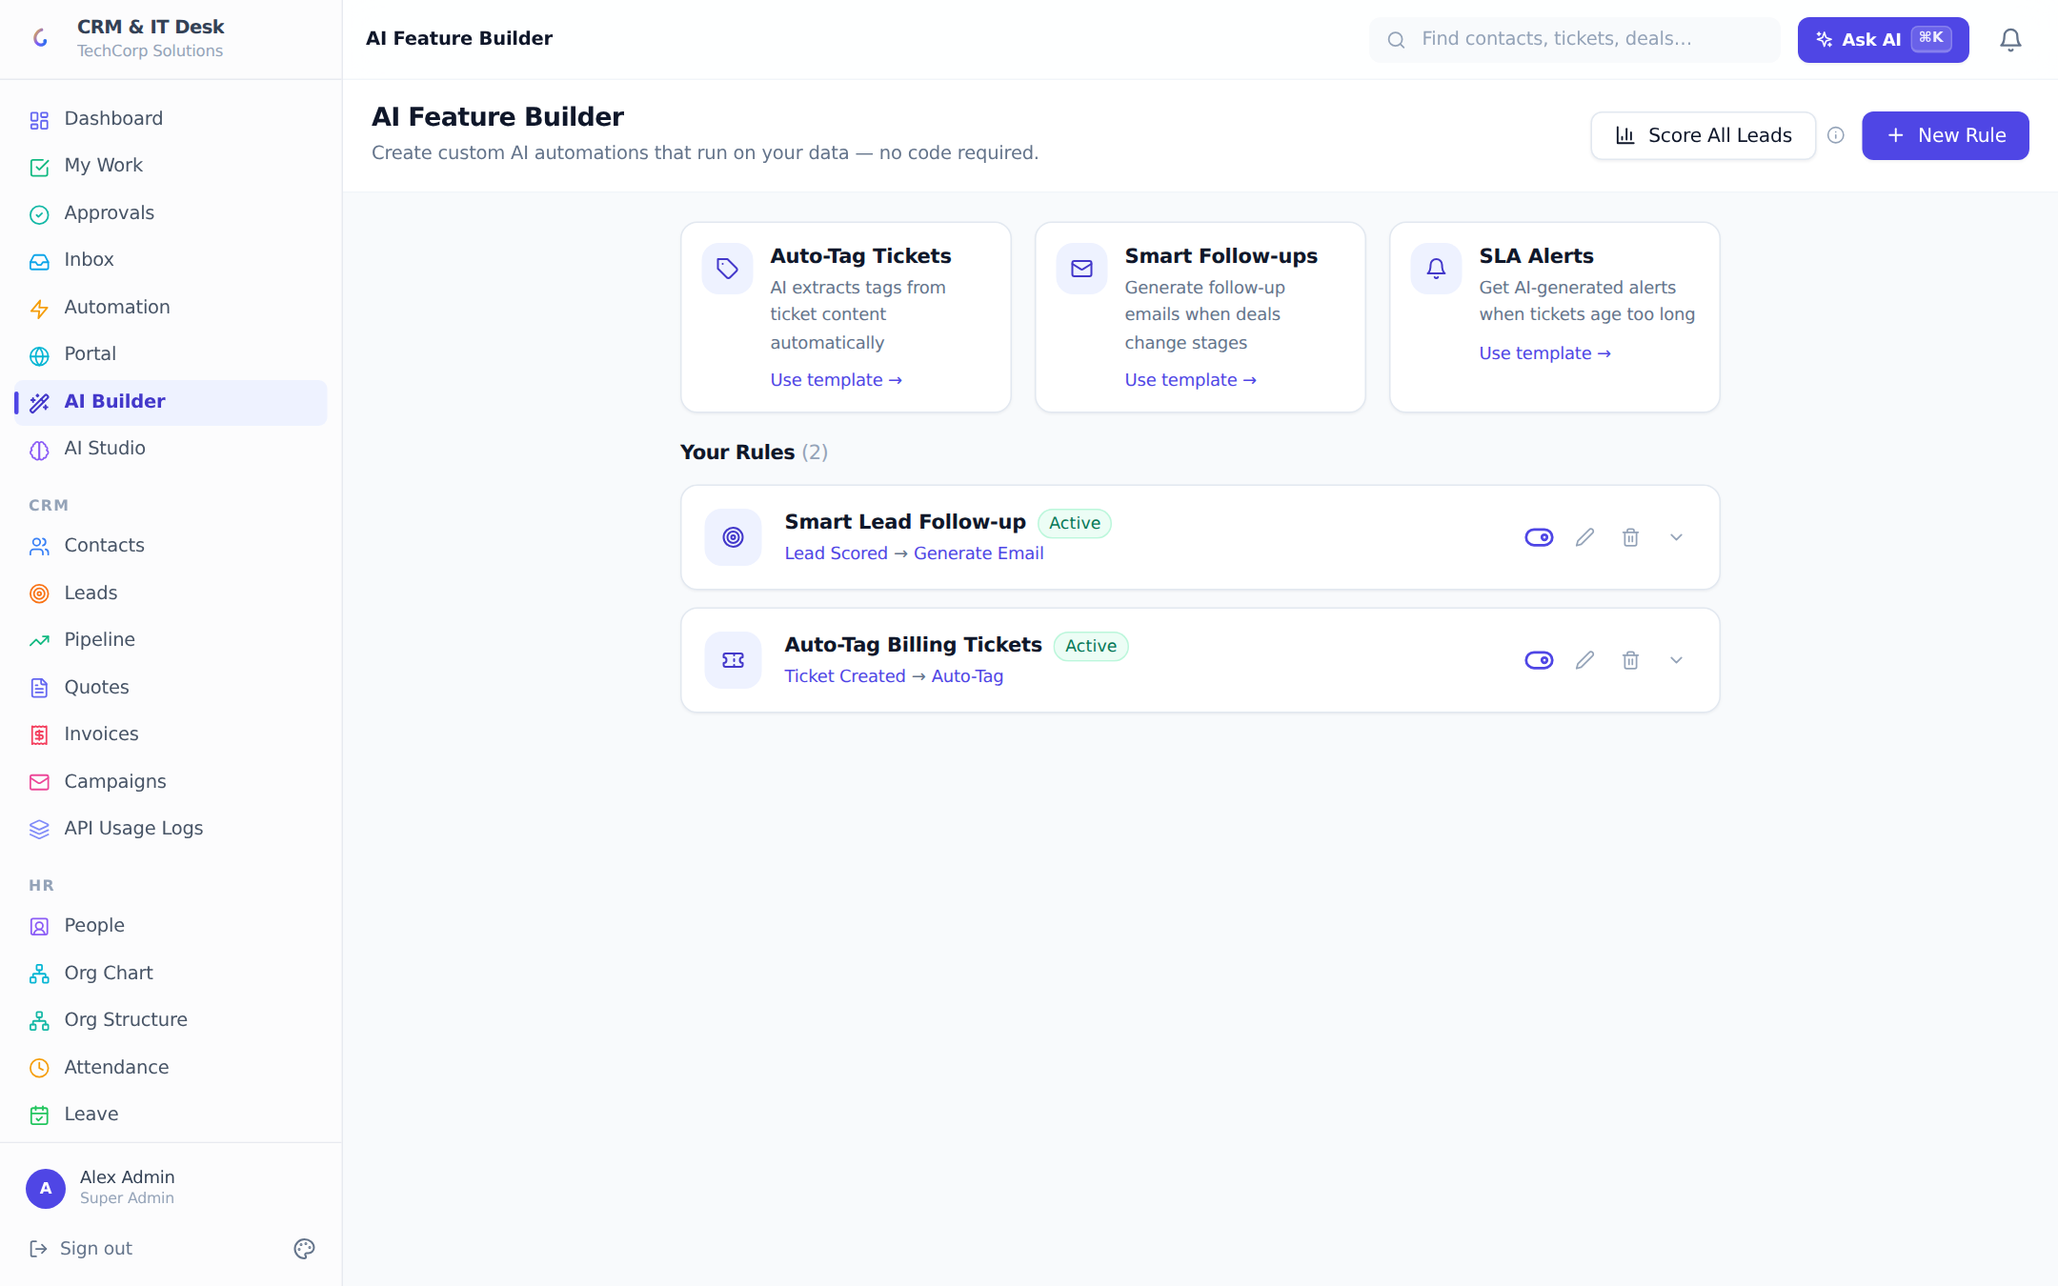
The AI Builder: no-code AI rules with triggers, actions, prompts and a live test panel.
The AI Builder lets managers create their own AI automations without code. A rule pairs a trigger (Ticket created, Lead scored, Deal stage changed, Contact updated, Ticket resolved, or Manual) with an AI action (auto-tag, smart route, draft email, AI alert, custom 0–100 score, summarize, or a free-form custom prompt) and an editable prompt template — the AI automatically receives the full record data. Rules have on/off toggles, run counters, quick-start templates, and an inline test panel where you paste sample text and watch the live output. A "Score All Leads" button runs bulk lead scoring across the org.

10.5 AI Studio
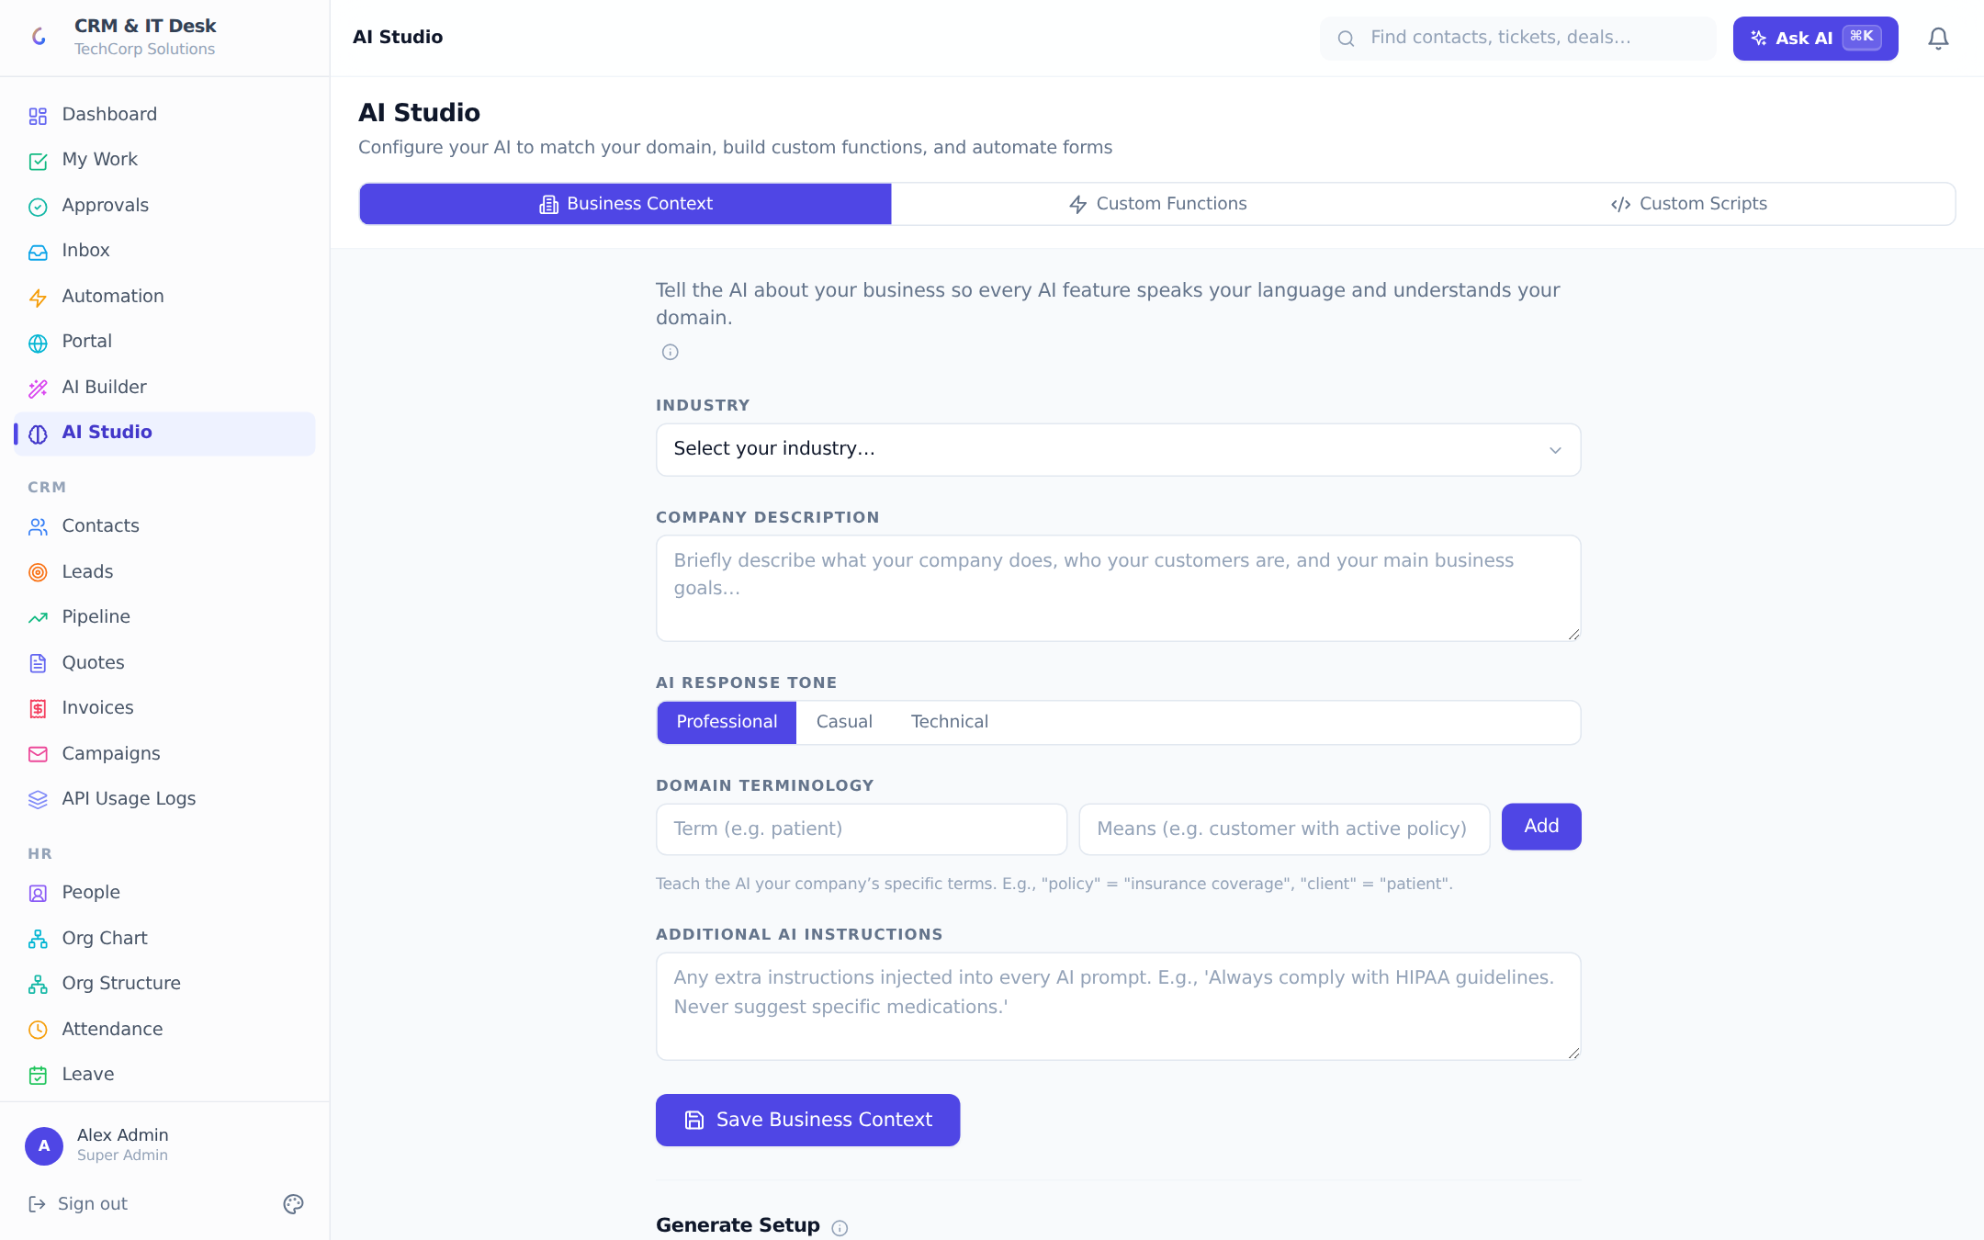
AI Studio: business context, one-click AI workspace setup, custom AI functions and form scripts.
- Business Context — teach the AI your world: industry, company description, response tone (professional/casual/technical), a domain terminology glossary ("client" means "patient"), and extra standing instructions ("always comply with HIPAA"). This context is injected into every AI prompt for your org.
- Generate Setup — a one-click setup generator: the AI reads your business context and proposes renamed terminology (entity and field label overrides, e.g. Tickets → Cases for a law firm) plus draft workflow rules tailored to your business. Everything is shown for review — each proposal individually toggleable and editable, with fill-in inputs for values the AI cannot know — and nothing persists until you apply.
- Custom AI Functions — reusable callable functions with a custom system prompt, a typed input schema (text/number/boolean/select) and an output type (text/JSON/number), with an inline test runner.
- Custom Scripts — admin-authored JavaScript that runs on entity forms (onLoad, onChange, onSubmit, onValidate, onFieldChange) with a sandboxed API: read the record, set values, raise validation errors, notify the user — and even call the AI from inside a script with await context.ai(prompt). A server-side syntax validator checks scripts before saving.

10.6 AI Governance
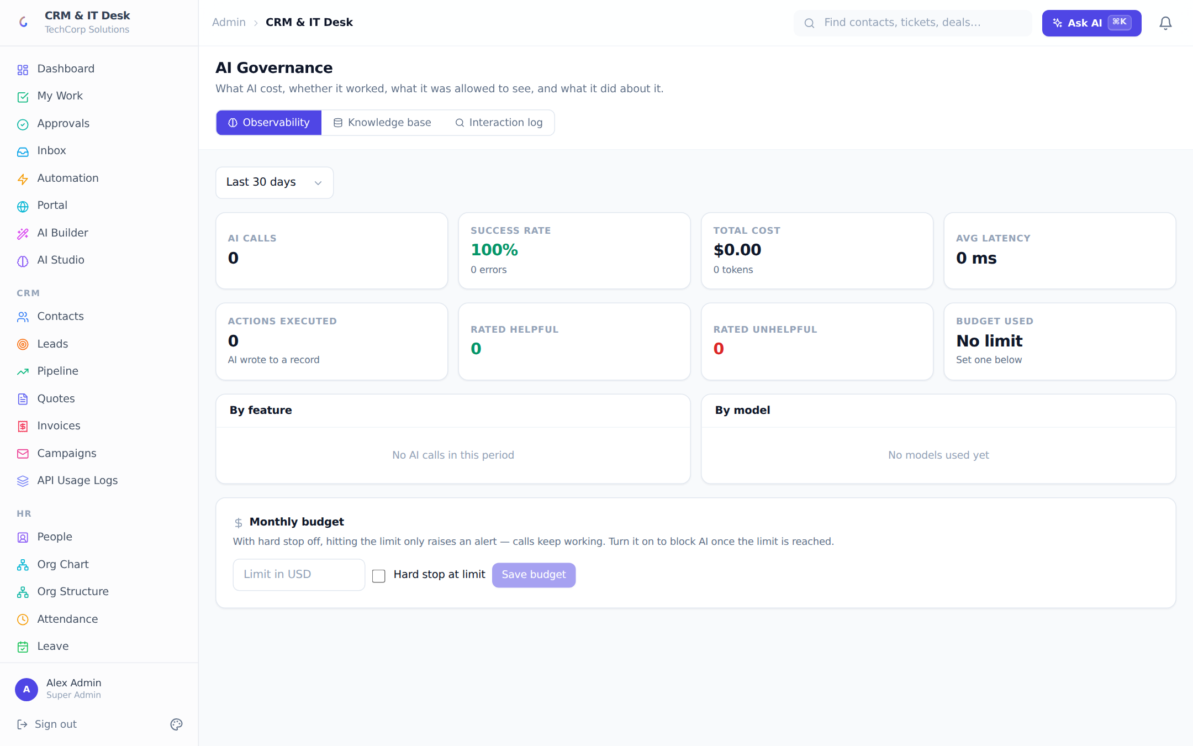
AI Governance: cost and latency observability, budget controls, a full interaction audit log and the knowledge base.
- Observability — for any date range: total calls, success rate, cost in USD, tokens, average latency, actions executed, user feedback counts, and cost breakdowns by feature and by model.
- Budget — set a monthly USD budget with warning banners at 80% and an optional hard stop: when exhausted, further AI calls are refused with a clear "budget reached" message instead of silently spending.
- Interaction log — every AI call is auditable: status, feature, model, tokens, cost, latency, the calling user, any executed action, user feedback, and exactly which fields were redacted from the model under field-level permissions.
- Knowledge base — shows indexed documents, chunk counts and the active vector backend (pgvector in Postgres, or an in-process fallback), with one-click re-indexing and an "Ask the knowledge base" box.

10.7 Knowledge-grounded answers (RAG)
Published knowledge-base articles are chunked (~400 tokens with overlap, heading-aware), embedded and indexed. Questions are answered strictly from retrieved content with numbered citations ("Leave Policy → Section 4.2", relevance %) and a confidence score — below 40% the answer is flagged for human review, and when nothing relevant exists the assistant says so rather than guessing. Retrieval is permission-aware: documents a user may not see are filtered out before ranking, so restricted content never leaks even as a relevance hint.

11. Automation & Customization

11.1 Workflow automation
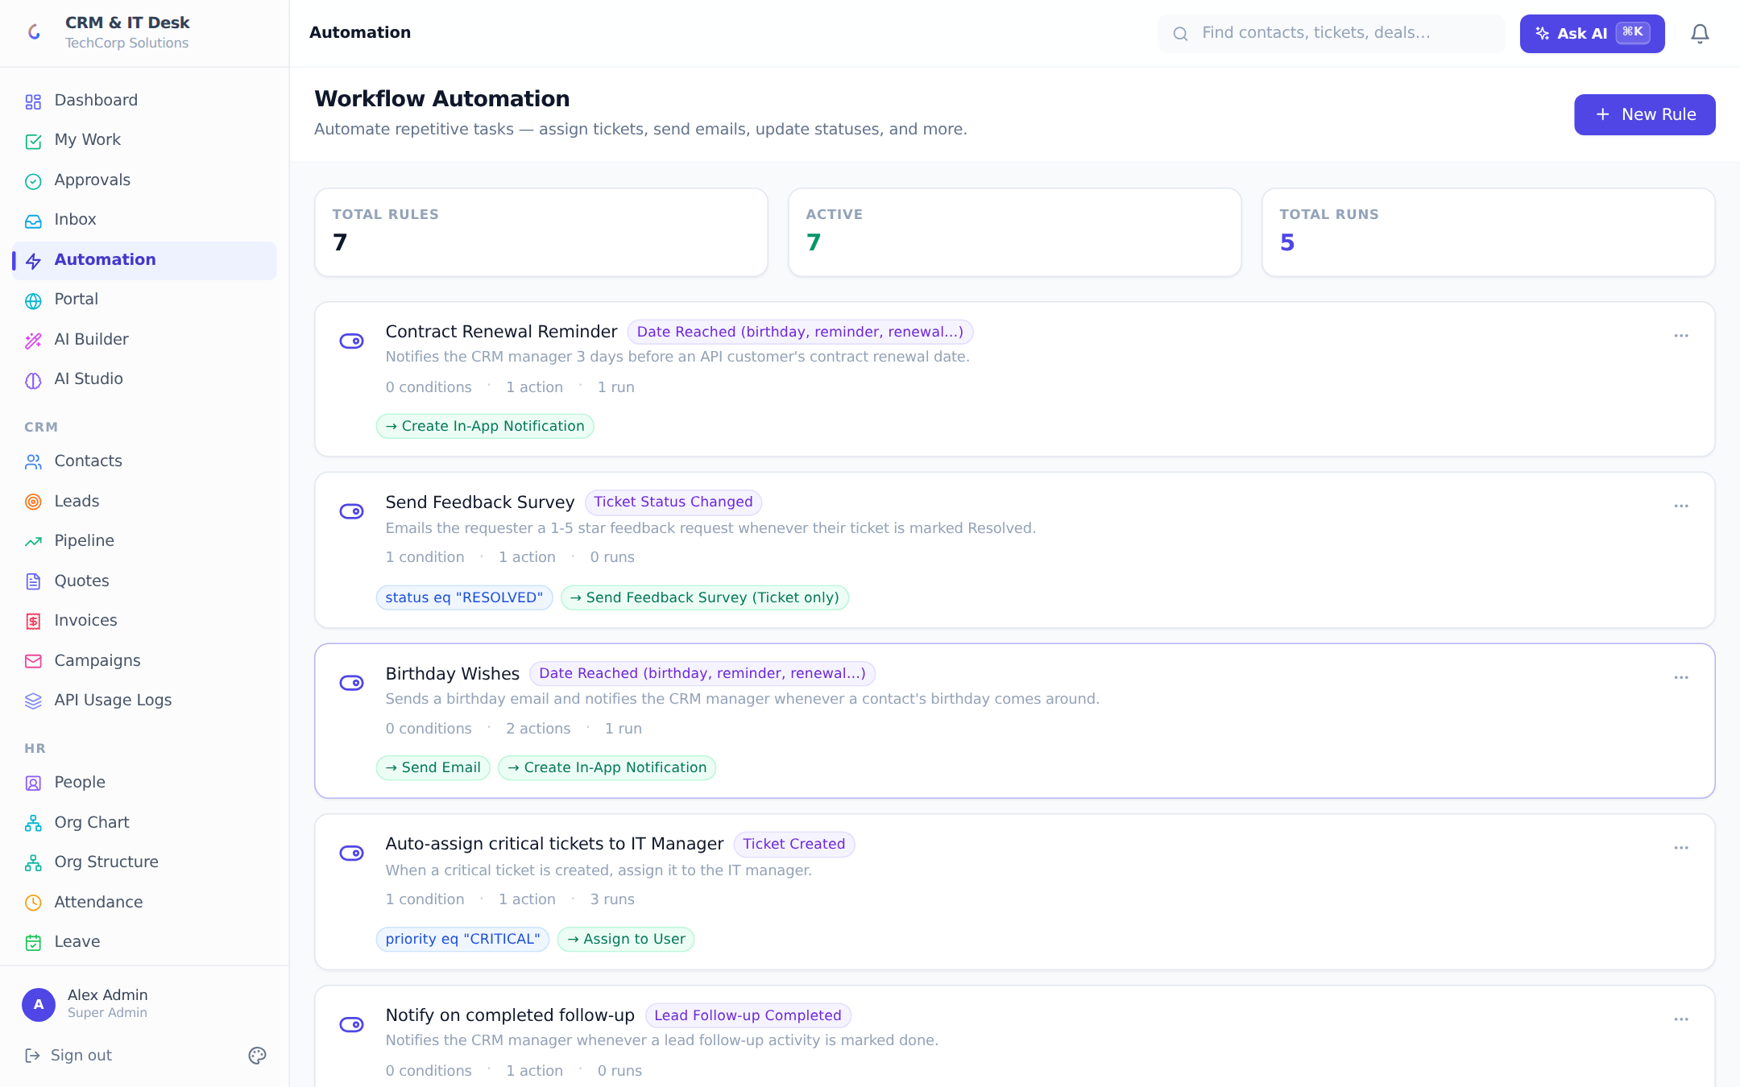
The visual rule builder: trigger → optional conditions → one or more actions, with run counts and logs.
Workflow rules automate the busywork. A rule is a named combination of one trigger, any number of AND-ed conditions, and one or more actions. Rules have on/off toggles, run counters and a per-rule execution log (Success / Skipped / Error with detail). The page shows Total Rules / Active / Total Runs stat tiles.

Triggers
Trigger | Fires when
Ticket Created / Status Changed / Updated | A ticket is filed, changes status, or is edited
Lead Created / Status Changed / Follow-up Completed | A lead is captured, moves status, or a follow-up activity is completed
Deal Stage Changed / Won / Lost | A deal moves stage or closes
SLA Breach | A ticket crosses its resolution deadline
Date Reached | A date field arrives — birthdays, renewals, appointments — with a before/after day offset and once/yearly recurrence, on standard or custom-module records; includes a dry-run "Preview matches" before enabling

Conditions
Conditions compare a field against a value with equals, not-equals, greater/less than, or contains — e.g. priority equals CRITICAL, stage equals Negotiation, source contains "Web". A rule with no conditions fires on every matching event.

Actions
Action | What it does
Assign to | Routes the record to a chosen teammate
Set priority / Set status | Updates ticket priority, or ticket/lead status
Send email | Templated email ({{title}}, {{status}}, {{contact.email}}…) through the org’s connected mailbox
Send WhatsApp | Message to the contact, the assignee, a custom number or the org default — templated
Add note | Appends an internal [Automation] comment
Send webhook | Signed JSON POST to an external URL (HMAC signature, SSRF-guarded, retried 3× with backoff)
Create notification | In-app + browser push to the record owner or a chosen user
Create ticket | Auto-files a follow-up ticket with templated title/description
Score lead (AI) | Runs AI lead scoring and stores the result
Send CSAT survey | Emails the requester a 1–5 star rating link

Example rules Auto-assign critical tickets: Ticket Created + priority = CRITICAL → Assign to senior engineer + notify them. Birthday greetings: Date Reached on Contacts’ date of birth, yearly → Send WhatsApp to the contact. Renewal reminders: Date Reached on a custom module’s "Warranty Expiry" 30 days before → Send email + Create ticket.

11.2 Custom fields
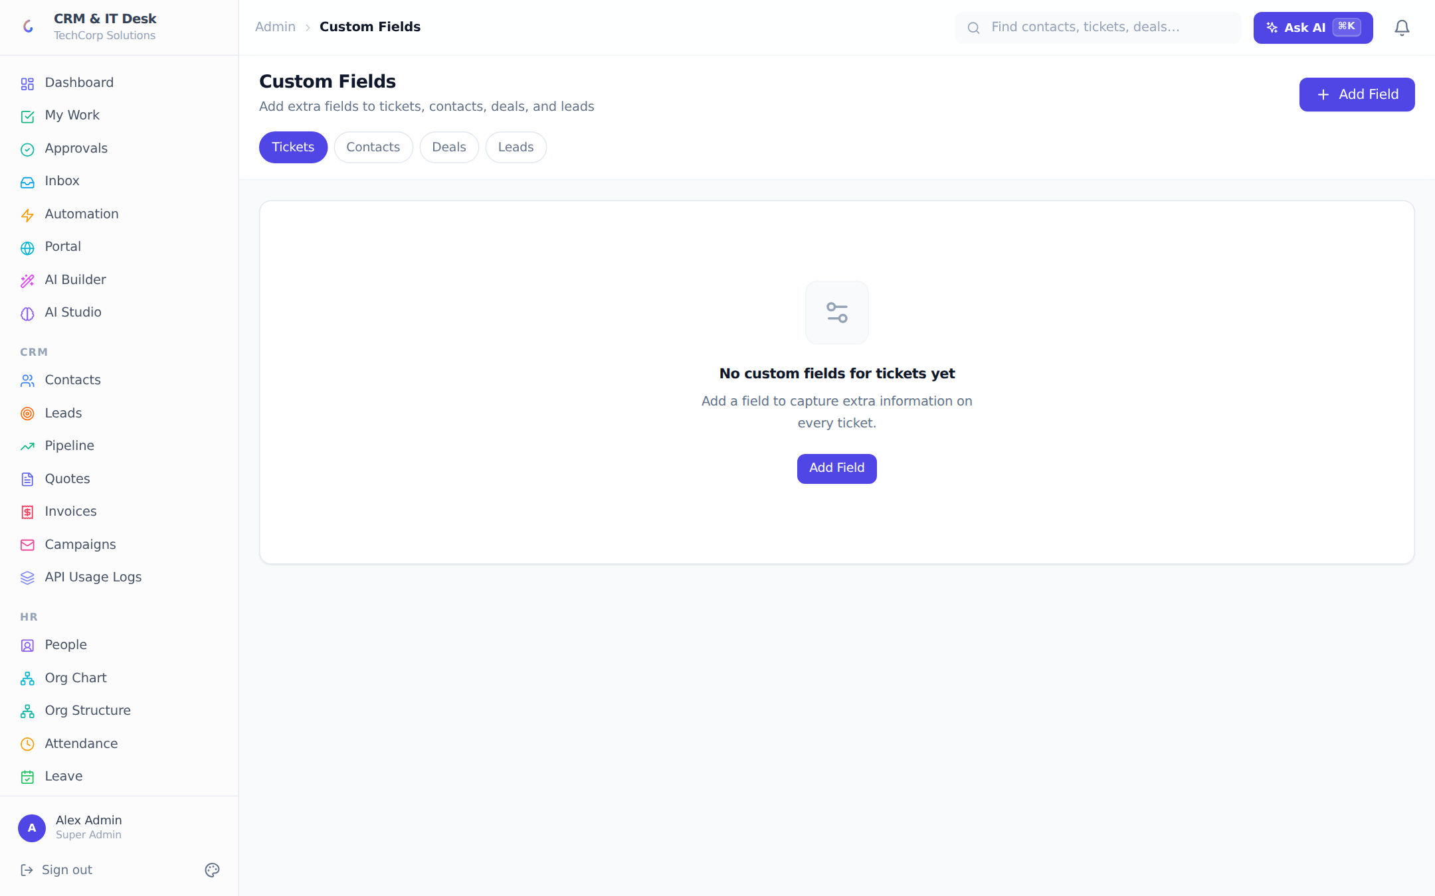
Custom fields: extend tickets, contacts, deals and leads with typed fields, defaults and conditional visibility.
Custom fields bolt extra data onto the four standard entities (Tickets, Contacts, Deals, Leads). Types: Text, Number, Date, Yes/No, Dropdown, Long Text, and Reference (links to a contact). Each field has a label, an API name (auto-generated from the label as you type — lowercase letters, numbers and underscores), a required flag, an optional default value pre-filled on new records, and conditional visibility: show this field only when a dropdown/yes-no parent field has chosen values (e.g. show "Contract End Date" only when Customer Type is "Enterprise"). Fields render on the entity’s forms and detail pages automatically, and custom DATE fields can drive Date Reached workflow rules.

11.3 Custom modules (no-code objects)
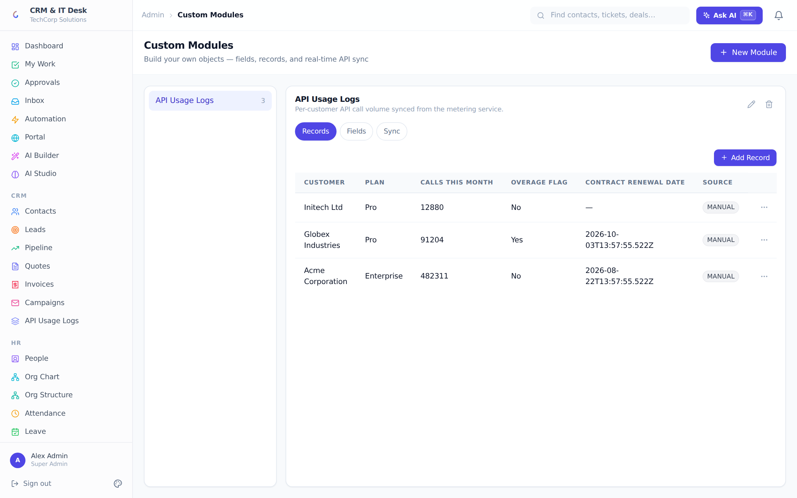
The custom-module builder: your own record types with fields, records and external API sync.
Custom modules go a step further: entirely new record types. A module has a name, icon, description and a sidebar section (CRM, IT Desk, HR or Admin) that controls where its link appears and who sees it. Start from scratch or from a starter template (Vendor Contracts, Asset Registry, Warranty Claims, Employee Equipment). Fields come in ten types — Text, Long Text, Number, Currency, Date, Yes/No, Dropdown, Email, Phone, URL — with required and "use as record title" flags. Once a module has a field it gets its own page at /modules/<slug> where staff manage records like any other entity.
External sync (managers) keeps a module mirrored from an outside system: poll any REST API on a 1–1440-minute schedule with None/API-Key/Bearer auth (secrets write-only), map external record keys to module fields, dedupe on an external ID, watch last-sync status, and trigger a manual Sync Now. The AI command bar can build modules conversationally ("Create a Vendor Contracts module under Admin with a renewal date field") — but sync configuration is deliberately excluded from AI control because credentials are involved.

11.4 Templates
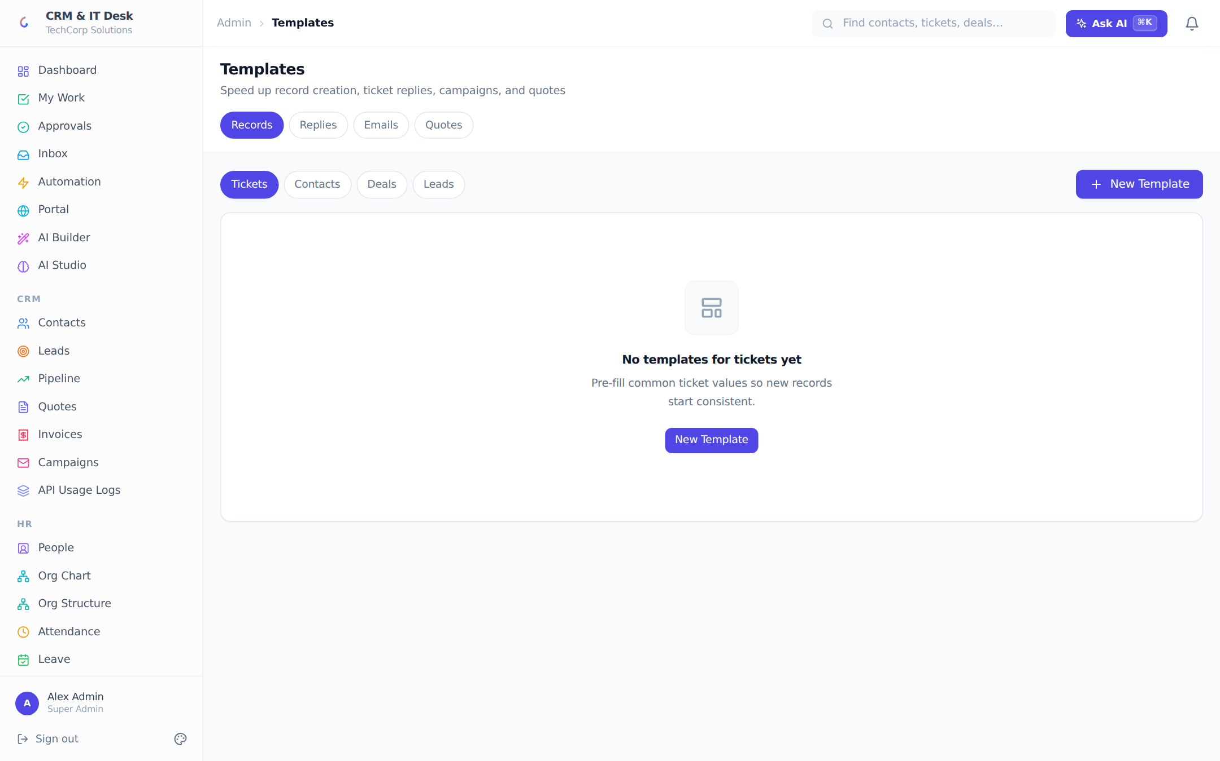
Four template libraries: record pre-fills, canned replies, campaign emails and quote line-item sets.
- Record templates — saved default values (including custom fields) that pre-fill New Ticket/Contact/Deal/Lead forms.
- Reply templates — canned responses agents drop into tickets.
- Email templates — reusable subject/body pairs for campaigns.
- Quote templates — standard line-item bundles for consistent quotes in seconds.

11.5 Bulk CSV import
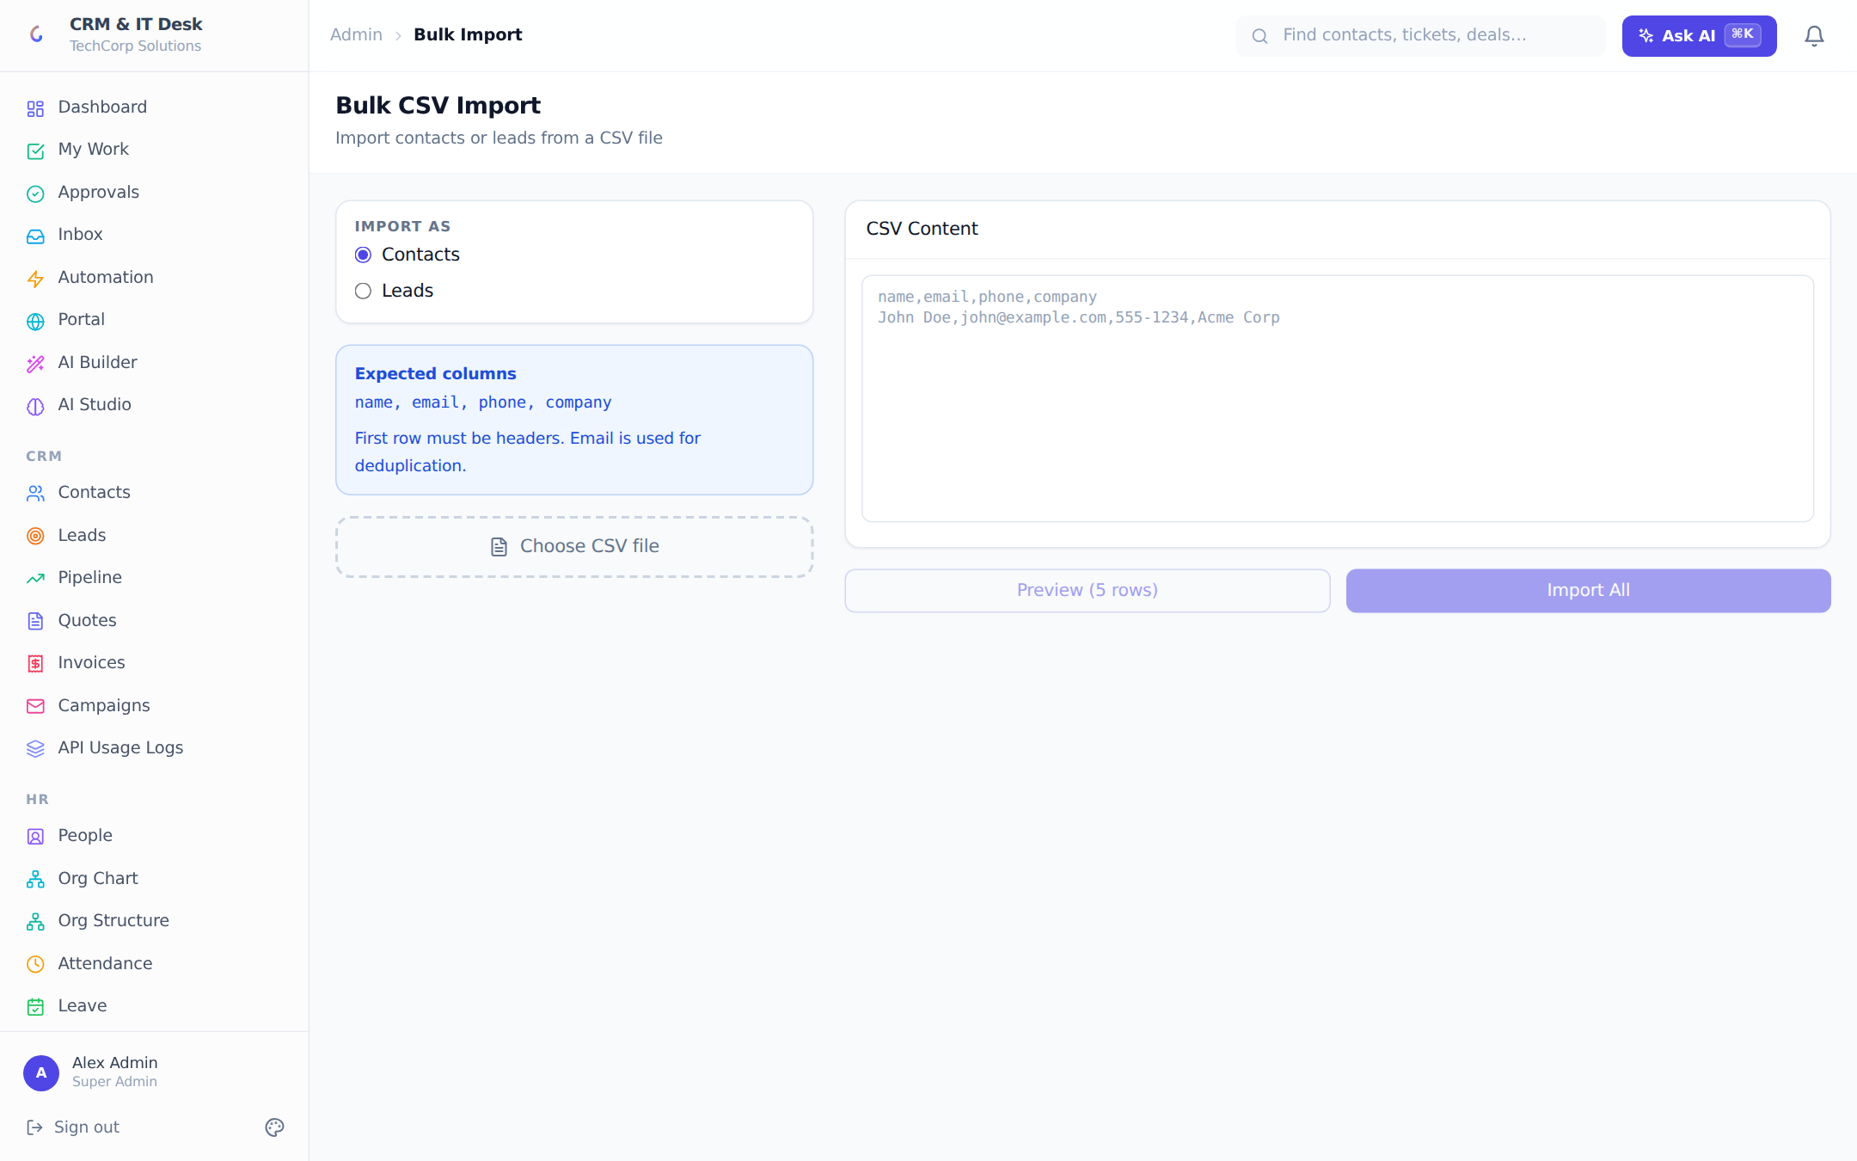
Two-step CSV import for contacts and leads with preview and dedupe.
Import Contacts (name, email, phone, company) or Leads (plus source) by pasting CSV or choosing a file — the first row must be headers. Preview shows the first five parsed rows before Import All commits. Email is the dedupe key: matching rows update existing records instead of creating duplicates. Results are summarized as Total / Created / Updated / Errors.

11.6 Background jobs
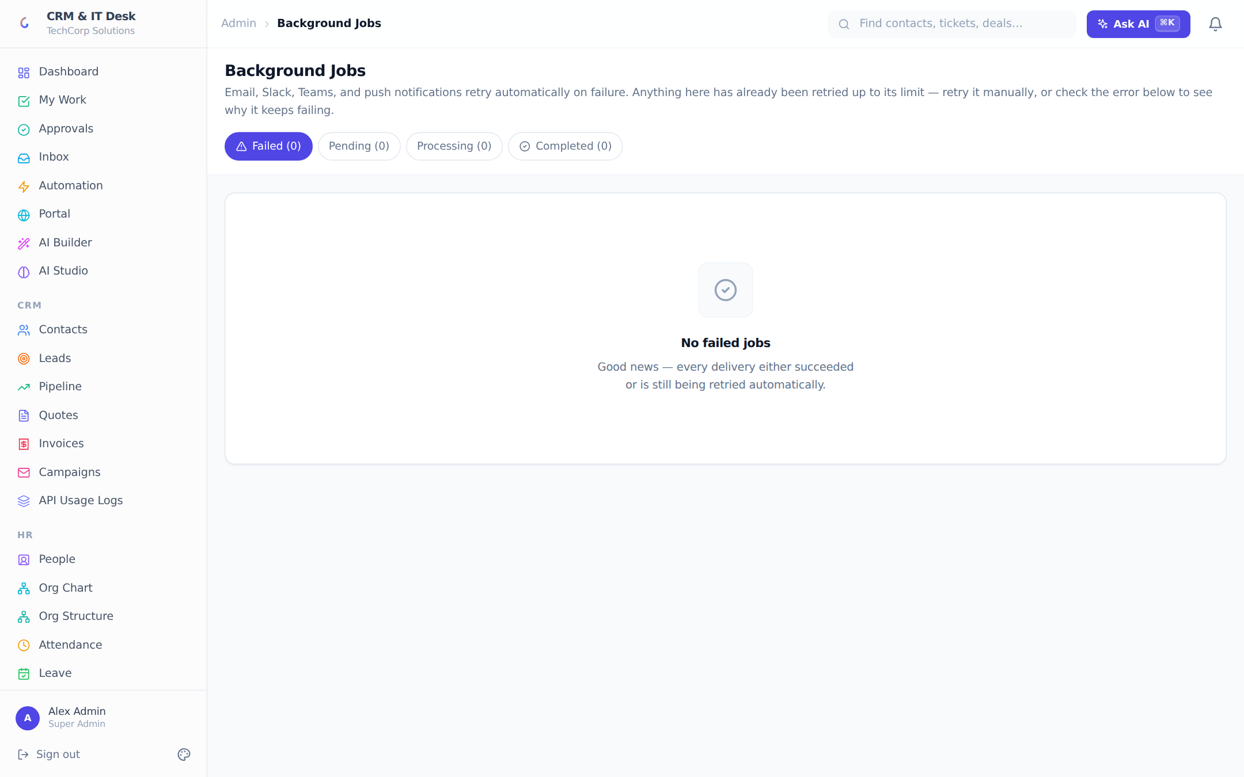
The delivery queue: failed email/Slack/Teams/push sends retry automatically with backoff.
Outbound deliveries (email, Slack, Teams, browser push) that fail are not dropped — they enter a Postgres-backed retry queue with exponential backoff (up to 6 attempts). The managers-only Jobs page monitors Failed / Pending / Processing / Completed with live 15-second refresh, human-readable payload summaries, error messages, next-attempt times, and a one-click manual Retry for exhausted jobs.

12. Analytics & Reports

12.1 Analytics
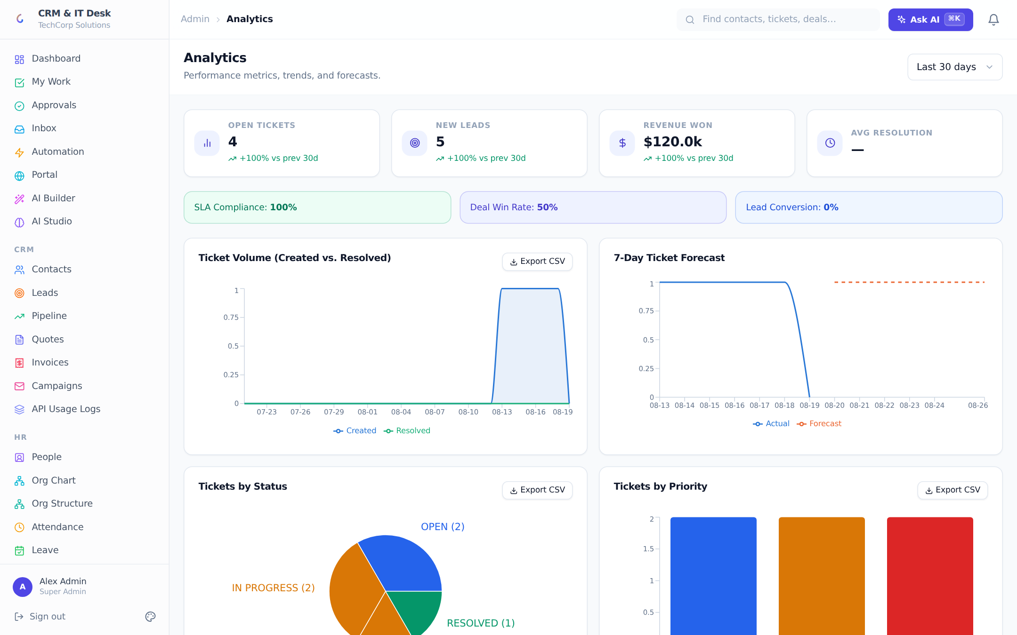
The analytics dashboard: KPIs with trends, ticket and CRM charts, forecasts and CSV export.
Analytics gives managers an interactive picture over a selectable range (7/14/30/90 days). A KPI row shows Open Tickets, New Leads, Revenue Won and Average Resolution time, each with a percentage trend vs the prior period. Highlight badges track SLA compliance, deal win rate and lead conversion. Charts include ticket volume (created vs resolved), a 7-day ticket forecast with a dashed prediction line, tickets by status/priority/category, deal pipeline by stage, won revenue over time, and lead status distribution — every chart exports to CSV, and each section only loads for roles allowed to see it.

12.2 Reports
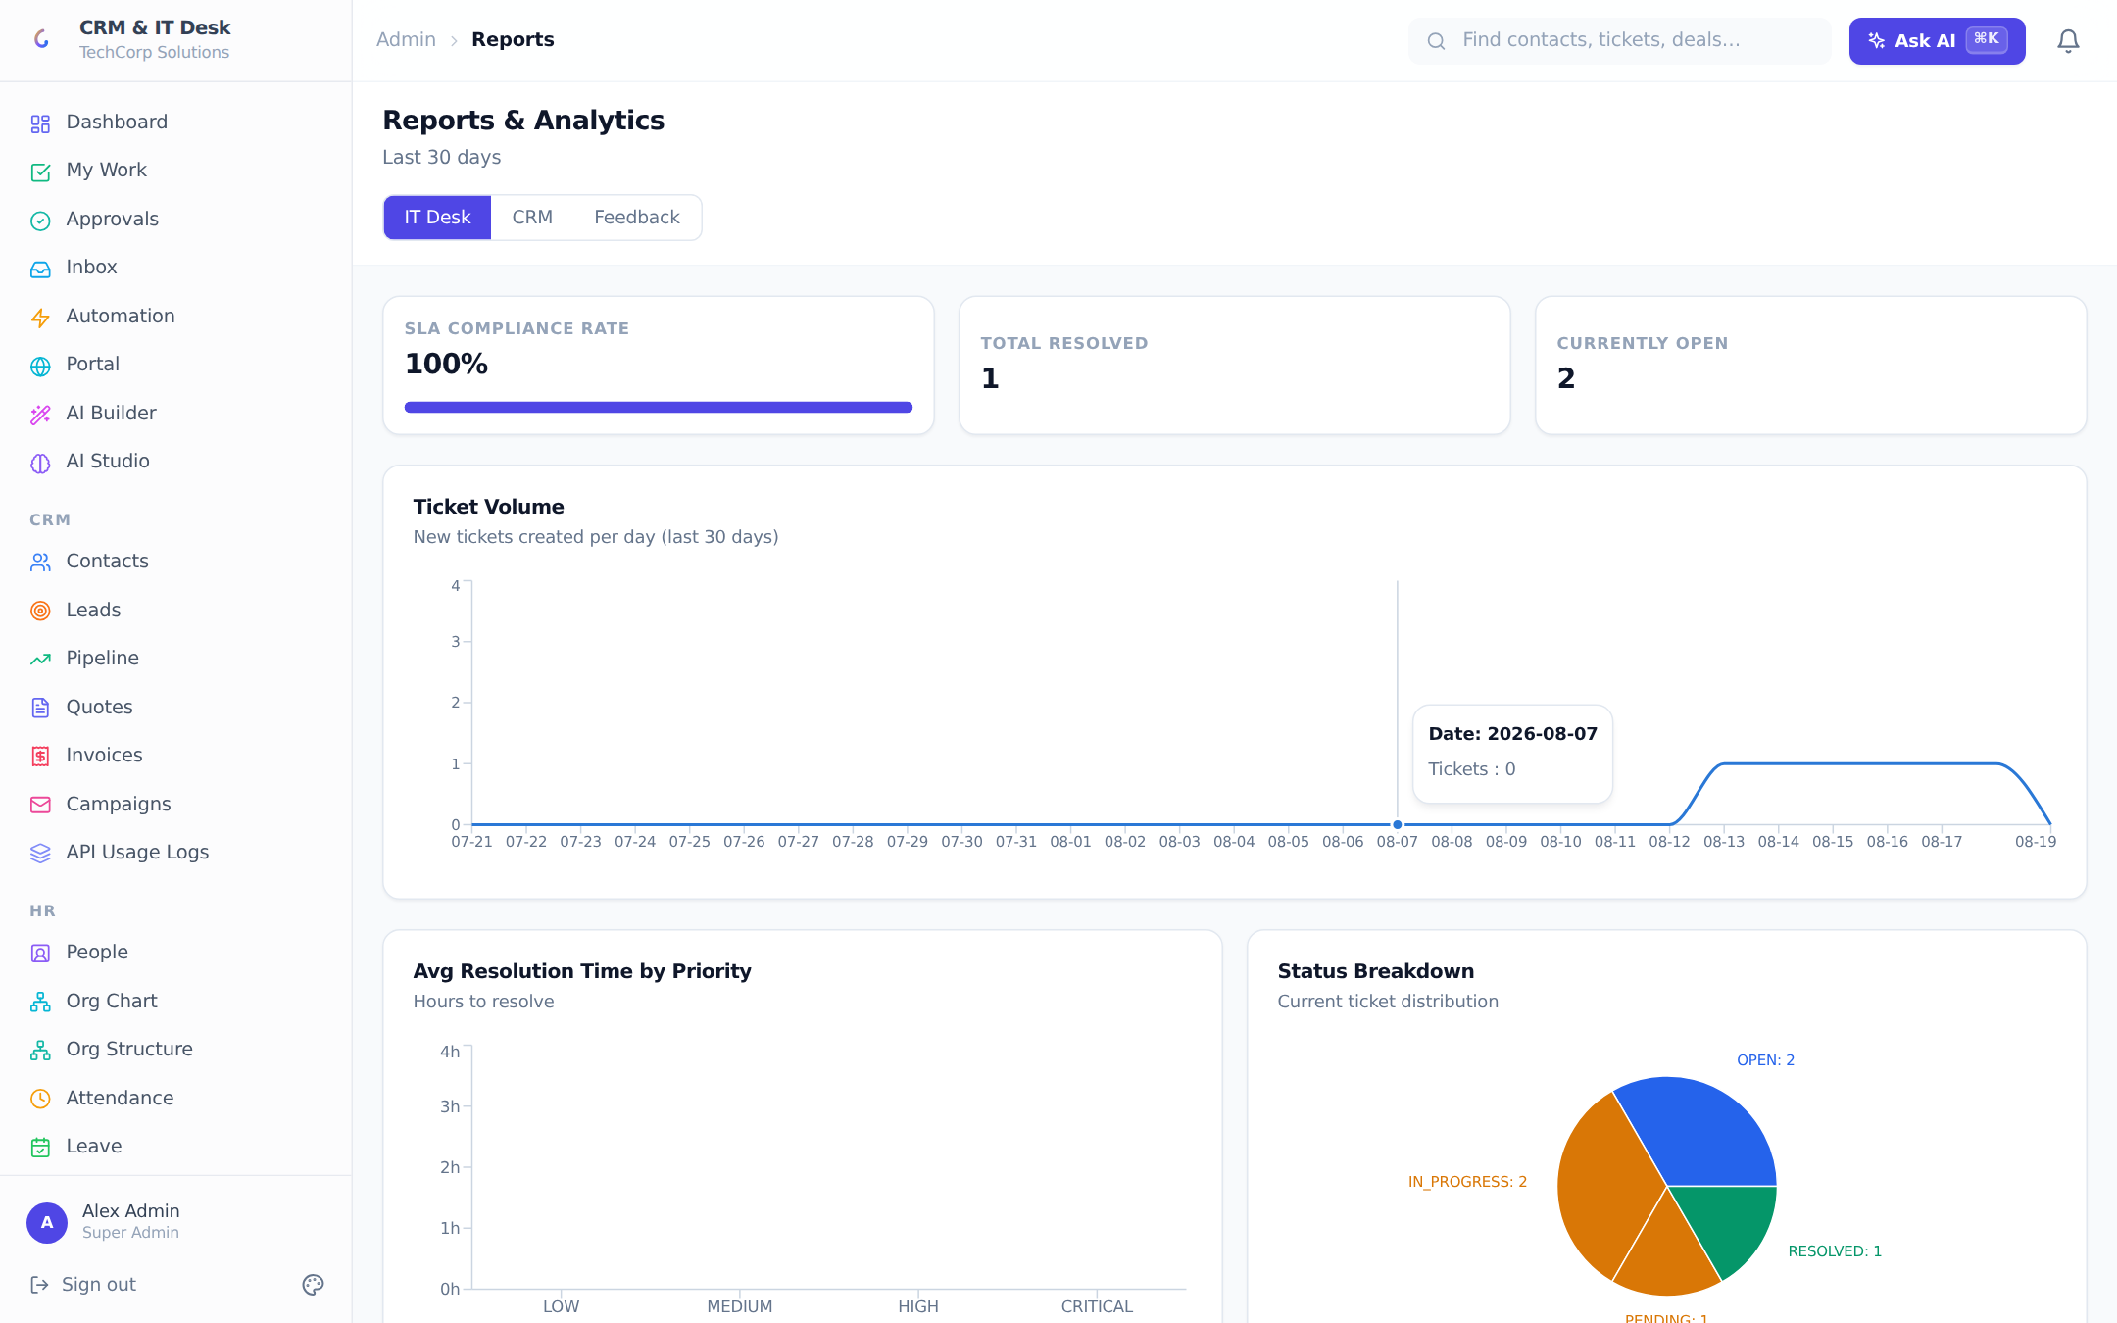
Reports: IT Desk, CRM and CSAT feedback tabs over the last 30 days.
Reports is the fixed 30-day summary: IT Desk (SLA compliance meter, resolved and open counts, volume, average resolution time by priority, status breakdown), CRM (win-rate meter, deals won/lost, new deals per day, probability-weighted forecast by stage, top contacts by pipeline value), and Feedback — the CSAT tab (IT managers) with average star rating, satisfaction percentage, response totals, a rating-distribution chart and a paginated list of individual survey responses linked to their tickets.

13. Administration & Security

13.1 Users & invites
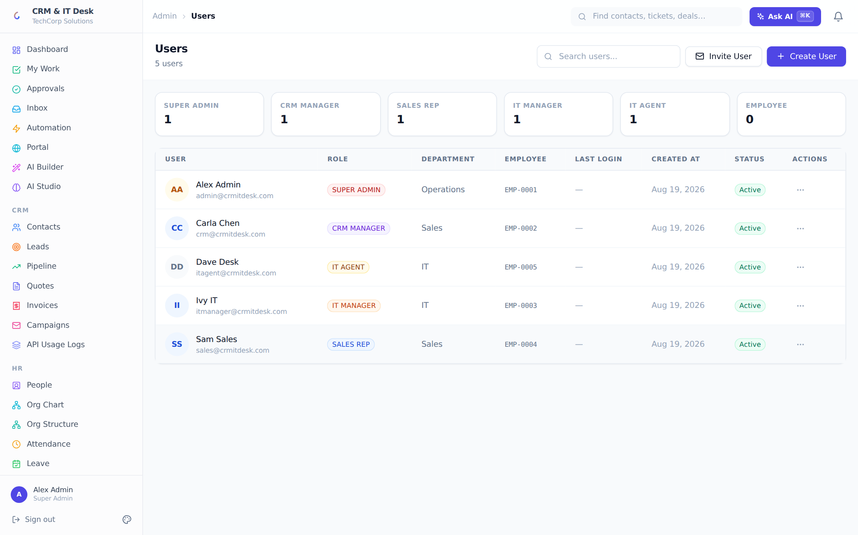
User administration: role stats, invites with shareable links, and per-user actions.
The Users page manages login accounts: create directly (name, email, password, department, phone, role) or invite by email — invites generate a shareable link valid seven days, listed in a Pending Invites panel. Per-user actions: edit, send a password-reset link, deactivate (soft — the seat frees immediately) and reactivate. The role picker includes custom roles, and a reconciliation banner repairs users missing an employee record in one click. Every user is linked to their employee/person record.

13.2 Roles & permissions
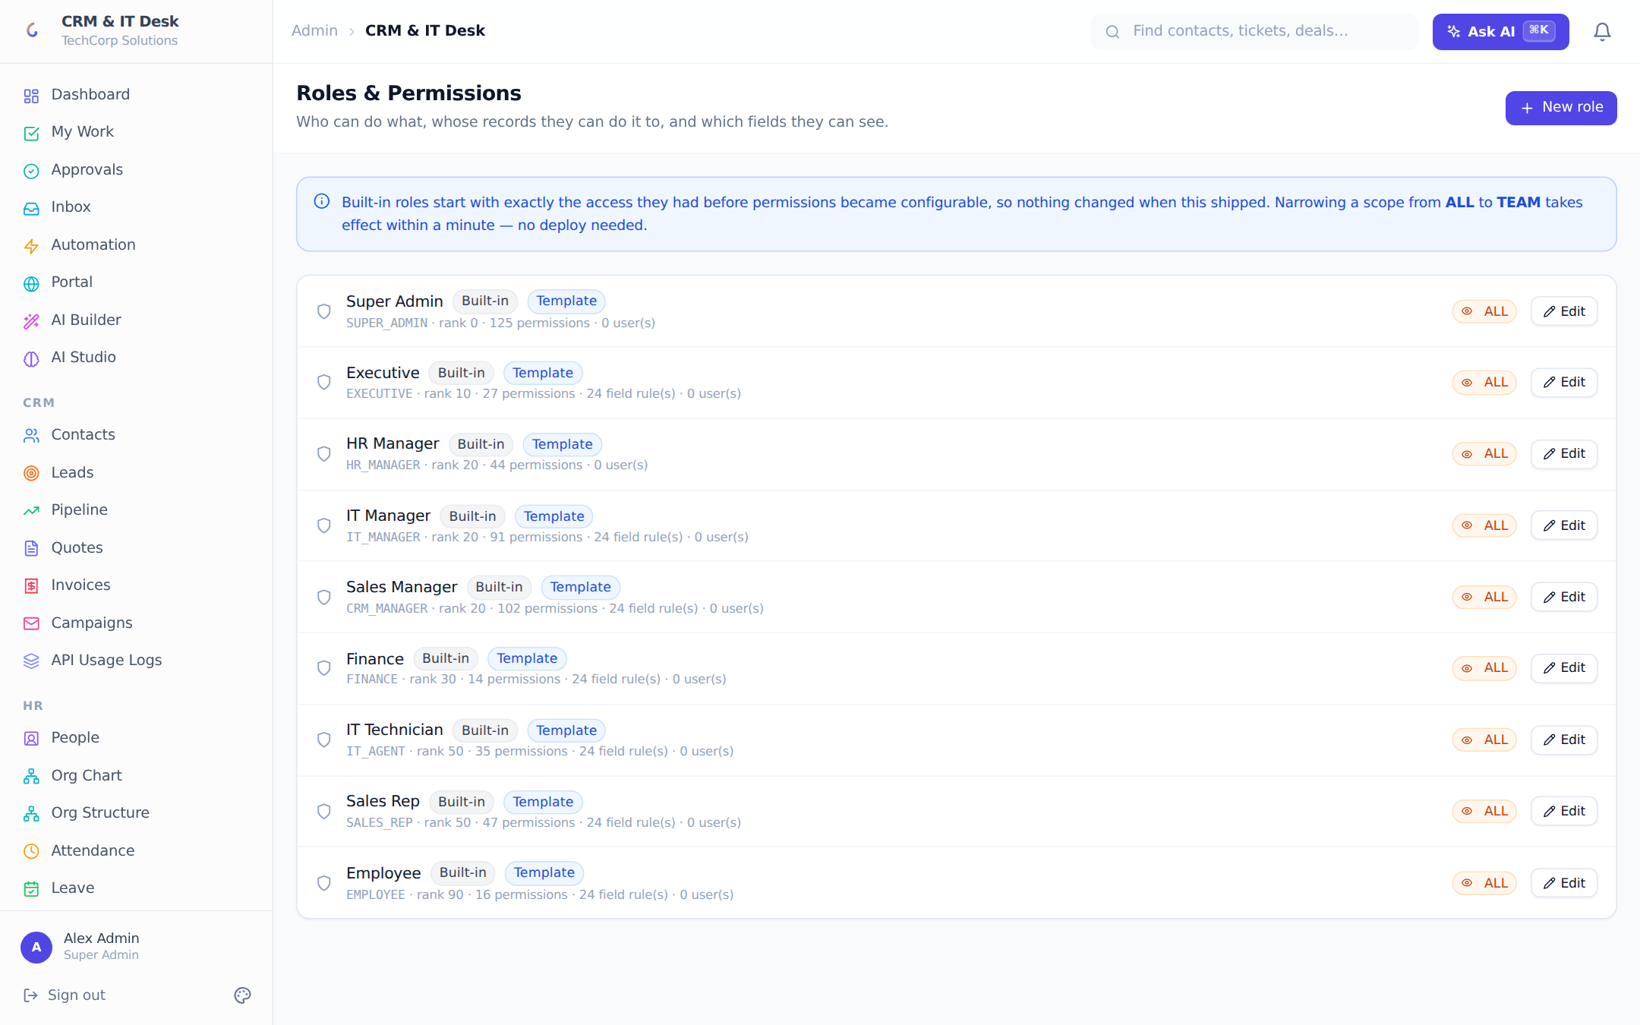
The permission engine: roles with per-permission scopes and field-level rules.
Access control is data-driven and three-dimensional: a permission is a verb on a resource ("read deals"); a scope answers whose records — None, Own, Team (yours + your team’s + your reports’), Department, All; and field rules answer which columns — Hidden, Masked (••••••1234), Read or Write. About 130 catalog permissions cover every module. Field rules apply on every path data leaves the system: API responses, search, CSV exports, and even AI prompts (redacted fields are logged for audit).
Nine built-in roles ship ready to use, and admins can create custom roles — typically by copying an existing role and adjusting scopes. A seniority rank prevents privilege escalation: you cannot create a role more senior than your own or grant a permission you do not hold. Baseline self-service grants (own attendance, leave, payslips, tickets, tasks) are unconditional, so no role misconfiguration can lock a person out of their own data.
Built-in role | Purpose
Super Admin | Full access to everything in the organization
Executive | Read-only visibility across every module
IT Manager | Runs the IT desk: tickets, assets, changes, SLAs
Sales Manager | Runs sales: pipeline, team performance, forecasting
HR Manager | Runs HR: employees, leave, attendance, payroll
Finance | Quotes, invoices, payroll cost, expense approvals
IT Technician | Works the ticket queue
Sales Rep | Works leads and deals
Employee | Self-service only — free seats, unlimited on every plan

Example Create a "Regional Sales Lead" role: copy Sales Rep, raise deal/lead read scope from OWN to TEAM, add crm.report.read, and add a field rule masking Deal.value for everyone below manager rank. Assign it inline from the People page — it takes effect within a minute, no deploy.

13.3 Two-factor authentication
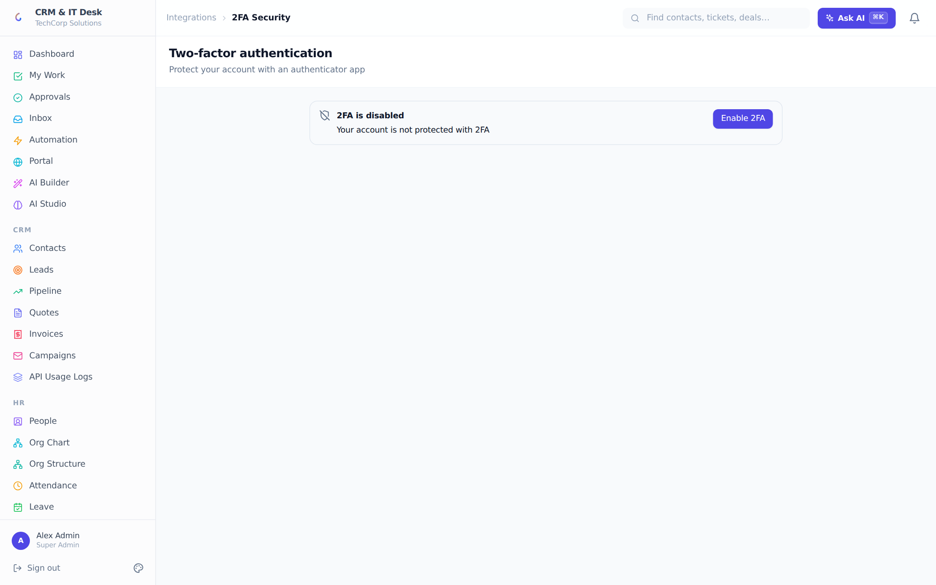
2FA setup: scan a locally rendered QR code, verify, and store one-time backup codes.
Any user can enable TOTP 2FA: scan a QR code (rendered locally in the browser — the secret never leaves the page), confirm a 6-digit code, and save the one-time backup codes shown on enable. Login then requires the authenticator code or a backup code; disabling requires a current code.

13.4 Single sign-on & directory sync (Microsoft Entra ID)
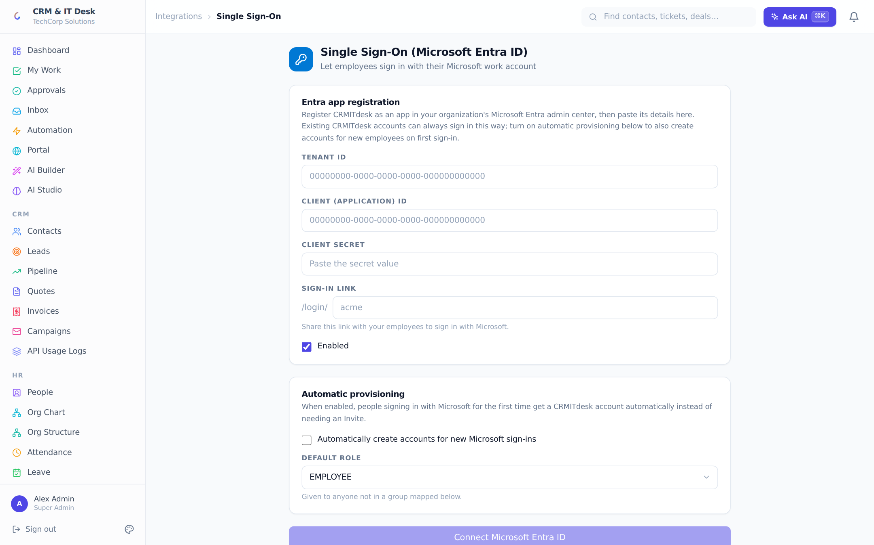
Entra ID SSO: per-org tenant config, group-to-role mappings, JIT provisioning and scheduled sync.
Each org can connect its own Microsoft Entra tenant: tenant ID, client ID, a write-only client secret, and a friendly sign-in slug that yields an employee login link /login/<slug>. Options include automatic just-in-time account provisioning on first Microsoft sign-in, a default role for unmapped users, and Entra security-group → role mappings with priorities (highest matching group wins). With provisioning on, a scheduled daily sync pre-creates and deactivates accounts from group membership; a Sync Now button and a sync-history log (created/deactivated counts, errors) complete the loop. Google Sign-In is available alongside — users link their Google account from their Profile.

13.5 Profile & privacy (GDPR)
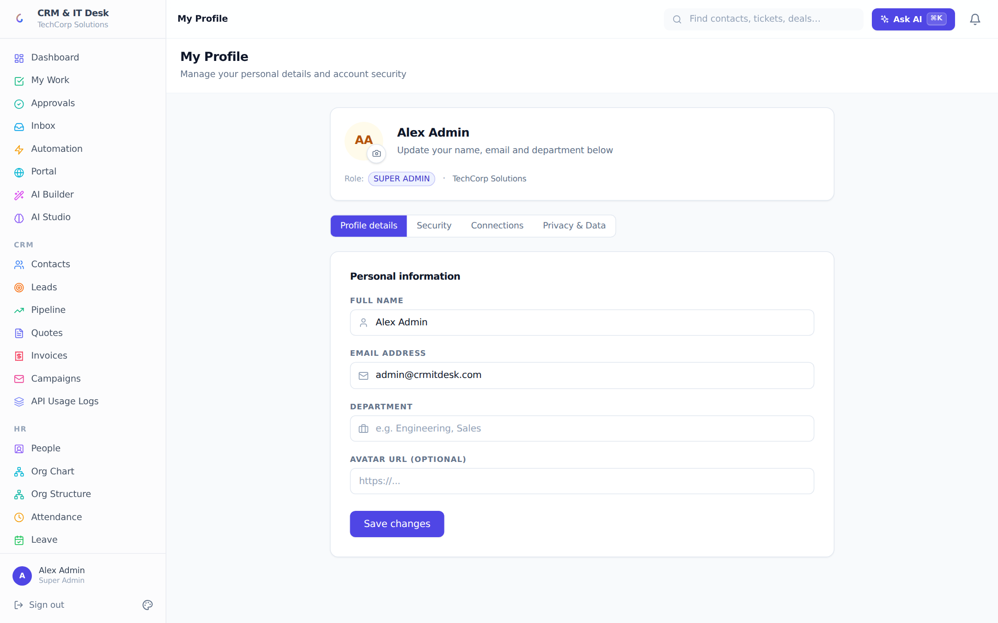
Profile self-service: details, password, connections (Google, Calendar) and GDPR data tools.
Every user manages their own profile (name, avatar, department), password (changing it signs out all other sessions), and connections: Google Sign-In linking and Google Calendar sync (activities and assigned tickets appear on their calendar). The Privacy tab implements GDPR self-service: export a JSON copy of your data, or request password-confirmed anonymization — name, email and phone are removed and the account deactivated while org records remain intact.

13.6 Audit log
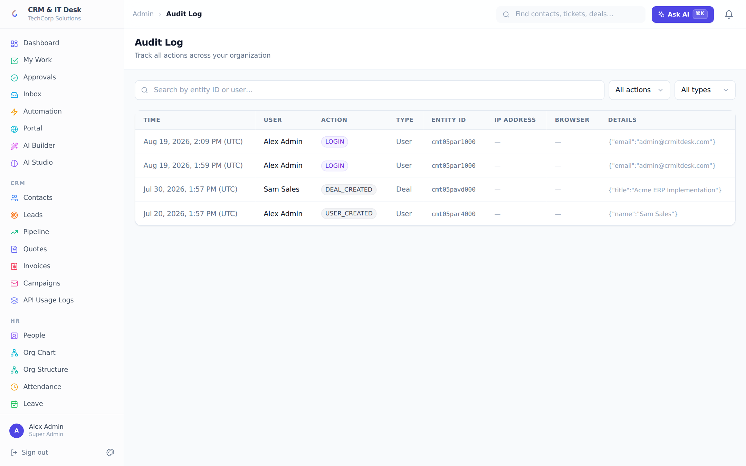
The org-wide audit trail with action, entity and user filters.
Managers can trace every create, update, delete and login across the org — who did what, to which record, when, with a JSON diff of changes. AI-executed actions appear with the original natural-language command, so "who told the AI to do that" is always answerable.

13.7 API keys & public API
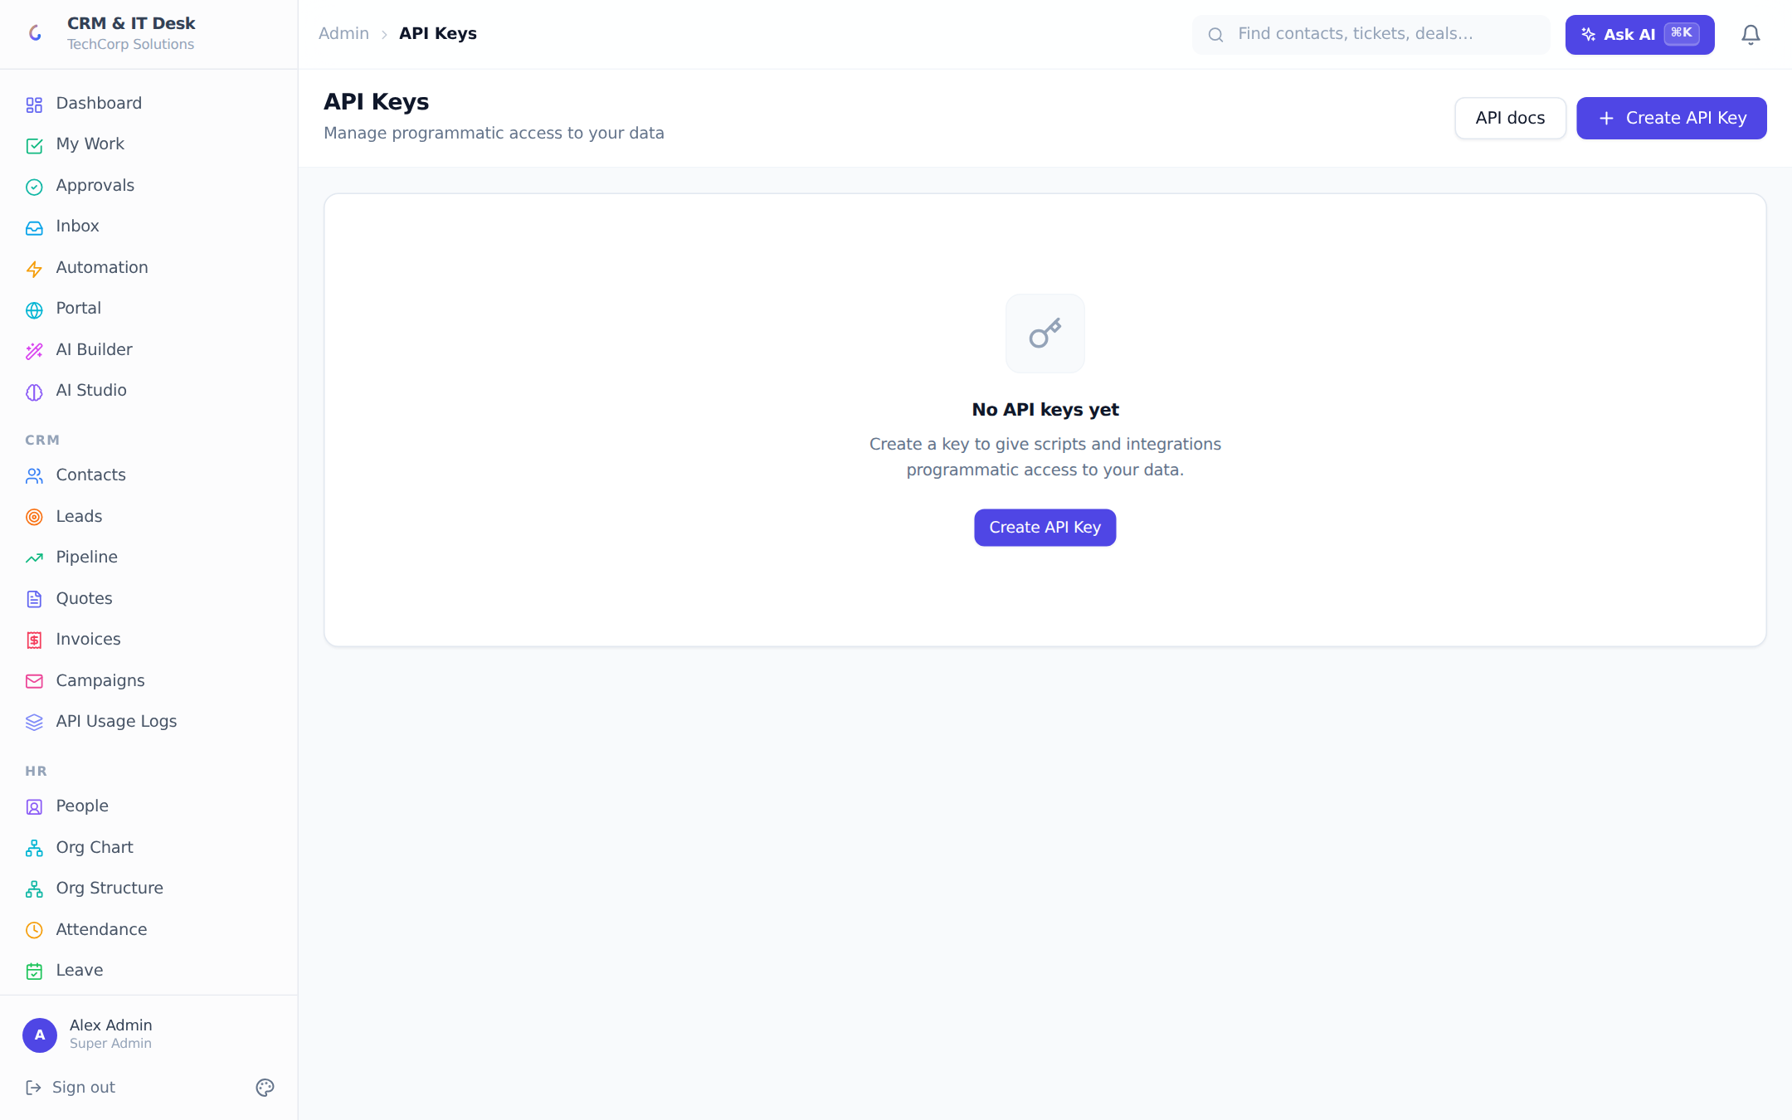
API keys with scopes, expiry and one-time display.
Org owners can mint API keys for integrations. Keys have a name, optional expiry, and one of three enforced scopes: read (GET only), write (plus create/update/delete) and admin. The full key is shown exactly once at creation. Requests carry an X-API-Key header, are rate-limited at 120 requests/minute per key, and cover the CRM and help-desk resources plus search — machine-readable docs live at GET /api/docs.

13.8 Branding & white-label
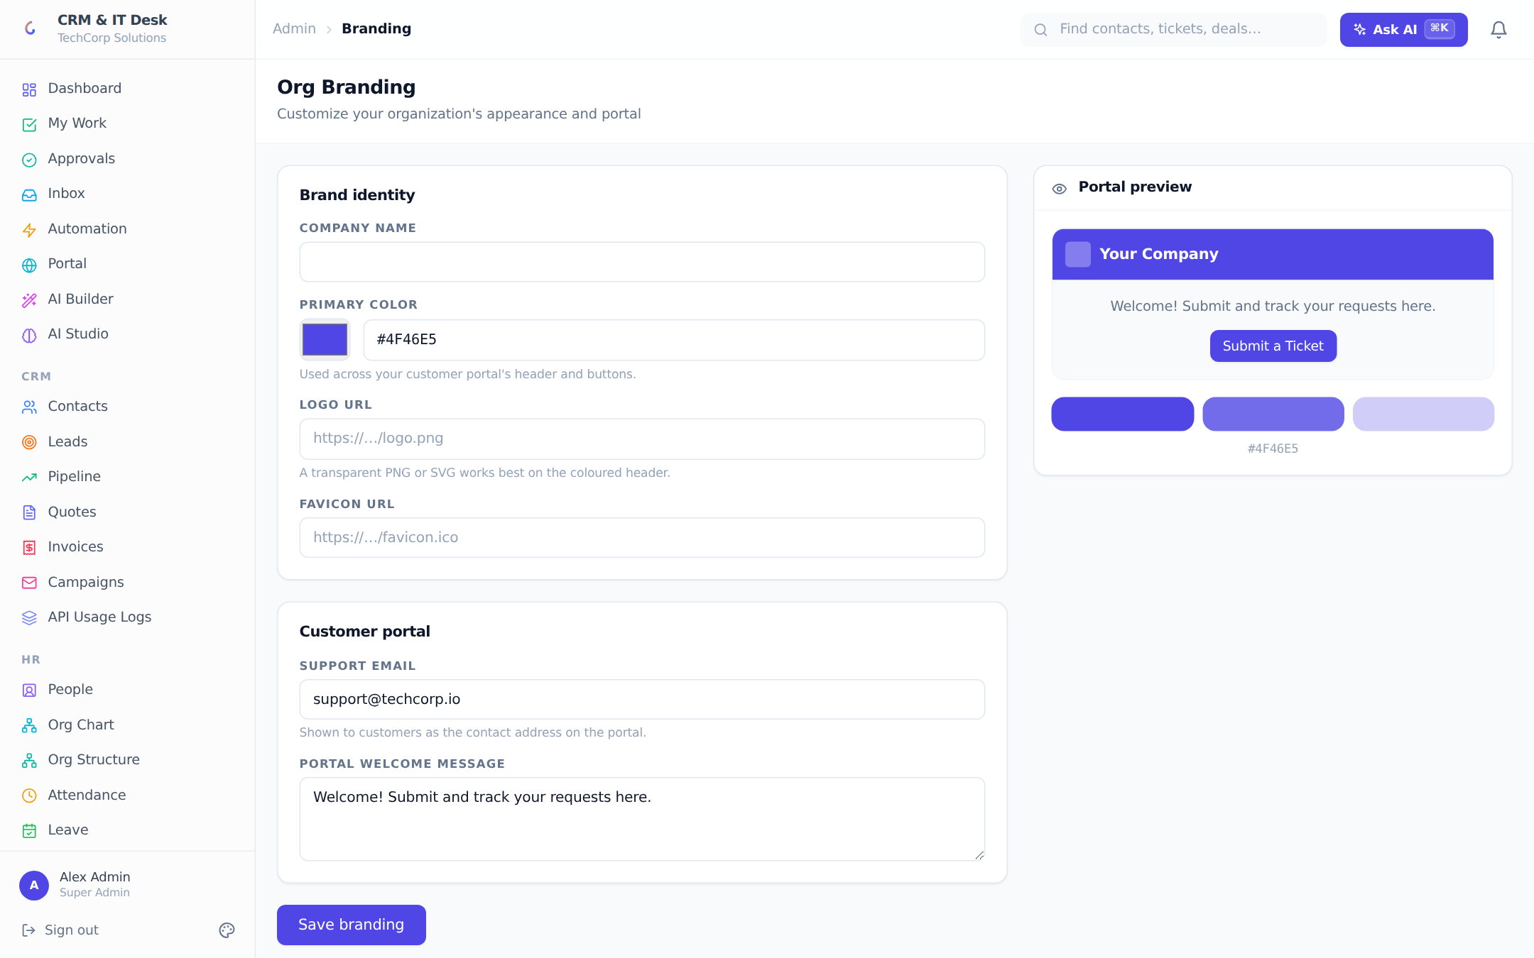
Org branding: company name, colors, logo — with a live customer-portal preview.
Branding sets the company name, primary color, logo and favicon, plus the customer-portal support email and welcome message, with a live portal preview. Branding extends to outbound mail: orgs without their own mailbox send through the platform mailer branded with their name and logo (Tier-1 white-label).

13.9 Org settings, storage & billing
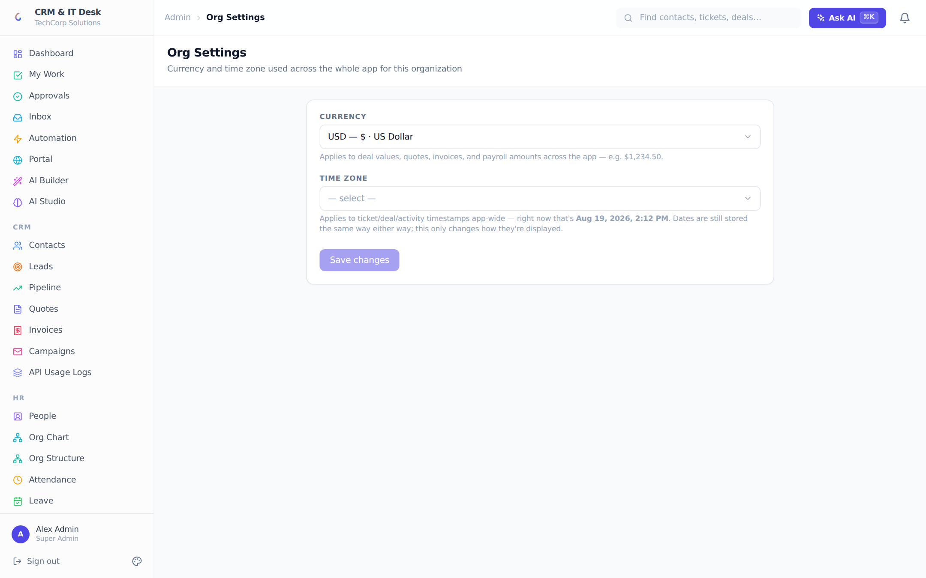
Org-wide currency and timezone.
Org Settings picks the workspace currency (applied to deals, quotes, invoices and payroll) and timezone (applied to every displayed date) with live previews.
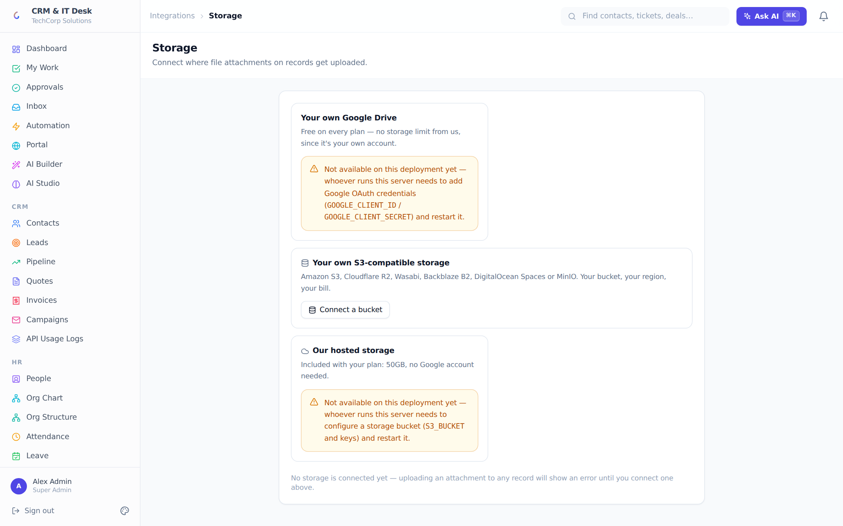
Attachment storage: your Google Drive, your S3 bucket, or plan-included hosted storage.
Storage chooses where file attachments live: your own Google Drive (free on every plan), your own S3-compatible bucket (Amazon S3, Cloudflare R2, Wasabi, Backblaze, DigitalOcean Spaces, MinIO), or platform-hosted storage with plan quotas (Pro 5 GB, Enterprise 50 GB) and a usage bar. Only the org owner can connect or change providers; existing files stay where they are on switch. Quotas are enforced server-side at upload time with clear remediation messages.
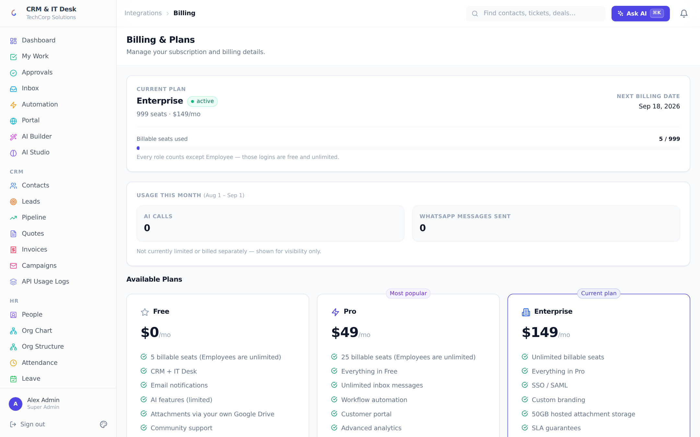
Billing: plan cards, seat usage, Stripe checkout and the customer portal.
Billing (owner-only) shows the current plan, seat usage (every active role counts except Employee), monthly AI and WhatsApp usage, and three plan cards — upgrades launch Stripe Checkout and "Manage billing" opens the Stripe customer portal.
Plan | Price | Seats | Hosted storage | Highlights
Free | $0/mo | 5 | — | CRM + IT Desk, email notifications, limited AI
Pro | $49/mo | 25 | 5 GB | Full AI suite, automation, customer portal, advanced analytics, priority support
Enterprise | $149/mo | Unlimited | 50 GB | SSO, custom branding, SLA guarantees, dedicated account manager

Seat limits only block new billable users — a downgrade never deactivates anyone. Adding a user beyond the seat count fails with a clear upgrade message.

14. Integrations

14.1 Slack & Microsoft Teams
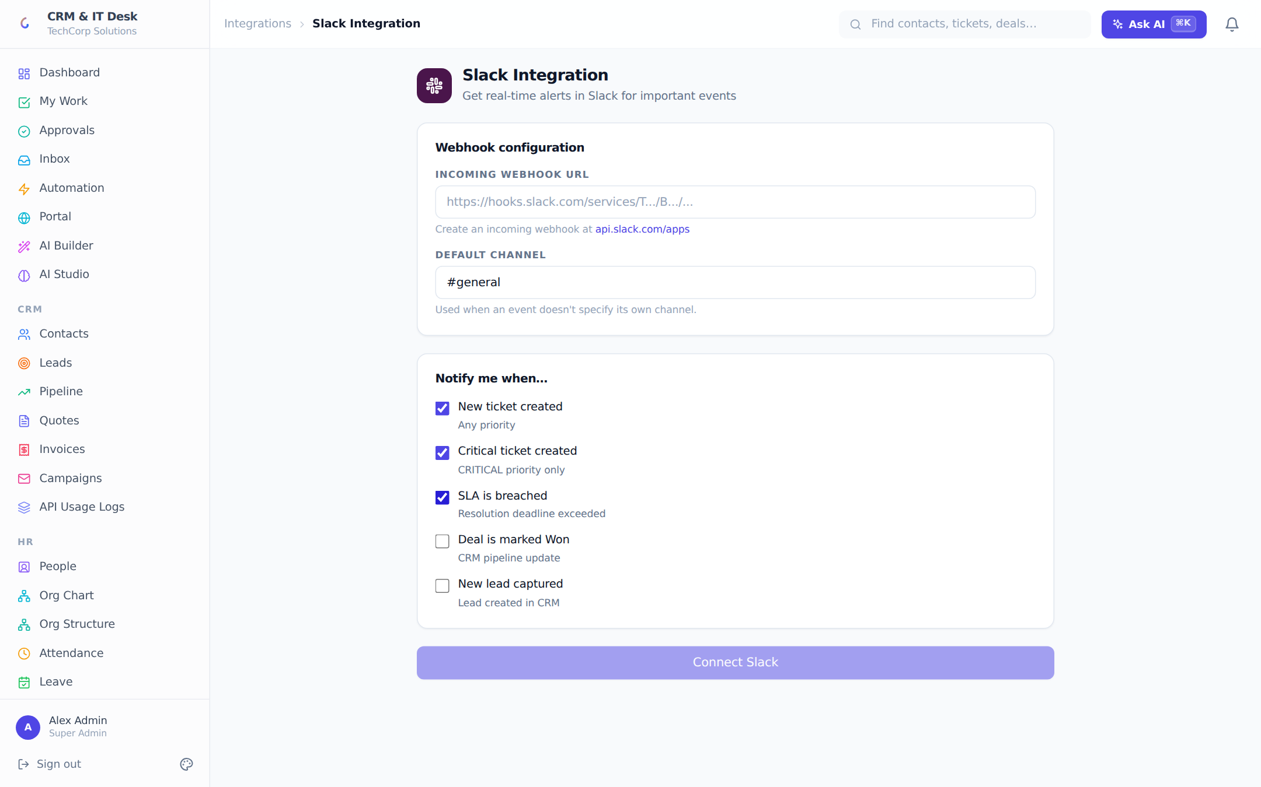
Slack notifications via incoming webhook with per-event toggles and a test button.
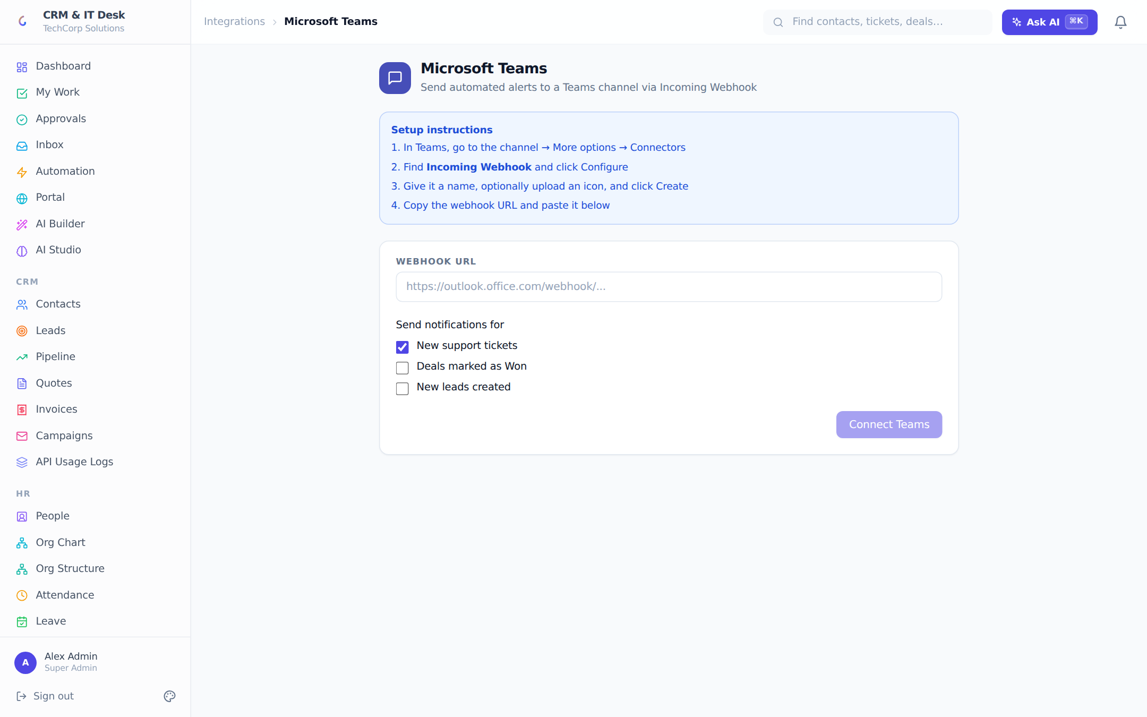
Microsoft Teams webhook with in-page setup instructions.
Both integrations post event notifications through incoming webhooks. Slack supports five toggles — new ticket, critical ticket, SLA breach, deal won, new lead — plus a default channel; Teams supports new tickets, deals won and new leads with step-by-step connector instructions. Both have Test and Disconnect buttons, and failed posts retry through the background job queue.

14.2 Everything else
Integration | What it enables
Email (IMAP/SMTP) | The shared inbox (ch. 6), campaign sending and workflow emails through the org’s own mailbox
WhatsApp (Twilio) | Two-way WhatsApp in the inbox, scheduled reminders on tickets/deals, workflow WhatsApp actions
Google | Google Sign-In, per-user Google Calendar sync, and Google Drive attachment storage
Microsoft Entra ID | Per-org SSO, JIT provisioning and daily directory sync (13.4)
Stripe | Subscription billing, checkout and the customer billing portal
Web Push | Real browser notifications for assignments, SLA warnings and workflow alerts
Webhooks (outbound) | Signed workflow webhooks to any external system
Public REST API | API-key access to CRM and help-desk resources (13.7)
External sync (inbound) | Custom modules polling any REST API on a schedule (11.3)

15. Platform Administration (Multi-tenant)
A separate console at /platform-admin serves the platform operator (a special cross-org role that never sees the normal app shell). Fleet stats show total organizations, users, connected-email counts and hosted storage use. Each tenant row expands into a detail panel where the operator can rename the org, edit its plan/seats/subscription status, inspect email and WhatsApp sending (own connection vs platform fallback, with all-time counters), review attachment-storage licensing, edit branding, and see usage tiles and the staff list.
Platform Settings configure the shared fallbacks that make white-labelling work — platform email (Resend or SMTP), platform Twilio WhatsApp, and the shared hosted-S3 bucket (with a connection test) — stored in the database so changes take effect immediately without redeploying. All secrets are write-only.

16. Technical Reference — Architecture

16.1 Project structure
crm-itdesk/
├── client/ React 18 + TypeScript + Tailwind frontend (Vite, port 5173)
├── server/ Node.js + Express + TypeScript + Prisma backend (port 4000)
│ ├── prisma/ schema.prisma + 40 migrations + seed
│ └── src/modules/ ~50 feature modules (controller + routes each)
└── tests/ Playwright end-to-end suite
The backend is a modular Express app: every feature lives in server/src/modules/<area> as a controller + routes pair, mounted under /api. Shared concerns live in src/utils (permissions engine, workflow engine, AI gateway, mailer, storage, licensing…). The frontend mirrors this with client/src/modules (feature pages) and client/src/pages (admin/settings pages), a shared component library, and React Query for all data fetching.

16.2 Request pipeline & hardening
- Helmet security headers, gzip compression, CORS restricted to the configured frontend origin, JSON body limits (1 MB).
- Rate limiting: 300 req/min per IP for the API, 20 attempts / 15 min on every auth endpoint, and a separate 120 req/min per-API-key bucket so integrations behind shared IPs are metered fairly.
- JWT access tokens (15 min) + rotating refresh tokens; expired refresh tokens purged hourly.
- Secrets at rest (OAuth tokens, mail passwords, bank/tax fields, S3 keys, SSO client secrets) are encrypted with a dedicated ENCRYPTION_KEY.
- Outbound workflow webhooks are HMAC-signed, SSRF-guarded (no private/metadata addresses), HTTPS-required in production and retried with backoff.
- Multi-tenancy: every query is scoped by orgId at the call site AND through the permission engine’s scope filters, so a scope bug can never widen access across tenants.

16.3 Background services
Poller | Cadence | Job
Email sync | 5 min | Pulls new IMAP mail into the unified inbox
Schedule poller | 1 min | Sends due WhatsApp reminders, reschedules recurring ones
SLA monitor | continuous | Detects resolution-deadline breaches; fires the SLA_BREACH trigger and notifications
Date automation | hourly | Evaluates Date Reached workflow rules (birthdays, renewals)
Custom-module sync | 1 min | Runs due external API polls into custom modules
Job queue | 15 s | Retries failed email/Slack/Teams/push deliveries with backoff
Approval expiry | 15 min | Expires approval requests past their deadline
Orphan reaper | daily | Reclaims storage quota from attachments whose parent was cascade-deleted
Token cleanup | hourly | Deletes expired refresh tokens

17. Technical Reference — Data & API

17.1 Data model overview
The Prisma schema defines roughly 110 tables. Grouped by area (each name is a model; every org-owned model carries an orgId):
Area | Models
Core & auth | Organization, User, RefreshToken, InviteToken, PasswordResetToken, TOTPSecret, ApiKey, AuditLog, Comment, Notification, PushSubscription, OrgSignupRequest
Permissions | Role, Permission, RolePermission, FieldPermission
CRM | Contact, Account, Lead, Deal, DealHistory, Pipeline, Activity, Campaign, Quote, QuoteLine, Tag, RecordTag
IT Desk | Ticket, TicketHistory, SlaPolicy, SlaBreaches, Category, KnowledgeArticle, Asset, TicketAsset, ChangeRequest, TimeEntry, CsatResponse
Inbox & portal | Conversation, Message, EmailAccount, WhatsAppConfig, PortalUser, PortalToken, OrgBranding
Automation | WorkflowRule, WorkflowLog, Schedule, BackgroundJob, SlackConfig, TeamsConfig, CalendarConnection, DirectoryConfig, DirectoryRoleMapping, DirectorySyncLog, ExternalSyncConfig
Customization | CustomField, CustomFieldValue, CustomModule, CustomModuleField, CustomModuleRecord, RecordTemplate, ReplyTemplate, EmailTemplate, QuoteTemplate, CustomScript
HR | Employee, Department, Location, Team, TeamMember, EmployeeContact, EmployeeEducation, EmployeeExperience, Skill, EmployeeSkill, EmployeeCertification, EmployeeDocument, OfficeLocation, AttendanceRecord, LeaveType, LeaveRequest, SalaryStructure, PayrollRun, Payslip, PayslipTemplate
Work & approvals | Task, TaskDependency, ApprovalPolicy, ApprovalPolicyStep, ApprovalRequest, ApprovalRequestStep, ApprovalAction, ApprovalDelegation
Billing & storage | Subscription, Invoice, InvoiceLine, StorageConfig, Attachment, PlatformSettings, UsageEvent
AI | BusinessContext, CustomAIFunction, AICustomRule, KnowledgeSource, KnowledgeDocument, KnowledgeChunk, AiProvider, AiModelConfig, AiInteractionLog, AiBudget

17.2 Key enums
Enum | Values
UserRole | SUPER_ADMIN, CRM_MANAGER, SALES_REP, IT_MANAGER, IT_AGENT, EMPLOYEE, PLATFORM_ADMIN
TicketStatus / Priority | OPEN, IN_PROGRESS, PENDING, RESOLVED, CLOSED / LOW, MEDIUM, HIGH, CRITICAL
LeadStatus | NEW, CONTACTED, QUALIFIED, UNQUALIFIED, CONVERTED
DealStatus | OPEN, WON, LOST
TaskStatus / Priority | OPEN, IN_PROGRESS, BLOCKED, DONE, CANCELLED / LOW, MEDIUM, HIGH, URGENT
EmploymentStatus | PROBATION, ACTIVE, ON_LEAVE, NOTICE_PERIOD, SUSPENDED, EXITED
ApprovalMode / ApproverType | SEQUENTIAL, PARALLEL, ANY_ONE, UNANIMOUS / USER, ROLE, MANAGER, SKIP_LEVEL_MANAGER, DEPARTMENT_HEAD, TEAM_LEAD, DYNAMIC_FIELD
PermissionScope / FieldAccess | NONE, OWN, TEAM, DEPARTMENT, ALL / HIDDEN, MASKED, READ, WRITE
Invoice / Quote status | DRAFT, SENT, PAID, OVERDUE, VOID / DRAFT, SENT, ACCEPTED, REJECTED
AiCallStatus | SUCCESS, ERROR, CACHED, BLOCKED, BUDGET_EXCEEDED

17.3 API surface
All endpoints mount under /api. The route families: auth, users, admin/users, notifications, crm/{contacts,accounts,leads,deals,pipelines,activities}, itdesk/{tickets,categories,sla-policies,articles,assets,time-tracking}, comments, search, reports, org, ai (30+ AI endpoints), inbox, workflows, portal, portal-users, billing, analytics, events (SSE), slack, teams, directory, csat, campaigns, change-requests, api-keys, custom-fields, audit-logs, branding, quotes, 2fa, import, templates/{records,replies,emails,quotes}, schedules, storage, attachments, tags, demo, custom-modules, push, platform, calendar, gdpr, hr/{attendance,leave,payroll,employees,org}, people, invoices, jobs, tasks, approvals, permissions, knowledge. A health check lives at GET /health and self-describing public-API docs at GET /api/docs.

17.4 Configuration (.env)
Variable(s) | Purpose
DATABASE_URL | PostgreSQL connection
JWT_SECRET, JWT_EXPIRES_IN | Access-token signing (15 min default)
ENCRYPTION_KEY | Required — encrypts stored secrets and sensitive HR fields
APP_URL, FRONTEND_URL, CORS_ORIGIN | Public URLs for OAuth redirects, links and CORS
OPENAI_API_KEY / GROQ_API_KEY (+ *_COST_PER_1K) | AI provider and per-token pricing for the cost ledger
SMTP_* / RESEND_API_KEY | Platform fallback email sender
TWILIO_ACCOUNT_SID / AUTH_TOKEN / FROM_NUMBER | Platform fallback WhatsApp sender
GOOGLE_CLIENT_ID / SECRET | Google Sign-In, Calendar and Drive OAuth
S3_BUCKET / KEYS / REGION / ENDPOINT | Platform-hosted attachment bucket (overridable live in Platform Settings)
STRIPE_SECRET_KEY / WEBHOOK_SECRET / PRICE_IDs | Subscription billing
VAPID_PUBLIC/PRIVATE_KEY, VAPID_SUBJECT | Browser push notifications
QUOTE_SHARE_SECRET, WORKFLOW_WEBHOOK_SECRET, DIRECTORY_SYNC_SECRET, DEMO_RESET_SECRET, PLATFORM_BOOTSTRAP_SECRET | Signing/guard secrets for public links, webhooks, directory push, demo reseed and first-admin bootstrap

Per-org integrations (Entra SSO, Slack/Teams webhooks, the org mailbox, org Twilio, org storage, org AI keys) are configured in-app and stored encrypted in the database — not in .env. Every optional variable degrades gracefully with a clear in-product message rather than crashing.

17.5 Running locally
npm install # root, installs client + server workspaces
cp server/.env.example server/.env # set DATABASE_URL, JWT_SECRET, ENCRYPTION_KEY
npm run db:migrate # Prisma migrations
npm run db:seed --workspace=server # optional: seed 8 industry demo workspaces
npm run dev # server on :4000, client on :5173
The seed creates eight demo organizations; sign in with admin@crmitdesk.com / Admin@123 (TechCorp Solutions). The Playwright suite runs with npm test.

Appendix A — Screenshot index
All screenshots in this document were captured from a live instance (v. August 2026) seeded with the TechCorp Solutions demo workspace, signed in as a Super Admin at 1440×900. Pages not pictured (public quote/invoice views, payslip print view, accept-invite and password-reset pages, the Entra login page) are minor variants of pictured flows.

