CRMITdesk Evolved
Custom Integrations Guide
Inbound API keys · outbound signed webhooks · external-API sync — every example verified live on 23 Aug 2026

Contents

How integrations work in CRMITdesk

Lane | Direction | What it is for | Where it lives
1. REST API + API keys | Inbound (they call you) | An external system creates or reads CRM/helpdesk data: push orders in, pull contacts out, file tickets from another app | Settings → API Keys; docs at GET /api/docs
2. Workflow webhooks | Outbound (you call them) | The moment something happens here (ticket created, deal won…), CRMITdesk POSTs the full record to any URL — signed, with retries | Automation → workflow rule → SEND_WEBHOOK action
3. Custom-module sync | Inbound (you poll them) | CRMITdesk periodically pulls records FROM an external API into a custom module — no code on their side at all | Custom module → Manage fields & sync

Rule of thumb If the other system wants to push data to you → Lane 1. If it needs to know when things happen here → Lane 2. If it just has an API you want to mirror into CRMITdesk → Lane 3.

Lane 1 — Inbound REST API with API keys
Any external system (an ERP, a website form, a partner's script) can talk to your CRMITdesk org directly over HTTP. Instead of logging in, it sends an API key in a header. Keys are created by the org admin and carry scopes, so a key can be read-only.

Step 1 — create a key

The same thing over the API, as I did in the live run:
POST /api/api-keys (as the logged-in admin)
{ "name": "ERP Integration Demo", "scopes": ["read", "write"] }
→ { "keyPrefix": "crm_57b97d6a", "scopes": ["read","write"],
"rawKey": "crm_57b97d6a0d56f142...e212efdf3d6ea" } ← shown once

Step 2 — the external system uses the key

curl -X POST https://<your-server>/api/crm/contacts \
-H "X-API-Key: crm_57b97d6a..." \
-H "Content-Type: application/json" \
-d '{ "name": "Erp Imported", "email": "erp.imported@acme-erp.example",
"phone": "+1-555-0142" }'
→ 201 { "id": "cmt5yer88...", "name": "Erp Imported", ... }
Reading works the same way:
curl -H "X-API-Key: crm_..." \
"https://<your-server>/api/crm/contacts?search=erp.imported"
→ { "data": [ { "id": "cmt5yer88...", "name": "Erp Imported", ... } ] }

What a key can and cannot do (verified live)

Fix shipped with this guide This live test exposed two bugs: API keys were rejected by every role-guarded route (so keys could not actually reach the endpoints /api/docs advertises), and key-created records pointed at a non-existent user. Both are fixed in server/src/middleware/authenticate.ts and server/src/modules/apikeys/apikeys.controller.ts — commit and push these.

Lane 2 — Outbound webhooks from workflows
When you need the outside world to react to events inside CRMITdesk — a new ticket should open a job in the ERP, a won deal should notify a billing system — you attach a SEND_WEBHOOK action to a workflow rule. No polling, no code inside CRMITdesk.

Step 1 — create the rule

POST /api/workflows
{
"name": "Notify ERP on new ticket",
"trigger": "TICKET_CREATED",
"conditions": [],
"actions": [{ "type": "SEND_WEBHOOK",
"params": { "url": "https://erp.partner.com/hook" } }],
"isActive": true
}

Step 2 — what the receiver gets
I created a ticket in the app; within a second the mock ERP's endpoint received this POST (trimmed):
POST /hook
X-Webhook-Signature: sha256=a82dfe5f6b3c4cc5...bd06fda1
{
"trigger": "TICKET_CREATED",
"entityType": "TICKET",
"entityId": "cmt5yfgzk00m57i7d7a1kgfmd",
"entity": {
"title": "Signed webhook test",
"priority": "LOW", "status": "OPEN",
"requester": { "name": "Alex Admin", "email": "admin@crmitdesk.com" },
...full record...
},
"timestamp": "2026-08-23T15:20:57.577Z"
}
Delivery retries transient failures 3 times, so a receiver that is briefly down does not lose events.

Step 3 — the receiver verifies it is really you

import hmac, hashlib
org_secret = hmac.new(PLATFORM_SECRET,
f"workflow-webhook:{ORG_ID}".encode(), hashlib.sha256).hexdigest()
# (you compute this once and hand it to the partner — they never see
# the platform secret)
expected = "sha256=" + hmac.new(org_secret.encode(),
raw_request_body, hashlib.sha256).hexdigest()
assert expected == request.headers["X-Webhook-Signature"]
I ran exactly this check against the live delivery above: computed and received signatures matched.
Production step Add WORKFLOW_WEBHOOK_SECRET (any long random string) to the server environment on Render. Without it, webhooks still deliver but are unsigned.

Lane 3 — Pull an external API into a custom module
The reverse direction, with zero code on either side: point a custom module at any JSON API and CRMITdesk polls it, maps fields, and upserts records. Perfect for "show our ERP work orders inside the CRM".

The live example, end to end

PUT /api/custom-modules/<moduleId>/sync
{
"url": "https://erp.example.com/workorders",
"method": "GET",
"authType": "API_KEY", // or BEARER / NONE
"authHeaderName": "X-Erp-Key",
"authValue": "erp-secret-123",
"pollIntervalMin": 60, // 1–1440 minutes
"recordPath": "items", // where the array lives in the JSON
"externalIdField": "wo_number", // dedupe key
"fieldMapping": { "wo_number": "wo_number", "customer": "customer",
"description": "description", "amount": "amount",
"due": "due" }, // module field ← external field
"isActive": true
}

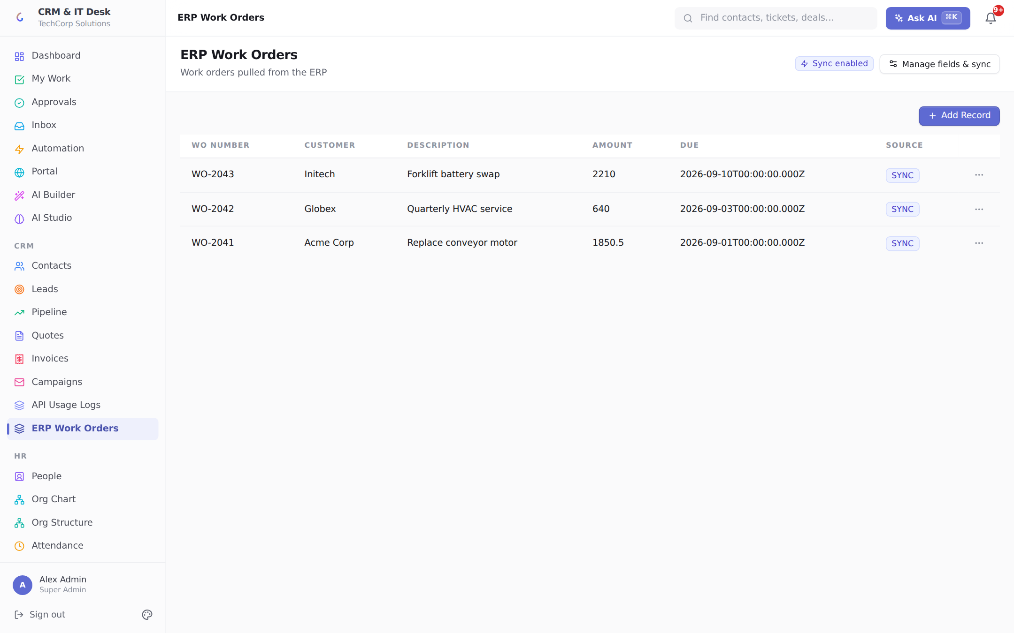
The custom module after the live sync: three ERP work orders imported, "Sync enabled" chip, SYNC source badges, and the module appears in the sidebar like any built-in one.

Choosing and combining lanes — worked scenarios
You want… | Recipe
ERP creates a service ticket whenever a machine faults | Lane 1: give the ERP a write-scoped key; it POSTs /api/itdesk/tickets
ERP hears about every ticket we open, to plan a technician | Lane 2: TICKET_CREATED rule → SEND_WEBHOOK to the ERP endpoint
Sales sees ERP work orders next to CRM data | Lane 3: custom module polling the ERP's /workorders API
Two-way ticket bridge with another helpdesk | Lane 1 (they push updates in) + Lane 2 (we push events out)
Website contact form straight into CRM leads | Lane 1: read+write key used by the site backend, POST /api/crm/leads
Nightly finance export | Lane 1: read-only key + GET /api/invoices from a scheduled script

Security model at a glance

Your checklist to go live
- Commit and push the two fixed server files delivered with this guide (authenticate.ts, apikeys.controller.ts), then redeploy on Render.

- Create a named API key per integration partner (never share one key) — revoking one partner then never disturbs another.

