CRMITdesk Evolved
Client Demo Runbook
45–60 minute live demo for an ERP-developer & marketing audience · prep, click path, talking points, fallbacks, Q&A
Presenter: Kesava · August 2026

Contents

0. Know Your Room
This runbook is tuned for a mixed audience of ERP developers and marketing people. They evaluate differently: the developers will judge architecture, extensibility and whether this threatens or complements what they build; marketing will judge whether they can position and sell it. Feed both throughout:
- The frame that wins the room: "This is not an ERP and doesn’t want to be one. ERP owns finance, inventory, procurement — the system of record. This owns the people-facing layer around it: sales pipeline, customer support, employee self-service, all AI-first. They connect over a REST API, signed webhooks and scheduled sync." Complement, not competitor — say it in the first two minutes and the developers relax.
- For the developers: sprinkle one-line technical asides throughout ("that check ran server-side against a permission engine, not in the UI") and give them a dedicated Under the Hood act (Act 7) — don’t make them wait until Q&A.
- For marketing: lead every module with the sellable phrase, not the mechanism — the phrases are marked Pitch line in each act. Act 8 hands them the full positioning kit: differentiators, verticals, white-label, pricing story.

1. Before the Demo — Preparation Checklist

1.1 The day before
- Pick the demo workspace. Eight seeded industry verticals exist (Technology, Healthcare, Retail, Financial Services, Manufacturing, Salon & Spa, Automotive, Real Estate). For this audience, Technology (TechCorp) is the safe default — but showing a second vertical for 30 seconds is itself a marketing point ("verticalized demos out of the box"). Default login: admin@crmitdesk.com / Admin@123; other verticals: admin@<slug>.demo / Admin@123.
- Reseed for a clean stage (locally: npm run db:seed --workspace=server; deployed: the nightly reset or POST /api/demo/reset). Fresh data = predictable demo.
- Confirm AI is live. Open a lead, click Score. If it says "AI not configured", set GROQ_API_KEY on the server — the AI moments carry this demo.
- Verify the keep-alive workflow is green in GitHub Actions so the server is warm at start time.
- Props: a second browser window in incognito ("the customer"), your phone for the attendance check-in, the 61-page documentation as leave-behind, and — for the developers — have the repo open in an editor tab in case they ask to see code (server/src/modules is a clean tour: one folder per feature).
- Have GET /api/docs open in a tab — the self-describing public API reference. Developers trust an endpoint more than a slide.

1.2 Thirty minutes before
- Open the app and sign in — this also wakes the server. Leave the tab open.
- Dry-run the five wow moments (2.2) silently: AI scoring, pipeline drag, quote e-sign, AI command bar, check-in.
- Browser zoom 100–110%, notifications off, extra tabs closed; incognito window ready and minimized.
- Hotspot ready as network fallback; documentation PDF open as visual fallback.

1.3 Golden rules during the demo
- Never type long text live — templates and AI generators fill content in one click. Typing is dead air.
- Alternate altitude deliberately: one sentence of business value (for marketing), one of mechanism (for developers). Never five minutes of either.
- If something misbehaves, don’t debug on screen — "I'll come back to that", move on.
- Park deep questions visibly: "Noting that for the technical section — Act 7 answers it properly."
- Let the room drive the AI moments: ask THEM what to type into the command bar. Their words, executed live with a confirmation card, is your strongest 30 seconds.

2. The Storyline (45–60 minutes)
One continuous story — a company running sales, support and HR in a single AI-first workspace that sits beside an ERP, not instead of it. Business acts run first and fast; the developers get a dedicated deep-dive before the close. Scripted time ≈ 48 minutes, leaving 10–12 for Q&A.

2.1 Act structure at a glance
Time | Act | Primarily for
0–4 | Opening: positioning vs ERP | Both — sets the frame
4–8 | Dashboard | Marketing (Ask-AI moment)
8–17 | CRM: lead to cash | Marketing (the sellable story)
17–24 | IT Desk + customer portal + inbox | Both
24–29 | HR & People (fast pass) | Marketing
29–36 | Automation & the AI platform | Both — AI governance impresses developers
36–44 | Under the hood | Developers — architecture, extensibility, ERP integration
44–48 | Positioning kit, white-label & plans | Marketing
48–60 | Q&A + close | Both

2.2 The five "wow" moments
Rehearse these above all: (1) the customer e-signing a quote on the public link while the invoice creates itself; (2) dragging a deal across the pipeline; (3) the AI command bar executing a dictated instruction behind a confirm card; (4) a ticket auto-routed, auto-drafted and turned into a KB article; (5) geo-verified check-in. For this audience add a sixth: (6) creating a custom module live and watching it appear in the sidebar — the "platform, not app" proof developers respect.

Act 1 — Opening: positioning vs ERP (0–4 min)
Say: "You build and sell ERP — the system of record for finance, inventory, operations. What I’m showing you is the layer your customers keep asking for around it: CRM, customer support, employee self-service — AI-first, white-labelable, and built to integrate rather than replace. By the end I’ll show you exactly how it talks to an ERP, and where the partnership opportunity is."
- Start at the /demo landing page. Point at the eight industry chips: "One seed, eight verticalized demo environments — your sales team gets an industry-native demo for every prospect." Click Technology → "Try the live demo".
- You land signed-in on the dashboard. One sentence on the shell: role-driven sidebar, four themes, org-level branding — "everything you'll see can carry a partner's brand."
Pitch line "ERP runs the back office. This runs the front office — and the two connect."

Act 2 — Dashboard (4–8 min)
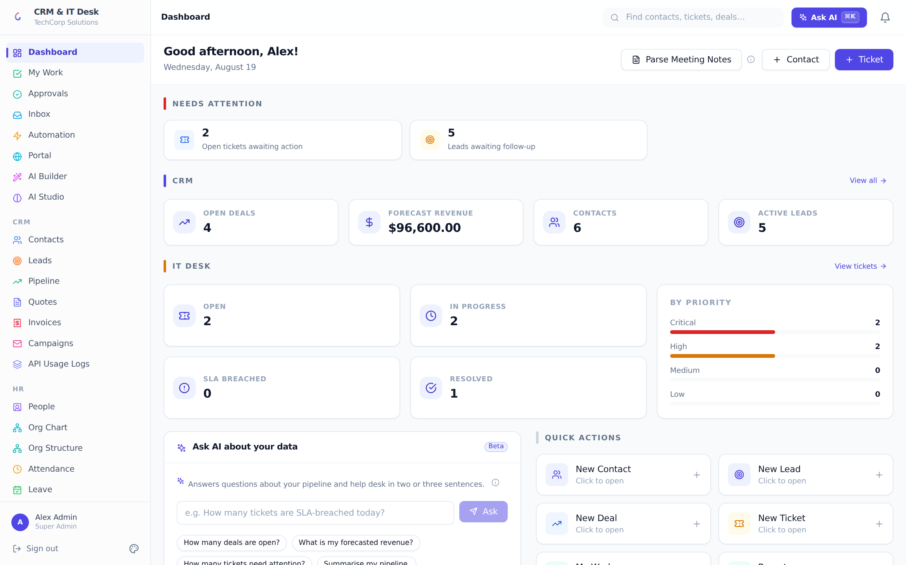
- Walk the "Needs attention" strip: "The system triages your day — SLA breaches, waiting tickets, cold leads — one click to the filtered list." Sweep the CRM and IT Desk stat rows briefly.
- Star moment: "Ask AI about your data" — invite the room to pick a question, or use "Summarise my pipeline". Read the answer aloud: "Computed from live data at ask-time, not a canned report." Developer aside: "the model gets aggregated metrics, not raw rows — row access is filtered by the permission engine first."
- Mention Parse Meeting Notes in one sentence; demo only if ahead of schedule.

Act 3 — CRM: lead to cash (8–17 min)
Say: "One deal, first contact to money in the bank, eight minutes." This act is marketing’s highlight reel — keep it moving.

Leads (2 min)
- CRM → Leads. Score an unscored lead: "AI-rated conversion likelihood, with the why." Hover the icon for reasoning. Developer aside: "scoring runs on the cheap fast-tier model; heavy generation uses a smarter tier — routed automatically."
- Row menu → AI follow-up email → Copy. Mention the 3-step nurture sequence. No live typing.
- Convert the lead → keep pre-filled title, set value, Create. "Lead becomes contact plus live deal."

Pipeline (3 min)
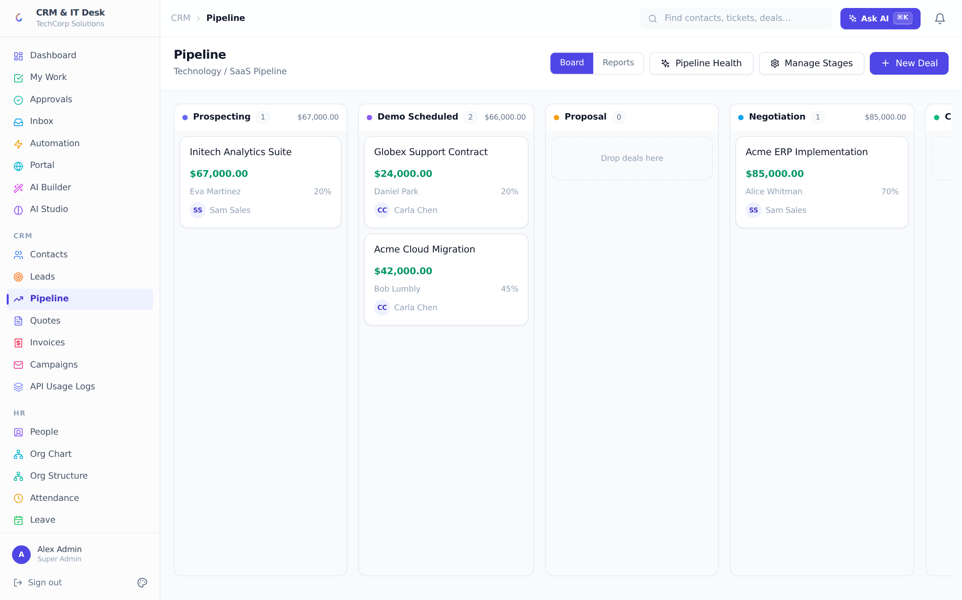
- Star moment: drag the new deal to the next stage — pause on the drop. "Stages, colors and win-percentages are org-defined" (flash Manage Stages five seconds).
- Open a big deal → Analyze win probability → read factors aloud. Generate follow-up email → Tone Check: "it reviews the email’s tone before the rep sends it."

Quote → e-signature → invoice (4 min)
- Quotes → New Quote → pick a quote template, title it, Create, Send.
- Star moment: "Copy customer link" → paste in incognito → play the customer: review, accept, draw a signature. Back in the app: quote Accepted, and in Invoices the invoice has created itself — numbered, taxed, with its own public link. Developer aside: "the link is HMAC-signed and login-free; signature, IP and timestamp are captured server-side."
- Close the act: "Lead → scored → converted → worked → quoted → signed → invoiced. No copy-paste, AI at every step." One sentence on Campaigns (bulk email from templates).
Pitch line "Your customer’s sales team lives here all day — and every number it produces can flow into the ERP’s ledgers through the API."

Act 4 — IT Desk, customer portal & unified inbox (17–24 min)
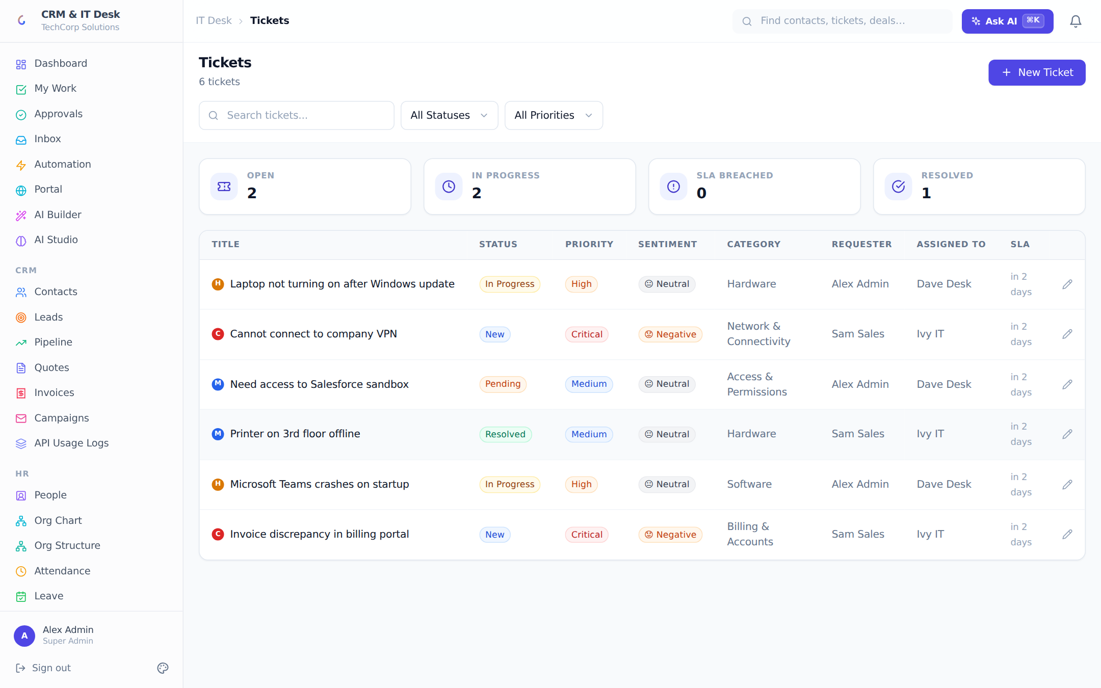
- Tickets queue: priority dots, AI sentiment emojis, SLA countdown column. "Response-time promises, enforced and escalated automatically."
- Star moment: open a ticket → AI Auto-Routing (category + agent + reasoning) → Suggest Reply, read two lines: "grounded in the org’s knowledge base, with citations". Resolve it → Generate KB Article: "every solved problem becomes searchable knowledge."
- Sidebar point, one sentence each: Assets, Changes (ITIL-style approval flow), Categories & SLA policies.
- Incognito window: open the customer portal → magic-link sign-in ("no passwords"), submit a ticket, send a chat message from the widget.
- Back in the app: Inbox — the chat message is a conversation; reply and it lands in the customer’s widget. "Email, WhatsApp and live chat, one queue, replies go back out on the customer’s own channel."
Pitch line "A branded self-service portal your customers can put their own logo on — that’s a resellable product in itself."

Act 5 — HR & People, fast pass (24–29 min)
- People: "Everyone in the company, with or without a login — directory-only people are free on every plan; access granted or revoked in one click." (Developers: note the deliberate person-vs-login split.)
- Org Chart: expand one branch — "built from reporting lines; the approval engine walks this tree to find the right manager automatically."
- Star moment: Attendance → Check In on your phone or browser. "GPS-verified against an office geo-fence, or the office network — including a dynamic-DNS hostname for offices without a static IP. Multiple sessions a day; managers see who’s on-site live."
- Leave balances + approval queue in 30 seconds; Payroll: open a payslip → Print — the branded letterhead. "One click runs the month; employees self-serve payslips."

Act 6 — Automation & the AI platform (29–36 min)
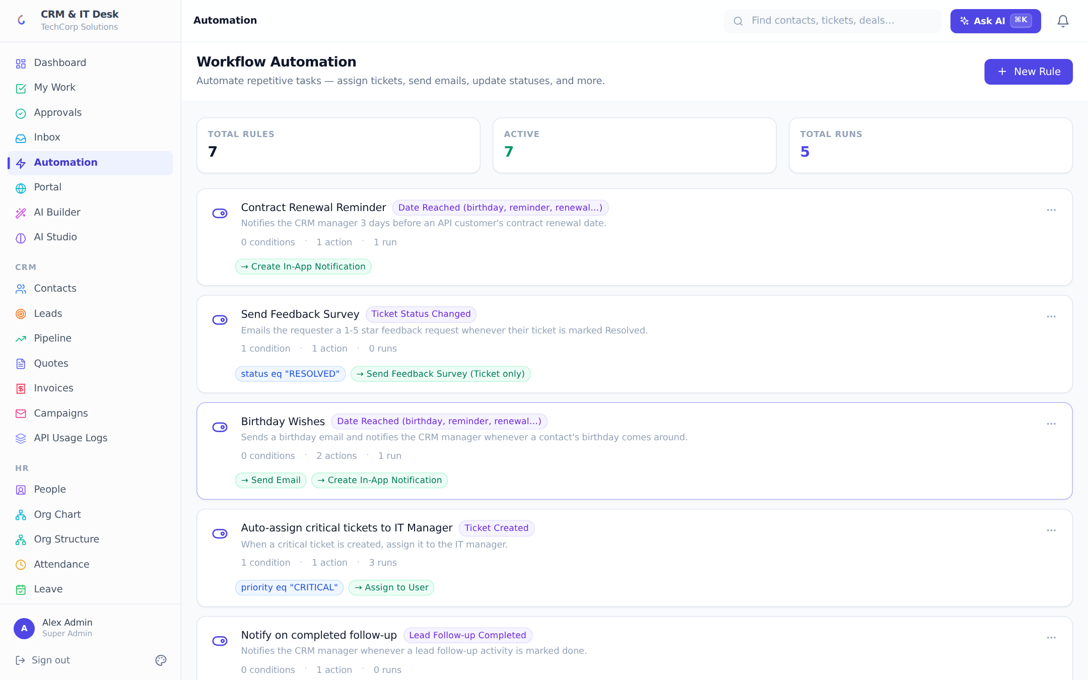
- Workflows: read one rule as a sentence ("critical ticket → assign senior engineer + phone notification"). Scroll triggers/actions once: emails, WhatsApp, webhooks, CSAT, date-driven birthdays and renewals. Show a rule’s run log.
- Star moment: Ctrl+K, let the room dictate — or use "Move the [deal] to Negotiation and add a note that the client asked for a discount." Read the confirm card before clicking Confirm & Run, then show the moved deal. To the developers: "The model can only select from a whitelist of 24 server-registered actions. Every handler re-validates role and org scope itself, nothing mutates without the confirmation click, and the execution lands in the audit log flagged as AI-performed with the original command text. The model plans; it never executes."
- AI Studio, 60 seconds: Business Context (industry, tone, glossary) and Generate Setup — "the AI proposes renamed terminology and starter automations for the customer’s industry; nothing applies without review." Mention custom AI functions and sandboxed form scripts for the developers.
- AI Governance: cost/latency dashboard, monthly budget with hard stop, and the interaction log — "every call: who, what, tokens, cost, and exactly which fields were redacted from the prompt under field-level permissions." This is the slide ERP buyers ask for; here it’s a live screen.
Pitch line "AI-first, but governed: budgets, audit, redaction. You can sell the AI story to a CFO, not just a demo audience."

Act 7 — Under the hood, for the developers (36–44 min)
Say: "Let me open the hood — five minutes of architecture, three of how it integrates with an ERP."

Architecture in five sentences (2 min)
- Stack: React 18 + TypeScript + Tailwind + React Query front; Node/Express + TypeScript + Prisma back; PostgreSQL; ~50 feature modules each a controller + routes pair under server/src/modules — show the folder tree in your editor for ten seconds.
- Multi-tenancy: every table carries orgId and every query is tenant-scoped at the call site AND through the permission engine’s scope filters — two independent walls. Roles are data, not code: ~130 catalog permissions, record scopes (own/team/department/all), and field-level hide/mask rules enforced on every egress path — REST, search, CSV export, and AI prompts.
- Demonstrate it: open an employee profile — bank account shows ••••1234. "Masked server-side by role. The client never even receives the value."
- Background machinery, one breath: email sync, SLA monitor, schedule/WhatsApp poller, date-driven automation, external-sync poller, and a Postgres-backed retry queue with exponential backoff for every outbound delivery — show the Jobs page for five seconds.
- Quality: Playwright end-to-end suite across the product, JWT+refresh auth, TOTP 2FA, rate limiting per-IP and per-API-key, encrypted secrets at rest, GDPR export/erasure.

The ERP integration story (3 min)
- Outbound: workflow webhooks — HMAC-signed JSON on any trigger ("deal won → POST to your ERP’s order intake"), SSRF-guarded, retried with backoff. Show the SEND_WEBHOOK action in the rule editor.
- Inbound: the REST API with scoped API keys (read/write/admin, 120 req/min per key) — flip to your GET /api/docs tab: "self-describing, covers CRM and desk resources plus search."
- Star moment #6: Custom Modules → create "ERP Work Orders" under IT Desk, add two fields — it appears in the sidebar as a working CRUD module. Then open its External Sync panel: "point it at an ERP endpoint, map fields, and it polls on schedule with dedupe — a read-model of your ERP inside this workspace, built in ninety seconds without code."
Pitch line "Integration isn’t a roadmap slide — you just watched me build one live."

Act 8 — Positioning kit, white-label & plans (44–48 min)
This act is for the marketing side — hand them the words to sell with.
- Differentiators, one breath each: unified front-office (CRM + desk + HR in one login); AI-first with governance (budgets, audit, redaction); verticalized demos out of the box; white-label from branding to outbound email; no-code extensibility (fields, modules, workflows, AI rules); free unlimited employee seats — "you only pay for the desk-workers".
- Branding: change the primary color live, show the portal preview; mention Tier-1 white-label sending (platform mail goes out under the org’s brand) and the platform admin console for managing many tenant orgs — "built for a partner reselling to their customer base."
- Plans: Free (5 seats, core + limited AI) → Pro $49/mo (25 seats, full AI, automation, portal, 5GB) → Enterprise $149/mo (unlimited seats, SSO, white-label, 50GB). "Employees who never work the desk are free on every tier — the pricing story sells itself to HR-heavy businesses."
- Close: "Two asks. Developers — pick one integration scenario and I’ll build it with you this week. Marketing — I’ll spin up a branded workspace in your name today so you can put it in front of one real prospect."

3. Fallback Plans
If this happens | Do this
"Waking up the server" screen appears | Own it: "free-tier hosting waking — production runs always-on." Sub-minute; use the gap for positioning talk. The developers will actually appreciate the honest cold-start UX.
An AI button errors or stalls | "AI provider hiccup — moving on." Retry once later, never three times on screen.
Public quote/portal link fails in incognito | Show a seeded accepted quote (signature fields visible) and the portal pages in the documentation.
Geolocation blocked | Use the manager manual-attendance entry via the AI command bar — itself a feature moment.
Internet dies | Hotspot; meanwhile walk the 61-page documentation PDF — full screenshots of every screen.
Demo data messy | Switch verticals from /demo — eight independent seeded workspaces.
A developer asks to see code | Say yes — open server/src/modules (feature-per-folder), utils/permissions.ts, utils/ai-actions.ts (the whitelist), or utils/workflow-engine.ts. Clean, commented code is a selling point here, not a risk.

4. Likely Questions — Prepared Answers

4.1 From the ERP developers
Question | Answer
What’s the stack and why? | React 18/TypeScript/Tailwind/React Query; Node/Express/Prisma; PostgreSQL. Boring on purpose — hireable skills, huge ecosystems, one language end to end. Playwright e2e suite on top.
How is multi-tenancy isolated? | Row-level: orgId on every table, enforced at every query call site AND by the permission engine’s scope filters (a deliberately unsatisfiable filter on scope=NONE, so a missed check returns nothing, not everything). No cross-tenant path has ever been in the API surface.
How would it sync with our ERP? | Three lanes: signed outbound webhooks on any workflow trigger; a scoped REST API (X-API-Key, 120/min per key, /api/docs self-describes); and scheduled inbound polling into custom modules with field mapping and dedupe — demonstrated live in Act 7.
Is the AI safe to let loose on business data? | The model never runs code or queries. Commands map to a fixed server-side whitelist of 24 actions; each handler re-validates role and org; execution requires an explicit confirm; everything is audit-logged with the original prompt. Field-level permission rules redact sensitive fields from prompts, and the redaction is itself logged.
What about scale? | Stateless API behind a proxy (scales horizontally), Postgres as the single store, 60-second cached permission contexts, paginated list endpoints, background work in pollers/queues rather than request paths. pgvector optional for AI retrieval with an in-process fallback.
Schema migrations / upgrades? | Prisma migrations, 40 in the repo, applied automatically on deploy (migrate deploy in the start command). Additive permission seeding never overwrites an admin’s narrowed grants.
Can we self-host / white-label the platform? | Deployable anywhere Node+Postgres runs (render.yaml blueprint included, Docker-ready). White-label: org branding, branded portal, branded outbound mail, and a platform-admin console for operating many tenant orgs — the partner-hosting story.
Auth & security posture? | JWT (15-min) + rotating refresh tokens, bcrypt, TOTP 2FA with backup codes, Google Sign-In, per-org Entra ID SSO with group→role mapping and daily directory sync, rate limiting, Helmet, encrypted secrets at rest, full audit log, GDPR export/anonymization.

4.2 From marketing
Question | Answer
Who is this for? What’s the ICP? | 20–500-person companies that need CRM + support + HR without an enterprise suite — and partners (like an ERP vendor) who want a front-office product to attach to their install base. Free employee seats make HR-heavy businesses unusually cheap to land.
What’s the one-line pitch? | "Your sales, support and people — one AI-first workspace that plugs into the systems you already run."
How is it different from Zoho/Freshworks/HubSpot? | One product instead of a bundle of separately-priced apps; AI with governance (budget, audit, redaction) rather than AI sprinkles; white-label and platform console for partners; verticalized demo environments; unlimited free employee seats.
Can we sell it under our brand? | Yes — per-org branding and portal today, Tier-1 branded sending, Enterprise white-label, and the platform admin console is built exactly for a partner operating many customer orgs.
What demo assets exist? | Eight seeded industry workspaces with a public /demo picker, a 61-page illustrated documentation set, a product showcase video and deck in the repo, and this runbook.
What’s the pricing story? | Free forever tier to land; Pro $49/mo per org (not per seat) as the volume tier; Enterprise $149/mo for SSO/white-label. Simple enough to put on one slide.
How fast can a customer onboard? | Same day: self-service workspace, invite links, CSV import with dedupe, and the AI setup generator configures industry terminology and starter automations in one click.

5. After the Demo
- Same-day follow-up, split by audience: developers get the documentation PDF, /api/docs link and a proposed integration scenario; marketing gets the positioning one-liners, pricing table and a branded trial workspace link.
- Propose a concrete next step for each side: a half-day integration spike with one developer, and one joint prospect demo with one marketer.
- Answer every parked question explicitly in writing — parked-and-forgotten questions kill momentum.

