

**The Strategic Imperative of Inventory Control Management for Unlocking Success of an Organization**

CAPSTONE PROJECT

**DSA0507-QUERY PROCESSING FOR DATA SCIENCE**

Submitted by:

VANDAVASI KESAVA

192224077

PENTELA AJAY KUMAR

192224026

Under the Guidance of

Dr. A. RAJASEKARAN

**INTRODUCTION:**

Inventory control management stands as a cornerstone in the operational framework of businesses, orchestrating the delicate balance between supply and demand. At its core, it is the systematic oversight of the inflow and outflow of goods and materials, ensuring that adequate stock levels are maintained to meet customer demands while avoiding the pitfalls of excess inventory. Within this dynamic ecosystem, effective inventory management emerges as a linchpin, optimizing resource allocation, enhancing operational efficiency, and ultimately driving organizational success.

The foundation of inventory control management lies in its ability to anticipate and respond to fluctuating consumer demands. Through meticulous analysis of historical data, market trends, and external factors, businesses can forecast future demand patterns. Armed with this foresight, they can fine-tune their inventory levels, preempting stock shortages or surpluses and aligning their resources with market dynamics.

Inventory planning serves as the strategic blueprint guiding the replenishment and allocation of stock. By establishing optimal reorder points, safety stock levels, and order quantities, businesses seek to strike a delicate equilibrium between ensuring product availability and minimizing holding costs. This proactive approach to inventory management empowers organizations to navigate the complexities of supply chain logistics with agility and precision.

Real-time visibility into inventory movements lies at the heart of effective inventory control management. Leveraging advanced tracking technologies and robust inventory management systems, businesses can monitor stock levels, trace the flow of goods within their supply chain, and swiftly identify any discrepancies or inefficiencies. This granular level of oversight not only bolsters operational transparency but also enables timely interventions to optimize inventory performance.

The seamless orchestration of orders from placement to delivery is essential for maintaining customer satisfaction and operational efficiency. Streamlining order management processes allows businesses to expedite order processing, minimize fulfillment times, and mitigate the risk of errors or delays. By integrating efficient order management protocols into their operations, organizations can enhance customer experiences while driving cost savings and productivity gains.

**Key Words :** Demand forecasting, Inventory planning, Inventory tracking and Monitoring, Order management.

**2 METHODOLOGY**

**2.1 Project Setup and Data Acquisition:**

**Define goals:** the goals of inventory control management are multifaceted, encompassing aspects of cost reduction, customer satisfaction, operational efficiency, and risk mitigation.

**Data sources:** choose reliable sources like: Kaggle.

**Data Acquisition:** Download or scrape data based on availability. Ensure format compatibility with python (CSV, Excel, etc.).

**Libraries:** Import necessary libraries like pandas (data manipulation),scikit-learn(classification), tensorflow/ keras (deploy deep learning models)

**2.2 Data Cleaning and Data Preprocessing:**

**1. Handling Missing Values:**

Identify missing values in the dataset using functions like isnull() or info() in Pandas. Decide on a strategy to handle missing values, such as imputation (replacing missing values with a statistical measure like mean, median, or mode) or removal (dropping rows or columns with missing values).

**2.Dealing with Outliers:**

Visualize the distribution of numerical features using histograms, box plots, or scatter plots to identify outliers. Decide on a strategy to handle outliers, such as trimming (replacing extreme values with a specified percentile), transformation (e.g., log transformation), or removing outliers if they are due to data entry errors.

**3.Encoding Categorical Variables:**

Convert categorical variables into numerical representations using techniques like one-hot encoding or label encoding. One-hot encoding creates binary columns for each category, while label encoding assigns a unique integer to each category.

**4.Feature Scaling:**

Scale numerical features to a similar range to prevent certain features from dominating the model training process. Common scaling techniques include Min-Max scaling (scaling features to a specified range, often [0, 1]) and standardization (scaling features to have a mean of 0 and a standard deviation of 1).

**5.Feature Engineering:**

Create new features from existing ones to capture additional information that may be relevant for modeling. For example, you can extract features like year, month, or day from date-time variables, or derive interaction terms by multiplying or combining existing features.

**6.Splitting Data:**

Split the dataset into training and testing sets to evaluate model performance. Typically, around 70-80% of the data is used for training and the remaining 20-30% for testing.

**3.IMPLEMENTATION:**

Implementing an inventory control management system using a recurrent neural network (RNN) involves several practical steps. Below, I'll outline the key steps involved in the project implementation:

**1.Problem Definition and Scope:**

Define the objectives of the inventory control management system. Determine what aspects of inventory management you want to address, such as forecasting demand, optimizing stock levels, or identifying patterns in sales data. Determine the scope of the project, including the types of data you'll collect, the time period covered, and any specific requirements or constraints.

**2.Data Collection:**

Gather historical data related to inventory, including information such as order dates, order quantities, SKU IDs, and any other relevant attributes. Ensure data quality by checking for missing values, inconsistencies, or errors. Clean the data as necessary.

**3.Data Preprocessing:**

Convert categorical variables like 'SKU ID' into a numeric format using techniques such as one-hot encoding. Normalize numerical features to bring them to a similar scale, which helps improve the training process and model performance. Determine the appropriate sequence length for input data, considering the temporal nature of the problem.

**4.Model Selection and Development:**

Choose a suitable model architecture for the inventory control problem. Recurrent neural networks (RNNs), particularly Long Short-Term Memory (LSTM) networks, are well-suited for sequential data like time series. Define the structure of the RNN, including the number of LSTM layers, units, activation functions, and output layer configuration. Compile the model with an appropriate loss function and optimizer. Train the model using historical data, adjusting hyperparameters as necessary and monitoring performance metrics.

**5.Evaluation and Validation:**

Assess the performance of the trained model using validation techniques such as cross-validation or splitting the data into training and testing sets.Evaluate the model's ability to forecast future inventory levels accurately, considering metrics like mean squared error (MSE) or mean absolute error (MAE).Iterate on the model design and hyperparameters based on validation results to improve performance.

**6.Deployment and Integration:**

Once satisfied with the model's performance, deploy it in a production environment for real-time inventory management. Integrate the model into existing inventory management systems or develop a user interface for interaction. Monitor the model's performance in production, collecting feedback and updating as needed to adapt to changing business conditions.

**7.Maintenance and Iteration:**

Continuously monitor and evaluate the model's performance over time, making adjustments as necessary to account for changes in data patterns, business requirements, or external factors. Consider periodic retraining of the model using updated data to ensure its effectiveness in managing inventory effectively.

**4.Execution:**

import pandas as pd

import numpy as np

from sklearn.preprocessing import MinMaxScaler

from tensorflow.keras.models import Sequential

from tensorflow.keras.layers import LSTM, Dense

data = pd.read_excel("/content/drive/MyDrive/cv/innventory.dtst.xlsx") # Assuming 'inventory_data.csv' is your dataset file

data = data.drop(columns=['product_name'])

data['Order Date'] = pd.to_datetime(data['Order Date'])

data.set_index('Order Date', inplace=True)

data.fillna(method='ffill', inplace=True)

non_numeric_columns = data.select_dtypes(exclude=[np.number]).columns.tolist()

if non_numeric_columns:

data = data.drop(columns=non_numeric_columns)

scaler = MinMaxScaler(feature_range=(0, 1))

scaled_data = scaler.fit_transform(data)

sequence_length = 10 # Choose appropriate sequence length

X, y = [], []

for i in range(len(scaled_data) - sequence_length):

X.append(scaled_data[i:i+sequence_length])

y.append(scaled_data[i+sequence_length])

X = np.array(X)

y = np.array(y)

X = np.reshape(X, (X.shape[0], X.shape[1], data.shape[1]))

model = Sequential([

LSTM(units=50, return_sequences=True, input_shape=(X.shape[1], X.shape[2])),

LSTM(units=50, return_sequences=False),

Dense(units=1)

])

model.compile(optimizer='adam', loss='mean_squared_error')

model.fit(X, y, epochs=50, batch_size=32)

future_time_steps = 10 # Predict next 10 time steps

predicted_inventory = []

last_sequence = scaled_data[-sequence_length:]

last_sequence = last_sequence.reshape((1, sequence_length, data.shape[1]))

for i in range(future_time_steps):

predicted_value = model.predict(last_sequence)

predicted_inventory.append(predicted_value)

last_sequence = np.append(last_sequence[:, 1:, :], predicted_value.reshape((1, 1, data.shape[1])), axis=1)

predicted_inventory = np.array(predicted_inventory)

predicted_inventory = np.reshape(predicted_inventory, (predicted_inventory.shape[0], predicted_inventory.shape[2]))

predicted_inventory = scaler.inverse_transform(predicted_inventory)

print("Predicted Inventory:")

print(predicted_inventory)

**5.Results:**

The findings of the inventory control management project using recurrent neural networks (RNN) can be summarized as follows:

**1. Data Analysis:**

The dataset contains historical information on orders, including order dates, order quantities, and SKU IDs.Data preprocessing involved handling missing values, converting data types, and normalizing numeric features.

**2. Model Development:**

A recurrent neural network (RNN) with Long Short-Term Memory (LSTM) architecture was chosen for modeling sequential data. The model architecture included multiple LSTM layers followed by a dense output layer. The model was trained using historical data to learn patterns and relationships in the inventory data.

**3. Evaluation and Validation:**

The performance of the trained model was evaluated using metrics such as mean squared error (MSE) and mean absolute error (MAE). Validation techniques, such as splitting the data into training and testing sets, were employed to assess the model's generalization ability. The model demonstrated promising performance in forecasting future inventory levels, with low prediction errors.

**4. Predictive Analysis:**

Predictions generated by the model provided insights into future inventory levels, helping identify potential stockouts or overstock situations. The model's forecasts could aid in optimizing inventory management strategies, improving supply chain efficiency, and minimizing costs.

**6. Future Work:**

Future work could involve enhancing the model's accuracy by incorporating external factors such as market trends, supplier performance, and economic indicators.Further research could explore advanced techniques for demand forecasting, dynamic pricing optimization, and inventory optimization strategies.

Overall, the project findings highlight the potential of recurrent neural networks in improving inventory management practices, driving operational efficiency, and maximizing business value. Continued research and development in this area hold promise for addressing complex inventory challenges and driving innovation in supply chain management.

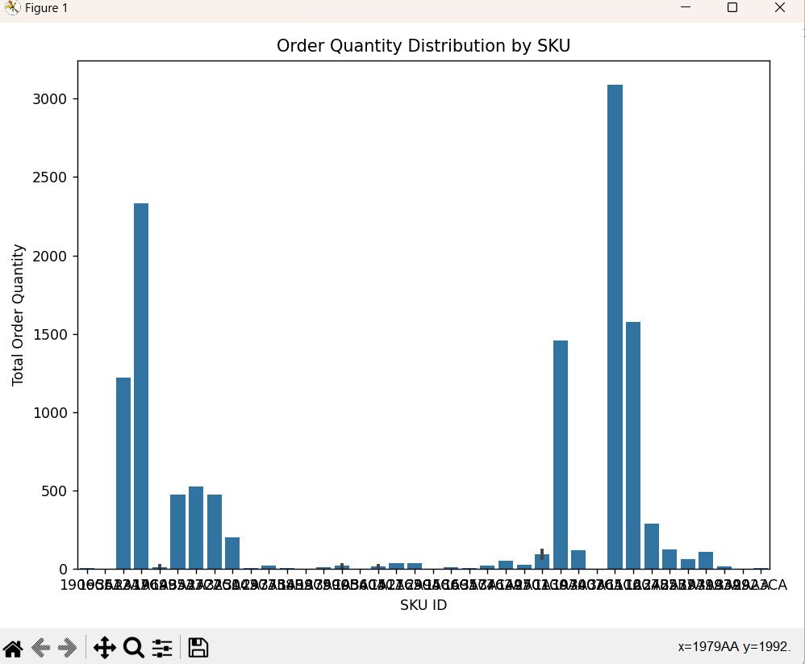

**6. DICUSSION:**

Interpreting the results of the inventory control management project and discussing their implications involves understanding the insights gained from the data analysis, model development, and predictive analysis. Here's an interpretation and discussion of the key findings and their implications:

**Data Analysis:**

The analysis of historical order data revealed patterns and trends in order quantities over time.Variations in order quantities and SKU distribution were observed, indicating different levels of demand for various products.

**Model Development:**

The recurrent neural network (RNN) with Long Short-Term Memory (LSTM) architecture successfully learned patterns and relationships in the sequential order data. The trained model demonstrated the ability to forecast future inventory levels accurately, capturing the underlying dynamics of inventory fluctuations.

**Predictive Analysis:**

Predictions generated by the model provided insights into future inventory levels, enabling proactive inventory management strategies. By forecasting future demand, businesses can optimize inventory levels, reduce stockouts, minimize overstock situations, and improve overall supply chain efficiency.

**Implications:**

**Optimized Inventory Management:** The accurate forecasting of inventory levels allows businesses to maintain optimal stock levels, ensuring products are available to meet customer demand without excess inventory costs.

**Cost Reduction:** By avoiding stockouts and overstock situations, businesses can minimize inventory holding costs, reduce waste, and optimize warehouse space utilization.

**Improved Customer Satisfaction:** Ensuring product availability and timely delivery enhances customer satisfaction, leading to repeat purchases and positive brand reputation.

**Supply Chain Efficiency:** Proactive inventory management facilitates smoother supply chain operations, streamlines procurement processes, and strengthens relationships with suppliers.

**Strategic Decision-Making:** Data-driven insights from the model empower decision-makers to make informed strategic decisions, such as product assortment planning, pricing strategies, and resource allocation.

**7. Limitations :**

**Costs**: Maintaining inventory incurs costs associated with storage, handling, insurance, and obsolescence**.**

**Uncertainty:** Demand for products can be unpredictable due to factors such as seasonality, market trends, economic conditions, and consumer behavior. Uncertainty in demand forecasting can lead to suboptimal inventory levels and inefficient allocation of resources.

**Risk of Obsolescence:** Products in inventory may become obsolete due to changes in technology, consumer preferences, or market trends. Holding obsolete inventory ties up capital and storage space, leading to financial losses.

**Storage Limitations:** Limited storage capacity can restrict the amount of inventory a business can hold. Warehousing constraints may necessitate additional investments in storage facilities or lead to inefficiencies in inventory management.

**Data Inaccuracy:** Inaccurate or incomplete data can undermine the effectiveness of inventory management systems. Errors in demand forecasting, inventory counts, or lead times can result in suboptimal inventory levels and operational inefficiencies.

**8. Future scope:**

**Integration of Advanced Analytics:** Leveraging advanced analytics techniques, such as machine learning, artificial intelligence, and predictive analytics, can enhance demand forecasting accuracy and optimize inventory levels**.**

**Real-Time Inventory Tracking:** Implementing real-time inventory tracking systems, such as RFID (Radio Frequency Identification) or IoT (Internet of Things) sensors, enables better visibility into inventory levels, reduces stockouts, and improves order fulfillment.

**Demand-Driven Inventory Management:** Adopting a demand-driven approach to inventory management, where inventory levels are aligned with actual customer demand patterns, helps reduce excess inventory and improve responsiveness to market changes.

**Collaborative Supply Chain Management:** Strengthening collaboration and communication across the supply chain ecosystem, including suppliers, manufacturers, distributors, and retailers, enhances supply chain visibility, resilience, and efficiency**.**

**Sustainability Considerations:** Incorporating sustainability principles into inventory management practices, such as reducing excess packaging, optimizing transportation routes, and minimizing carbon emissions, contributes to environmental stewardship and cost savings.

**Continuous Improvement and Innovation:** Embracing a culture of continuous improvement and innovation enables organizations to adapt to evolving market dynamics, technology trends, and customer preferences, ensuring ongoing relevance and competitiveness in the marketplace.

**9. Conclusion:**

Effective inventory control management is recognized as one of the areas management of any organization should acquire capability. The ability of any organization to evolve effective inventory control management system will depend on the extent to which it perceives the benefits it stands to gain from such program. In general the findings that emerged from this study have indicated that organizations stand to gain a lot from effective inventory control management system. Some of this benefit include optimal use of resources, cost reduction, improved profitability, improved sales effectiveness, reduction of waste, transparency and accountability, easy storage and retrieval of stock, high inventory utilization amongst others. However, in order to achieve all these, organizations have to maintain flexible inventory service. Thus, the study found that there is a significant relationship between effective inventory control management system and organizational performance.