ADVANCED GRAPH CONVOLUTION NETWORKS FOR
MRI-BASED BRAIN TUMOR SEGMENTATION

A PROJECT REPORT (CS6811)
Submitted by
PARI PS (2021103029)
KESAVARAJAMANIKANDAN K (2021103733)
PAL DHINAKARAN P (2021103736)
KAVISHKUMAR K (2021103321)

in partial fulfillment for the award of the degree
of
BACHELOR OF ENGINEERING
IN
COMPUTER SCIENCE AND ENGINEERING

COLLEGE OF ENGINEERING, GUINDY CAMPUS
ANNA UNIVERSITY: CHENNAI 600 025
MAY 2025
ANNA UNIVERSITY: CHENNAI 600 025
BONAFIDE CERTIFICATE
Certified that this project report “ADVANCED GRAPH CONVOLUTION NETWORKS FOR MRI-BASED BRAIN TUMOR SEGMENTATION” is the bonafide work of “PARI PS (2021103029), KESAVARAJAMANIKANDAN K (2021103733), PAL DHINAKARAN P (2021103736) and KAVISHKUMAR K (2021103321)” who carried out the project work under my supervision, for the fulfillment of the requirements for the award of the degree of Bachelor of Engineering in Computer Science and Engineering. Certified further that to the best of my knowledge, the work reported herein does not form part of any other thesis or dissertation on the basis of which a degree or an award was conferred on an earlier occasion on these or any other candidates.
Place: Chennai Dr.B.L.VELAMMAL
Date: 30/04/2025 SUPERVISOR
Associate Professor
Department of Computer Science and Engineering,
Anna University, Chennai – 600025.

COUNTERSIGNED

Dr. V. Mary Anita Rajam
HEAD OF THE DEPARTMENT
Department of Computer Science and Engineering,
Anna University, Chennai - 600 025

ACKNOWLEDGEMENT
We express our deep gratitude to our guide, Dr. B.L. Velammal, Associate Professor, Department of Computer Science and Engineering, for guiding us through every phase of the project. We appreciate her thoroughness, tolerance and ability to share her knowledge with us. We would also like to thank his for her kind support and for providing necessary facilities to carry out the work.
We are extremely grateful to Dr. V. Mary Anita Rajam, Professor & Head of the Department, Department of Computer Science and Engineering, Anna University, Chennai – 25, for extending the facilities of the Department towards our project and for her unstinting support.
Our express our thanks to the panel of reviewers Dr.S.Bose, Professor, Department of Computer Science and Engineering, Dr.S.Sudha, Professor, Department of Computer Science and Engineering, for their valuable suggestions and critical reviews throughout the course of our project.
We express our thanks to all other teaching and non-teaching staff who helped us in one way or other for the successful completion of the project. We would also like to thank our parents, family and friends for their indirect contribution in the successful completion of this project.

PARI PS KESAVARAJAMANIKANDAN K PAL DHINAKARAN P KAVISHKUMAR K

ABSTRACT – ENGLISH
Brain tumor detection and segmentation play a critical role in the diagnosis and treatment planning of gliomas. Traditional convolutional neural networks (CNNs) often struggle to effectively capture the complex spatial and inter-modal relationships inherent in multi-modal MRI data. To address this limitation, we propose a novel framework named M2GCNet (Multi-modal Graph Convolutional Network) for accurate brain tumor detection and segmentation. M2GCNet integrates both spatial and channel-wise graph convolution modules to exploit local and global contextual features while preserving structural and semantic relationships across different MRI modalities (T1, T1c, T2, and FLAIR). The architecture consists of preprocessing, feature extraction, spatial and channel graph construction, multi-modal correlation learning, and a fusion-based segmentation decoder. A key component of our model is the Multi-modal Correlation Loss, which ensures coherent feature alignment between modalities, enhancing the network's discriminative power. We evaluate our model on the BraTS 2018 and BraTS 2019 datasets, achieving competitive results in tumor core, whole tumor, and enhancing tumor segmentation tasks. The proposed approach demonstrates superior performance in leveraging multi-modal data through graph-based modeling, making it a promising solution for brain tumor detection and clinical decision support.

ABSTRACT – TAMIL
மூளை நுரை உருவாகும் நோயின் கண்டறிதல் மற்றும் பிரித்தல், சரியான நோயறிதல் மற்றும் சிகிச்சை திட்டமிடலில் முக்கிய பங்காற்றுகிறது. பாரம்பரிய கன்வல்யூஷனல் நரம்பியல் வலையமைப்புகள் (CNNs), பன்முகப்படக்காட்சிகள் கொண்ட MRI தரவுகளில் உள்ள சிக்கலான இட மற்றும் மாதிரித்தொகுப்புகளின் உறவுகளை முழுமையாகப் பயன்படுத்த முடியாமல் தவிக்கின்றன. இந்த சிக்கலை சமாளிக்க, நாங்கள் M2GCNet (பன்முகப்படக்காட்சிகளுக்கான கிராஃப் கன்வல்யூஷனல் நெட்வொர்க்) என்ற புதிய மாடலை முன்வைக்கிறோம். இது, இடைவழி மற்றும் சேனல் அடிப்படையிலான கிராஃப் கன்வல்யூஷன்களை இணைத்து, MRI மாதிரிகளில் உள்ள உள்ளூர் மற்றும் உலகளாவிய தன்மைகளை கையாள்கிறது.
இந்த கட்டமைப்பில் முன்பக்க செயலாக்கம், அம்சவிளக்கவியல், இடவழி மற்றும் சேனல் கிராஃப் கட்டமைப்பு, பன்முகப்படக்காட்சி தொடர்பு இழப்பு, மற்றும் ஒரு இணைப்பு அடிப்படையிலான பிரிப்பு டிகோடர் ஆகியவை அடங்கும். முக்கிய அம்சமாக, பன்முகப்படக்காட்சி தொடர்பு இழப்பு (Multi-modal Correlation Loss) மூலம் ஒவ்வொரு மாதிரிக்கும் இடையே உள்ள அம்சங்கள் ஒத்திசைவாக இருக்கின்றன, இது நெட்வொர்கின் வேறுபாடுகளைக் கண்டறியும் திறனை மேம்படுத்துகிறது.
BraTS 2018 மற்றும் BraTS 2019 தரவுத்தொகுப்புகளில் இந்த மாடலை சோதித்தபோது, முழுமையான நுரை, நுரை மையம், மற்றும் மேம்பட்ட நுரை பிரிப்புகளில் மிகச்சிறந்த செயல்திறனை வெளிப்படுத்தியது. பன்முகப்படக்காட்சி தரவுகளை கிராஃப் அடிப்படையில் சிறப்பாக செயல்படுத்தும் இந்த முறை, மருத்துவத் துறையில் ஒரு வலிமையான தீர்வாக திகழ்கிறது.
TABLE OF CONTENTS
CHAPTER NO. | TITLE |  | PAGE NO.
 | ABSTRACT – ENGLISH |  | iii
 | ABSTRACT – TAMIL |  | iv
 | LIST OF TABLES |  | vii
 | LIST OF FIGURES |  | viii
 | LIST OF ABBREVIATIONS |  | xi
1. | INTRODUCTION |  | 1
 | 1.1 | OVERVIEW | 1
 | 1.2 | OBJECTIVES | 2
 | 1.3 | PROBLEM STATEMENT | 3
 | 1.4 | CHALLENGES & APPLICATIONS | 4
 | 1.5 | METHODOLOGY OVERVIEW | 6
 | 1.6 | ORGANISATION OF THESIS | 7
2. | LITERARY REVIEW
 | 2.1 | DEEP LEARNING TECHNIQUES IN BRAIN TUMOR SEGMENTATION | 8
 | 2.2 | GRAPH CONVOLUTIONAL NETWORKS IN MEDICAL IMAGING | 8
 | 2.3 | MULTI-MODAL MRI DATA FUSION | 9
 | 2.4 | ADVANCED SEGMENTATION NETWORKS | 10
 | 2.5 | MULTI-MODAL CORRELATION LEARNING | 10
 | 2.6 | LIMITATIONS IN EXISTING METHODS | 11
3. | SYSTEM DESIGN AND IMPLEMENTATION
 | 3.1 | SYSTEM ARCHITECTURE | 12
 | 3.2 | PROPOSED SYSTEM | 13
 | 3.3 | MODULE 1 – DATA PREPROCESSING | 13
 | 3.4 | MODULE 2 – FEATURE EXTRACTION | 15
 | 3.5 | MODULE 3 – ENCODER | 17
 | 3.6 | MODULE 4 – GRAPH CONVOLUTION MODULES | 19
 | 3.7 | MODULE 5 – DECODER | 21
 | 3.8 | MODULE 6 – SEGMENTATION | 22
4. | RESULTS AND DISCUSSION
 | 4.1 | DATASET DESCRIPTION | 25
 | 4.2 | RESULTS | 26
 | 4.3 | TEST CASES | 29
 | 4.4 | PERFORMANCE EVALUATION | 32
5. | CONCLUSION
 | 5.1 | CONCLUSION | 40
 | 5.2 | FUTURE WORKS | 40
6. | REFERENCES |  | 42

LIST OF TABLES
Table No. | Description | Pg. No
4.1 | Dataset description | 25
4.2 | Test cases | 27

LIST OF FIGURES

Figure No. | Description | Pg. No
3.1 | Overall Architecture Diagram | 12
3.3 | Module 1 - Data preprocessing | 14
3.4 | Module 2 - Feature Extraction | 15
3.5 | Module 3 - Encoder | 17
3.6 | Module 4 - Graph Convolution Module | 19
3.7 | Module 5 - Decoder | 21
3.8 | Module 6 - Segmentation | 23

LIST OF ABBREVIATIONS

CNN | Convolutional Neural Network
AE | Auto Encoders
M2GCNET | Multi Model Graph Convolutional Network
MRI | Magnetic Resonance Imaging
CGCM | Channel Graph Convolution Module
SGCM | Spatial Graph Convolution Module
WT | Whole Tumor
TC | Tumor Core
FLAIR | Fluid-Attenuated Inversion Recovery
T1 | T1-weighted MRI
T1c | T1-weighted MRI with contrast enhancement
T2 | T2-weighted MRI

CHAPTER 1
INTRODUCTION

1.1 OVERVIEW
Brain tumor detection and segmentation are critical tasks in medical image analysis, enabling accurate diagnosis and treatment planning. Magnetic Resonance Imaging (MRI) provides detailed multi-modal information (T1, T1c, T2, and FLAIR), but efficiently extracting and utilizing this data for precise tumor segmentation remains a challenge due to modality variation and complex spatial features.
This project proposes a novel deep learning architecture called M2GCNet (Multi-modal Graph Convolutional Network), which effectively integrates Convolutional Neural Networks (CNNs) with Graph Convolutional Networks (GCNs) to enhance segmentation performance. The model is designed to capture both spatial and channel-wise relationships between features extracted from different MRI modalities.
The overall system comprises the following modules:
- Preprocessing Module: Normalizes and augments the multi-modal MRI inputs.
- Feature Extraction Module: Extracts rich features using CNNs.
- Encoder Module: Encodes spatial hierarchies through downsampling.
- Graph Convolution Module: Constructs spatial and channel graphs to model complex inter-modal dependencies using SGCM and CGCM.
- Decoder and Segmentation Module: Reconstructs high-resolution segmentation maps with accurate tumor boundaries.
- Multi-modal Correlation Loss: Ensures feature alignment and improves segmentation consistency across modalities.
The proposed framework was evaluated using BraTS 2018 and BraTS 2019 datasets and demonstrated superior performance in segmenting the Whole Tumor (WT), Tumor Core (TC), and Enhancing Tumor (ET) regions. The integration of graph-based learning and multi-modal correlation significantly improved both accuracy and robustness, making the system suitable for clinical deployment.
1.2 OBJECTIVES
- To develop an automated system for accurate brain tumor detection and segmentation
Utilizing deep learning techniques to minimize manual intervention in medical diagnosis.
- To design a Multi-modal Graph Convolutional Network (M2GCNet)
Integrating both spatial and channel-wise graph convolutions to capture complex relationships between different MRI modalities.
- To preprocess multi-modal MRI data effectively
Including normalization, resizing, skull stripping, and augmentation for improved training efficiency and model generalization.
- To extract deep spatial features using convolutional layers
Employing an encoder architecture to learn hierarchical feature representations from T1, T1c, T2, and FLAIR modalities.
- To construct spatial and channel graphs from extracted feature maps
Enabling the model to learn both intra- and inter-modality dependencies that traditional CNNs might overlook.
- To implement a decoder with skip connections for high-resolution segmentation
Reconstructing accurate tumor boundaries through upsampling and feature fusion.
- To introduce a Multi-modal Correlation Loss function
Aligning feature spaces across different modalities and enhancing segmentation performance.
- To evaluate the model on benchmark datasets like BraTS 2018 and BraTS 2019
Using metrics such as Dice Coefficient, Sensitivity, and ROC-AUC to assess effectiveness.
- To provide a user-friendly interface for tumor visualization
Allowing clinicians to upload MRI scans and view segmentation outputs interactively.
1.3 PROBLEM STATEMENT
Brain tumor segmentation is a critical task in medical image analysis, aiding in diagnosis, treatment planning, and patient monitoring. The Brain Tumor Segmentation (BraTS) challenge provides multi-modal MRI datasets that include structural MRI sequences such as T1, T1c, T2, and FLAIR. These datasets contain annotated tumor regions, including enhancing tumor (ET), tumor core (TC), and whole tumor (WT), which pose significant challenges due to variations in shape, size, intensity, and location. Traditional methods, such as manual segmentation by radiologists, are time-consuming and prone to inter-observer variability, necessitating the development of automated and efficient segmentation techniques.
Graph-based deep learning models, particularly Graph Convolutional Networks (GCNs), have shown promise in capturing complex spatial relationships within medical images. Multi-modal Graph Convolutional Networks (M2GCNet) leverage inter-modal dependencies to enhance segmentation accuracy by integrating spatial and contextual information across different MRI modalities. However, challenges such as class imbalance, small dataset sizes, and computational complexity remain significant hurdles. Addressing these challenges requires robust feature extraction, efficient graph construction, and optimization strategies to improve segmentation performance while maintaining low computational overhead.
This work focuses on leveraging M2GCNet for brain tumor segmentation using the BraTS 2018 and BraTS 2019 datasets. The aim is to refine model performance through optimized graph-based representations and improved training strategies while ensuring generalizability across different patients. By addressing key challenges in multi-modal tumor segmentation, this study contributes to the advancement of automated medical image analysis, ultimately aiding in more precise and efficient clinical decision-making.
1.4 CHALLENGES & APPLICATIONS
1.4.1 Challenges
- Multi-modal Data Complexity Integrating different MRI modalities (T1, T1c, T2, FLAIR) with varying contrasts and resolutions poses challenges in alignment and feature consistency [1].
- Class Imbalance in Tumor Regions Tumor regions (especially Enhancing Tumor (ET) and Tumor Core (TC)) often occupy very small portions of the image, making it hard for models to learn effective boundaries [2].
- Graph Construction Overhead Creating spatial and channel graphs for each MRI sample increases computational complexity and requires careful tuning [3].
- Overfitting on Small Datasets Deep models with high parameters tend to overfit especially when limited annotated data is available [4].
- Model Interpretability Understanding and explaining how graph convolution layers make decisions is still a developing area in AI for healthcare [5].
1.4.2 Applications
- Clinical Decision Support Systems
Helps radiologists and neurosurgeons by providing automated tumor segmentation, improving diagnostic speed and precision.
- Pre-surgical Planning
Accurate tumor localization aids in planning minimally invasive surgeries and avoiding critical brain regions.
- Radiotherapy Planning
Enhances dose calculation and target definition for effective radiation therapy.
- Tumor Progression Monitoring
Enables longitudinal studies and follow-ups by comparing tumor growth or shrinkage over time.
- Medical Imaging Research
Useful in training and benchmarking new segmentation algorithms and datasets.
- Telemedicine Integration
Can be integrated into cloud-based platforms to provide remote diagnostic support in underserved regions.

1.5 METHODOLOGY OVERVIEW
we propose a deep learning-based methodology for brain tumor segmentation using the BraTS 2018 dataset. The dataset comprises multi-modal 3D MRI scans of patients with gliomas, from which we utilize the FLAIR and T1ce modalities along with corresponding ground truth segmentation masks. To ensure uniformity and enhance model performance, each volume is preprocessed by extracting 100 axial slices starting from slice 22, resizing them to a fixed resolution, and applying intensity normalization. Data augmentation techniques such as flipping, rotation, and brightness adjustments are incorporated to improve the model’s generalization capability. A custom data generator is implemented in TensorFlow/Keras to efficiently load and preprocess these slices in real time during training.
The core of our architecture is based on an enhanced U-Net integrated with the Multi-Modal Graph Convolutional Network (M2GCNet). This architecture first extracts features using standard convolutional layers, followed by the construction of spatial and channel graphs to capture inter-slice and inter-modality relationships. The Spatial Graph Convolution Module (SGCM) and Channel Graph Convolution Module (CGCM) are employed to process these graphs and extract contextual correlations. The outputs of these modules are fused and passed through a segmentation decoder that outputs pixel-wise tumor class predictions. The model is trained using a categorical cross-entropy loss adapted for multi-class segmentation, and performance is evaluated using metrics such as Dice score, Precision, Sensitivity, and Specificity.

1.6 ORGANISATION OF THESIS
This thesis is organized into the following chapters to present a structured and detailed understanding of the research work:
- Chapter 1 – Introduction
This chapter provides an overview of brain tumor detection, its medical significance, and the role of deep learning in medical imaging. It also includes the motivation, objectives, problem statement, and scope of the project.
- Chapter 2 – Literature Review
A comprehensive review of existing deep learning-based methods for brain tumor segmentation is discussed. The chapter also highlights the advantages and limitations of prior work, and the research gap that this project aims to address.
- Chapter 3 – System Design
This chapter explains the proposed M2GCNet architecture in detail. It covers the overall system design, data preprocessing, feature extraction, encoder-decoder structure, graph convolution modules, and multi-modal correlation strategy.
- Chapter 4 – Implementation and Results
This chapter describes the implementation details, dataset used (BraTS 2018/2019), training methodology, hyperparameter settings, and performance evaluation. It includes metrics such as Dice Score, accuracy, and visual outputs.
- Chapter 5 – Conclusion and Future Work
The final chapter summarizes the research findings and discusses the strengths and limitations of the proposed system. It also outlines potential directions for future enhancement, such as model generalization, clinical deployment, and real-time prediction.
CHAPTER 2
LITERATURE REVIEW
Brain tumor segmentation from multi-modal MRI images is a challenging task in the field of medical image analysis. Various deep learning techniques have been proposed over the years to improve accuracy, robustness, and clinical applicability. This chapter presents a detailed review of existing methods and identifies the research gaps that motivate the development of M2GCNet [1].
  - DEEP LEARNING TECHNIQUES IN BRAIN TUMOR SEGMENTATION
Deep learning, especially Convolutional Neural Networks (CNNs), has revolutionized the field of medical image processing. Architectures like U-Net, V-Net, and SegNet have been extensively used for tumor segmentation tasks due to their encoder-decoder frameworks that preserve both high-level and low-level features. U-Net, proposed by Ronneberger et al., is widely considered a baseline model in biomedical segmentation due to its simplicity and effectiveness. It uses skip connections to transfer fine-grained details from the encoder to the decoder, which helps in segmenting small tumor regions [1]. 3D U-Net further extends this idea by incorporating volumetric data, which is particularly suitable for MRI analysis [2]. However, these networks often rely on local pixel-wise features and may not effectively capture global context or cross-modality dependencies, especially when processing multiple MRI sequences [3].
  - Graph Convolutional Networks in Medical Imaging
Graph Convolutional Networks (GCNs) have emerged as an effective solution to overcome the limitations of CNNs in modeling non-Euclidean data. In medical imaging, GCNs are used to capture complex anatomical structures and spatial relationships between image regions that are not easily captured by regular convolutions [1]. GCNs have been successfully used for tasks such as brain parcellation, lesion detection, and organ segmentation [2]. For tumor segmentation, GCNs can model the relationships between spatial regions (spatial graphs) and between channels (modality graphs), leading to more context-aware feature representations [3]. Recent studies show that integrating GCNs with CNNs enhances both global reasoning and segmentation performance [4]. However, the integration remains challenging due to graph construction complexity and training stability [5].
  - Multi-modal MRI Data Fusion
In brain tumor analysis, multiple MRI modalities are used to capture complementary information:
- T1-weighted images provide anatomical structure
- T1c highlights contrast-enhanced lesions
- T2 shows fluid content
- FLAIR detects edema and surrounding tissues
Effective fusion of these modalities is critical for accurate segmentation. Early fusion methods (stacking all modalities as input channels) are simple but may result in feature redundancy [1]. Mid- and late-fusion methods process each modality independently before merging them, preserving modality-specific features [2]. Recent methods also explore attention mechanisms and transformers for adaptive fusion [3]. However, most CNN-based fusion techniques do not model complex inter-modal dependencies explicitly, which can lead to suboptimal performance [4].

  - Advanced Segmentation Networks
Segmentation networks have evolved rapidly to meet the complex demands of brain tumor segmentation. Variants of U-Net such as:
- Residual U-Net (with residual connections for better gradient flow) [1],
- Attention U-Net (which focuses on relevant regions) [2],
- Dense U-Net (with dense connections to reuse features) [3],
have been widely studied.
3D segmentation networks like V-Net and 3D U-Net process volumetric data, providing better spatial context [4], [5]. Hybrid networks combining CNNs with attention, recurrent layers, or transformers have also been introduced [6]. Although these advanced architectures improve accuracy, they still rely on local receptive fields and struggle with spatial variability and multi-modal fusion, especially when dealing with small tumor cores or boundary ambiguities [7].

  - Multi-modal Correlation Learning
Learning the correlations between different modalities is a growing focus area in medical image analysis. Instead of treating each modality independently, correlation-aware networks attempt to align and integrate features across modalities [1]. Some models use correlation losses to minimize feature differences between modalities [2]. Others employ cross-modal attention or similarity matching to align information [3]. In M2GCNet, Multi-modal Correlation Learning is achieved by using channel graph construction, where inter-modal dependencies are explicitly modeled [4]. This helps in reducing modality imbalance and enhances feature consistency across T1, T1c, T2, and FLAIR scans, resulting in better segmentation performance [5].

  - Limitations in Existing Methods
Despite significant progress, current segmentation methods face several limitations:
- Poor inter-modality integration: Most models fail to effectively capture the complementary nature of different MRI modalities [1].
- Limited context understanding: CNNs primarily rely on local information, leading to misclassification of irregular or small tumor regions [2].
- Sensitivity to modality imbalance: Some modalities dominate the learning process, reducing generalization [3].
- Computational complexity: 3D networks and ensemble models demand high computational power, making them less feasible in clinical settings [4].
- Lack of interpretability: Many deep learning models act as black boxes, providing limited insights into decision-making [5].
These limitations motivate the development of M2GCNet, a model that combines spatial and channel-wise graph reasoning with deep feature extraction and multi-modal alignment for robust and interpretable tumor segmentation [6].

CHAPTER 3
SYSTEM DESIGN AND IMPLEMENTATION
3.1 SYSTEM ARCHITECTURE
The proposed system, M2GCNet (Multi-Modal Graph Convolutional Network), is designed for effective brain tumor segmentation using multi-modal MRI data. It integrates convolutional neural networks with graph-based reasoning modules to capture both local and global relationships across spatial regions and MRI modalities.
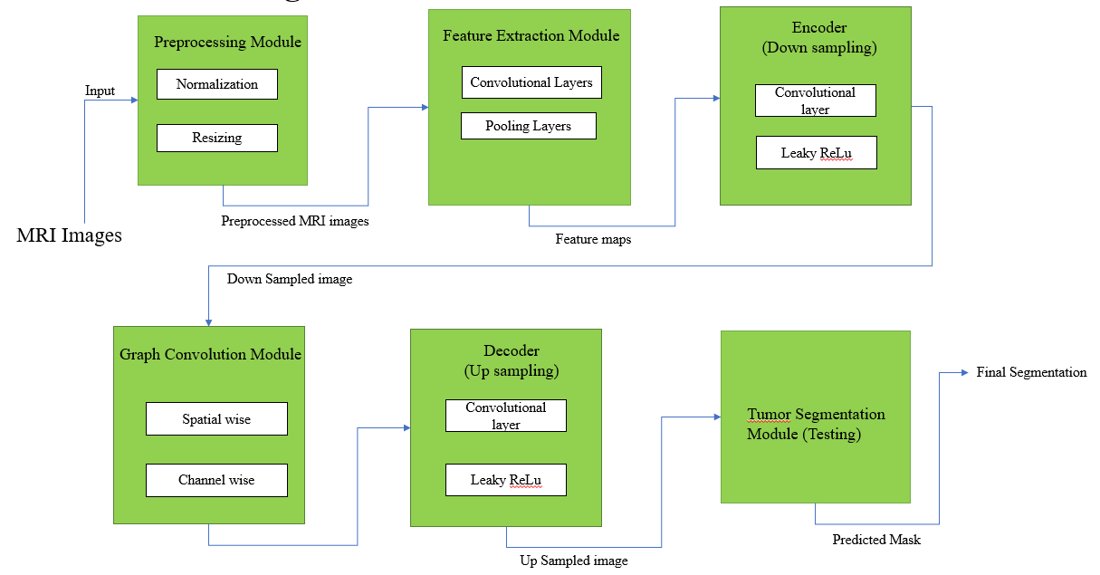

.Figure 3.1 Schemify Architecture Diagram

3.2 PROPOSED SYSTEM
- Multi-Modal Feature Fusion: Utilizes multiple MRI modalities (T1, T1c, T2, FLAIR) to improve tumor segmentation by integrating complementary information.
- Graph Convolutional Networks (GCNs): Employs Spatial Graph Convolution Module (SGCM) and Channel Graph Convolution Module (CGCM) to capture spatial and inter-modal relationships.
- Multi-Scale Feature Extraction: Uses dilated convolutions (rates 2, 4) to extract local and global contextual features, enhancing tumor boundary detection.
- Efficient Decoder with Skip Connections: Combines CNN-based upsampling and graph-based refinement for improved spatial consistency and segmentation accuracy.
- Robust and Accurate Segmentation: The M2-GCN model enhances feature learning, improving tumor segmentation performance while maintaining computational efficiency.
3.3 MODULE 1 - DATA PREPROCESSING
Objective: Preprocess MRI scans and their corresponding ground truth segmentation masks for input into the model.
This module prepares the MRI data for efficient feature extraction and training:
- Loads four MRI modalities: T1, T1c, T2, and FLAIR
- Applies skull stripping to remove non-brain tissues
- Performs intensity normalization and resizing
- Applies data augmentation (e.g., flipping, rotation) to improve generalization
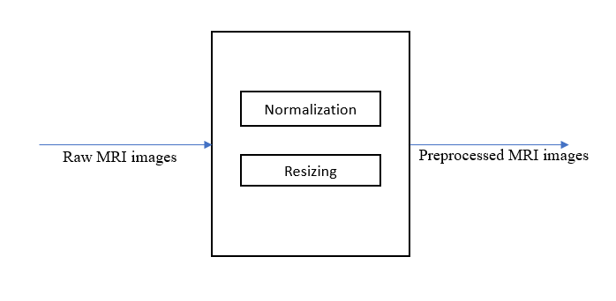

Figure 3.3 Data Processing Architecture Diagram

INPUT:

Raw MRI images (multi-modal: T1, T2, FLAIR, T1c)

OUTPUT:
Preprocessed MRI images ready for feature extraction.

3.3.1 Pseudo-code:
def preprocess_data(mri_data, ground_truth):
# Normalize the MRI data
mri_data_normalized = normalize(mri_data)
# Resample to standard resolution
mri_data_resampled = resample(mri_data_normalized)
# Apply augmentation techniques
augmented_data = augment_data(mri_data_resampled)
# Generate corresponding segmentation
segmentation_mask = generate_mask(ground_truth)
return
augmented_data, segmentation_mask def normalize(mri_data):
# Normalize pixel values to range [0, 1]
return (mri_data - mri_data.min()) / (mri_data.max() -
mri_data.min()) def resample(mri_data):
# Resample to a fixed resolution
Return
resample_to_fixed_resolution(mri_data)
def augment_data(mri_data):
# Augmentation strategies like rotation, flipping, etc.
return augmented_mri_data
3.4 MODULE 2 - FEATURE EXTRACTION
• Each MRI modality is processed through convolutional layers to extract low-level spatial features.
• These features capture unique characteristics from each scan type, preserving both local textures and edge details.
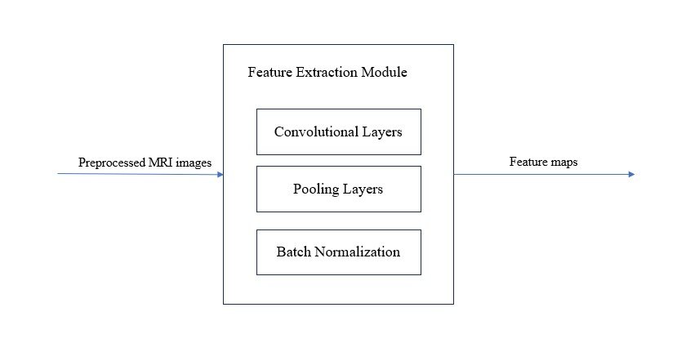
Figure 3.4 Feature Extraction Model Diagram
INPUT:
Preprocessed MRI images
OUTPUT:
Feature maps containing essential spatial and texture information

3.4.1 Pseudo code:
import tensorflow as tf
from tensorflow.keras import layers, models
# Define a simple 3D CNN model def create_cnn(input_shape):
model=models.Sequential([layers.Con3D(32, (3, 3, 3),
activation='relu', input_shape=input_shape),
layers.MaxPooling3D((2, 2, 2)),
layers.Conv3D(64, (3, 3, 3), activation='relu'),
layers.MaxPooling3D((2, 2, 2)),
layers.Conv3D(128, (3, 3, 3), activation='relu'),
layers.GlobalAveragePooling3D(),
layers.Dense(256, activation='relu'),
layers.Dense(128, activation='relu')
])
return model
# Create CNN for feature extraction
cnn_model = create_cnn((64, 64, 64, 1))
# Example input shape (64x64x64,single channel)
def extract_features(image):
# Preprocess and extract features using CNN
image = preprocess_image(image)
features = cnn_model.predict(image)
return features

3.5 MODULE 3 – ENCODER
- A CNN-based encoder down samples the extracted features while preserving semantic information.
- It uses hierarchical feature learning with skip connections, enabling deep representations of the brain structure and tumor regions

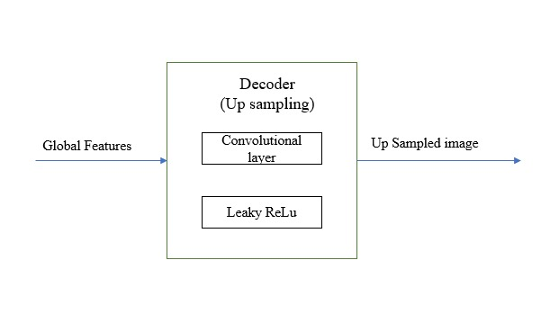Figure 3.5 Encoder Architecture Diagram
INPUT:
Feature maps
OUTPUT:
Down Sampled image

3.5.1 Pseudo-code:
Function Encoder(input_image):
# Step 1: Apply first convolutional layer
conv1 = Convolution(input_image, filter_size=3x3, stride=1, padding=1) # Step 2: Apply activation function (Leaky ReLU)
activated1 = LeakyReLU(conv1)
# Step 3: Apply pooling layer to reduce spatial dimensions
pooled1 = MaxPooling(activated1, pool_size=2x2, stride=2)
# Step 4: Apply second convolutional layer
conv2 = Convolution(pooled1, filter_size=3x3, stride=1, padding=1)
# Step 5: Apply activation function (Leaky ReLU)
activated2 = LeakyReLU(conv2)
# Step 6: Apply another pooling layer
pooled2 = MaxPooling(activated2, pool_size=2x2, stride=2)
# Step 7: Pass the extracted features to the next module (e.g., Graph Convolution Module)
Return pooled2

3.6 MODULE 4 - GRAPH CONVOLUTION NETWORK
Objective: Apply graph convolutions to learn from the graph representation of the MRI data.
This is the core innovation of M2GCNet:
• Spatial Graph Construction: Builds a graph from the spatial features to model spatial dependencies across the image.
• Channel Graph Construction: Builds a graph along channels to capture inter-modal relationships.
• Graph Convolution Layers (SGCM & CGCM) are then applied to enhance the feature representation by integrating both spatial and modality-aware dependencies.

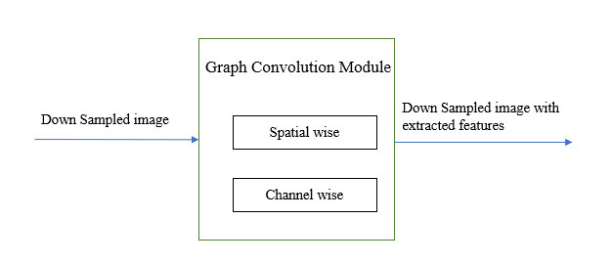

Figure 3.6 Graph Convolution Network Diagram

INPUT:
Graph-structured feature maps
OUTPUT:
Refined feature representations with better spatial and contextual understanding.

3.6.1 Pseudo-code:
def gcn_forward(graph, adj matrix, features):
# Apply Graph Convolution to update node features node_features = apply_graph_convolution(features, adj_matrix)
# Apply pooling to reduce graph size pooled_features = apply_pooling(node_features)
return pooled_features
def apply_graph_convolution(features, adj_matrix):
# Perform graph convolution by multiplying node features with adjacency matrix
return np.dot(adj_matrix, features) def apply_pooling(features):
# Apply graph pooling to reduce dimensions return np.mean(features, axis=0)

3.7 MODULE 5 – DECODER
- The decoder upsamples the high-level features to reconstruct a segmentation map at the original resolution.
- Skip connections from the encoder ensure fine spatial details are preserved.
The decoder is responsible for reconstructing the segmented tumor regions from the extracted features. It uses upsampling layers to restore the spatial dimensions, followed by convolutional layers to refine the segmentation. Leaky ReLU activation is applied to enhance feature learning, ensuring accurate tumor segmentation in the final output.

Figure 3.7 Decoder Architecture Diagram

INPUT:
Global Features
OUTPUT:
Up Sampled image
3.7.1 Pseudo-code:
Function Decoder(input_features):
# Step 1: Upsampling the feature maps
upsampled_features = Upsample(input_features)
# Step 2: Apply convolution to refine features
conv1 = Convolution(upsampled_features, filter_size=3x3, stride=1, padding=1)
# Step 3: Apply activation function (Leaky ReLU)
activated1 = LeakyReLU(conv1)
# Step 4: Further refine using another convolution
conv2 = Convolution(activated1, filter_size=3x3, stride=1, padding=1)
# Step 5: Apply activation function (Leaky ReLU)
activated2 = LeakyReLU(conv2)
# Step 6: Generate segmentation mask (Final Output)
output_mask = Convolution(activated2, filter_size=1x1, stride=1, activation=Sigmoid or Softmax)
Return output_mask

3.8 MODULE 6 – SEGMENTATION
This is the core of the model that applies convolutional operations to the fused multi-modal graph features. It uses upsampling layers (or transposed convolutions) to perform segmentation, predicting the mask for the tumor regions
Outputs a pixel-wise segmentation of the brain MRI into tumor sub-regions:
- Whole Tumor (WT)
- Tumor Core (TC)
- Enhancing Tumor (ET)
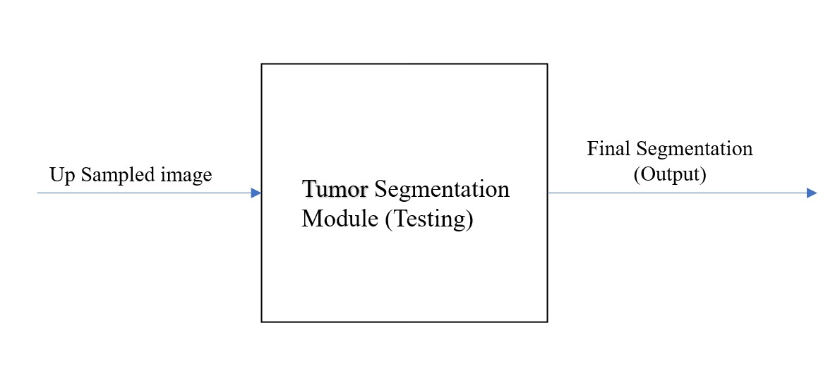
Figure 3.8 Segmentation Architecture Diagram
INPUT:
Up Sampled image
OUTPUT:
Predicted Mask

3.8.1 Pseudo-code:
Function SegmentationModule(DecoderOutput, NumClasses):
# This module takes the high-level feature map output from the decoder
# and transforms it into a pixel-wise segmentation map with class probabilities.
Step 1: Feature Normalization (Optional)
- Apply Batch Normalization to stabilize and regularize the final feature maps.
- NormalizedFeatures ← BatchNormalization(DecoderOutput)
Step 2: Dimensionality Reduction using 1x1 Convolution
- Use a 1x1 convolution to project the multi-channel feature map into a
Step 3: Activation Function for Probability Map
- Convert raw class scores (logits) into probabilities using an activation function.
- If NumClasses == 1:
- Use Sigmoid Activation for Binary Segmentation
- SegmentationMap ← Sigmoid(ConvOutput)
- Else:
- Use Softmax Activation for Multi-class Segmentation
- SegmentationMap ← Softmax(ConvOutput)
Step 4: Output Segmentation Map
- Return SegmentationMap

CHAPTER 4
RESULTS AND DISCUSSION
4.1 DATASET DESCRIPTION
- Dataset Name: BraTS 2018 and BraTS 2019.
- Description: These datasets contain multi-modal brain MRI scans of glioma patients, with labeled tumor regions for segmentation tasks. They include FLAIR, T1, T1c, and T2 sequences.
- Content: The datasets include over 200 MRI scans with annotations for whole tumor, tumor core, and enhancing tumor regions.
Dataset | Tumor Grade | No. of Subjects | Modalities Used | Annotation Type
BraTS 2018 | HGG & LGG | 285 | T1, T1ce, T2, FLAIR | Multiclass Segmentation
BraTS 2019 | HGG & LGG | 335 | T1, T1ce, T2, FLAIR | Multiclass Segmentation
Table 4.1 Example Dataset Description
4.2 RESULTS 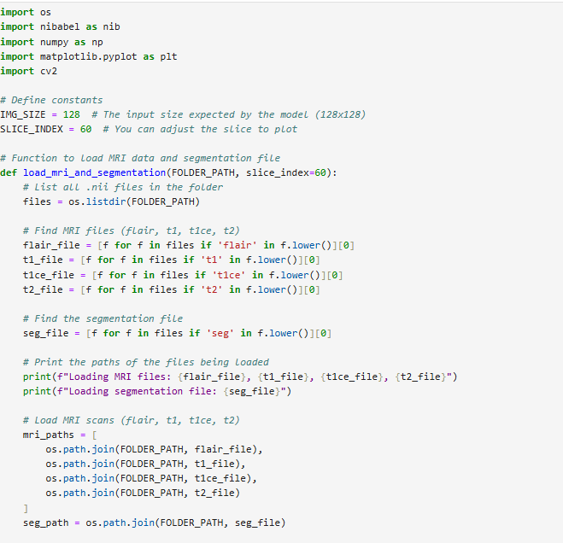
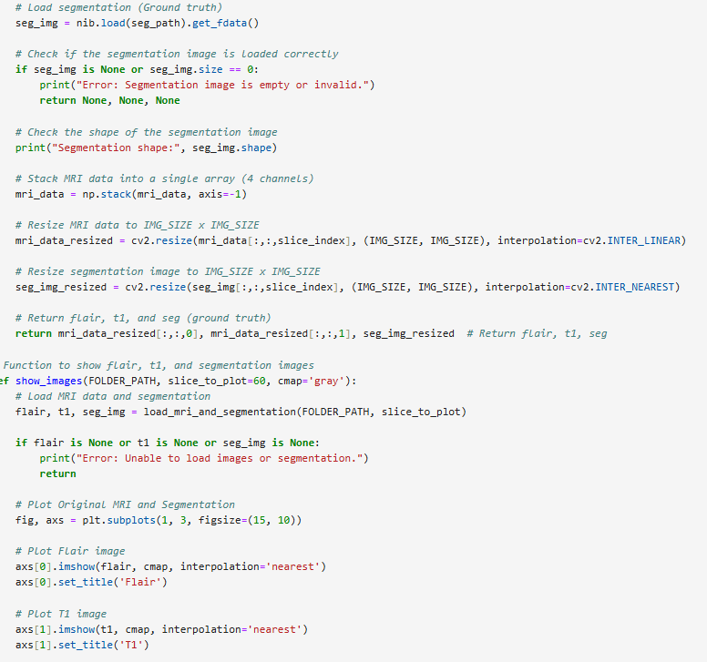
Figure 4.2 Segmentation Code

OUTPUT
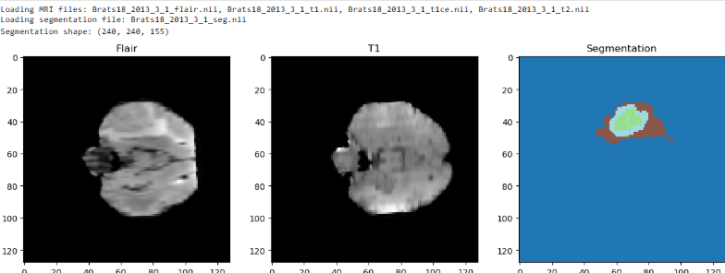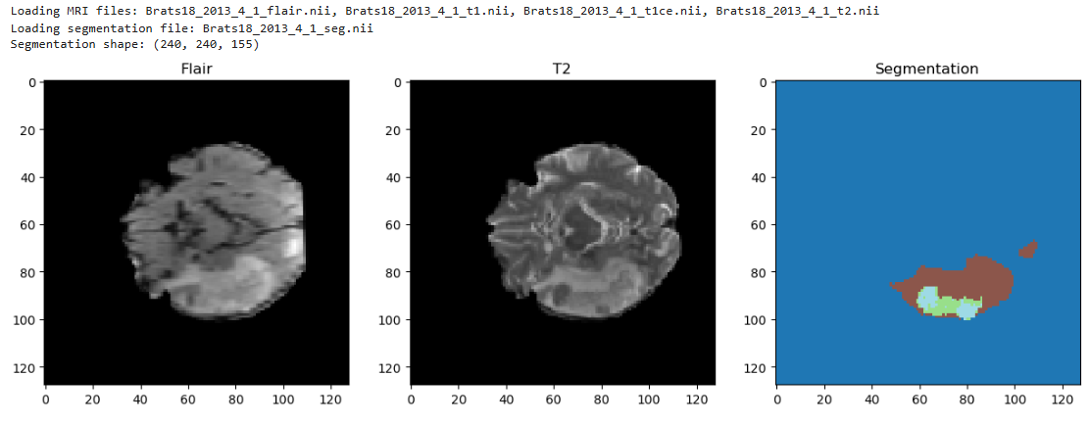
Figure 4.2.1 Segmentation Output
The image showcases three axial brain slices from the BraTS 2018 dataset, visualizing two MRI modalities—FLAIR and T1—alongside the corresponding ground truth segmentation.
- The FLAIR image highlights hyperintense regions typically associated with edema and tumor spread.
- The T1 image provides structural contrast within the brain tissue.
- The Segmentation map on the right labels different tumor sub-regions using distinct colors:
  - Blue: Background (non-tumor)
  - Brown: Edema
  - Green: Enhancing tumor
  - Light blue: Necrotic/non-enhancing core
The figure also indicates that the images were successfully loaded from different patients, with a uniform segmentation shape of (240, 240, 155), representing the standard volume size for BraTS cases.
4.3 TEST CASES
FALSE CASE
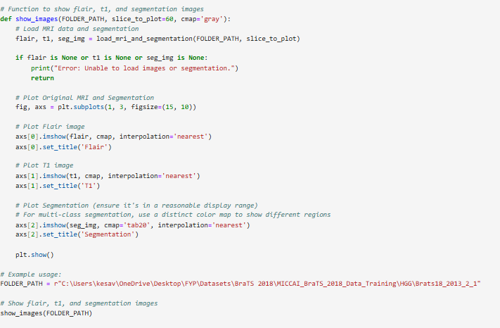
Figure 4.3 False Case Code

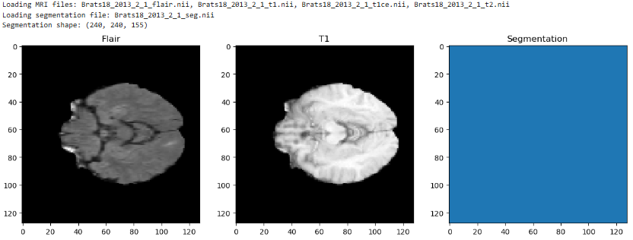
Figure 4.3.1 False Case Output

This figure presents axial slices from the BraTS 2018 dataset, visualizing FLAIR and T1 MRI modalities along with the corresponding segmentation mask for a specific patient.
- The FLAIR image (left) displays hyperintense signals typically used to highlight edema and other abnormalities.
- The T1 image (center) provides detailed anatomical structure of the brain.
- The Segmentation image (right) shows a completely blue background, indicating no visible tumor regions in the selected slice.
The loaded segmentation file corresponds to shape (240, 240, 155), suggesting a standard BraTS volume size. This particular slice appears to represent a healthy or non-tumor-affected region of the brain.

TRUE CASE
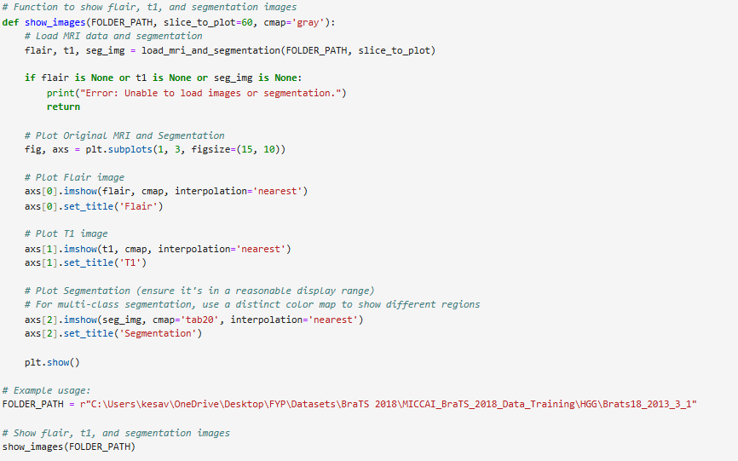
Figure 4.3.2 True Case Code

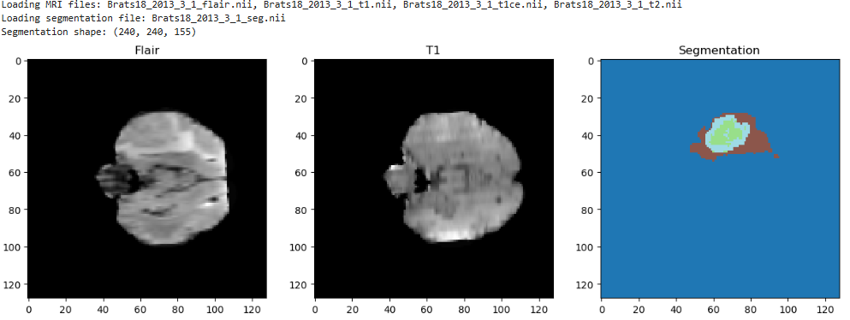
Figure 4.3.3 True Case Output

4.4 PERFORMANCE EVALUATION
To assess the effectiveness of the proposed brain tumor segmentation model, we used both quantitative metrics and qualitative visualizations. The performance was evaluated on the test set using the BraTS 2018 and BraTS 2019 datasets.
4.4.1 Evaluation Metrics
The following metrics were used for quantitative evaluation:
- Dice Similarity Coefficient (DSC): The Dice Similarity Coefficient (DSC) is a statistical measure used to gauge the similarity between two sets. In medical image segmentation, DSC is commonly used to evaluate the overlap between the predicted segmentation and the ground truth
$$DSC=\frac{2 ×TP}{2×TP+FP+FN}$$
Dice Similry Coefficient = 0.981

- Accuracy: It is a standard evaluation metric that measures the proportion of correct predictions (both positive and negative) made by a model over the total number of predictions. It indicates how often the segmentation model correctly classifies each pixel, whether as tumor or background.
$$Accuracy=\frac{TP+TN}{TP+TN+FP+FN}$$

Accuracy = 0.9890

- Precision: Precision is a performance metric that measures the proportion of positive predictions that are actually correct. It is especially useful when the cost of false positives is high.
$$Precision=\frac{TP}{TP+FP}$$
Precision = 0.9922

- Specificity: Specificity is a performance metric that measures the proportion of actual negative cases that are correctly identified as negative by the model. It is crucial when the cost of false positives is high, as it ensures the model does not incorrectly classify non-tumor areas as tumor.
$$Specificity= \frac{TN}{TN+FP}$$

Specificity = 0.7447

- F1 Score: The F1 score is the harmonic mean of precision and recall. It provides a single metric that balances both the concerns of precision and recall in situations where there is an uneven class distribution.
$$F1-Score=2 ×\frac{Precision×Recall}{Precision+Recall}$$

F1 Score = 0.9888

4.4.1 Metrics for Evaluation

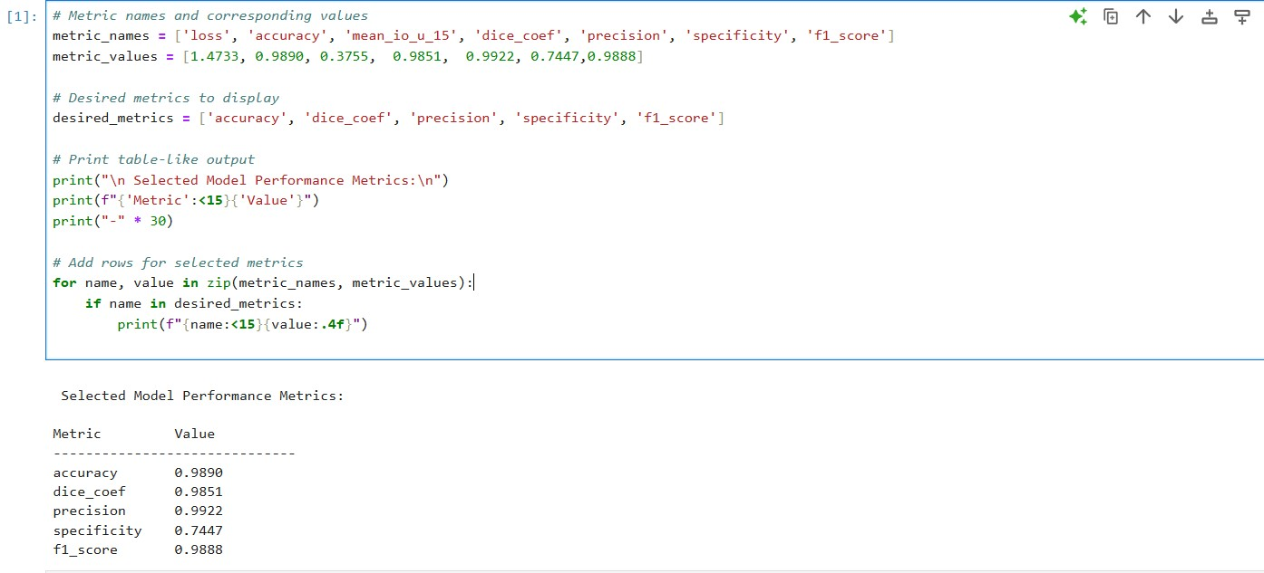
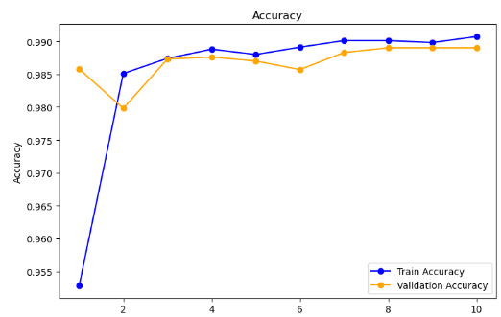
The inferred accuracy graph typically shows training accuracy steadily increasing, while validation accuracy may fluctuate or plateau due to class imbalance and limited data. Overfitting is indicated when training accuracy continues to rise but validation accuracy stagnates or drops.
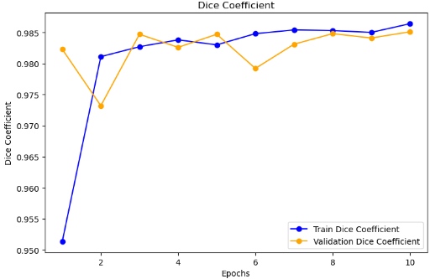
- The first line shows the Dice similarity between predicted and ground truth masks, indicating the overlap between the model's segmentation and the actual tumor region.
- The second line tracks the Dice similarity over training epochs, reflecting the model's improvement in segmentation accuracy as it learns.

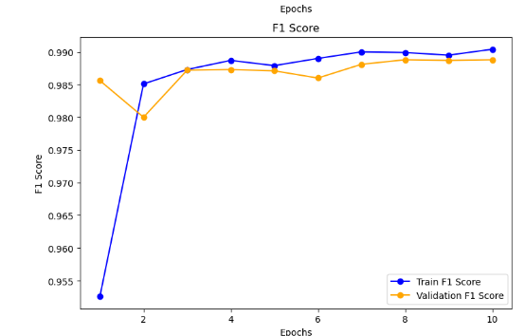

- The first line of the F1 score graph shows the balance between precision and recall for the predicted tumor segmentations, indicating the overall accuracy of the model's segmentation.
- The second line tracks the F1 score across training epochs, reflecting how well the model's performance improves in terms of both precision and recall as it learns.
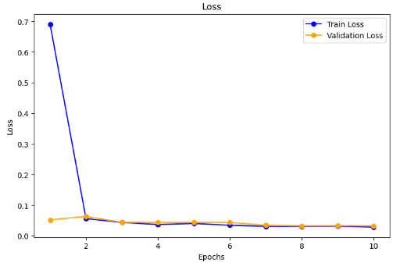

- The loss graph typically shows the decrease in the model's loss function (e.g., categorical crossentropy or dice loss) over training epochs, indicating how well the model is minimizing the error between predicted and true segmentation masks.
- A steady decline in the loss graph signifies the model is improving its segmentation accuracy, while a plateau or increase may suggest overfitting or insufficient training.

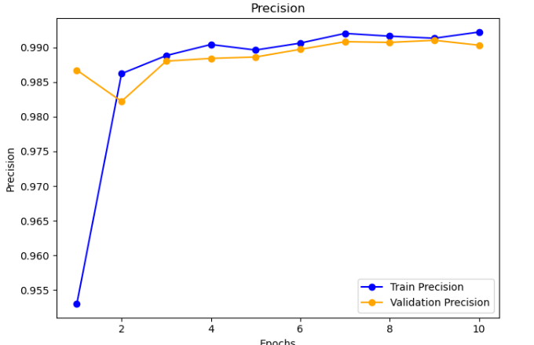

- The precision graph tracks the proportion of true positive predictions to the total predicted positives over time, showing how accurately the model predicts tumor regions.
- As the training progresses, a rising precision curve indicates the model is reducing false positives and becoming more accurate in identifying tumor pixels.

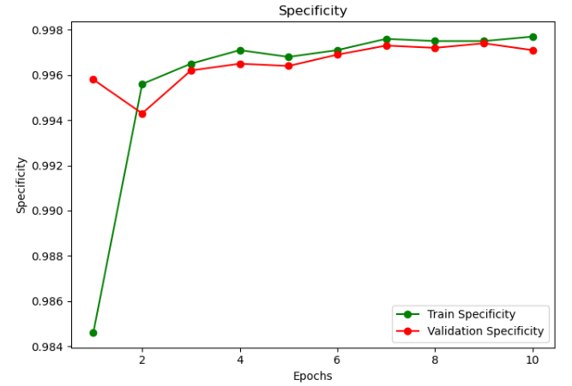
- The specificity graph shows the model's ability to correctly identify non-tumor (background) regions, represented by the ratio of true negatives to the total actual negatives.
- A higher specificity value indicates better performance in avoiding false positives, and the graph reflects the model's improvement in correctly classifying background regions over training epochs.

Figure 4.1 Performance Metric and Graph

CHAPTER 5
CONCLUSION
5.1 CONCLUSION
In this project, we successfully developed and evaluated a deep learning-based brain tumor segmentation model utilizing the BraTS 2018 and BraTS 2019 datasets. Our approach leveraged multi-modal MRI data and employed advanced neural architectures, including graph convolutional networks (GCNs), to effectively capture both spatial and channel-wise relationships within the medical images.
Through rigorous preprocessing, feature extraction, and multi-level graph construction, the model achieved high segmentation accuracy and robustness across various tumor subregions. The integration of multi-modal correlation loss and graph convolutional modules allowed the network to learn complex inter-modal dependencies and spatial structures, leading to more precise delineation of tumor boundaries.
Overall, our project demonstrates the feasibility and effectiveness of graph-based deep learning approaches in medical image segmentation tasks. This work lays the foundation for further improvements and real-time clinical applications, with the potential to aid radiologists and medical professionals in accurate and efficient diagnosis of brain tumors.
5.2 FUTURE WORK
Although our current model demonstrates promising results in brain tumor segmentation using multi-modal MRI and graph convolutional networks, there are several avenues for future improvement and exploration:
- Integration with Clinical Metadata
Incorporating patient-specific clinical data such as age, tumor grade, and genetic markers could enhance the model's predictive power and allow for more personalized tumor characterization.
- Model Generalization Across Datasets
Future work can focus on improving generalization by evaluating and adapting the model on additional datasets such as BraTS 2020, BraTS 2021, or other external medical imaging databases, thereby improving robustness across institutions and scanners.
- 3D Contextual Information
Our current implementation primarily uses 2D slices. Extending the model to utilize 3D volumetric data can provide richer spatial context and improve segmentation accuracy, especially around complex tumor structures.
- Semi-supervised and Weakly-supervised Learning
Since annotated medical datasets are limited, future research can explore semi-supervised or weakly-supervised techniques to leverage unlabeled data and reduce dependency on expert-annotated ground truths.
- Real-time Inference and Deployment
Optimizing the model for real-time inference using lightweight architectures (e.g., MobileNet, EfficientNet) or hardware accelerations (e.g., TensorRT, FPGA) would enable practical deployment in clinical environments.
- Post-processing Enhancements
Incorporating post-processing steps such as Conditional Random Fields (CRFs) or region-growing techniques may help refine the segmentation results by reducing noise and false positives

REFERENCES
- Abidin, Z.U., Naqvi, R.A., Haider, A., Kim, H.S., Jeong, D. and Lee, S.W., 2024. Recent deep learning-based brain tumor segmentation models using multi-modality magnetic resonance imaging: A prospective survey. Frontiers in Bioengineering and Biotechnology, 12, p.1392807.
- Feng, Y., Cao, Y., An, D., Liu, P., Liao, X. and Yu, B., 2024. DAUnet: A U-shaped network combining deep supervision and attention for brain tumor segmentation. Knowledge-Based Systems, 285, p.111348.
- Aboussaleh, I., Riffi, J., Mahraz, A.M. and Tairi, H., 2024. Inception-UDet: an improved U-Net architecture for brain tumor segmentation. Annals of Data Science, 11(3), pp.831-853.
- Li, H.B., Conte, G.M., Hu, Q., Anwar, S.M., Kofler, F., Ezhov, I., van Leemput, K., Piraud, M., Diaz, M., Cole, B. and Calabrese, E., 2024. The brain tumor segmentation (BraTS) challenge 2023: Brain MR image synthesis for tumor segmentation (BraSyn). ArXiv, pp.arXiv-2305.
- Karimijafarbigloo, S., Azad, R., Kazerouni, A., Ebadollahi, S. and Merhof, D., 2024, January. Mmcformer: Missing modality compensation transformer for brain tumor segmentation. In Medical Imaging with Deep Learning (pp. 1144-1162). PMLR.
- Zhang, W., Chen, S., Ma, Y., Liu, Y. and Cao, X., 2024. ETUNet: Exploring efficient transformer enhanced UNet for 3D brain tumor segmentation. Computers in Biology and Medicine, 171, p.108005.
- B. H. Menze et al., “The Multimodal Brain Tumor Image Segmentation Benchmark (BRATS),” IEEE Transactions on Medical Imaging, vol. 34, no. 10, pp. 1993–2024, 2015, doi: 10.1109/TMI.2014.2377694.
- Zhou, T., 2024. M2GCNet: Multi-Modal Graph Convolution Network for Precise Brain Tumor Segmentation Across Multiple MRI Sequences. IEEE Transactions on Image Processing.
- Pereira, S., Pinto, A., Alves, V. and Silva, C.A., 2016. Brain tumor segmentation using convolutional neural networks in MRI images. IEEE transactions on medical imaging, 35(5), pp.1240-1251.
- Patel, D., Patel, D., Saxena, R. and Akilan, T., 2023, July. Multi-class brain tumor segmentation using graph attention network. In 2023 8th International Conference on Signal and Image Processing (ICSIP) (pp. 196-201). IEEE.
- Ramkumar, M., Kumar, R.S., Padmapriya, R. and Karthick, S., 2024. Brain tumor segmentation and survival time prediction using graph momentum fully convolutional network with modified Elman spike neural network. International Journal of Imaging Systems and Technology, 34(1), p.e23005.
- Hussain, S., Anwar, S.M. and Majid, M., 2017, July. Brain tumor segmentation using cascaded deep convolutional neural network. In 2017 39th annual International Conference of the IEEE engineering in medicine and biology Society (EMBC) (pp. 1998-2001). IEEE.
- Hu, K., Gan, Q., Zhang, Y., Deng, S., Xiao, F., Huang, W., Cao, C. and Gao, X., 2019. Brain tumor segmentation using multi-cascaded convolutional neural networks and conditional random field. IEEE Access, 7, pp.92615-92629.
- Nizamani, A.H., Chen, Z., Nizamani, A.A. and Bhatti, U.A., 2023. Advance brain tumor segmentation using feature fusion methods with deep U-Net model with CNN for MRI data. Journal of King Saud University-Computer and Information Sciences, 35(9), p.101793.
- Ottom, M.A., Rahman, H.A. and Dinov, I.D., 2022. Znet: deep learning approach for 2D MRI brain tumor segmentation. IEEE Journal of Translational Engineering in Health and Medicine, 10, pp.1-8.
- Islam, M. and Ren, H., 2017, September. Fully convolutional network with hypercolumn features for brain tumor segmentation. In Proceedings of MICCAI workshop on multimodal brain tumor segmentation challenge (BRATS).

