ML Based Credit Risk Assessment System
INTRODUCTION

Project Overview

The credit score is a numeric expression measuring people’s creditworthiness. Banks usually use it to determine who should get credit, how much credit they should receive, and which operational strategy can be taken to reduce the credit risk.The problem with credit scores is that they provide an incomplete picture of individuals and small companies with less or no banking history therefore making it difficult for these parties to receive credit even in cases where they would be capable of repay the credit.The goal is to use machine learning for credit risk classification and instead of focusing on an individual or company’s banking history,the focus would instead be based on banking patterns of similar clients behaviour and data from those transactions.With machine learning, the number of data sources that can factor into a credit model are theoretically infinite. There exist countless variables that might predict an applicant’s ability to pay back their loan, and machine learning is good at finding patterns within large data sets.Models could factor in data points that are yet unknown to predict a borrower’s likelihood of paying back their loan.This allow banks and other lenders to increase revenue by approving more credit invisible applicants while avoiding high risk at the same time.The platform would provide individuals and companies to assess risks before even going through the loan application process.

Requirements

Primary Requirements

Secondary Requirements

BACKGROUND LITERATURE
Today ‘s Credit Industry is data driven,all big players rely on consumer lending data inorder to model and try to minimise risk while also maximising profit.Credit score development data has been the common way of doing things but unfortunately does not provide a competitive edge in the market.The most common credit scoring method uses scorecards which are made of statistical models and these statistical models give scores to existing credit accounts.This method is common because it is easily understood by customers and it is standard across all systems so companies do not spend alot of money on development of models as they have to keep re-using the same legacy code.Consumer data is explored,cleaned and features are engineered.Data is then transformed using Weight of Evidence method for each feature and determining the the information value of each characteristic that will be used to measure the predictive power of each variable from the data provided by the customer.Formulas for Weight of Evidence and Information Value:
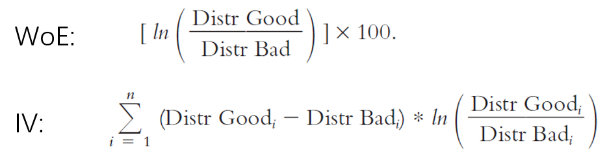
To transform the data variables split into bins,calculate the percentage of good and bad events,calculate
Weight Of Evidence using the natural log and replace raw data with Weight Of Evidence values.Look in code:
“
import pandas as pd
import numpy as np
# example
age = ['18 to 25','26 to 35','36 to 45','46 to 60','>= 60']
df = pd.DataFrame(age, columns=['Age Group'])
df['counts'] = [31234, 30293, 29384, 30192, 27394]
df['bad'] = [4920, 4123, 3784, 2608, 1479]
df['good'] = df.counts - df.bad
# calculate WOE
df['total_distri'] = df.counts/sum(df.counts)
df['bad_distri'] = df.bad/sum(df.bad)
df['good_distri'] = df.good/sum(df.good)
df['WOE'] = np.log(df.good_distri / df.bad_distri)
df['WOE%'] = df.WOE * 100
”
WoE transformation builds linear relationship,handles missing values,outliers and feeds model with fitted values.Features are then selected using Information Values.Fit the Logistic Regression model with the transformed Weight of Evidence of the training dataset that is then scaled to the scored card.All this will be used to calculate the scorecard point for all characteristics thus resulting in the final scorecard.Each individual feature score can then be computed with the formula:
Score = (β×WoE+ α/n)×Factor + Offset/n

β-logistic regression coefficient
α-logistic regression intercept
WoE-Weight of Evidence
n-number of characteristics in the model
Factor,Offset-this is a scaling parameter
Factor = pdo/Ln(2)
Offset=Score-(Factor*ln(Odds))

The total score is the sum of all scores calculated.
Total Score=ΣScore_i

The problem with scorecards is they require alot of data points in order to increase accuracy therefore alot data on a consumer has to be fitted to scorecards and do not give the whole picture about a client.Instead of weighing variables it would be ideal to take a dataset with good and bad risk transactions,train the model based on this dataset,use the same Logistic Regression for binary classification inoder to establish patterns and learn then classify weather a client is a bad risk or a good risk.This would be require less data points and the model would be custom.

