Assignment for day-4

Name:Keshav Jayakrishnan

Email:kesh.jayan@gmail.com

**Question-1:**

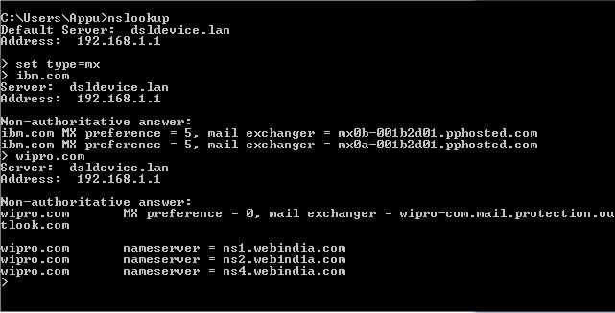

The names given after ‘mail exchanger’ are the mail servers of the respective domains.

**Question 2:**

Once the mail servers are pinged, the ip address shows up and you can run a simple online geolocation scan on it.

For ibm.com, the ip of the mail server is 148.163.158.5 or 148.163.158.1

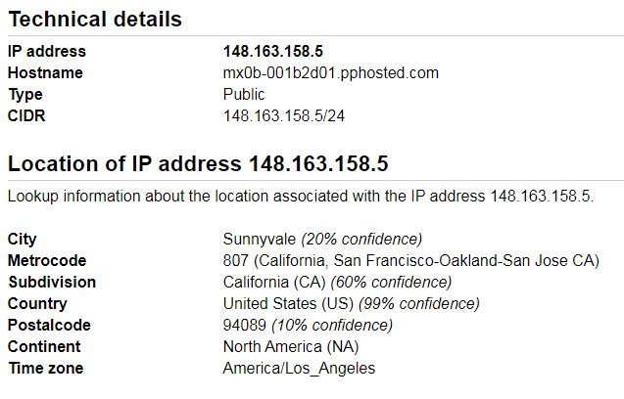

For wipro.com, the ip of the mail server is 34.235.29171

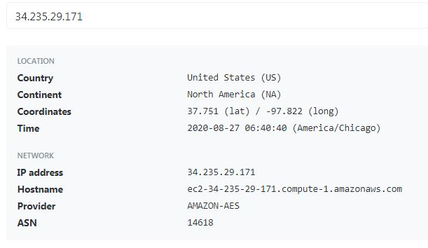

**Question 3:**

A simple nmap scan can provide the open port numbers for the particular ip, but in this case, all the ports are filtered.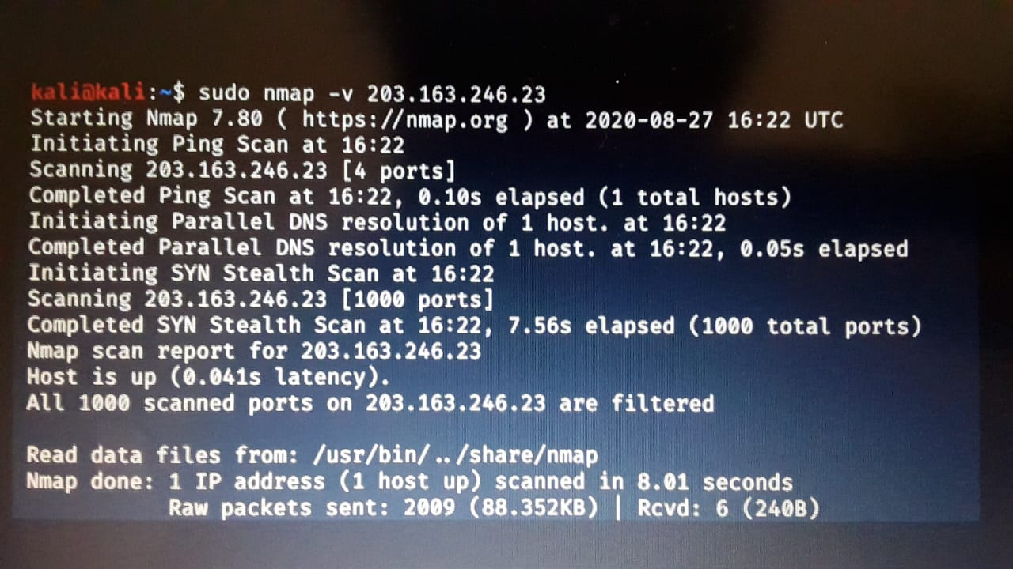

**Question 4:**

