
Project Title:
Design and Implementation of a Retail Inventory and Lost-Sales Analytics Data Pipeline
Prepared by:
Kesha Oza (Y00878953)
Anita Burri (Y00869033)
Institutional Affiliation:
Youngstown State University
Course Title:
Data Engineering Capstone
Faculty Advisor:
Dr. Robert Gilliland
Course Professor:
Dr. Goerge Yu
Submission Date:
April 24, 2026

1. Introduction
For retailers today, having a good inventory management process helps keep their business profitable and customers happy. One of the biggest problems retailers have is when they run out of stock, also known as stocking problems, because this creates problems for both customer satisfaction and business. Not only do retailers lose revenue immediately from stocking problems, but they also lose customer trust and brand loyalty over the long term. Retailers can now utilize the wealth of data available to them through data analytics to make better decisions.
This project will create a data-driven solution that will analyze retail sales data and simulate inventory behavior while estimating lost sales due to poor inventory levels. The goal of the project is to establish an entire data pipeline from end to end. In addition, there will be an integration between SQL-based data processing with Power BI visualization to provide a complete solution for determining stockout risks and optimizing inventory planning strategies.

2. Background
Analytics in retail is a critical aspect of Business Intelligence systems. The foundation for understanding consumer behavior, forecasting product demand, and enhancing operational efficiency lies within an organization’s historical sales database and other external data sources. This project will use Walmart’s weekly sales dataset as the primary data source. The dataset includes:
- Weekly sales data for multiple stores
- Time-based attributes such as date and week
- Economic indicators such as temperature, fuel price, CPI, and unemployment
These variables provide a broader context for analyzing sales performance and understanding external influences on demand.
Traditional inventory control methods have historically depended upon fixed rules and presumptions that may fail to provide suitable flexible responses to the ongoing changes in buying behavior due to ever fluctuating demand. Rather than traditional inventory management approaches which frequently rely on rules and/or suppositions. The methods used herein will be analytical in nature and will provide an opportunity to model historical sales data to generate dynamic models. The stockout scenarios can be developed based on real sales data

3. Problem Statement
Retail companies often do not handle balancing supply with demand, as this can be difficult. When a retailer overestimates demand, they may end up with too many products, which raises their operating expenses. When they underestimate demand, they risk running out of stock, resulting in lost sales. This project aims to address the following key problems:
- How can stockouts be identified using historical sales data?
- How can lost sales be estimated when inventory is insufficient?
- Which stores are most affected by stockouts and demand variability?
- How can inventory levels be adjusted to minimize lost sales?
- How can raw data be transformed into meaningful insights for decision-making?
By solving these problems, the project aims to provide a framework for improving inventory management through data-driven analysis.

4. Methodology
The project follows a structured data engineering approach consisting of multiple layers:
4.1 Data Ingestion
The raw dataset was imported into MySQL using the Table Data Import Wizard. The data was initially stored in a raw table named raw_walmart_sales, preserving the original structure of the dataset.
4.2 Data Cleaning and Transformation (Staging Layer)
A staging table (stg_sales) was created to clean and preprocess the data. Key transformations included:
- Converting date fields into proper date format
- Standardizing column names and data types
- Identifying and removing invalid or null values
- Ensuring data consistency across all records
This step ensures that the data is reliable and ready for further processing.

4.3 Data Modeling (Dimensional Model)
A star schema was implemented to support efficient analytical queries:
- Fact Table (fact_sales)
Contains transactional sales data, including weekly sales and store identifiers
- Dimension Tables
  - dim_store: Contains unique store identifiers
  - dim_date: Contains time-related attributes such as year, month, and week
This structure improves query performance and simplifies reporting.
4.4 Analytical Layer
SQL was used to create analytical queries and views to calculate key performance metrics, including:
- Total Sales
- Average Weekly Sales
- Starting Inventory
- Simulated Inventory
- Stockout Flag
- Lost Sales
A dynamic parameter table (inventory_parameter) was implemented to allow flexible adjustment of inventory levels without modifying core logic.
4.5 Visualization Layer
Power BI was used to develop an interactive dashboard consisting of three main pages:
- Executive Summary
- Trend Analysis
- Business Insights and Recommendations
The dashboard provides a user-friendly interface for exploring data and understanding key insights.

5. Experiments
To evaluate the effectiveness of the proposed approach, several experiments were conducted:
- Different inventory coverage levels were tested to observe their impact on stockout frequency
- The relationship between inventory levels and lost sales was analyzed
- Store-level comparisons were made to identify high-risk locations
- Time-based analysis was conducted to identify seasonal trends and demand patterns
The experiments demonstrated that small changes in inventory levels can significantly impact stockout occurrences and lost sales.

6. Discussion
The results of the analysis provide several important insights:
- High-performing stores tend to experience higher stockout rates due to increased demand
- Inventory levels are often insufficient during peak demand periods, leading to significant lost sales
- Lost sales are not evenly distributed but are concentrated in specific stores
- Seasonal trends and external factors influence sales performance
- Implementing data-driven inventory strategies can reduce stockouts and improve efficiency
These findings highlight the importance of using analytical tools to support inventory planning decisions.

7. Conclusion
The project successfully illustrates how a retail data analytics pipeline can be designed and developed. This process uses both SQL-based data processing and Power BI visualization for providing a solution to delivering insightful information on inventory performance to inform decisions regarding lost sales due to inaccurate inventory. The project achieved the following outcomes:

- Developed a scalable data pipeline for retail analytics
- Simulated inventory levels and identified stockout scenarios
- Estimated lost sales using analytical models
- Created an interactive dashboard for business users
Overall, the project illustrates how data engineering and analytics can be used to solve real-world business problems and support decision-making processes.

8. Contribution of Team Members
Kesha Oza:
- Designed and implemented SQL data pipeline
- Developed fact and dimension tables
- Built Power BI dashboard
- Performed data analysis and KPI calculations
Anita Burri:
- Assisted in data cleaning and validation
- Supported dashboard visualization and formatting
- Contributed to documentation and report writing
- Assisted in interpreting results and insights

9. References
- Walmart Inc. (n.d.). Walmart weekly sales dataset. Kaggle. https://www.kaggle.com/
- Microsoft. (n.d.). Power BI documentation. Microsoft Learn. https://learn.microsoft.com/en-us/power-bi/
- Oracle Corporation. (n.d.). MySQL 8.0 reference manual. https://dev.mysql.com/doc/
- Kimball, R., & Ross, M. (2013). The data warehouse toolkit: The definitive guide to dimensional modeling (3rd ed.). Wiley.
- Sharda, R., Delen, D., & Turban, E. (2020). Business intelligence, analytics, and data science: A managerial perspective (4th ed.). Pearson.
- Chopra, S., & Meindl, P. (2016). Supply chain management: Strategy, planning, and operation (6th ed.). Pearson.
- Elmasri, R., & Navathe, S. B. (2016). Fundamentals of database systems (7th ed.). Pearson.

10. Appendix
A. Source Code Repository
https://github.com/kesha-oza/retail-inventory-data-pipeline
Datasets Table
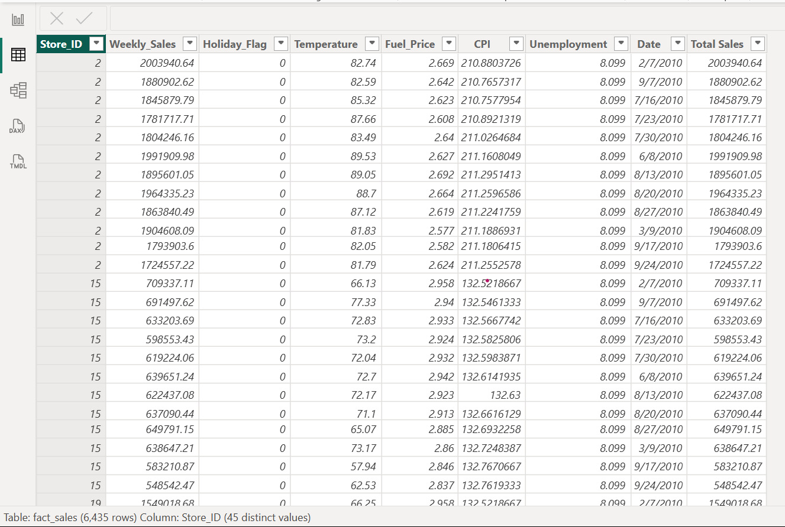

Data Model Diagram
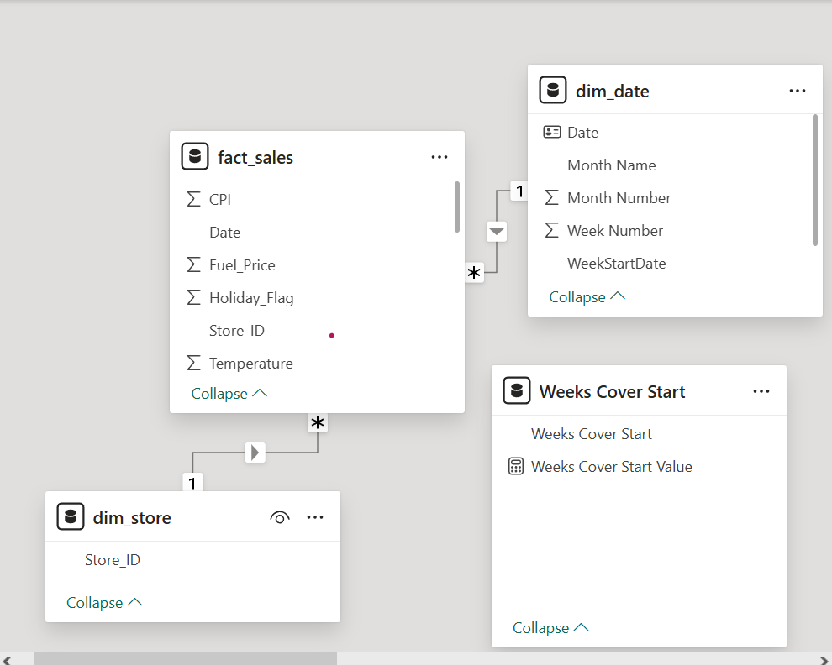

Dashboard Screenshots
Executive Summary
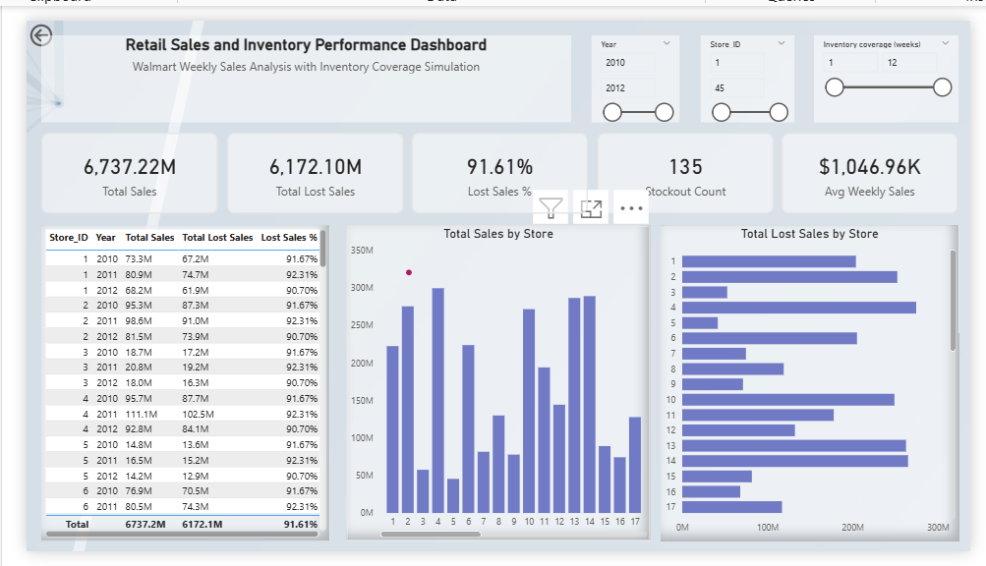
Trend Analysis
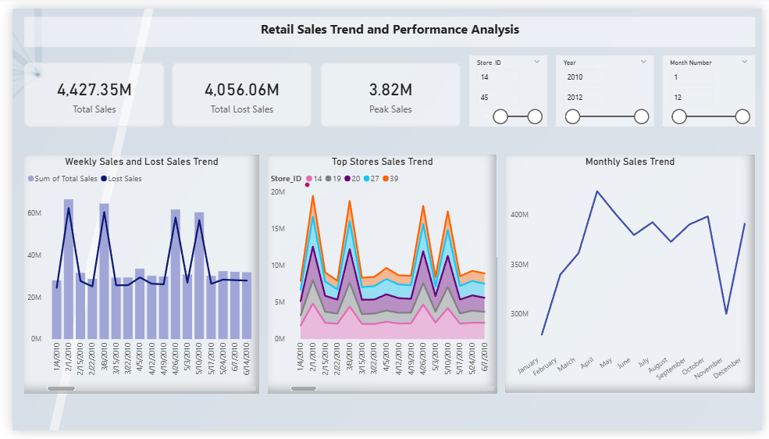

Business Insights
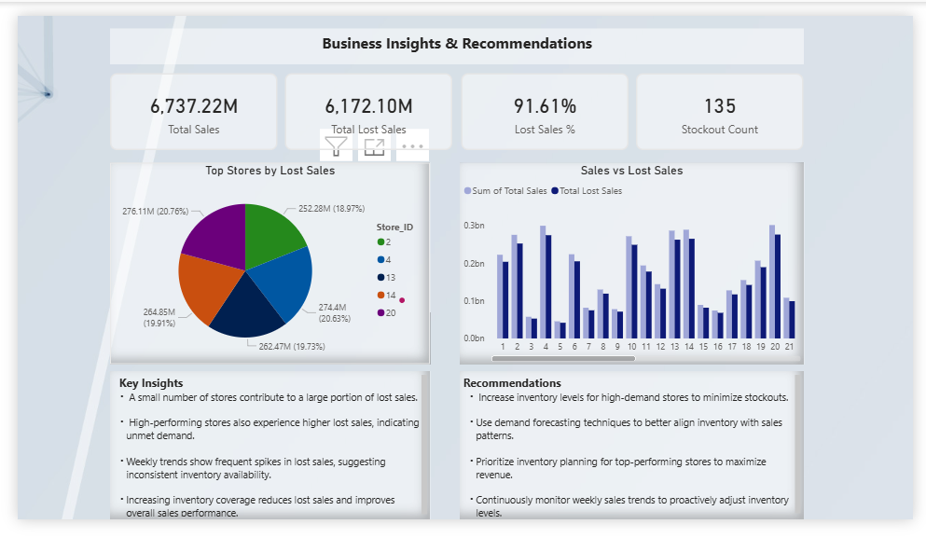

Data Architecture Diagram
[ Walmart Sales Data (Excel / CSV) ]
↓
[ Raw Layer (MySQL) ]
raw_walmart_sales
↓
[ Staging Layer ]
stg_sales (data cleaning & date conversion)
↓
[ Data Model Layer ]
fact_sales
dim_store
dim_date
↓
[ Analytical Layer ]
SQL Views:
- vw_store_year_inventory_analysis
- vw_monthly_sales_trend
- vw_dynamic_inventory
↓
[ Visualization Layer ]
Power BI Dashboard
- Executive Summary
- Trend Analysis
- Business Insights

SQL Query
CREATE VIEW vw_store_year_inventory_dynamic AS
SELECT
f.store_id,
YEAR(f.sale_date) AS year,
SUM(f.weekly_sales) AS total_sales,
AVG(f.weekly_sales) AS avg_weekly_sales,
AVG(f.weekly_sales) * p.weeks_cover_start AS starting_inventory,
(AVG(f.weekly_sales) * p.weeks_cover_start) - SUM(f.weekly_sales) AS simulated_inventory,
CASE
WHEN ((AVG(f.weekly_sales) * p.weeks_cover_start) - SUM(f.weekly_sales)) <= 0 THEN 1
ELSE 0
END AS stockout_flag,
CASE
WHEN ((AVG(f.weekly_sales) * p.weeks_cover_start) - SUM(f.weekly_sales)) <= 0
THEN ABS((AVG(f.weekly_sales) * p.weeks_cover_start) - SUM(f.weekly_sales))
ELSE 0
END AS lost_sales
FROM fact_sales f
CROSS JOIN inventory_parameter p
GROUP BY
f.store_id,
YEAR(f.sale_date),
p.weeks_cover_start;

SQL Query Output
