**Objective Questions**:

1. The data consists of some inconsistent and missing values so ensure that the data used for further analysis is cleaned.

ANS: There was some missing value in the given data. It was necessary to clean it. I have used filter function in all the important field of the given sheet section to remove all blanks and “0” values as well as remove duplicate function to remove duplicate restaurants Id from the sheet.

1. Using the LookUp functions, fill up the countries in the original data using the country code.

Ans: I have used LOOKUP function for filling the country name as per given country code.

The formula I have used is:

=VLOOKUP(C3,'country description'!$A$1:$B$16,2,0)

1. Create a table to represent the number of restaurants opened in each country.

ANS:

|  |  |  |
| --- | --- | --- |
| **Country Code** | **Country Name** | **NO of Restaurant opened** |
| 1 | India | 8651 |
| 14 | Australia | 24 |
| 30 | Brazil | 60 |
| 37 | Canada | 4 |
| 94 | Indonesia | 21 |
| 148 | New Zealand | 40 |
| 162 | Philippines | 22 |
| 166 | Qatar | 20 |
| 184 | Singapore | 20 |
| 189 | South Africa | 60 |
| 191 | Sri Lanka | 20 |
| 208 | Turkey | 34 |
| 214 | United Arab Emirates | 60 |
| 215 | United Kingdom | 80 |
| 216 | United States of America | 434 |

1. Also, the management wants to look at the number of restaurants opened each year, so provide them with something here.

ANS: The no of restaurants opened each years are as follows:

|  |  |
| --- | --- |
|  |  |
| **years** | **no of restaurant open** |
| 2010 | 1080 |
| 2011 | 1098 |
| 2012 | 1022 |
| 2013 | 1061 |
| 2014 | 1051 |
| 2015 | 1024 |
| 2016 | 1027 |
| 2017 | 1086 |
| 2018 | 1094 |

1. What is the total number of restaurants in India in the price range of 4?

ANS:

|  |  |  |  |
| --- | --- | --- | --- |
|  |  |  |  |
|  | 4) Total no of restaurant in India in price range of 4 Is | 388 |  |
|  |  |  |  |

1. According to the data, what is the average number of voters for the restaurants in each country?

ANS:

|  |  |
| --- | --- |
| **Row Labels** | **Average of Votes** |
| Australia | 111.4166667 |
| Brazil | 19.61666667 |
| Canada | 103 |
| India | 137.212552 |
| Indonesia | 772.0952381 |
| New Zealand | 243.025 |
| Philippines | 407.4090909 |
| Qatar | 163.8 |
| Singapore | 31.9 |
| South Africa | 315.1666667 |
| Sri Lanka | 146.45 |
| Turkey | 431.4705882 |
| United Arab Emirates | 493.5166667 |
| United Kingdom | 205.4875 |
| United States of America | 428.2211982 |
| **Grand Total** | **156.9097477** |

**Subjective Question:**

1. Suggest a few countries where the team can open newer restaurants with lesser competition. Which visualization/technique will you use here to justify the suggestions?

ANS:

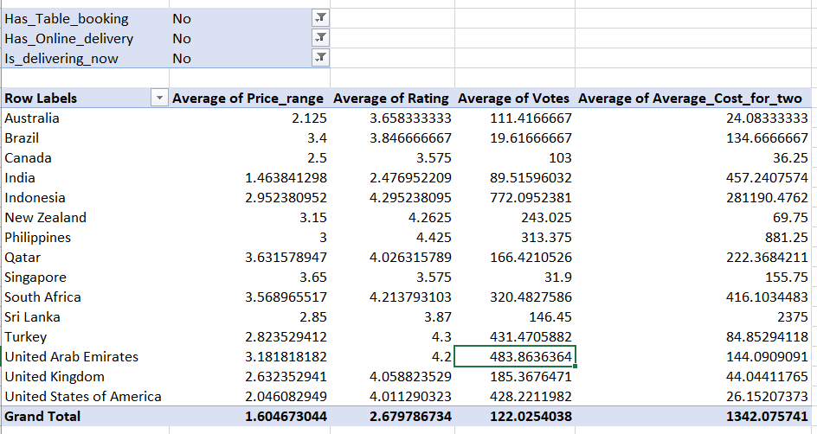

Australia, Canada, New Zealand, Philippines, South Africa, Qatar, Sri Lanka, Turkey, UAE, UK, are the countries where table booking, online delivery and they has not started delivering food online now. There are higher average of voters in areas. Average cost of two person is also below 500$. Average of price range is also greater than 2 that is medium. Number of restaurants are 24, 4, 40, 22, 43, 20, 20, 34, 60, 80 respectively.

There factors are in the favour of opening a new restaurants in these areas.

1. Come up with the names of States and cities in the suggested countries

suitable for opening restaurants.

ANS:

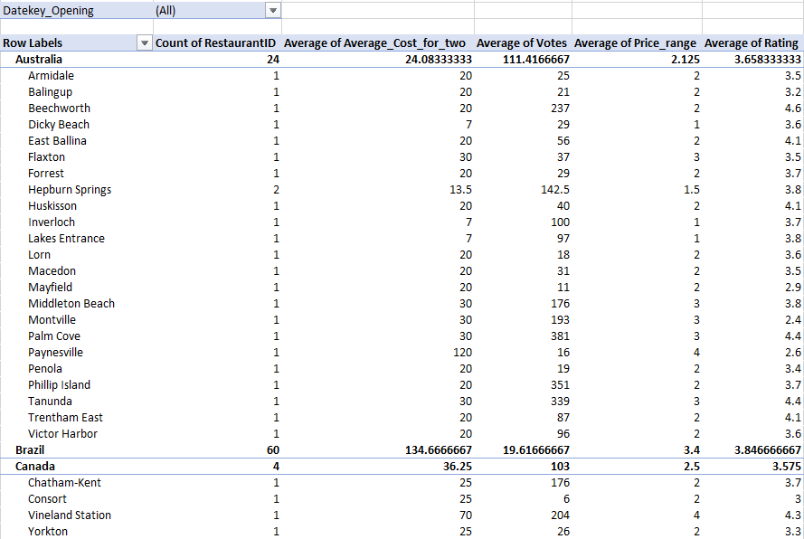

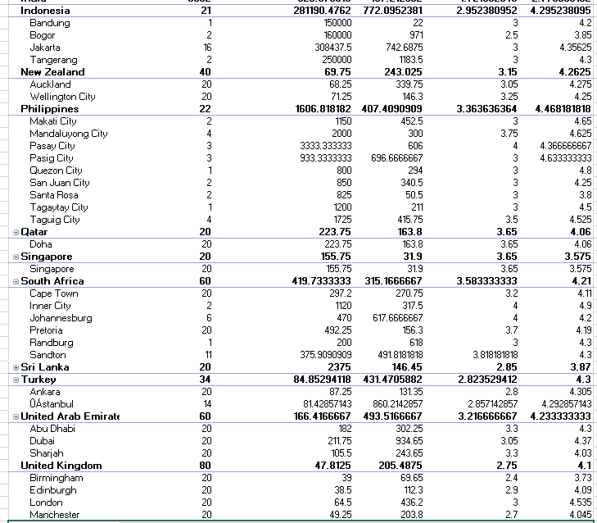

Australia has 24 famous cities, all cities has only one restaurant in it. Plam cove, Tanunda, phillip island and Beechworth have higher average votes. Average cost of two per meal price is also moderate in this area. Average of price range is also low i.e 2 to 3. So, I suggest Plam cove, Tanunda, phillip island and Beechworth would be best cities for starting new restaurants.

Canada has 4 famous cities, all cities has only one restaurant in it. Vineland station has higher average votes and average cost of two per meal price is also higher in this area. So, I suggest Chatham- Kent, Consort and Yorkton would be best cities for starting new restaurants.

Philippines has 22 famous cities, all cities has a good no of restaurant in it. Quezon has one restaurant with 294 average votes. Average cost of two per meal price is 800 less than other cities in this country. Average of price range is 3. So, I suggest Quezon would be best cities for starting new restaurants here.

South Africa has 60 famous cities, all cities has a good no of restaurant in it. Randburg has one restaurant with 618 average votes. Average cost of two per meal price is 200 less than other cities in this country. Average of price range is 3. So, I suggest Randburg would be best cities for starting new restaurants here.

1. According to the countries you suggested, what is the current quality regarding ratings for restaurants that are open there?

ANS:

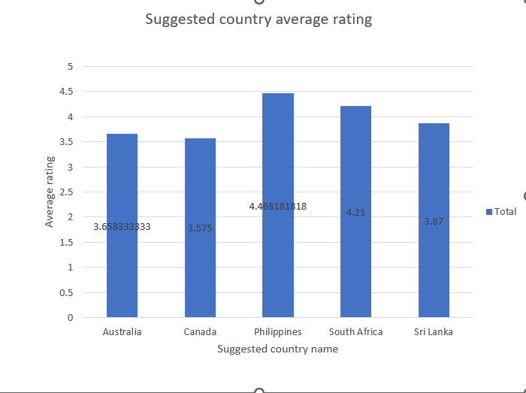

The current average rating of the countries, I have suggested is between 3.5 to 4.5. Means all countries have very good restaurants. I could not compromise with the quality of food in our new restaurants for survivals.

1. Also, what is the current expenditure on food in the suggested countries, so we can keep our financial expenditure in control?

ANS:

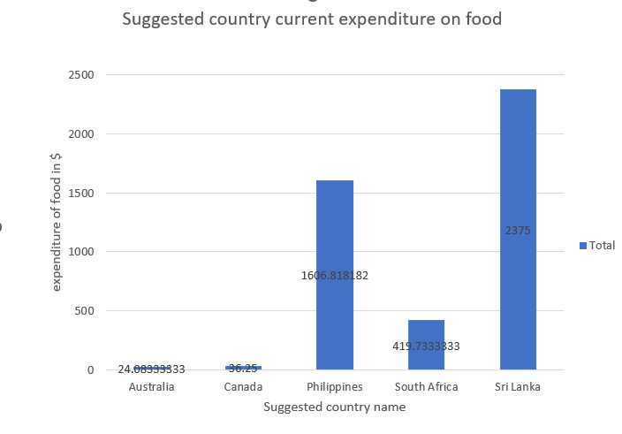

Australia have very cheap among all suggested countries expenditure on food is only 24.08$. Canada is also not much expensive, the average expenditure on food is 36.25$.

The average expenditure on food in Philippines is 1606.81$, which is a bit high. The average expenditure on food in South Africa is 419.73$, which is moderate. The average expenditure on food in Sri Lanka is 2375$, which is very expensive.

1. Come up with the names of restaurants from the recommended states that are our biggest competitors and also those that are rated in the lower brackets, i.e. 1-2 or 2-3.

ANS: Vineland station is our biggest competitors because of its highest rating in Canada that is 204 and price range is also high that is 4.

Chatham- Kent has also higher rating that is 176, but price range is low that is 2, Consort and Yorkton could not be our competitors because of its lower ratings that is 6 and 26 respectively and its price range is also low that is 2.



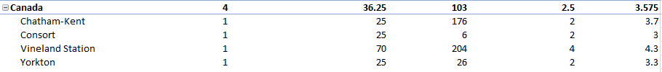

Plam cove is our biggest competitors because of its highest rating in Australia that is 381 and price range is also moderate that is 3.

phillip island has also higher rating that is 351, but price range is low that is 2, Beechworth could be our competitors because of its ratings that is 237 and its price range is also low that is 2.

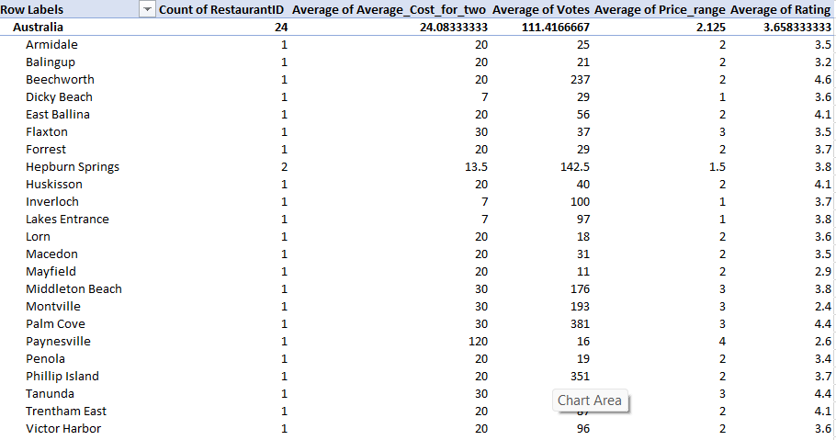

1. Which cuisines should we focus on in the newer restaurants to get better feedback? Does the choice of cuisines affect the restaurant ratings?

ANS: Asian, Chinese-Canadian, Italian-mediterranean-pizza and Japanese-sushi are the most demanding cuisines in that area, I recommend the same in Canada.

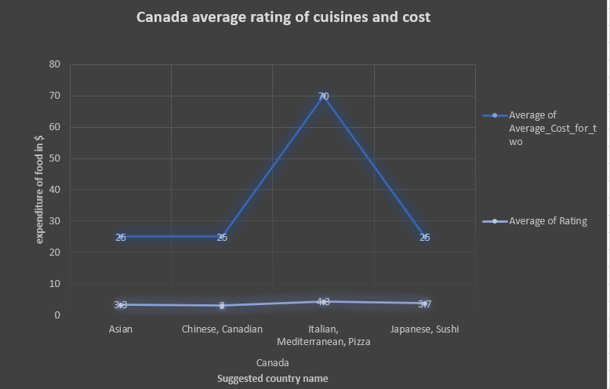

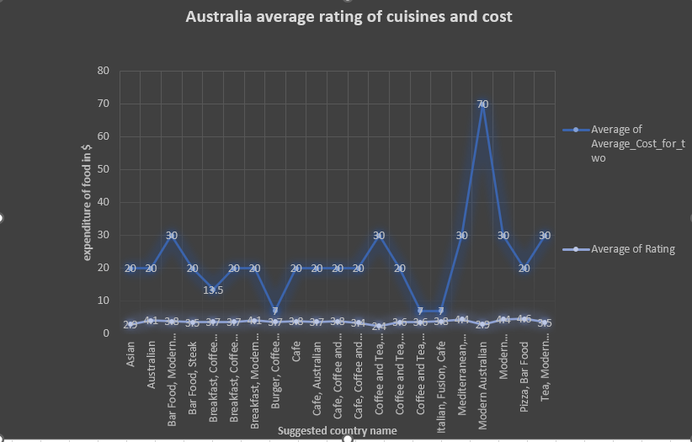

I recommend all cuisines, except modern Australian because of high price and low average rating of Australia.

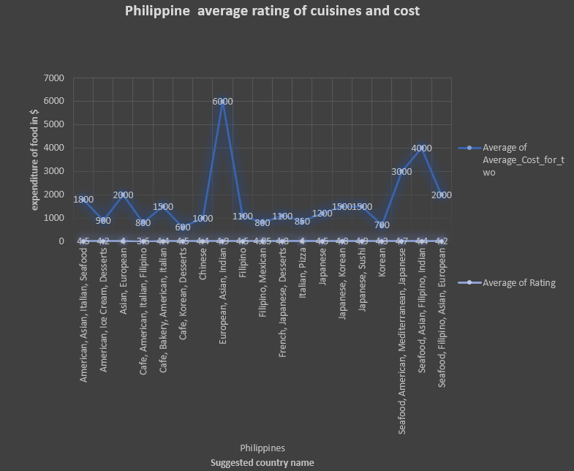

1. According to our current data, should we go for online delivery and table booking? Does that affect the customer’s ratings?

ANS: As from the given pie chart Canadians neither booked table and nor went for online delivery. Yes, that could affects customer’s ratings. 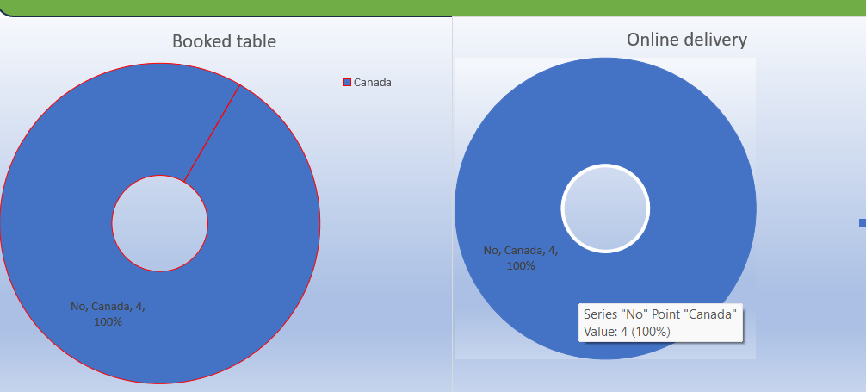

1. Should the team keep the rate of cuisines higher? Will that affect the feedback? According to our data are the rates of cuisines and ratings, correlated?

Ans:

I should not keep the rate of cuisines higher they because there are also a good restaurant having same cuisines at cheaper rate and it is obvious that, they don’t buy it at higher price. Yes, it will affect feedback. Yes, they are correlated, because Italian-mediterranean-pizza has average of

Average of average cost of two person is 75 and other cuisines like: Asian, Chinese-Canadian and Japanese-sushi have average of average cost of two person is less than 10.

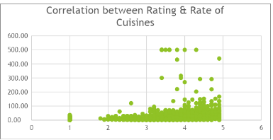

1. What is the distribution of number of restaurants of different price ranges in all the countries?

Ans:

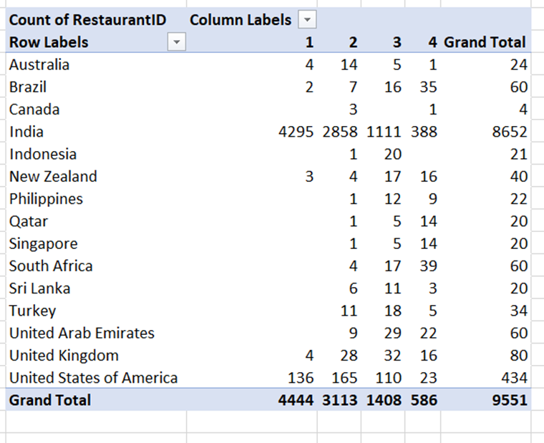

**The dashboard must consist of date and country slicers.**