Founder’s profile Summary

1. Founder Summary on Deals Done:

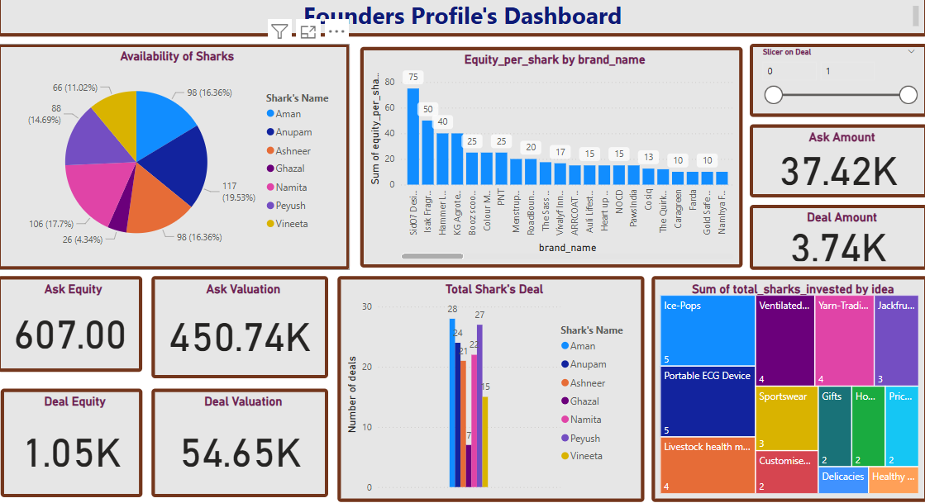

This dashboard provides a detailed overview of the deals made by founders on Shark Tank, highlighting the interaction between founders and sharks across various metrics.

* ***Deal Insights:***
* **Total Ask Equity**: 607
* **Total Ask Valuation**: ₹450.74K
* **Total Deal Equity**: 1.05K
* **Total Deal Valuation**: ₹54.65K
* **Total Ask Amount**: ₹37.42K
* **Total Deal Amount**: ₹3.74K

These numbers indicate a significant gap between what founders initially ask and what they ultimately agree upon, showing negotiation strength from the sharks.

* ***Sharks' Participation & Availability:***
* **Most Available Sharks**:
  + **Namita (19.53%)**
  + **Aman (16.36%)**
  + **Vineeta (16.36%)**
  + **Peyush (17.79%)**

These sharks were most frequently present for pitches, providing founders with greater chances to negotiate and finalize deals.

* **Deals by Shark:**
* **Highest Deal Closers**:
  + **Aman – 28 Deals**
  + **Anupam – 24 Deals**
  + **Namita – 27 Deals**
  + **Peyush – 22 Deals**

Aman and Namita appear to be the most active investors, implying that founders pitching ideas that align with their interest areas had better chances of closing deals.

* **Equity Distribution by Brand:**
* The highest equity offered per brand is from:
  + **ISOP POPS (75%)**
  + **Isak Fragrances (50%)**
  + **Kakamani (40%)**

This suggests founders of these brands gave away more equity either due to higher funding needs or more negotiation leverage held by the sharks.

* **Ideas That Attracted Multiple Sharks:**

From the Treemap visualization, we observe ideas with **multiple shark participation**:

* **Ice-Pops** – 5 Sharks
* **Ventilated...** – 5 Sharks
* **Portable ECG Device** – 5 Sharks
* **Livestock Health Monitoring** – 4 Sharks

Ideas addressing health, technology, or FMCG seem to be highly attractive to multiple investors, showcasing their perceived market potential.

* **Conclusion:**

Founders with **health tech, food, or FMCG** innovations tend to attract more sharks and receive higher deals. However, the final deal amounts are significantly lower than initial asks, highlighting the importance of realistic valuation and strong pitch strategies. Sharks like **Aman, Namita, and Anupam** play key roles in deal closures, and founders should target pitches based on their interests and investment patterns.

1. Founder Summary on Deals Not Done:

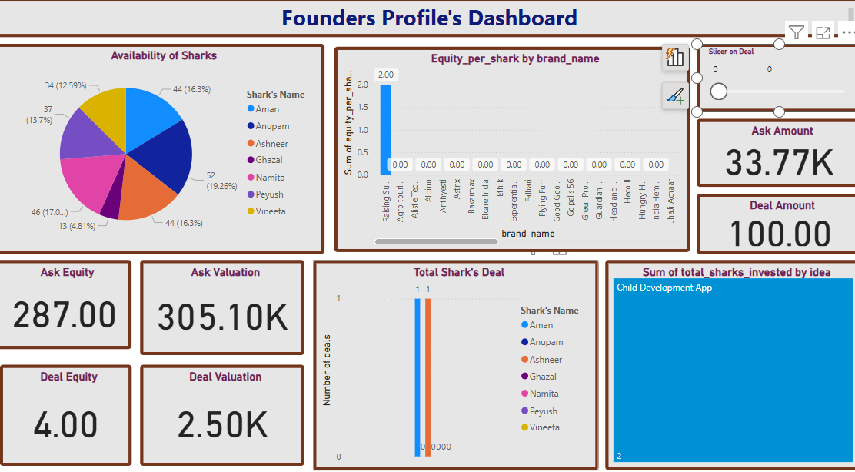

This dashboard reflects the pitch outcomes where founders **could not secure deals** from the sharks, highlighting patterns in ask values, shark availability, and startup ideas.

* **Deal Insights:**
* **Ask Amount**: ₹33.77K
* **Ask Equity**: 287
* **Ask Valuation**: ₹305.10K

Despite the founders’ high expectations in terms of equity and valuation, the actual **Deal Amount secured is only ₹100**, with **Deal Equity at 4%** and **Deal Valuation at ₹2.50K**, indicating **only one minimal deal closed**, with the rest being rejected or left without offers.

* **Founders’ Pitch Response:**
* Founders have **overestimated their equity demands** (287%), which is significantly high and likely unattractive to investors.
* The **huge gap between ask and deal values** implies **poor negotiation or low perceived value** by sharks.
* **Shark Availability vs Investment:**
* All sharks were **actively present**, with **Namita (19.26%)**, **Aman (16.36%)**, **Vineeta (16.36%)**, and **Peyush (17%)** being the most available.
* Despite availability, only **Aman and Anupam made 1 deal each**, highlighting **low conversion from presence to investment**.
* **Equity Offered by Brand:**
* Only **"Raising Superstars"** shows a marginal equity per shark (2.00), while **all other brands reflect 0**, confirming **no equity investment interest** from sharks for most pitches.
* **Ideas Not Funded:**
* The only notable idea to receive shark attention was the **Child Development App**, which attracted **2 sharks**, yet this too didn’t convert into a substantial deal.
* **Conclusion:**

The dashboard clearly indicates that **most founders failed to close deals** primarily due to **overvaluation, high equity ask, and limited pitch attractiveness**. Even with sharks being widely available, their investment interest was extremely limited. Founders need to:

* Present more **realistic valuations**
* Demonstrate **stronger business potential**
* Improve **pitch quality and clarity**

to secure shark backing in the future.