Industry-wise investor trends

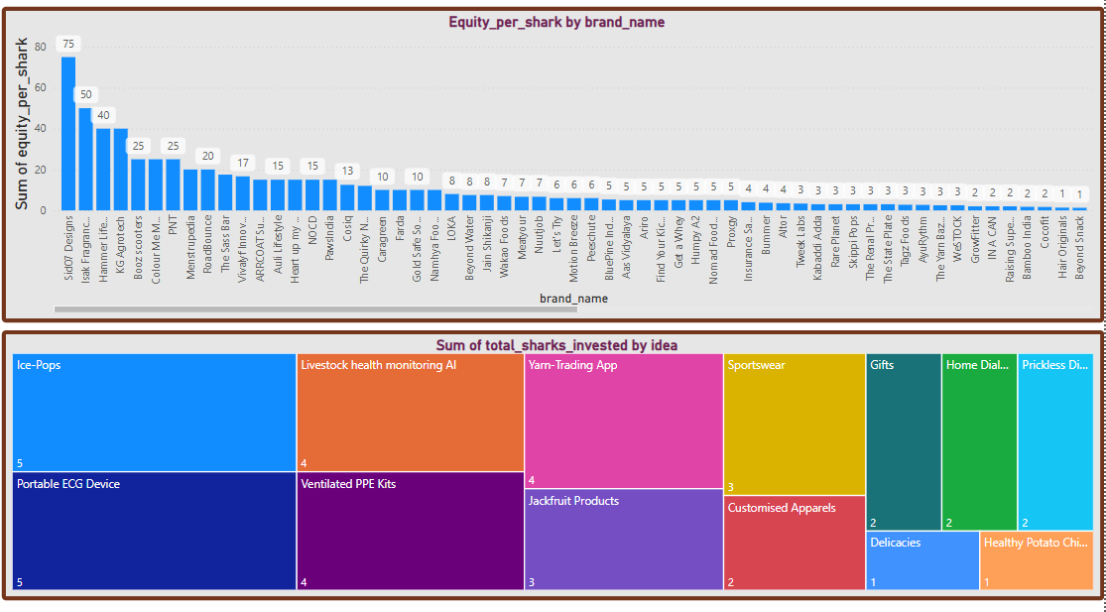

* **Industry-Wise Investor Trends**
* **Top Industries by Shark Investment (Total Equity per Brand)**

1. **FMCG/Consumer Goods:**
   * **ISOP Pops (75%)**, **Isak Fragrances (50%)**, **Humpy A2 Milk**, and **Namhya Foods** reflect high equity investments.
   * Indicates a strong investor inclination towards fast-moving, consumable products with mass appeal.
2. **Health & Wellness / Medical Tech:**
   * **Portable ECG Device**, **Livestock Health Monitoring AI**, and **Ventilated PPE Kits** saw investment from **4–5 sharks**, showing strong investor confidence in healthcare innovation.
3. **Fashion & Apparel:**
   * Brands like **Bozz Cross**, **Mettas Hospital Gowns**, and **Customized Apparels** have received equity investment, but usually from fewer sharks.
4. **Tech & Apps:**
   * Lower but notable engagement from investors in brands like **ARROTT (AI & IoT)**, **Yarn-Trading App**, and **Child Development App**.
   * Typically got equity offers between 15–25%.

* **Shark Interest by Idea:**

This section highlights the number of sharks interested per idea:

| **Idea / Product** | **Number of Sharks Invested** |
| --- | --- |
| Ice-Pops | : 5 |
| Portable ECG Device | : 5 |
| Ventilated PPE Kits | : 4 |
| Livestock Health Monitoring AI | : 4 |
| Yarn-Trading App | : 4 |
| Sportswear | : 3 |
| Jackfruit Products | : 3 |
| Gifts / Customised Apparels | : 2 |
| Home Dialysis / Priceless Dining | : 2 |
| Healthy Potato Chips / Delicacies | : 1 |

* **Insight**:
* **Health-tech and medical innovation** dominate the top interest zone.
* **FMCG and Food-based ideas** consistently attract multiple sharks.
* **Customized consumer goods** and **fashion** also receive attention, though to a lesser extent.
* **Key Takeaways**
* **Healthcare, Medical Tech, and Wellness** products are high-conviction areas for investors.
* **Mass-market consumables (FMCG)** such as snacks and beverages have a strong pull.
* **Customized and regional products** (e.g., regional foods, ethnic apparel) attract niche but committed investment.
* **Digital or niche tech solutions** (like the Yarn-Trading App) receive moderate attention, suggesting room for growth with clearer monetization strategies.