**Learners have to develop a Report to support the answers to the following questions and suggestions.**

**Objective Questions:**

1. In analysis the hospital dataset with Power BI, ensure data cleaning to address inconsistencies and missing values before further analysis.

ANS: There are 72% null values in the Hospital ER data at the patient_set_score column.

1. Assess the Average Waiting Time: Analyse the patient wait times to identify the average duration a patient spends before receiving care.

ANS: The average waiting time of the patient before receiving care in the hospital is 35.35

1. **Visits by Department Referral:** Calculate the total number of visits to each department based on referrals to understand which departments are most frequently visited.

ANS: from below data we can say that General Practice department is most visited departments among all.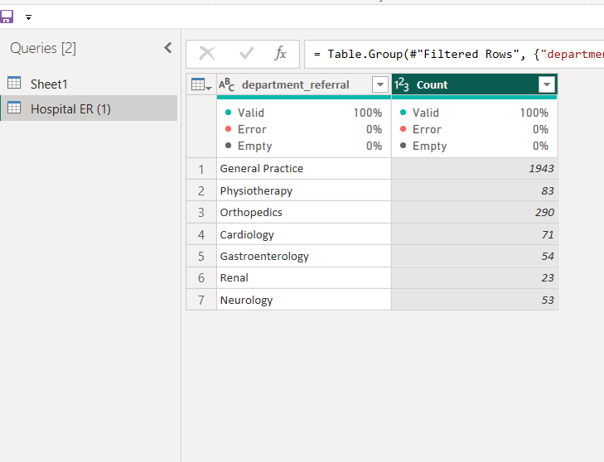

1. **Patient Visits by Age Group:** Segregate patient visits according to different age groups to see which demographics utilize healthcare services the most.

**Ans: patient having age group of 39 have utilize healthcare services the most.**

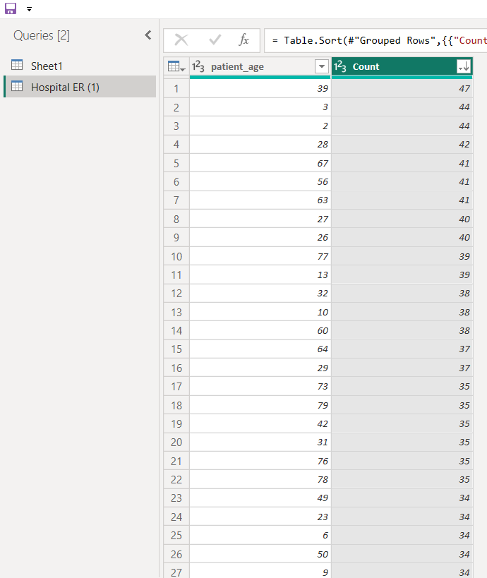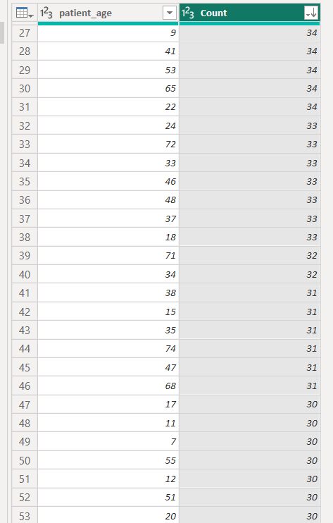

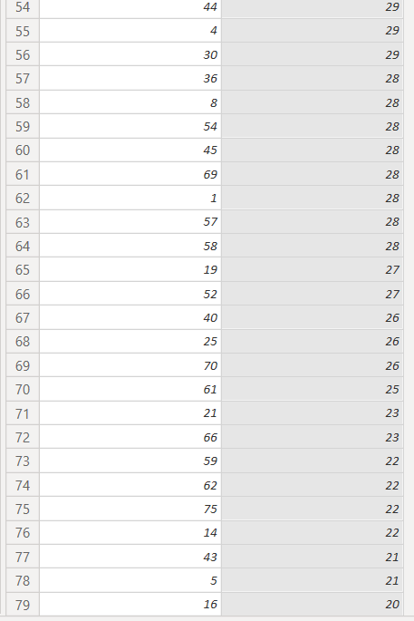

Patient having age group 39 has visited the hospital the most 47.

1. Were there any Null values in the data? What would be the best way to handle these Null values and which approach have you opted for?

ANS: Yes, there was null values in the Hospital ER data at the patient_set_score column.

The best way to handle those nulls are to remove it from the given data set.

I have clicked on data transformation tab and then click on filter buttons of patient_set_score column and uncheck null in the text filter list.

1. Is there any relation between the number of visits and the Gender of the patients?

ANS:

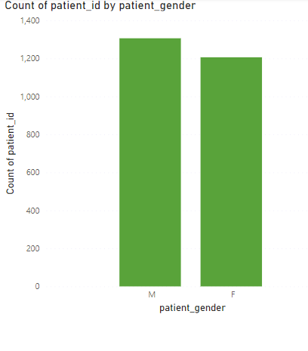

Number of male patients visited: 1306

Number of females patients visited: 1206

Number of females patients visited is less than no of male patients visited.

1. Average Satisfaction by Demographics: Determine the relationship between patient satisfaction scores, their age groups, and racial backgrounds to pinpoint areas for improvement in patient experience.

ANS: The average sat_score of pacific islander is high, the average sat_score of Two or more races is low. The over all relation is uniform.

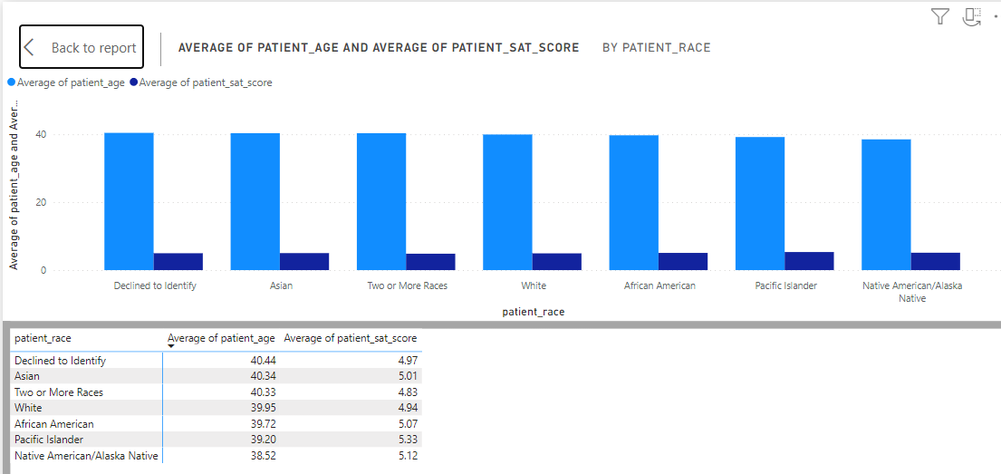

1. The hospital's managing director seeks to evaluate the revenue of each department to understand how much revenue is generated by each.

ANS : from the below chart we could say that orthopedics department has generated highest revenue that is 172939773 rupees.

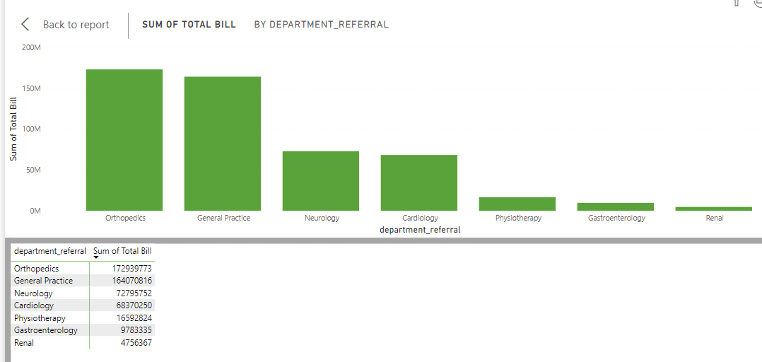

1. Which department is charging the highest appointment fees in general? Use an aggregation DAX function to solve this question.

ANS: Dax function is given below for highest appointment fees charging department.

Neurology is the highest fee charging department.

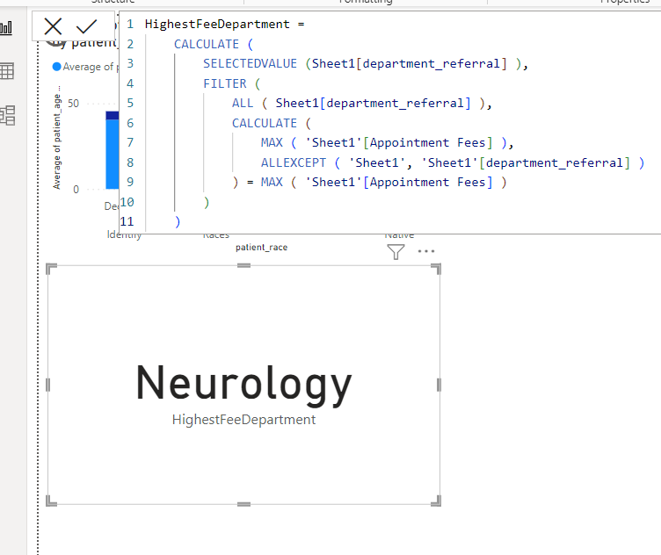

1. Create a tabular visualization in the Report view which consists of Month-wise total visits in the hospital. Add a third column in the table that consists of the previous month’s total visits for each month’s row. Also, include a column that states whether the visits in a month are greater than that of the previous month's visits.

Ans:

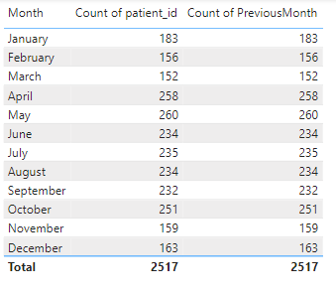

1. Using ‘Calculate’ and a row iteration DAX function calculate the total number of patients who have visited Dr. Smith.

ANS: The total no of patients visited Dr. smith is 5986

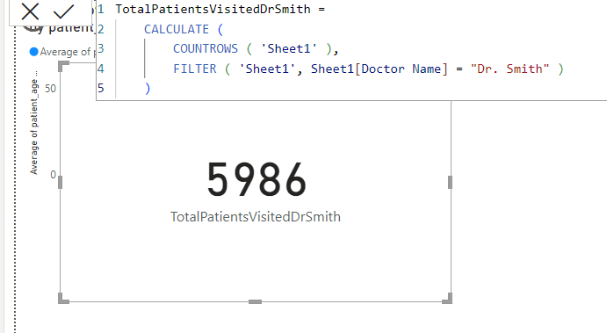

1. Calculate the average age of the patients who visit the Orthopedics department. Will the approach used to calculate this metric be different if the requirement had been all departments’ average age?

ANS: The average age of the patients visited Orthopedics department is 39.017

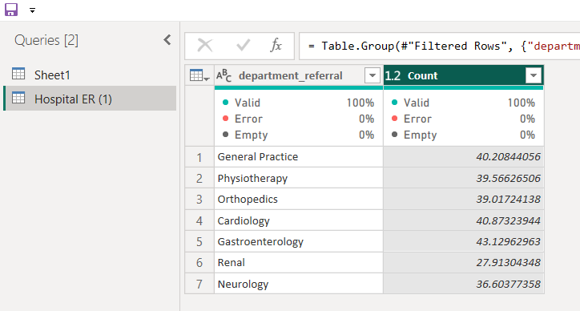

No, for that I have use Group By function in the transformation tab.

1. Were there any data format issues in the data, and if there were/are how you handle them?

ANS: Yes, There is data format issues in the date column of the data.

For that click on left side of the columns header and then a dialog box will appear and then

Select the write format of the data, it will automatically change it all.

1. When we add a column in Power Query what’s the code that comes in M language in the formula bar? What do you know about M-query?

ANS:

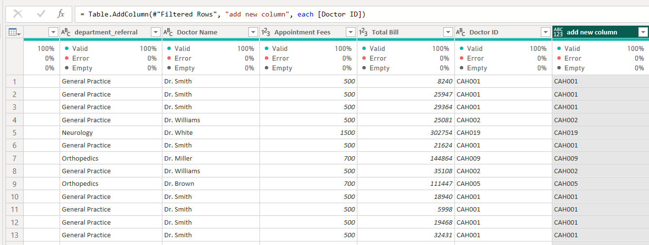

M Query, or Power Query Formula Language, is a data transformation language used in Power Query for Excel and Power BI. It connects to various data sources, transforms data through functions like filtering and merging, and allows custom function creation. It's known for its step-by-step approach and user-friendly interface.

**Subjective Questions**

1. What is the relation between patient wait time and satisfaction scores?

ANS:

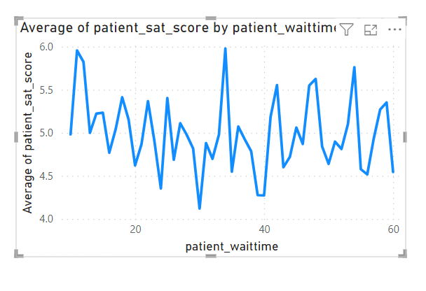

From the above line chart we can easily say that it is highly varying in nature.

Some patients has given a highly satisfaction score if there waiting time is low and some has given if there waiting time is between 20 to 40.

But, highest waiting time satisfaction score is medium between 4.5 to 5.5.

I could conclude that patients have less waiting time given higher satisfaction score as compare to patients having higher waiting time.

1. How do patient demographics affect the frequency of visits to different departments?

ANS: Yes, the demographic affect the frequency of the visits to the different departments. From the below charts I could say that, there are not any similarities and patterns between male and female patients of different races visiting departments.

It is a matter of surprise that in Native American/Alaska Native there is no any male patient of Gastroenterology , female patient of Neurology and female patient of Rental.

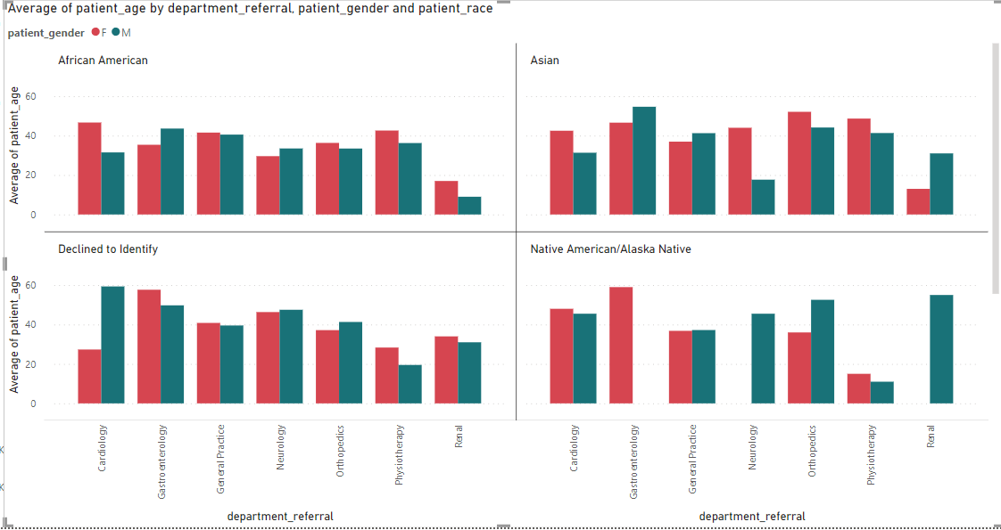

1. Is there a noticeable trend in the volume of patient visits throughout the year?

ANS: Yes, there is a noticeable trend in the volume of patient visited throughout the year.

In year 2019 there were 1197 patients visited the Columbia Asia Hospital.

In year 2020 there were 1315 patients visited the Columbia Asia Hospital.

To total percentage increase in the no of patients is 9.86%.

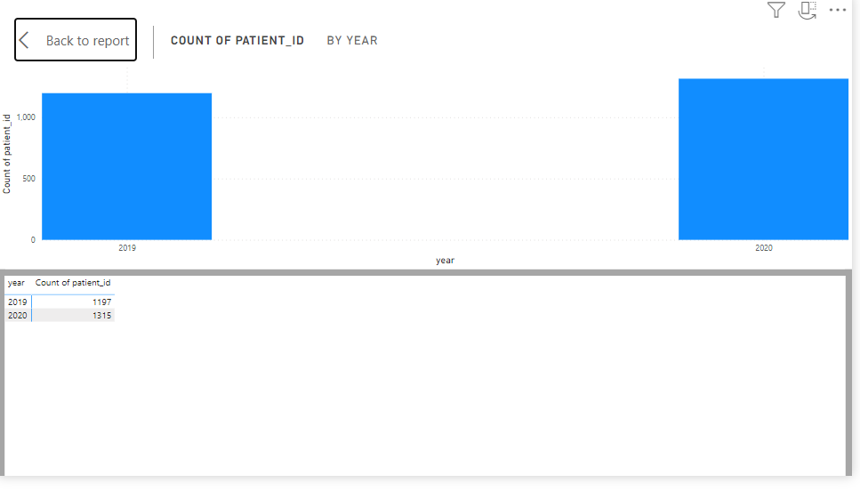

1. Which age groups report the highest and lowest satisfaction scores?

ANS: All age group have highest and lowest satisfaction scores.

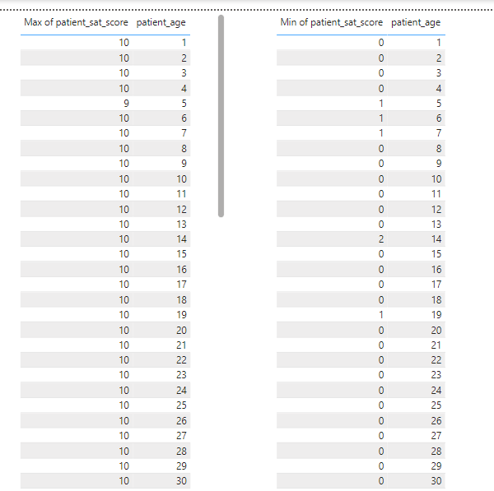

1. Say someone outside of the hospital claims that there is racial or gender-based discrimination in the hospital, how will you identify whether the claim was right or not?

ANS:

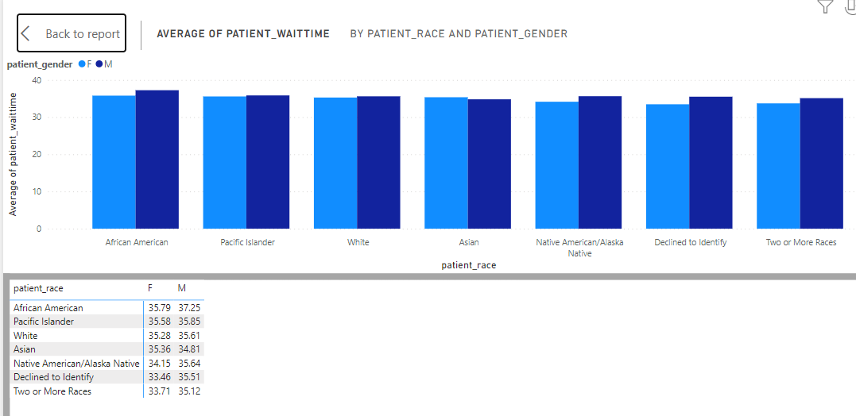

From the above clustered column chart, I could say that there is not any high variation in the column chart of male/female and respective races. So, there are not any discrimination happening here.

1. The hospital management intends to offer discounts to patients. How should these offers/discounts be assigned to patients, on what basis, and why?

ANS: Assigning discounts to patients in a hospital can be based on several factors, including the patient's financial status, the type of treatment or service required, the frequency of visits, and the hospital's overall pricing strategy. Here are some common approaches:

Financial Need: Hospitals may offer discounts to patients who demonstrate financial need, such as those who are uninsured or underinsured. This can be determined through a financial assessment process, where patients provide information about their income and expenses.

Insurance Coverage: Hospitals may offer discounts to patients based on their insurance coverage. For example, patients with high-deductible health plans or limited coverage for certain services may be eligible for discounts.

Treatment Type: Discounts can be assigned based on the type of treatment or service required. For example, hospitals may offer discounts for preventive care services to encourage patients to seek early treatment and avoid more serious health issues later on.

Frequency of Visits: Patients who require frequent visits or ongoing treatment may be eligible for discounts to help manage the cost of care over time.

Promotions and Offers: Hospitals may also offer discounts as part of promotional campaigns or special offers. For example, discounts may be offered for certain procedures during specific times of the year.

1. The hospital has a budget to hire 2-3 new doctors. They have asked for your suggestions on which departments they should hire.

ANS:

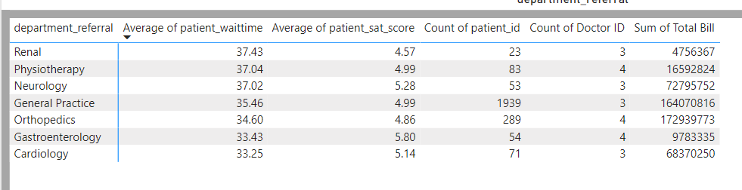

Renal: No of patients per doctors= 7

Physiotherapy: No of patients per doctors= 20

Neurology: No of patients per doctors= 17

General Practice: No of patients per doctors= 646

Orthopedics: No of patients per doctors= 72

Gastroenterology: No of patients per doctors= 13

Cardiology: No of patients per doctors= 23

Form the above analysis it is found that the no of patients in General Practice, Orthopedics per doctor is very high and revenue generated form this department is also very high as per all departments. Average waiting time of the patients is moderate and Average sat score is also moderate. So, it is my recommendation to appointment doctors form General practices and orthopedics department.

1. Is the hospital profitable? How will you determine the profitability?

Ans: The total revenue generated by Columbia Asia Hospital is 509309117 rupees and the total sum of appointment fee is 5347200.

For determining profitability I should have the data of total expances of hospital.

Because of lack of data, I could not determine the profitability.

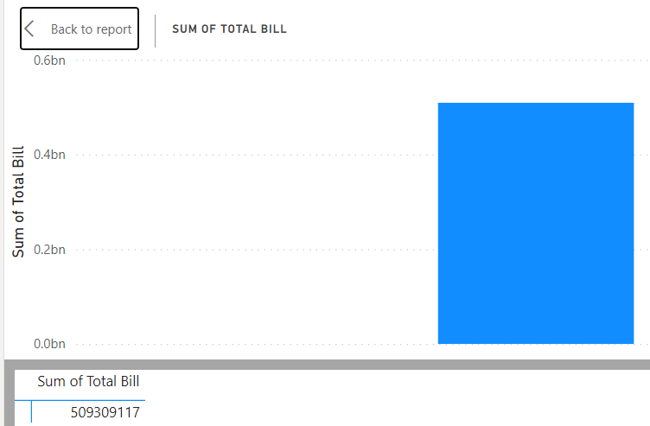

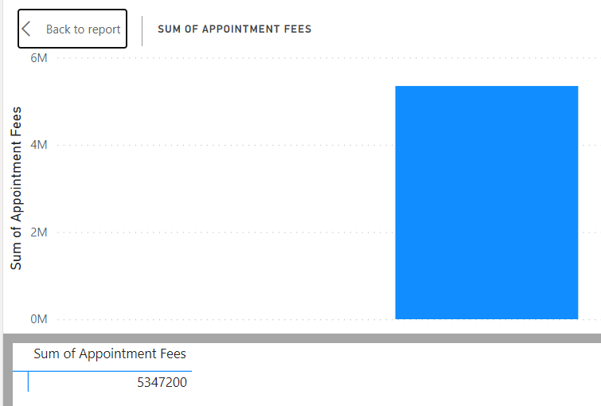

1. Any Department for which the waiting time is oddly large?

ANS: No

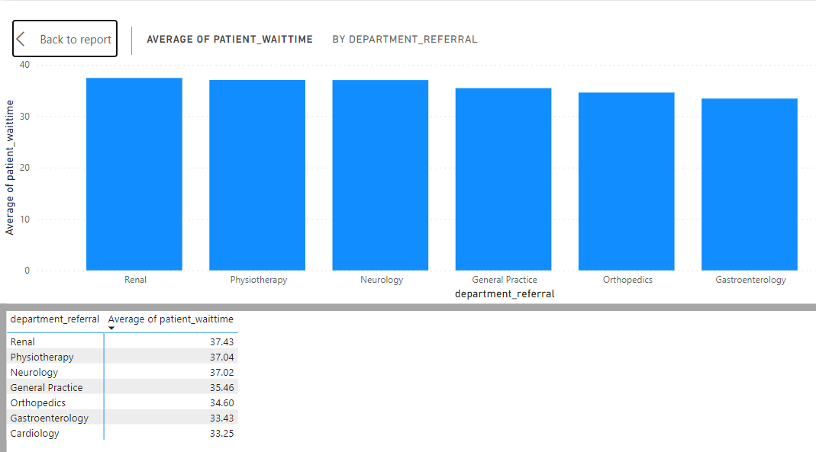

There is not any department having oddly large waiting period. But Renal and Physiotherapy departments have highest waiting period that is 37.43 and 37.04 respectively.

1. Come up with strategies to provide discounts to the patients.

ANS: Assigning discounts to patients in a hospital can be based on several factors, including the patient's financial status, the type of treatment or service required, the frequency of visits, and the hospital's overall pricing strategy. Here are some common approaches:

Financial Need: Hospitals may offer discounts to patients who demonstrate financial need, such as those who are uninsured or underinsured. This can be determined through a financial assessment process, where patients provide information about their income and expenses.

Insurance Coverage: Hospitals may offer discounts to patients based on their insurance coverage. For example, patients with high-deductible health plans or limited coverage for certain services may be eligible for discounts.

Treatment Type: Discounts can be assigned based on the type of treatment or service required. For example, hospitals may offer discounts for preventive care services to encourage patients to seek early treatment and avoid more serious health issues later on.

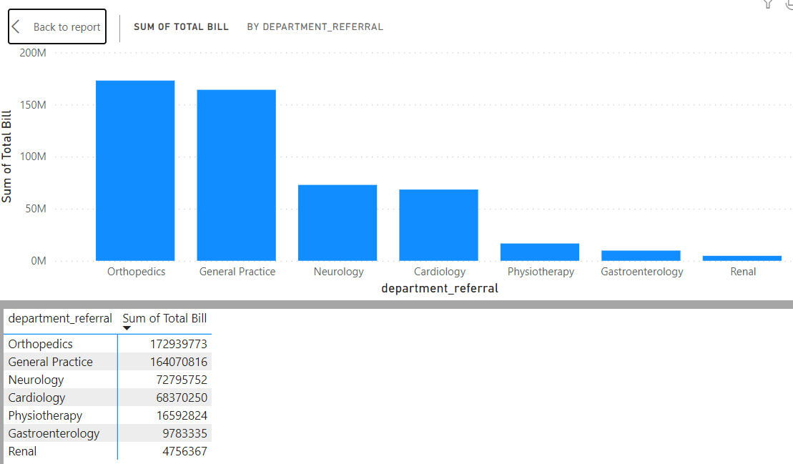

Frequency of Visits: Patients who require frequent visits or ongoing treatment may be eligible for discounts to help manage the cost of care over time.

Promotions and Offers: Hospitals may also offer discounts as part of promotional campaigns or special offers. For example, discounts may be offered for certain procedures during specific times of the year.

1. Say you need to align the doctors of the “General Practice” department to work in one of the two shifts, how will you identify what will these two shifts' timings be, and how will you divide the doctors in these two shifts? And also will this 2 shift policy be helpful for the hospital?

ANS: There are 3 doctors in General practice department.

1. Dr. Johnson
2. Dr. Smith
3. Dr. Williams

From the below chart we can see that sum of total bill is at pick at day time that is 8 AM to 8 PM. So, 2 shift policy will definitely would be helpful for the hospital and also for the doctors for balancing their personal life.

1. At day shift 8 AM to 8PM Dr. Johnson and Dr. Smith will be on duty,
2. At night shift 8 PM to 8 AM Dr. Williams will be on duty

And after one week one day shift doctor will go in night shift and one night shift doctor will come in day shift.

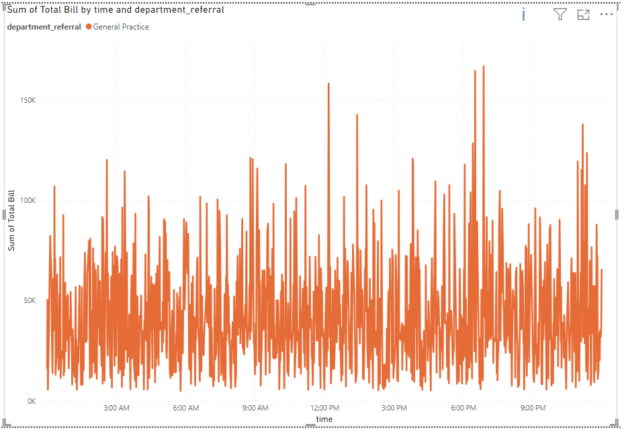

1. What do you understand by PowerBI gateway? What are its use cases?

ANS: Power BI Gateway is a tool that allows you to connect on-premises data sources to Power BI service in the cloud. It acts as a bridge, providing secure data transfer between your on-premises data sources and the Power BI service. There are two types of Power BI Gateways:

On-premises data gateway (personal mode): This gateway is used for scenarios where only one user needs to connect to on-premises data sources from Power BI, such as for personal reports.

On-premises data gateway (standard mode): This gateway is used when multiple users need to connect to on-premises data sources from Power BI, such as for organizational reports and dashboards.

Use cases of Power BI Gateway include:

Direct Query: When you want to use Direct Query mode to connect to on-premises data sources for real-time data visualization in Power BI.

Scheduled Refresh: When you want to schedule automatic data refreshes for datasets stored in on-premises data sources.

Live Connection: When you want to establish a live connection to on-premises data sources for interactive analysis and reporting in Power BI.

Data Sources: When you want to connect to on-premises data sources like SQL Server, MySQL, Oracle, etc., that are not accessible from the internet.

Security: When you need to ensure that data transfers between on-premises data sources and Power BI service are secure and compliant with organizational security policies.

Overall, Power BI Gateway enables you to leverage the capabilities of Power BI while securely connecting to on-premises data sources, ensuring that your reports and dashboards are always up-to-date with the latest data.

1. How would you approach this problem, if the objective and subjective questions weren't given?

ANS: If the objective and subjective questions were not given for dashboard creation, I would approach the problem by following these general steps:

Define the Purpose: Understand the main goal of the dashboard. Is it to monitor sales performance, track operational metrics, analyze marketing campaigns, or something else?

Identify Key Metrics: Determine the key performance indicators (KPIs) that are relevant to the goal of the dashboard. These could include metrics like sales revenue, customer acquisition cost, conversion rates, etc.

Gather Data: Collect the data needed to calculate the KPIs. This data could come from various sources such as databases, spreadsheets, APIs, etc.

Clean and Prepare Data: Clean the data to remove any inconsistencies or errors. Transform the data into a format that is suitable for analysis and visualization.

Design the Dashboard: Decide on the layout and visualizations that will best convey the insights from the data. Use charts, graphs, tables, and other visual elements to present the data in an easy-to-understand manner.

Create the Dashboard: Use a tool like Power BI to create the dashboard. Import the cleaned and prepared data into the tool and create the visualizations according to the design.

Iterate and Refine: Review the dashboard with stakeholders and gather feedback. Make any necessary changes to improve the clarity and effectiveness of the dashboard.

Publish and Share: Once the dashboard is finalized, publish it to a platform where stakeholders can access it. Set up automated refresh schedules if the data needs to be updated regularly.

Monitor and Maintain: Continuously monitor the dashboard to ensure that it remains relevant and useful. Update the dashboard as needed to reflect changes in the underlying data or business requirements.

1. Can you analyze and write the type of relationship between the doctor id and department, is it one-to-one?

ANS: No, it is many to many relationships.

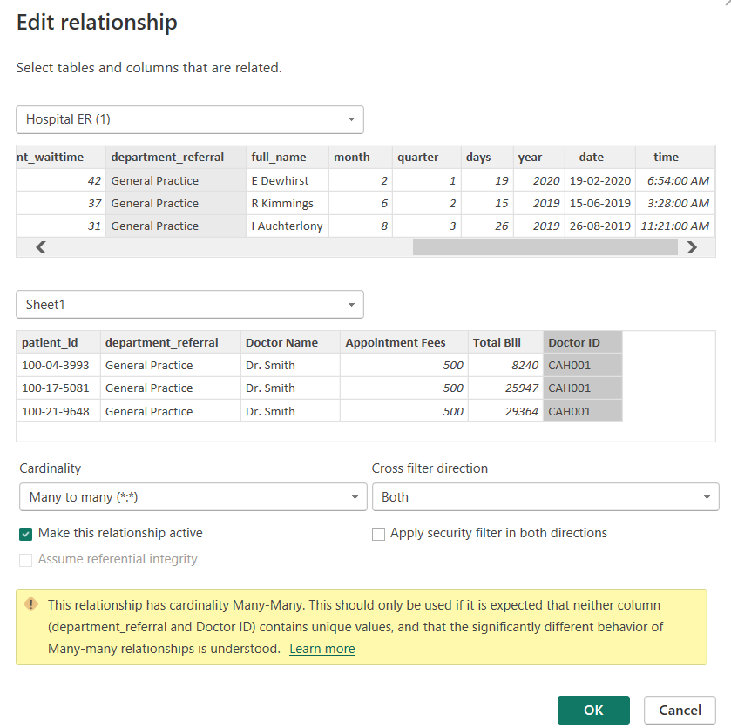

**Report**

The hospital has asked for a report with three tabs:

* Main Tab
* Doctors’ Tab
* Patients’ Tab
* **Using the Main tab in the report,** the hospital should be able to look at the overall metrics like the number of daily visits, revenue produced on that day, customer satisfaction, how busy are different departments on that day, and general waiting time on that day. This tab should have a slicer of date.
* **Using the Doctors’ Tab,** the Chief Of Staff at the hospital should be able to look at the individual doctor’s performance metrics like customer satisfaction, the number of patients he was visited by, the revenue he has generated, and his appointment fees. This tab should have a slicer of the Doctor's Name or ID.
* **Using the Patients’ Tab,** the Patient’s Care Chief at the hospital wants to look at a customer’s profile which would involve metrics like the most frequently visited department, their age, their race, their waiting time, number of visits, the total amount that they have paid to the hospital, etc. All the metrics using which they can address the patient very carefully in their visits. This tab should have a slicer of the Patient's Name or ID.

**Make sure that all the visualizations look decent and are placed in a proper order. Each tab has different POCs (Point Of Contact), so make sure you involve all the metrics that POC may look at in that tab along with those mentioned in the tab description.**

**After making the report on the Desktop ensure that it is hosted on PowerBI service and use the hosted link for submission of the dashboard and mentioning on the resume.**