**Project Report on**

**“Online Voting System”**

***Submitted to***

**SCHOOL OF INNOVATION & TECHNOLOGY**

**By**

**Keshabananda Konwar (MCA 3rd Semester)**

**Registration no - 22T41001(2022-2024)**

***In partial fulfillment of the requirement for the award of the degree***

**Of**

**MASTER OF COMPUTER APPLICATIONS**



**SCHOOL OF INNOVATION & TECHNOLOGY**

**ASSAM RAJIV GANDHI UNIVERSITY OF COOPERATIVE MANAGEMEN JOYSAGAR,**

**BASIC TINALI ASSAM, INDIA.**

DECLARATION

I hereby declare that the project report entitled **“ONLINE VOTING SYSTEM”** submitted by me to the **School of Innovation and Technology**, **Assam Rajiv Gandhi University of Cooperative Management** in fulfillment of the requirements for the award of **Master of Computer Application** is a confide record of the work carried out by me.

I further declare that the work reported in here, has not been submitted and will not be submitted, either in part or in full, for the award of any other degree or diploma of this institute or of any other institute or University.

Keshabananda Konwar

Roll No – MCA/02

Registration no-22T41001

MCA 3rd Semester

Batch (2022-2024)

ACKNOWLEDGEMENT

It is my privilege to express my sincere regards and gratitude to **School of Innovation and Technology, ARGUCOM** for providing me opportunity to work on such relevant project and guiding me to the successful competition of the report on **Online Voting System of ARGUCOM** for the fulfillment of the requirements leading to the award of MCA degree.

I deeply express my sincere thanks for their valuable inputs, able guidance, encouragement, whole-hearted cooperation and constructive criticism throughout the duration of the study which ensures the worthiness of my work.

I take this opportunity to thank all our faculty members who have directly or indirectly helped us and also thank our friends and family for their cooperation and support throughout. Without them this work would never have been possible.

Keshabananda Konwar

Roll No – MCA/02

Registration no-22T41001

MCA 3rd Semester

Batch (2022-2024)



**Assam Rajiv Gandhi University of Cooperative Management**

(A Govt. of Assam University)

Recognized by UGC and member of Association of Indian Universities

Basic Tinali, Gadadhar Nagar, Joysagar, Sivasagar

Email: [info.argucom@gmail.com](mailto:info.argucom@gmail.com)

*Faculty Associate*

*SIT, ARGUCOM*

*Email:*

*Ph:*

.

CERTIFICATE

This is to certify that **Keshabananda Konwar** student of **Master of Computer Application**, Department of **School of Innovation & Technology** of **Assam Rajiv Gandhi University of Cooperative Management**, have persuade the project entitled “**Online Voting System *of ARGUCOM***” under the guidance of myself and the report has been submitted in partial fulfilment of **Master of Computer Application Third Semester, Minor Project by Assam Rajiv Gandhi University of Cooperative Management in the year 2023.**

Faculty Associate

School of Innovation &Technology

Assam Rajiv Gandhi University of Cooperative Management,

Sivasagar, Assam

(Internal Guide)



**Assam Rajiv Gandhi University of Cooperative Management**

(A Govt. of Assam University)

Recognized by UGC and member of Association of Indian Universities

Basic Tinali, Gadadhar Nagar, Joysagar, Sivasagar

Email: [info.argucom@gmail.com](mailto:info.argucom@gmail.com)

*Ranjan Sarmah*

*Asst. proof. & Head (i/c)*

*SIT, ARGUCOM*

*Email:* [*sarmah.ranjan@gmail.com*](mailto:mahanta.ankur12@gmail.com)

*Ph: 9435156782*

CERTIFICATE

This is certify that the project entitled “**Online Voting** **System *of ARGUCOM***” is submitted by **Keshabananda Konwar, Roll No-MCA/02, Registration No-22T41001, Batch (2022-2024)** in partial fulfilment of Master of Computer Application Third Semester, Minor Project of **Assam Rajiv Gandhi University of Cooperative Management**, Sivasagar, Assam , during the year 2023.This work has been found satisfactory and is approved for submission.

Dr. Ranjan Sarmah

HOD (i/c) & Assist Prof, SIT

Assam Rajiv Gandhi University of Cooperative Management,

Sivasagar, Assam

CERTIFICATE

This is to certify that **Keshabananda Konwar, Roll No-MCA 02, Registration No-22T41001, Batch (2022-2024)** a student of **Master of Computer Application** 3th Semester, **School of Innovation and Technology**, **Assam Rajiv Gandhi University of Cooperative Management** has successfully completed and defended the Major Project entitled “**Online voting** **System”*.***

I wish her all the success in her endeavours.

External Examiner

|  |  |
| --- | --- |
|  |  |
|  |  |

TABLE OF CONTENT

|  |  |  |
| --- | --- | --- |
| Declaration | | i |
| Acknowledgement | | ii |
| Certificate from Internal Guide | | iii |
| Certificate from External Guide | | iv |
| Certificate | | v |
| List of Figures | | ix |
|  | |  |
| **CHAPTER 1: INTRODUCTION** | |  |
| 1.1 About the project | | 1 |
| 1.2 Overview | | 1 |
| 1.3 Objective of the project | | 1 |
| 1.4 Drawback of the existing System | | 1 |
| 1.5 Need for a new system | | 2 |
| 1.6 System Requirement | | 2 |
| 1.6.1. Hardware Requirement | | 2 |
| 1.6.2. Software Requirement | | 2 |
| 1.7. Feasibility Studies | | 3 |
| 1.7.1. Technical Feasibility | | 4 |
| 1.7.2. Operational Feasibility | | 4 |
| 1.7.3. Economic Feasibility | | 5 |
| CHAPTER 2 METHODOLOGY | |  |
| 2.1 Introduction | | 6 |
| 2.2 Work Process | | 6 |
| 2.2.1 Methodology Used | | 6 |
| 2.2.2 Analysis Model | | 7 |
| 2.3 Merit | | 7 |
|  | |  |
| **CHAPTER 3: SYSTEM ANALYSIS AND DESIGN** | |  |
| 3.1. Introduction | | 12 |
| 3.1.1 Structured Analysis | | 12 |
| 3.1.2. Context Diagram | 13 | |
| 3.1.3. Data Flow Diagram | 13 | |
| 3.2. Software Requirements and Specification (SRS) | 18 | |
| 3.3. Design | 18 | |
| 3.4.1. Introduction | 18 | |
| 3.4.2. Objective | 19 | |

|  |  |  |
| --- | --- | --- |
| 3.4.2.1. Logical Design | | 19 |
| 3.4.2.2. Physical Design | | 19 |
| 3.4.2.3. User Interface Design | | 19 |
| 3.4.2.4. Schema Design (entity-Relationship Diagram) | | 19 |
| 3.4.3. Database Design | | 20 |
| 3.4.4. Table Structure  3.4.5. Work Breakdown Structure  3.4.6. Gantt Chart | | 21  20  21 |
|  |
| **CHAPTER 4: IMPLEMENTATION** | |  |
| 4.1. Screen Shots | | 27 |
| 4.2. Testing | | 32 |
| 4.2.1. Black Box Testing | | 33 |
| 4.2.2. White Box Testing | | 33 |
| 4.2.3. Security Testing | | 33 |
| 4.2.4. Validation Testing | | 34 |
| 4.2.5. Integrated Testing | | 35 |
| 4.2.6. Unit Testing | | 35 |
| **CHAPTER 5: CONCLUSION & FUTURE WORK** | |  |
| 5.1. Introduction | | 36 |
| 5.2. Conclusion | | 36 |
| 5.3. Limitations | | 37 |
| 5.4. Future Work | | 38 |
| **BIBLIOGRAPHY** | | 39 |

**CHAPTER 1**

**INTRODUCTION**

* 1. ABOUT THE PROJECT:

In “Online Voting System” a voter can use his/her voting right online without any difficulty. He/she has to register first for him/her to vote manually.

After registration, voter is assigned a secret login ID and password with which he\she can use to log into the system and enjoy services provided by the system such as voting. If invalid /wrong password or ID details are submitted, then the system will not permit that student to vote.

* 1. Overview

An “Online Voting System” is a software platform that allows groups to securely conduct votes and election. High –quality online voting systems balance ballot security, accessibility, and the overall requirements of an organization voting event.

* 1. OBJECTIVE OF THE PROJECT:

The specific objective of the project includes:

* Reviewing the existing /current voting process;
* Coming up with an automated voting system;
* Implementing an automated/online voting system;
* Validating the system to ensure that only legible voters are allowed to vote.
  1. Drawback of Existing System

There is no such Annual Appraisal Report Management System deployed in ARGUCOM yet. The present system is completely offline.

* Time-consuming Problem.
* Compulsory to come University.

1.5 Need for a new System

* Online Process works will fast.
* Online Process will reduce the time Period.
* Paper work to be removed.
* Information stored in the database, which provides data security.

**1.6 SYSTEM REQUIRMENT:**

* + 1. **Hardware requirements:**

|  |  |
| --- | --- |
| Processor | Pentium |
| RAM | 4 GB |
| Disk Space | 10 GB of Available Hard Disk |
| Graphic | DirectX 11-Capable Video Card |
| Display | 1024 X 768 or Higher Resolution |

* + 1. **Software requirements**

|  |  |
| --- | --- |
| Operating System | Windows 7 or Later |
| Front End | HTML, CSS, JavaScript |
| Back End | PHP |
| Library/ Framework | CSS, JQuery, Bootstrap, Font Awesome |
| Code Editor | Visual Studio Code , Atom |
| Database | MySQL |
| Web Server | Apache |
| Web Browser | Google Chrome |

**1.6.3 Language**

***1.6.3.1 PHP***

PHP is a server-side scripting language that is used to develop Static websites or Dynamic websites or Web applications. PHP stands for Hypertext Pre-processor, that earlier stood for Personal Home Pages. PHP scripts can only be interpreted on a server that has PHP installed.

* + - 1. ***HTML***

HTML (Hypertext Markup Language) is the set of markup symbols or codes inserted in a file intended for display on a World Wide Web browser page. The markup tells the Web browser how to display a Web page's words and images for the user. Each individual markup code is referred to as an element (but many people also refer to it as a tag). Some elements come in pairs that indicate when some display effect is to begin and when it is to end.

***1.6.3.3 CSS***

Cascading Style Sheets (CSS) are a collection of rules we use to define and modify web pages. CSS are similar to styles in Word. CSS allow Web designers to have much more control over their pages look and layout. For instance, you could create a style that defines the body text to be Verdana, 10 points. Later on, you may easily change the body text to Times New Roman, 12 points by just changing the rule in the CSS. Instead of having to change the font on each page of your website, all you need to do is redefine the style on the style sheet, and it will instantly change on all of the pages that the style sheet has been applied to. With HTML styles, the font change would be applied to each instance of that font and have to be changed in each spot.

CSS can control the placement of text and objects on your pages as well as the look of those objects.

***1.6.3.4 JavaScript***

JavaScript is a lightweight object-oriented scripting language which is generally used in making or development of scripting webpage. It is an interpreted full- fledged programming language that enables dynamic interactivity on websites.

* 1. Feasibility studies

A feasibility study is defined as an evaluation or analysis of the potential impact of a proposed project or program. A feasibility study is conducted to assist decision makers in determining whether or not to implement a particular project or program. The feasibility study is based on extensive research on both the current practices and the proposed project or program and will contain extensive data related to financial and operational impact.

The main objective of the feasibility study is to test the Technical, Operational and Economical feasibility for adding new modules and debugging old running system. All system is feasible if they are unlimited resources and infinite time.

* + 1. **Technical Feasibility**

The technical issue usually raised during the feasibility stage of the investigation includes the following:

* Does the necessary technology exist to do what is suggested?
* Do the proposed equipment’s have the technical capacity to hold the data required to use the new system?
* Will the proposed system provide adequate response to inquiries, regardless of the number or location of users?
* Can the system be upgraded if developed?
* Are there technical guarantees of accuracy, reliability, ease of access and data security?

The current system developed is technically feasible. It is a web-based user interface. Thus, it provides an easy access to the users. The database’s purpose is to create, establish and maintain a workflow among various entities in order to facilitate all concerned users in their various capacities or roles. Permission to the users would be granted based on the roles specified. Therefore, it provides the technical guarantee of accuracy, reliability and security. The software and hard requirements for the development of this project are not many and are available as free as open source. The work for the project is done with the current equipment and existing software technology. Necessary bandwidth exists for providing fast feedback to the users irrespective of the number of users using the system.

* + 1. **Operational Feasibility**

Proposed projects are beneficial only if they can be turned out into information system. That will meet the organization’s operating requirements. Operational feasibility aspects of the project are to be taken as an important part of the project implementation. Some of the important issues raised are to test the operational feasibility of a project includes the following: -

* Is there sufficient support for the management from the users?
* Will the system be used and work properly if it is being developed and implemented?
* Will there be any resistance from the user that will undermine the possible application benefits?

This system is targeted to be in accordance with the above-mentioned issues. Beforehand, the management issues and user requirements have been taken into consideration. So there is no question of resistance from the users that can undermine the possible application benefits.

The well-planned design would ensure the optimal utilization of the computer resources and would help in the improvement of performance status.

* + 1. **Economic Feasibility**

A system can be developed technically and that will be used if installed must still be a good investment for the organization. In the economic feasibility, the development cost in creating the system is evaluated against the ultimate benefit derived from the new systems. Financial benefits must equal or exceed the costs.

The system is economically feasible. It does not require any addition hardware or software. Since the interface for this system is developed using the existing resources and technologies available. There is nominal expenditure and economic feasibility for certain.

CHAPTER 2

METHODOLOGY

* 1. Introduction

In order to achieve the objectives and coming up with the Online Voting System of ARGUCOM, the preliminary investigation about the workability of the software is necessary and need to be carried out first. This chapter discusses the different research and methodology and the software development methodologies that are to be considered for this project and the ones that are to be used in the development of this project. The term methodology refers to a systematic way of carrying out all the activities, by providing a framework of development. The details of the different methodologies that can be used for this project. Software development methodologies help the development team structure their work in a timely and effective way.

* 1. Work Process

1. **Methodology Used**

Waterfall methodology was used to develop this project.

The waterfall methodology also known as the Waterfall model is a sequential development process that flows like a waterfall through all phases of a project, with each phase completely wrapping up before the next phase begins.

1. **Analysis Model**

There are five stages to analyze the model-

* + - 1. ***Requirements***

In this stage all the information required to develop this project are being gathered. All the key attributes required to design the Online Voting System of ARGUCOM are gathered.

* + - 1. **Design**

In this stage, a technical solution to the problems set out by the product requirements, including scenarios, page layouts, and database design has been laid out.

* + - 1. **Implementation**

Once the design is complete, technical implementation starts and coding parts of the project are carried out.

* + - 1. **Testing**

Before a system can be released to use, testing needs to be done to ensure the product has no errors and all of the requirements have been completed, ensuring a good user experience with the system.

* + - 1. **Deployment and maintenance**

Once the software has been deployed in the market or released to customers, the maintenance phase begins. As defects are found and change requests come in from users, a team will be assigned to take care of updates and release new versions of the software.

* 1. Merits
     + Developers can catch design errors during the analysis and design stages, helping them to avoid writing faulty code during the implementation phase.
     + The total cost of the project can be accurately estimated, as can the timeline, after the requirements have been defined.

CHAPTER 3

SYSTEM ANALYSIS & DESIGN

* 1. Introduction

The analysis of the project begins with a series of modeling tasks. The analysis model achieves two primary objectives:

* To establish a basis for the creation of a software design, and
* To define a set of requirements that can be validated once the software is built.

Two dominant analysis modeling method are very common: -

1. Structured Analysis
2. Object Oriented Analysis

In this project, the structured analysis method is used.

1. Structured Analysis

Structured Analysis is a set of techniques and graphical tools that allows the analysis to develop a new kind of system. Various structured analysis tools are used with certain methodologies to describe the system, e.g., Data Flow Diagrams, Decision Tables, and Structured Charts etc.

The main features of structured analysis are:

1. It is graphical. The DFD, for example, depicts a picture of what being specified and makes it conceptually easy to understand the logic of the application.
2. The process is portioned so that we have a clear picture of progression from general to specific in the system flow.
3. It is logical rather than physical. The element of the system doesn’t depend on the hardware. They specify the system in a precise, concise and highly readable manner.
4. It collects for the rigorous study of the user area, a commitment that is often taken lightly in the traditional from system analysis.
5. Certain Task that is normally carried out late in the system development cycle is moved to the analysis phase. For example, user’s procedures are documented during analysis rather in the application.

The end of structured analysis produces a structured specification that uses several basic tools such as:

1. Context Diagram

2. Data Flow Diagram

3. Data Dictionary

1. Context Diagram

A context diagram is a data flow diagram by which the whole system is modeled by one process. It shows all the external entities and the system.

Actually, the system shown by the context diagram doesn’t describe the system in detail. For more details it is necessary to identify the major system processes and the data flow between them. Such a diagram is called a Top-Level DFD. We can go on expanding each process of the top-level DFD into a more detailed DFD.

* + 1. Data Flow Diagram

The Data Flow diagram is a graphical representation tool, which has the purpose of clarifying the system requirements and identifying major transformation that will become programs in the system design. A DFD consists of a series of bubble joined by the lines. The represents data transformations and lines represent data flows in the system. It depicts the information flow and transformation that occurs as data moves from input top output. The DFD provides a mechanism for functional modeling as well as information glow modeling.

The following diagram illustrates notations and symbols used to construct DFD: -

|  |  |
| --- | --- |
|  | External Entity |
|  | A process |
|  | Data in Flow |
|  | Data storage |
|  | Reports or outputs from the system |

Figure 3.1 DFD Symbols

**Figure: 3.2 Level 0 DFD**

**Candidate**

**Admin**

**Student**

**Figure 3.3 Level 1 DFD (Admin side)**

**ADMIN**

Check for login

candidate

position

View result

semester

courses

election

admin

voters

Reply

Confirm/cancel request

Reply

Reply

Reply

del/update data

Add/update data

Reply

Add/update data

department

Reply

Add/update data

Add/update data

Reply

Reply

Add/update data

add/delete data

Reply

Reply

admin

**Figure 3.3 Level 1 DFD (Voter side)**

Reg/update data

Insert/update data

voters

**ADMIN**

response

reply

candidate

Req for candidate

Insert data

response

reply

Apply vote

Insert data

vote

response

reply

Send feedback

Insert data

response

query

reply

3.2 Software Requirements and Specification (SRS)

The Software Requirements Specification document is developed as a consequence of analysis. The function and performance allocated to software as part of system engineering and refined by establishing a complete information description, a representation of system behavior, an indication of performance requirements and design constraints, appropriate validation criteria, and other information pertinent to requirements.

The introduction of the software requirements specification states the goals and objectives of the software.

* 1. SRS-Design

Software design is actually a multistep process that focuses on four distinct attributes of a program- Data Structure, Software Architecture, Interface Representations and Procedural (Algorithmic) Detail. The design process actually translates requirements into a representation of the software that can be accessed for quality before code generations begins. The design is documented and is part of the software configuration.

Design begins by using identified system problem as a basis for developing objectives for the new system. It then proposes a system that satisfies these objectives.

1. **Introduction**

The most creative and challenging phase of the system life cycle is system design. It refers to the technical specification that will be applied in implementing the candidate system. System design specifies how the system will achieve the objective of the proposed system.

1. **Objective**

To design a new system that fulfills the requirement of the Project.

System design goes through the following phase of development:

1. **Logical design**

Logical system design involves developing general specification for how the basic information system activities such as input, process, output, storage and control can meet user requirements.

1. **Physical Design**

Physical design involves the detail design of the user interface methods and products, database structure, processing and control procedures.

1. **User interface design**

The first step in the interface design activity focuses on the preparation of input and the design of output reports in a form acceptable to the users.

User interface design consists of two steps input design and output design.

1. **Schema design (entity relationship diagram)**

The most important consideration is the database design is to how to store the information. The various applications and procedures that will use the database introduce requirements upon the structure of data.

In the relational database, the data on the relationships are represented as collection of tables.

The first in creating a database is designing. First plan, what tables we require and what they will contain. It also determines how the tables are related. These are the most important steps and require a careful consideration.

It should be determined that information we to store about things(entities) and how they are related(relationship).a useful technique is designing the database is to draw the pictures of tables. The graphical display of database is called Entities-Relationship Diagram. It is a popular high-level conceptual data model. This model and its variation are frequently used for conceptual design of database design tools employ its concepts.

1. **Database design**

The general purpose of database is to handle information as an integrated whole. A database is a collection of interrelated data, Stored with minimum redundancy. In database design, several objectives are considered.

1. Control redundancy’s unique of database design is starting data only once, which redundancy and improves performance.
2. Easy to learn and use.
3. Data independence.
4. Accuracy and integrity.
5. Performance improvement.

6. Privacy and security.

A database can be thought of as a set of logically related files organized to facilitate access by one or more applications programs and to minimize the data redundancy. In fact, a database is defined as a stored collection of data, organized on the basis of relationships in the data rather than the convenience of storage structures; it is not a replacement of files.

The cost of storing and retrieving the data has been kept minimum by reducing the unnecessary data and repetition of similar data.

1. **Table Structure**

Table 3.1. Admin Table

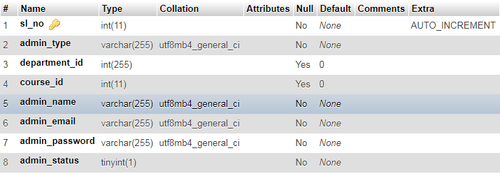

Table 3.2 Candidate Table

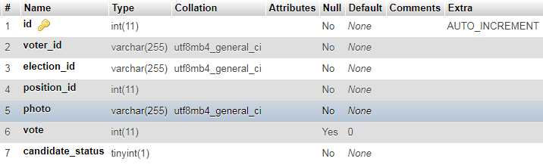

Table 3.3 Query table

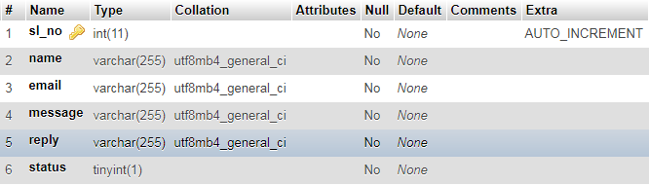

Table 3.3 Department table

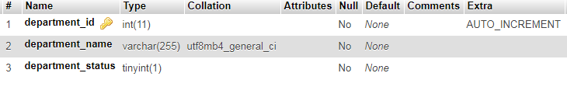

Table 3.3 Course table

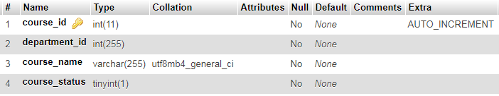

Table 3.3 Semester table

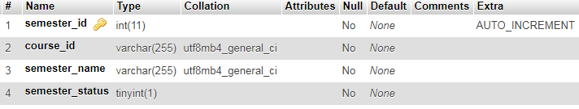

Table 3.3 Election table

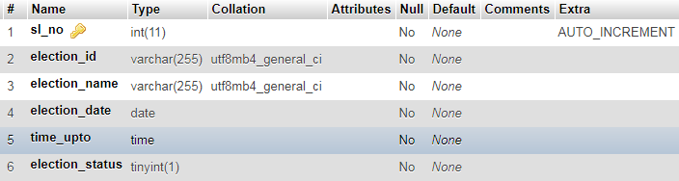

Table 3.3 Positions table

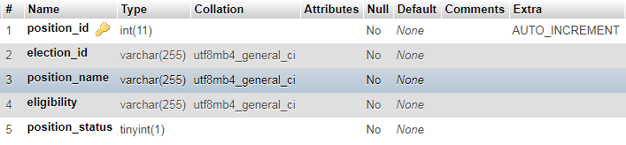

Table 3.3 Voters table

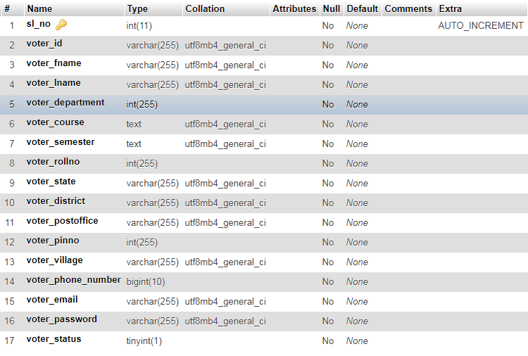

Table 3.3 Vote table

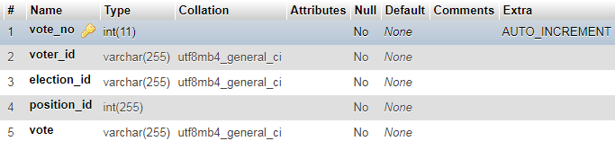

**3.4 Entity-Relationship Diagram**

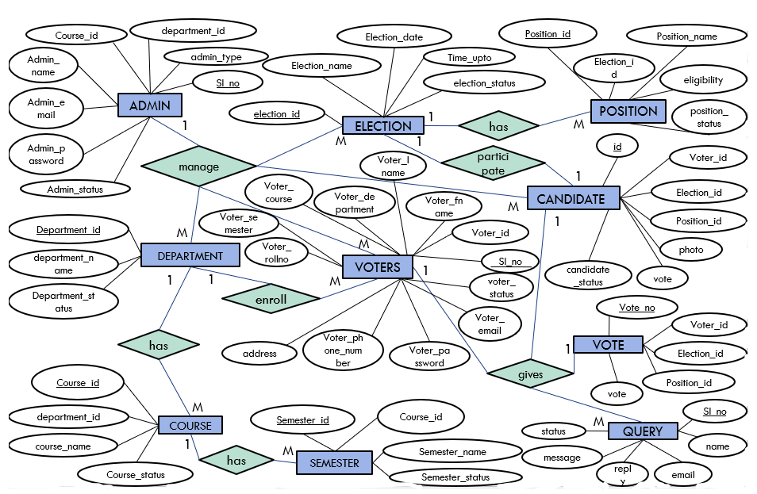

**Fig: ER Diagram**

1. **WORK BREAKDOWN STRUCTURE**

Work breakdown structure (WBS) breaks the project into Major Deliverables, Sub Deliverables, and further sub deliverables and ultimately in to work packages.For process-oriented projects such as this project (Website) WBS is difficult to apply. This kind of project suits best Process Breakdown Structure (PBS). Here the project is divided in to several steps or phases. The work breakdown structure including the following contents:

* Deliverable needs to exit a phase to enter another.
* Checkpoints that ensure that deliverables are complete and accurate.
* Sign-off by the stakeholders that the phase has successfully completed and it should move on to next steps.

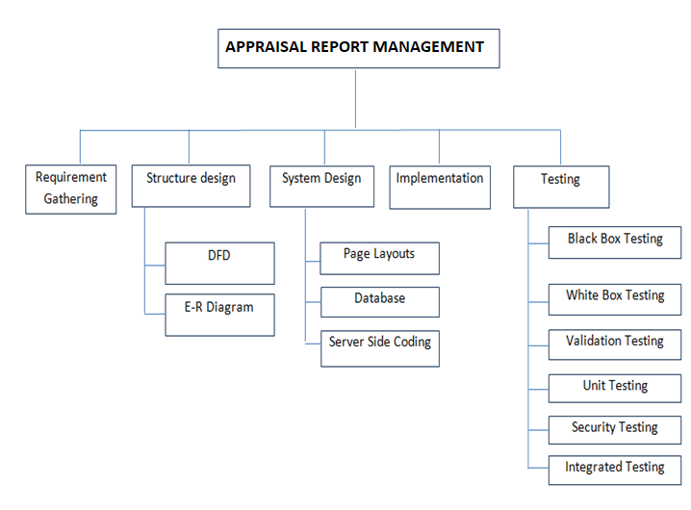

Online Voting System

**Fig: Work Breakdown Structure**

**3.4.8. GANTT CHART**

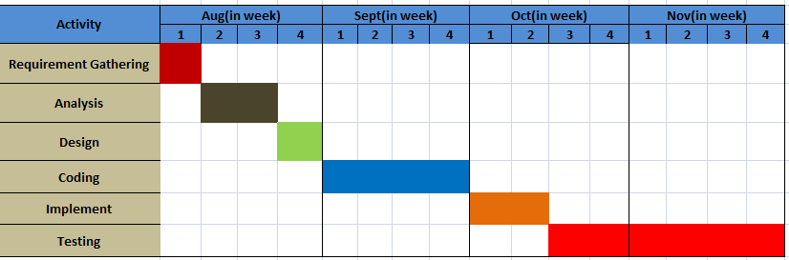

**Fig : GANTT CHART**

CHAPTER 4

IMPLEMENTATION

1. Screen Shots

* 4.1.1 Index Page

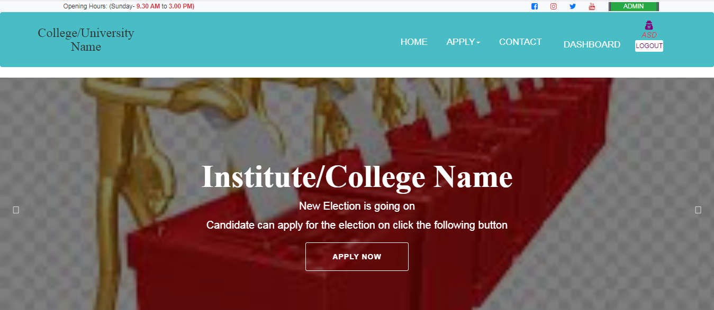

* **4.1.2 Voter signup/signin page**

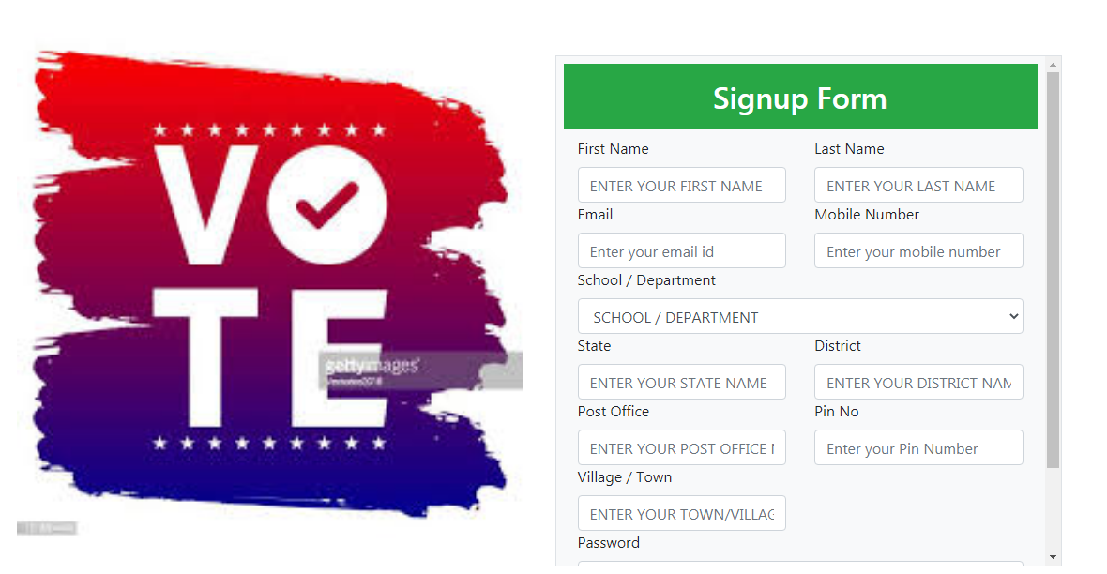

* **4.1.3 Candidate application form**

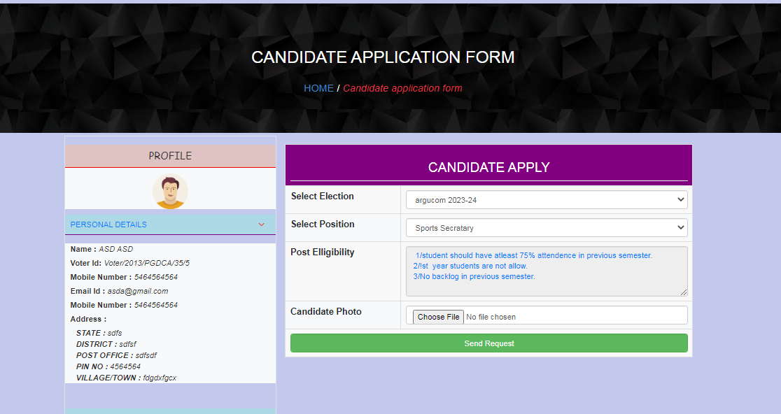

* **4.1.4 Ballot form**

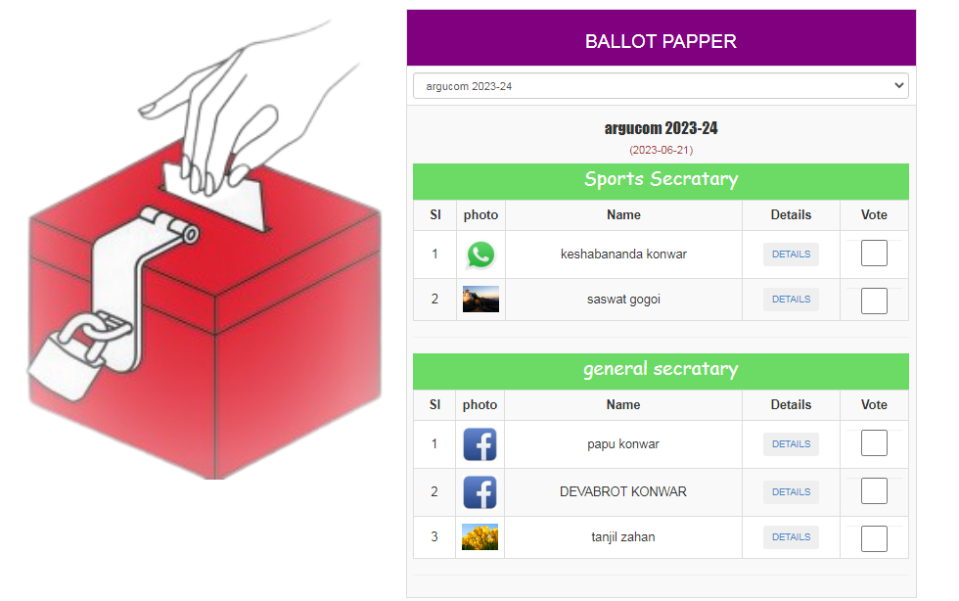

* **4.1.6 voter’s details page**

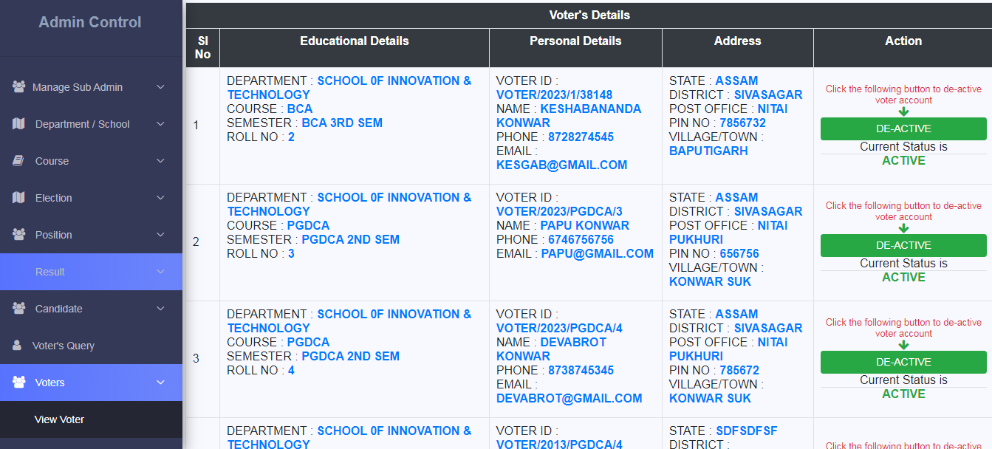

* **4.1.8 Election details page**

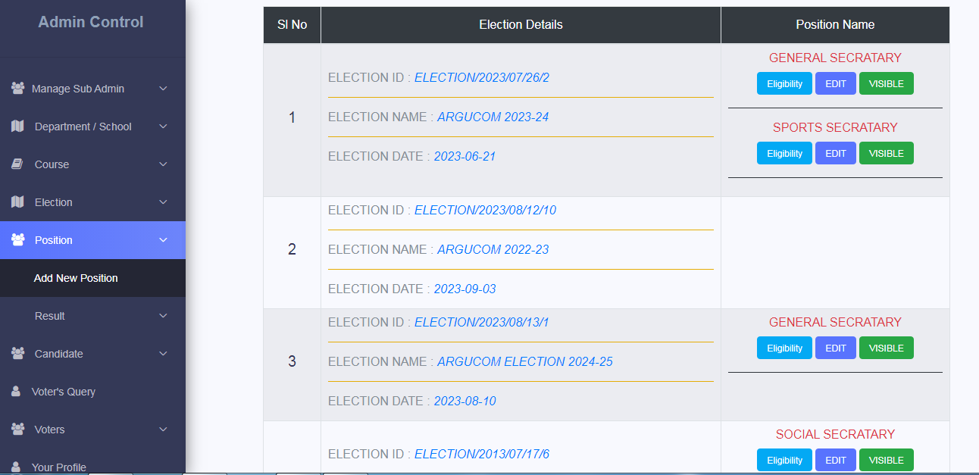

* **4.1.9 Candidate Details page**

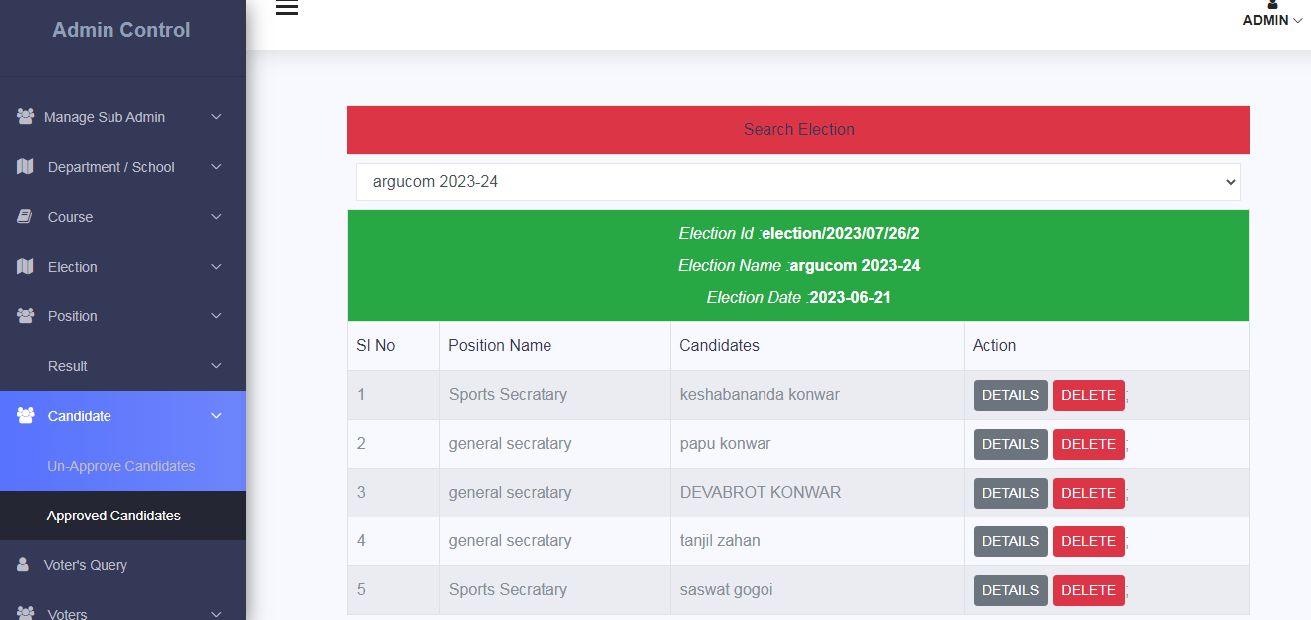

* **4.1.10 Result page**

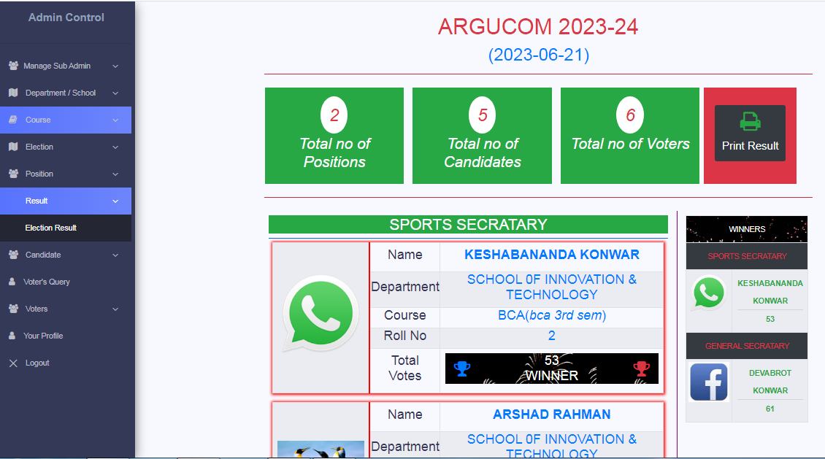

4.2 Testing

In Early days testing doesn’t get too much importance because coders have no to time to tested the software well due to heavy burden of code from initial point of observation to find creation of find creation of the software display. But now-a-days the software testing is a technique for ensuring the quality and product satisfactory management policy in order to cop up with heavy market demand and more than 65% of work of a software development process engaged in testing. Software testing should be done by keeping following two things in mind:-

1. To find out error which may discovered or undiscovered during the process of any intermediate testing, or general observation.
2. To find out the clauses due to which the customer become dissatisfactory which may discovered or undiscovered during the process of development.

The above points generate the testing should be done in terms of ­­:-

1. Internal logic of software development process.
2. Integration method of the software to applied environment.

In short testing means collection of some techniques from the book or from practical point of view to rectify the drawbacks and errors of developed software in order to ensure the quality by internal logic and adoption of internal environment.

Software can be testable if the software has following qualities:-

1. A well determined objective.
2. A well control flow of the data.
3. A well control system output.
4. The objectives and the environment easily predictable.
5. The technique used by the software to commonly understandable.

4.2.1. Black Box Testing

Black box testing known as behavioral testing or interface testing where whole system software considered into one unit and the resultant output are analyzed. Suppose a program to multiply two matrixes of hundred lines in C having two or more nesting loops; here if the resultant output is satisfactory then program is correct as per the black box testing.

4.2.2. White Box testing

This testing is also known as glass box testing where every function or activity are tested individually by giving input on a graph page path chart which is for control line input and output. Path chart are of two types. One is basic path chart based on primary objectives and another one is program path chart based on execution style.

4.2.3. Security Testing

Security testing means to protect the system from improper penetration. During security testing the tester plays the role of the individual who desire to penetrate the system. Security testing means to protect the system from improper penetration.

Some of the security measures we have used in our software are as follows:

1. No one could enter any page other than the login page by typing the URL in the browser. If anyone tries to do that then the software redirects the user to the login page.
2. No one could enter any page by clicking the back button in the web browser as it is disabled.
3. Based on the category of the user, a fraction of all activities in the software is presented to him or her.

4.2.4 Validation Testing

Software validation is achieved through a series of black-box tests that demonstration conformity with requirements. A test plan outlines the classes of tests to be conducted and a test procedure defines specific test cases that will be used to demonstrate conformity with requirements. The end user of the software, staff of student management system performs the validation test. Validation test is succeeded when the expectation of the user is fulfilled completely.

A list plan outlines the classes of test to be conducted and a list procedure defines specific test causes that will be used to demonstrate conformity with requirements. Therefore mentioned tests are done to detect errors when the data of real system is input. This is very important stage for the developer is noted down for the removal in the next stage.

This is conducted to be more important as the users are aware of the processes inside the system. Proper validation and messages are needed to be informed the user during each mistake they make. Also necessary help is required to be given for each time they are confused.

4.2.5 Integrated Testing

It is the collaboration of black box testing and unit testing. The all units of software are grouped into some particular segments. These are known as integrated units. Some sample data are input to the process or general unit and the resulted figures are recorded and this processes carried on for fulfillment of one integrated unit. In final summation of the recorded figures if necessary then new unit is introduced or otherwise adjustment codes are introduced.

4.2.6 Unit Testing

It is similar to the white box testing but it is under the proper segmentation principle of applied DFD without considering quotes in respect of function and variable. One process of DFD are represented as a unit, some sample data input to the unit and based on the output validity of the unit is determined. It looks like the black box testing for a particular unit. Difference with the white box testing is that the white box testing goes for every detail of a variables and function code in order to estimate the proper efficiency level but unit testing aims to find out error in the co-relation between different activities of a software development process.

CHAPTER 5

CONCLUSION AND FUTURE WORK

1. Introduction

Once a person cast his/her vote, with proper authentication the devoting will be prohibited. Once the voting is over, all the counting will be done online and result will be displayed. This method of web voting can provide security and proxy voting can be done.

**5.2 Conclusion**

A voting system or electoral system is a method by which voters make a choice between options, often in an election. A voting system enforces rules to ensure valid voting, and how votes are counted and aggregated to yield a final result. The word “vote” means to choose from a list, to elect or to determine. The main goal of voting is to come up with leaders of the student’s choice, in order this to happen, the voting system is needed. Today, the voting system is widely known and used in almost all schools who exercise their right to vote specially in electing school officers. In voting system, a user can use his or her voting right. He/she has to be registered first in order to vote. After registered, the voter is given a secret voter code which he/she can use to access the system. If invalid/wrong details are submitted, then the system will not permit that student to vote.

* 1. Limitations
* One of the most significant limitation of online voting systems is that they're not as secure as traditional paper-based systems because there's always the potential for hackers to tamper with the results
* Another limitation of online voting is that it can lack transparency. With traditional paper-based voting, voters can see people counting the ballots. But with online voting, the process is entirely electronic, making it harder to verify the results.
  1. FUTURE WORK

The possible future work of the project includes improvement in security level of the system. In annexation to that it would be interesting to meet some other confidential primitive to improve the security level of system.

The future improvement can also be done for system crash and power failure so that the voters can vote with more assurance.

**BIBLIOGRAPHY**

* www.w3school.co.in
* www.wikipedia.org
* www.javatpoint.com
* YahooBaba(YouTube Channel)
* Gate Smashers(YouTube Channel)