**Anonymously New**

**Key to Crack**

Ready to know how to reach to the final certificate?  
*Awesome! Here the complete solution to find the destination.*

Crossing the Access Key page!

You start your journey from the main page and land on the Access Key page. You would see a text box with an alt test saying, ‘Everything requires me’. Quite tricky right?!😂

Don’t worry, since this was a sort of CTF you are supposed to find something from somewhere from which you can fill this text box. The very first thing which someone must do is to open the Inspect element of the page and find something suspicious. You might have also noticed the text written ‘There are clues everywhere’. Why not look for the names or classes of these divs/spans? Alas! And when go to look for the div class name, you get that there are 5 similar types of classname of span assigned to the text ‘There are clues everywhere’. Those are nothing but a combination of ascii letters of the Greek language of English word ‘Knowledge’ which you can link with the alt text of text box that knowledge is everywhere.

**ASCII:** &#947; &#957; &#974; &#963; &#951;

**GREEK:** γ ν ώ σ η

**ENGLISH:** KNOWLEDGE

Click submit and you’ll cross the first page 🦾

Cross the Access Granted page!

Now comes the equation, which god knows what a b c d e f equals to. To solve this, you must be a keen observer for whatever happens around you. When you passed the last page, you might have seen some digits on success message. Those numbers are basically the digits equivalent to each letter of the equation.

**a b c d e f**

**0 3 1 8 4 1**

**a!+d*c%b+e/f =** **7**

Enter 7 and BOOM, the table turns to open a new game where you will have to click ‘Click me’ text to score 10 scores to cross the level within a given period.

Ughh!! This might be very annoying for you to cross because the time given is really very short. Once you try the match for 3 times, you see a text “Try Harder.. ‘Stop Timer()’ ”. This wants you to stop the timer right. So move to the inspect element portion of the page and write the command, “StopTimer()” and you will see this output:

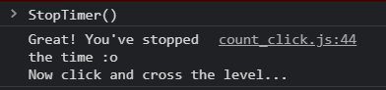

Click the Click Me text 10 times and the table turns again giving you a encrypted text which you will have to decrypt using your brains. The algorithm used here is Caesar Cipher with a key 7. When decrypted, the text results in:

**Type “extract” function in console**

As soon as you type “Extract()” in console, a file will be automatically be downloaded named “access_granted_steg.jpg”.

*Now this is something suspicious👀*

The file name ends with steg which denotes that something must be inside the jpg file which need to find. When you open the image with notepad to find the details which is hidden using steganography technique, you see at the end of the file written an English statement shown here:

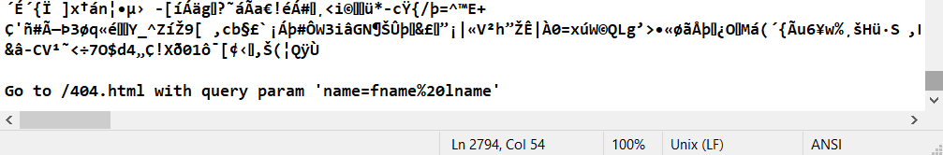

Now quickly surf through the url hint given to you that is for example <https://keshakaneria.github.io/Anonymously-New/404.html?name=kesha%20kaneria>.

You see a pop to download the certificate by writing the command “download()” in console and you have your certificate in pdf ready for you as a mark of successful completion💯