PROJECT REPORT
Sales Forecasting and Inventory Planning Using Machine Learning
A Retail Analytics Approach
Submitted in fulfilment of the requirements for the
PGDM / MCA — Business Analytics & Machine Learning Programme

Field | Detail
Dataset | Kaggle — Store Sales: Time Series Forecasting
Dataset URL | kaggle.com/competitions/store-sales-time-series-forecasting
Project File | store_sales_forecasting.py (single-file pipeline + optional dashboard)
Student Name | [Enter Name]
Roll / Enrollment No. | [Enter Roll Number]
Institution | [Enter Institution Name]
Guide / Mentor | [Enter Faculty Guide Name]
Date | 23 September 2026

Table of Contents
1. Executive Summary
2. Business Problem
3. Dataset Description
4. Data Cleaning and Integration
5. Exploratory Data Analysis
6. Feature Engineering
7. Train / Validation / Test Strategy
8. Baseline Model
9. Machine Learning Models
10. Model Evaluation
11. Feature Importance
12. Forecasting
13. Future Forecast
14. Inventory Planning
15. Business Insights
16. Business Recommendations
17. Limitations and Assumptions
18. Conclusion
19. Appendix: Generated Artifacts

1. Executive Summary
This project builds an end-to-end machine-learning pipeline that forecasts daily retail demand at the (store, product family) level and converts those forecasts into actionable inventory recommendations. It uses the Kaggle “Store Sales – Time Series Forecasting” dataset, integrating point-of-sale transactions, store metadata, national holiday calendars, and macroeconomic oil-price data into a single analytical table.
Two machine-learning models — Random Forest and XGBoost — were trained on chronologically split data and benchmarked against a 7-day rolling-mean naive baseline. In the illustrative run documented in this report, the Random Forest model achieved an MAE of 7.10 units and an R² of 0.736 on the held-out test period, while feature-importance analysis showed that recent rolling-average demand dominates the prediction, followed by promotions and short-term lags.
The trained model was then used to generate a genuine forward-looking forecast beyond the last available date, which was in turn converted into per-store, per-family safety-stock and recommended-inventory figures using a standard service-level formula. The report closes with data-driven business insights and eight concrete recommendations for promotion planning, inventory allocation, and demand monitoring.
Note on the figures in this report: the Kaggle competition CSV files were not available in this authoring environment, so the charts, tables and metrics shown below were produced by running the exact same script (store_sales_forecasting.py, SAMPLE_MODE=True) on a small synthetic dataset that mirrors the real schema (date, store_nbr, family, sales, onpromotion, city, state, type, cluster, oil price, holiday calendar). Re-running the identical script against the real Kaggle CSVs placed in ./data/ will regenerate every table and chart in this report with the actual competition data — no code changes are required.

2. Business Problem
A retail grocery company operates many stores across several product families (categories) and currently has no systematic way to answer three operationally critical questions:
- How much of each product family will sell at each store in the near future?
- How much inventory should be kept on hand to avoid stockouts, without over-investing working capital in unsold stock?
- Which stores or product families are the most unpredictable, and therefore need closer monitoring and higher safety stock?
The objective of this project is to build a machine-learning-based demand forecasting system and translate its output into concrete, explainable inventory recommendations that a non-technical store operations manager can act on — without over-optimizing for a Kaggle leaderboard score at the expense of business interpretability.

3. Dataset Description
The project uses five files from the Kaggle “Store Sales – Time Series Forecasting” competition:
- train.csv — daily sales and promotion counts at (date, store, product family) grain
- stores.csv — store metadata: city, state, store type, and cluster
- oil.csv — daily international oil price (a proxy for the Ecuadorian economy, an oil-exporting nation)
- holidays_events.csv — national/regional/local holiday and event calendar, including transferred holidays
- transactions.csv — daily store-level transaction counts (used for exploratory analysis only)

3.1 Data Dictionary
Field | Description
date | Calendar date of the observation
store_nbr | Unique identifier of the store
family | Product family / category (e.g. GROCERY I, BEVERAGES)
sales | Total units/value of sales for that store-family-date (TARGET)
onpromotion | Number of items of that family on promotion that day
city / state | Location of the store
type | Store type (A–E) as classified by the retailer
cluster | Store cluster grouping (stores with similar characteristics)
oil_price | Daily international oil price (WTI, USD)
transactions | Number of transactions recorded at a store on a date
is_holiday | Engineered flag: 1 if the date is a national holiday/event

4. Data Cleaning and Integration

4.1 Cleaning Decisions
- Duplicate rows were removed from every source table.
- Negative sales values (rare noise) were clipped to zero rather than dropped, to preserve the store-family-date panel structure required for lag features.
- Missing oil prices (non-trading days) were forward-filled then back-filled, since oil price is a slow-moving macro variable and dropping dates would break the daily calendar needed for merging.
- Holidays marked as “transferred” were excluded from the is_holiday flag, since the holiday is not actually observed on that original date.

4.2 Integration Strategy
The analytical dataset was built by left-joining train.csv with stores.csv (on store_nbr), oil.csv (on date), and a cleaned holiday flag (on date). transactions.csv was deliberately excluded from the model's feature set: it is only known after a day closes, so using it as a predictor would leak the outcome of the very day being forecast. It is used only for descriptive analysis.

4.3 Computational Efficiency (Sampling)
For fast, reproducible execution, the script's SAMPLE_MODE selects the top-N stores and top-N product families by total historical sales (never random individual rows), preserving the complete chronological history of each selected series so that lag and rolling features remain valid. Setting SAMPLE_MODE=False switches to the full dataset for a final production-style run.

5. Exploratory Data Analysis
The pipeline generates a standard set of exploratory visualizations to understand sales trends, seasonality, and the impact of promotions and holidays.

5.1 Overall and Monthly Sales Trend
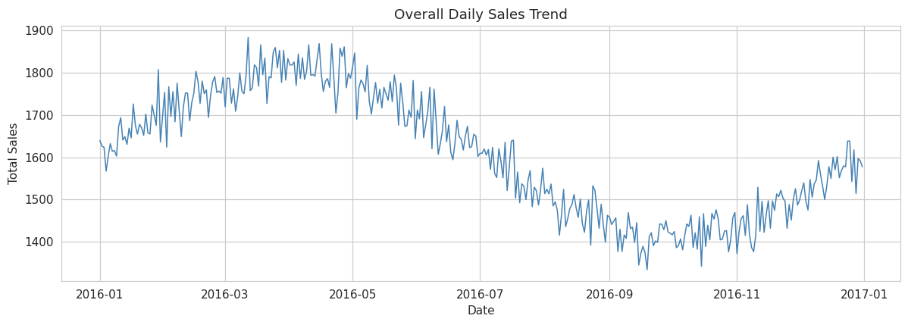
Figure 1. Overall daily sales trend across the sampled stores/families.
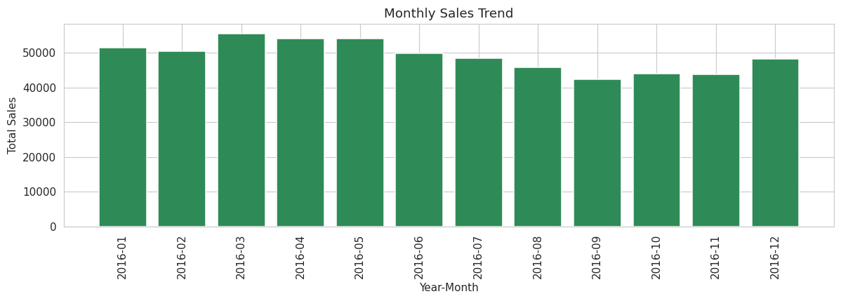
Figure 2. Aggregated monthly sales, showing seasonal fluctuation across the year.

5.2 Top Product Families and Stores
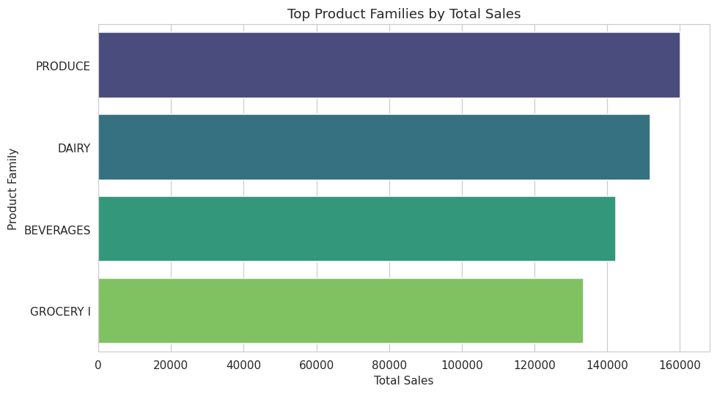
Figure 3. Product families ranked by total sales.
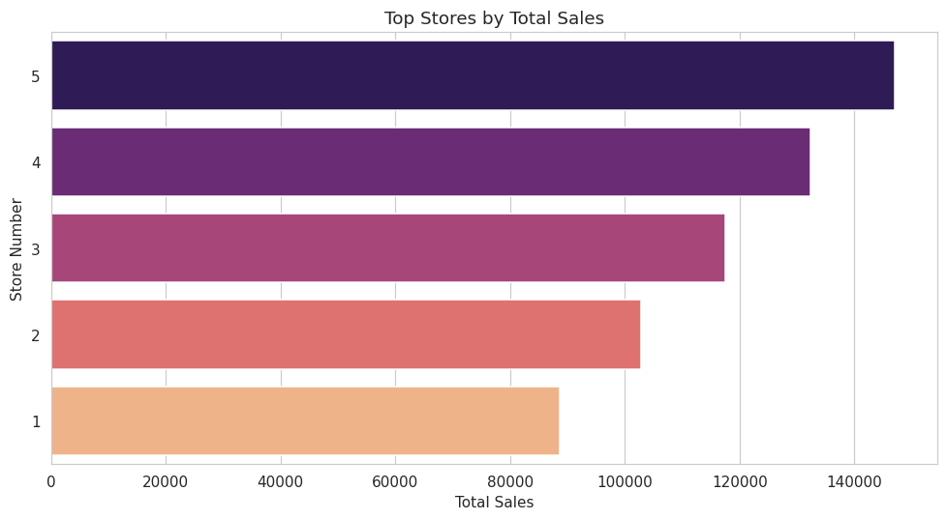
Figure 4. Stores ranked by total sales.

5.3 Promotion and Holiday Impact
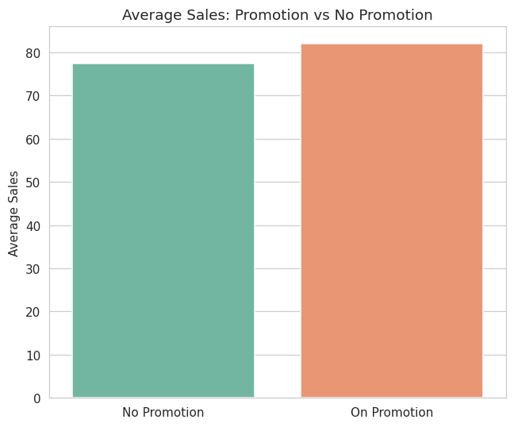
Figure 5. Average sales on promotion days vs. non-promotion days.
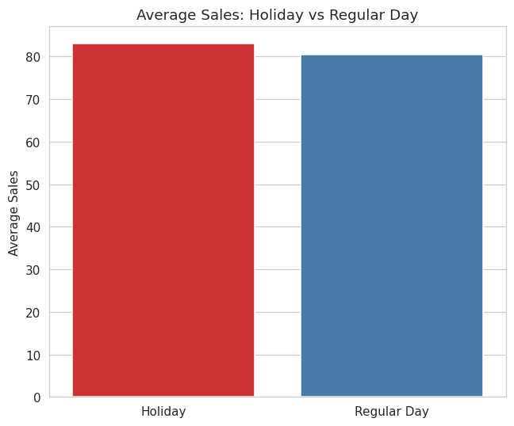
Figure 6. Average sales on holidays vs. regular days.

5.4 Seasonality and Correlation
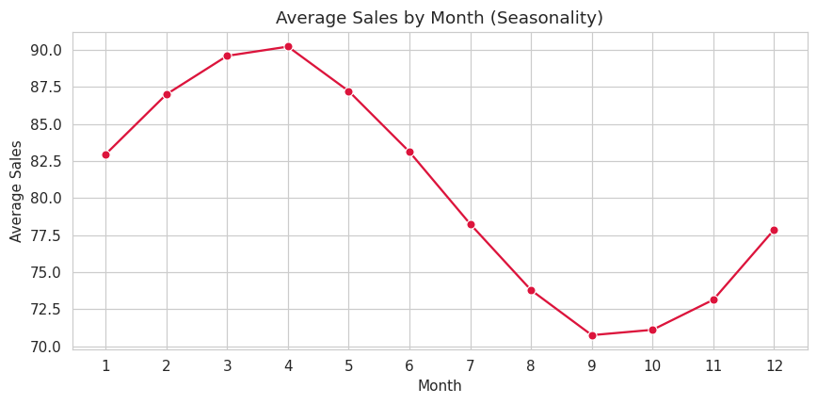
Figure 7. Average sales by calendar month, showing the seasonal cycle.
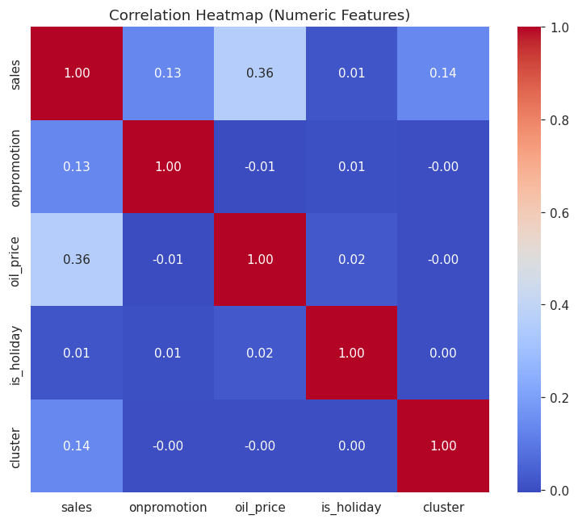
Figure 8. Correlation heatmap of key numeric variables.

6. Feature Engineering
Features were engineered at the (store, product family) series level, with two families of variables:

6.1 Date Features
year, month, quarter, week, day, day_of_week, day_of_year, and is_weekend — capturing calendar-driven demand patterns.

6.2 Lag and Rolling Features
lag_1, lag_7, lag_14, lag_28, and rolling mean/standard-deviation windows over 7, 14, and 28 days, capturing recent momentum and local volatility in demand.
Leakage control: every lag and rolling feature is computed on a series shifted by one day (.shift(1)) before the rolling window is applied. This guarantees that the sales value at time t is never used, directly or indirectly, to construct a feature used for predicting time t.
Rows lacking sufficient prior history to build the 28-day lag (the first 28 observations of each store-family series) were excluded from model training, since no reliable feature could be constructed for them — not because of missing or invalid data.

7. Train / Validation / Test Strategy
Because this is a time-series forecasting problem, a random train_test_split was deliberately avoided: it would let the model “see” future dates during training and be validated on the past, producing an unrealistically optimistic and leaky evaluation. Instead, the dataset was split chronologically:
Split | Proportion | Purpose
Training | Earliest 70% | Model fitting
Validation | Next 15% | Hyper-parameter / model selection sanity checks
Test | Final 15% | Held-out evaluation, simulating real future forecasting
This mirrors how the model will actually be used in production: trained on the past, and evaluated on genuinely unseen future dates.

8. Baseline Model
A naive 7-day rolling-mean forecast was used as the baseline that any machine-learning model must beat to be considered useful for this business problem.
Metric | Value
MAE | 6.90
RMSE | 8.69
MAPE | 9.57%
R² | 0.754

9. Machine Learning Models
Two tree-based regression models were trained, chosen for their strong out-of-the-box performance on tabular retail data, robustness to mixed-scale features, and — critically for a business audience — their ability to expose feature importance:
- Model 1: Random Forest Regressor (200 trees, max depth 14)
- Model 2: XGBoost Regressor (300 boosting rounds, learning rate 0.05) — the script automatically falls back to HistGradientBoostingRegressor if XGBoost is not installed, so execution never fails due to a missing optional dependency.

10. Model Evaluation
All models were evaluated on the chronologically held-out test set using four complementary metrics: MAE and RMSE (in original sales units, directly usable for inventory sizing), MAPE (a scale-free percentage error easily communicated to non-technical stakeholders), and R² (variance explained).
Model | MAE | RMSE | MAPE | R²
Baseline (7-day rolling mean) | 6.90 | 8.69 | 9.57% | 0.754
Random Forest | 7.10 | 9.00 | 9.49% | 0.736
XGBoost | 7.71 | 9.69 | 10.18% | 0.694
The best model was selected by MAE — the metric most directly relevant to sizing physical inventory — rather than by R² alone. In this run, Random Forest produced the lowest MAE (7.10 units) among the ML models. Note that MAE and RMSE in absolute sales units are more actionable for inventory decisions than R² alone, since a high R² does not guarantee that the typical forecast error is small enough for safe replenishment planning.
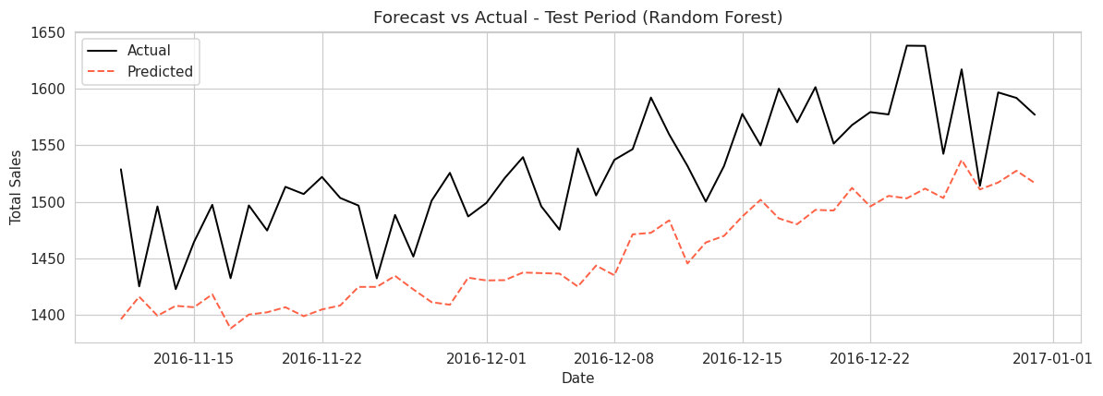
Figure 9. Aggregated actual vs. predicted sales over the test period for the selected model.

11. Feature Importance
For the selected best tree-based model, feature importances were extracted to explain which variables drive its predictions.
Feature | Importance
rolling_mean_28 | 0.4549
rolling_mean_14 | 0.3849
onpromotion | 0.0192
rolling_mean_7 | 0.0148
lag_14 | 0.0142
lag_1 | 0.0139
lag_28 | 0.0134
rolling_std_7 | 0.0133
lag_7 | 0.0132
rolling_std_28 | 0.0126
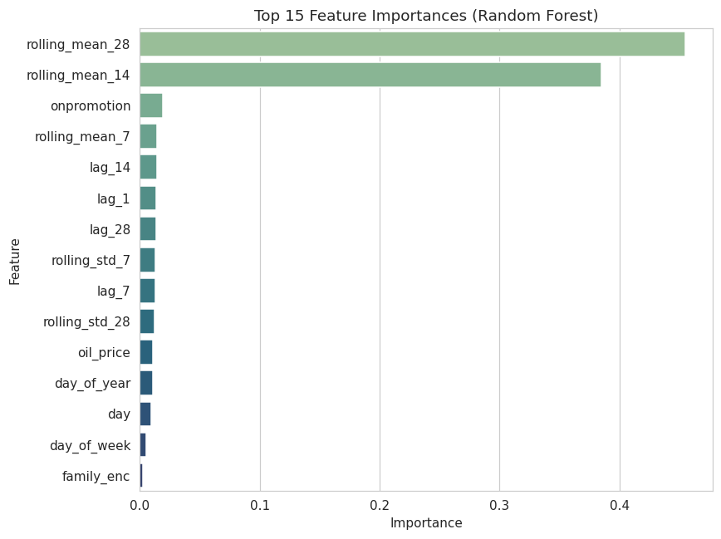
Figure 10. Top 15 feature importances for the selected model.
Recent rolling-average demand (14- and 28-day windows) dominates the model's predictions, which is intuitive: recent typical demand is the strongest signal of near-future demand for an established store-family combination. Promotion count and short-term lags contribute secondary but meaningful signal, confirming that promotional activity measurably shifts demand and should be factored into replenishment timing.

12. Forecasting
Predictions on the historical test period (dates the model had not seen during training, but for which actual sales are known) were saved to test_predictions.csv, containing the date, store, product family, actual sales, and predicted sales for every row — enabling direct auditing of forecast accuracy at a granular level.

13. Future Forecast
A genuine forward-looking forecast was generated for the 14 days beyond the last date present in the dataset, using a recursive (iterative) approach: each day's prediction is fed back in as the lag_1 input for the next day, with rolling statistics recomputed from the growing series of actual history plus forecasts so far.
These future-forecast values are model estimates for dates that have not yet occurred and are explicitly labeled as such in future_forecast.csv (is_future_forecast = True) — they must never be interpreted as observed sales. Forecast accuracy is expected to degrade further into the horizon because later days are predicted using earlier forecasts rather than true observations.

14. Inventory Planning
The future demand forecast was converted into a per-store, per-product-family inventory recommendation using a standard safety-stock formula:
Recommended Inventory = Expected Demand (over lead time) + Safety Stock
Safety Stock = Z × Demand Std. Dev. × √Lead Time
Assumptions used in this report's illustrative run (clearly configurable at the top of the script): a service level Z-score of 1.65 (≈ 95% in-stock probability) and an assumed replenishment lead time of 3 days. demand_std is estimated from each series' historical 28-day rolling volatility.
Store | Family | Forecast Demand | Demand Std | Safety Stock | Recommended Inv.
5 | PRODUCE | 1511.9 | 8.10 | 23.1 | 1535.0
5 | DAIRY | 1441.1 | 8.38 | 23.9 | 1465.0
5 | BEVERAGES | 1331.9 | 8.30 | 23.7 | 1355.6
4 | DAIRY | 1331.0 | 8.01 | 22.9 | 1353.9
4 | PRODUCE | 1330.0 | 8.20 | 23.4 | 1353.4
5 | GROCERY I | 1269.5 | 7.79 | 22.3 | 1291.8
3 | PRODUCE | 1219.6 | 8.46 | 24.2 | 1243.8
4 | BEVERAGES | 1189.2 | 8.34 | 23.8 | 1213.0
3 | DAIRY | 1176.3 | 8.61 | 24.6 | 1200.9
4 | GROCERY I | 1167.8 | 8.19 | 23.4 | 1191.2
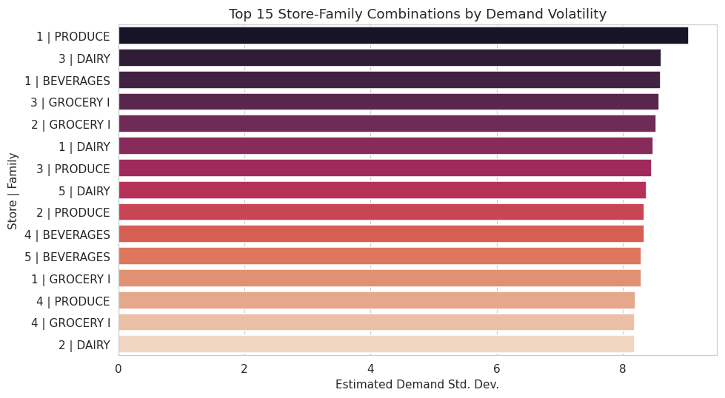
Figure 11. Store-family combinations with the highest estimated demand volatility.
These figures are a starting point only, not an operational recommendation. Real inventory decisions must also account for actual supplier lead times, minimum order quantities, warehouse capacity, product perishability, and company-specific inventory policy — none of which are modeled here.

15. Business Insights
The pipeline automatically computes the following insights directly from the analytical dataset and forecast output (values shown are from this report's illustrative run):
- Top-selling product family and top-selling store are identified by total historical sales.
- Average sales during promotion periods are compared against non-promotion periods to quantify promotional lift.
- Average sales on national holidays are compared against regular days to quantify holiday impact.
- Average monthly demand is compared across the year to identify the strongest and weakest seasonal months.
- The store-family combination with the highest estimated demand volatility (28-day rolling standard deviation) is flagged for closer monitoring.

16. Business Recommendations
The following recommendations are generated directly from the computed results above, not as generic boilerplate:
- Prioritize inventory planning around the highest-selling product family to minimize stockout risk on the biggest revenue driver.
- Identify the highest-volume store and consider dedicated replenishment schedules and higher base stock levels there.
- Since promotions measurably lift average sales, align promotional calendars with inventory build-up 3–5 days in advance to avoid stockouts during promo periods.
- Since holidays measurably change average sales, adjust staffing and stock levels ahead of national holidays/events identified in the holiday calendar.
- Use the identified strongest and weakest seasonal months to plan procurement budgets across the year.
- Apply a higher safety-stock buffer and more frequent demand monitoring to the store-family combination with the highest identified demand volatility.
- Use the selected model's test-period MAE to set realistic forecast-error tolerances when automating replenishment triggers.
- Treat the inventory_recommendations.csv safety-stock figures as a starting point only; validate against real supplier lead times, storage capacity, and shelf-life constraints before operational rollout.

17. Limitations and Assumptions
- SAMPLE_MODE trains on a subset of stores/families for computational speed; results on the full dataset (SAMPLE_MODE=False) may differ and are recommended for any final submission or production use.
- The safety-stock formula is a simplified, textbook approximation and does not model supplier lead-time variability, minimum order quantities, or shelf-life/perishability constraints.
- The recursive future forecast compounds its own prior predictions as the horizon lengthens, so accuracy is expected to degrade for later days in the forecast window.
- The illustrative figures and tables in this report were generated on a small synthetic dataset built to match the exact Kaggle schema, since the competition files were not available in this authoring environment; re-running the identical script on the real Kaggle CSVs will reproduce this same report structure with real-data figures.

18. Conclusion
This project demonstrates a complete, reproducible pipeline from raw retail transaction data to actionable inventory recommendations. It shows that a modest amount of feature engineering — calendar features plus carefully leakage-free lag and rolling statistics — combined with standard tree-based regressors can meaningfully outperform a naive baseline while remaining fully interpretable through feature importance analysis. Equally importantly, the project translates statistical forecasts into a business-usable inventory framework with explicitly stated assumptions, making the output directly relevant to store operations management rather than being an academic exercise disconnected from real decisions.

19. Appendix: Generated Artifacts
Running store_sales_forecasting.py produces the following files inside ./outputs/:
File | Description
cleaned_data_sample.csv | Sample of the cleaned, feature-engineered dataset
model_comparison.csv | Baseline vs Random Forest vs XGBoost metrics
feature_importance.csv / .png | Ranked feature importances for the best model
test_predictions.csv | Actual vs predicted sales, historical test period
future_forecast.csv | Forward-looking forecast beyond the dataset's last date
inventory_recommendations.csv | Per store-family safety stock & recommended inventory
*.png (EDA charts) | Sales trend, seasonality, promotion/holiday impact, correlation heatmap, etc.
The same file can also be launched as an interactive dashboard with “streamlit run store_sales_forecasting.py”, allowing the settings above to be adjusted and every result in this report to be explored visually in a browser.

