Marwadi University
Faculty of Computer Applications

BCA 4E Python CSE Exam

Enrollment No. : 92400527304
Name : KESHAR SHAH
Class : 4E
Date : 3-04-2026for i in range(1, 5):
print(i * ((10**i - 1)//9))

Answer – 1
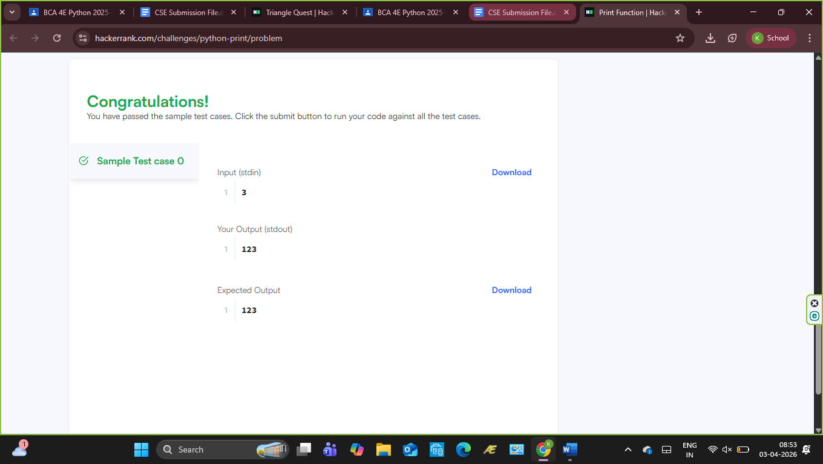

Answer – 2
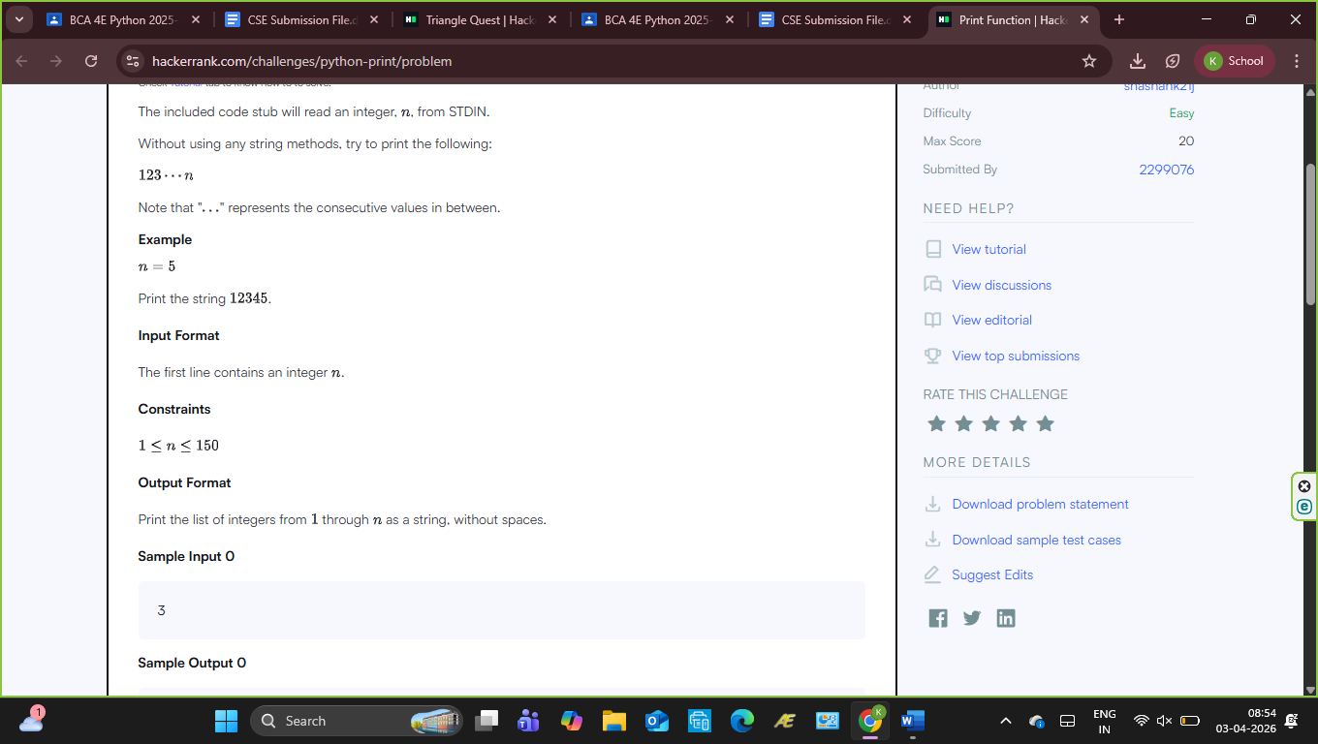
Answer – 3

Answer – 4

Answer - 5

