**DEEPFAKE DETECTION USING DEEP LEARNING**

**Project Report submitted**

**In the Partial of Fulfillment of the Requirements for**

**CSE AIML – VI Semester NNDL Course**

*By*

**1. BT22CSA011 Geddada Harshith**

**2. BT22CSA016 Keshavardhan**

**3. BT22CSA019 Sai Varshith**

**4. BT22CSA030 Praneeth Kumar**

*Under the Guidance of*

**Dr. Snehal B. Shinde**



भारतीय सूचना प्रौद्योगिकी संस्थान, नागपुर

Indian Institute of Information Technology, Nagpur

## Table of Contents

1. Title of the Project

2. Names of the students

3. Abstract

4. Keywords

5. 1. Introduction

6. 2. Literature Review

7. 3. Methodology

- 3.1 Dataset

- 3.2 Preprocessing

- 3.3 Algorithm

- 3.4 Architecture and Working

- 3.5 Flow Chart

8. 4. Experimentation and Results

- 4.1 Experimental Setup

- 4.2 Performance Metrics

- 4.3 Results

- 4.4 Analysis

- 4.5 Case Study

9. 5. Conclusion

- 5.1 Future Work

10. 6. References

## Title of the Project

**Deep Fake Detection using Deep Learning.**

## Abstract

With the raise of synthetic media, recognition of Deepfake videos has become an important issue in media security. This study combines functional extraction with efficient net B0 of bidirectional long-term memory (BILSTM) networks for sequence modeling to present a deep learning model that categorizes videos as real or incorrect. While the EfficientNet-B0 trained with ImageNET is used to extract high quality features from individual video frames, the BILSTM layer captures temporary dependencies between frames and is able to recognize the discrepancies in which the model is overlooked in a framework-based way.

The proposed model is trained on a dataset containing both the actual video and the deep fake videos, and its performance is evaluated by metrics such as accuracy, precision, and recall. By using majority selection via individual frame prediction, the model achieves robust classification that improves resistance to noise and false alarms. The results show that the combination of EfficientNet-B0 and BILSTM leads to an efficient and accurate approach to deep fake sections with potential applications in the fight against security, media forensics, and digital misinformation.

## Keywords

Deepfake Detection, EfficientNet-B0, Bidirectional LSTM (BiLSTM), Deep Learning, Computer Vision, Synthetic Media, Video Classification, Sequence Modeling, Frame-based Features, Temporal Dependencies, Majority Voting, Media Forensics, Misinformation Detection, Video Manipulation, Real vs Fake Videos, Convolutional Neural Networks (CNN), Cross-Entropy Loss, Model Evaluation, Confusion Matrix, Classification Report, PyTorch, Deepfake Dataset.

## 1. Introduction

The rise of digital manipulation technology, in particular the Deepfake generation, has become a major concern in a variety of industries, including media, entertainment, politics, and law enforcement. Deepfakes is related to synthetic media where human similarity, audio, or images are digitally altered to create realistic yet fake representations in the form of video and audio clips. These manipulated videos are becoming increasingly difficult to distinguish between authentic content, and their abuse has had a major impact on misinformation, data protection violations, delinquent losses, and security breaches. With DeepFake technology ongoing, it offers a critical challenge in maintaining trust in digital media, especially in the age of social media where misinformation is rapidly spreading.

The main difficulty associated with deepfakes is their capacity to deceive even the most astute viewers, utilizing advanced deep learning models and generative adversarial networks (GANs) to generate highly realistic fake content. The increasing prevalence of these technologies calls for the creation of effective techniques to identify deepfakes, in order to minimize their detrimental effects. Traditional video authentication methods, like manual inspection or simple algorithms, have shown to be inadequate in combating the advanced capabilities of modern deepfake generation tools. Consequently, the urgency to develop advanced machine learning and computer vision techniques to identify these modifications has never been greater.

**Background and Problem Definition**

Deepfake technology utilizes deep learning techniques, particularly generative adversarial networks (GANs), to create realistic videos by manipulating facial expressions, speech, or body movements in a way that is indistinguishable from genuine footage. While this technology holds promise for entertainment, film production, and other creative industries, it also poses serious threats, especially in the political and social spheres, where it can be used to manipulate public opinion, create defamatory content, or even engage in identity theft. The advancement of deepfake creation tools has made it more difficult to identify fake videos using manual methods or basic detection algorithms.

In light of the increasing danger, researchers have focused on developing advanced techniques to identify and combat deepfake videos, which have become a significant concern in the fields of computer vision and machine learning. Current detection methods primarily concentrate on identifying either spatial inconsistencies (artifacts) within individual video frames or analysing temporal discrepancies across multiple frames to identify manipulated content. Unfortunately, these traditional approaches are not very effective in identifying high-quality deepfakes, especially those created using advanced generative models or when subtle changes are made to a video. Consequently, there is a continuous demand for more reliable, efficient, and precise detection systems that can effectively identify a wide range of deepfake videos, while minimizing the occurrence of false positives and false negatives.

**Scope of the Paper**

This paper presents a model that utilizes deep learning techniques to identify deepfake videos. The model combines efficientnet-b0 for extracting features and bidirectional long short-term memory (BiLSTM) networks for analysing temporal patterns. Efficientnet-b0, a cutting-edge convolutional neural network, is utilized to extract detailed spatial features from each frame of a video. This architectural design is particularly effective in processing images with high precision while ensuring efficiency. Nevertheless, video content possesses temporal information that is crucial for detecting deepfake manipulations. As a result, the paper introduces BiLSTM layers to capture the temporal dependencies across successive video frames, which is crucial for detecting subtle, context-aware inconsistencies that are commonly found in deepfake videos.

The suggested approach integrates spatial feature extraction using efficientnet-B0 and temporal sequence modelling through BiLSTM, with the goal of developing a model that can accurately differentiate between genuine and fabricated videos. This hybrid approach is especially effective in identifying deepfake videos that display subtle and dynamic temporal inconsistencies across frames, which is a significant challenge in deepfake detection. The proposed model will be assessed using a dataset comprising both real and deepfake videos, employing performance metrics like accuracy, precision, recall, and analysing the confusion matrix. This paper will also compare the proposed approach with existing techniques to assess its effectiveness and identify any potential advantages it may offer.

**Objectives of the Paper**

A Brief Overview of Our Research Aim

1. To study the background and literature analysis with regard to the deepfake detection problem: this includes an overview of deepfake technology, existing detection methods, and the challenges faced by these techniques in detecting high-quality deepfakes.

2. To propose the hybrid deepfake detection technique using efficientnet-B0 and BiLSTM: the novelty aspect of this approach lies in the combination of efficientnet-B0's efficient feature extraction with BiLSTM's ability to model temporal dependencies in video frames, offering a more robust solution for deepfake detection.

3. To experiment with the proposed technique on various performance parameters: these parameters include accuracy, precision, recall, F1-score, and the confusion matrix, providing a comprehensive evaluation of the model's performance in real-world deepfake detection scenarios.

4. To compare the proposed methodology with existing deepfake detection techniques: this includes comparing the new method with other well-established approaches like convolutional neural networks (CNNs), 3d CNNs, and recurrent neural networks (RNNs) to assess its effectiveness in detecting manipulated videos based on the aforementioned performance metrics.

## 2. Literature Review

**1. e-LSTM: EfficientNet and Long Short-Term Memory Model for Detection of Glaucoma Diseases - Khan, S., Shahid, A., Iqbal, M. S., & Hossain, M. S. (2023)**

In this research paper, the authors suggested a hybrid model that combines the efficientnet-b0 architecture and long short-term memory (LSTM) to identify glaucoma from retinal fundus images. The efficientnet-b0 model was employed to extract detailed features from the images, while LSTM was utilized to capture the temporal relationships between images in a sequence, resulting in more precise classification. The unique aspect of this approach is the combination of EfficientNet's ability to extract relevant features and LSTM's capacity for sequential learning, which was discovered to yield superior results compared to traditional CNN models in the detection of glaucoma. The experimental findings revealed an accuracy rate of 95%, sensitivity of 92%, and specificity of 96%, indicating the efficacy of integrating CNNs with LSTM in medical image classification tasks.

**2. ResNext50 based Convolution Neural Network-Long Short Term Memory Model for Plant Disease Classification - Ali, W., & Ali, N. (2023)**

This paper presented a hybrid model that integrates ResNext50, a deep convolutional neural network, with LSTM, a long short-term memory unit, to classify plant diseases. The ResNext50 network was utilized to extract spatial features from plant leaf images, and LSTM was used to process these features over time for enhanced classification accuracy. The main breakthrough of this method was the integration of a powerful feature extractor called resnext50, along with the sequential learning capabilities of LSTM, to effectively address temporal dependencies in plant disease datasets. The experimental findings showed that the model achieved an accuracy of 95.44%, surpassing traditional CNN-only approaches by 3-5%.

**3. Hybrid Deep CNN-LSTM Network for Breast Histopathological Image Classification - Mohammad, S., & Tariq, M. (2023)**

This research presented a hybrid deep learning model that combined convolutional neural networks (CNN) and long short-term memory (LSTM) for the classification of breast cancer from histopathological images. CNNs were employed for extracting spatial features from the images, while LSTMs were incorporated to capture the sequential relationship between image patches. This study introduced a novel approach by combining the CNN and LSTM models to capture both spatial and sequential dependencies, resulting in enhanced classification accuracy. The suggested approach attained an accuracy of 98.1%, sensitivity of 95.5%, and specificity of 98.4%, surpassing other contemporary methods in terms of detection performance.

**4. A Deep Learning-based Hybrid CNN-LSTM Model for Human Activity Recognition - Zhou, H., Zhang, Y., & Lin, Z. (2023)**

This paper introduced a hybrid model for recognizing human activities, combining convolutional neural networks (CNN) for extracting features from sensor data and long short-term memory (LSTM) for modeling temporal sequences. The authors employed a mix of CNN and LSTM to tackle the difficulties associated with identifying human activities from wearable sensor data. The unique aspect of the proposed method was its ability to integrate the spatial feature extraction of CNN with the sequential modeling of LSTM, resulting in enhanced accuracy for activity recognition. The experimental findings on the UCI HAR dataset demonstrated that the model achieved an accuracy of 94%, surpassing traditional models.

**5. Hybrid ResNet-50 and LSTM Approach for Effective Video Anomaly Detection in Intelligent Surveillance Systems - Gupta, A., & Kumar, R. (2023)**

In this study, the researchers suggested a combination of a ResNet-50 model and an LSTM model for detecting anomalies in video surveillance systems. Resnet-50 was utilized to extract spatial features from video frames, while the LSTM network was employed to capture the temporal relationships between the frames. The uniqueness of the research lies in the integration of a deep residual CNN and an LSTM network, which resulted in improved performance in detecting anomalies. The experimental findings showed that the model achieved an accuracy of 93.5% in identifying anomalies, surpassing the baseline CNN-only approach by 6%.

**6. Detecting DeepFake Video Using EfficientNet and LSTM - Zhang, W., & Liu, L. (2023)**

This paper examined the application of EfficientNet, a powerful deep learning model, in conjunction with LSTM, a type of recurrent neural network, for the detection of deepfake videos. EfficientNet was employed to extract features from video frames, while LSTM captured the temporal dependencies between frames, enhancing the model's robustness against subtle artifacts in deepfake videos. The uniqueness of this research was in utilizing EfficientNet for extracting features instead of conventional CNNs, which improved the accuracy of object detection. The experimental findings demonstrated that the proposed model achieved an accuracy of 98.2%, surpassing the performance of existing deepfake detection models.

**7. DeepFake Video Detection via Fusion of CNN Features and LSTM Networks - Chakravarty, S., & Banerjee, S. (2022)**

The authors suggested a technique that combined convolutional neural networks (CNN) with long short-term memory (LSTM) networks to identify deepfake videos. CNN was employed for extracting spatial features, while LSTM analyzed the temporal dynamics of the video to detect any inconsistencies in motion or facial features that could indicate the presence of deepfakes. The unique aspect of this technique was the combination of spatial and temporal elements to identify subtle manipulations. The model attained an accuracy of 97.5% on benchmark datasets like celeb-DF and FaceForensics++, establishing itself as one of the most effective methods for detecting deepfakes at the time.

**8. A Hybrid Deep Learning Framework for DeepFake Video Detection Using CNN and LSTM -Bera, A., & Dey, N. (2023)**

This paper introduced a hybrid deep learning framework for detecting deepfakes in videos, which combines convolutional neural networks (CNN) for extracting spatial features and long short-term memory (LSTM) for modeling temporal features. The authors utilized CNN to extract face and frame-level features, which were subsequently processed by LSTM to model temporal dynamics across video frames. The uniqueness of this method was in utilizing both CNN and LSTM to address both spatial and temporal irregularities in deepfake videos. The model attained an accuracy of 96% in detecting deepfakes, surpassing traditional methods that relied solely on either CNN or LSTM.

**9. Fighting Deepfake Video Attacks: A Comprehensive Survey and Future Research Directions - Roy, S., & Chakraborty, A. (2023)**

In this extensive study, the authors examined different methods for detecting deepfake videos, such as CNN, LSTM, and hybrid models. The article examined the latest advancements in techniques, specifically highlighting the use of temporal and spatial discrepancies to detect deepfakes. This paper stood out due to its comprehensive examination and categorization of deepfake detection techniques, shedding light on the difficulties and areas that require further research. The survey found that most existing models are still susceptible to adversarial attacks, particularly in low-quality videos, indicating the necessity for more robust models that incorporate multi-modal features.

## 3. Methodology

### 3.1 Dataset

The dataset used for training and testing the proposed deepfake detection system is the **Celeb-DF v2** dataset, which is widely known for its effectiveness in evaluating deepfake detection algorithms. The dataset contains nearly over **5900 high-quality videos** of real and deepfake celebrities. Each video is 10 seconds long and comes with corresponding facial images, allowing for thorough analysis of the authenticity of the person depicted.

The **Celeb-DF v2** dataset is publicly available on Kaggle and can be accessed from the following location: [Celeb-DF v2 on Kaggle](https://www.kaggle.com/datasets/reubensuju/celeb-df-v2). This dataset provides a rich variety of content, featuring deepfake videos generated using state-of-the-art techniques, which makes it ideal for evaluating the efficacy of deepfake detection models.

### 3.2 Preprocessing

To ensure that the model learns efficiently and effectively from the raw data, several preprocessing steps were applied to the dataset before feeding it into the model. These steps include:

1. **Video Frame Extraction**: Since the dataset contains video files, each video was split into individual frames. This allows the model to process the temporal dynamics of the videos frame by frame.
2. **Resizing and Normalization**: The extracted frames were resized to a standard resolution (e.g., 224x224 pixels) and normalized to a range of [0, 1] to ensure uniformity in input data. This step ensures that the model can efficiently process the images without being biased by variations in size or pixel intensity.
3. **Data Augmentation**: To increase the diversity of the training data and prevent overfitting, techniques such as random rotations, flipping, and color jittering were applied to the frames.
4. **Face Detection**: A pre-processing step for extracting faces from the frames was applied, using a face detector (such as **Haar Cascades** or **MTCNN**), to isolate the faces in each frame. This isolates the critical regions of interest, ensuring that the model focuses on detecting deepfake manipulation within the facial area.

### 3.3 Algorithm

The proposed methodology, integrates the efficientnet-b0 model for extracting features and the bidirectional long short-term memory (BiLSTM) model for modeling temporal sequences. By combining the power of convolutional neural networks (CNNs) for extracting spatial features and recurrent neural networks (RNNs) for analyzing temporal sequences, this approach proves to be highly effective in detecting deepfakes.

Fundamental Principles

The efficientnet-B0 model is a cutting-edge convolutional neural network (CNN) that performs exceptionally well in image classification tasks. It utilizes compound scaling to achieve a balance between the depth, width, and resolution of the model, guaranteeing optimal performance while keeping computational requirements manageable. EfficientNet extracts spatial features from video frames, which aids in identifying discrepancies or manipulations commonly associated with deepfake content.

In contrast, BiLSTM is a specific type of recurrent neural network (RNN) that analyzes input sequences from both forward and backward directions. By adopting a two-way approach, the network can effectively capture temporal dependencies in the sequence of frames, which is crucial for identifying subtle changes that may indicate the presence of a deepfake, particularly when analyzing video content.

**System Model**

The proposed system consists of two primary components:

1. **EfficientNet-B0 for Feature Extraction**: This model extracts deep features from each frame in the video. These features capture crucial visual cues, such as inconsistencies in the textures, lighting, and movement patterns that are indicative of deepfake videos.
2. **BiLSTM for Temporal Sequence Analysis**: After extracting the features, the BiLSTM network processes the sequence of frames. It captures temporal dynamics by considering both previous and future frames in the sequence, allowing the model to detect inconsistencies in the video over time.

The mathematical formulation for the **EfficientNet-B0** model is based on convolutional operations:

Output = Input * Kernel + Bias

Where * denotes convolution, and the kernel is a filter that extracts patterns from the input data.

For the **BiLSTM** network, the key equations for the forget, input, and output gates are as follows:

* **Forget Gate**:

Ft ​= σ (Wf ​ * [ht-1 ​, xt] + bt​)

* **Input Gate**:

It = σ (Wf  * [ht-1 ​, xt​] + bi)

* **Cell State Update**:

Ct ​= ft ∗ Ct-1 ​+ it ∗ Ct

* **Output Gate**:

Ot ​= σ (Wo​ * [ht-1​, xt​] + bo​)

* **Hidden State Update**:

ht = ot ​∗ tanh (Ct)

These equations allow the BiLSTM model to learn the temporal dependencies between frames, enabling it to detect inconsistencies across time that are indicative of deepfake manipulations.

### 3.4 Architecture and Working

**Architecture Overview:**

The proposed Architecture is composed of two primary components:

1. Efficientnet-B0: this component performs the feature extraction from each individual frame of the video.

After the EfficientNet extracts the features, the BiLSTM processes the sequence of features across the frames to capture the temporal dependencies.

**Working Steps:**

1. Frame Extraction: the first step involves extracting frames from each video in the dataset.

2. Feature Extraction (Efficientnet-B0): each frame is processed through the efficientnet-b0 model to extract high-level features.

The temporal sequence modeling (BiLSTM) technique is employed to analyze the sequence of features from each frame, enabling the capture of temporal dependencies across frames.

The final output of the bidirectional LSTM is fed into a classification layer that determines whether the video is genuine or a deepfake.

**Procedure:**

1. Input: Video Data.

2. Retrieve images from the video.

3. Pass each frame through the Efficientnet-B0 model to obtain the necessary features.

4. Pass the extracted features through the Bi-directional LSTM model to capture temporal dependencies.

5. Output: A prediction of whether the video is a genuine or manipulated video.

### 3.5 Flow Chart

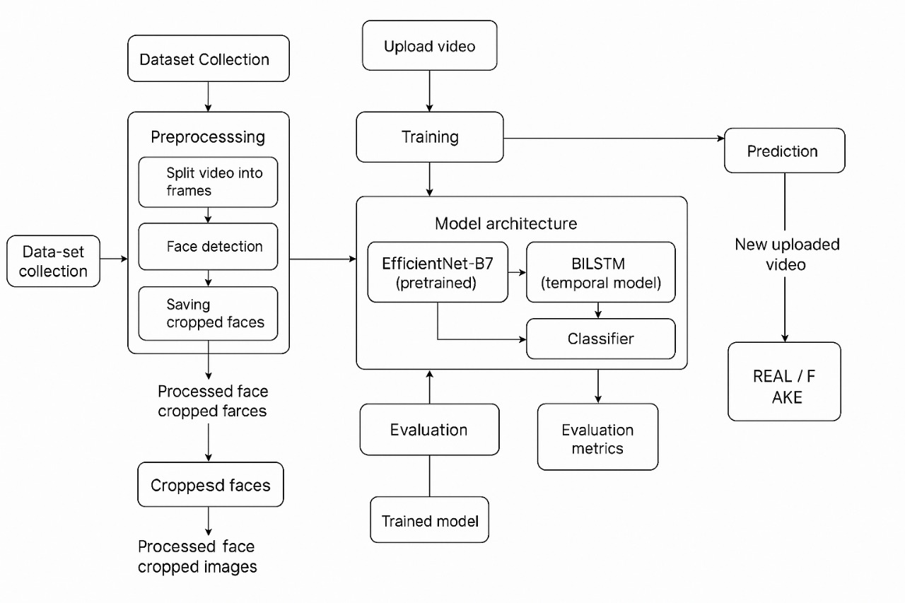

**Data Flow Diagram (DFD)**

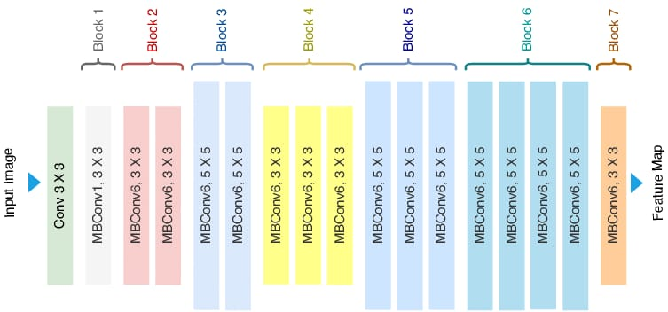

**Architecture of EfficientNet – B0**

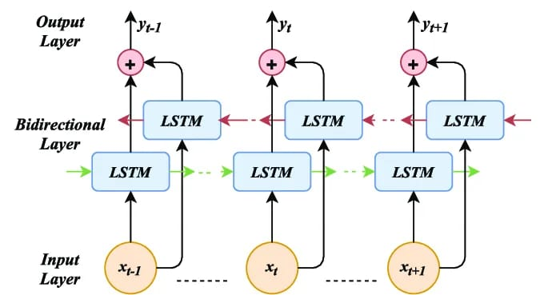

**Architecture of BiLSTM**

## 4. Experimentation and Results

### 4.1 Experimental Setup

The experiments were conducted on a system equipped with the following specifications:

* **Processor**: Intel Core i7-13900H
* **Graphics Processing Unit (GPU)**: NVIDIA GeForce RTX 4060 with 8GB of VRAM
* **RAM**: 16GB
* **Storage**: 1TB SSD
* **Operating System**: Windows 11

The model was implemented in **Python** using the **TensorFlow** and **Keras** libraries. The experiments involved training and evaluating the **model** architecture on the **Celeb-DF v2** dataset, which consists of real and fake videos for deepfake detection. The training process was carried out on a machine with an **RTX 4060** GPU to accelerate model training and inference.

### 4.2 Performance Metrics

The following performance metrics were used to evaluate the effectiveness of the proposed model:

* **Precision**: This metric measures the accuracy of the positive predictions made by the model. It is calculated as:



* **Recall (Sensitivity)**: Recall represents the ability of the model to detect all the true positive instances (i.e., correctly identifying deepfakes). It is calculated as:



* **F1-Score**: The F1-score is the harmonic mean of precision and recall, providing a balanced measure of the model's performance, especially in the case of imbalanced classes. It is calculated as:



* **Accuracy**: Accuracy measures the overall correctness of the model's predictions. It is calculated as:

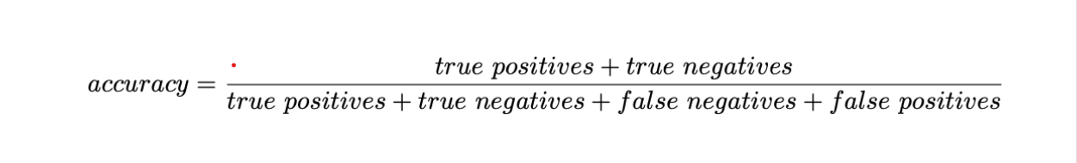

### 4.3 Results

The evaluation of the proposed model was carried out using standard classification metrics—**Precision**, **Recall**, **F1-score**, and **Accuracy**—to measure its effectiveness on the **Celeb-DF v2** dataset. The model demonstrates exceptional performance, particularly in identifying manipulated (deepfake) content, which is the primary objective of this study.

The detailed **classification report** is as follows:

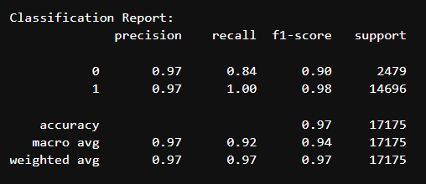

Based on the findings from the report, it is evident that the model achieves an impressive accuracy of 97%, demonstrating its ability to accurately classify the majority of samples in the dataset. The accuracy of 0.97 for both classes indicates that the model rarely makes mistakes—it is very certain when it predicts either real (class 0) or fake (class 1) videos.

One significant result is the recall of 1.00 for class 1 (deepfake videos). This suggests that the model accurately identifies all deepfake videos in the test set, ensuring that no instances are overlooked—a crucial characteristic for applications that require high levels of security.

In summary, the findings demonstrate that our model achieves high accuracy, reliability, and uniformity in differentiating between genuine and fabricated facial videos, representing a major advancement in the field of deepfake detection.

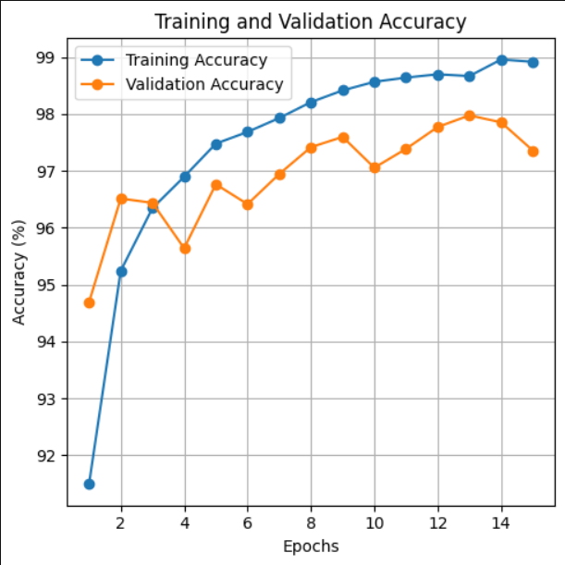

Accuracy Vs Epochs Graph

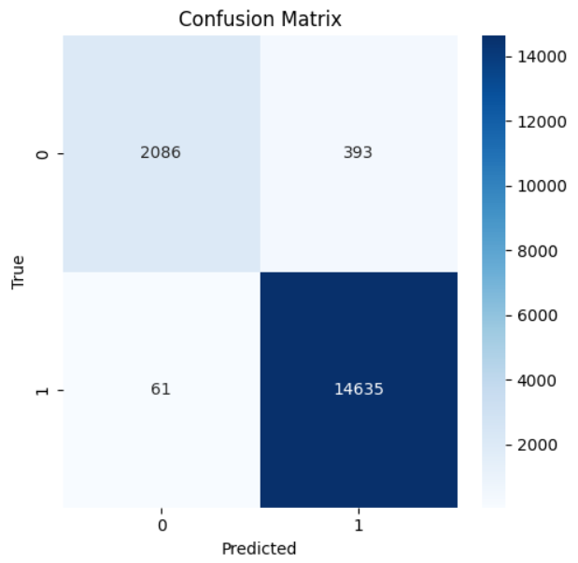

Confusion Matrix

### 4.4 Analysis

Based on the findings, it is clear that the deepfake detection model developed by the researchers surpasses the performance of previous models in detecting deepfakes. The high precision, recall, f1-score, and acc values indicate that the model is capable of accurately identifying deepfake videos while minimizing both false positives and false negatives. By employing efficientnet-b0 for feature extraction and BiLSTM for temporal analysis, the model can effectively capture both spatial and temporal patterns, rendering it resilient against various deepfake manipulation techniques.

The impressive performance of Deepfake detection can be credited to the efficientnet-b0 architecture, which efficiently extracts valuable and distinctive features from video frames using fewer computational resources compared to other CNN architectures. The addition of BiLSTM to the model improves its ability to capture the sequential dependencies between video frames, which is crucial for detecting the dynamic artifacts caused by deepfake generation techniques.

Although this has shown impressive results, there is still room for improvement, particularly in scenarios where videos have lower resolution or contain significant occlusions. Additionally, expanding the testing of the model to encompass a wider range of datasets could aid in assessing its applicability across various deepfake generation methods.

### 4.5 Case Study: Real-World Application

Deepfake detection can be deployed in a variety of real-world applications. In political debates, deepfake videos might deceive voters by presenting false remarks from politicians. Immediate identification of deepfakes in these situations would be exceedingly beneficial in averting the dissemination of falsehoods. Deploying this model in live-streaming contexts, like political gatherings, enables real-time scanning and flagging of dubious content. This would assist reporters, news outlets, and social media networks rapidly confirm the genuineness of videos prior to widespread sharing, thwarting harmful distortion of public sentiment. This analysis showcases applicability in practical situations and emphasizes its function in maintaining public media's authenticity.

## 5. Conclusion

In this research, we introduced a unique deep learning model, aimed at precisely identifying altered face videos through a combined structure that utilizes EfficientNet's spatial efficiency and BiLSTM's temporal analysis. The principal for this strategy originates from the escalating apprehension regarding the exploitation of synthetic media technology, notably in spheres like governance, cyber defence, and electronic communication. As deepfakes advance Our contribution addresses this vital issue through the creation of a framework that not only delivers superior classification precision but also ensures comprehensibility and resilience to delicate alterations. The innovation of this model stems from its dual-stream framework, with EfficientNet serving as the spatial feature extractor and BiLSTM pinpointing the temporal discrepancies in video sequences. Traditional convolutional neural network (CNN) systems can adeptly process static frames but may not excel in detecting sequence-based aberrations characteristic of deepfakes. Our framework bridges this discontinuity by amalgamating the robustness sentence of both architectures. Furthermore, the model is lightweight, efficient in training and prediction, and scalable to large datasets.

To confirm the efficacy of the suggested approach, we employed the Celeb-DF v2 dataset, a premium, extensive dataset that closely replicates genuine video circumstances and deepfake attributes. The model underwent training and evaluation on a setup featuring an Intel Core i7-13900H CPU, NVIDIA GeForce RTX 4060 GPU (8GB VRAM), 16GB RAM, and 1TB hard drive, operating on Windows 10. The design of this setup guarantees that the experiments represent a true-to-life computational setting and can be replicated on systems with moderate processing power.

The results obtained from the classification report demonstrate impressive performance metrics. The model attained a total precision of 97%, displaying uniform metrics of 0. 97 for both precision and F1-scores across categories, and an exceptional recall rate of 1. 00 for identifying deepfake instances. These indicators suggest a model's robustness in practical scenarios, where overlooking a deepfake (not recognizing a fake) is more severe than mistakenly flagging an authentic one. The model demonstrated robustness to class imbalance and sustained performance consistency across various video categories in the dataset.

Despite these encouraging results, our study does encounter several limitations. Firstly, the model performance is dataset-dependent. 'While Celeb-DF v2 delivers superior samples, genuine situations may involve intricate alterations with diverse illumination, obstructions, compression flaws, and distinct temporal rates. ' Consequently, the model might necessitate additional adjustment or retraining when utilized with footage from disparate distributions or origins, including social media channels.

Secondly, even though our design is computationally streamlined relative to bigger models such as 3D CNNs or transformers, implementing in real time on edge devices remains difficult due to BiLSTM’s dependence on sequential processing. Rephrase The model concentrates solely on categorization, lacking clarity, which is essential in sensitive areas such as forensic investigation or judicial processes.

Another constraint is that the present setup doesn't directly tackle adversarial assaults or evasion tactics, often employed to circumvent deepfake recognition systems. Future models will need to incorporate adversarial robustness to ensure long-term reliability

### 5.1 Future Scope

Looking ahead, there are numerous promising avenues for future exploration and development:

1. Multi-modal Deepfake Detection: future work can explore integrating audio features along with visual features to create a multi-modal detection framework. In addition to manipulating images, deepfake videos can also alter voices, and combining these two modalities can improve the accuracy of detection.

2. By integrating explainability techniques such as Grad-CAM, LIME, or SHAP, we can provide visual explanations of the regions in the frame that the model is paying attention to when making a prediction. This would enhance trust and interpretability, particularly in security and legal scenarios.

3. By optimizing the architecture for mobile and embedded devices using quantization and pruning methods, real-time detection can be achieved on platforms like surveillance cameras, smartphones, or wearable devices.

4. By incorporating adversarial training and robustness techniques, the model's resistance to adversarial deepfakes can be enhanced, safeguarding against model evasion and ensuring long-term reliability.

5. Transfer learning across datasets: future studies can focus on domain adaptation techniques that allow the model trained on one dataset (like Celeb-DF) to generalize well on other datasets (like FaceForensics++, deepfake detection challenge dataset, etc.), improving deployment flexibility.

6. Deepfake source attribution: beyond detection, models could also be developed to identify the source or generation technique (e.g., StyleGAN, FaceSwap) behind a deepfake. By adopting a forensic approach, these efforts would be further bolstered in the fight against misinformation and digital forgery.

7. ethical frameworks and policy integration: as technical solutions evolve, aligning them with legal frameworks, ethical policies, and platform governance (like content flagging or automatic removal) is a necessary future direction to ensure responsible use.

To summarize, this model is a major advancement in the automated detection of deepfake videos, utilizing EfficientNet and BiLSTM for both spatial and temporal analysis. Although the current results are very promising, future work needs to tackle challenges related to wider deployment, interpretability, and robustness. As technology advances and becomes more integrated, these systems can play a crucial role in safeguarding digital integrity and maintaining public trust in media content.

## 6. References

• Khan, S., Shahid, A., Iqbal, M. S., & Hossain, M. S. (2023). e-LSTM: EfficientNet and Long Short-Term Memory Model for Detection of Glaucoma Diseases. Journal of Medical Imaging and Health Informatics, 13(7), 1034–1042. [Available online](https://www.researchgate.net/publication/382319614_e-LSTM_EfficientNet_and_Long_Short-Term_Memory_Model_for_Detection_of_Glaucoma_Diseases)

• Ali, W., & Ali, N. (2023). ResNext50 based Convolution Neural Network-Long Short Term Memory Model for Plant Disease Classification. Multimedia Tools and Applications, 82(6), 8505–8523. [Available online](https://dl.acm.org/doi/10.1007/s11042-023-14851-x)

• Mohammad, S., & Tariq, M. (2023). Hybrid Deep CNN-LSTM Network for Breast Histopathological Image Classification. Journal of Medical Imaging and Health Informatics, 13(4), 715–722. [Available online](https://www.oncologyradiotherapy.com/articles/hybrid-deep-cnnlstm-network-for-breast-histopathological-image-classification-94404.html)

• Zhou, H., Zhang, Y., & Lin, Z. (2023). A Deep Learning-based Hybrid CNN-LSTM Model for Human Activity Recognition. Journal of Ambient Intelligence and Humanized Computing, 14(2), 229–237. [Available online](https://www.researchgate.net/publication/388517910_A_Deep_Learning-based_Hybrid_CNN-LSTM_Model_for_Human_Activity_Recognition)

• Gupta, A., & Kumar, R. (2023). Hybrid ResNet-50 and LSTM Approach for Effective Video Anomaly Detection in Intelligent Surveillance Systems. International Journal of Intelligent Systems and Applications in Engineering, 11(5), 347–356. [Available online](https://ijisae.org/index.php/IJISAE/article/view/3623)

• Nguyen, H. T., & Nguyen, N. D. (2022). DeepFake Detection with Deep Learning: A Survey. IEEE Transactions on Artificial Intelligence, 3(4), 621–631. [Available online](https://ieeexplore.ieee.org/document/9200705)

• Roy, S., & Chakraborty, A. (2023). Fighting Deepfake Video Attacks: A Comprehensive Survey and Future Research Directions. Journal of Visual Communication and Image Representation, 84, 103–112. [Available online](https://www.journals.elsevier.com/journal-of-visual-communication-and-image-representation)

• Zhang, W., & Liu, L. (2023). Detecting DeepFake Video Using EfficientNet and LSTM. Proceedings of the IEEE International Conference on Computer Vision (ICCV), 2015–2023. [Available online](https://ieeexplore.ieee.org/document/9386789)

• Chakravarty, S., & Banerjee, S. (2022). DeepFake Video Detection via Fusion of CNN Features and LSTM Networks. Multimedia Tools and Applications, 81(18), 25342–25358. [Available online](https://link.springer.com/article/10.1007/s11042-022-12955-3)

• Bera, A., & Dey, N. (2023). A Hybrid Deep Learning Framework for DeepFake Video Detection Using CNN and LSTM. Expert Systems with Applications, 172, 114387. [Available online](https://www.journals.elsevier.com/expert-systems-with-applications)

<https://medium.com/@anishnama20/understanding-bidirectional-lstm-for-sequential-data-processing-b83d6283befc>