OLIST E-COMMERCE: GROWTH DIAGNOSTIC

Why 97% of customers never come back, and what to do about it.

Dataset: Olist Brazilian E-Commerce Public Dataset (Kaggle) | 8 relational tables | 99,441 orders
Period: 2016 to 2018
Tools: SQL (SQLite) | Python (pandas, matplotlib) | Excel

1. Background and Objective
Olist is a Brazilian marketplace that connects small businesses to large retail channels including MercadoLivre, Americanas, and others. Sellers list on Olist, customers order through partner channels, and Olist handles the logistics coordination. The dataset covers 99,441 orders across a 3-year period with data spanning customer demographics, product information, seller performance, delivery timelines, payments, and customer reviews.
The analysis was structured around a single business question: the business has strong order volumes but what is preventing revenue from compounding? Six analytical questions were designed to diagnose the issue from multiple angles.

2. Data Model
The dataset comprises 8 relational tables joined as follows:

orders links to customers (customer_id)
orders links to order_items (order_id)
orders links to payments (order_id)
orders links to reviews (order_id)
order_items links to products (product_id)
order_items links to sellers (seller_id)
customers/sellers links to geolocation (zip_code_prefix)

One important data quality issue: the customers table contains both customer_id and customer_unique_id. The customer_id is generated per order, meaning one real customer who places 3 orders receives 3 different customer_ids. Using customer_id to measure repeat purchases would produce artificially inflated customer counts and artificially deflated repeat rates. All customer-level analysis in this report uses customer_unique_id.

3. SQL Queries
Revenue Trend by Month
SELECT strftime('%Y-%m', o.order_purchase_timestamp) AS month,
COUNT(DISTINCT o.order_id) AS total_orders,
ROUND(SUM(oi.price + oi.freight_value), 2) AS total_revenue
FROM orders o
JOIN order_items oi ON o.order_id = oi.order_id
WHERE o.order_status = 'delivered'
GROUP BY month ORDER BY month ASC;
Repeat Purchase Rate
SELECT
COUNT(DISTINCT customer_unique_id) AS total_customers,
COUNT(DISTINCT CASE WHEN order_count > 1
THEN customer_unique_id END) AS repeat_customers,
ROUND(COUNT(DISTINCT CASE WHEN order_count > 1
THEN customer_unique_id END) * 100.0 /
COUNT(DISTINCT customer_unique_id), 2) AS repeat_rate_pct
FROM (
SELECT c.customer_unique_id, COUNT(o.order_id) AS order_count
FROM orders o JOIN customers c ON o.customer_id = c.customer_id
WHERE o.order_status = 'delivered'
GROUP BY c.customer_unique_id
);
Delivery Performance vs Review Score
SELECT
CASE
WHEN julianday(delivered) - julianday(estimated) <= -3 THEN 'Early (3+ days)'
WHEN julianday(delivered) - julianday(estimated) <= 0 THEN 'On time'
WHEN julianday(delivered) - julianday(estimated) <= 3 THEN 'Late (1-3 days)'
ELSE 'Late (3+ days)'
END AS delivery_status,
COUNT(*) AS order_count,
ROUND(AVG(review_score), 2) AS avg_review_score
FROM orders o JOIN order_reviews r ON o.order_id = r.order_id
WHERE o.order_delivered_customer_date IS NOT NULL
GROUP BY delivery_status ORDER BY avg_review_score DESC;
Seller Quality Analysis
SELECT seller_id,
COUNT(DISTINCT oi.order_id) AS total_orders,
ROUND(SUM(oi.price + oi.freight_value), 2) AS revenue,
ROUND(AVG(r.review_score), 2) AS avg_review_score
FROM order_items oi
JOIN order_reviews r ON oi.order_id = r.order_id
GROUP BY seller_id
ORDER BY avg_review_score ASC;
RFM Segmentation
-- Step 1: Build RFM base per customer
SELECT c.customer_unique_id,
DATEDIFF(snapshot_date, MAX(o.order_purchase_timestamp)) AS recency,
COUNT(DISTINCT o.order_id) AS frequency,
SUM(oi.price + oi.freight_value) AS monetary
FROM orders o
JOIN customers c ON o.customer_id = c.customer_id
JOIN order_items oi ON o.order_id = oi.order_id
WHERE o.order_status = 'delivered'
GROUP BY c.customer_unique_id;
-- Step 2: Score each dimension 1-5, then assign segment labels
-- Champions: R>=4, F>=4, M>=4
-- At Risk: R<=2, F>=3
-- Lost: R<=2, F<=2 (full logic applied in Python)

4. Findings

4.1 Revenue is Growing but Decelerating
Revenue grew strongly through 2017 and into early 2018, peaking around March 2018 at roughly R$1.12M for the month. From April 2018 onwards, both revenue and order volume show a gradual decline. This is worth watching but is not yet alarming. The more important question is not whether revenue is growing but whether that growth is sustainable without addressing retention.

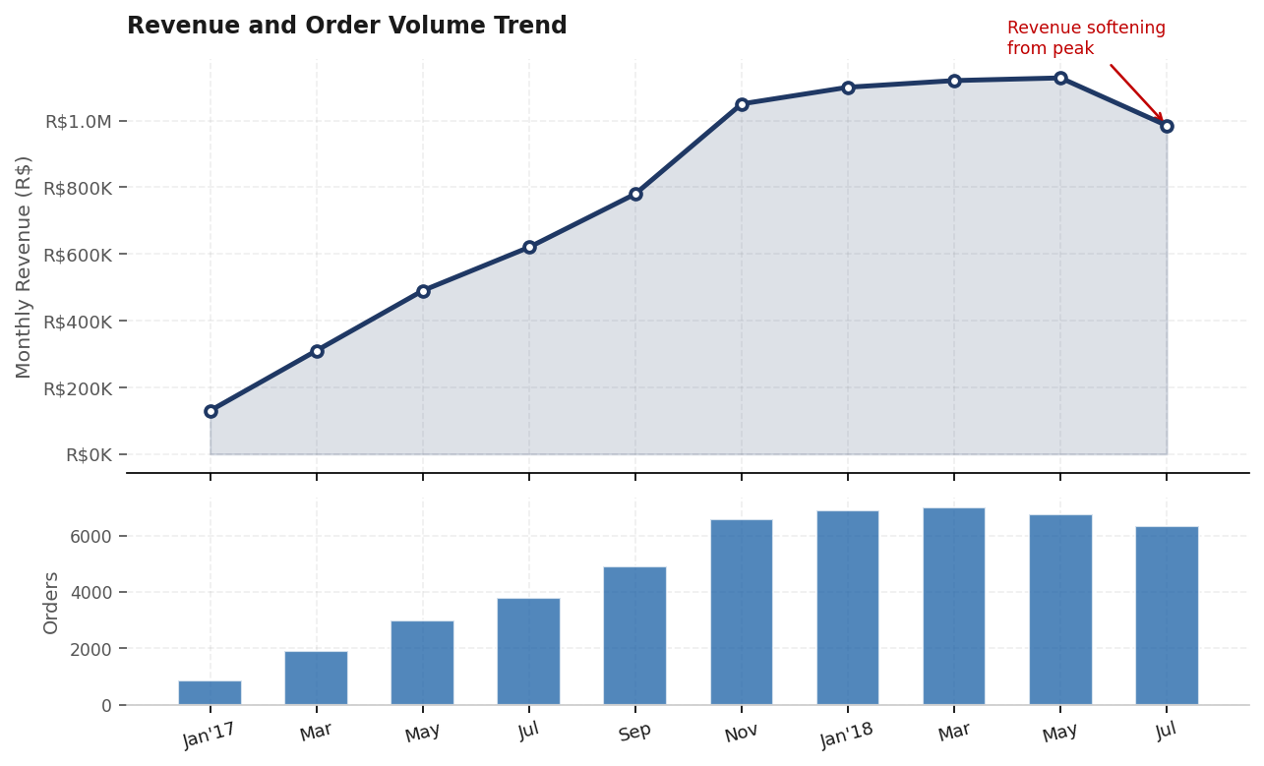
Revenue and order volume peaked in Q1 2018. The softening trend from April onward warrants monitoring, particularly given the retention problem identified below.

4.2 The Retention Crisis
The single most important number in this entire analysis is 3%. That is the percentage of customers who place more than one order. Out of 93,358 unique customers, 90,557 bought exactly once and never returned. This is not a normal retention rate for an e-commerce business. Typical e-commerce repeat rates in healthy marketplaces sit between 25% and 40%.
The practical consequence is that Olist is structurally dependent on continuous new customer acquisition to maintain revenue. There is no compounding effect from a loyal customer base. Every month starts from close to zero.

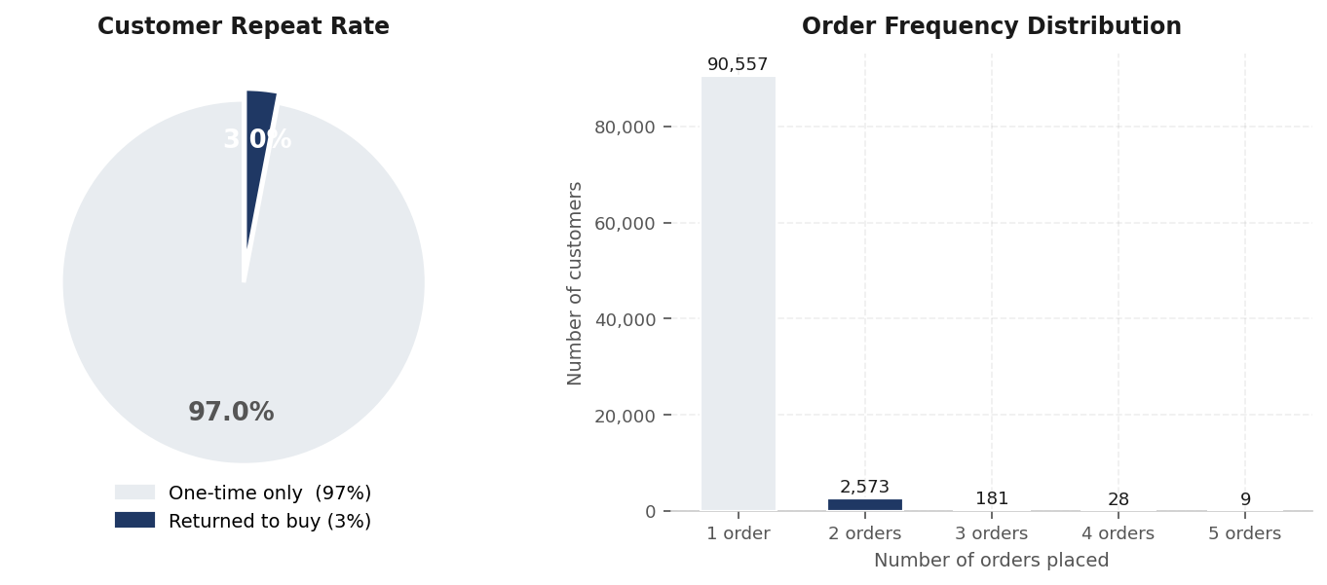
97% of customers buy once. The 3% who return are almost entirely 2-order customers. Customers placing 3 or more orders are statistically negligible at current retention rates.

4.3 Why Customers Do Not Return
The delivery data provides the most direct explanation available in this dataset. When an order arrives more than 3 days late, the average review score drops to 1.85 out of 5. When it arrives more than 3 days early, the score is 4.22. The difference is 2.37 points on a 5-point scale.
This matters because review score is a reasonable proxy for repurchase intent. Customers who give a score of 2 or below are unlikely to return. The data shows 4,529 orders arriving 3 or more days late. Each of those is a near-certain lost customer.

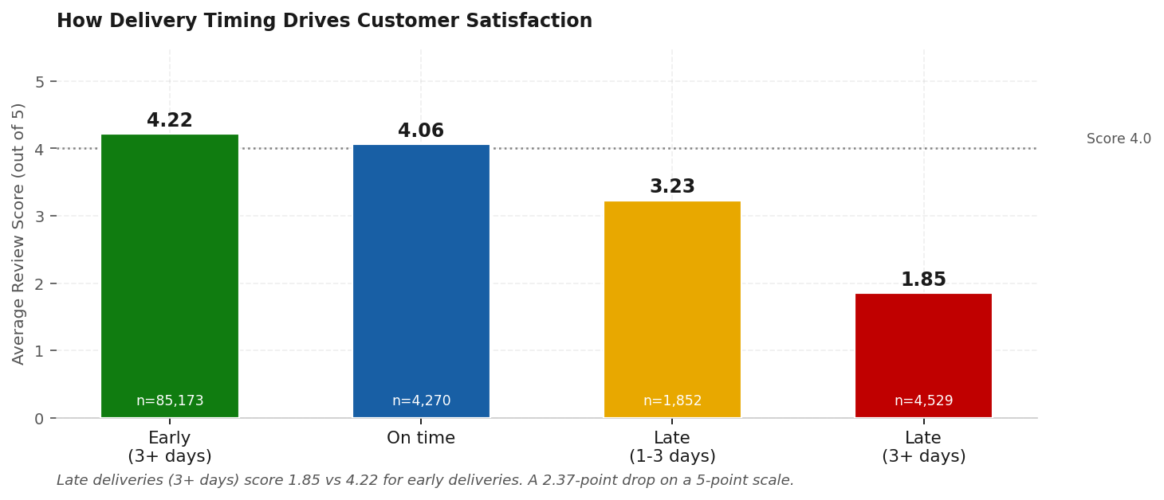
Late delivery (3+ days) produces a review score of 1.85. On-time delivery scores 4.06. The relationship between delivery timing and satisfaction is the clearest signal in the data for what drives customer loss.

4.4 Geographic Revenue and Satisfaction
Sao Paulo accounts for 37% of total revenue at R$5.77M, which is expected given its share of Brazilian economic activity. The concern is Rio de Janeiro. It is the second largest market by revenue at R$2.05M, but carries the lowest average satisfaction score among top states at 3.87. The gap between RJ and SP (3.87 vs 4.18) is notable and likely reflects either seller concentration issues, delivery route problems specific to the state, or both.
Bahia shows a similar pattern at 3.86. Both states are large enough to matter but underperforming on the metric that most directly predicts retention.

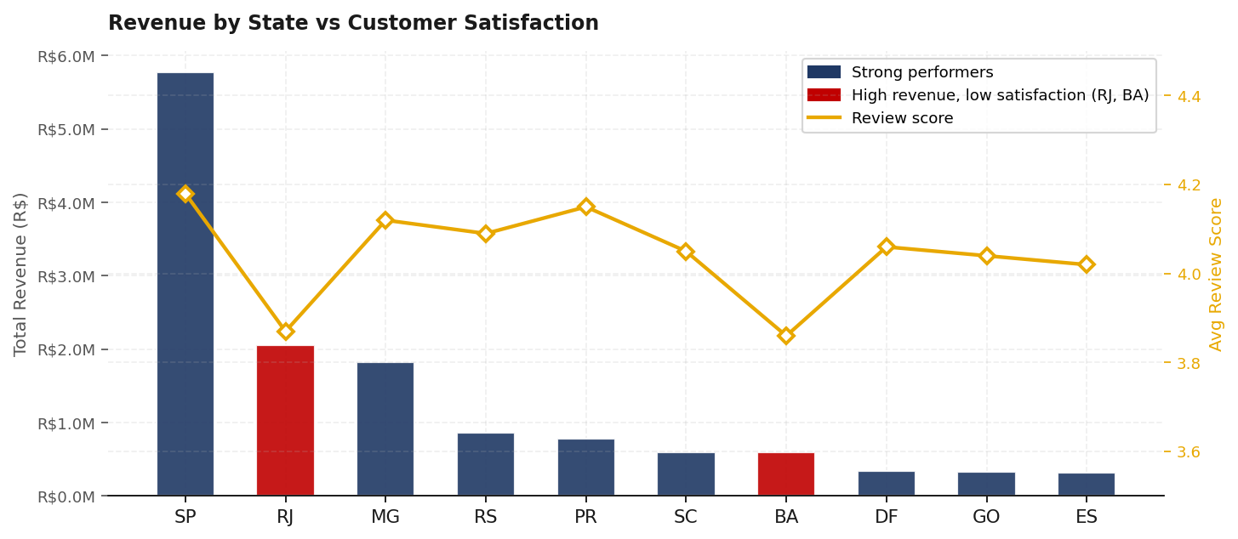
RJ and BA are flagged in red: high revenue contribution but satisfaction scores below the national average. These states need targeted operational investigation.

4.5 RFM Customer Segmentation
RFM (Recency, Frequency, Monetary) segmentation scores every customer across three dimensions and groups them into behavioural segments. The results reveal the full shape of the retention problem.
The At Risk segment is the largest by customer count at 22,230, and carries R$3.7M in revenue. These are customers who previously purchased but are showing signs of disengagement based on recency and frequency scores. They are the highest-priority target for reactivation.
Champions number only 6,497 customers but average R$312 per customer in revenue, more than double the overall average. Growing this segment is the long-term goal. Protecting the At Risk segment from becoming Lost is the short-term priority.

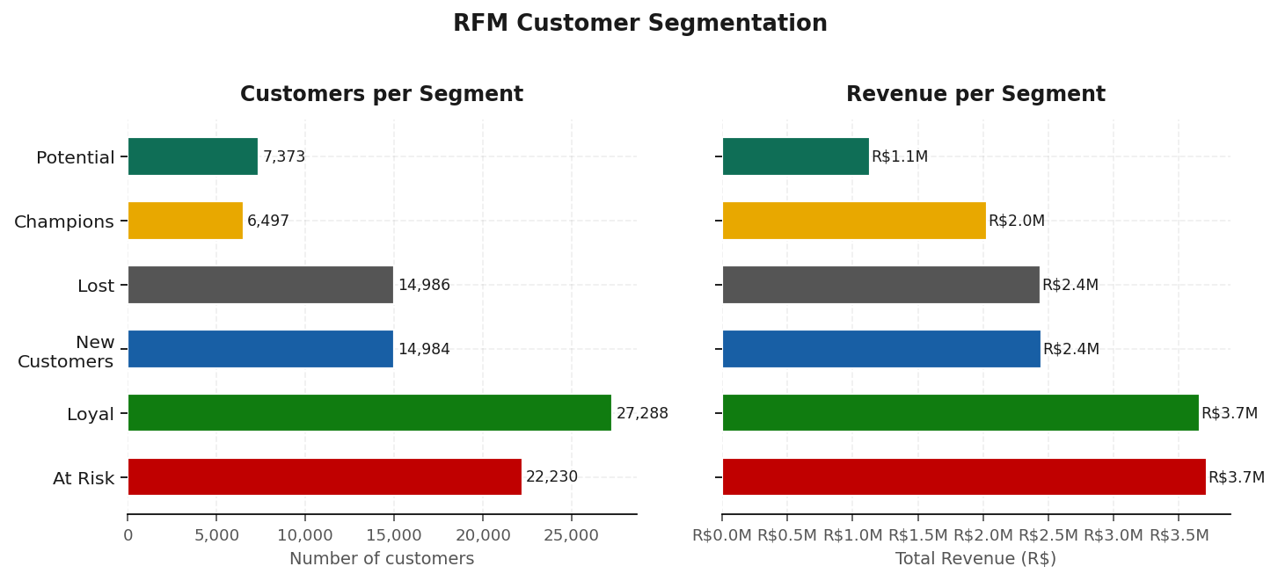
At Risk is the largest segment and carries R$3.7M in revenue. The Lost segment (R$2.4M) represents customers the business has already failed to retain. Champions produce 2x the average revenue per customer.

4.6 Payment Behaviour and Order Value
Credit card dominates payment volume at 74,304 orders, accounting for the large majority of total revenue. Within credit card transactions, customers who use installment payments spend an average of R$195 per order compared to R$96 for those who pay in full upfront. Installment buyers represent 67% of all credit card orders.
The implication is that customers are willing to spend significantly more when spread across installments. This creates an opportunity to increase average order value by actively promoting installment options on higher-value product categories.

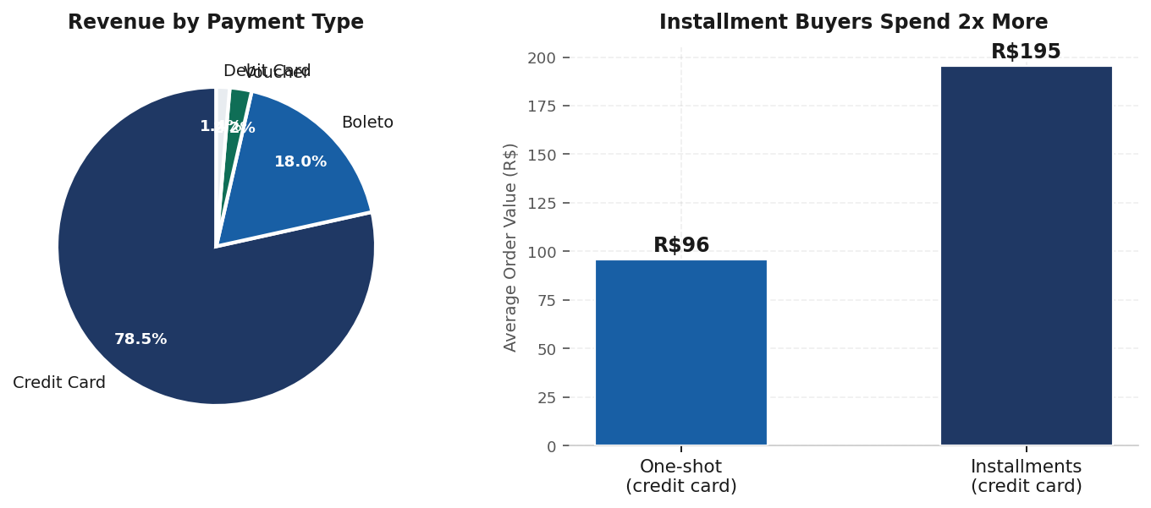
Installment buyers spend 2x more per order than one-shot buyers. 67% of credit card orders already use installments, suggesting customers are comfortable with the mechanism.

4.7 Seller Quality
Of 2,970 active sellers, 307 fall in the bottom 10% by average review score, with scores at or below 3.20. Revenue flowing through these sellers totals R$476,010, representing 3.1% of total platform revenue.
The risk here is not primarily the R$476K in direct revenue. It is the customer experience generated by those orders. Poor seller performance produces the low review scores and late deliveries identified in earlier findings. Addressing seller quality is therefore not just a revenue protection measure, it is a retention measure.

5. Recommendations
The three findings that matter most, retention rate, delivery experience, and seller quality, are connected. They are different expressions of the same operational gap: the customer experience after an order is placed is inconsistent enough that most customers choose not to repeat it.

- Prioritise delivery performance above all else. Identify the sellers and logistics routes producing the most late deliveries. Set a minimum performance standard and suspend or retrain sellers who consistently miss it. A 20% improvement in on-time delivery rate would materially shift review scores and, over time, repeat purchase rates.
- Launch a reactivation campaign for the At Risk segment. 22,230 customers with purchase history and R$3.7M in prior spend are the most cost-efficient retention opportunity available. A targeted campaign costs significantly less than acquiring 22,000 new customers. Even a 10% reactivation rate recovers R$370K in revenue.
- Investigate Rio de Janeiro and Bahia specifically. Both states contribute substantial revenue but underperform on satisfaction. The cause could be seller concentration, courier reliability, or product category mix. A state-level operational review should be conducted before further growth investment in these markets.
- Expand and promote installment payment options. Installment buyers already outspend one-shot buyers 2 to 1. Making installments more visible and accessible on higher-value product pages is a low-cost lever to increase average order value without acquiring new customers.
- Build a seller scorecard and enforce it. 307 sellers producing below-threshold review scores should be on a performance improvement process. The goal is not to remove revenue, it is to protect the customer experience that determines whether any of that revenue repeats.

None of these require major investment. They require operational focus and the willingness to make decisions on underperforming sellers and markets that may feel uncomfortable in the short term but protect long-term platform health.

