RETAIL OPERATIONS ANALYSIS

Where the business is bleeding money and what to do about it.

Dataset: Sample Superstore (Kaggle) | 9,994 transactions | 4-year period
Tools: SQL (SQLite) | Python (pandas, matplotlib) | Excel

1. Background and Objective
The Superstore dataset represents a mid-size US retail chain selling Furniture, Office Supplies, and Technology products across four geographic regions. The business processes roughly 10,000 orders over a four-year period and generates $2.3M in total revenue.
The analysis was structured around a simple brief: find where money is being lost, understand who drives value for the business, and produce one clear recommendation the business can act on. Five core questions guided the work, each answered first in SQL and then validated in Python.

2. Data Overview
The dataset contained 9,994 rows and 21 columns covering order details, customer information, product hierarchy (Category and Sub-Category), geographic data, and financial fields including Sales, Profit, Discount, and Quantity.

Key observations on first inspection:
- No null values in core financial columns
- Discount values ranged from 0% to 80%, with a notable cluster of orders at 40 to 50% discount
- Roughly 1,800 rows showed negative profit, indicating widespread below-cost selling
- Order dates ran from 2019 to 2022 with visible seasonal patterns even in the raw data

3. SQL Queries
All five analytical questions were answered using SQL on the cleaned dataset. Queries are documented below for reproducibility.

Revenue Pareto Analysis
SELECT Sub_Category,
ROUND(SUM(Sales), 0) AS total_sales,
ROUND(SUM(Sales)*100.0 / SUM(SUM(Sales)) OVER (), 3) AS sales_pct,
ROUND(SUM(SUM(Sales)*100.0 / SUM(SUM(Sales)) OVER ())
OVER (ORDER BY SUM(Sales) DESC), 3) AS cumulative_pct
FROM orders
GROUP BY Sub_Category
ORDER BY total_sales DESC;
Regional Discount and Margin Analysis
SELECT Region,
ROUND(AVG(Discount)*100, 2) AS avg_discount_pct,
ROUND(SUM(Profit), 0) AS total_profit,
ROUND(SUM(Profit)*100.0 / SUM(Sales), 2) AS profit_margin_pct
FROM orders
GROUP BY Region
ORDER BY profit_margin_pct DESC;
Discount Threshold vs Profit
SELECT ROUND(Discount, 1) AS discount_level,
COUNT(*) AS num_orders,
ROUND(AVG(Profit), 2) AS avg_profit
FROM orders
GROUP BY ROUND(Discount, 1)
ORDER BY discount_level ASC;
Sub-Category Profitability with Loss Isolation
SELECT Sub_Category,
ROUND(SUM(Sales), 0) AS total_sales,
ROUND(SUM(Profit), 0) AS total_profit,
ROUND(SUM(Profit)*100.0 / SUM(Sales), 2) AS profit_margin_pct,
ROUND(AVG(Discount)*100, 2) AS avg_discount_pct
FROM orders
GROUP BY Sub_Category
ORDER BY total_profit ASC;
Monthly Profit Trend
SELECT strftime('%m', Order_Date) AS month,
ROUND(SUM(Sales), 0) AS total_sales,
ROUND(SUM(Profit), 0) AS total_profit,
ROUND(SUM(Profit)*100.0 / SUM(Sales), 2) AS profit_margin_pct
FROM orders
GROUP BY month
ORDER BY month ASC;

4. Findings

4.1 Revenue Concentration
Eight sub-categories account for 78% of total revenue. The four largest, Chairs, Phones, Storage, and Tables, represent nearly half of all sales on their own. The chart below shows revenue share with cumulative percentage overlay.

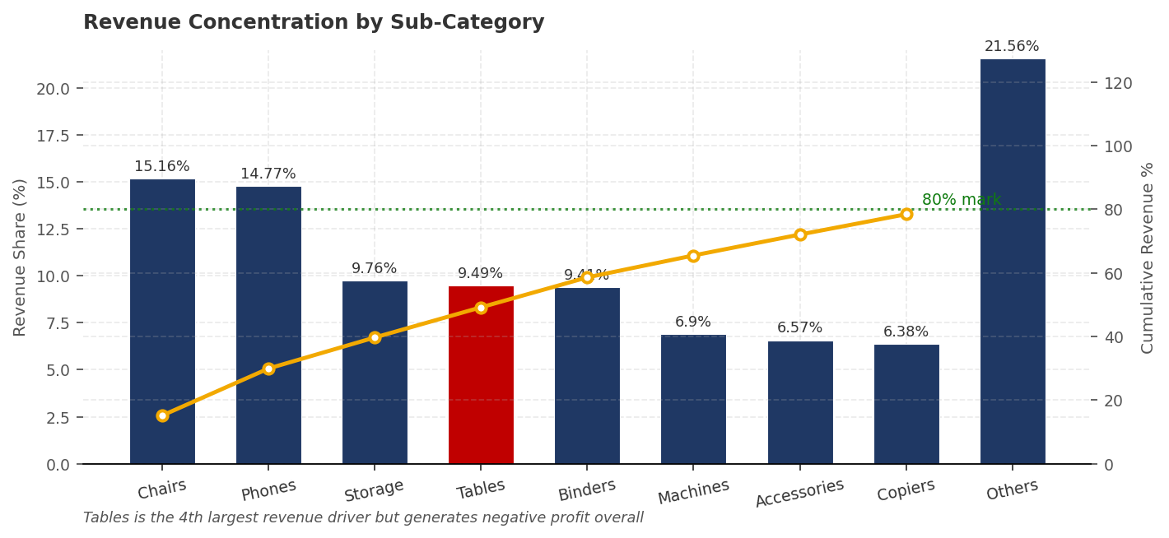
Tables appears in the top 4 by revenue but generates negative total profit. High revenue does not mean high value.

The practical takeaway is straightforward. The business can concentrate promotions, inventory investment, and sales effort on 8 sub-categories without any meaningful risk to overall revenue. The remaining 9 sub-categories combined contribute less than 22%.

4.2 The Central Region Problem
The most significant finding in the entire dataset is the gap between Central and every other region. Central discounts at 20.51% on average and returns just 4.61% profit margin. East, by contrast, discounts at 6.92% and earns 15.85%.

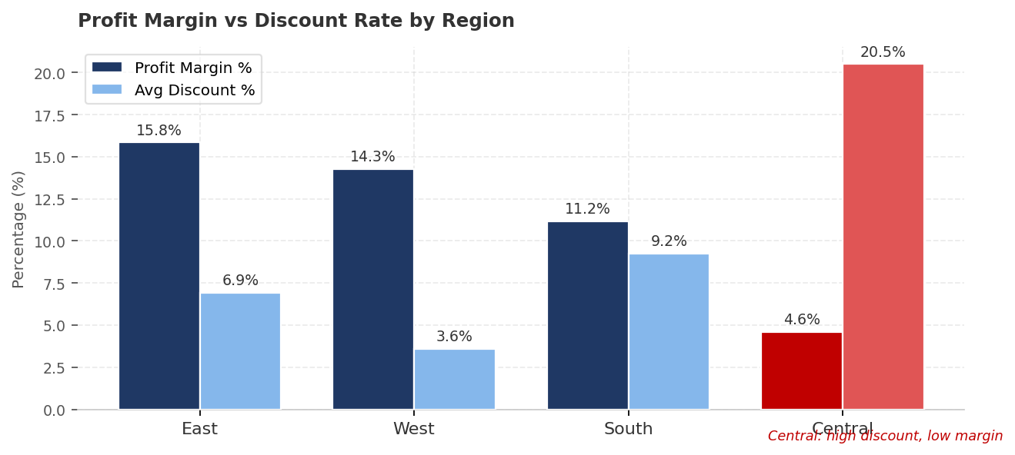
Central applies nearly 3x the discount rate of East, and earns less than a third of the margin. The correlation is not a coincidence.

Drilling into Central by sub-category, Furnishings stands out sharply. The average discount on Furnishings in Central is 67.65%, producing a -40.58% profit margin and a direct cash loss of $2,704 on that sub-category. The same products in other regions carry 40 to 50% discounts and still manage marginal profitability. Central is the clear outlier, and there is no competitive or demand-side explanation that justifies a 67% discount on furniture.

4.3 Products Being Sold Below Cost
Three sub-categories generate negative total profit across the full dataset period.

Sub-Category | Total Profit | Avg Discount | Action
Tables | -$11,000 | High | Reprice or remove
Bookcases | -$1,253 | Moderate | Pricing review
Supplies | -$753 | Moderate | Pricing review

Tables is the critical case. It sits in the top 4 revenue generators, which creates the illusion that it is a healthy product line. The moment profitability is examined, the reality is a $11,000 aggregate loss. This is precisely the kind of issue that gets missed when leadership reviews only revenue dashboards.

4.4 The Discount Threshold That Destroys Profit
Grouping orders by discount level and measuring average profit per order reveals a clear breakpoint. Once discounts exceed 20%, average profit per order turns negative. Beyond 30%, losses accelerate steeply.

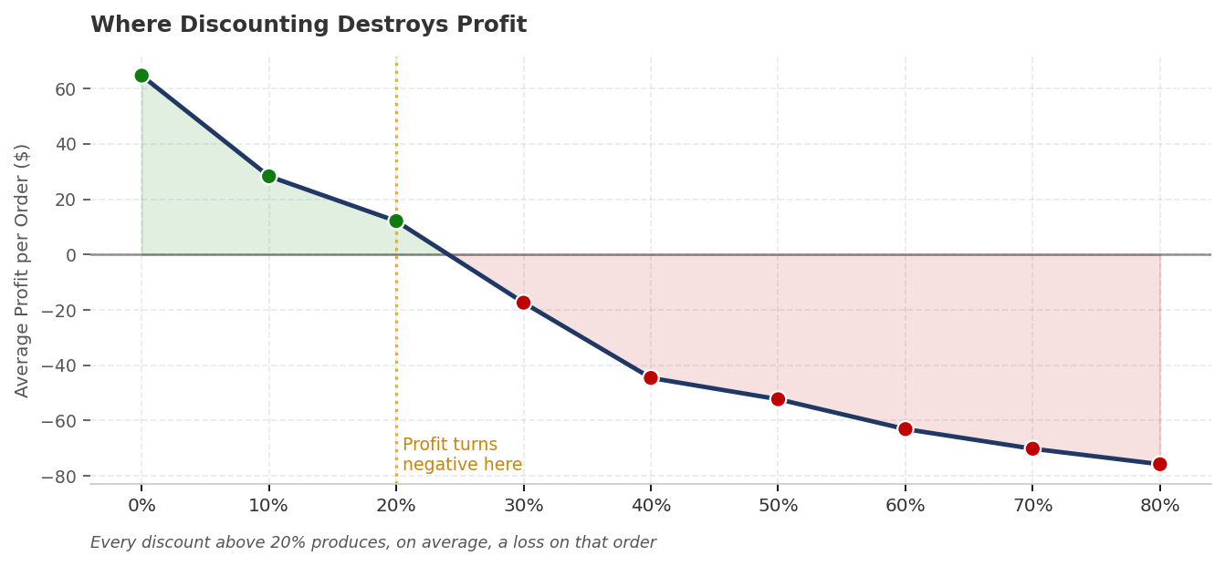
Every order placed with a discount above 20% produces, on average, a net loss. The business is paying to make those sales.

This is the single most important chart in the analysis. It provides the quantitative basis for the recommendation: a 15% discount ceiling would keep the business comfortably in the profit zone on every order, while still allowing competitive pricing.

4.5 Seasonality and the July Problem
The monthly profit chart shows a consistent pattern across all four years. Q4 is dominant, with November and December alone accounting for a disproportionate share of annual profit. This aligns with typical corporate procurement cycles.

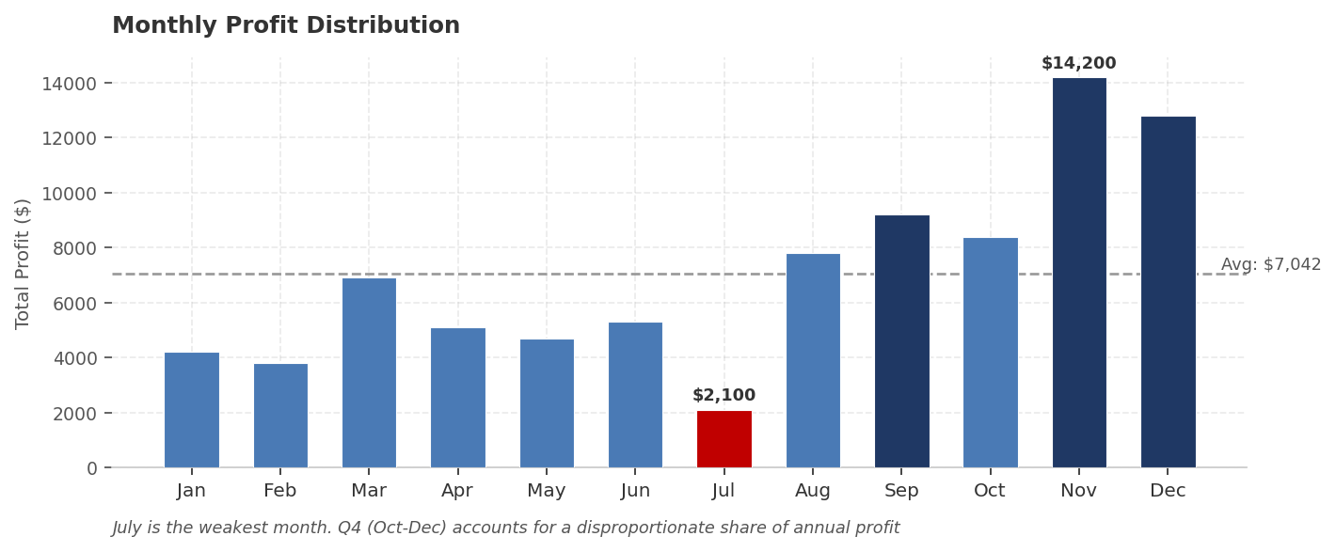
July is the weakest month by profit. Machines in July carry a -93% profit margin in the Central region, suggesting a promotion that goes far deeper than the margin can support.

The issue with July is not low demand. Sales volume in July is the third lowest but not dramatically different from neighbouring months. The problem is margin destruction through aggressive discounting on Machines, specifically in Central region. That promotion should be reviewed before the next cycle.

4.6 Customer and Segment Value
The Home Office segment delivers the highest profit margin at 15.52%, ahead of Consumer and Corporate. This is counterintuitive since Home Office typically has lower order volumes. The explanation is that Home Office customers negotiate less aggressively and receive smaller discounts, which preserves margin.
The top 20 customers by total spend are dominated by high-frequency buyers of lower-value consumable items rather than single large transactions. Retention for these customers depends on service reliability, not product range.

5. Recommendation
The data points to one root cause behind most of the profit problems in this business: uncapped discounting, concentrated in Central region and Furniture. The fix is operational and does not require capital investment.

- Introduce a 15% discount ceiling in Central region with manager approval required for any exception. This is the single highest-leverage change available and directly addresses Findings 2, 3, and 4.
- Conduct a pricing review for Tables and Bookcases. If the landed cost cannot support a 10% margin at current price points, reprice or phase out these lines. Continuing to sell them at current pricing loses money on every unit.
- Increase focus on the Home Office segment. It is the most profitable and currently underserved. Targeted outreach here costs little and has a direct margin benefit.
- Review July Machines promotions before the next annual cycle. The current depth of discounting in that window produces losses, not incremental volume.

Estimated profit recovery from the discount ceiling alone is $40,000 to $60,000 annually. That is 14 to 21% of the business's current total profit, from one process change.

