
Project Synopsis: Migoo AI — Guidance, Simplified.

0. Cover
- Project title: Migoo AI — Guidance, Simplified.
- Team name & ID: Team Migoo AI (T4)
- Institute / Course: GLA UNIVERSITY, Semester-Project
- Version: v1.0
- Date: 2nd February 2026
Revision history
Version | Date | Author | Change
v0.1 | 15 Jan 2026 | Keshav Agrawal | Initial draft
v1.0 | 2 Feb 2026 | Team Migoo AI | Complete synopsis with technical specifications

1. Overview
- Problem statement: Current learning and content creation systems require manual scripting, editing, and platform-specific optimization. Educators and creators struggle to convert topics or long-form content into structured courses, short-form videos, and exam-ready material, leading to inefficiency and content inconsistency.
- Goal: To build Migoo, an AI-powered platform that converts any topic or long-form content into structured courses, short learning videos, exam material, handwritten notes, and auto-published content, using a single unified workflow.
- Non-goals: Live video recording, Advanced animation rendering, Full LMS integration in v1, Autonomous AI agents
- Value proposition: Single-input multi-output learning automation, reduced manual effort, fast content generation, workflow-based publishing, and scalability for education-focused use cases.

2. Scope and Control
2.1 In-scope
AI-based course structure generation, Shorts / reels generation from courses, YouTube video to shorts conversion, AI-generated exam material, Handwritten-style PDF notes (Proposed), Workflow automation and scheduling, Web-based deployment.
2.2 Out-of-scope
Live classroom interaction, Multi-language dubbing, Advanced analytics dashboard, Messaging platform integrations
2.3 Assumptions
- Users have modern browsers, Stable internet or local inference setup, Usage in academic and content-creation environments
2.4 Constraints
- Semester timeline, Open-source AI models, Limited compute resources, Initial single-language support
2.5 Dependencies
- Ollama (Local AI runtime), Open-source LLMs (Llama / Qwen / DeepSeek), FastAPI / Flask (Backend), React.js (Frontend)
2.6 Acceptance criteria and sign-off
- GIVEN a topic or content
- WHEN processed by Migoo
- THEN structured courses, shorts, and notes are generated within seconds
- Content relevance ≥ 85%
- Sign-off: Mentor approval after successful demo
Sign-off table
Stakeholder | Role | Decision area | Signature/Approval | Date
Dr. Ram Manohar Nisarg | Mentor | Scope, final acceptance | Approved | 3 Feb 2026
Keshav Agrawal | Product Lead | Release readiness | Approved | 3 Feb 2026

3. Stakeholders and RACI
Activity | Responsible (R) | Accountable (A) | Consulted (C) | Informed (I)
Requirements | Keshav | Keshav | Mentor | Team
Design | Parmeet | Keshav | Mentor | Team
Implementation | Keshav, Parmeet | Keshav | — | Team
Testing | Parmeet | Keshav | Mentor | Team
Release | Keshav | Keshav | Mentor | Dept

4. Team and Roles
Member | Role | Responsibilities | Key skills | Availability | Contact
Keshav Agrawal | Tech Lead & Backend | AI workflows, backend APIs, system architecture | GenAI, Backend | 10 hrs/wk | keshav.agrawal_cs.h23@gla.ac.in
Parmeet Singh | Frontend & Testing | UI development, workflow integration, testing | React, UI/UX | 8 hrs/wk | parmeet.singh_cs.h23@gla.ac.in

5. Week-wise Plan and Assignments
Week | Dates | Milestones | Keshav (Lead) | Parmeet (Backend / AI) | Deliverables | Status
1 | 3–9 Feb | Requirements Freeze | Finalize scope, core modules & use-cases | Define AI inputs/outputs, content formats | Draft SRS, Tech Stack doc | Planned
2 | 10–16 Feb | Architecture & DB Design | Architecture & workflow review | DB schema (sessions, content pipeline) | ERD, API Spec v1 | Planned
3 | 17–23 Feb | Backend Scaffolding | Risk analysis & unblock | AI pipeline setup (Ollama + LLM), course generator | Core backend services (Course Gen) | Planned
4 | 24 Feb–2 Mar | Frontend Scaffolding | Weekly sync & feature review | API integration & testing | UI screens, dashboard layout | Planned
5 | 3–9 Mar | Feature Set A | Scope adjustment if needed | Shorts/Reels generator, exam material logic | End-to-end demo (Course + Shorts) | Planned
6 | 10–16 Mar | Feature Set B | Define KPIs & optimization goals | Handwritten notes generator, workflow engine | Demo: Notes + Workflow automation | Planned
7 | 17–23 Mar | Hardening & Testing | Risk burn-down & final checks | Backend bug fixes & optimization | Test report + Debug log | Planned
8 | 24–30 Mar | Release & Presentation | Final sign-off, project deck preparation | Deployment, documentation & configs | v1.0 Release + Project Deck | Planned

6. Users and UX
6.1 Personas
- Student Learner: Wants short, structured learning content
- Educator: Wants fast course creation
- Content Creator: Wants repurposable short-form content
6.2 Top user journeys
- Home → Enter Topic / YouTube Link → AI Processing → Course / Shorts / Notes
KPI: Response time ≤ 25s, engagement ≥ 85%
6.3 User stories
- As a learner or educator, I want to convert a topic into structured learning content and revision material so that I can save time and improve learning efficiency.
6.4 Accessibility & localization
- Simple text-based interaction
- Clean UI for ease of use
- English language support (v1)

7. Market and Competitors
7.1 Competitor table
Competitor | Product | Target Users | Key Features | Pricing | Strengths | Weaknesses | Our Differentiator
ChatGPT | AI Assistant | Students, Educators | Text-based explanations, Q&A | Freemium | Fast responses | No video/course automation | Migoo generates structured courses & videos
Google Gemini | AI Assistant | General users | Knowledge-based answers | Freemium | Strong search integration | No learning workflow | Migoo focuses on learning + content creation
Notion AI | AI Workspace | Professionals, Students | Notes & summaries | Paid | Good organization | No video/shorts generation | Migoo produces video-ready content
Manual Course Creators | YouTube / LMS | Educators | Custom teaching style | Free / Paid | High quality | Time-consuming | Migoo automates entire pipeline

7.2 Positioning
- Unique angle: Migoo uniquely combines learning automation, content repurposing, and auto-distribution into a single AI-powered workflow.
- Measurable delta: Reduces course creation time by 70–80%, converts one topic into multiple formats automatically, designed for education-first use cases
8. Objectives and Success Metrics
- O1 Onboarding: Course or content generation start time ≤ 3 seconds
- O2 Content Quality: Generated learning content relevance ≥ 85%
- O3 Automation Efficiency: One input generates multiple outputs successfully
- O4 Accessibility: No major usability issues in core workflows
9. Key Features
Feature | Description | Priority | Dependencies | Acceptance Criteria
AI Course Generator | Converts topic into structured chapters | Must | Ollama, LLM | GIVEN a topic WHEN processed THEN course is generated
Shorts / Reels Generator | Converts lessons into short videos | Must | LLM, Prompt Engine | Shorts generated with key concepts
YouTube to Shorts | Extracts concepts from long videos | Must | Transcript parser | Shorts reflect main ideas
Exam Material Generator | Creates questions & revision notes | Should | LLM | Exam-ready content generated
Handwritten Notes | AI handwritten-style PDFs | Should | Font engine | Notes are readable & exam-friendly

10. Architecture
10.1 High-level
- Frontend: React.js for dashboard, course input, workflow control
- Backend: FastAPI / Flask for AI orchestration, workflows, APIs
- AI Engine: Ollama (Local) with Open-source LLMs (Llama / Qwen)
- Content Processing: Prompt pipelines for course, shorts, notes & exam material

10.2 API spec snapshot
Endpoint | Method | Auth | Purpose | Request Schema | Response Schema | Codes
/generate-course | POST | — | Course generation | {topic: string} | {chapters: list} | 200, 400
/generate-shorts | POST | — | Shorts generation | {content: text} | {shorts: list} | 200, 400
/generate-notes | POST | — | Handwritten notes | {topic: string} | {pdf: file} | 200, 400
/execute-work | POST | — | Automation exe. | {config: json} | {status: string} | 200, 400

10.3 Config and secrets
- .env file for environment variables, API keys and model configs stored securely, Sensitive files Git-ignored

11. Data Design
11.1 Data dictionary
Entity | Field | Type | Null? | Allowed Values | Source | Notes
User | input | String | No | — | User | Primary Input
Course | content | Text | No | — | System | Generated Output
Shorts | clip | Text | No | — | System | Short-form Content
Notes | pdf | File | No | — | System | Handwritten Notes
Workflow | status | String | No | pending / completed | System | Execution State

11.2 Schemas and migrations
- Minimal session-based schema used
- No permanent user data storage
- Generated content exists only for the active session
- Stateless backend design for scalability

11.3 Privacy, retention, backup/DR
- Local and session-level data storage only
- Generated content retained only during session lifetime
- No external data transmission without user action
- No personal user information stored

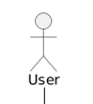
- 12. Technical Workflow Diagram
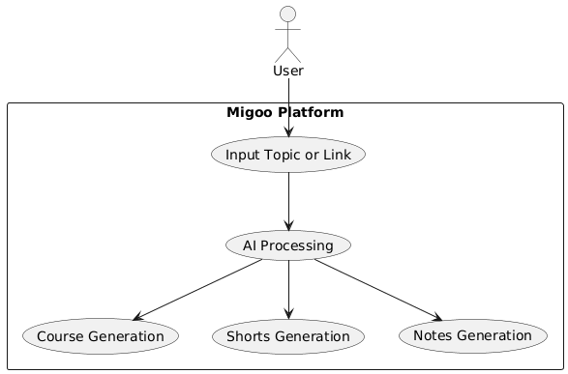

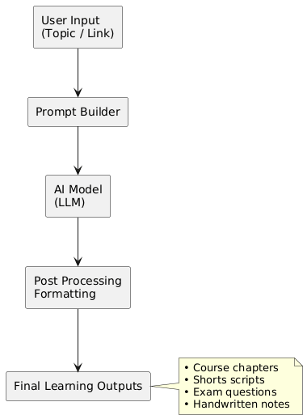
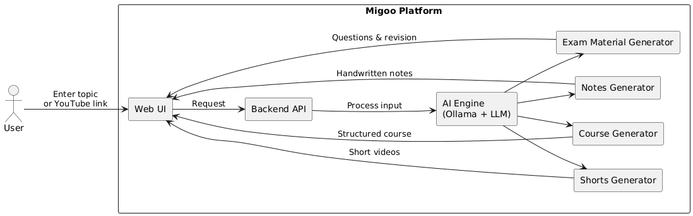

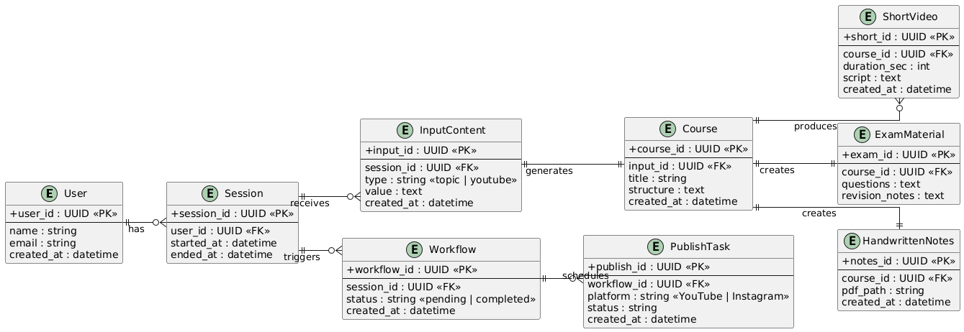
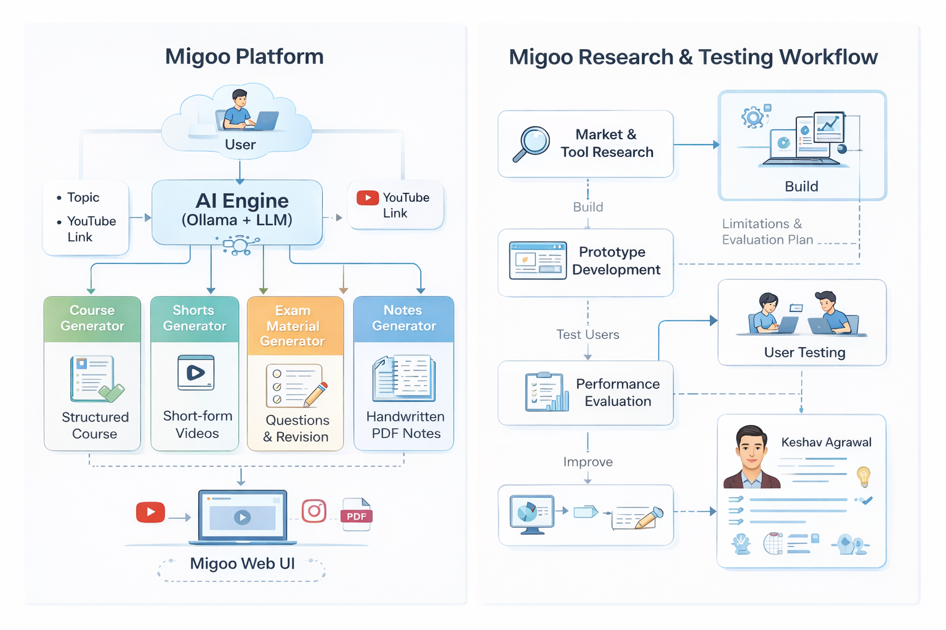

13. Quality: NFRs and Testing
- AI output relevance and accuracy testing
- Workflow execution validation
- UI usability testing
- Performance testing for multiple requests
- Manual review of generated learning content

14. Security and Compliance
- Secure handling of AI model responses
- No storage of personal or sensitive user data
- Environment variables protected via configuration files
- Local inference option reduces external dependency risks

15. Delivery and Operations
- Deployed using Vercel / Render for public access
- Logs monitored for error detection and performance analysis
- Easy redeployment using containerized or script-based setup

16. Risks and Mitigations
- Risk: Slow AI response time, Mitigation: Optimized prompts and lightweight models
- Risk: Large input content size, Mitigation: Chunked processing approach
- Risk: Platform publishing failures, Mitigation: Retry and fallback mechanisms

17. Research and Evaluation
- Study of AI-based learning platforms and content tools
- Comparison with manual course creation workflows
- Evaluation through test users and generated content quality
- Limitations identified for future improvement

18. Appendices
- Glossary:
• LLM - Large Language Model
• GenAI: Generative Artificial Intelligence
• Workflow Engine: Automated content execution pipeline
• KPI – Key Performance Indicator

- References: Course Handbook, React Documentation, Ollama Documentation, Open-source LLM Documentation

