**Refer: http://websystique.com/spring-security/secure-spring-rest-api-using-oauth2/**

**Client 1: Postman**

Try to access a resource without any auth info, wil get a 401.

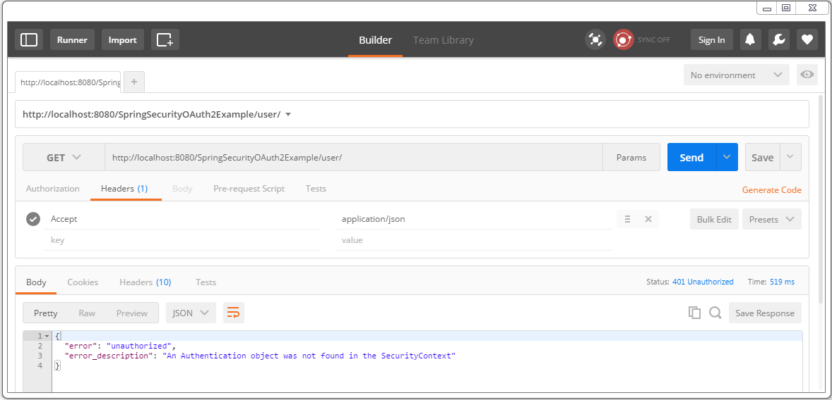

Let’s get the tokens. First add an authorization header with **client credentials** [my-trusted-client/secret].

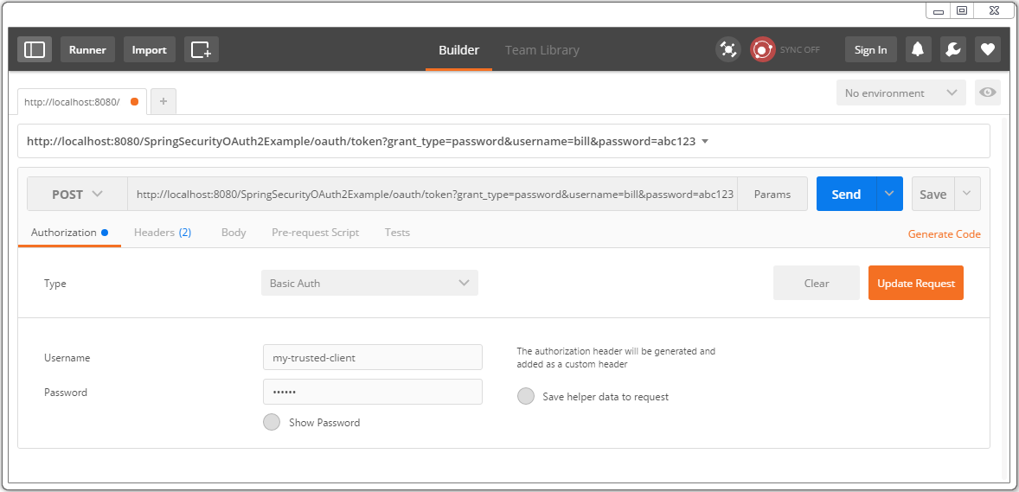

Click on update request, verify the header in header-tab.

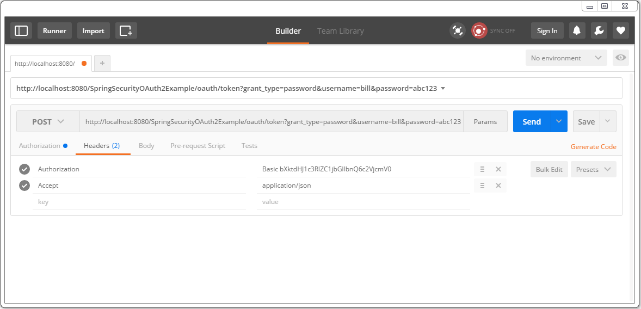

Send the Post request, you should receive the response containing access-token as well as refresh-token.

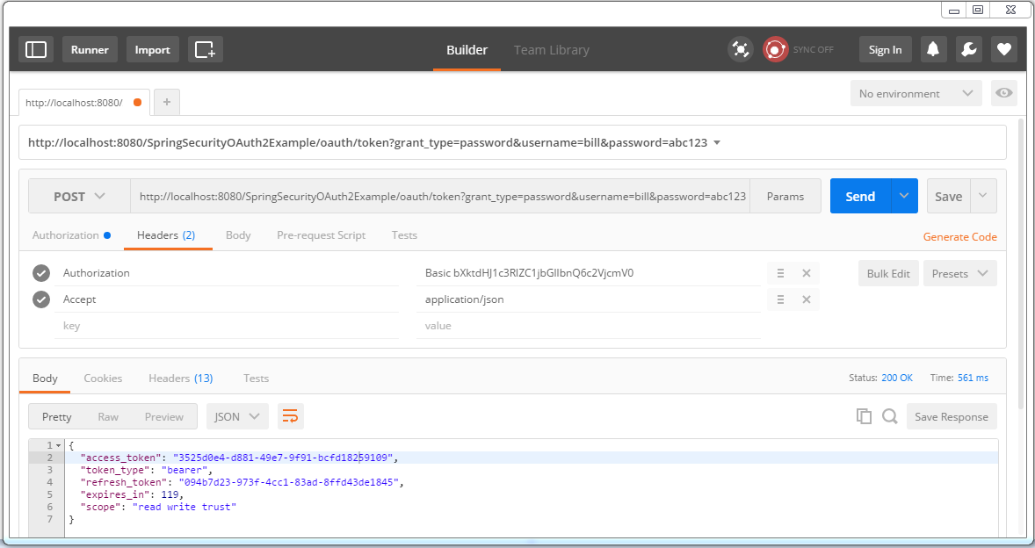

Save these tokens somewhere, you will need them. Now you can use this access-token [valid for 2 minutes] to access resources.

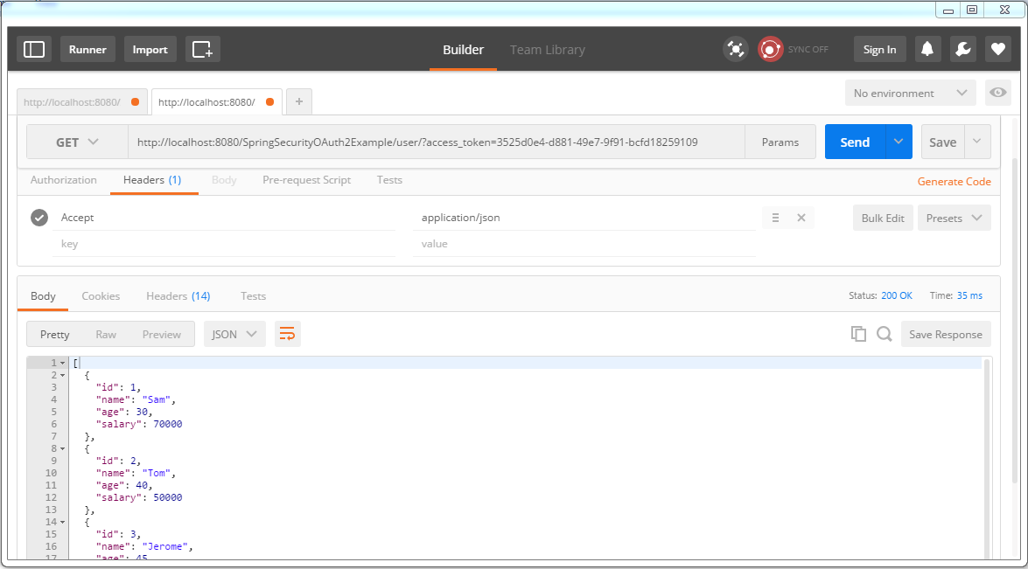

After 2 minutes, access-token gets expired, your further resource requests will fail.

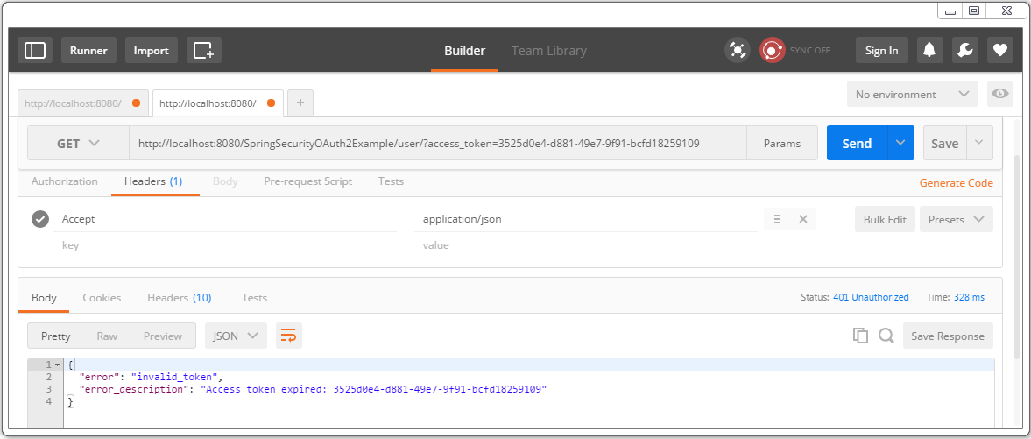

We need a new access-token. Fire a post to with refresh-token to get a brand-new access-token.

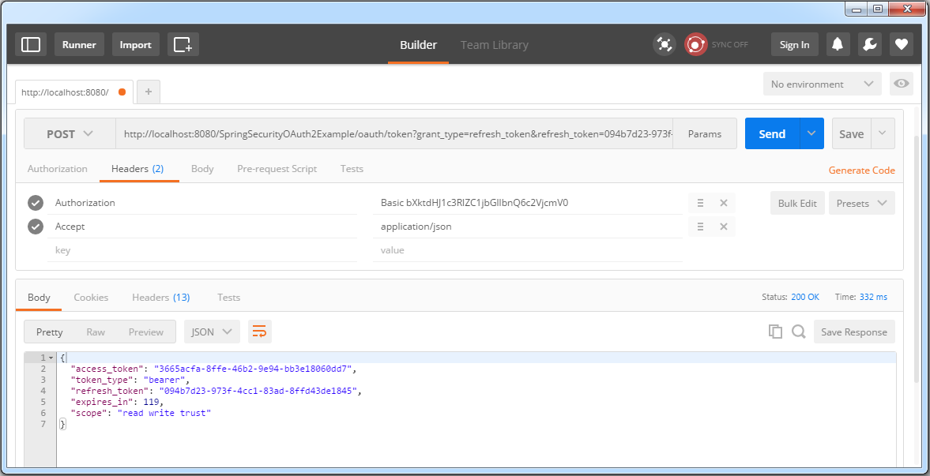

Use this new access-token to access the resources.

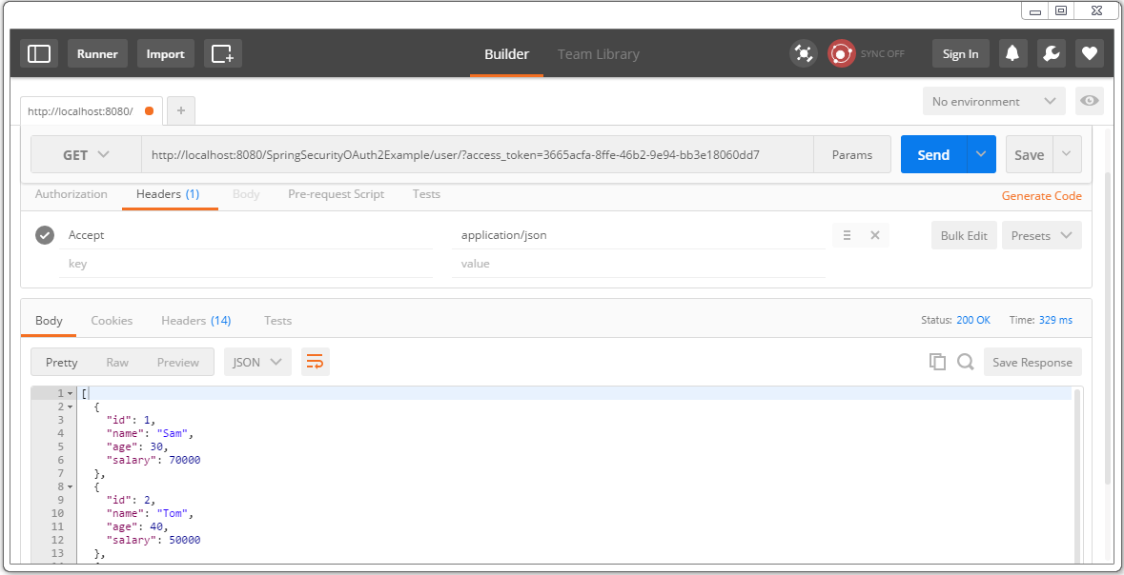

Refresh-token expires too[10 minutes]. After that, you should see your refresh request getting failed.

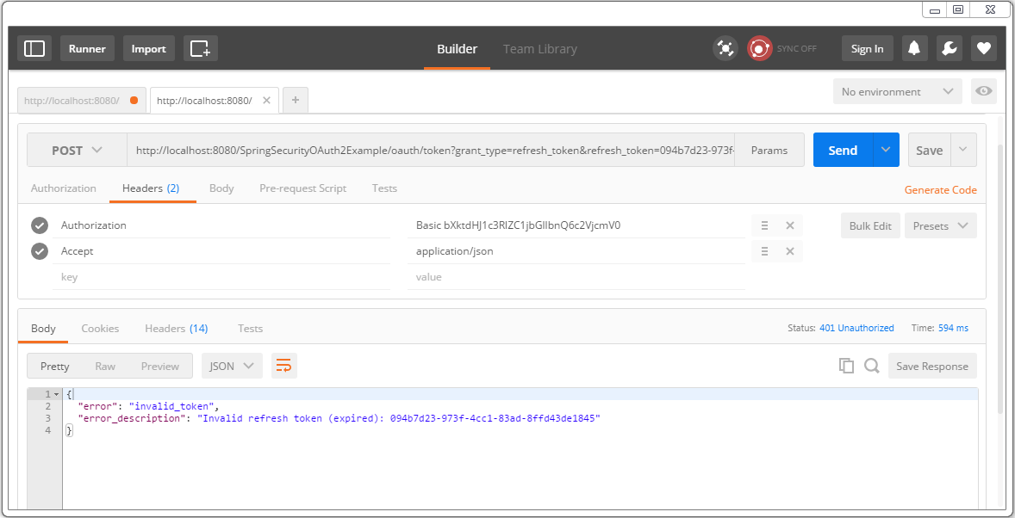

It means you need to request a new refresh+access-token, as in step 2.