**Task 1:** **Password validator:**

1. **Task Description**

Password validator the check the value of password like it's good, very good, strong, excellent based on password

1. **Task Output Screenshot**

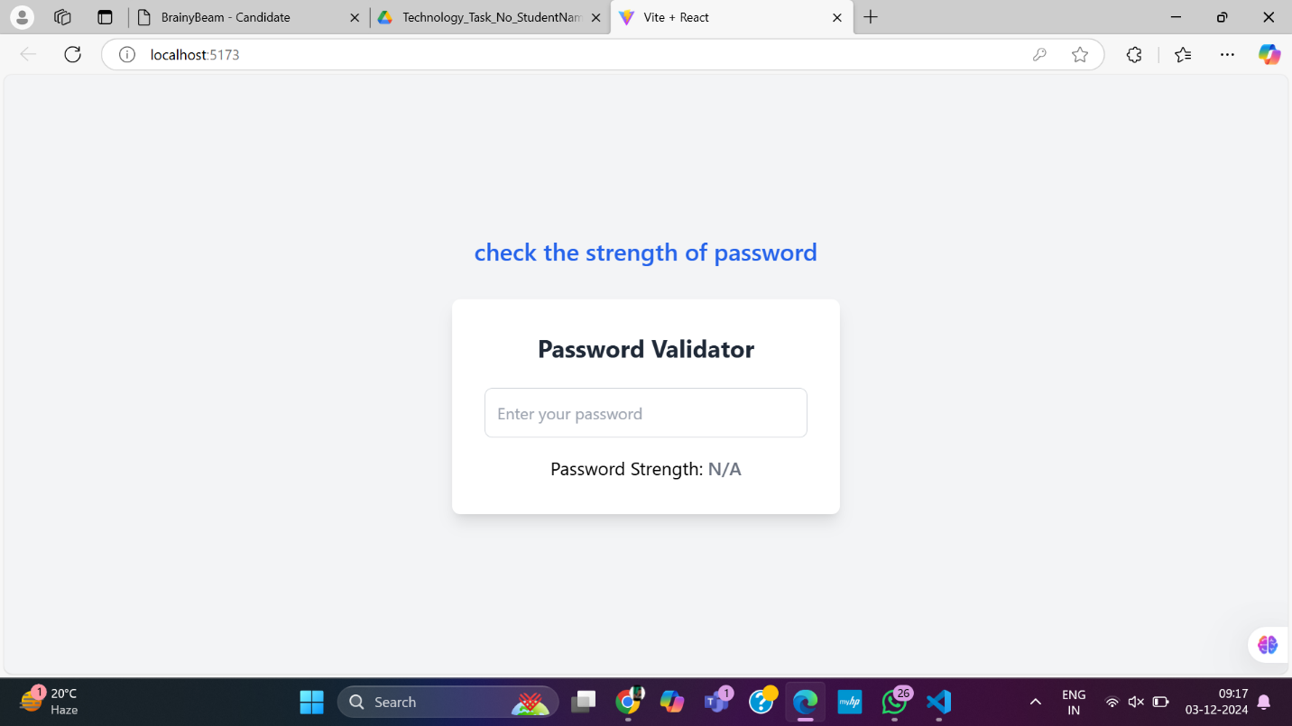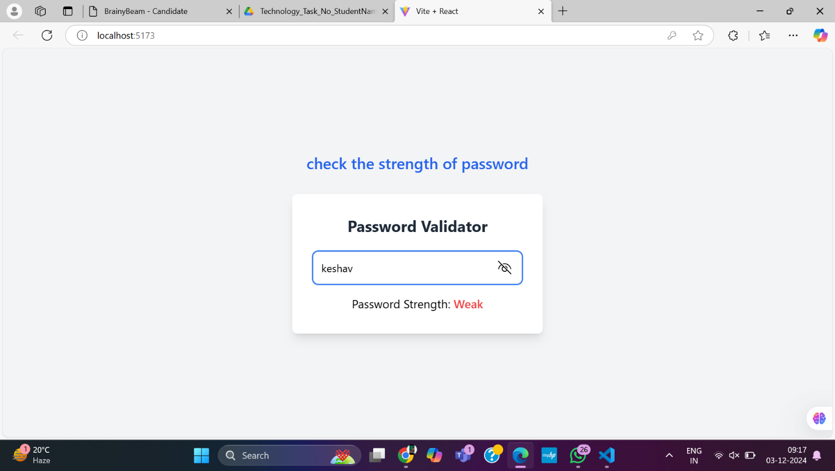

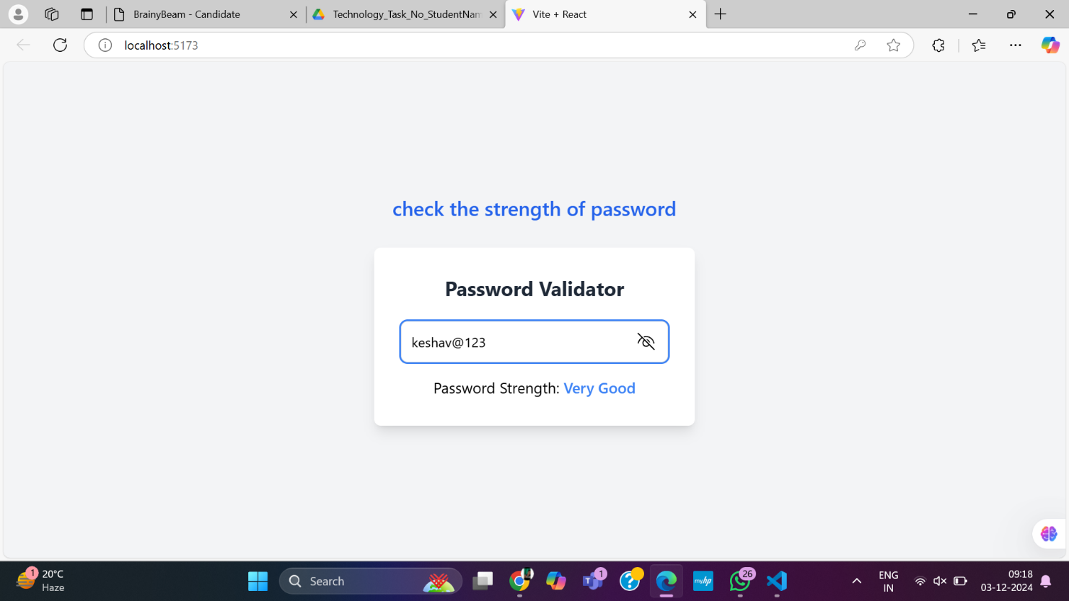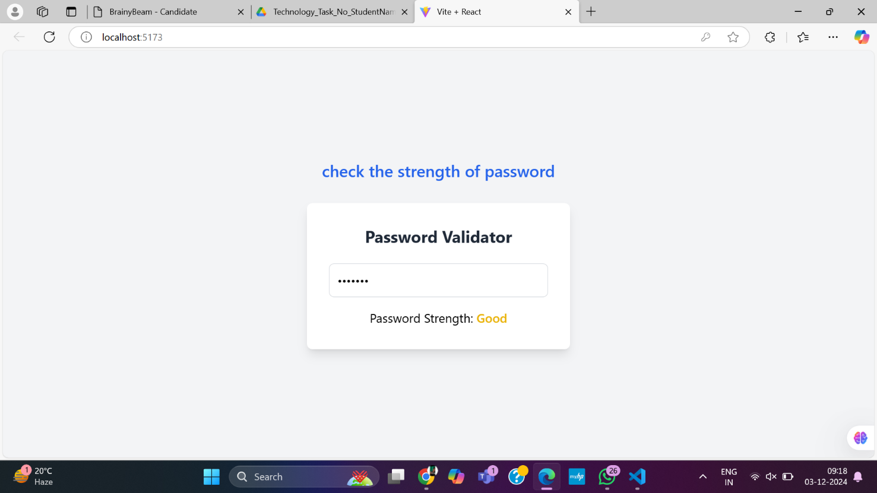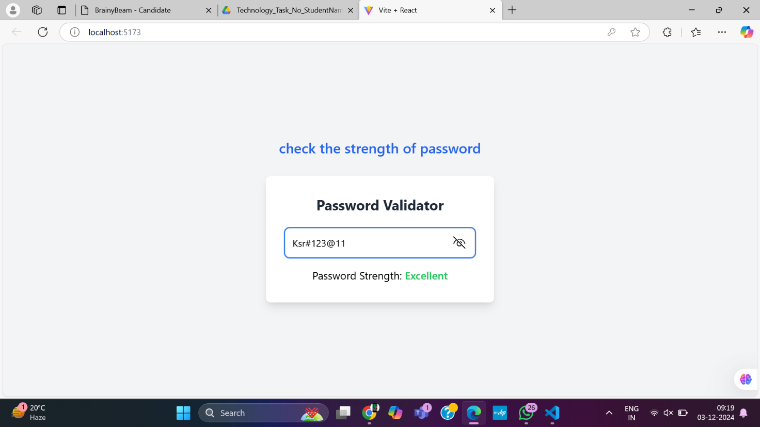

1. **Widget/Algorithm Used In Task**

* **Input Fields (<input />)**: For collecting user information like password .
* **Button (<button />)**: To trigger the form submission .
* **Text (<p />, <span />)**: For displaying error messages and validation feedback.
* **useState Hook**: Track form inputs and validation errors.
* **Regex Validation**: For validating email format, password strength, etc.
* **Form Event Handling**: Handling the form submission to send data to an API for authentication.
* **Conditional Rendering**: Show appropriate error messages based on validation.