**e-maze-in**

Ankit is in maze. The command center sent him a string which decodes to come out from the maze. He is initially at **(0, 0)**. String contains **L, R, U, D** denoting left, right, up and down. In each command he will traverse **1** unit distance in the respective direction.

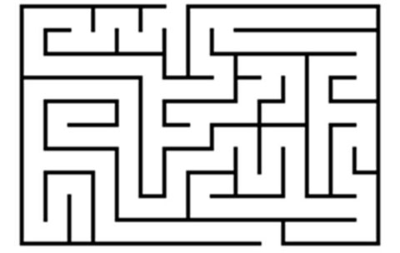

For example if he is at **(2, 0)** and the command is **L** he will go to **(1, 0)**.

**Input:**

Input contains a single string.

**Output:**

Print the final point where he came out.

**Constraints:**

1 ≤ |S| ≤ 200

**SAMPLE INPUT**

LLRDDR

**SAMPLE OUTPUT**

0 -2