package mongodb;
import com.mongodb.client.*;
import com.mongodb.client.model.Filters;
import com.mongodb.client.model.Updates;
import org.bson.Document;
public class crudex{
public static void main(String[] args) {
// Connect to MongoDB
MongoClient mongoClient = MongoClients.create("mongodb://localhost:27017");
// Access database
MongoDatabase database = mongoClient.getDatabase("CollegeDB");
// Access collection
MongoCollection<Document> collection =
database.getCollection("Students");
// ==========================
// CREATE (Insert)
// ==========================
Document student = new Document("id", 101)
.append("name", "John")
.append("department", "CSE")
.append("cgpa", 8.7);
collection.insertOne(student);
System.out.println("Document Inserted Successfully");
// ==========================
// READ (Find)
// ==========================
System.out.println("\nStudent Records:");
FindIterable<Document> students = collection.find();
for (Document doc : students) {System.out.println(doc.toJson());
}
// ==========================
// UPDATE
// ==========================
collection.updateOne(
Filters.eq("id", 101),
Updates.set("cgpa", 9.2)
);
System.out.println("\nDocument Updated Successfully");
// ==========================
// READ Updated Record
// ==========================
Document updatedStudent =
collection.find(Filters.eq("id", 101)).first();
System.out.println("\nUpdated Record:");
System.out.println(updatedStudent.toJson());
// ==========================
// DELETE
// ==========================
collection.deleteOne(Filters.eq("id", 101));
System.out.println("\nDocument Deleted Successfully");
// Close connection
mongoClient.close();
}
}

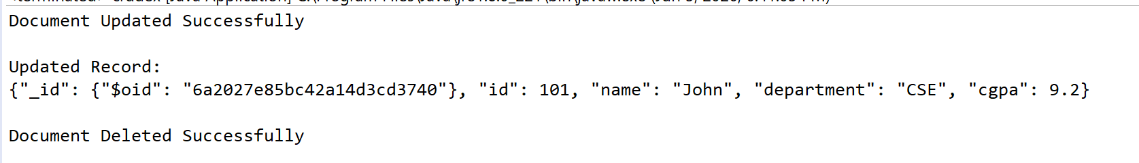

package mongodb;
import com.mongodb.client.*;
import com.mongodb.client.model.Filters;
import com.mongodb.client.model.Updates;
import org.bson.Document;
public class crudex{
public static void main(String[] args) {
// Connect to MongoDB
MongoClient mongoClient = MongoClients.create("mongodb://localhost:27017");
// Access database
MongoDatabase database = mongoClient.getDatabase("CollegeDB");
// Access collection
MongoCollection<Document> collection =
database.getCollection("Students");
// ==========================
// CREATE (Insert)
// ==========================
Document student = new Document("id", 101)
.append("name", "John")
.append("department", "CSE")
.append("cgpa", 8.7);
collection.insertOne(student);
System.out.println("Document Inserted Successfully");
collection.insertMany(java.util.Arrays.asList(
new Document("id", 1).append("name", "Alice"),
new Document("id", 2).append("name", "Bob"),
new Document("id", 3).append("name", "Charlie")
));
// ==========================
// READ (Find)
// ==========================
System.out.println("\nStudent Records:");
FindIterable<Document> students = collection.find();
for (Document doc : students) {System.out.println(doc.toJson());
}

// Close connection
mongoClient.close();
}
}
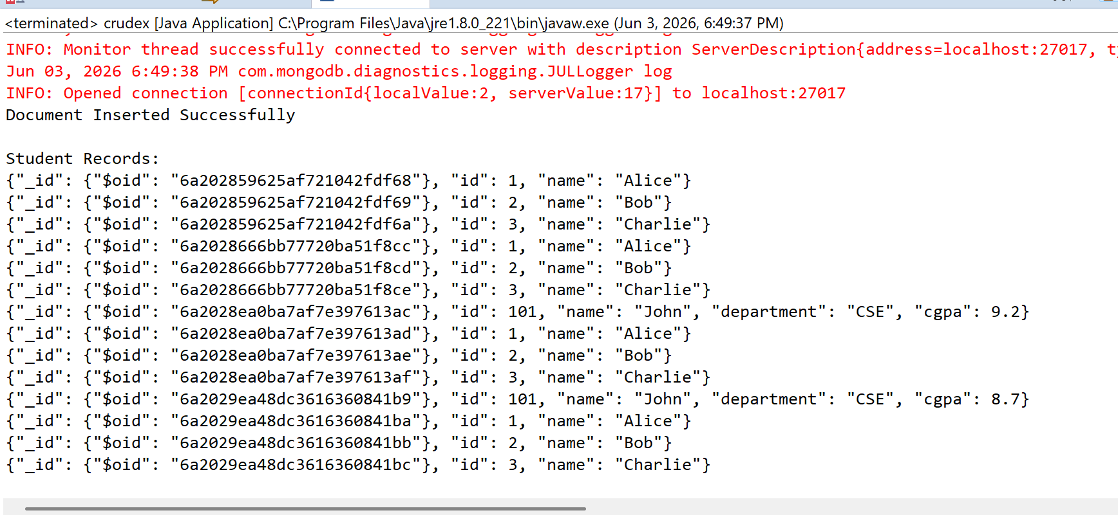

package mongodb;
import com.mongodb.client.*;
import com.mongodb.client.model.Filters;
import com.mongodb.client.model.Updates;
import org.bson.Document;
public class crudex{
public static void main(String[] args) {
// Connect to MongoDB
MongoClient mongoClient = MongoClients.create("mongodb://localhost:27017");
// Access database
MongoDatabase database = mongoClient.getDatabase("CollegeDB");
// Access collection
MongoCollection<Document> collection =
database.getCollection("Students");
// ==========================
// CREATE (Insert)
// ==========================
Document student = new Document("id", 101)
.append("name", "John")
.append("department", "CSE")
.append("cgpa", 8.7);
collection.insertOne(student);
System.out.println("Document Inserted Successfully");
collection.insertMany(java.util.Arrays.asList(
new Document("id", 1).append("name", "Alice"),
new Document("id", 2).append("name", "Bob"),
new Document("id", 3).append("name", "Charlie")
));
// ==========================
// READ (Find)
// ==========================
//System.out.println("\nStudent Records:");
//FindIterable<Document> students = collection.find();
//for (Document doc : students) {System.out.println(doc.toJson());

//find
Document doc = collection.find(Filters.eq("id", 2)).first();
System.out.println(doc.toJson());

// Close connection
mongoClient.close();
}
}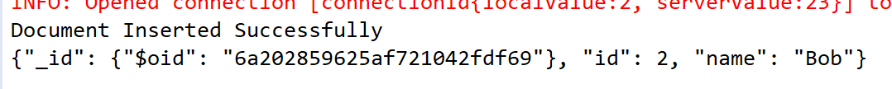
package mongodb;
import com.mongodb.client.*;
import com.mongodb.client.model.Filters;
import com.mongodb.client.model.Updates;
import org.bson.Document;
public class crudex{
public static void main(String[] args) {
// Connect to MongoDB
MongoClient mongoClient = MongoClients.create("mongodb://localhost:27017");
// Access database
MongoDatabase database = mongoClient.getDatabase("CollegeDB");
// Access collection
MongoCollection<Document> collection =
database.getCollection("Students");
// ==========================
// CREATE (Insert)
// ==========================
Document student = new Document("id", 101)
.append("name", "John")
.append("department", "CSE")
.append("cgpa", 8.7);
collection.insertOne(student);
System.out.println("Document Inserted Successfully");
collection.insertMany(java.util.Arrays.asList(
new Document("id", 1).append("name", "Alice"),
new Document("id", 2).append("name", "Bob"),
new Document("id", 3).append("name", "Charlie")
));
// ==========================
// READ (Find)
// ==========================
//System.out.println("\nStudent Records:");
//FindIterable<Document> students = collection.find();
//for (Document doc : students) {System.out.println(doc.toJson());

//update
collection.updateOne(
Filters.eq("id", 2),
Updates.set("name", "Bobby")
);
System.out.println("updated");
Document doc1 = collection.find(Filters.eq("id", 2)).first();
System.out.println(doc1.toJson());

// Close connection
mongoClient.close();
}
}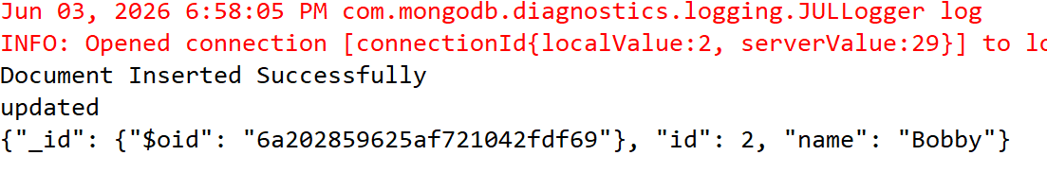
package mongodb;
import com.mongodb.client.*;
import com.mongodb.client.model.Filters;
import com.mongodb.client.model.Updates;
import org.bson.Document;
public class crudex{
public static void main(String[] args) {
// Connect to MongoDB
MongoClient mongoClient = MongoClients.create("mongodb://localhost:27017");
// Access database
MongoDatabase database = mongoClient.getDatabase("CollegeDB");
// Access collection
MongoCollection<Document> collection =
database.getCollection("Students");
// ==========================
// CREATE (Insert)
// ==========================
Document student = new Document("id", 101)
.append("name", "John")
.append("department", "CSE")
.append("cgpa", 8.7);
collection.insertOne(student);
System.out.println("Document Inserted Successfully");
collection.insertMany(java.util.Arrays.asList(
new Document("id", 1).append("name", "Alice"),
new Document("id", 2).append("name", "Bob"),
new Document("id", 3).append("name", "Charlie")
));
// ==========================
// READ (Find)
// ==========================
//System.out.println("\nStudent Records:");
//FindIterable<Document> students = collection.find();
//for (Document doc : students) {System.out.println(doc.toJson());

//update
collection.updateOne(
Filters.eq("id", 2),
Updates.set("name", "Bobby")
);
System.out.println("updated");
Document doc1 = collection.find(Filters.eq("id", 2)).first();
System.out.println(doc1.toJson());
//delete
collection.deleteOne(Filters.eq("id", 2));
System.out.println("deleted");

// Close connection
mongoClient.close();
}
}

