Q –

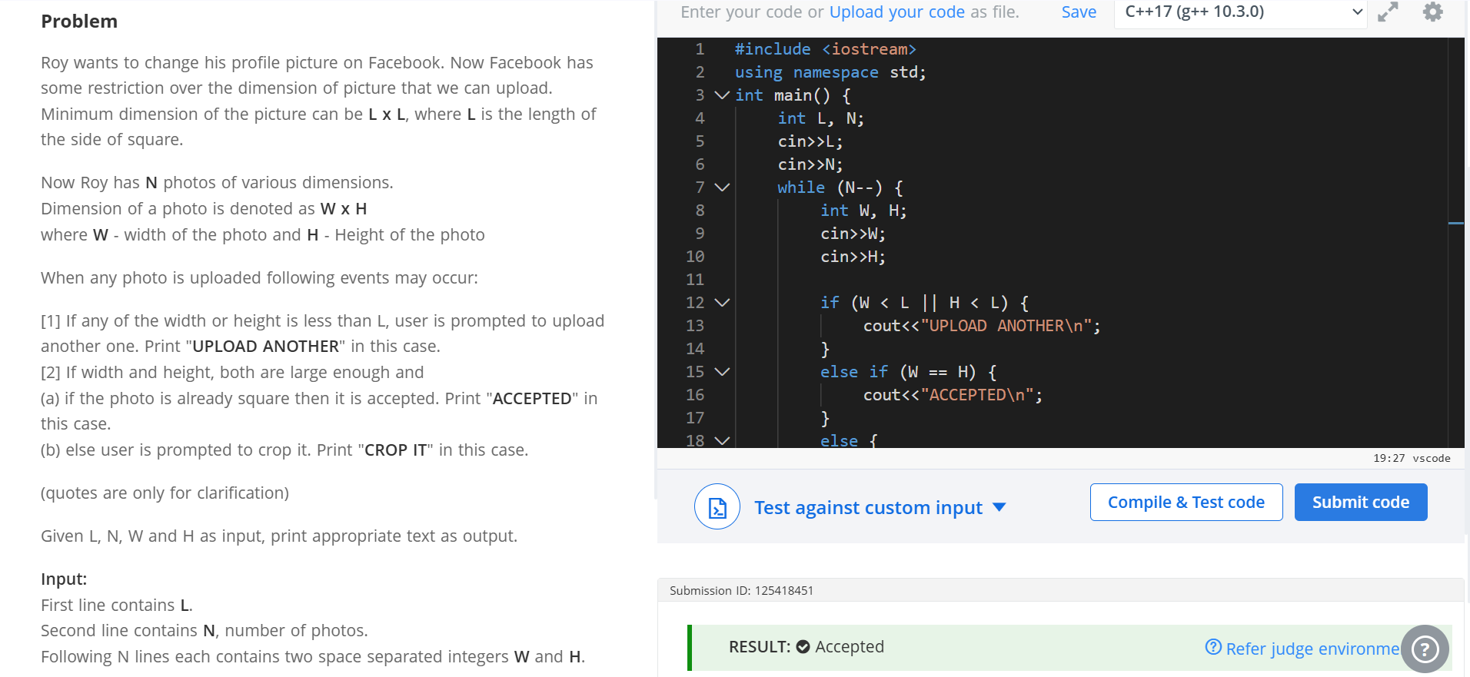
Code –

#include <iostream>
using namespace std;
int main() {
int L, N;
cin>>L;
cin>>N;
while (N--) {
int W, H;
cin>>W;
cin>>H;

if (W < L || H < L) {
cout<<"UPLOAD ANOTHER\n";
}
else if (W == H) {
cout<<"ACCEPTED\n";
}
else {
cout<<"CROP IT\n";
}
}
return 0;
}

