Q –

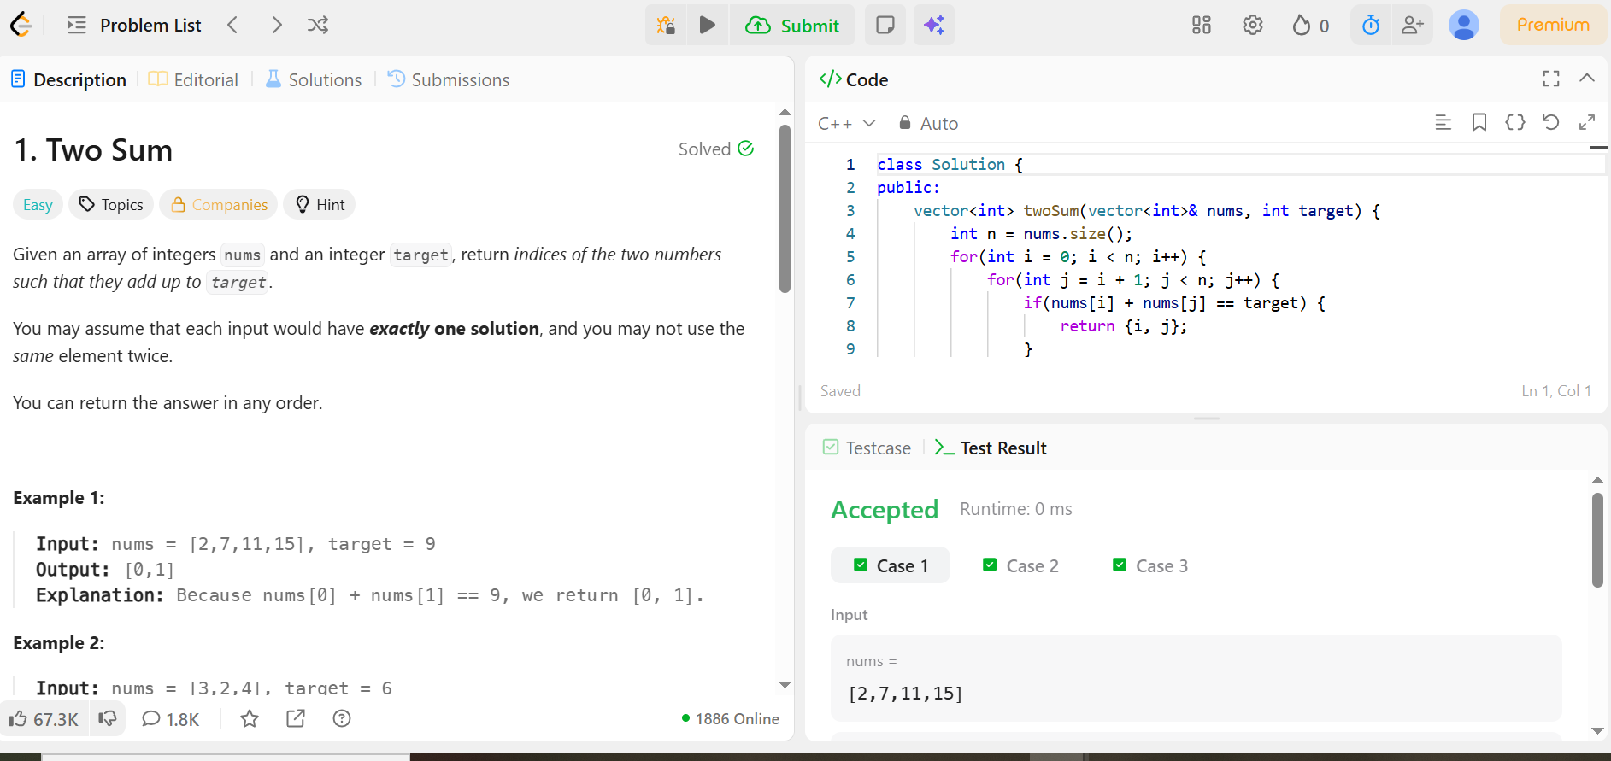

Code –

class Solution {
public:
vector<int> twoSum(vector<int>& nums, int target) {
int n = nums.size();
for(int i = 0; i < n; i++) {
for(int j = i + 1; j < n; j++) {
if(nums[i] + nums[j] == target) {
return {i, j};
}
}
}
return {};
}
};

