Q –

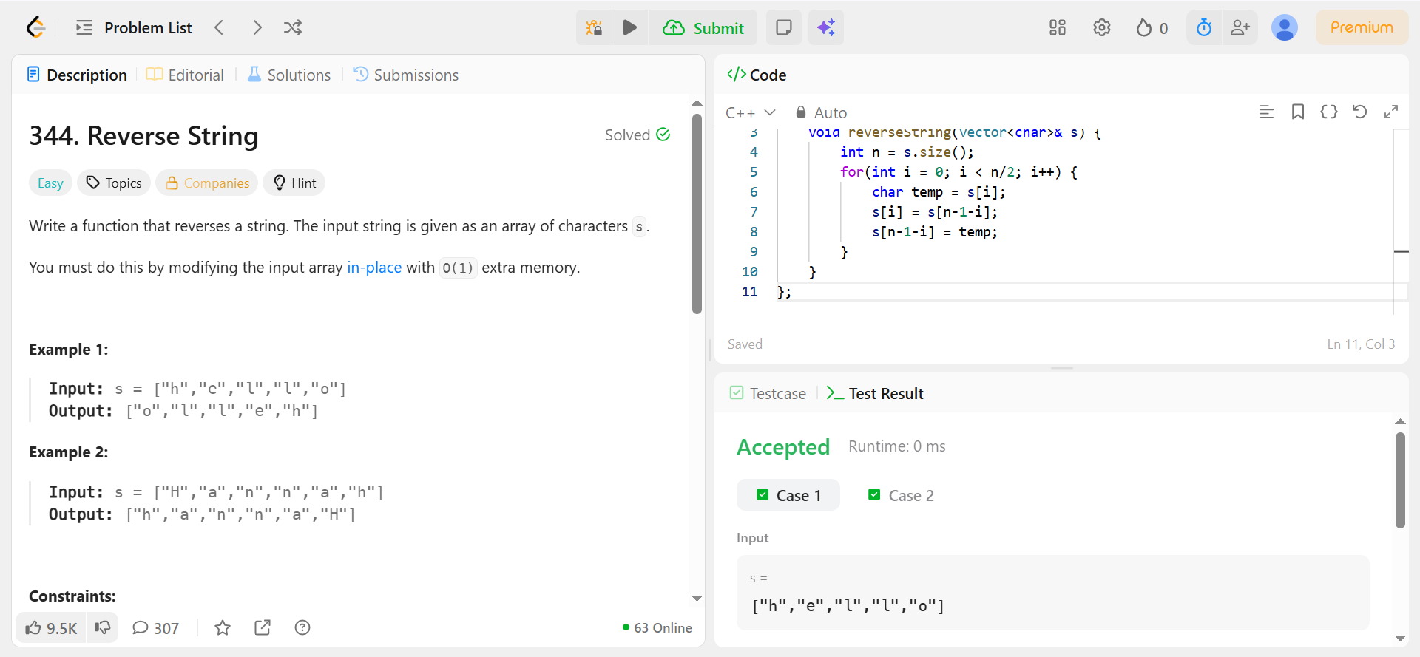

Code –

class Solution {
public:
void reverseString(vector<char>& s) {
int n = s.size();
for(int i = 0; i < n/2; i++) {
char temp = s[i];
s[i] = s[n-1-i];
s[n-1-i] = temp;
}
}
};

