Q-

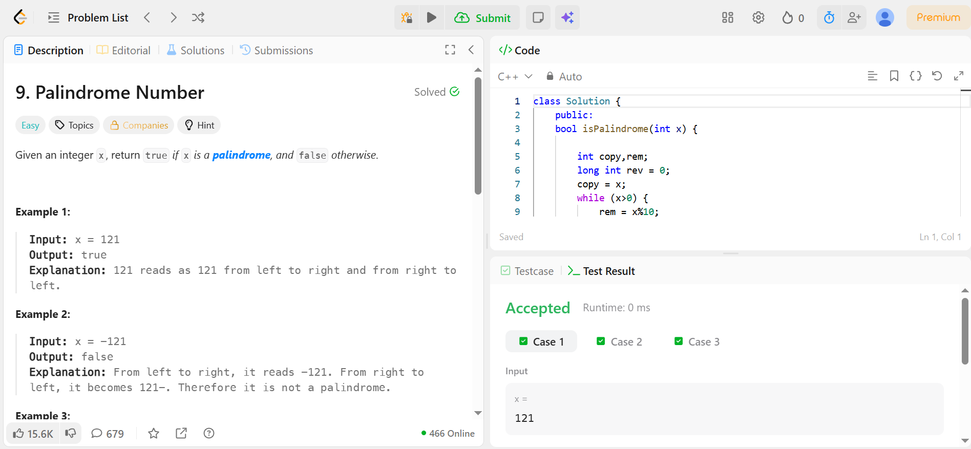

Code –

class Solution {
public:
bool isPalindrome(int x) {

int copy,rem;
long int rev = 0;
copy = x;
while (x>0) {
rem = x%10;
x/=10;
rev = (rev+rem)*10;
}
if (rev/10==copy)
return true;
else
return false;
}
};

