Q –

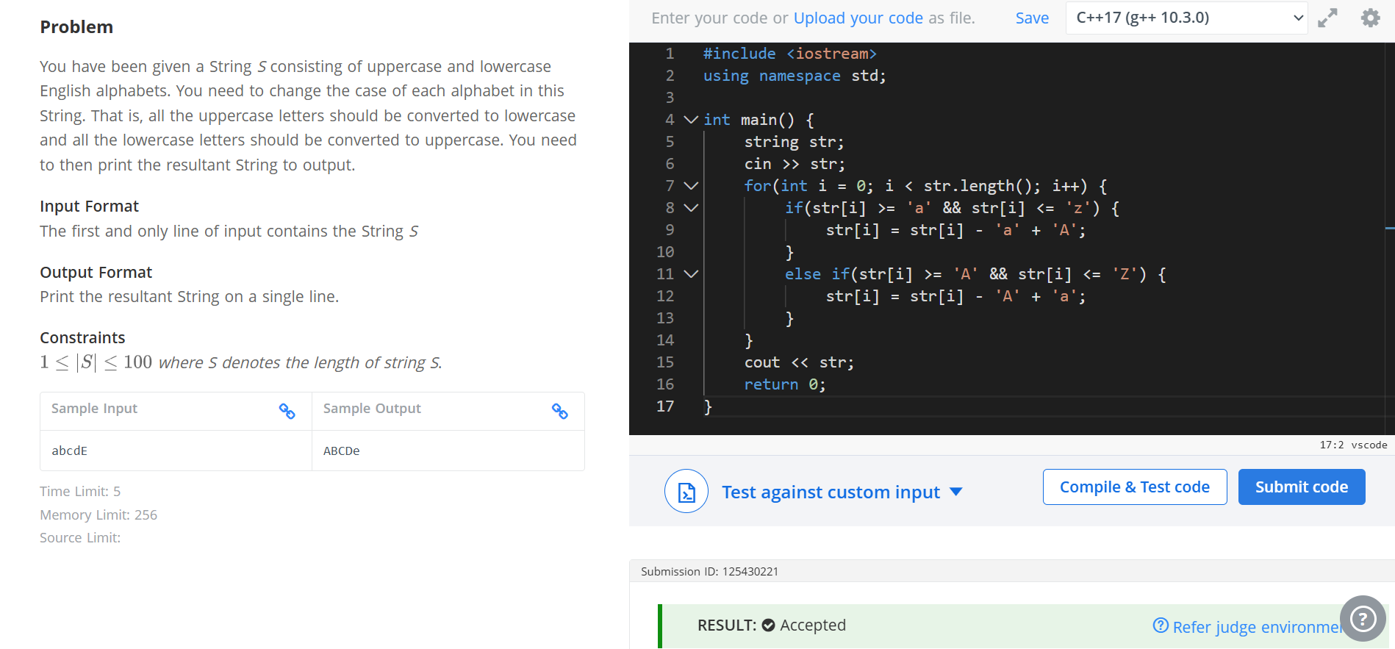
Code –

#include <iostream>
using namespace std;

int main() {
string str;
cin >> str;
for(int i = 0; i < str.length(); i++) {
if(str[i] >= 'a' && str[i] <= 'z') {
str[i] = str[i] - 'a' + 'A';
}
else if(str[i] >= 'A' && str[i] <= 'Z') {
str[i] = str[i] - 'A' + 'a';
}
}
cout << str;
return 0;
}

