Q-

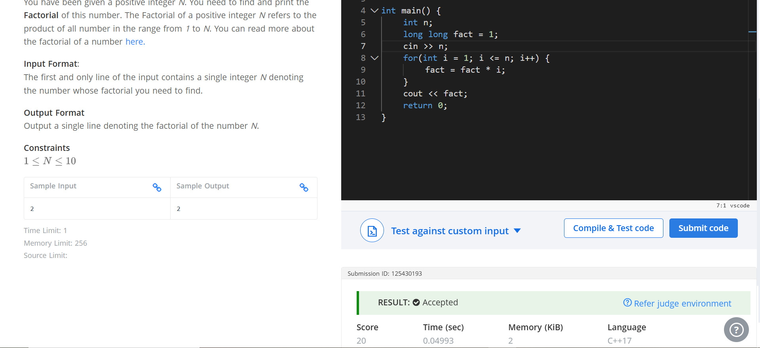
Code –

#include <iostream>
using namespace std;

int main() {
int n;
long long fact = 1;
cin >> n;
for(int i = 1; i <= n; i++) {
fact = fact * i;
}
cout << fact;
return 0;
}

