Assignment 3 – Q19

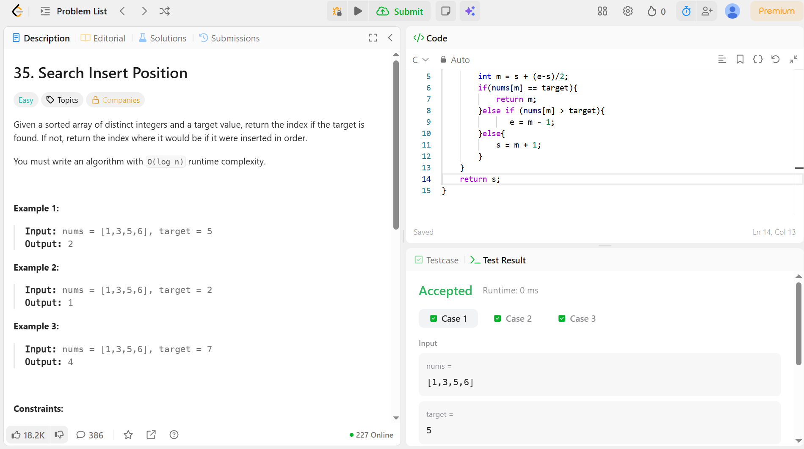

Code –
int searchInsert(int* nums, int numsSize, int target) {
int s = 0;
int e = numsSize - 1;
while(s<=e){
int m = s + (e-s)/2;
if(nums[m] == target){
return m;
}else if (nums[m] > target){
e = m - 1;
}else{
s = m + 1;
}
}
return s;
}

