Assignment 3 – Q20

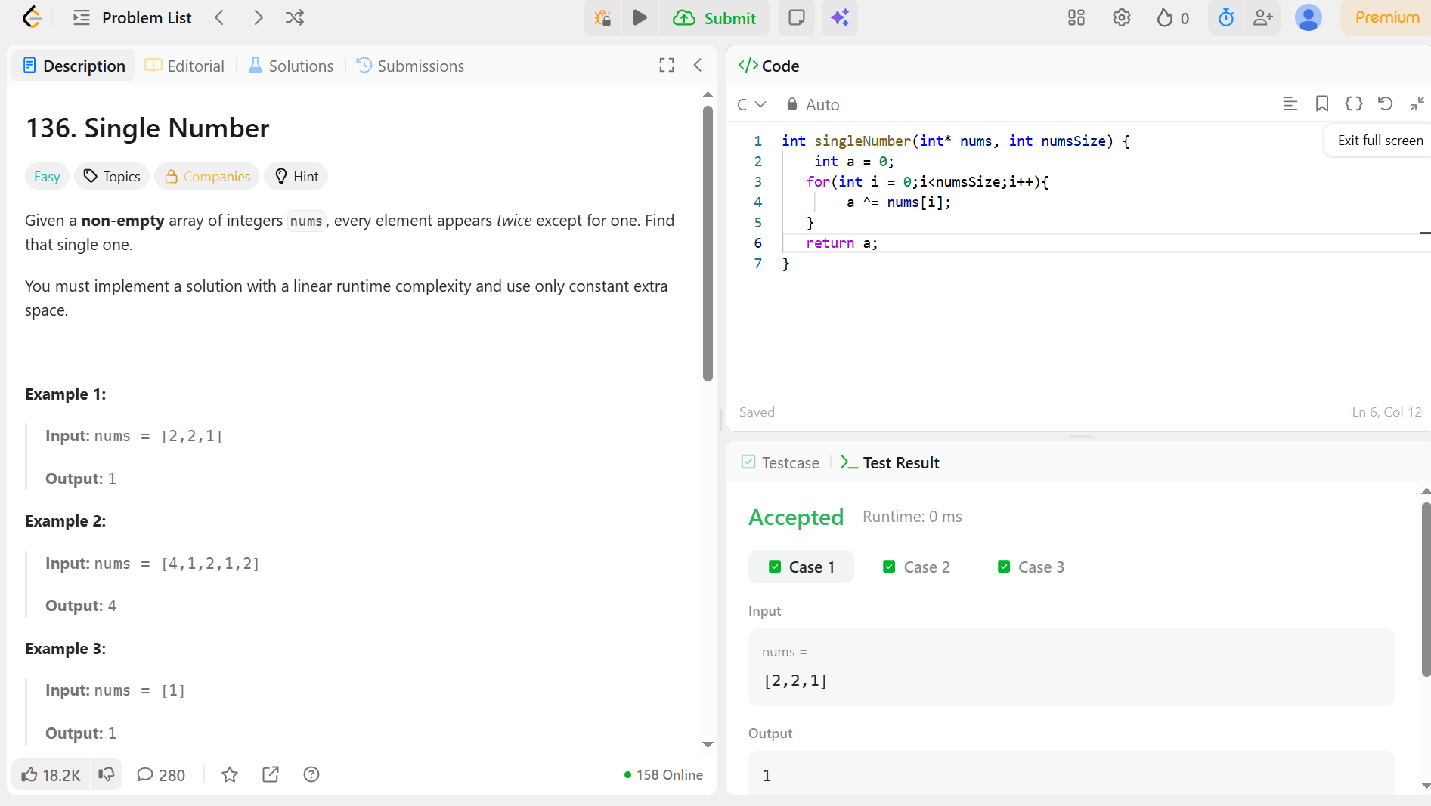

Code –
int singleNumber(int* nums, int numsSize) {
int a = 0;
for(int i = 0;i<numsSize;i++){
a ^= nums[i];
}
return a;
}

