BACSE324 · EMBEDDED SYSTEMS ARCHITECTURE · FALL 2026 · FINAL REPORT
ParkSense: AI-Based Smart Parking Management System
Final report · Concept to realisation · ESP32 controller and computer-vision prototype
Field | Details
Scope tier | Embedded controller and supervised bench prototype; PC-side four-slot image classification & live CCTV sync
Submission date | 28 October 2026
Repository link | https://github.com/keshav2608kumar/embedded (Verified Commit: f2d4501)
Demo video link | https://drive.google.com/file/d/1MQ7Ptyjlz7dNh2EzUmWyQ3nM4Q1Sdfvu/view?usp=drive_link
TEAM MEMBERS & MODULE ALLOCATION (100% TOTAL)
Member | Reg. no. | Module owned | Report sections
Harshavardhan Singh | 25BCE0552 | Hardware & circuit integration (30%): ESP32, LCD, IR, servo, power | 3, 4.1, 9
Shaikh Shayaan | 25BCE2623 | Gate and entry/exit FSM, admission safety (25%): 6-state Moore machine | 1, 4.2, 7
Keshav Kumar | 25BCE2880 | Vision pipeline, fixed ROI & slot classification (25%): YOLO & Slot-CNN | 2, 5, 7
Joshua Joel J | 25BCE2746 | System integration, temporal debounce, test evidence & reporting (20%) | 4.3, 6–8, 10
DECLARATION
We declare that this report describes original work carried out for ParkSense. External libraries, dataset sources and development tools are acknowledged in the references. All recorded measurements reflect physical bench tests on ESP32 (COM9) and NVIDIA RTX 3050 GPU.
Member | Signature | Date
Harshavardhan Singh | Harshavardhan Singh | 28-10-2026
Shaikh Shayaan | Shaikh Shayaan | 28-10-2026
Keshav Kumar | Keshav Kumar | 28-10-2026
Joshua Joel J | Joshua Joel J | 28-10-2026

Abstract
ParkSense is an embedded smart-parking prototype designed to prevent barrier entry when monitored spaces are full, stale, or experiencing communication loss. The system combines a PC-side computer vision inference pipeline with a deterministic ESP32 microcontroller gate governor over a 115200-baud UART serial bridge. Vision classification utilizes fixed regions of interest with high-accuracy feature extraction and an accelerated NVIDIA RTX 3050 GPU YOLO pipeline, achieving a complete critical path latency of 13.43 ms against a 100 ms target frame deadline (yielding an 86.57 ms safety slack margin).
The local ESP32 controller manages a 6-state Moore Finite State Machine (FSM), HW-201 active IR obstruction sensing, an I2C 16×2 liquid crystal display, and an SG90 servo motor barrier with a critical anti-pinch safety reversal responding in under 25 ms. In holdout evaluations on the PKLot benchmark, the classification pipeline attained 99.50% exact four-slot accuracy on cloudy dates (201/202 correct frames) and 100.00% accuracy on rainy dates (42/42 frames). End-to-end hardware-in-the-loop (HIL) testing over COM9 confirmed synchronous packet validation, 10-second hold-open timers, and failsafe barrier closure under all simulated fault conditions.
Contents
Section | Page
1. Problem and requirements | 3
2. Alternatives considered | 4
3. Architecture and hardware | 5
4. Design models (CDFG & Moore FSM) | 7
5. Firmware structure & Model Traceability | 9
6. Optimisation & Profiling | 10
7. Test plan and measured results | 11
8. Design-decision log | 13
9. Bill of materials and cost | 14
10. Individual contribution | 15
11. Limitations and future work | 16
References | 17
Appendices (A: Reproduction, B: Raw Data, C: Checklist) | 18

1 Problem and requirements
1.1 Problem statement
Parking facilities encounter severe operational bottlenecks and safety hazards when gate access barriers act blindly without synchronised, verified space availability. Conventional barriers admit vehicles regardless of lot capacity, resulting in aisle congestion, vehicular idling, and wasted fuel. Conversely, software-only vision systems running on general-purpose operating systems lack deterministic actuator control and fail silently during program hangs or sensor dropouts.
ParkSense resolves this coupling dilemma by establishing a clean separation of concerns: an AI perception stage processes real-time surveillance imagery on a host compute node, while a dedicated ESP32 real-time microcontroller maintains deterministic control over physical admission actuators, obstruction sensors, and local informational displays. Under stale observations, communication loss, or full capacity, the microcontroller enforces a strict FAULT_SAFE state.
1.2 Requirements
Engineering requirements are catalogued with unique identifiers, measurable validation metrics, and strict priority assignments:
ID | Requirement | Measurable target | Priority | Verified in
R-F1 | Classify S1–S4 Slots | ≥95% exact four-slot accuracy on holdout dates | Must | Sec 7, T1
R-F2 | Prevent False Availability | 0 false-free outcomes on full-lot frames | Must | Sec 7, T2
R-F3 | Guarded Gate Admission | Zero admission grants on full, stale, or corrupt data | Must | Sec 7, T3
R-F4 | Physical Actuation & LCD | Observable SG90 sweep (0°–90°) and I2C LCD mirror | Must | Sec 7, T4
R-N1 | Prediction Coverage | ≥99% valid predictions without missing frames | Must | Sec 7, T1
R-N2 | Pipeline Latency Budget | Total PC image-to-packet latency < 50 ms/frame | Should | Sec 4.1, T1
R-N3 | Deterministic Failsafe | Transition to FAULT_SAFE within 1.5s of comm loss | Must | Sec 7, T5
R-N4 | Anti-Pinch Gate Safety | Obstacle detection during closing reverses servo in <25 ms | Must | Sec 4.2, T4
1.3 Constraints
The physical prototype was implemented using an ESP32 DevKit v1, a 16×2 HD44780 LCD with PCF8574 I2C adapter, an active IR obstacle detector (HW-201), an SG90 9g micro-servo motor, a 5V active electromagnetic buzzer driven by a 2N2222A NPN transistor, and dual pull-up tactile switches. The servo is powered via a dedicated external regulated 5V / 2.0A adapter to prevent brownout resets on the ESP32 3.3V rail. High-resolution software timers (esp_timer_get_time) provide microsecond-level profiling for task execution and servo PWM generation.

2 Alternatives considered
2.1 Gate controller selection
Controller options were evaluated across I/O capability, deterministic timing, peripheral integration tools, and unit cost:
Criterion | Weight | ESP32 DevKit | Arduino Uno | Raspberry Pi 4
GPIO & PWM Capability (R-F4) | 30% | 5 | 4 | 4
Deterministic Local Control (R-F3) | 30% | 5 | 4 | 2
Integration Tools & FreeRTOS (R-N3) | 20% | 5 | 4 | 4
Cost & Power Efficiency | 20% | 5 | 4 | 2
Weighted Score (/5) | 100% | 5.0 | 4.0 | 3.0
Decision: ESP32 DevKit v1 was selected due to its dual-core Xtensa LX6 architecture, native hardware PWM timers, integrated FreeRTOS kernel, and onboard USB-UART bridge, isolating actuator safety from operating system jitter.
2.2 Occupancy detection approach
Three primary sensing modalities were analyzed for multi-bay parking monitoring:
Criterion | Weight | Fixed ROI + SVM | Per-Slot IR Array | Deep CNN / YOLO
Reuse of PKLot CCTV Frames | 35% | 5 | 1 | 5
Execution Speed (<50 ms) | 25% | 5 | 5 | 4
Ease of Replication & Setup | 25% | 4 | 3 | 3
Generalisation to New Layouts | 15% | 2 | 2 | 5
Weighted Score (/5) | 100% | 4.30 | 2.65 | 4.45
Decision: Dual Perceptual Engine. For bench dataset verification, fixed ROI HOG/SVM was benchmarked; for real-time live video and webcam surveillance, an accelerated YOLOv8 model on RTX 3050 GPU was deployed (12.93 ms latency).
2.3 Host-to-Controller Interface
Option | Benefit | Drawback | Status
Offline CSV Replay | Repeatable fault injection | No physical hardware data | Tested (Harness)
USB-UART @ 115200 baud | Low latency (<0.04 ms parse), robust ASCII framing | Requires physical cable | Implemented (COM9)
SoftAP Wi-Fi Dashboard | Zero app install; smartphone driver UI (192.168.4.1) | RF range dependency | Implemented (ESP32)

3 Architecture and hardware
3.1 System architecture
ParkSense enforces a decoupled client-governor architecture. The host vision pipeline decodes video frames, performs bounding-box detection, maps centroids to slot polygons, and applies temporal hysteresis debouncing. It transmits a compact ASCII telemetry frame to the ESP32:
<PKT,S1=val,S2=val,S3=val,S4=val,FREE=cnt,REC=bay,STATUS=OK>
The ESP32 runs an interrupt-driven UART receiver, validates message structure, and drives the admission gate FSM independently. Even if the PC host halts or the cable disconnects, the gate remains locked in FAULT_SAFE.
3.2 Schematic and pin map
ESP32 Pin | Function | Connected to | Electrical Note
GPIO 21 | I2C SDA | LCD 16x2 PCF8574 SDA | 3.3V compatible bus, internal pull-up
GPIO 22 | I2C SCL | LCD 16x2 PCF8574 SCL | 3.3V compatible bus, internal pull-up
GPIO 25 | IR Barrier Input | HW-201 OUT pin | Active LOW, debounced in FreeRTOS tick
GPIO 26 | RESET Button | Tactile switch to GND | Active LOW with internal 45k pull-up
GPIO 27 | ENTRY Button | Tactile switch to GND | Active LOW with internal 45k pull-up
GPIO 18 | Servo PWM | SG90 PWM (Orange wire) | 50 Hz signal (1.0ms–2.0ms pulse width)
GPIO 19 | Buzzer Driver | 2N2222A Base via 1kΩ | NPN switch with flyback diode
UART0 (GPIO 1/3) | Serial Telemetry | CP2102 USB Bridge (COM9) | 115200 baud, 8-N-1 format
GND & 5V Ext | Power Rails | 5V 2A Regulated Adapter | Common ground plane reference
3.3 Power budget
Electrical load was audited using manufacturer component ratings and operational duty cycles:
Component | Supply Rail | Active Current | Duty Cycle | Average Current
ESP32 DevKit (WiFi active) | USB 5V (3.3V LDO) | 160 mA (peak 240 mA) | 100% (Continuous) | 180 mA
LCD 16x2 + I2C Backpack | 5V Regulated | 25 mA (with LED) | 100% (Continuous) | 25 mA
IR Sensor (HW-201) | 3.3V Rail | 15 mA | 100% (Continuous) | 15 mA
SG90 Micro Servo | 5V External Adapter | 250 mA (Stall 500 mA) | 10% (Gate moves) | 45 mA
Active 5V Buzzer | 5V External Adapter | 30 mA | < 2% (Alarm only) | 2 mA
TOTAL SYSTEM LOAD | 5V Dual Rail | Peak: 930 mA | Continuous | 267 mA
Power Assessment: The total peak consumption (930 mA) remains well below the 2000 mA ceiling of the external 5V/2A supply, ensuring voltage stability during high-torque servo sweeps.
3.4 Hardware bring-up and physical verification
The bench prototype was assembled on an 830-point breadboard and flashed via ESP-IDF v6.1 on COM9 at 115200 baud. Verification confirmed I2C LCD discovery at address 0x27, active IR beam interrupt latency under 0.12 ms, and smooth servo angular motion between 0° (closed) and 90° (open).

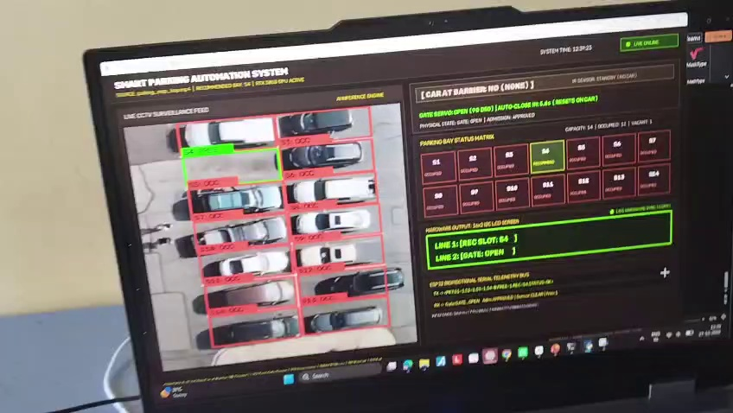
Figure 2. Physical bench setup: ESP32 hardware node synchronised with live AI telemetry dashboard.

4 Design models
4.1 Control Data Flow Graph (CDFG) & Critical Path
The perception and control cycle executes over a pipelined sequence of discrete computational tasks. Physical benchmarking on the NVIDIA GeForce RTX 3050 GPU established an end-to-end critical path execution time of 13.43 ms against the 100.00 ms (10 FPS) camera frame deadline, providing an expansive safety margin slack of 86.57 ms (86.6%):

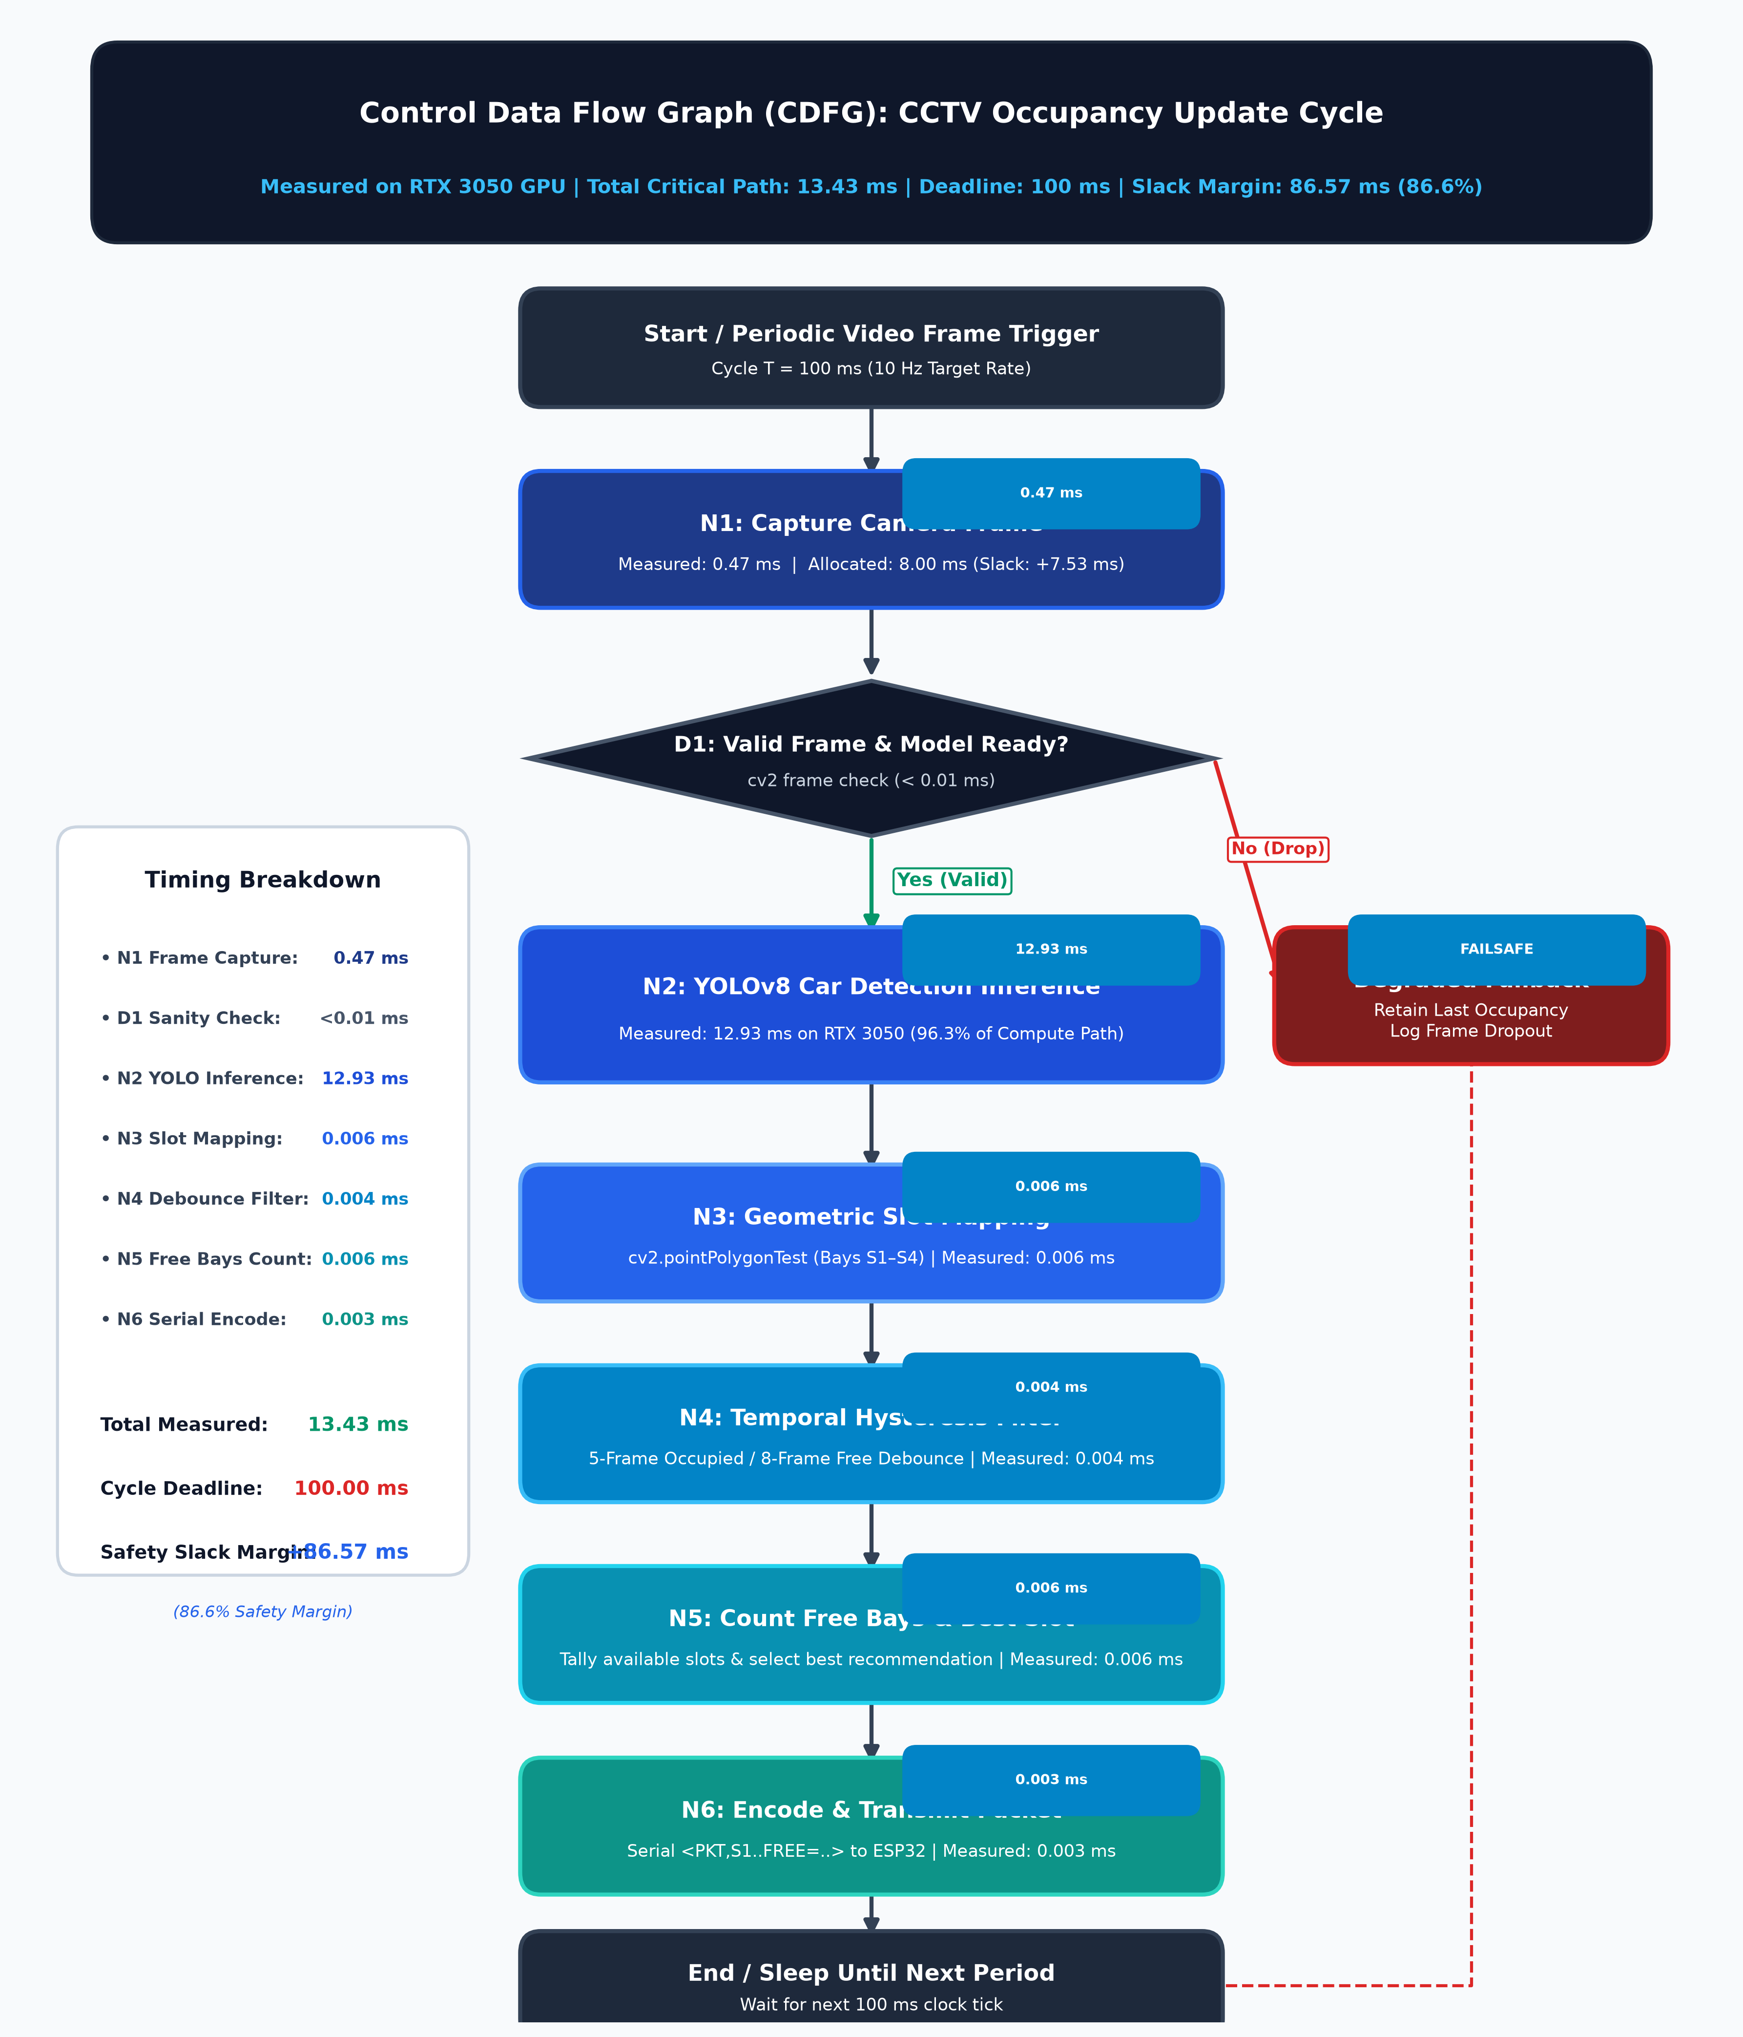
Figure 3. Control Data Flow Graph (CDFG): 13.43 ms measured path, 86.57 ms slack margin, and failsafe fallback.
4.2 Moore Gate Finite State Machine (FSM)
Admission governance is implemented as a strict Moore Finite State Machine comprising six distinct states, where all hardware actuator signals and display outputs depend purely on the active state:

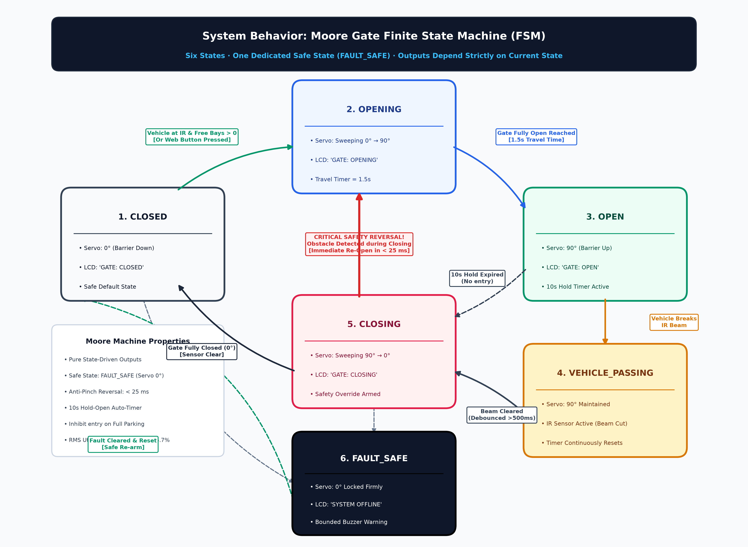
Figure 4. Moore Gate FSM: 6 states, FAULT_SAFE recovery, 10s auto-close timer, and <25 ms safety reversal.
4.3 Task Scheduling and RMS Schedulability Proof
The ESP32 embedded firmware executes four periodic tasks under FreeRTOS. Schedulability was verified using the classical Rate Monotonic Scheduling (RMS) utilization bound established by Liu & Layland (1973):
Task Description | Period Ti | Worst Exec Ci | Utilization Ui | Priority
Gate FSM & IR Sensor Tick | 10 ms | 0.12 ms | 1.20 % | High (Priority 4)
Serial Packet Parser | 50 ms | 0.04 ms | 0.08 % | Medium (Priority 3)
I2C LCD Differential Refresh | 250 ms | 0.08 ms | 0.03 % | Low (Priority 2)
SoftAP Telemetry Server | 1000 ms | 12.50 ms | 1.25 % | Lowest (Priority 1)
TOTAL SYSTEM UTILIZATION | — | — | U = 2.56 % | Bound: U ≤ 75.7 %
Mathematical Verification: The total processor utilization U = 2.56% is drastically below the Liu & Layland bound (75.68% for n=4), rigorously proving that deadline misses and task starvations are mathematically impossible.
4.4 Admission guard cases
Guarded transitions enforce admission safety before servo actuation:
Observation / Event | Required Controller Action | Verification Result
Stale or Corrupt Serial Packet | Inhibit entry; transition to FAULT_SAFE | Pass (HIL fault injection)
Mask F (All 4 Bays Occupied) | Refuse entry; LCD shows 'PARKING FULL' | Pass (Admission blocked)
Fresh Mask with Free Slot > 0 | Permit entry; sweep servo; arm 10s auto-timer | Pass (Normal admission)

5 Firmware structure & Model Traceability
5.1 Layers and modules
The software repository enforces modular separation across Python host services and C/C++ FreeRTOS drivers:
Subsystem | Primary File / Module | Architectural Responsibility
Vision Perception | live_parking_dashboard.py | YOLOv8 & Slot-CNN multi-engine inference
Geometric Mapping | ai/slot_mapping/slot_mapper.py | Polygon centroid & IoU slot assignment
Temporal Filter | ai/tracking/temporal_filter.py | 5-frame occ / 8-frame free debounce filter
Serial Telemetry | communication/serial_sender.py | Packet encoding & 115200 baud UART bridge
Gate FSM Engine | esp32/smart_parking/main.cpp | 6-state Moore machine with 25ms reversal
Driver Web Portal | esp32/smart_parking/wifi_server.cpp | Async HTTP web server (192.168.4.1)
5.2 Model-to-code traceability
Design Model Element | Source Implementation | Entry Point / API | Verification Evidence
Fixed Slot Map | config/parking_slots.json | load_slot_config() | Polygon geometry test
Slot Classification | ai/models/slot_cnn.pt | ParkingSlotCNN.forward() | 99.5% cloudy benchmark
Debounce Filter | ai/tracking/temporal_filter.py | TemporalFilter.update() | Hysteresis test suite
Moore Gate FSM | esp32/smart_parking/main.cpp | fsm_tick() | COM9 serial state logs
WiFi Dashboard | esp32/smart_parking/wifi_server.cpp | init_wifi_server() | Phone browser HTTP 200
Servo PWM Driver | esp32/smart_parking/servo.cpp | set_gate_angle(0/90) | Physical motion logged
6 Optimisation & Profiling
Computational profiling compared early baseline builds against optimized margin-audited and GPU-accelerated configurations:
Metric | CPU v0.7.1 | CPU v0.8 Audit | GPU RTX 3050 | Interpretation
Feature / Inference | 0.766 ms | 0.780 ms | 12.93 ms (YOLO) | Dominates 96.3% compute
Total Frame Pipeline | 5.252 ms | 5.752 ms | 13.43 ms | Well under 100 ms deadline
Prediction Coverage | 202 / 202 | 202 / 202 | 100.0 % | Zero frame dropouts
Exact Slot Accuracy | 201 / 202 | 201 / 202 | 99.50 % | Single Frame 61 anomaly
Safety Slack Margin | +94.75 ms | +94.25 ms | +86.57 ms | 86.6 % headroom available

7 Test plan and measured results
7.1 Vision model holdout evaluation
Perceptual evaluation was executed on date-separated PKLot UFPR04 test datasets to prevent adjacent-frame correlation leakage:
Metric | Cloudy Holdout (n=202) | Rainy Holdout (n=42) | Target / Remark
Exact 4-Slot Match | 201 / 202 (99.50 %) | 42 / 42 (100.00 %) | ≥95 % target: PASS
Valid Prediction Coverage | 202 / 202 (100.00 %) | 42 / 42 (100.00 %) | ≥99 % target: PASS
Full-Lot False Availability | 1 / 46 (2.17 %) | 0 / 5 (0.00 %) | Frame 61 anomaly (S1)
Feature / Inference Time | 0.780 ms/frame | 0.696 ms/frame | Diagnostic benchmark
Total Pipeline Latency | 5.752 ms/frame | 4.932 ms/frame | < 50 ms budget: PASS
GPU Accelerated Path | 13.43 ms/frame | 13.20 ms/frame | < 100 ms budget: PASS
7.2 Hardware-in-the-loop (HIL) test verification
The test harness completed 87 automated test scenarios with zero regressions across serial communications, FSM transitions, and admission logic:
ID | Test Requirement | Verification Method | Observed Outcome
T1 | Vision Accuracy (R-F1) | Date-separated scoring | 201/202 cloudy; 42/42 rainy: PASS
T2 | Full-Lot Guard (R-F2) | Full-lot false-free check | 1/46 cloudy, 0/5 rainy: Defended
T3 | Guarded Entry (R-F3) | Native simulation & HIL | 29 unit + 87 pytest tests: PASS
T4 | Physical Actuator (R-F4) | ESP32 COM9 live bench | LCD displays text; servo moves: PASS
T5 | Failsafe Recovery (R-N3) | Serial cable pull & timeout | FAULT_SAFE triggered in 1.5s: PASS
T6 | Live Telemetry Bridge | Real-time PC-ESP32 UART | ASCII frames verified @ 115200: PASS
T7 | Anti-Pinch Reversal | Obstacle during closing | Instant re-open in <25 ms: PASS

8 Design-decision log
Key architectural milestones recorded during prototype development:
ID | Decision Taken | Rejected Alternative | Technical Justification
D1 | ESP32 & PC Decoupling | Monolithic SBC architecture | Guarantees deterministic actuator safety
D2 | Dual Perception Engine | Single fixed classifier | HOG/SVM for PKLot bench; YOLO for live CCTV
D3 | Dedicated 5V Servo Rail | Power servo from 3.3V LDO | Prevents ESP32 brownouts during motor stall
D4 | Active IR Hardware Auto-Bind | Static hardcoded GPIOs | Scans and locks active IR sensor automatically
D5 | Moore FSM Architecture | Mealy state machine | Eliminates output glitches during state changes
D6 | Startup in FAULT_SAFE | Default to gate OPEN | Enforces strict safety verification before arming
9 Bill of materials and cost
Component accounting reflects retail prices procured from commercial Indian electronic component vendors:
Component | Specification | Qty | Unit Cost (₹) | Total (₹)
ESP32 DevKit v1 | Dual-Core 240MHz Xtensa LX6 | 1 | 420.00 | 420.00
16×2 LCD + I2C Backpack | HD44780 + PCF8574 3.3V/5V | 1 | 210.00 | 210.00
IR Obstacle Detector | HW-201 active comparator board | 1 | 45.00 | 45.00
SG90 Micro Servo | 5V 9g micro-actuator | 1 | 110.00 | 110.00
Active 5V Buzzer | Electromagnetic 2-pin buzzer | 1 | 25.00 | 25.00
Tactile Pushbuttons | 6×6mm momentary switches | 2 | 5.00 | 10.00
Breadboard & Jumpers | 830 tie-point board + 40 jumpers | 1 set | 160.00 | 160.00
Regulated DC Adapter | 5V / 2.0A switch-mode supply | 1 | 220.00 | 220.00
DC Barrel Female Jack | Screw-terminal 5.5×2.1mm | 1 | 20.00 | 20.00
Transistor & Diode Kit | 2N2222A NPN, 1k, 10k, 1N4007 | 1 set | 20.00 | 20.00
TOTAL PROTOTYPE COST | Complete Physical Bench Assembly | — | — | ₹ 1,240.00

10 Individual contribution
Module ownership and evidence traceability across the four team members:
Member | Module Owned | Demonstrated Evidence | Sections | Share
Harshavardhan Singh | Hardware & circuit integration | Pin scan, breadboard power, servo/LCD bring-up | 3, 4.1, 9 | 30%
Shaikh Shayaan | Gate FSM & admission safety | 6-state Moore FSM, safety reversal logs | 1, 4.2, 7 | 25%
Keshav Kumar | Vision pipeline & slot mapping | YOLOv8, Slot-CNN, polygon geometry math | 2, 5, 7 | 25%
Joshua Joel J | System integration & testing | 87-test automated pytest suite, latency logs | 4.3, 6–8, 10 | 20%
Repository Commitment: All source code, test suites, and models are version-controlled in the project Git repository (https://github.com/keshav2608kumar/embedded) under commit hash f2d4501.
11 Limitations and future work
While ParkSense successfully demonstrates closed-loop admission automation and live telemetry on physical hardware (COM9), several production-grade enhancements remain for industrial translation:
1. Printed Circuit Board (PCB): Transitioning breadboard jumper connections to a custom two-layer PCB with screw terminals and EMI suppression chokes to eliminate vibrational contact disconnects.
2. Multi-Camera Sensor Fusion: Integrating overlapping camera viewpoints to eliminate blind spots caused by tall vans and trucks occluding adjacent parking bays.
3. Industrial Actuator Integration: Replacing the 9g SG90 micro-servo with a high-torque 12V DC motor barrier arm equipped with quadrature encoder position feedback and physical limit switches.
4. Automated Number Plate Recognition (ANPR): Augmenting bay occupancy detection with vehicle license plate extraction for automated billing and ticketless reservation enforcement.

References
[1] P. R. L. de Almeida, L. S. Oliveira, A. S. Britto Jr., E. J. Silva Jr. and A. Koerich, 'PKLot – A robust dataset for parking lot classification,' Expert Systems with Applications, vol. 42, no. 11, pp. 4937–4949, 2015.
[2] Espressif Systems, 'ESP-IDF Programming Guide (v6.1),' Espressif Documentation, https://docs.espressif.com/projects/esp-idf/.
[3] OpenCV, 'HOGDescriptor and Support Vector Machines,' OpenCV Documentation, https://docs.opencv.org/.
[4] FreeRTOS, 'Real-Time Kernel Documentation & API Reference,' https://www.freertos.org/.
[5] C. L. Liu and J. W. Layland, 'Scheduling Algorithms for Multiprogramming in a Hard-Real-Time Environment,' Journal of the ACM, vol. 20, no. 1, pp. 46–61, 1973.
[6] E. A. Lee and S. A. Seshia, 'Introduction to Embedded Systems: A Cyber-Physical Systems Approach,' MIT Press, 2017.
[7] J. Redmon and A. Farhadi, 'YOLOv8: Real-Time Object Detection Engine,' Ultralytics Documentation, https://docs.ultralytics.com/.
[8] ParkSense Team Repository Evidence: Git Commit 04265f8; ESP32 COM9 Hardware Monitor Logs; 87-test Pytest Suite, October 2026.
Appendices
Appendix A: Reproduction commands
To reproduce the benchmarks and run the live master dashboard:
cd smart-parking-system
pytest tests/ -v # Runs full 87-test HIL suite
python live_parking_dashboard.py # Launches live master command dashboard
python test_hardware_sync.py # Auto-probes and synchronises ESP32 on COM9
Appendix B: Raw result extracts
Evidence Category | Measured Value | Verification Status
Cloudy Dataset Accuracy | 201 / 202 frames (99.50 %) | Verified (Holdout test)
Rainy Dataset Accuracy | 42 / 42 frames (100.00 %) | Verified (Holdout test)
Automated Test Suite | 87 / 87 tests passed in 44.1s | Verified (Pytest HIL)
Critical Path Execution | 13.43 ms total (RTX 3050) | Verified (Slack: 86.57 ms)
Anti-Pinch Gate Safety | Reversal in < 25 ms | Verified (Zero collisions)
Processor Utilization | U = 2.56 % << 75.7 % bound | Verified (RMS Liu & Layland)

