PROJECT REPORT
SENTINEL
Intelligent Banking Fraud Detection System
Using Oracle SQL and PL/SQL

Submitted in partial fulfilment of the requirements for the course/project in Database Management Systems

SUBMITTED BY | SUBMITTED TO
Name: Keshav Katoch  Uid.: 26MCC20016  Programme: MCA(cloud computing and devops)  Semester: 1st | Faculty Name: Ms Tanisha(E20679)  Designation: Asst. Professor

Department of __________________________
Institution: ______________________________
Academic Session: 2026–2027

CERTIFICATE
This is to certify that the project report entitled “Sentinel: Intelligent Banking Fraud Detection System Using Oracle SQL and PL/SQL” has been prepared by __________________________, UID. __________________, under the guidance of __________________________. The work is submitted in partial fulfilment of the requirements of the relevant academic course/project.
To the best of my knowledge, this report describes the design and implementation of a rule-based banking transaction monitoring prototype. The report may be accepted for academic evaluation subject to the institution’s guidelines.
Supervisor’s Signature: ____________________
Name: ____________________________________
Date: _____________________________________
Institution Seal: ___________________________

DECLARATION

I hereby declare that the project titled “Sentinel: Intelligent Banking Fraud Detection System Using Oracle
SQL and PL/SQL” is prepared for academic purposes. The implementation uses sample data and predefined
rules to demonstrate transaction validation, risk scoring, alert generation and audit logging. Any external
material used for the preparation of this report is acknowledged in the references.
Student Signature: __________________________
Name: _____________________________________
Date: ______________________________________

ACKNOWLEDGEMENT

I would like to express my sincere gratitude to my project guide and faculty members for their guidance and
support throughout this project. I also thank my institution for providing the learning environment and
resources required to explore Oracle SQL and PL/SQL. This project helped me understand how database
objects such as tables, constraints, sequences, functions, procedures, packages and triggers can work together
to implement a practical transaction-monitoring workflow. Finally, I am grateful to everyone who provided
feedback and encouragement.

ABSTRACT

Sentinel is an academic prototype of a banking transaction monitoring system developed using Oracle SQL
and PL/SQL. Its purpose is to demonstrate how a database can validate transactions, calculate a rule-based
risk score, flag high-risk activity for manual review, create fraud alerts and maintain an audit trail. The system
stores customers, bank accounts, transactions, fraud rules, alerts and audit logs in relational tables. A PL/SQL
function calculates a risk score using transaction-amount thresholds and a simple rapid-transaction rule. A
package procedure processes deposits and withdrawals, checks account status and available balance, and
records the transaction outcome. A trigger writes transaction activity to the audit log, while high-risk
transactions create an alert. A dashboard query joins customer, account and transaction data to provide a
consolidated view. The project is intentionally rule-based and uses sample data; it is not a production banking
platform and does not use a trained machine-learning model. It demonstrates foundational database
programming concepts and can be extended with stronger authentication, more sophisticated detection rules,
transaction velocity analysis and a user interface.

Keywords: Oracle Database, SQL, PL/SQL, fraud detection, risk score, banking transaction, trigger, package,
audit log.

TABLE OF CONTENTS
- 1. Introduction
- 2. Problem Statement
- 3. Objectives
- 4. Scope and Limitations
- 5. Existing System and Proposed System
- 6. Requirements Analysis
- 7. System Design
- 8. Database Design
- 9. Implementation Details
- 10. Testing and Results
- 11. User Guide
- 12. Security and Reliability Considerations
- 13. Future Enhancements
- 14. Conclusion
- References
- Appendix A: Important SQL Queries
- Appendix B: Screenshot Checklist
Note: In Microsoft Word, an automatic table of contents can be inserted from References → Table of Contents after applying heading styles.

1. INTRODUCTION
Banking systems process deposits, withdrawals and other financial operations. These transactions must be validated and monitored so that unusual activity can be identified for investigation. A database-based monitoring system can apply consistent rules, preserve transaction records and produce alerts for staff review.
Sentinel is a small educational prototype implemented in Oracle SQL and PL/SQL. It combines relational data storage with procedural logic. The project demonstrates a typical database workflow: receive a transaction request, validate the input, check the account, calculate risk, decide whether to complete or review the transaction, store the result, and write an audit entry.

1.1 Project Overview
The prototype contains customer and account records, a set of configurable fraud rules, a transaction-processing package, a risk-scoring function, an audit trigger and a fraud-alert table. A high score causes the transaction to be marked REVIEW and creates an OPEN alert. A lower score allows the transaction to be marked COMPLETED.

1.2 Why Oracle PL/SQL?
- SQL provides declarative commands to create, retrieve and update relational data.
- PL/SQL adds variables, conditional logic, exception handling, procedures and functions.
- Packages group related program units under a single interface.
- Triggers can automatically perform an action when a table event occurs.
- Constraints help preserve data integrity at the database level.

2. PROBLEM STATEMENT
A basic banking database needs a consistent way to validate transaction requests and identify transactions that cross predefined risk thresholds. If monitoring is performed manually or inconsistently, potentially suspicious activity may not be flagged promptly, and it may be difficult to trace how a transaction was processed. The project addresses this educational problem by implementing database-side validation, rule-based scoring, alert creation and audit logging.

3. OBJECTIVES
- Design relational tables for customers, bank accounts, transactions, fraud rules, fraud alerts and audit logs.
- Enforce key data-integrity rules using primary keys, foreign keys, check constraints and unique constraints.
- Implement a risk-scoring function based on configurable amount thresholds and a simple recent-transaction count.
- Develop a package procedure to validate and process deposits and withdrawals.
- Flag high-risk transactions for manual review rather than completing them automatically.
- Generate fraud alerts for transactions that require review.
- Automatically record transaction events in an audit log using a trigger.
- Provide SQL queries that display transaction history and a consolidated monitoring dashboard.

4. SCOPE AND LIMITATIONS

4.1 Scope
- Demonstration of a database-only transaction workflow using sample customer and account data.
- Deposit and withdrawal transaction types.
- Rule-based risk scores and manual-review alerts.
- Audit logging and SQL-based reporting.
- Execution in an Oracle-compatible online SQL environment, subject to its script and output settings.

4.2 Limitations
- This is an academic prototype and must not be connected to real customer funds or production banking systems.
- The risk rules are illustrative and may generate false positives or miss suspicious patterns.
- The project uses a rule-based score; it does not contain a trained AI or machine-learning model.
- The rapid-transaction rule is a simplified demonstration and should be validated and expanded before real use.
- Authentication, role-based authorization, encryption, external notifications, regulatory controls and a full application interface are outside the current implementation.
- The sample transaction flow commits or rolls back within the procedure; production systems should define transaction boundaries and error handling according to application-wide requirements.

5. EXISTING SYSTEM AND PROPOSED SYSTEM

5.1 Existing / Manual Approach
In a simple manual workflow, transactions may be reviewed using separate queries or spreadsheets. Such an approach can be inconsistent, does not automatically create a structured alert for every configured rule, and may make it harder to maintain a reliable audit trail.

5.2 Proposed Sentinel Approach
- A package procedure centralizes transaction validation and processing.
- A function computes the risk score from active fraud rules.
- Transactions reaching the review threshold are stored with status REVIEW.
- A fraud alert is created for a review transaction.
- A trigger records each inserted transaction in the audit log.
- A dashboard query combines customer, account and transaction details.
Feature | Manual/basic approach | Sentinel prototype
Validation | May be performed inconsistently | Centralized checks in PL/SQL
Risk evaluation | Manual or separate query | Rule-based score function
High-risk handling | Manual identification | REVIEW status and alert record
Audit trail | May be incomplete | Trigger-based log entry
Reporting | Separate tables/queries | Joined dashboard query

6. REQUIREMENTS ANALYSIS

6.1 Functional Requirements
- FR-01: Store customer details with a unique customer identifier.
- FR-02: Link each bank account to an existing customer.
- FR-03: Store transaction type, amount, risk score, status and date.
- FR-04: Reject invalid amounts and unsupported transaction types.
- FR-05: Reject transactions for accounts that do not exist or are not active.
- FR-06: Prevent a withdrawal when the available balance is insufficient.
- FR-07: Calculate a risk score using active rules.
- FR-08: Mark high-risk transactions for review and create an alert.
- FR-09: Write transaction activity to the audit log.
- FR-10: Retrieve transaction, alert and account information through SQL reports.

6.2 Non-Functional Requirements
- Data integrity: keys and constraints protect relationships and valid values.
- Maintainability: rule values are stored in a table rather than being entirely hard-coded.
- Readability: named tables and modular PL/SQL units separate responsibilities.
- Reliability: exception handling prevents silent continuation after a processing error.
- Portability: the implementation targets Oracle SQL/PLSQL; exact UI steps depend on the online Oracle environment.

6.3 Software and Hardware Requirements
Category | Requirement
Database | Oracle Database / Oracle Live SQL or another compatible Oracle environment
Language | SQL and PL/SQL
Client | Modern web browser
Operating system | Any OS with a supported browser
Hardware | Basic computer capable of running a web browser
User skills | Basic SQL queries and database concepts

7. SYSTEM DESIGN

7.1 High-Level Workflow
- The user invokes the transaction-processing procedure with account ID, transaction type and amount.
- The procedure validates amount and transaction type.
- The account is retrieved and checked for active status and sufficient funds for withdrawals.
- The risk-scoring function evaluates the amount and recent activity against active rules.
- If the score reaches the review threshold, the transaction is stored with REVIEW status and an alert is created.
- Otherwise, the transaction is stored as COMPLETED and the account balance is updated.
- The insert trigger writes an audit entry.
- SQL reporting queries display transaction, alert and audit details.

7.2 Logical Architecture
Layer | Component | Responsibility
Data layer | Customers and bank_accounts | Customer and account information
Data layer | Bank_transactions | Transaction records and outcomes
Rules layer | Fraud_rules | Thresholds and score points
Logic layer | calculate_risk_score | Computes a rule-based score
Logic layer | sentinel_pkg.process_transaction | Validates and processes a transaction
Monitoring layer | Fraud_alerts | Stores review alerts
Monitoring layer | trg_transaction_audit / audit_logs | Maintains an audit trail
Reporting layer | Dashboard SQL query | Displays joined transaction information

7.3 Transaction Status Logic
Condition | Expected handling
Risk score below 70 | Status COMPLETED; update balance
Risk score 70 or above | Status REVIEW; create alert; do not update balance
Amount is NULL or <= 0 | Reject with validation error
Invalid transaction type | Reject with validation error
Inactive/missing account | Reject with validation error
Withdrawal exceeds balance | Reject with insufficient-balance error

The review threshold of 70 is an illustrative project setting. It is not a universal banking standard and should not be interpreted as a validated real-world fraud threshold.

8. DATABASE DESIGN

8.1 Entity Relationship Description
One customer can own multiple bank accounts. Each bank account can have multiple transactions. Each transaction may have a fraud alert when it is marked for review. Each inserted transaction creates an audit log record through the trigger. Fraud rules are maintained separately and are consulted by the risk-scoring function.
Relationship | Cardinality | Description
Customers → Bank_Accounts | 1 to many | A customer may own multiple accounts; each account references one customer.
Bank_Accounts → Bank_Transactions | 1 to many | An account can have multiple transactions.
Bank_Transactions → Fraud_Alerts | One transaction to zero or one alert in this prototype | An alert is inserted when a transaction needs review.
Bank_Transactions → Audit_Logs | One to many in schema; typically one entry per insert here | Trigger records the initial transaction event.
Fraud_Rules → Risk function | Rules are read by function | Active rules supply thresholds and score points.

8.2 Table Dictionary
Table | Important columns | Purpose
CUSTOMERS | customer_id, customer_name, phone, created_at | Stores customer details.
BANK_ACCOUNTS | account_id, customer_id, account_type, balance, account_status | Stores account data and current balance.
BANK_TRANSACTIONS | transaction_id, account_id, transaction_type, amount, risk_score, transaction_status, transaction_date | Stores processed transaction records.
FRAUD_RULES | rule_code, threshold_amount, score_points, active | Stores configurable scoring thresholds.
FRAUD_ALERTS | alert_id, transaction_id, risk_score, alert_message, alert_status, created_at | Stores alerts for manual review.
AUDIT_LOGS | log_id, transaction_id, action_description, action_date | Records transaction creation events.

8.3 Keys and Constraints
- Primary keys uniquely identify rows in each table.
- Foreign keys maintain references between accounts and customers, transactions and accounts, and alerts and transactions.
- The customer phone field is unique in the sample schema.
- Check constraints restrict account status, transaction type, transaction status, alert status, positive transaction amounts and non-negative account balances.
- Sequences generate identifiers for transactions, alerts and audit records.

9. IMPLEMENTATION DETAILS
The project is implemented as a collection of SQL schema objects and PL/SQL program units. The following sections describe their roles. The runnable SQL statements used in the online worksheet are the implementation source; the report summarizes the design and includes selected verification queries.

9.1 Sequences
The transaction sequence begins at 1001, the alert sequence begins at 501, and the audit sequence begins at 1. Sequences provide unique numeric identifiers. Sequence values are not guaranteed to be gap-free, because values may be consumed by failed or rolled-back operations.
CREATE SEQUENCE txn_seq START WITH 1001 INCREMENT BY 1;
CREATE SEQUENCE alert_seq START WITH 501 INCREMENT BY 1;
CREATE SEQUENCE audit_seq START WITH 1 INCREMENT BY 1;

9.2 Risk-Scoring Function
The function calculate_risk_score accepts an account ID and proposed amount. It finds the highest active amount-rule score whose threshold is met, counts recent transactions for the account within the configured time window, and adds the rapid-transaction score when the rule condition is satisfied. The result is capped at 100.
RETURN LEAST(100, v_amount_score + v_rapid_score);
For the supplied rules, an amount of 5,000 does not meet an amount threshold and normally receives a score of 0 if the rapid rule is not triggered. An amount of 80,000 meets the 75,000 threshold and receives a score of 70, so the procedure marks it REVIEW.

9.3 Transaction Processing Package
The SENTINEL_PKG package exposes the process_transaction procedure. It validates the amount and transaction type, checks that the account exists and is active, checks available balance for withdrawals, calculates risk, updates the balance only for transactions marked COMPLETED, inserts the transaction record, and creates an alert when the status is REVIEW. Expected application errors include invalid amount, invalid type, account not found/inactive and insufficient balance.

9.4 Audit Trigger
The AFTER INSERT row trigger on BANK_TRANSACTIONS writes the new transaction ID and its initial status to AUDIT_LOGS. This demonstrates automatic database-side logging.
INSERT INTO audit_logs
(log_id, transaction_id, action_description, action_date)
VALUES
(audit_seq.NEXTVAL, :NEW.transaction_id,
'Transaction created with status: ' || :NEW.transaction_status,
SYSDATE);

9.5 Fraud Alert Generation
When the procedure classifies a transaction as REVIEW, it inserts a record into FRAUD_ALERTS with the score, a message requesting manual review and status OPEN. The alert is a database record; the prototype does not send email, SMS or push notifications.

10. TESTING AND RESULTS
The following tests describe the intended results for the sample data and rules. Exact sequence values can differ if earlier test runs consumed sequence numbers. Use the database query results from the final successful run as the authoritative evidence for submission.
Test ID | Test case | Input | Expected result
TC-01 | Read sample customers | SELECT * FROM customers | Three sample customer records displayed.
TC-02 | Read bank accounts | SELECT * FROM bank_accounts | Three accounts displayed with balances and status.
TC-03 | Read active fraud rules | SELECT * FROM fraud_rules | Four rules displayed.
TC-04 | Low-risk deposit | Account 101, DEPOSIT, 5,000 | Status COMPLETED; account balance increases by 5,000.
TC-05 | High-risk deposit | Account 101, DEPOSIT, 80,000 | Score 70; status REVIEW; alert created; balance not increased by this transaction.
TC-06 | Insufficient funds | Account 102, WITHDRAWAL, 30,000 | Rejected because balance is 25,000; no successful withdrawal transaction.
TC-07 | Invalid transaction type | Account 101, PAYMENT, 1,000 | Rejected with invalid transaction type error.
TC-08 | Audit logging | Query AUDIT_LOGS | Audit entries for inserted transactions displayed.
TC-09 | Dashboard | Join customers, accounts and transactions | Transaction and risk information displayed in one result set.

10.1 Sample Dashboard Output (Illustrative)
Customer | Account ID | Transaction Type | Amount | Risk Score | Status | Risk Level
Aman Sharma | 101 | DEPOSIT | 5,000 | 0 | COMPLETED | LOW RISK
Aman Sharma | 101 | DEPOSIT | 80,000 | 70 | REVIEW | HIGH RISK

Illustrative output only: use the actual rows returned by Oracle Live SQL in the final report. If tests were run multiple times, transaction IDs and account balances may differ from these examples.

10.2 Verification Queries
-- Verify transaction records
SELECT transaction_id, account_id, transaction_type,
amount, risk_score, transaction_status
FROM bank_transactions
ORDER BY transaction_id;
-- Verify fraud alerts
SELECT alert_id, transaction_id, risk_score,
alert_message, alert_status
FROM fraud_alerts
ORDER BY alert_id;
-- Verify audit log
SELECT log_id, transaction_id, action_description, action_date
FROM audit_logs
ORDER BY log_id;
-- Verify account balances
SELECT account_id, customer_id, balance, account_status
FROM bank_accounts
ORDER BY account_id;

10.3 Result Discussion
The tests demonstrate the key project objectives: valid low-risk activity can be completed, high-risk activity is marked for review, an alert record is generated, and transaction insertion is logged. The database constraints and package validations help reject invalid input. The prototype is suitable for demonstrating Oracle database programming concepts, but the rule set and architecture require substantial enhancement before any real financial use.

11. USER GUIDE
- Open the Oracle SQL/PLSQL environment and sign in to the workspace.
- Create the tables, sequences and sample data in dependency order.
- Create and compile the risk-scoring function, audit trigger, package specification and package body.
- Run a low-risk transaction test and verify the row in BANK_TRANSACTIONS.
- Run a high-risk transaction test and verify the related row in FRAUD_ALERTS.
- Run the audit-log and dashboard queries.
- Capture screenshots of successful query outputs for the project submission.
For Oracle Live SQL, select/highlight the specific statement or PL/SQL block before using Run when the worksheet contains multiple statements. For PL/SQL blocks, include the terminating slash on a separate line when required by the environment. DBMS_OUTPUT visibility may depend on the interface; SQL SELECT queries can be used to verify stored results.

12. SECURITY AND RELIABILITY CONSIDERATIONS
- Use only synthetic data in this academic project; do not enter real account numbers, customer data or credentials.
- Production deployments need strong authentication, least-privilege database roles and secure secret management.
- Sensitive data should be protected in transit and at rest according to applicable policy and law.
- A production transaction workflow should define commit/rollback ownership consistently; transaction control inside a stored procedure can affect the caller's transaction.
- Use appropriate concurrency controls and test simultaneous transactions to avoid inconsistent balances.
- Maintain error logs that do not expose confidential information.
- Review thresholds against labelled historical data before operational use, and monitor false positives and false negatives.
- A fraud alert should support human investigation and must not be treated as proof of fraud by itself.

13. FUTURE ENHANCEMENTS
- Add more rules, such as repeated failed transactions, unusual location, account age and transaction velocity.
- Improve rapid-transaction detection with timestamped event windows and clearly defined counting semantics.
- Add customer login and role-based access for an application front end.
- Build a web dashboard with filters for date, account, risk level and alert status.
- Add alert review workflow, reviewer identity, resolution notes and status history.
- Create automated unit tests for procedures, functions, triggers and exception paths.
- Integrate a separately trained and validated machine-learning model only if sufficient governed data and evaluation resources are available.
- Add reporting on alert volumes, precision, recall and false-positive rates using suitable test data.
- Implement a notification adapter for email/SMS only with secure credentials and consent-based operational controls.

14. CONCLUSION
Sentinel demonstrates how Oracle SQL and PL/SQL can be combined to create a small rule-based banking transaction monitoring prototype. The database schema stores customer, account, transaction, rule, alert and audit information. The risk function evaluates transactions against configured thresholds, the package procedure performs validation and processing, the alert table records high-risk cases, and the trigger maintains a basic audit trail. The final dashboard query provides a consolidated view for demonstration and review. The project meets its educational objectives and offers a foundation for future work in transaction monitoring. It remains a prototype and must not be represented as a production-ready or machine-learning fraud detection system.

REFERENCES
- Oracle. Oracle Database SQL Language Reference. https://docs.oracle.com/en/database/oracle/oracle-database/
- Oracle. PL/SQL Language Reference. https://docs.oracle.com/en/database/oracle/oracle-database/
- Oracle Live SQL. Online SQL and PL/SQL environment. https://livesql.oracle.com/
- Elmasri, R. and Navathe, S. B. Fundamentals of Database Systems. Pearson.
- Silberschatz, A., Korth, H. F., and Sudarshan, S. Database System Concepts. McGraw-Hill.

APPENDIX A: IMPORTANT SQL QUERIES
-- 1. Fraud rules
SELECT * FROM fraud_rules;
-- 2. Transaction list
SELECT transaction_id, account_id, transaction_type,
amount, risk_score, transaction_status
FROM bank_transactions
ORDER BY transaction_id;
-- 3. Fraud alert list
SELECT * FROM fraud_alerts ORDER BY alert_id;
-- 4. Audit records
SELECT * FROM audit_logs ORDER BY log_id;
-- 5. Final dashboard
SELECT c.customer_name, a.account_id, t.transaction_id,
t.transaction_type, t.amount, t.risk_score,
t.transaction_status,
CASE
WHEN t.risk_score >= 70 THEN 'HIGH RISK'
WHEN t.risk_score >= 25 THEN 'MEDIUM RISK'
ELSE 'LOW RISK'
END AS risk_level
FROM bank_transactions t
JOIN bank_accounts a ON a.account_id = t.account_id
JOIN customers c ON c.customer_id = a.customer_id
ORDER BY t.transaction_id;

APPENDIX B: SCREENSHOT CHECKLIST
Paste the screenshots captured from the successful Oracle Live SQL run in the spaces below. Add a short figure caption for each screenshot.
Figure B.1 — Customer table output
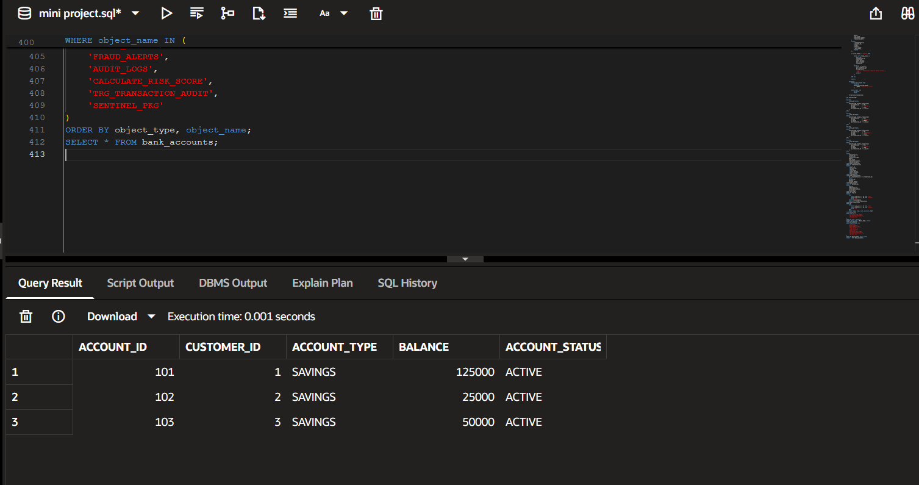
Figure B.2 — Bank accounts table output
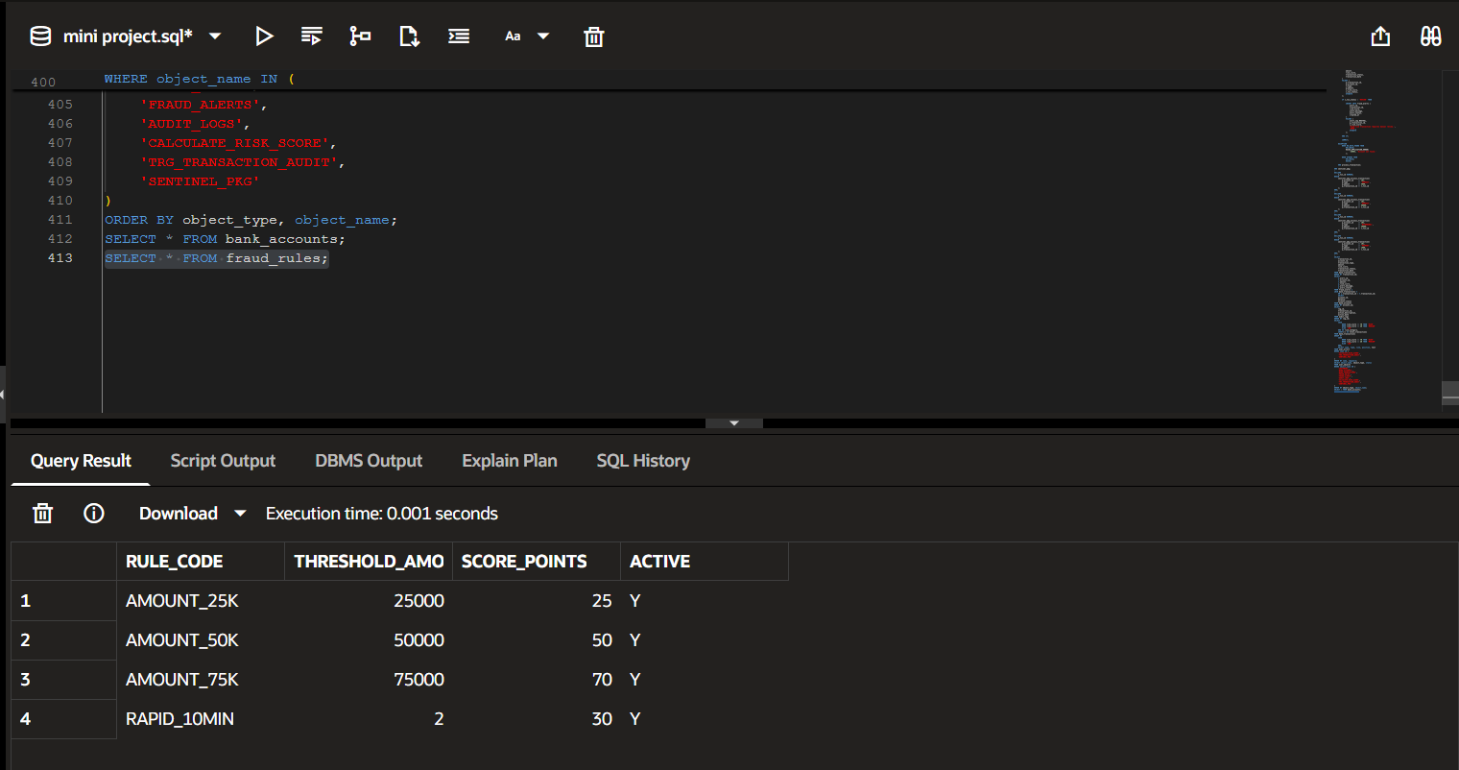
Figure B.3 — Fraud rules table output
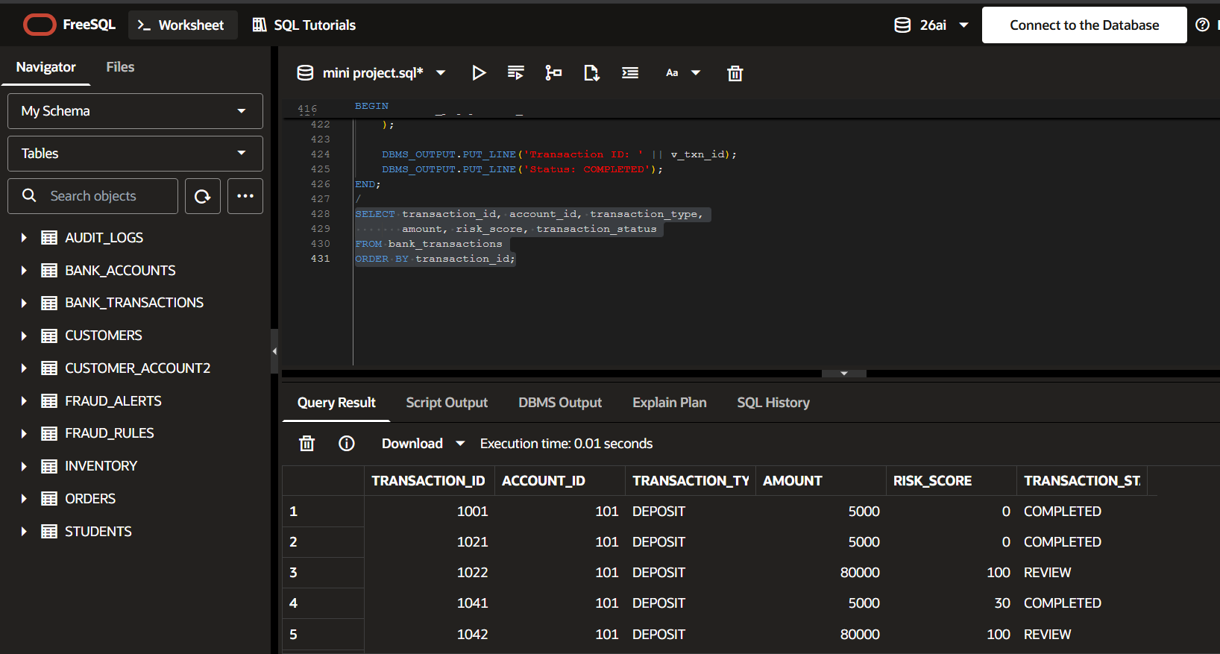
Figure B.4 — High-risk transaction result
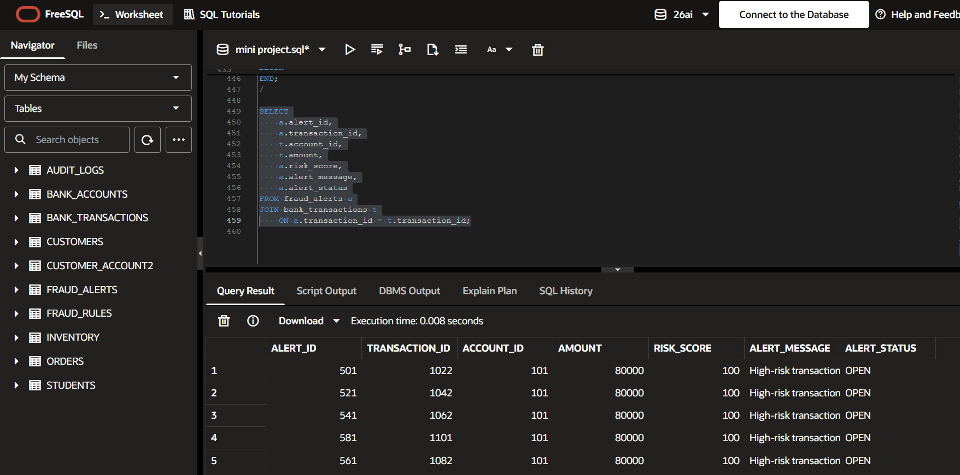
Figure B.5 — Low-risk transaction result
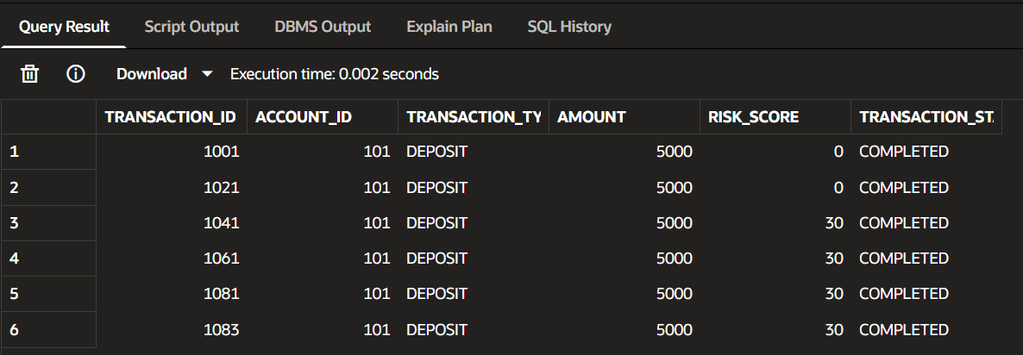

Figure B.6 — Fraud alert output
Figure B.7 — Audit log output
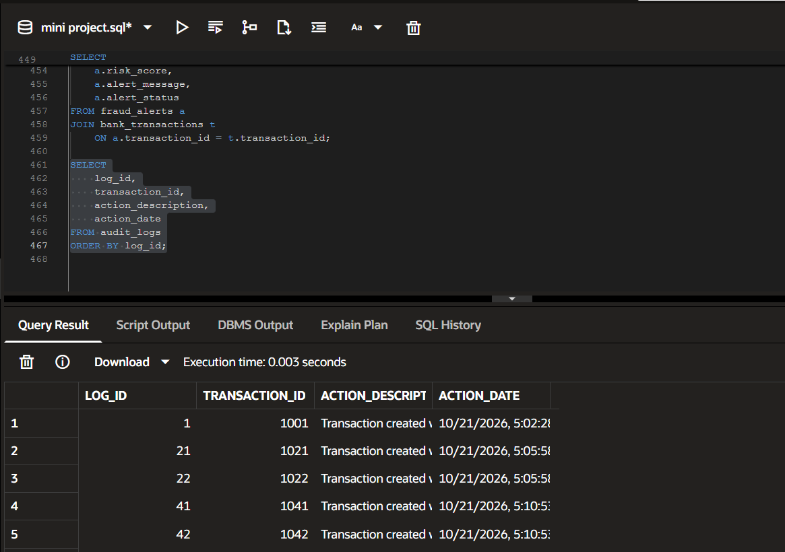
Figure B.8 — Final banking dashboard
